Conversational AI Integration for IRCTC 139 IVR System
Structured Technical Documentation

1. Introduction
Indian Railways is one of the largest railway networks in the world, transporting millions of passengers daily across thousands of routes. To support this massive transportation system, Indian Railways provides a centralized helpline known as the 139 Railway Helpline, which assists passengers with queries related to ticket reservations, train schedules, complaints, safety issues, and general travel information. Over the years, the helpline has become an essential communication channel between passengers and railway authorities. However, the increasing number of passengers and the growing demand for real-time information have exposed several limitations in the traditional Interactive Voice Response (IVR) system used by the helpline.
Traditional IVR systems rely heavily on keypad-based inputs where users must navigate through a series of predefined menu options by pressing numbers on their phone keypad. Although this system has served its purpose for many years, it has become increasingly inefficient due to its rigid structure and inability to understand natural human communication. Passengers often struggle with complex menu navigation, language barriers, and repeated prompts, which leads to frustration and long call durations. In addition, many callers end up transferring their queries to human customer service agents, increasing operational costs and reducing system efficiency.
To address these challenges, Indian Railways has begun exploring the integration of Conversational Artificial Intelligence (AI) into the existing IVR framework. Conversational AI systems enable passengers to interact with the helpline using natural spoken language rather than numeric keypad inputs. By leveraging technologies such as speech recognition, natural language processing, and intelligent dialogue management, conversational systems can understand user intent and provide relevant responses quickly and efficiently. The goal of this modernization effort is to transform the 139 helpline into an intelligent voice assistant capable of handling passenger queries in a more intuitive and human-like manner.

2. Limitations of Traditional IVR Systems
Traditional IVR systems are built around the concept of structured menu navigation. When a passenger calls the helpline, the system presents a list of numbered options, and the user must select the appropriate option by pressing a key on their phone. While this approach allows automation of basic queries, it creates several usability challenges that significantly affect passenger experience.
One of the major limitations of traditional IVR systems is the complexity of menu structures. Many services require users to navigate through multiple layers of menus before reaching the desired option. For example, a passenger who wishes to check their ticket confirmation status may need to navigate through the main menu, then select enquiry services, and finally choose the PNR status option. This multi-level navigation process often confuses users, especially those who are unfamiliar with the system or those calling in urgent situations.
Another major challenge associated with traditional IVR systems is the high rate of call abandonment. Passengers frequently disconnect calls if they select incorrect menu options or fail to locate the correct service. Studies indicate that a significant percentage of callers terminate their calls prematurely due to frustration with the menu system. This results in poor service satisfaction and increases the likelihood that passengers will seek alternative support channels.
Language limitations also play a crucial role in reducing the accessibility of IVR systems. India is a linguistically diverse country with hundreds of regional languages and dialects. Traditional IVR systems typically support only a few major languages such as Hindi and English, which means that many passengers are unable to interact with the system comfortably in their native language. This creates communication barriers and reduces the effectiveness of automated support services.
Furthermore, traditional IVR systems often fail to resolve queries efficiently, resulting in a high number of calls being forwarded to human agents. Even simple queries such as checking train arrival times or ticket confirmation status frequently require assistance from customer service representatives. This dependency increases the workload on call center staff and raises the operational costs associated with maintaining the helpline infrastructure.

3. Transition to Conversational AI
The transition from traditional IVR systems to conversational AI represents a fundamental shift in the way automated customer service platforms operate. Unlike keypad-driven systems, conversational AI enables users to communicate with the system using natural speech. Instead of navigating through predefined menus, passengers can simply describe their problem or request in their own words, and the system interprets the query to provide an appropriate response.
Conversational AI systems rely on advanced technologies such as speech recognition, natural language understanding, machine learning, and dialogue management to process and interpret human speech. These technologies allow the system to identify the user’s intent, extract relevant information from the conversation, and respond in a contextually appropriate manner. As a result, the interaction becomes more intuitive and closely resembles human conversation.
One of the most important advantages of conversational AI systems is their ability to maintain context throughout the interaction. Traditional IVR systems treat each user input as an isolated command, which means that the system does not remember previous responses. Conversational systems, on the other hand, maintain a contextual understanding of the conversation, allowing them to provide more accurate and meaningful responses.
Another key benefit of conversational AI is its scalability. Modern AI platforms are typically deployed on cloud infrastructure, which allows them to handle large volumes of simultaneous interactions without requiring additional hardware resources. This scalability is particularly important for large public service platforms like the IRCTC helpline, which must support millions of calls each day.

4. Conversational AI Technology Components
The implementation of conversational AI systems requires several specialized technological components that work together to process voice interactions and generate appropriate responses. These components form the foundation of modern voice-enabled virtual assistants.
The first component is Automatic Speech Recognition (ASR), which is responsible for converting spoken audio signals into text. When a passenger speaks into the phone, the ASR engine analyzes the audio waveform and identifies the corresponding words using trained speech recognition models. The second component is Natural Language Understanding (NLU), which analyzes the text produced by the ASR engine to determine the meaning of the user’s request. NLU systems identify the user’s intent and extract relevant entities from the sentence. For example, if a passenger says “Check my PNR number 4488123456,” the system identifies the intent as a request for ticket status and extracts the PNR number as a key entity required for retrieving the information.
Once the intent and entities have been identified, the request is passed to the Dialogue Management and Fulfillment Layer. This layer acts as the decision-making engine of the system. It determines how the conversation should proceed and which backend services should be contacted to fulfill the request. In the case of railway enquiries, the system may retrieve information from databases such as the Passenger Reservation System (PRS) or the National Train Enquiry System (NTES).
Finally, the system uses Text-to-Speech (TTS) technology to convert the generated response into spoken audio. Modern TTS systems use deep learning techniques to produce highly natural and expressive speech, making the interaction feel more human-like and engaging.

5. IRCTC 139 System Architecture
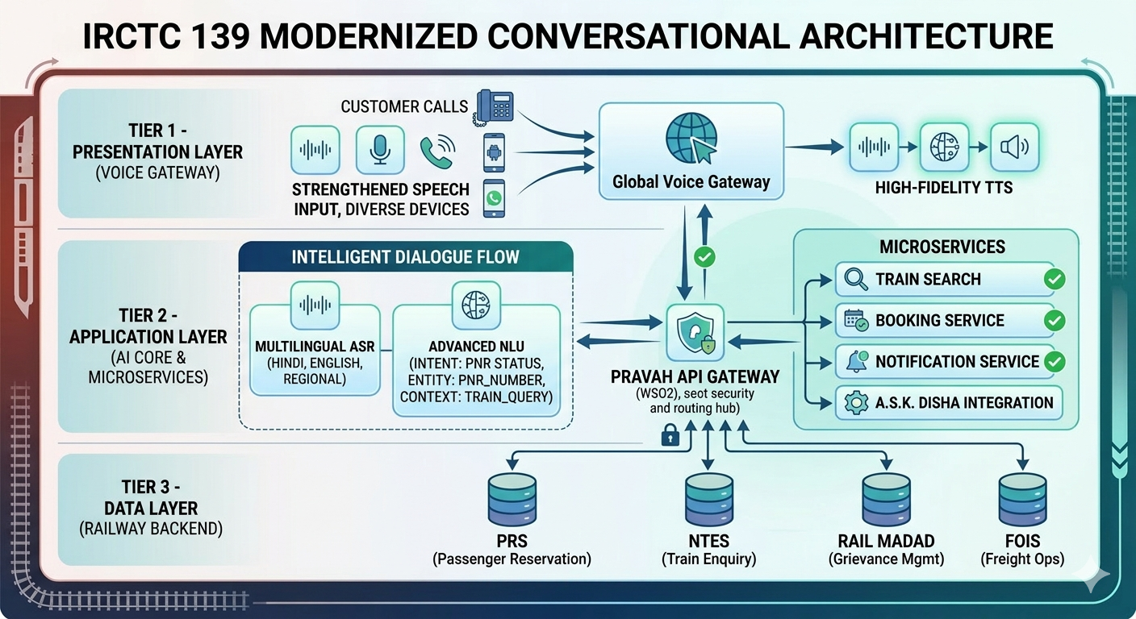
The IRCTC 139 helpline operates on a multi-layered architecture designed to manage large volumes of voice interactions efficiently. The architecture is typically divided into three primary layers: the presentation layer, the application layer, and the data layer.
The presentation layer serves as the interface between passengers and the IVR system. This layer includes telecommunication networks, voice gateways, and VoiceXML browsers that process incoming calls. When a passenger dials the helpline number, the call is routed through the telecommunications network and delivered to the voice gateway. The voice gateway then interacts with the VoiceXML application that controls the dialogue flow.
The application layer contains the core logic responsible for processing user requests and coordinating communication between different services. This layer includes microservices responsible for tasks such as train search, ticket booking, passenger account management, and notification services. It also includes API gateways that manage authentication, traffic routing, and service orchestration. Conversational AI platforms such as Ask Disha operate within this layer to provide intelligent conversational capabilities.
The data layer contains the backend databases that store operational information used by railway services. These databases include the Passenger Reservation System for ticket bookings, the National Train Enquiry System for real-time train status information, and grievance management systems used to track passenger complaints. The application layer communicates with these databases to retrieve information required to respond to passenger queries.

6. Conversational Dialogue Design
Designing effective conversational experiences requires careful planning and structured dialogue flows. The system must be able to interpret a wide variety of user phrases that may express the same intent. For example, a passenger may say “Check my ticket status,” “Tell me my PNR details,” or “Is my ticket confirmed?” Even though the wording differs, the underlying intent is the same. Conversational AI systems use intent mapping techniques to group such variations under a single intent category.
Entity recognition plays an equally important role in dialogue design. Entities represent specific pieces of information required to fulfill a request. In the context of railway enquiries, entities may include PNR numbers, train numbers, travel dates, or complaint reference numbers. Extracting these entities accurately allows the system to retrieve relevant data from backend systems.
Another important aspect of conversational systems is context management. Unlike traditional IVR systems, conversational AI systems remember the previous steps in the interaction. This allows them to handle multi-step queries more efficiently. For example, if a passenger asks about train status and later provides the train number, the system can link the two pieces of information and complete the request without restarting the conversation.

7. Performance and Latency Considerations
Real-time voice interactions require extremely fast processing speeds in order to maintain a natural conversational experience. If the system takes too long to respond, users may assume that the call has disconnected or that the system has malfunctioned. Therefore, optimizing system performance is a critical aspect of conversational AI design.
Voice processing involves multiple stages including speech recognition, language understanding, database queries, and speech synthesis. Each stage introduces a small amount of latency, which can accumulate if the system is not optimized properly. Engineers must carefully design the processing pipeline to ensure that responses are generated within a fraction of a second. Techniques such as caching frequently requested data, optimizing neural network models, and deploying services on regional edge servers help reduce response times.

8. Security and Compliance
Because the IRCTC helpline handles sensitive passenger information, strong security measures must be implemented to protect user data. Authentication mechanisms ensure that only authorized systems can access backend services. Encryption protocols such as TLS protect data during transmission, while advanced encryption standards safeguard stored information within databases.
In addition to technical safeguards, the system must comply with government regulations governing data privacy and telecommunications. These regulations ensure that passenger information is handled responsibly and that users are informed about call recording and data usage policies.

9. Future Developments
The modernization of the IRCTC helpline represents only the first step toward a fully intelligent railway support system. Future developments may include multilingual conversational interfaces capable of supporting dozens of regional languages and dialects. Predictive AI systems may proactively notify passengers about train delays, platform changes, or travel reminders before they even request the information.
Integration with messaging platforms such as WhatsApp and mobile applications will also allow passengers to interact with railway services through multiple communication channels. Additionally, AI-powered kiosks installed at railway stations may provide visual and voice-based assistance to travelers, making railway services more accessible to people with disabilities.

10. Conclusion
The integration of conversational AI into the IRCTC 139 helpline marks a significant advancement in public service technology. By replacing rigid keypad-driven interactions with natural language conversations, Indian Railways can provide faster, more efficient, and more accessible support to millions of passengers. The combination of speech recognition, natural language processing, cloud infrastructure, and enterprise integration frameworks enables the creation of intelligent voice systems capable of handling complex queries in real time.
As conversational technologies continue to evolve, the railway helpline will gradually transform into a fully autonomous digital assistant that understands passenger needs and delivers accurate information instantly. This modernization effort not only improves passenger experience but also demonstrates how advanced technologies can enhance large-scale public infrastructure systems

