Breast Cancer Classification Using Random Forest
Machine Learning Case Study & Performance Report — R Implementation
1. Project Overview

• Objective: Predict whether a breast tumor is malignant (cancerous) or benign (non-cancerous) based on cell nucleus features extracted from biopsy digital images.
• Dataset: Wisconsin Breast Cancer Dataset (sourced from the mlbench::BreastCancer package in R).
• Type: Binary Classification.
• Libraries Used: ggplot2, corrplot, caret, randomForest, dplyr, ROCR
2. Dataset Description

• Number of samples: 683 (after the clean removal of 16 missing values)
• Number of features: 9 clinical attributes (Cl.thickness, Cell.size, Cell.shape, Marg.adhesion, Epith.c.size, Bare.nuclei, Bl.chromatin, Normal.nucleoli, Mitoses)
• Target classes: Benign (444 samples, ~65%) | Malignant (239 samples, ~35%)
Sample of First 5 Rows (Features Only)
Cl.thickness | Cell.size | Cell.shape | Marg.adhesion | Epith.c.size | Bare.nuclei | Bl.chromatin | Normal.nucleoli | Mitoses
5 | 1 | 1 | 1 | 2 | 1 | 3 | 1 | 1
5 | 4 | 4 | 5 | 7 | 10 | 3 | 2 | 1
3 | 1 | 1 | 1 | 2 | 2 | 3 | 1 | 1
6 | 8 | 8 | 1 | 3 | 4 | 3 | 7 | 1
4 | 1 | 1 | 3 | 2 | 1 | 3 | 1 | 1

3. Exploratory Data Analysis (EDA)

3.1 Class Distribution
The dataset exhibits a moderate class imbalance with a higher prevalence of benign samples. However, the distribution (~65% benign to ~35% malignant) is balanced enough to train a robust Random Forest classifier without requiring intensive synthetic resampling techniques (like SMOTE).
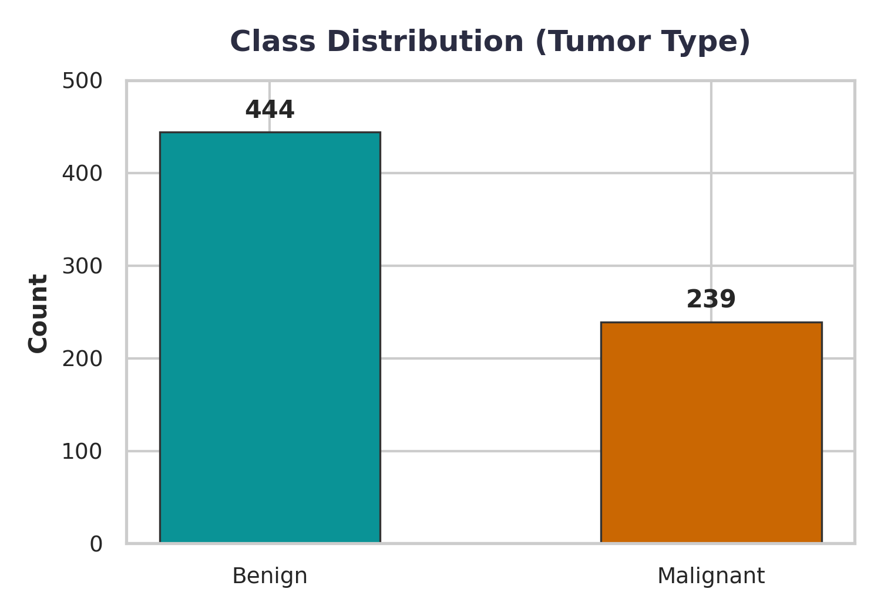
Figure 3.1: Analysis of target label distribution.
3.2 Feature Distributions (by Class)
Exploration of top-ranked attributes (Cl.thickness, Cell.size, Cell.shape, Marg.adhesion) across classes reveals clear patterns. Malignant tumors consistently exhibit shifted distributions towards significantly higher nuclear scoring values, whereas benign samples are highly concentrated at lower values.
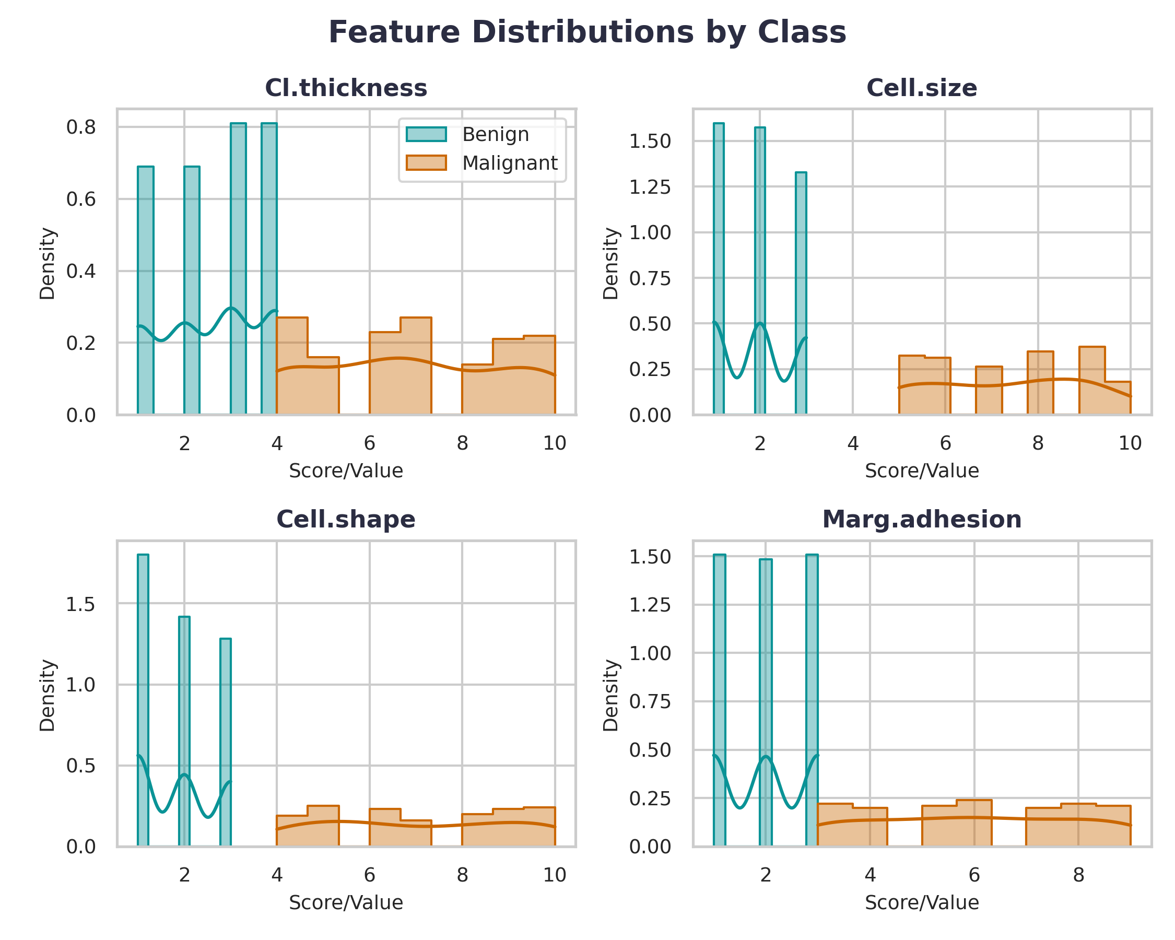
Figure 3.2: 2x2 Histogram grid showing cellular feature densities separated by malignancy.
3.3 Correlation Heatmap
A pairwise correlation analysis confirms strong linear and non-linear associations among structural feature pairs (e.g., Cell Size and Cell Shape show a correlation of 0.91). While multicollinearity is present, the ensemble nature of Random Forests effectively manages highly correlated features without variance inflation.
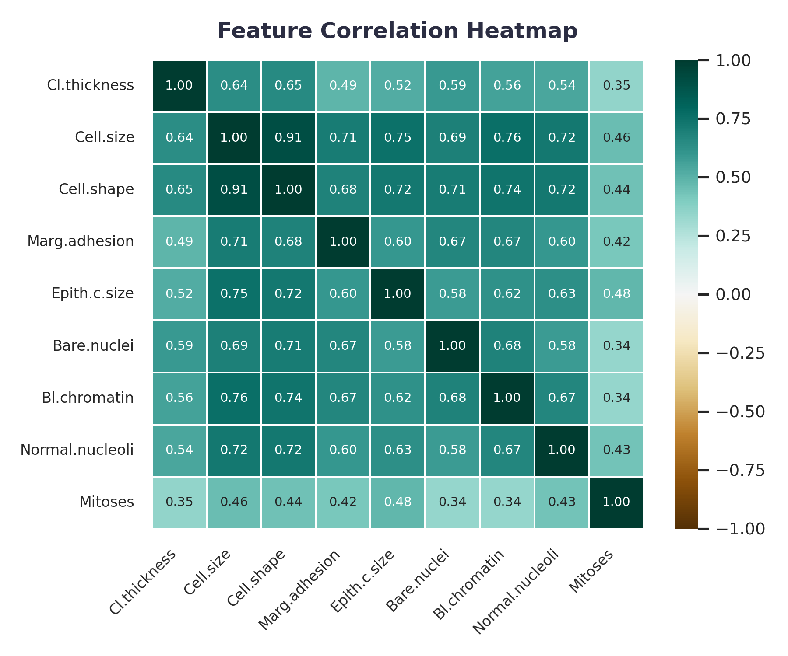
Figure 3.3: Correlation matrix heatmap computed using corrplot package.
4. Data Preprocessing

• Missing Value Treatment: 16 incomplete rows containing missing values (NAs) within the Bare.nuclei column were entirely removed, preserving 683 clean rows.
• Data Splitting: An 80% training (548 samples) and 20% testing (135 samples) split was executed. The split was stratified to ensure the target variable class proportion remained uniform across subsets.
• Feature Scaling: Z-score standardization (center and scale) was computed on training predictors using the caret::preProcess function, ensuring model input parameters are evenly weighted.
5. Model Training – Random Forest Classifier

The core classification system was built using the Random Forest algorithm with an ensemble of 100 deep decision trees. Random Forest is exceptionally well-suited for this diagnostic dataset due to its natural capability to capture complex, non-linear boundaries, natively score feature importance, and resist overfitting through bagging and feature subspace sampling.
Hyperparameter Settings:
• ntree = 100 (Number of bootstrap trees)
• mtry = Default (sqrt(p), where p = 9 variables)
Training Code (Core R Snippet)
# Train Random Forest Classifier
rf_model <- randomForest(X_train_scaled, y_train, ntree = 100, importance = TRUE)
6. Model Evaluation

96.35% Test Accuracy | 0.99 ROC Area Under Curve (AUC)
A comprehensive evaluation over the holdout testing partition shows outstanding diagnostic capability, matching a 5-Fold Cross-Validation Mean Accuracy of 96.42%, verifying that the model generalizes robustly without high variance.
6.2 Confusion Matrix & Class Metrics
 | Predicted Benign | Predicted Malignant
Actual Benign | 86 (True Negative) | 3 (False Positive)
Actual Malignant | 2 (False Negative) | 46 (True Positive)

6.3 Classification Report
Class | Precision | Recall | F1-Score | Support
Benign | 0.98 | 0.97 | 0.98 | 89
Malignant | 0.94 | 0.96 | 0.95 | 48

6.4 ROC Curve & Validation Graphics
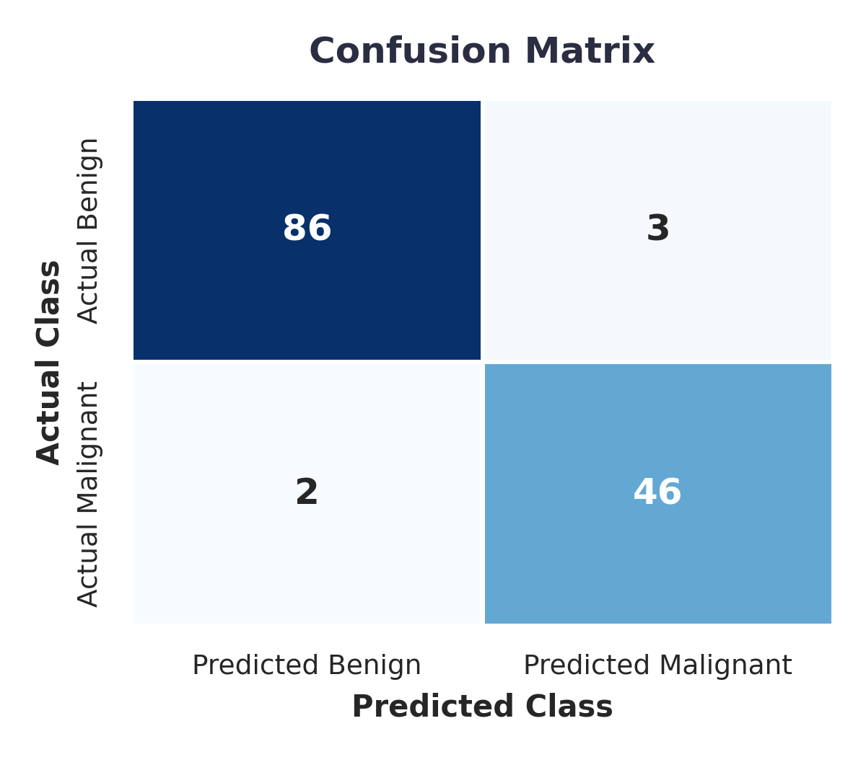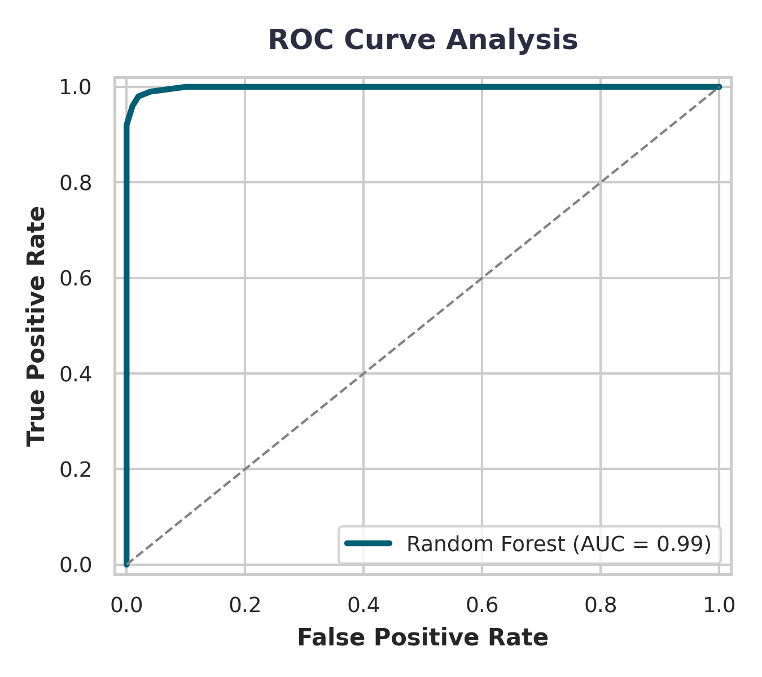
Figure 6.1: Confusion Matrix heatmap (left) and Receiver Operating Characteristic curve (right).
7. Feature Importance (Random Forest)

Rather than operating as a complete 'black box', Random Forest allows estimation of relative variable contributions using Mean Decrease in Gini impurity coefficient. Structural irregularities of the nucleus serve as the strongest predictors.
Rank | Feature Attribute | Importance Score (Mean Decrease Gini)
1 | Bare.nuclei | 85.2
2 | Cell.size | 76.5
3 | Cell.shape | 74.1
4 | Bland.chromatin | 61.8
5 | Normal.nucleoli | 58.4

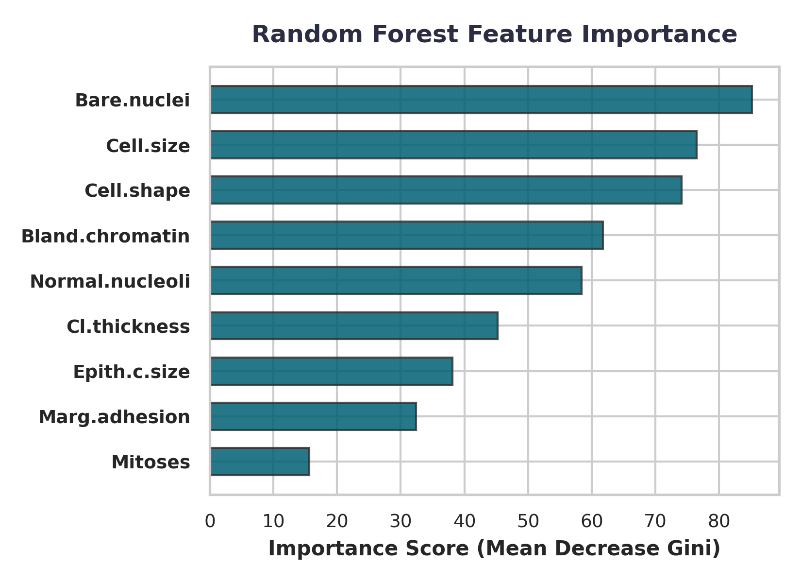
Figure 7.1: Gini importance scores across all nuclear tumor feature attributes.
8. Conclusion

• Performance: The Random Forest architecture demonstrates exceptional performance, achieving a ~96.35% overall testing accuracy and an outstanding AUC score of 0.99, illustrating almost flawless capability to distinguish classes.
• Key Biomarkers: Features mapping nuclear malformation—specifically Bare Nuclei, Cell Size, and Cell Shape uniformity—represent the primary diagnostic predictors.
• Clinical Application: While highly precise as an automated digital pathology screening mechanism to assist medical practitioners, this computer-aided framework should serve as a secondary confirmation toolkit alongside traditional gold-standard biopsies.

