Project Scoping Submission
Predicting Early Termination of Clinical Trials
Team Members
- Atharva Nilesh Mahadik
- Danush Gopinath
- Nithish Bhat
- Pavanchytanya Dharmapuri (Group Leader)
- Sathyasai Rajan
- Sivapriya Sugumaran
Submission Date: October 4, 2026

Table of Contents
1. Introduction
2. Dataset Information
3. Data Planning and Splits
4. GitHub Repository
5. Project Scope
6. Current Approach and Bottlenecks
7. Metrics, Objectives, and Business Goals
8. Failure Analysis
9. Deployment Infrastructure
10. Monitoring Plan
11. Success and Acceptance Criteria
12. Timeline Planning
13. Additional Information

1. Introduction
Clinical drug trials are long, costly, and frequently do not reach completion. A large share of registered trials are stopped before they can answer their research question, which wastes years of work and significant funding. Many of these early stops trace back to design choices made before enrollment begins, such as eligibility criteria that are too restrictive, too few recruiting sites, or enrollment targets that were never realistic. These weaknesses are usually noticed late, after the trial has launched and spent much of its budget.
A trial can end early in three ways, as recorded in its status field. Terminated means the study stopped early and will not resume, after at least some participants had enrolled. Withdrawn means the study stopped before enrolling any participant. Suspended means the study paused early and may resume later. All three are treated as stopped early.
The proposed system works at the design stage, in two parts. First, a prediction model estimates the probability that a trial will be stopped early, using both the structured design fields (such as phase, enrollment target, number of sites, eligibility complexity, and sponsor type) and the trial's free text. The main model combines BioBERT text embeddings with the structured features in a neural network. Second, an agentic AI system explains why a flagged trial is at risk by looking up similar past trials that were stopped and citing their recorded reasons. The unit of prediction is one trial, identified by its NCT ID, the unique number ClinicalTrials.gov gives every registered trial. Both the model and the agent's reference data are refreshed on a schedule so they stay current.

2. Dataset Information

2.1 Dataset Introduction
All data comes from ClinicalTrials.gov, the public global registry of clinical studies maintained by the U.S. National Library of Medicine. It is free and public, and it holds roughly 450,000 or more registered trials from around the world, with fields covering trial design, status, sponsors, eligibility, interventions, conditions, and outcomes. Terminated, withdrawn, and suspended trials also carry a free-text "why_stopped" field that records the reason the trial ended. The registry is accessed through the AACT database (Aggregate Analysis of ClinicalTrials.gov), a relational PostgreSQL copy of the full registry published by the Clinical Trials Transformation Initiative (CTTI) and refreshed as a monthly snapshot. AACT is used because it mirrors the entire registry as queryable tables, which suits bulk feature engineering across all trials.
Scope: all registered interventional and observational trials across all phases, therapeutic areas, and regions available in the registry are included.

2.2 Data Card
Item | Detail
Source | ClinicalTrials.gov, accessed via the AACT (CTTI) PostgreSQL mirror
Size | About 450,000+ registered trials (global)
Format | Relational tables (AACT PostgreSQL)
Data types | Categorical, numeric, dates, and free text
Unit of prediction | One trial, identified by its NCT ID (the unique registry number, for example NCT01234567)
Target | Terminated / Withdrawn / Suspended (stopped) vs Completed; binary, derived from "overall_status"
Agent ground truth | "why_stopped" free text (the recorded reason a trial ended), used to build the gold-standard dataset
Update cadence | Monthly AACT snapshot
License / rights | Public data; credit ClinicalTrials.gov and CTTI AACT
Privacy | Trial-level aggregate records; no patient-level personal data

2.3 Data Sources
- AACT relational database (CTTI): https://aact.ctti-clinicaltrials.org/ (monthly PostgreSQL snapshot)
- Registry home: https://clinicaltrials.gov/

2.4 Data Rights and Privacy
- Rights: the registry data is public and free to use. ClinicalTrials.gov and CTTI/AACT are credited as the sources.
- Privacy: records are trial-level and aggregate. They describe studies, sponsors, and designs, not individual patients, so there is no patient-level personal data to handle.
- GDPR: the EU General Data Protection Regulation, a law protecting personal data, does not directly apply, because this is public, aggregate, non-personal trial data. Only the needed fields are kept, and the sources are credited.

3. Data Planning and Splits

3.1 Loading
- Pull the monthly AACT PostgreSQL snapshot on a set schedule.
- Save a dated copy of each snapshot to object storage, so the data is always kept as it looked on that day (versioned with DVC).
- Load the records into a data warehouse (BigQuery) that can be queried to build features.

3.2 Preprocessing
- Work at the unit of one trial (NCT ID).
- Clean the structured fields: standardize categories (for example phase and sponsor class), normalize units and dates, and fill or flag missing values.
- Clean the free text: remove boilerplate, normalize characters, and split the eligibility text into inclusion and exclusion parts.
- Turn the cleaned free text into embeddings with BioBERT, a biomedical language model used as is (not fine-tuned), and store them with the other features.
- Derive the training label from "overall_status" (stopped vs completed).
- Exclude any field that is only known after a trial ends, such as "why_stopped" and result fields, from the model inputs, so the model cannot see the outcome. These are kept only as the label and as the agent's reference.

3.3 Splitting the Data
Because the task is to predict the future, the data is split by time rather than randomly:
- Time-based split: train on older trials, validate on the next period, and test on the most recent period, by trial start date.
- Time gap: keep a gap between splits so the model never sees information from the future during training.
- Stratification: within each time split, keep a similar mix of trial phase, therapeutic area (disease group), and sponsor type. Trials cover many diseases and design levels, so the stratification variables are chosen carefully, keeping each group large enough to be useful.
- Censoring: a trial's label is known only after it ends, so trials that are still running are left out of training and testing.

3.4 Feature Set
Features are built per trial (NCT ID). The lists below are representative; the exact set is finalized during feature engineering.
Structured features (from AACT tables)
Design (phase, study type, masking), scale (enrollment target, number of sites, number of outcomes), eligibility complexity (counts of inclusion and exclusion criteria, age range), sponsor and funding (sponsor class, number of collaborators), clinical context (condition and intervention categories), and timing (start period, planned duration).
Text features (from AACT text fields)
Free-text fields (title, brief summary, detailed description, eligibility criteria, and outcome descriptions) are cleaned and turned into embeddings with BioBERT (used as is, not fine-tuned). These embeddings are combined with the structured features as model input.
Label and reference
The label is derived from "overall_status" (stopped vs completed). The "why_stopped" text is kept as the agent's reference, not as a model feature.

4. GitHub Repository
Repository link: https://github.com/PavanchytanyaD/clinical-trial-termination (public)
Planned folder structure:
clinical-trial-termination/
|- data/ raw and processed data (DVC-tracked)
|- src/ ingestion, features, model, and agent code
|- pipelines/ pipeline definitions (ingest, train, evaluate, deploy)
|- tests/ unit and integration tests
|- docs/ the scoping document and notes
|- README.md
The README will explain what the system does, how to install and run it, where the data comes from and the rights and privacy around it, the overall architecture, and how retraining is triggered.

5. Project Scope

5.1 Problems
- A large share of trials are terminated or stopped early, wasting years of effort and large budgets.
- Many failures come from fixable design flaws (restrictive eligibility, too few sites, unrealistic enrollment).
- These flaws are usually caught late, after the trial has launched and spent money.
- Knowledge from past failures is not reused in a systematic way when new trials are designed.

5.2 Current Solutions
- Manual review of each trial design by an expert or biostatistician: careful, but slow and inconsistent.
- Checklists and rules of thumb for common design mistakes.
- Risk-based monitoring, but mostly while the trial is running rather than at design time.
- Academic studies that predict termination after the fact, but no design-stage tool that both predicts and explains, and is kept up to date.

5.3 Proposed Solutions
The proposed system has two parts: a prediction model and an agentic system that explains its predictions.
Prediction model (modeling approach)
- Step 1, baseline: a classical ML model (gradient-boosted trees or logistic regression) trained on the structured features only.
- Step 2, main model: BioBERT turns the trial's free text into embeddings; BioBERT itself is not fine-tuned. A neural network takes these text embeddings together with the structured features and is trained with a classification head, a final layer that outputs the probability that the trial is stopped early.
- Choice: the main model is kept only if it clearly beats the baseline on the time-based test set.
Agentic system
For each flagged trial, an AI agent works in steps, using the result of each step to decide the next one:
- Look up similar past trials in the structured data and in the text index (trial index).
- Read why each similar trial was stopped ("why_stopped").
- Compare those trials with the current design to find the likely risk factors.
- Write a short explanation that cites the past trials it used.
Keeping it current
The model and the trial index are refreshed on a schedule, or when a new version of the data arrives.

6. Current Approach and Bottlenecks
Today, a sponsor or one of the CROs (Contract Research Organizations) drafts the trial design, an expert or biostatistician reviews it by hand, and an ethics board (IRB, Institutional Review Board) approves it before the sites open and patients enroll. The trial then runs for months or years. Because past failures are not reused in a systematic way, design flaws are often found only after launch.
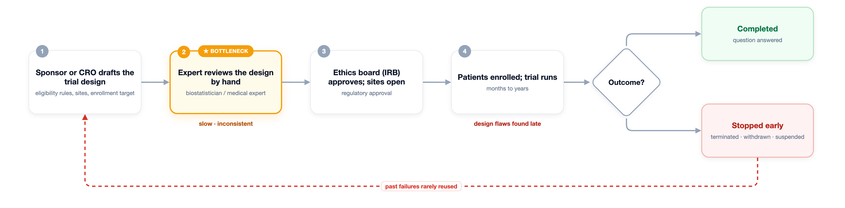
Figure 1: How clinical-trial design review happens today, and where the bottlenecks are.

Bottlenecks
- Review is manual, slow, and depends on individual judgement, so it is inconsistent.
- Design flaws are caught late, after the trial has launched.
- Past failures and their recorded reasons are not reused when designing new trials.
- The rich free-text design fields are barely used.

How the proposed system improves it
The model screens every trial design automatically and consistently and ranks its risk of stopping early. The agent then looks up similar past stopped trials and writes a clear, evidence-backed explanation that reuses what went wrong before, at the design stage, when it can still be fixed.

7. Metrics, Objectives, and Business Goals

7.1 Metrics
Targets below are initial values and will be adjusted once the baseline is measured.
Model metrics
- PR-AUC: main metric, because stopped trials are much rarer than completed ones; target at least 0.35.
- ROC-AUC: target at least 0.75.
- Precision@K: share of truly stopped trials among the 10% highest-risk trials; target at least 0.40.
- Calibration (Brier score): how well predicted probabilities match reality; target at most 0.12.
- Lead time: median time between the prediction (at registration) and the actual stop; target at least 6 months.
Agent metrics
- Citation validity (code check): cited trials exist and their quoted reasons match the record; target at least 98%.
- Grounding (LLM-as-judge, on a sample): the explanation is supported by the cited evidence; target at least 90%.
- Reason match: on the gold-standard dataset, the explanation matches the recorded "why_stopped" reason; target at least 70%.

7.2 Objectives
- Catch fixable design flaws early, at the design stage.
- Help reviewers focus on the highest-risk trials first.
- Give a clear, cited explanation for every flagged trial.
- Keep the model and the trial index current through scheduled retraining.

7.3 Business Goals
Reduce wasted trial spending, catch fixable design flaws before launch, and raise the share of trials that complete, by giving sponsors, CROs (Contract Research Organizations), and reviewers an early, evidence-backed warning they can act on.

8. Failure Analysis

8.1 What could go wrong (data and model)
Risk | Mitigation
Agent explanations are hard to evaluate and can be wrong, for example made up or citing irrelevant trials | Build a gold-standard dataset from the recorded "why_stopped" reasons; check citations in code on every output; use an LLM-as-judge plus human review on a sample; let the agent decline to answer when evidence is weak
Rare positives: far fewer stopped trials than completed ones | Use PR-AUC and Precision@K, class weighting or resampling, and calibration
Weak signal from the text | Use a biomedical language model; confirm the text adds accuracy over the structured-only baseline
The data changes over time as trial practice shifts | Time-based evaluation, scheduled retraining, and drift monitoring

8.2 What could go wrong (pipeline and after deployment)
Problem | Mitigation
The AACT schema or snapshot format changes | Automated schema checks that stop the run and raise an alert
The model or its inputs drift in production | Drift monitoring, the online evaluation loop, and scheduled retraining
The agent produces an unsupported or wrong citation | Citation checks on every output, a sampled LLM-as-judge, reviewer feedback, and declining to answer when unsure
A weaker model could be promoted by mistake | A promotion gate: a new model is approved only if it beats the current one on validation and passes the agent evaluation

9. Deployment Infrastructure
The system runs on Google Cloud Platform (GCP). All code is packaged as containers, so the same images run in the pipelines and in serving.

9.1 Platform and Services
GCP services
- Artifact Registry: stores the three container images (feature, training, inference).
- Cloud Storage: stores the dated AACT snapshots, versioned with DVC.
- BigQuery: stores features and prediction results.
- Vertex AI Pipelines: runs the training pipeline (feature step, training step, evaluation).
- Vertex AI Training: computes the BioBERT embeddings (GPU) and trains the models.
- Vertex AI Model Registry: keeps model versions and marks the approved one.
- Vertex AI Vector Search: holds the trial index used by the agent.
- Gemini (Vertex AI): the language model behind the agent.
- GKE (Google Kubernetes Engine): runs the inference service on pods that scale with demand.
- Cloud Scheduler: starts scheduled runs.
- Vertex AI Model Monitoring, Cloud Logging, Cloud Monitoring: drift checks, logs, and alerts.
Other tools
- GitHub Actions (CI/CD), DVC (data versioning), and MLflow (experiment tracking).
Supported platforms
- GCP for deployment; any machine with Docker for local development and testing.

9.2 Training Pipeline
The training pipeline turns a new version of the data into a new, tested model version. It runs on Vertex AI Pipelines in six steps:
- 1. Build: on every push, GitHub Actions runs the tests and builds the three container images into Artifact Registry. The agent's prompt is code in the same repository, so it is versioned and tested the same way.
- 2. Trigger: the pipeline starts on a set schedule (for example monthly) or when DVC records a new version of the AACT data.
- 3. Feature step: reads the AACT snapshot from Cloud Storage, builds the structured features and the BioBERT text embeddings, and writes them to BigQuery.
- 4. Training step: reads the features from BigQuery, trains the baseline and the neural network, and logs metrics to MLflow.
- 5. Evaluation gate: the agent offline evaluation checks the candidate model and the current prompt against the gold-standard dataset.
- 6. Promotion: only if the gate passes, the new model is approved in the Vertex AI Model Registry and the trial index in Vertex AI Vector Search is rebuilt.
Improving the agent means changing its prompt or refreshing the trial index, not retraining a model. Every such change passes the same evaluation gate.

9.3 Inference Pipeline
Inference runs as one container (the inference image) on GKE, which adds or removes pods as demand changes. Each request goes through five steps:
- 1. Request: the reviewer app, or a monthly batch run over all active trials, sends a trial to the FastAPI service.
- 2. Features: the service builds the structured features and BioBERT embeddings with the same code used in training.
- 3. Score: it loads the latest approved model from the Vertex AI Model Registry and computes the probability that the trial stops early.
- 4. Explain: the agent looks up similar past stopped trials (structured data and trial index) and writes an explanation that cites them.
- 5. Output: the result is returned as an API response and stored in BigQuery.
An online evaluation loop checks citations on every output, uses an LLM-as-judge on a sample, and collects reviewer feedback. These signals feed monitoring, and drift or quality alerts trigger retraining. Because AACT is a monthly snapshot, a newly registered trial is included in the next monthly batch run.

9.4 Versioning, Tracking, and Monitoring
- Data versioning: DVC on Cloud Storage.
- Model versioning: Vertex AI Model Registry.
- Experiment tracking: MLflow.
- Monitoring: Vertex AI Model Monitoring with Cloud Logging and Cloud Monitoring watch for drift and failures, raise alerts, and can trigger retraining.

9.5 Architecture Diagrams
Figures 2 and 3 show the training and inference pipelines on GCP.
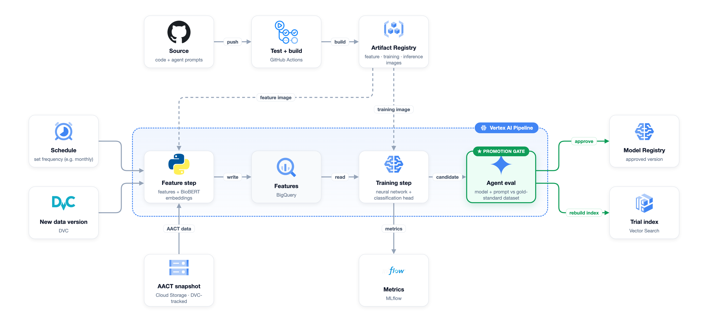
Figure 2: Training pipeline on GCP.
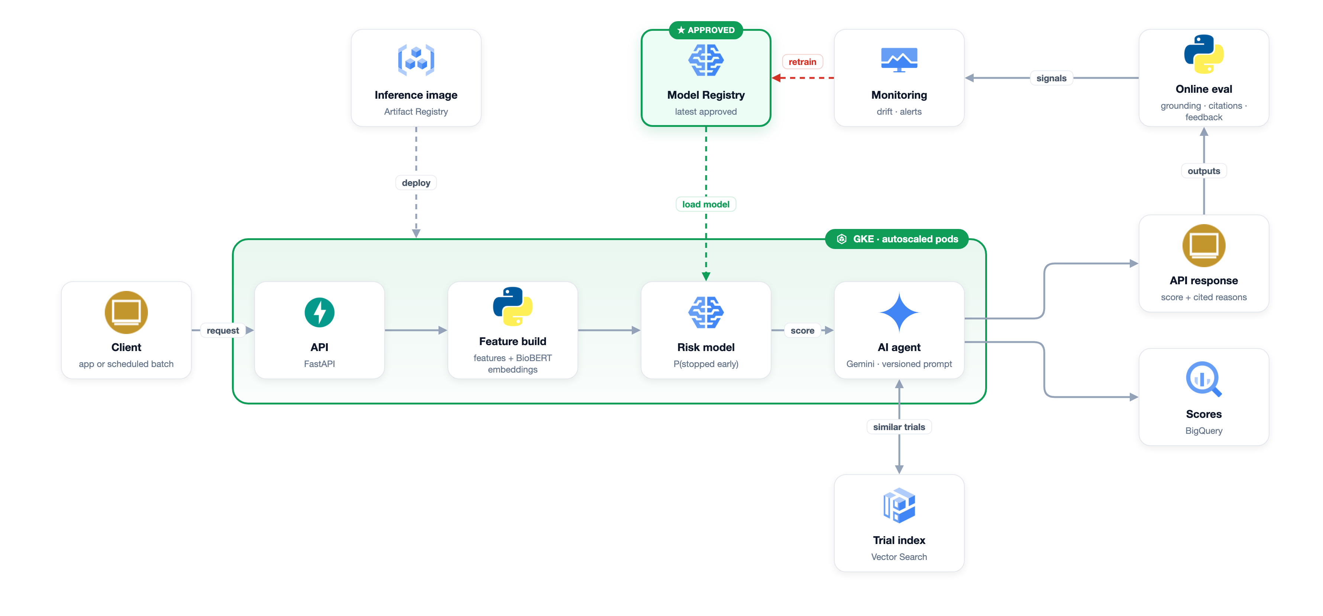
Figure 3: Inference pipeline on GCP.

10. Monitoring Plan
Five things are monitored, because each can fail on its own:
- Data: is the monthly snapshot fresh, complete, and in the expected schema?
- Model: are predictions still accurate, and is the input data drifting over time?
- Text inputs: is the trial text changing in ways the model has not seen?
- Agent: citations are checked in code on every output (the cited trial exists and the quoted reason matches the record). An LLM-as-judge, run on a sample, checks whether each explanation follows from its evidence and matches the real stop reason. Reviewer feedback and, later, the real trial outcomes confirm the results.
- Jobs: did the scheduled jobs run successfully, with alerts if not?
Detailed thresholds and dashboards will be documented as the system is built.

11. Success and Acceptance Criteria

11.1 Success Criteria
- The neural network beats the baseline by at least 0.05 PR-AUC on the time-based test set.
- The model reaches PR-AUC of at least 0.35 and ROC-AUC of at least 0.75.
- The agent reaches at least 98% citation validity, 90% grounding, and 70% reason match.
- Scheduled retraining runs on its own and promotes a new model only when it passes the gate.

11.2 Acceptance Criteria
- The system runs end to end, from data ingestion to scoring to the cited explanation, without manual steps.
- Results can be reproduced from versioned data, code, and models.
- The README covers setup, usage, data sources, and known limits.

12. Timeline Planning
A preliminary plan for October to mid-December 2026, aligned with the course milestones. It can change with deadlines and constraints.
Period | Milestone | Main activities
Oct 1 to Oct 10 | Scoping | Scoping document, GitHub repository, access to AACT
Oct 11 to Oct 31 | Data pipeline | AACT ingestion, DVC versioning, cleaning, structured features, BioBERT embeddings, BigQuery tables, time-based and stratified splits
Nov 1 to Nov 21 | Model pipeline | Baseline model, neural network on BioBERT embeddings and structured features, MLflow tracking, gold-standard dataset, agent and trial index, evaluation gate
Nov 22 to Dec 5 | Deployment | CI/CD and container images, Vertex AI pipeline, GKE inference service, online evaluation, monitoring and alerts
Dec 6 to Dec 12 | Final | End-to-end testing, documentation, final presentation

13. Additional Information
- What is new: the system combines structured design features with biomedical text and an agentic explanation that cites similar past stopped trials, at the design stage, before a trial launches. Earlier work tends to either predict or explain, and usually during or after the trial.
- Possible extension: separate models by phase or therapeutic area, where stop patterns differ.
- Who benefits: trial sponsors, CROs (Contract Research Organizations), IRBs (Institutional Review Boards), and funders.

