**13-01-2025**

**1. Factorial Calculation:** Write a recursive function to calculate the factorial of a given non-negative integer n.

Pointer:

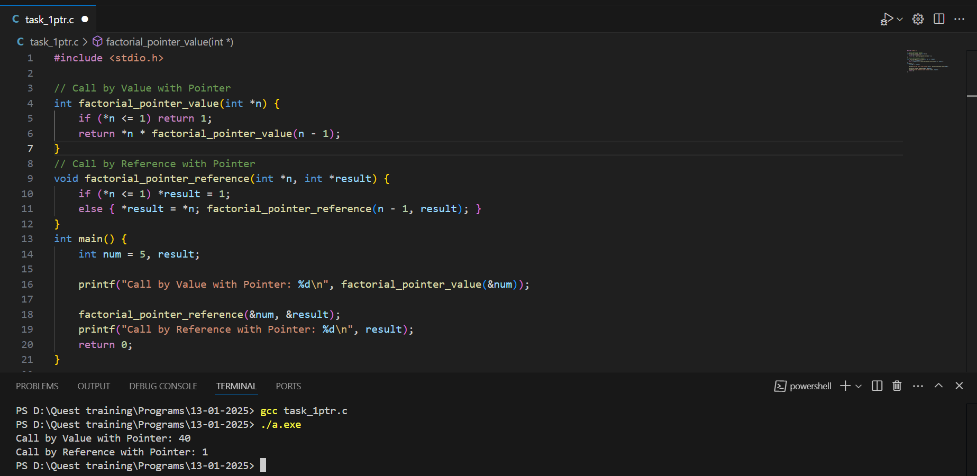

Without Pointer:

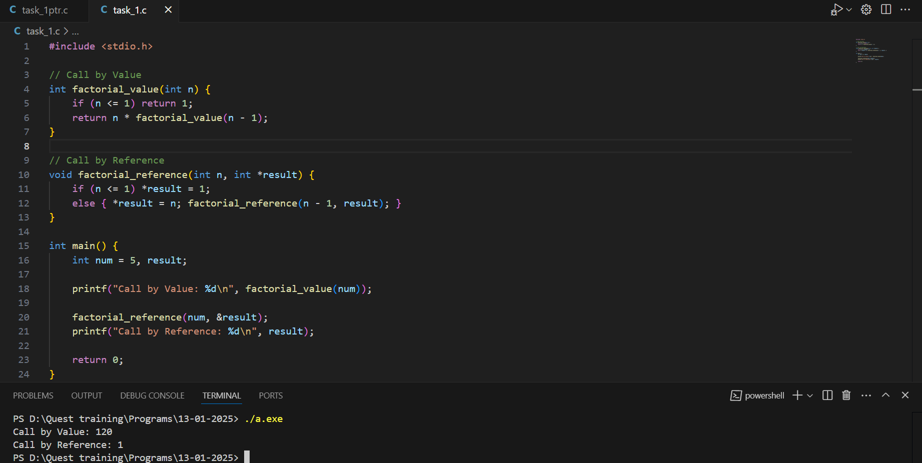

**2. Fibonacci Series:** Create a recursive function to find the nth term of the Fibonacci series.

**Pointer:**

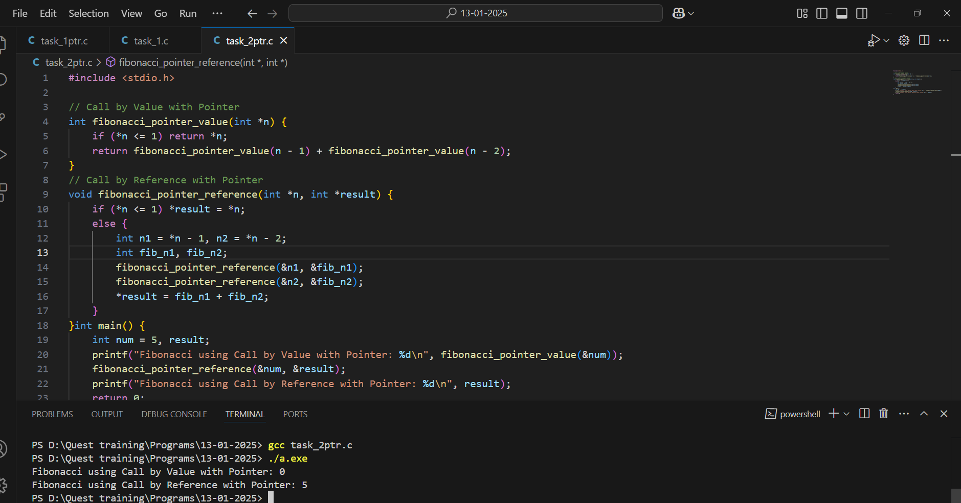

**Without Pointer:**

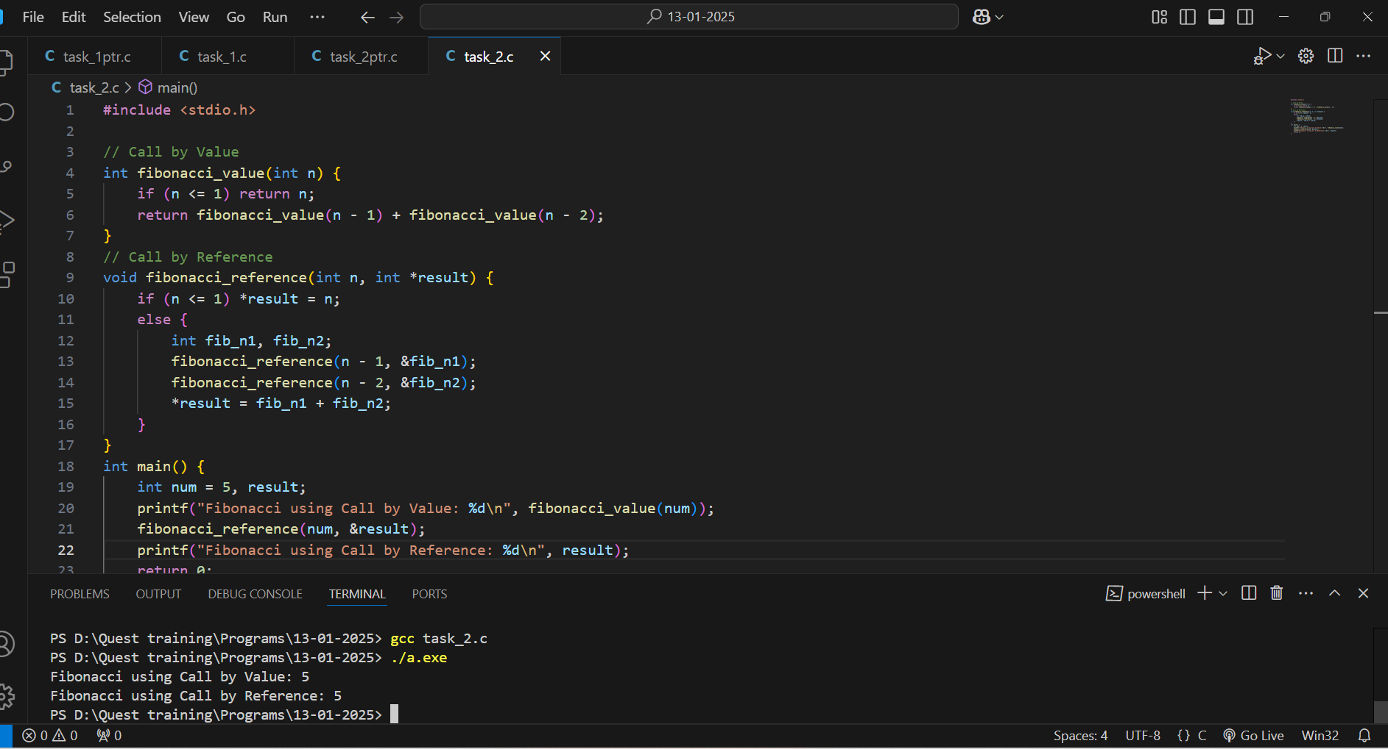

**3. Sum of Digits:** Implement a recursive function to calculate the sum of the digits of a given positive integer.

**Pointer:**

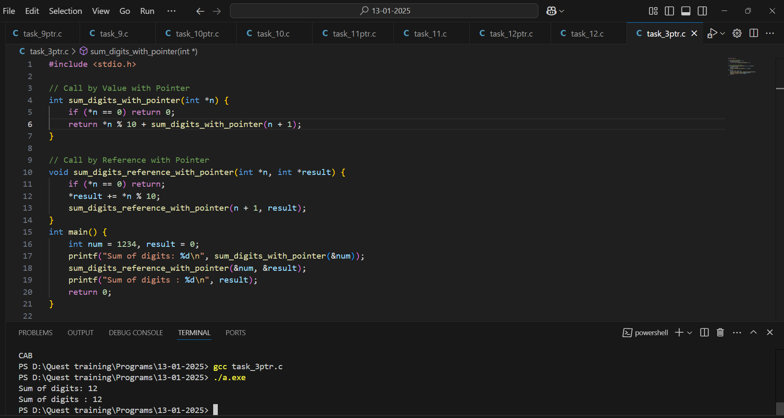

**Without Pointer:**

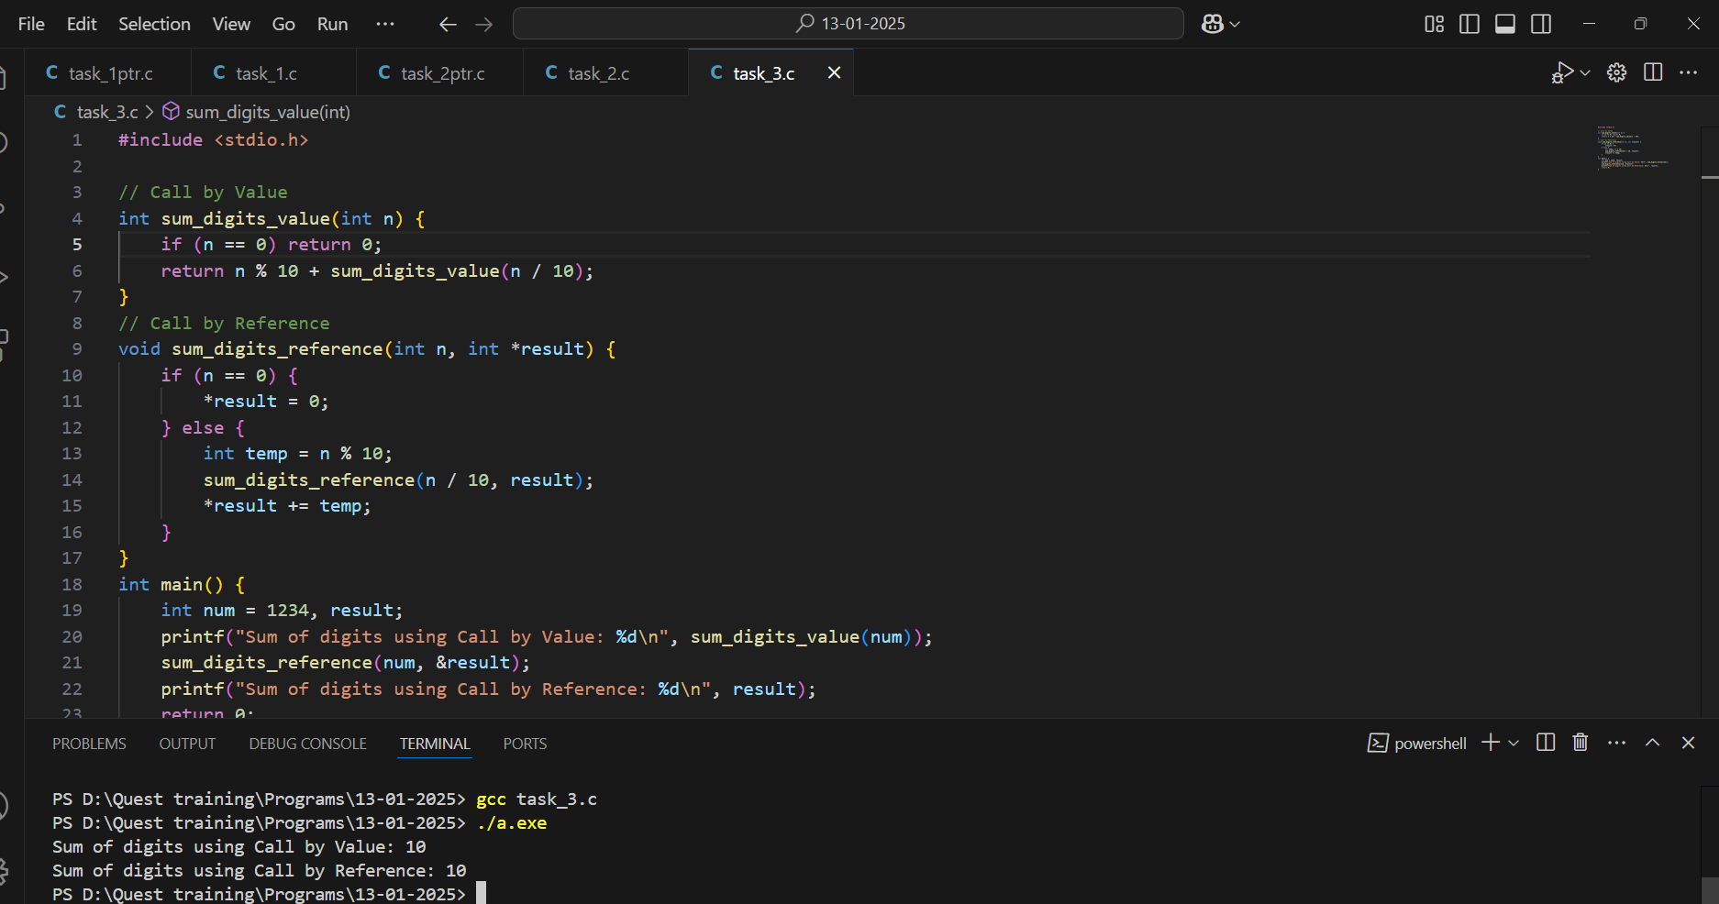

**4. Reverse a String: Write a recursive function to reverse a string.**

**Pointer:**

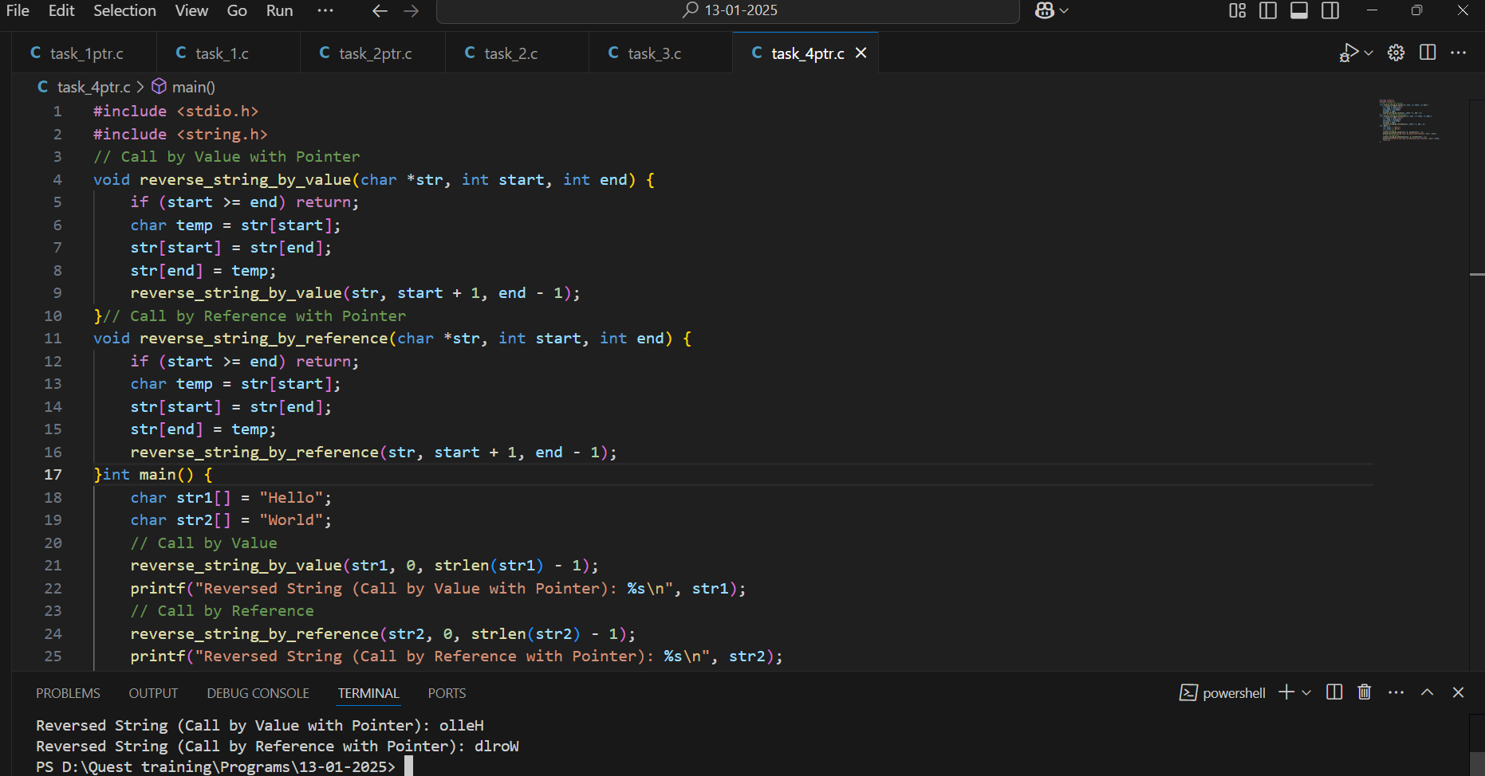

**Without Pointer:**

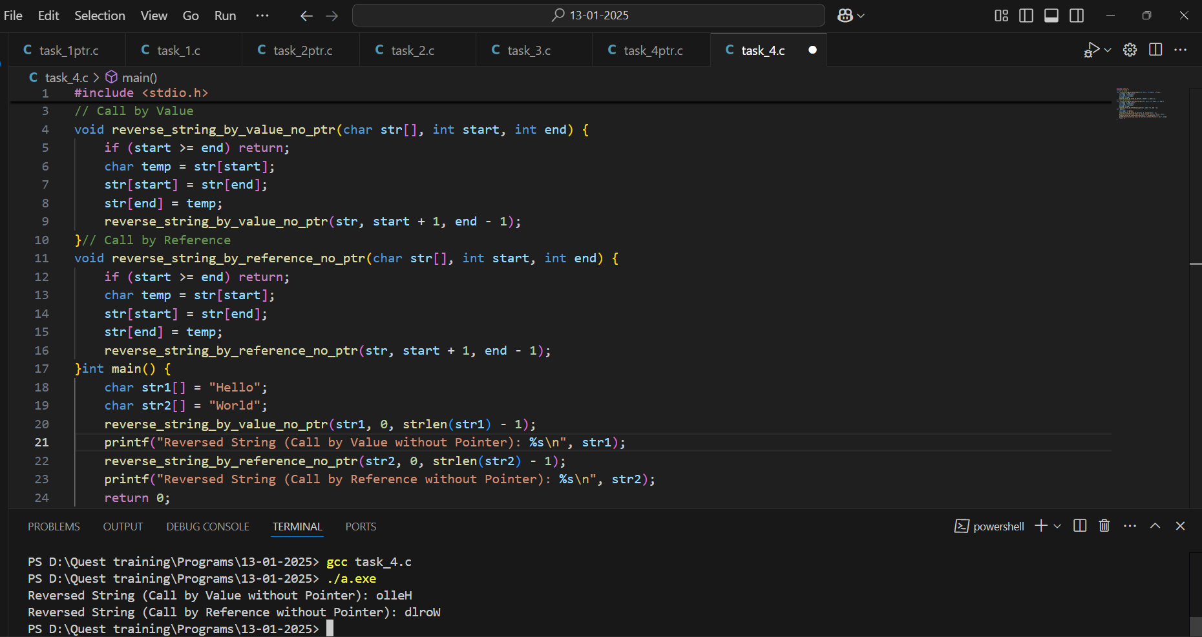

5. **Power Calculation: Develop a recursive function to calculate the power of a number x raised to n Greatest Common Divisor (GCD): Create a recursive function to find the GCD of two given integers using the Euclidean algorithm.**

**Pointer:**

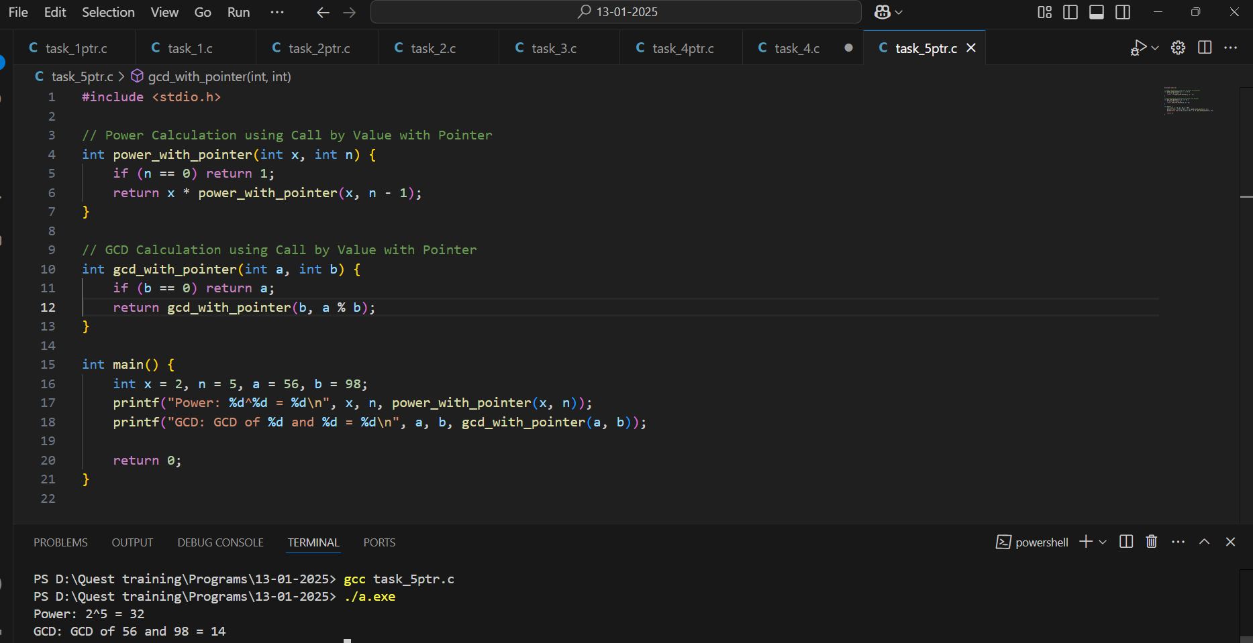

**Without Pointer:**

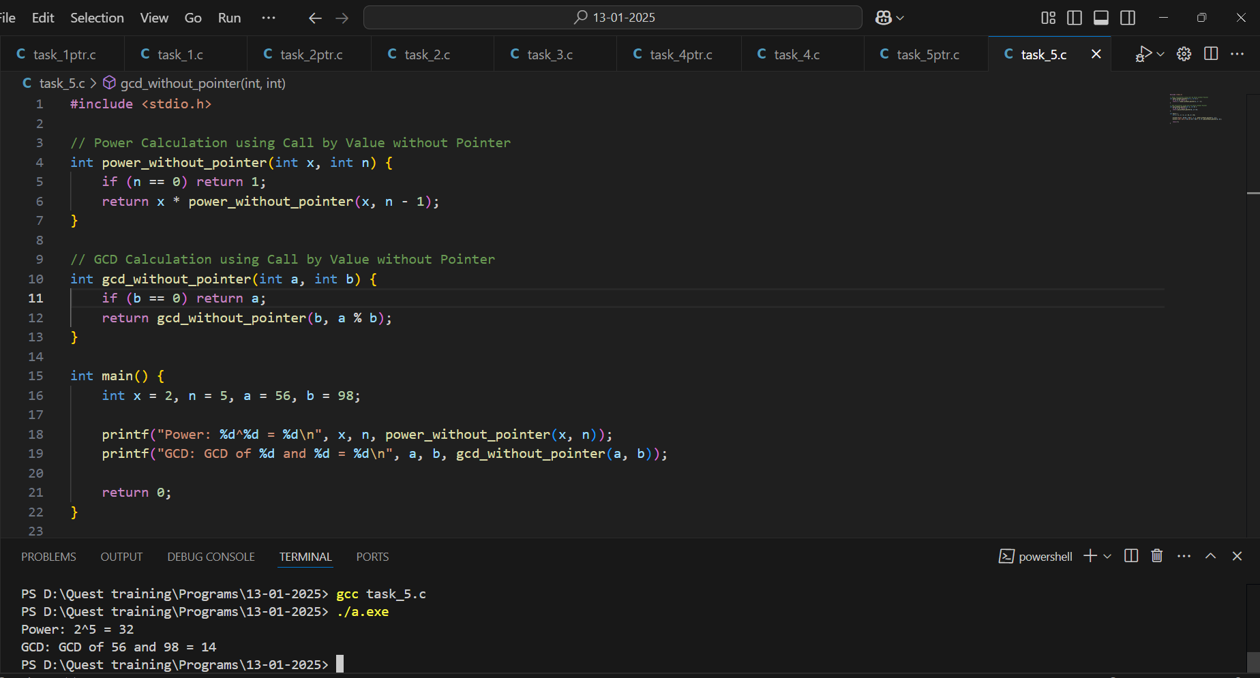

6. **Count Occurrences of a Character: Develop a recursive function to count the number of times a specific character appears in a string.**

**Pointer:**

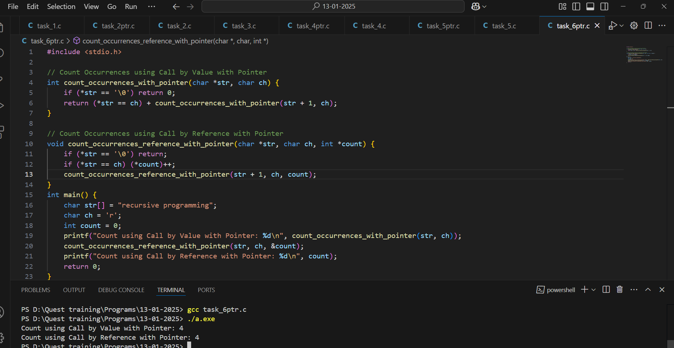

**Without Pointer:**

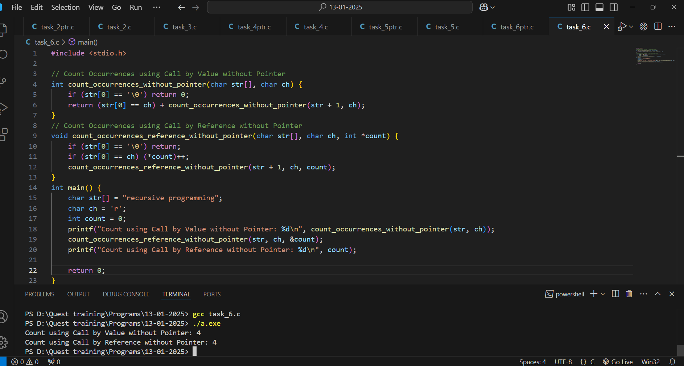

**7. Palindrome Check: Create a recursive function to check if a given string is a palindrome.**

**Pointer:**

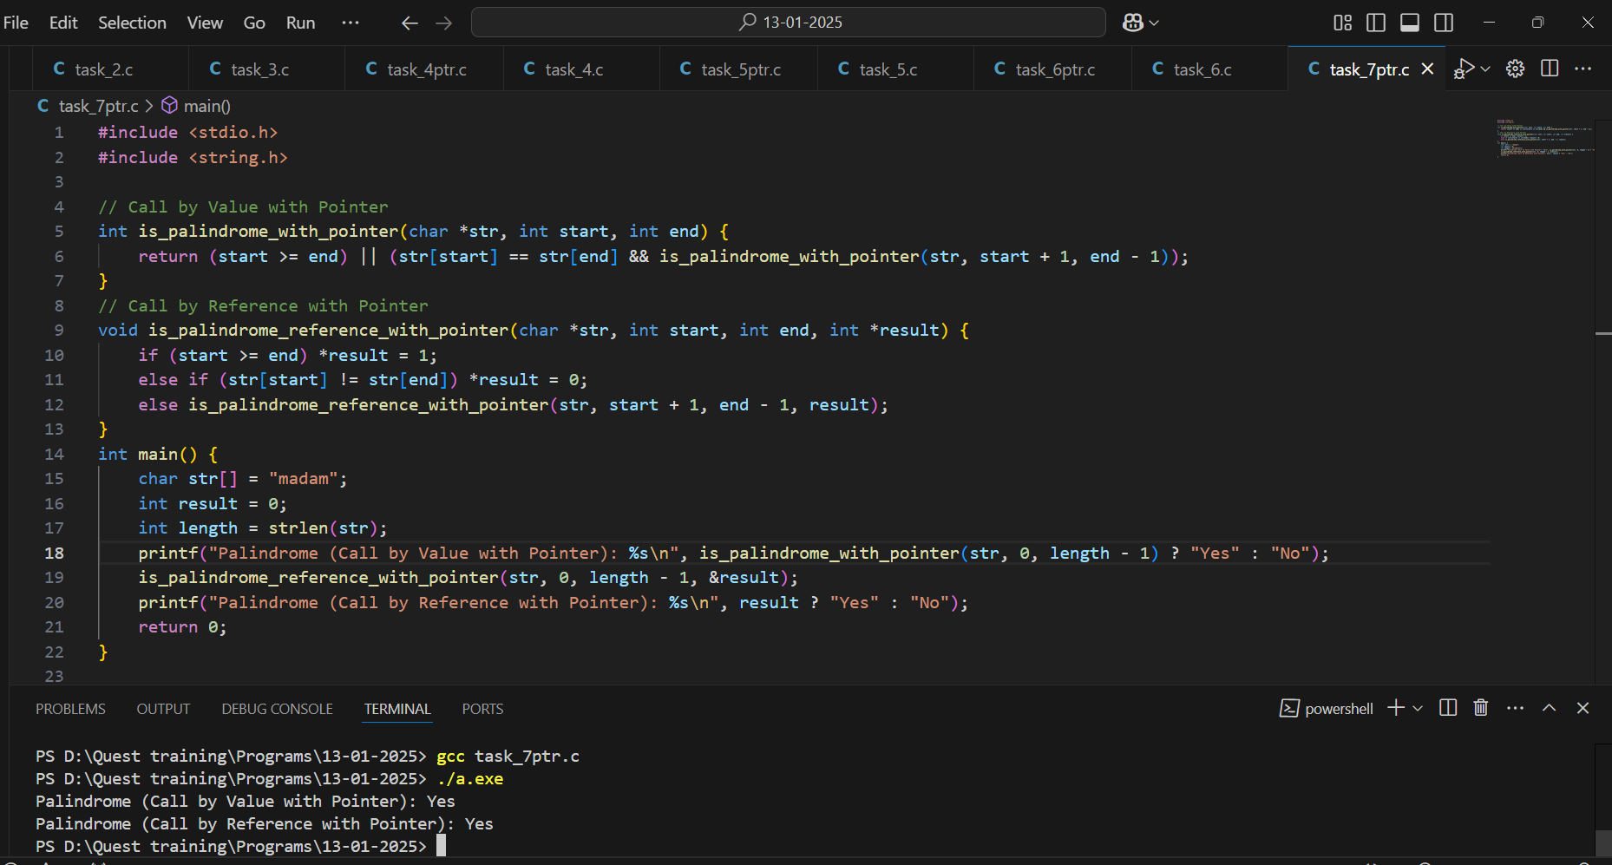

**Without Pointer:**

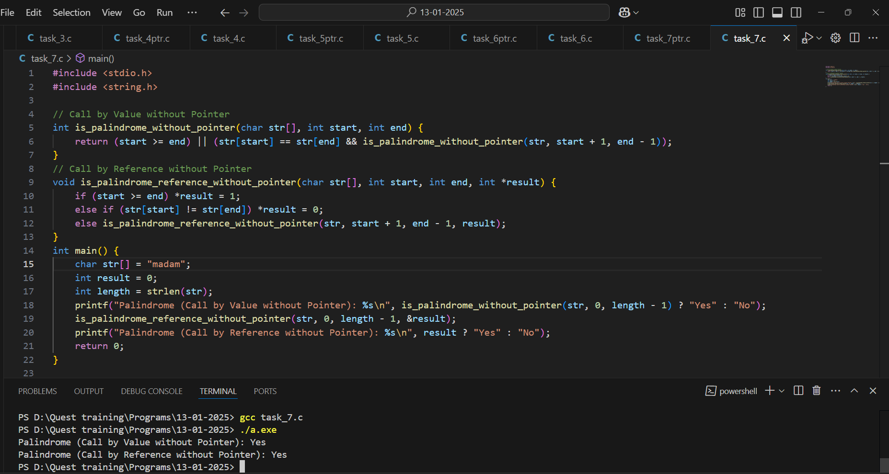

8. **String Length: Write a recursive function to calculate the length of a given string without using any library functions.**

**Pointer:**

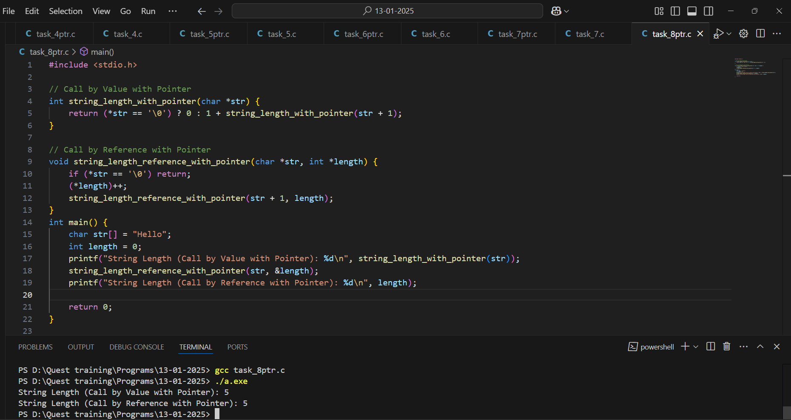

**Without Pointer:**

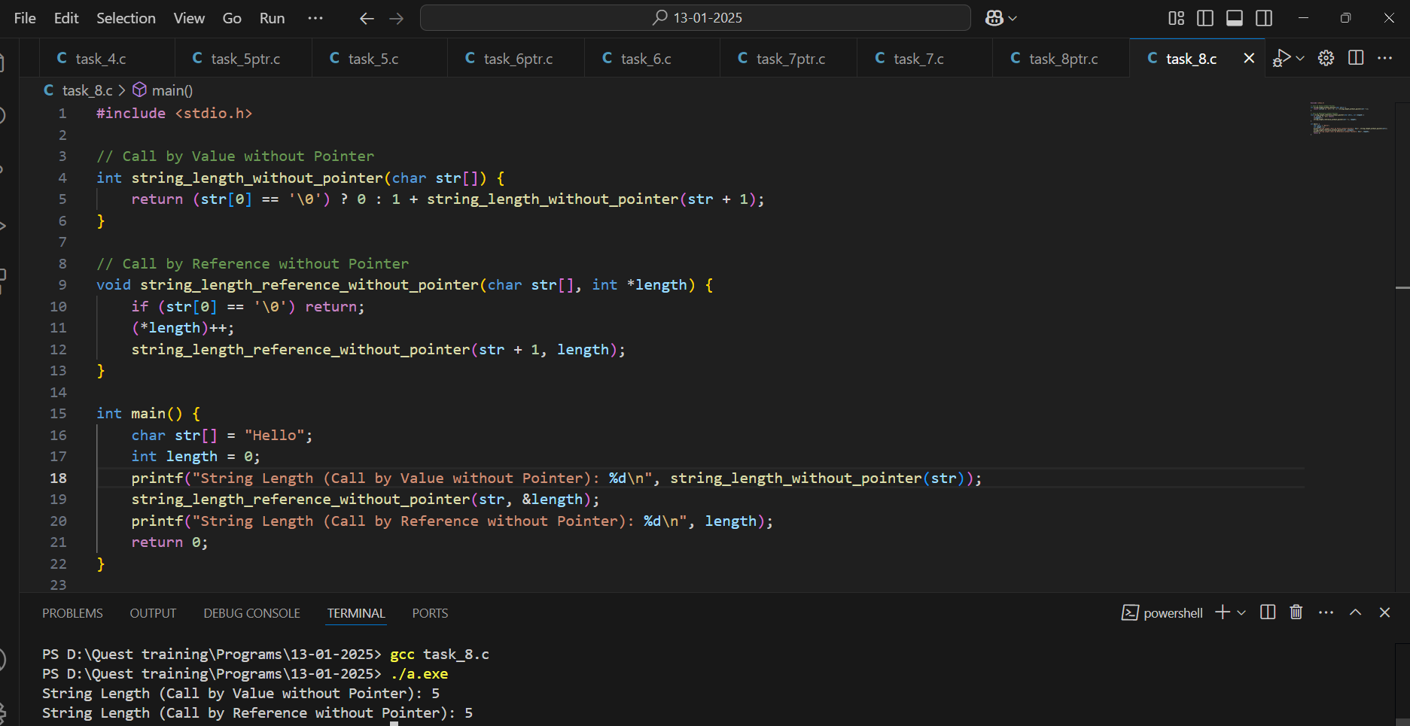

9. **Check for Prime Number: Implement a recursive function to check if a given number is a prime number.**

**Pointer:**

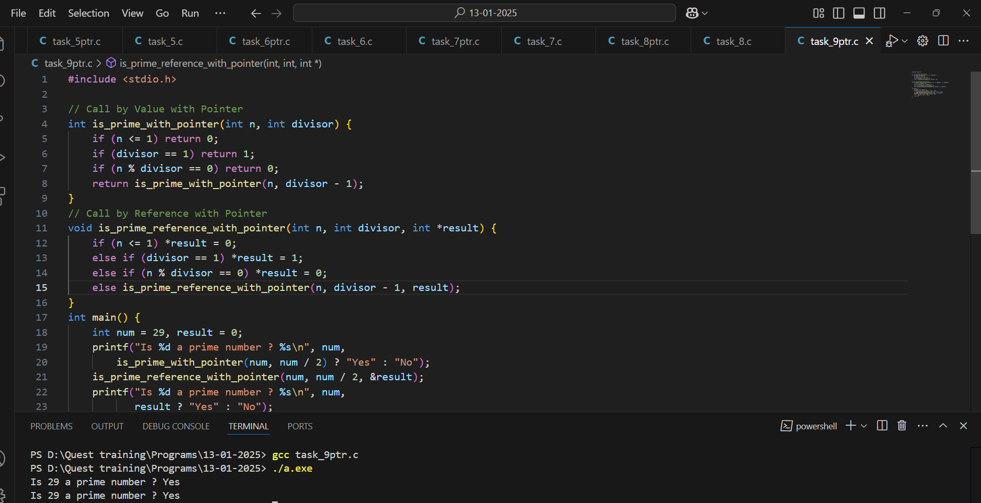

**Without Pointer:**

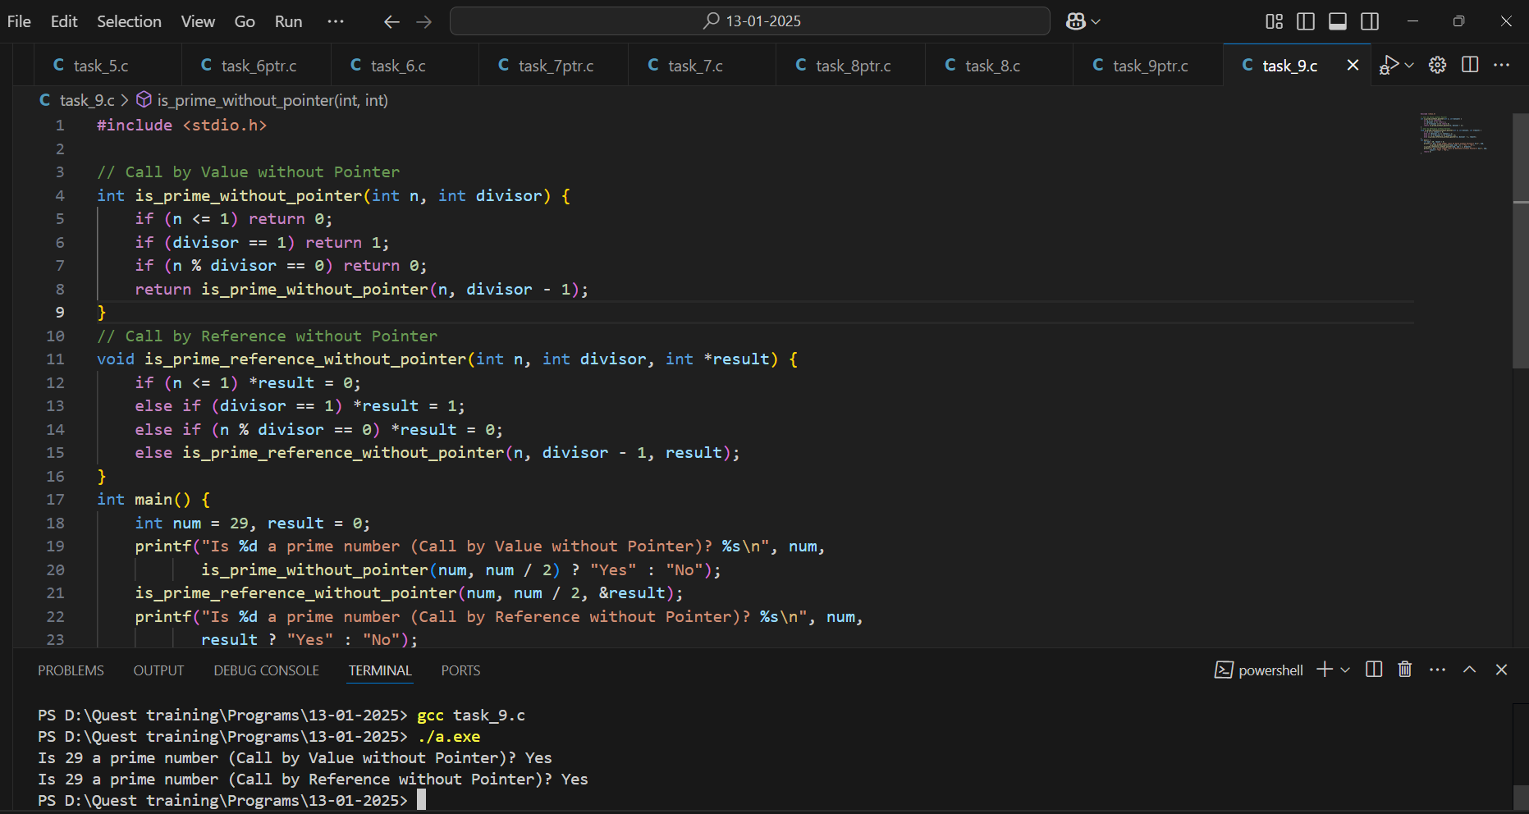

**10. Print Numbers in Reverse: Create a recursive function to print the numbers from n down to 1 in reverse order.**

**Pointer:**

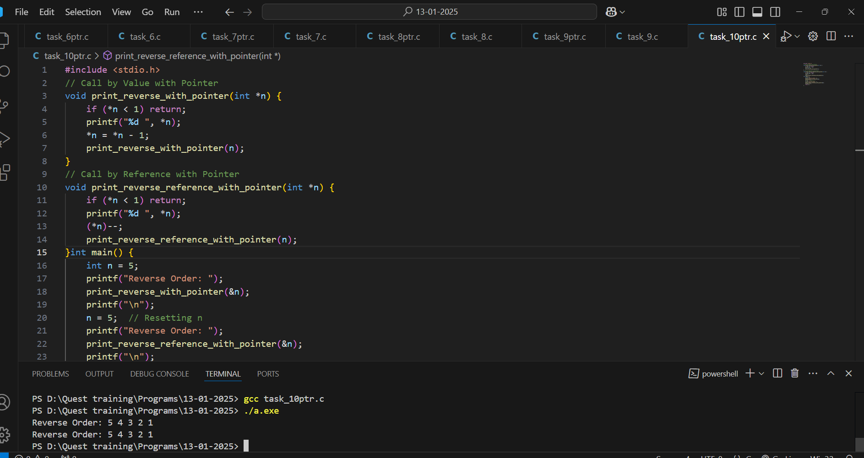

**Without Pointer:**

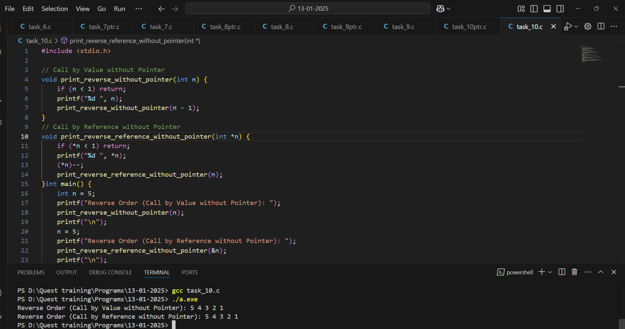

11. **Array Sum: Write a recursive function to find the sum of all elements in an array of integers.**

**Pointer:**

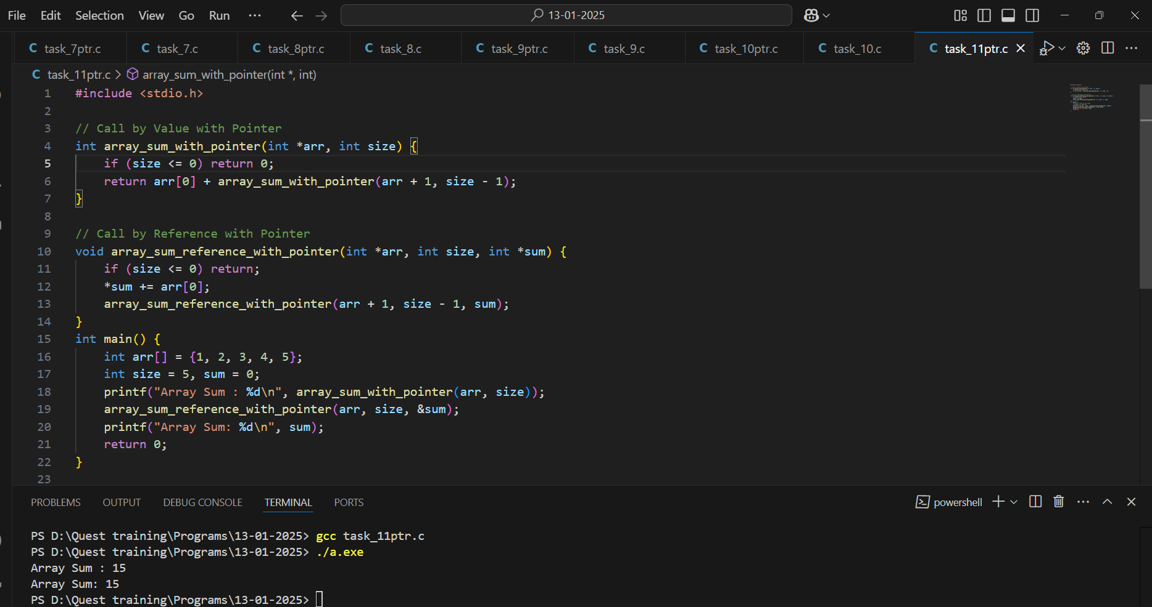

**Without Pointer:**

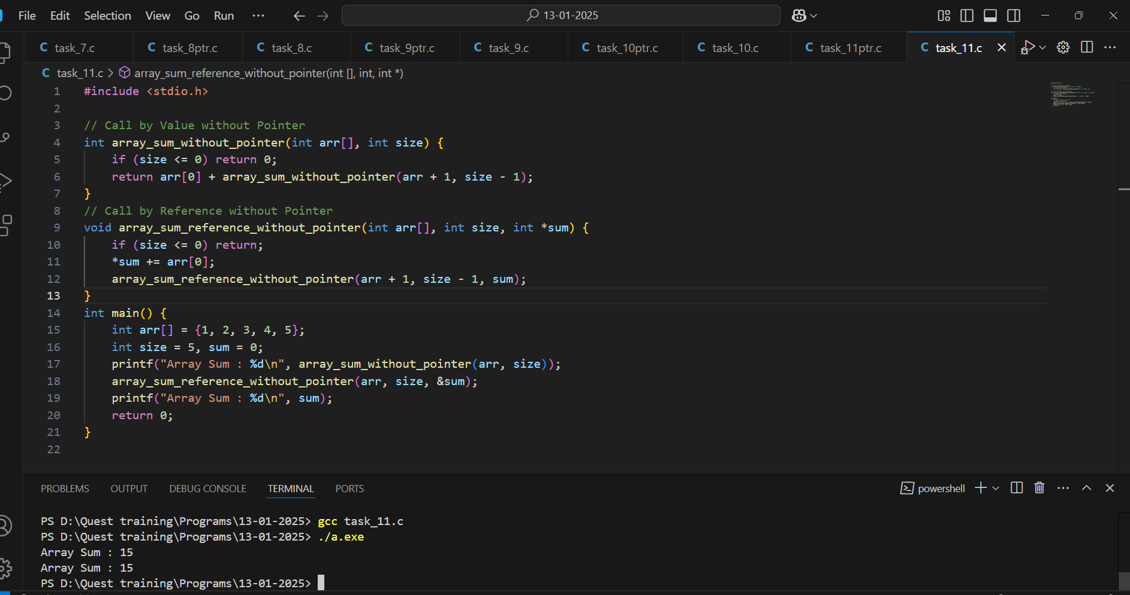

12. **Permutations of a String: Develop a recursive function to generate all possible permutations of a given string.**

**Pointer:**

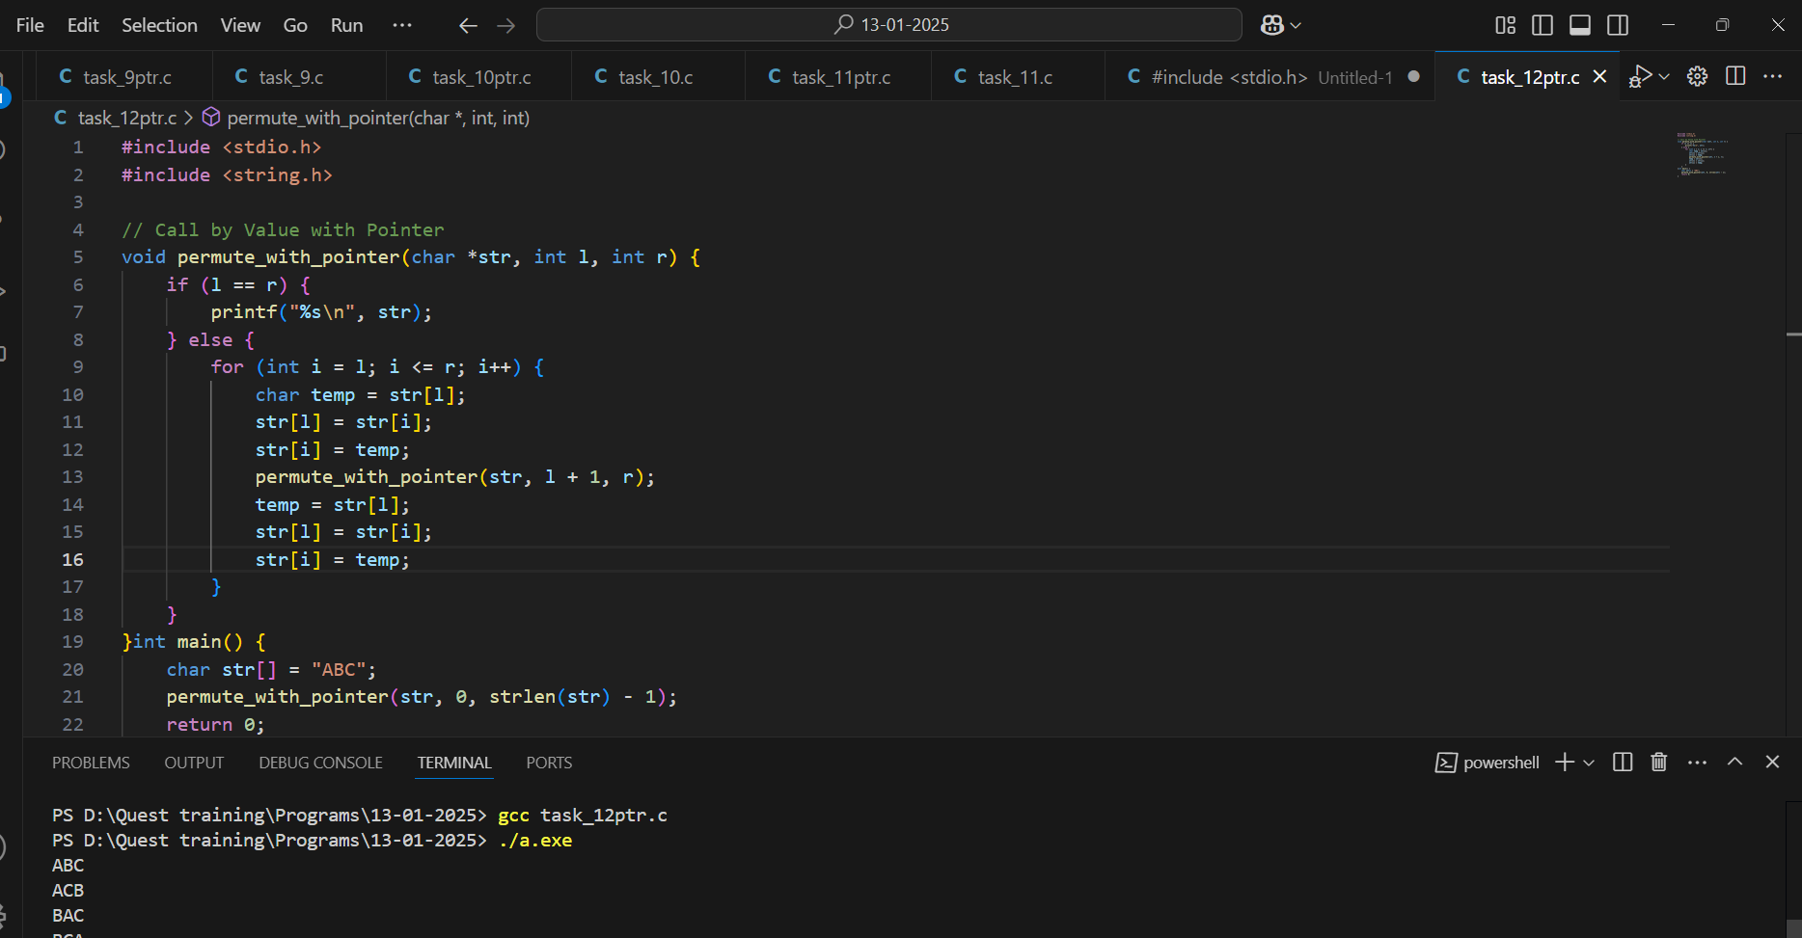

**Without Pointer:**

