1. Write a program to check if two integers provided by the user are equal or not. 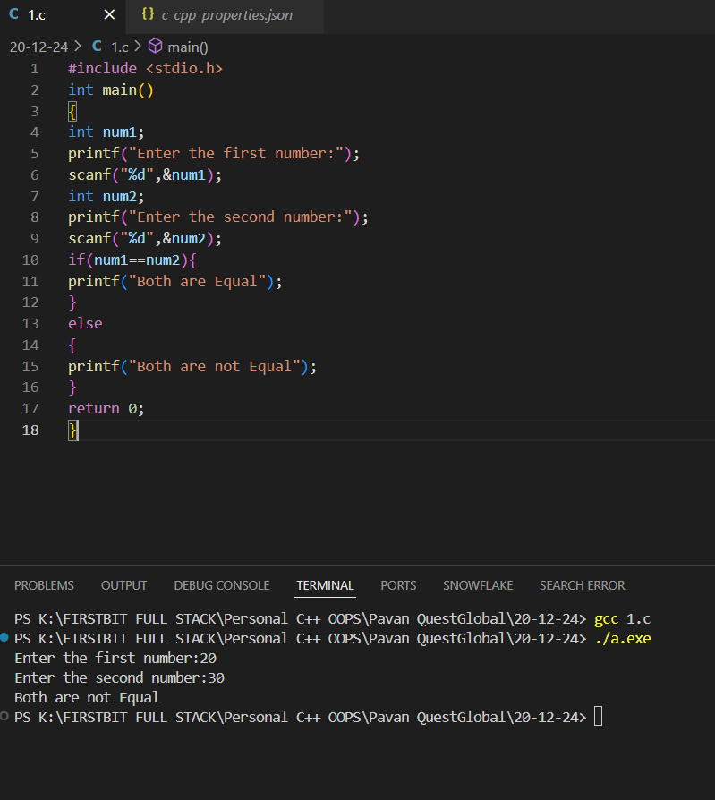
2. Write a program to determine which of two numbers is greater using relational operators.

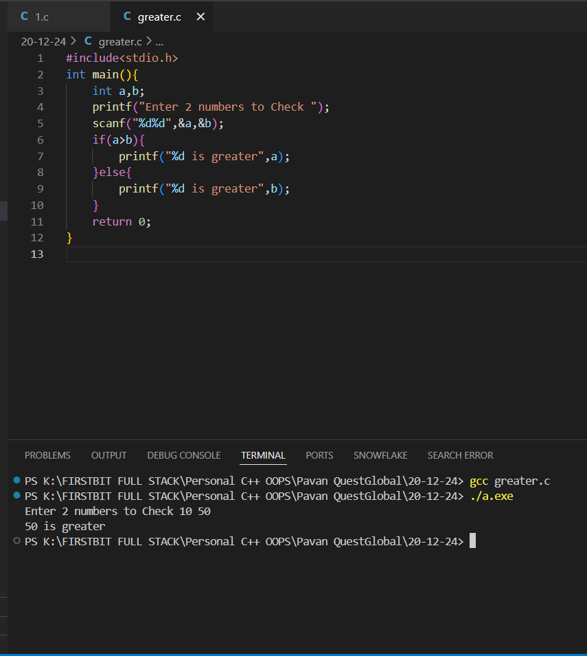

1. Use relational operators to check if a given number is positive (greater than 0).

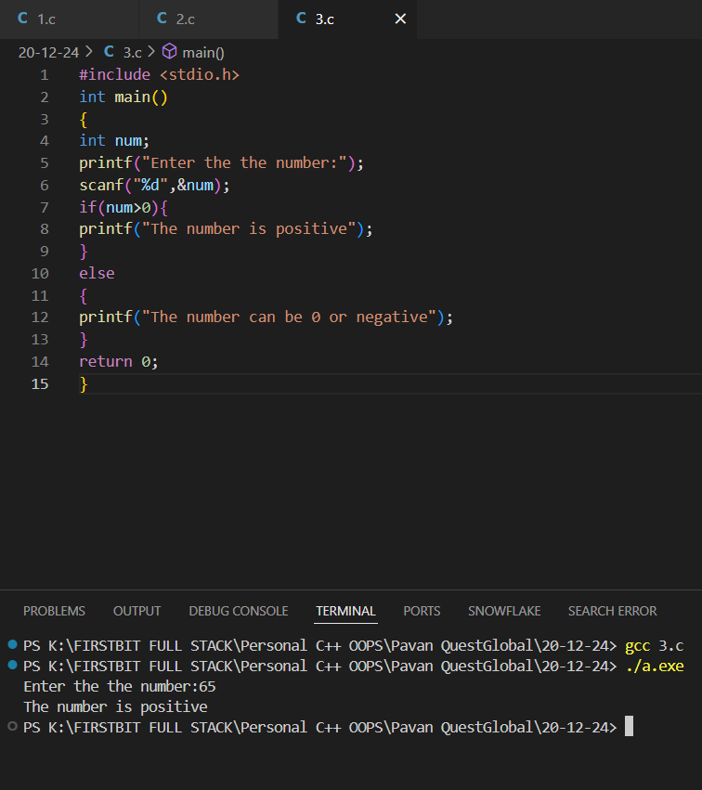

1. Write a program to verify if the given length and breadth of a rectangle satisfy the condition of a valid rectangle (length > 0 and breadth > 0).

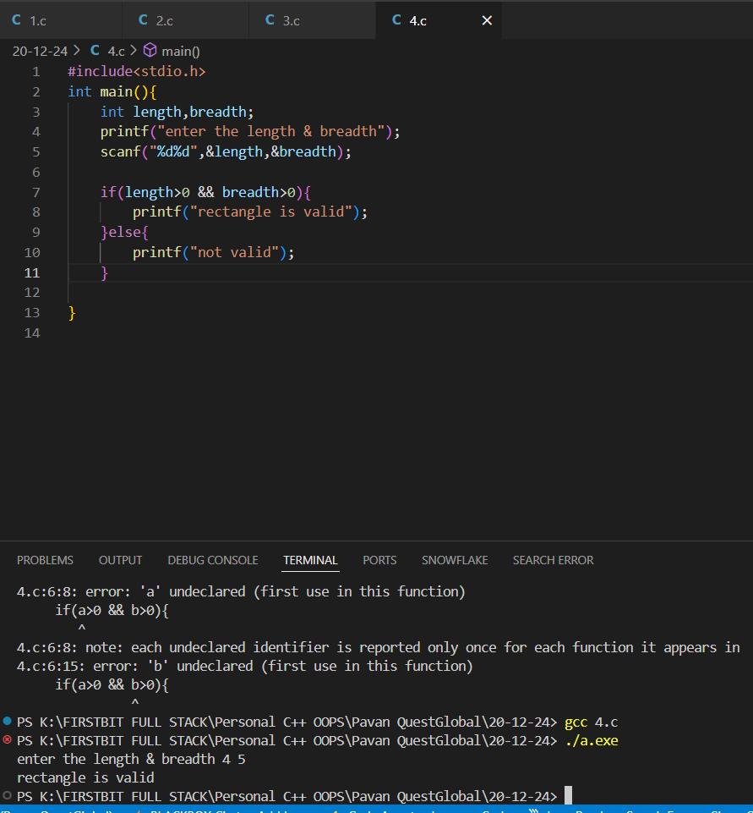

1. Given a student's marks in a subject, determine if the student has passed (marks >= 40).

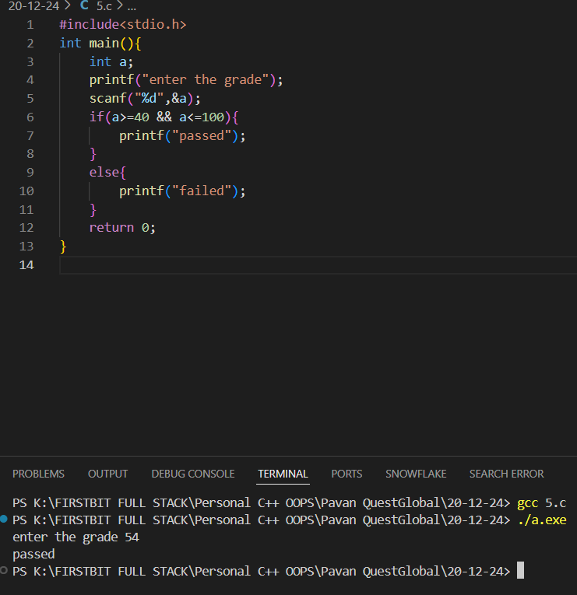

1. Use relational operators to check if a given number lies between 10 and 50 (inclusive).

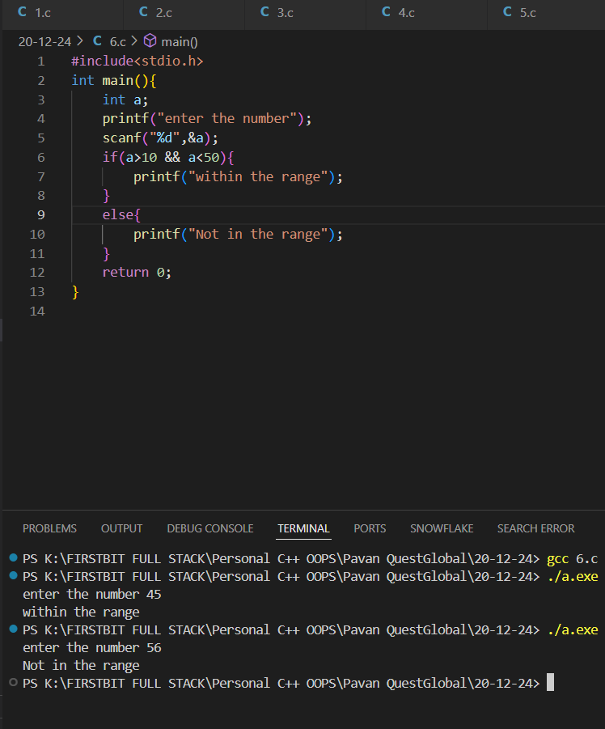

1. Write a program to check if a given character is a lowercase English letter (between 'a' and 'z'). 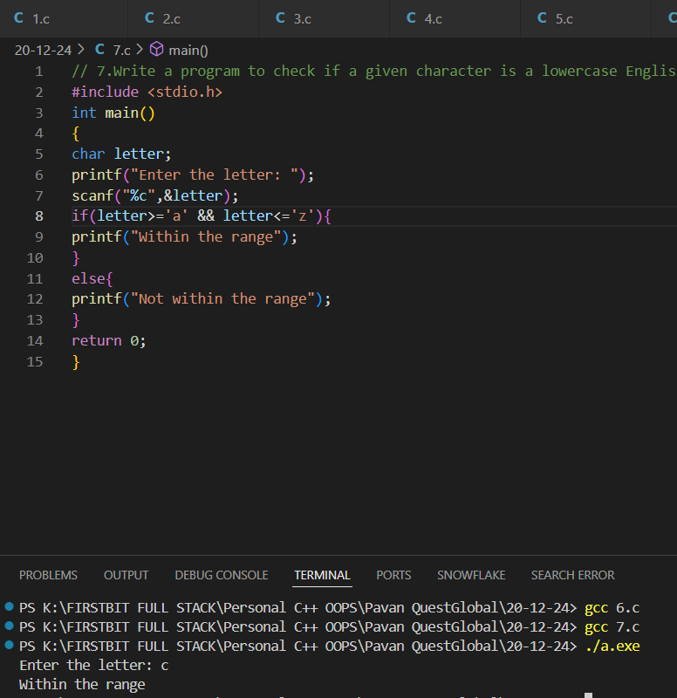
2. Compare the ages of two people and determine who is older or if both are of the same age.

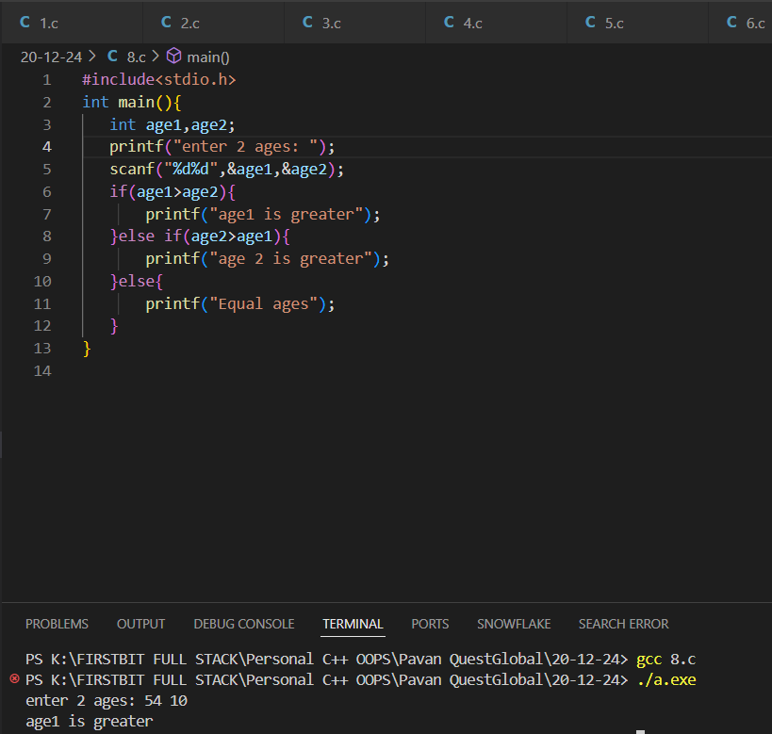

1. Write a program to determine if the weight of an object exceeds the specified maximum limit (e.g., 50 kg).

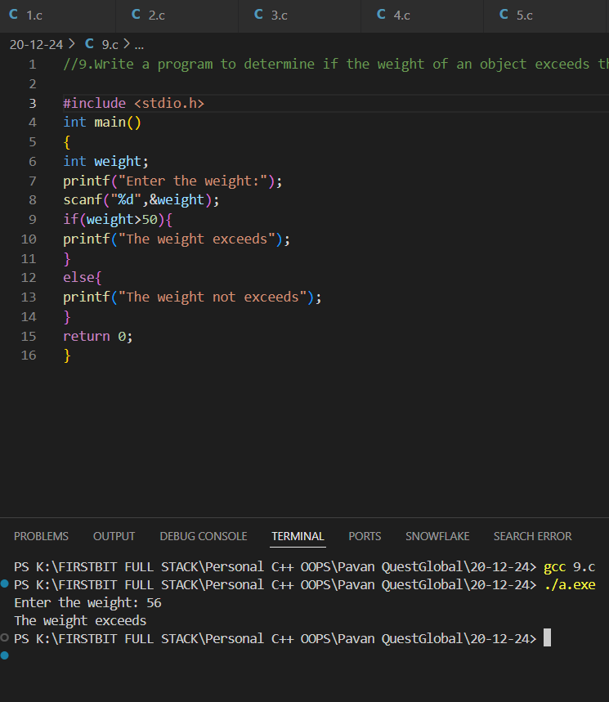

1. Compare the areas of two rectangles given their lengths and breadths and determine which rectangle has a larger area.

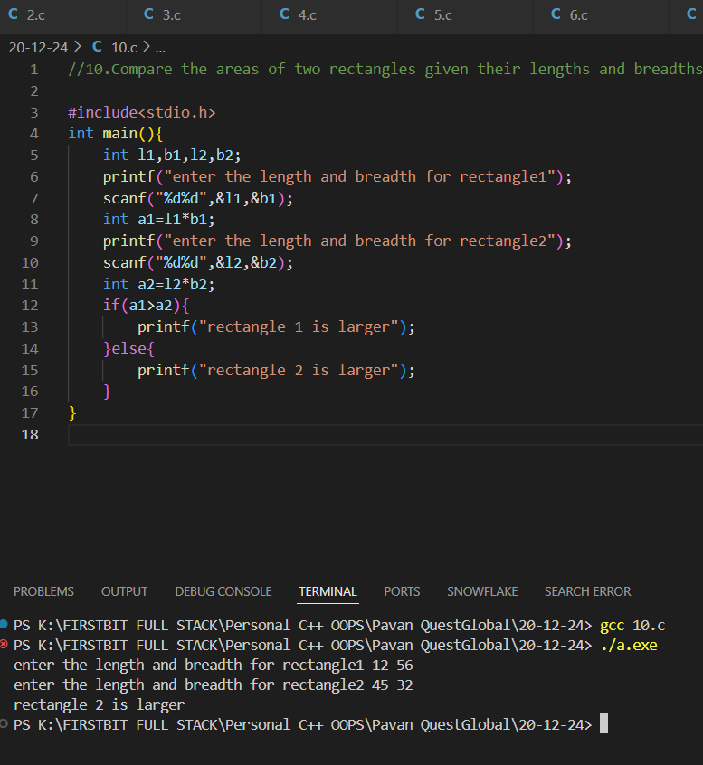

Bitwise Operators

1. Write a program to compute the result of the bitwise AND operation between two integers provided by the user.

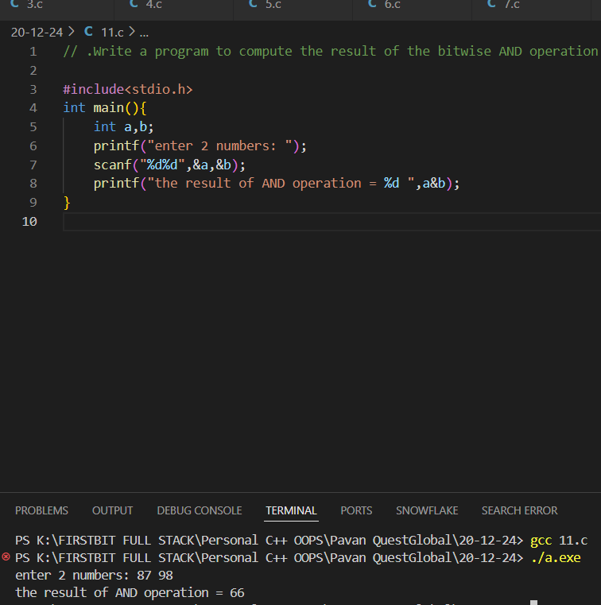

1. Write a program to compute the result of the bitwise OR operation between two integers provided by the user.

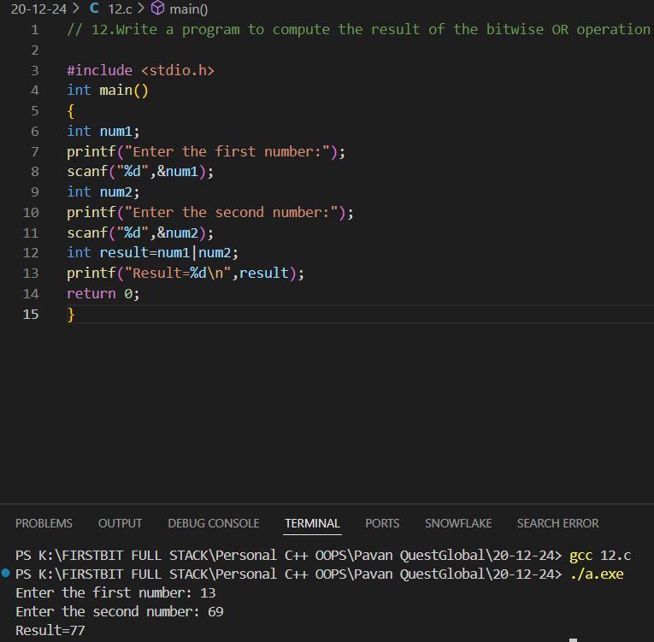

1. Write a program to compute the result of the bitwise XOR operation between two integers provided by the user.

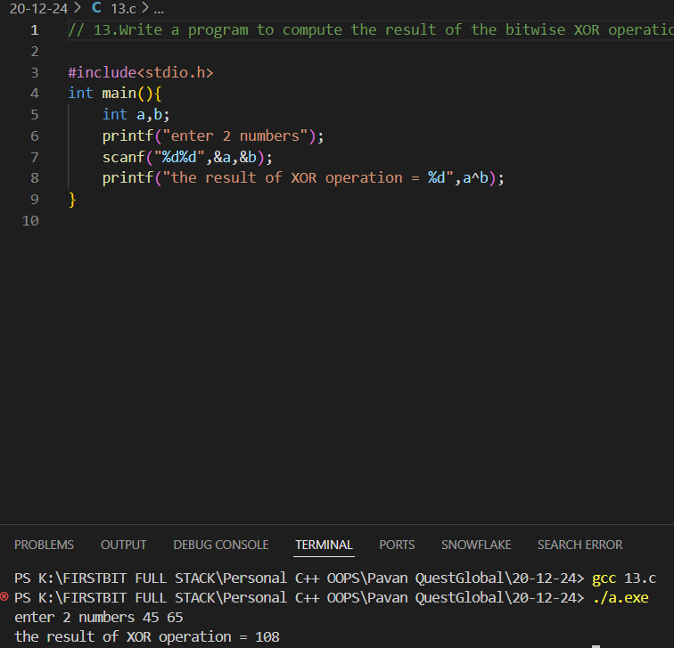

1. Write a program to find the bitwise complement of a given integer and print the result.

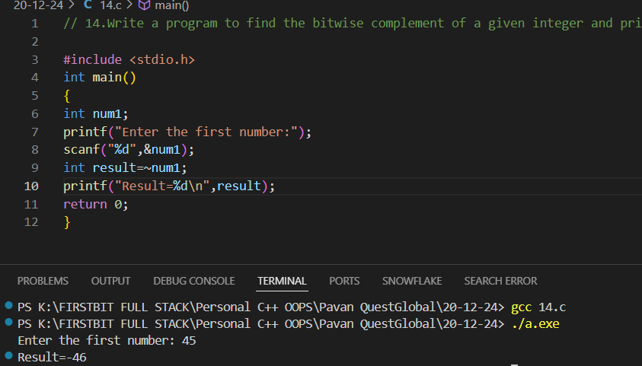

1. Given an integer n and a position p, write a program to toggle the bit at position p using the XOR operator

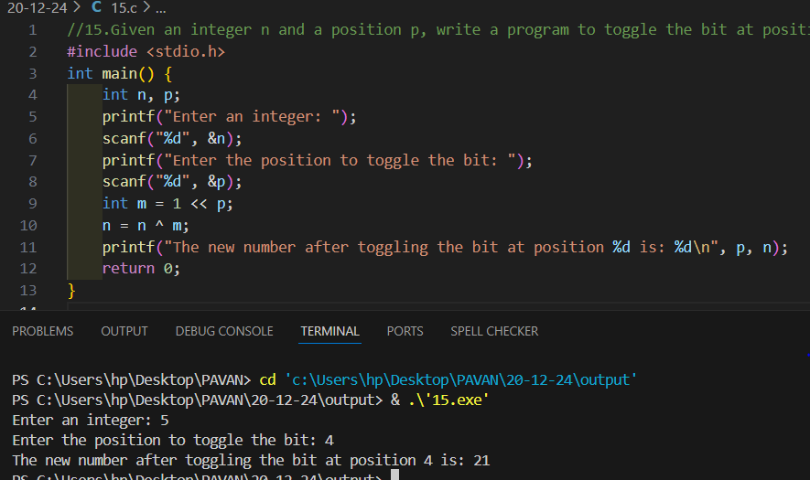

1. Write a program to set the bit at a given position p in an integer n to 1 using the OR operator.

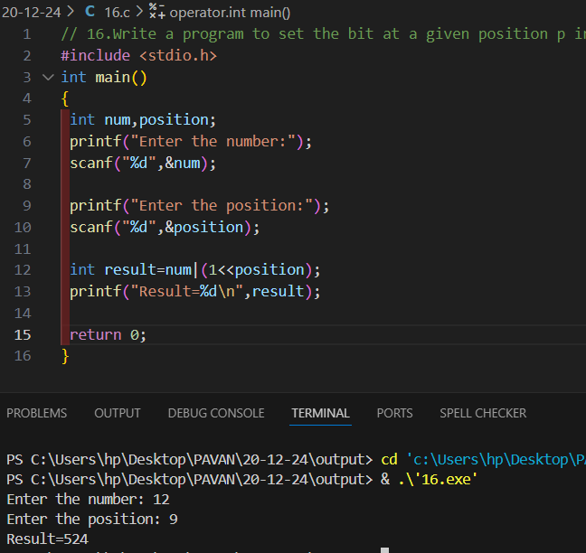

1. Write a program to clear (set to 0) the bit at a given position p in an integer n using the AND and NOT operators.

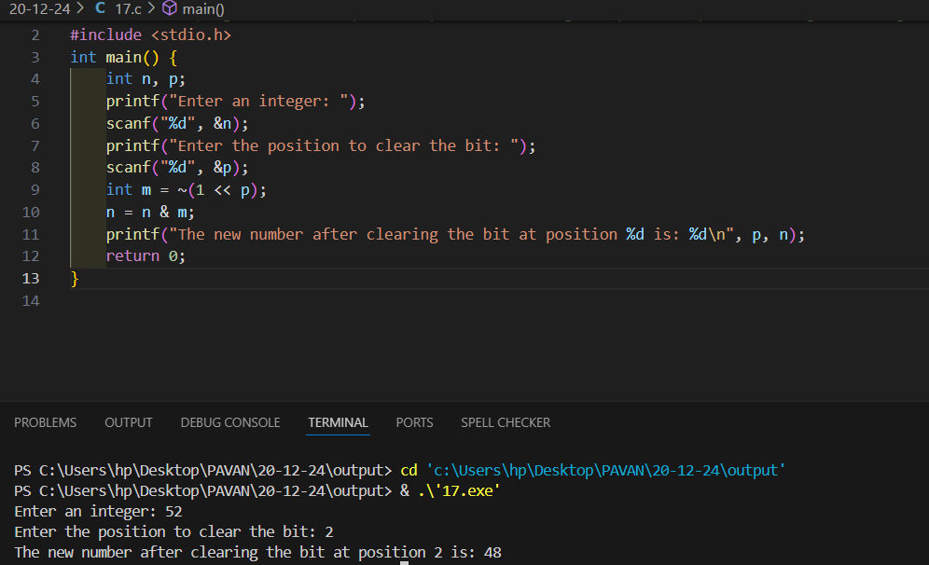

1. Write a program to check if a given integer is both a multiple of 5 (arithmetic operator) and greater than 50 (relational operator). Additionally, verify if its binary representation has its least significant bit set (bitwise AND operation).

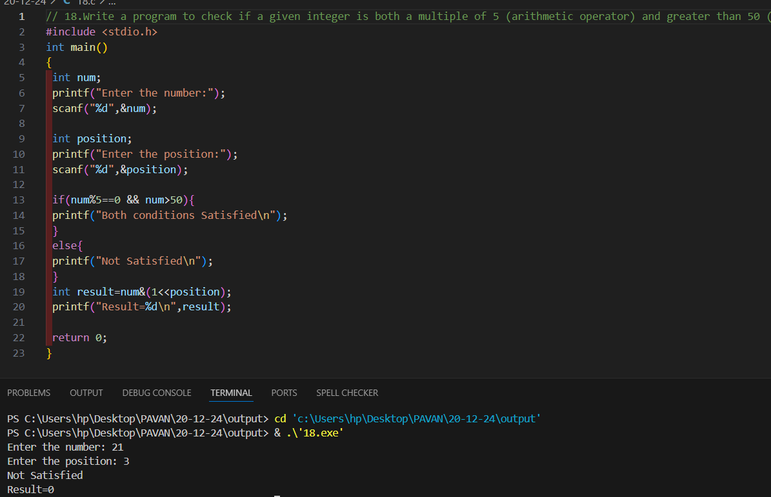

1. Given an integer n and a bit position p: Use bit masking and bitwise XOR to toggle the bit at position p. After toggling, check if the updated number is positive (arithmetic and relational operators) and divisible by 2 (logical operators).

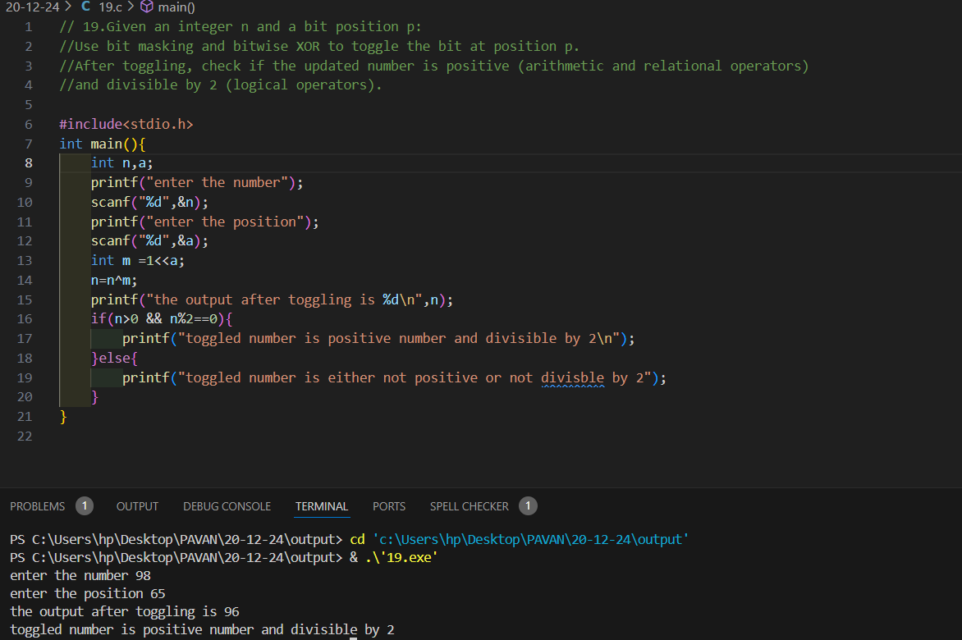

1. A person can vote if: Their age is greater than or equal to 18 (relational operator). They are a registered citizen, represented by a specific bit set in their ID number (bit masking and bitwise AND). Write a program to verify these conditions using logical operators.

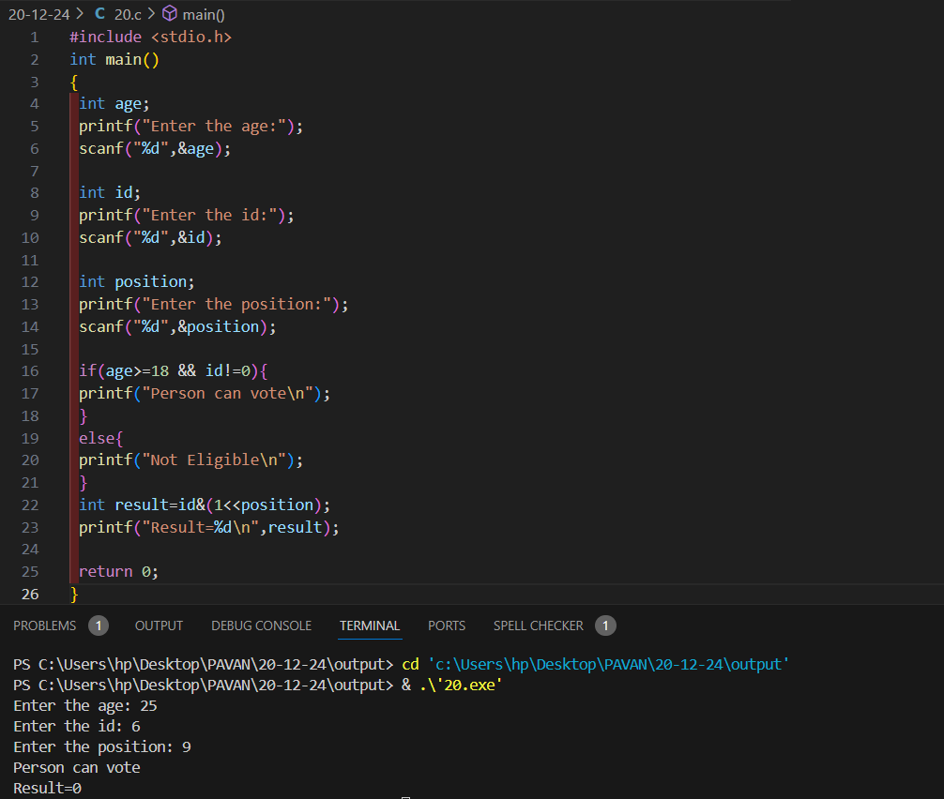

1. Write a program to: Use bit masking and bitwise OR to set a specific bit in a number. Use bitwise AND and NOT to clear another specific bit. Check if the resulting number is odd (arithmetic and relational operators) and lies within a range (logical operators).

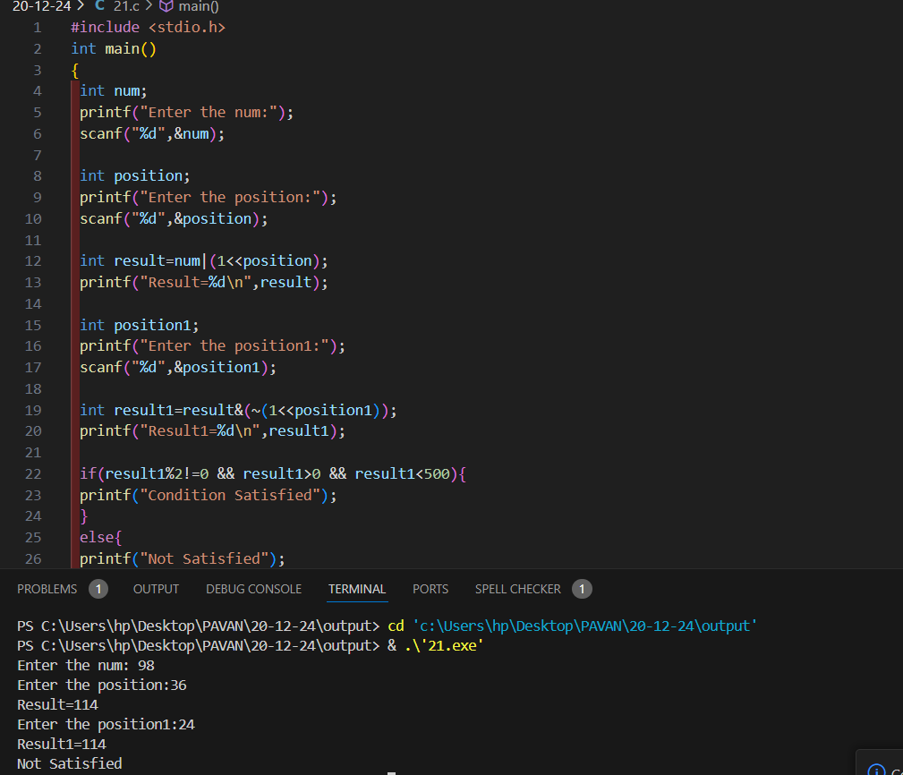

1. Given two integers a and b, perform the following: Compute their sum and product (arithmetic operators). Verify if the sum is greater than 100 and the product is divisible by 4 (relational and logical operators). Check if the binary representation of a has its second bit set (bitwise AND with a mask).

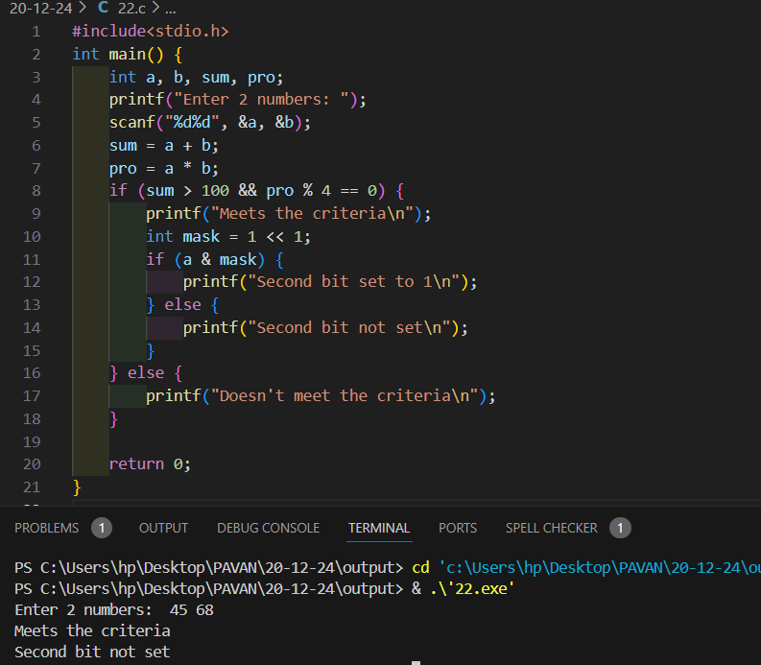

----------------------------------Control Statements---------------

----------------------------------- if Statement---------

1. Write a program to check if a number entered by the user is positive using an if statement.

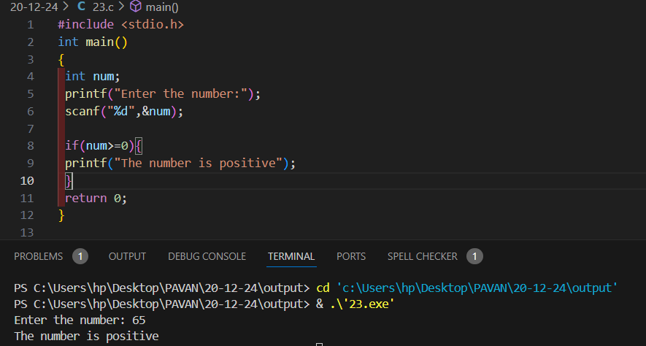

1. Write a program to check if a number is divisible by 3 using an if statement

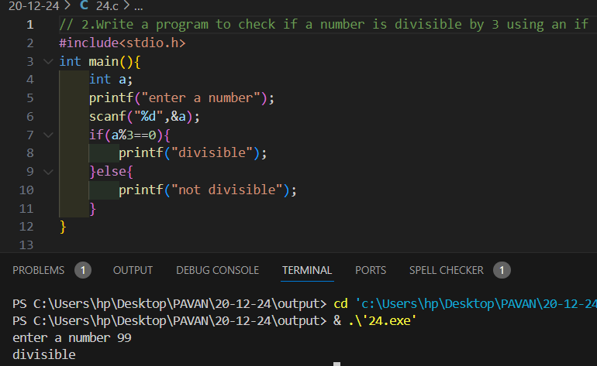

1. Write a program to determine if a number is odd or even using an if-else statement.

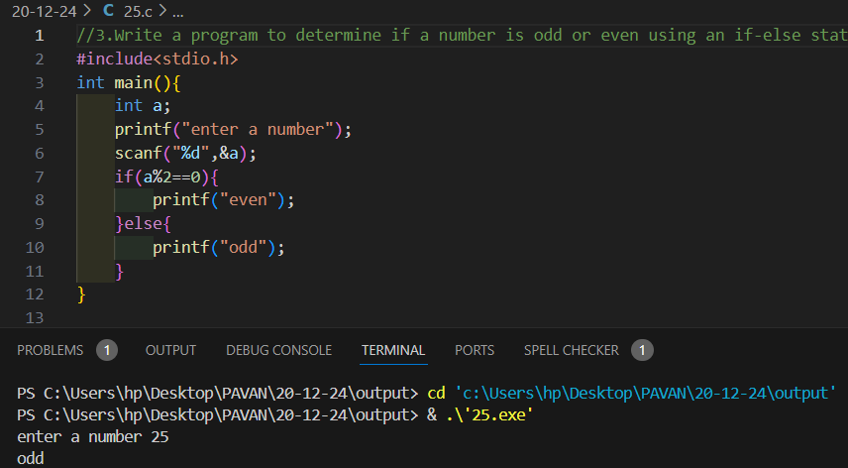

1. Write a program to check if a student has passed an exam based on their marks (pass marks are 40). If the marks are below 40, display "Fail."

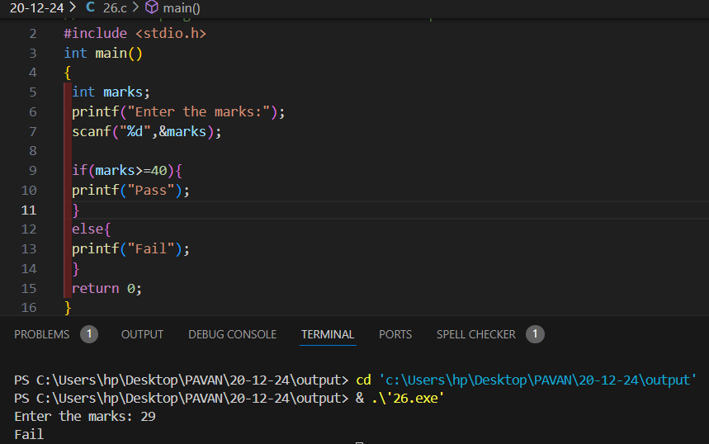

------------------------------Nested-if-else statement -------------------------

1. Given the lengths of three sides, write a program to determine if the triangle is valid using nested if-else. If valid, check if it is an equilateral triangle

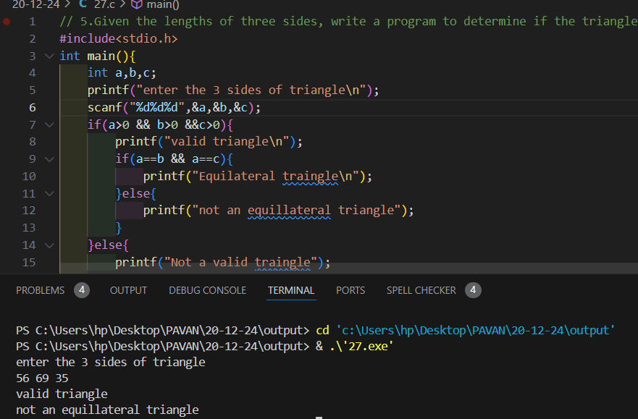

1. Write a program to check if a student is eligible for admission based on the following criteria: Marks in mathematics >= 50 Marks in physics >= 50 Total marks (math + physics) >= 120 Use nested if-else statements.

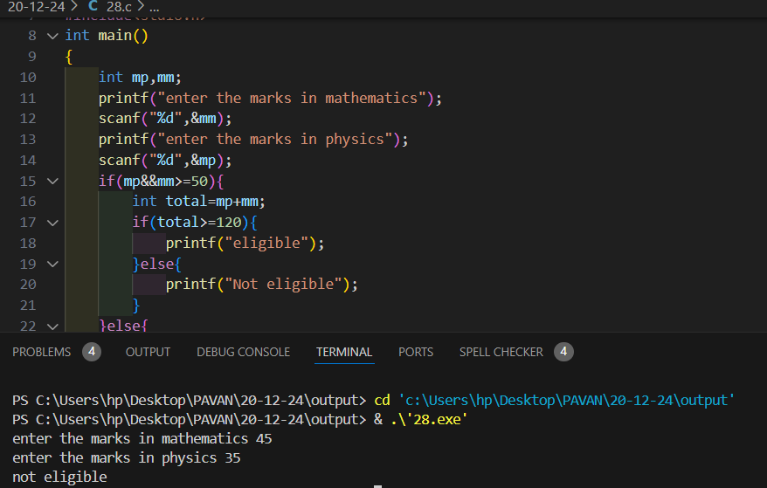

1. Write a program to calculate and print the grade of a student based on their percentage using an if-else-if ladder: = 90: Grade A = 75: Grade B = 50: Grade C < 50: Fail

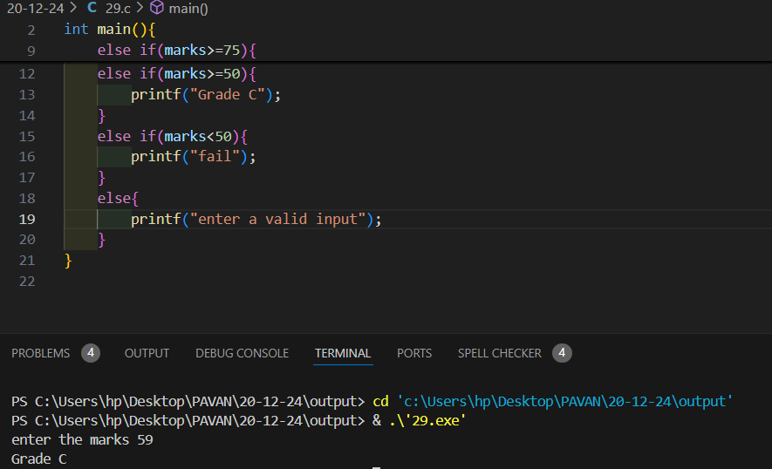

1. Write a program to classify an integer as positive, negative, or zero using an if-else-if ladder.

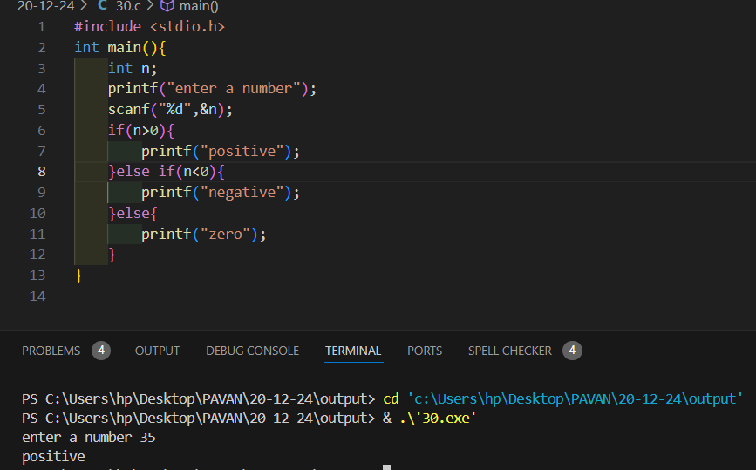

1. Write a program to calculate the electricity bill based on the number of units consumed using the following criteria: Units <= 100: ₹5 per unit Units > 100 and <= 200: ₹7 per unit Units > 200: ₹10 per unit Use an if-else-if ladder to implement this

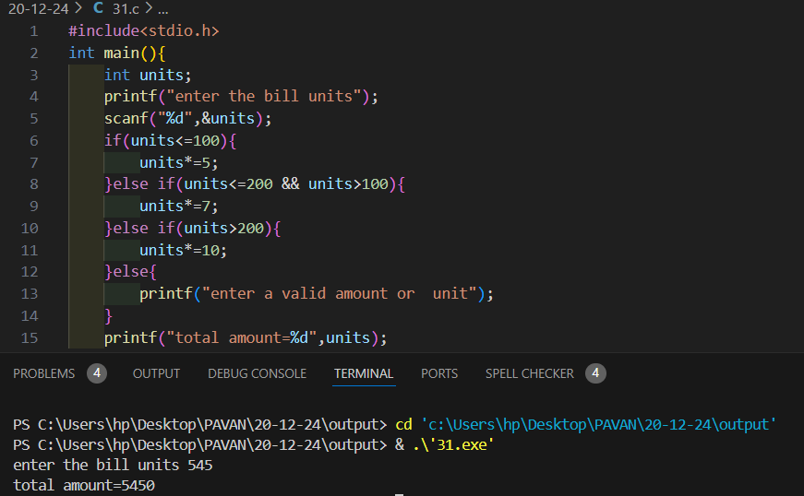

1. Write a program to print the name of the day of the week based on a number entered by the user (1 for Monday, 2 for Tuesday, ..., 7 for Sunday) using an if-else-if ladder.

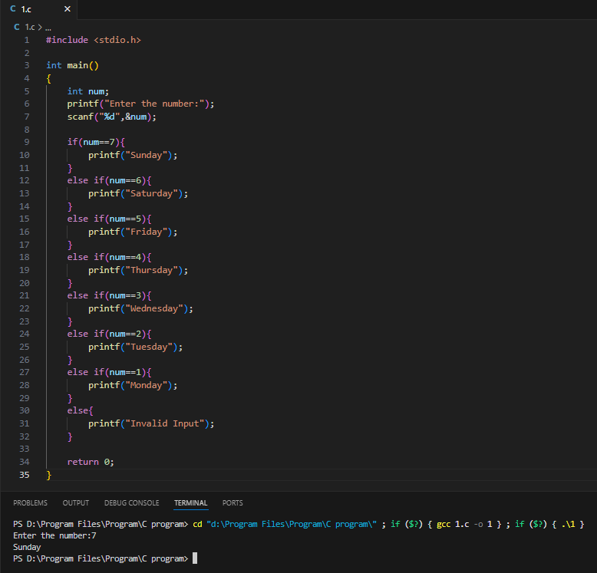

1. Write a program that takes an integer (1-7) as input and uses a switch-case to print the corresponding day of the week (e.g., 1 for Monday, 2 for Tuesday, etc.).

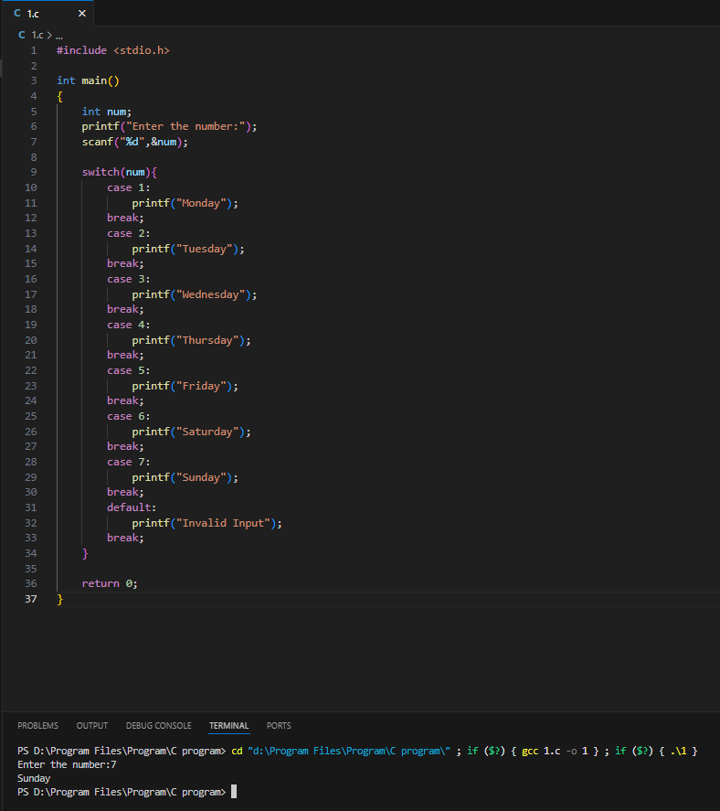

1. Write a program to perform basic arithmetic operations (addition, subtraction, multiplication, division) based on the operator input (+, -, \*, /) using a switch-case statement.

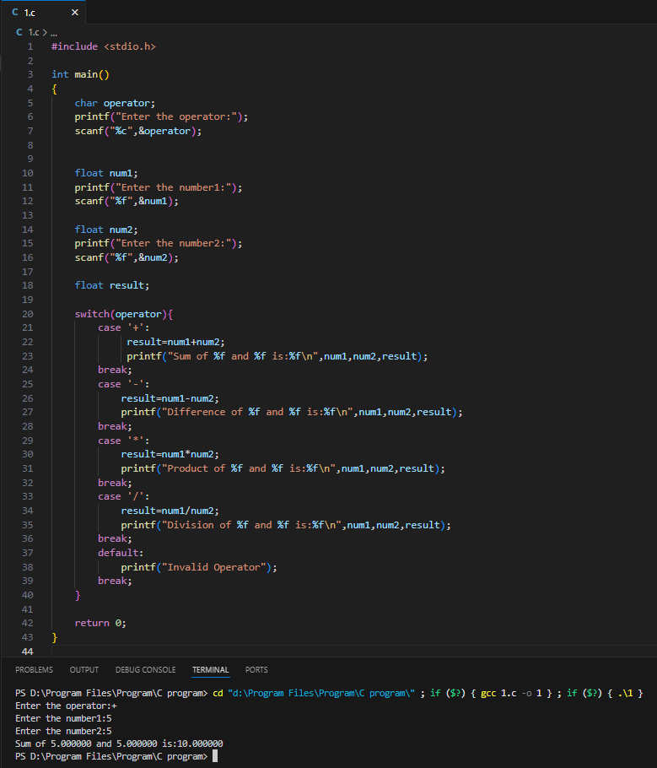

1. Write a program that takes a single character as input and uses a switch-case to determine if it is a vowel or a consonant.

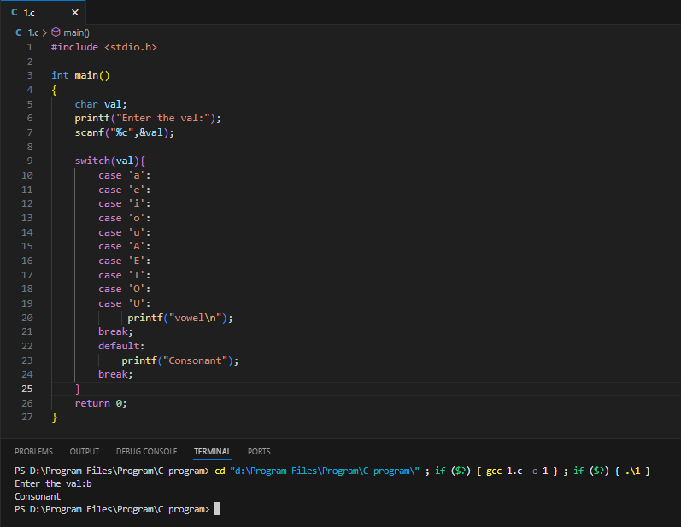

1. Write a program to convert a single-digit number (0-9) into its word representation (e.g., 1 to "One", 2 to "Two") using a switch-case statement.

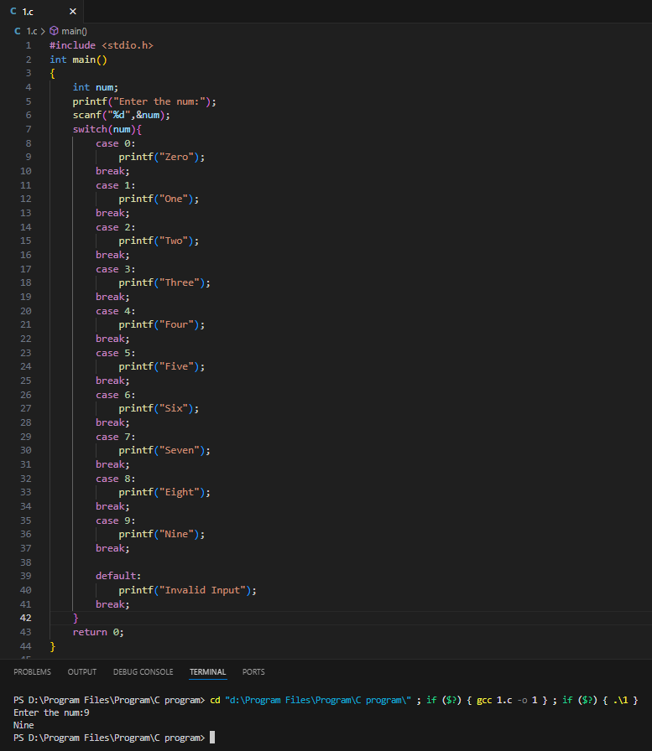

1. Write a program that takes an integer (1-12) as input and uses a switch-case to print the name of the corresponding month (e.g., 1 for January, 2 for February, etc.).

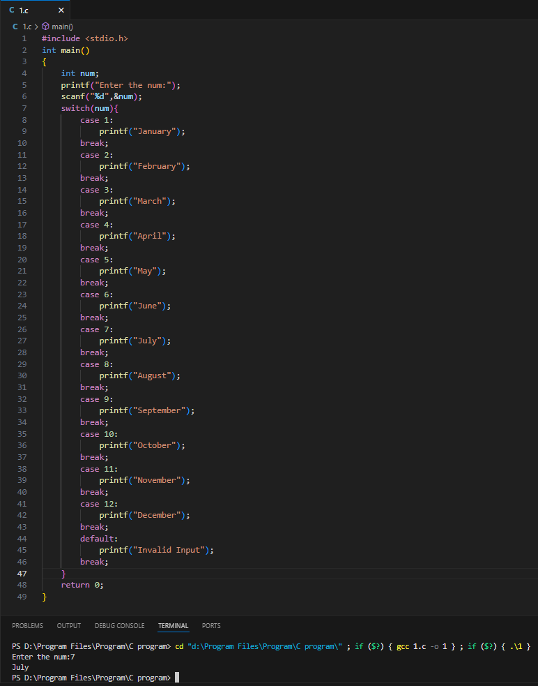

1. Write a program that takes a grade (A, B, C, D, F) as input and uses a switch-case to print the description of the grade (e.g., A: "Excellent", B: "Good", etc.).

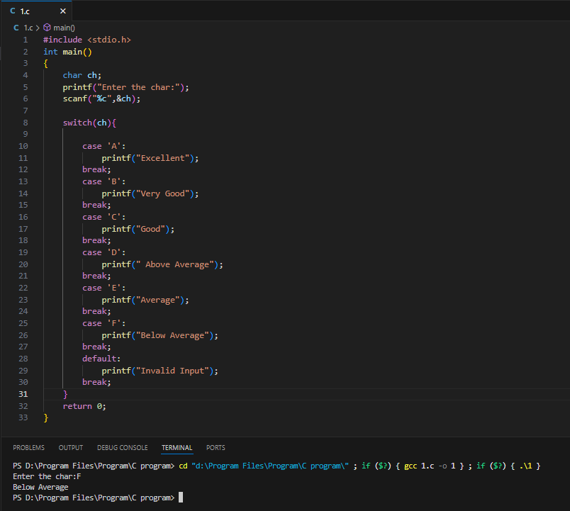

1. Write a menu-driven program that offers the user options for basic mathematical operations (addition, subtraction, etc.). Based on the user’s choice, perform the corresponding operation using a switch-case.

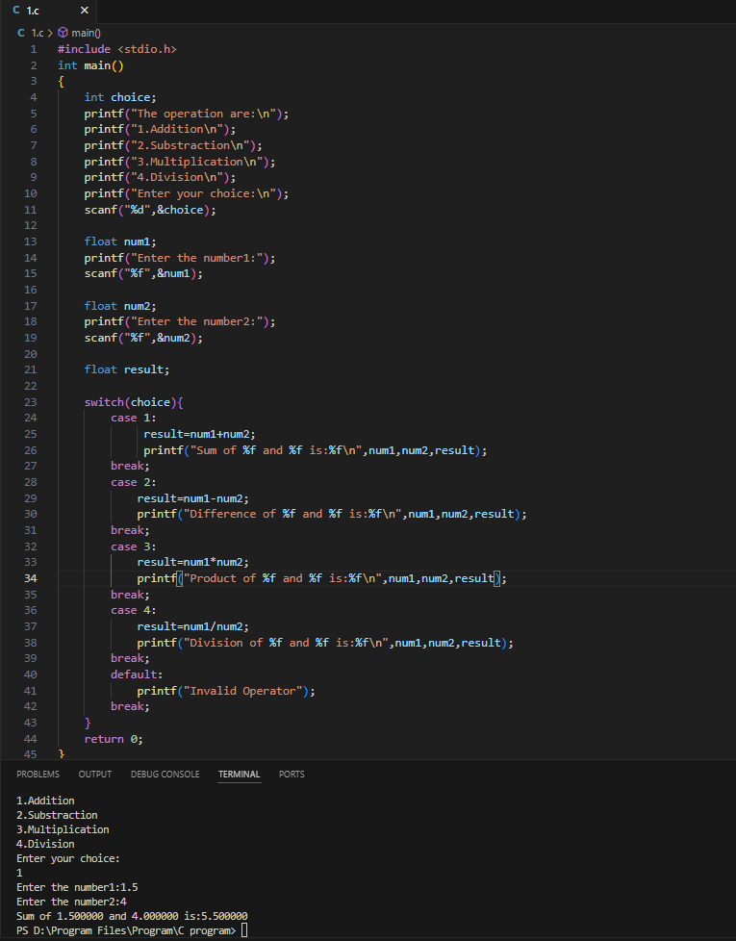

1. Write a program to simulate a traffic light system. Take input as R, Y, or G (Red, Yellow, Green) and use a switch-case to display the corresponding action (e.g., R for Stop, Y for Get Ready, G for Go).

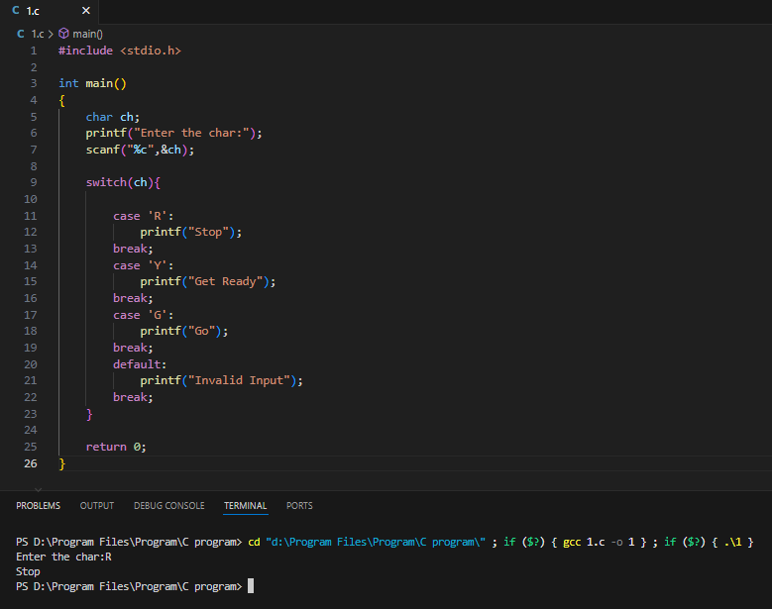

1. Write a program that takes the year as input and uses a switch-case to check and print whether it is a leap year or not (use logical division by 4 and additional logic in cases).

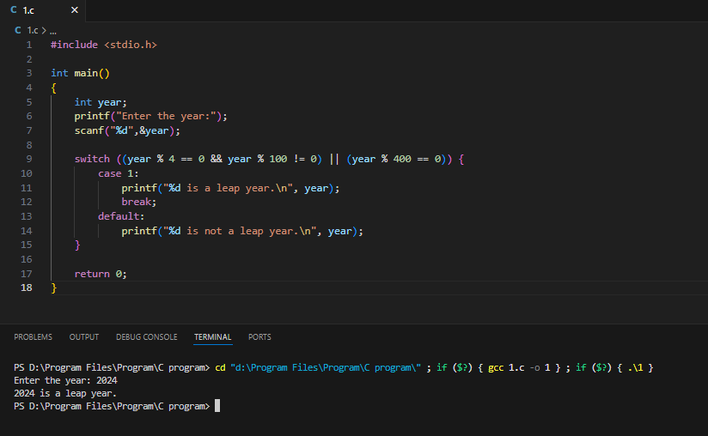

1. Write a program to calculate the area of different shapes based on user input:

1 for Circle

2 for Rectangle

3 for Triangle Use a switch-case to perform the respective area calculations.

