**24-12-2024**

**1.Basic Global and Local Variable Usage- Problem Statement**: Write a program that declares a global variable and a local variable with the same name. Modify and print both variables to demonstrate their scope and accessibility.

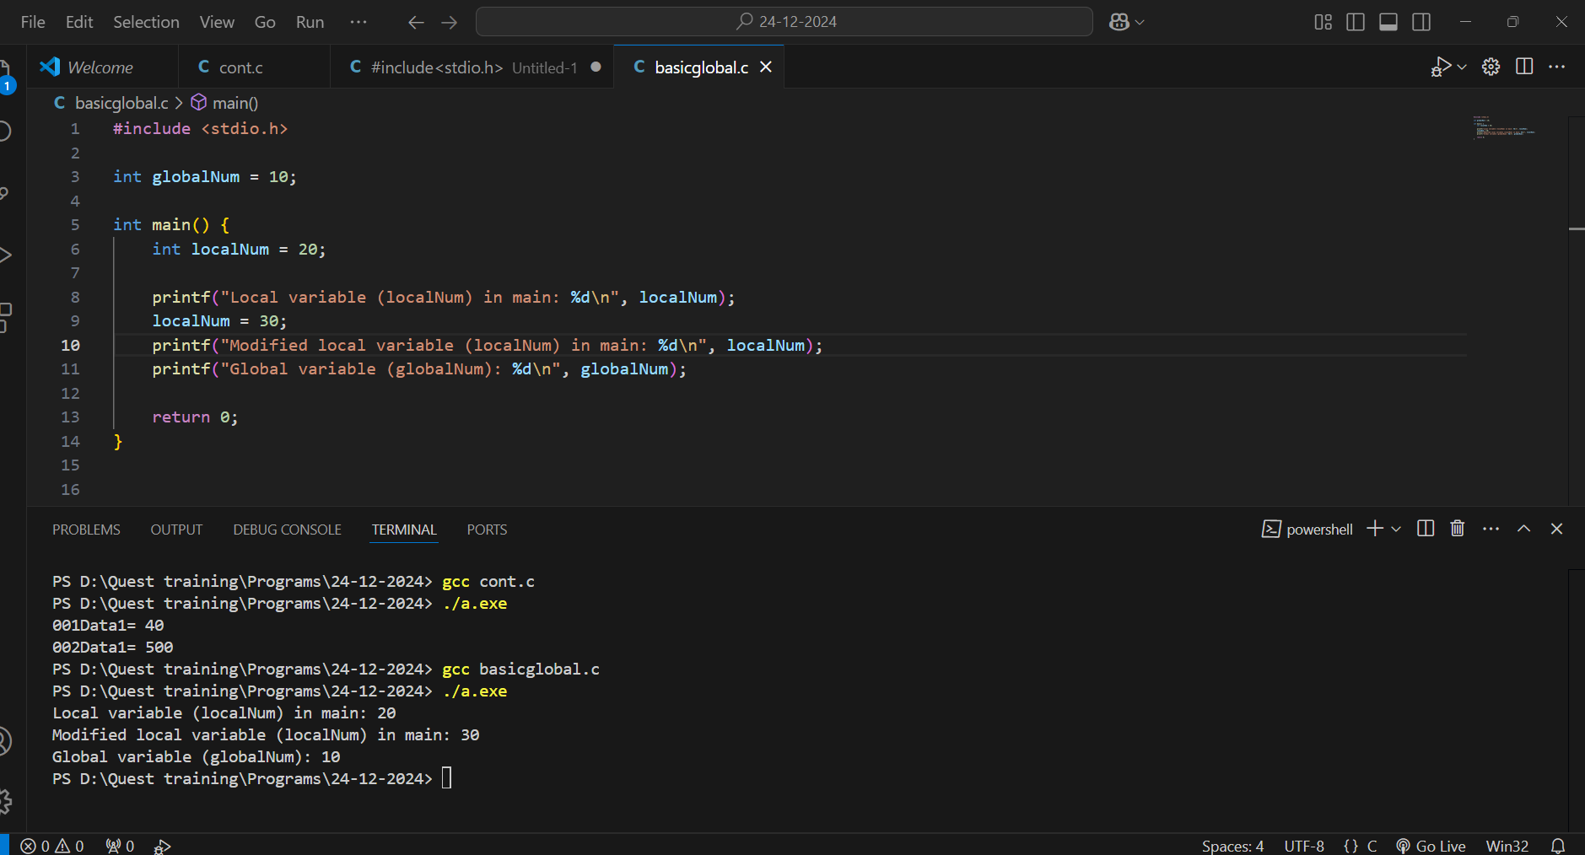

**2. Global Variable Across Functions-** **Problem Statement**: Declare a global variable and create multiple functions to modify its value. Each function should perform a different operation (e.g., addition, subtraction) on the global variable and print its updated value.

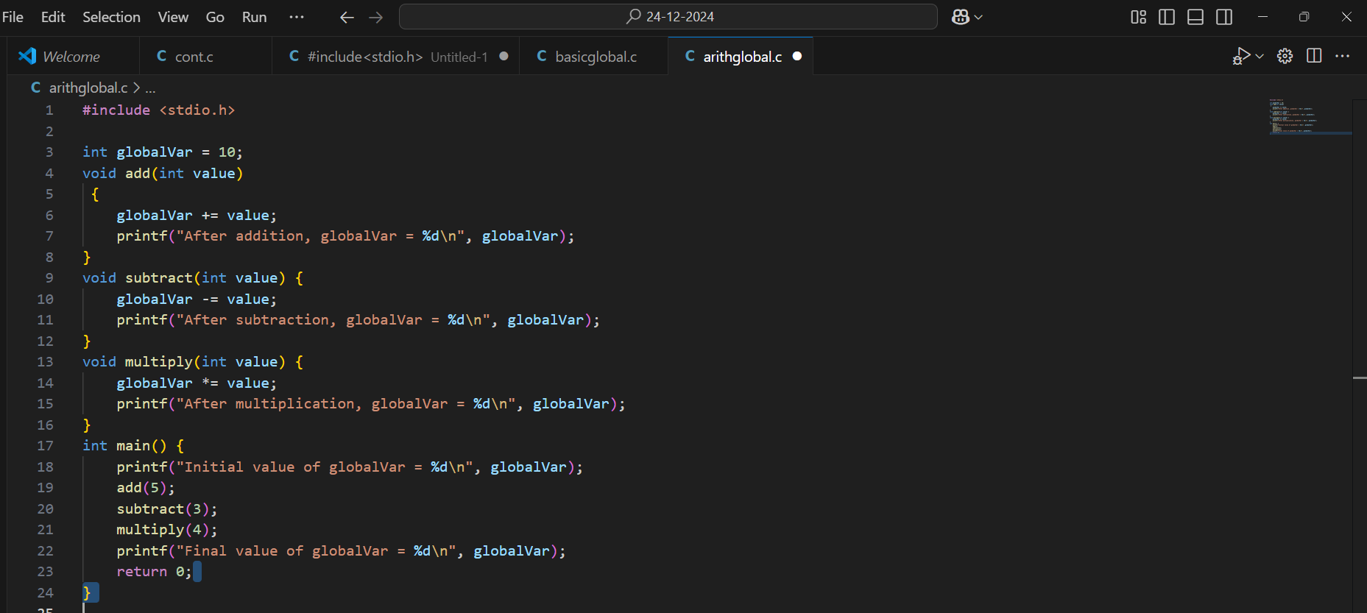

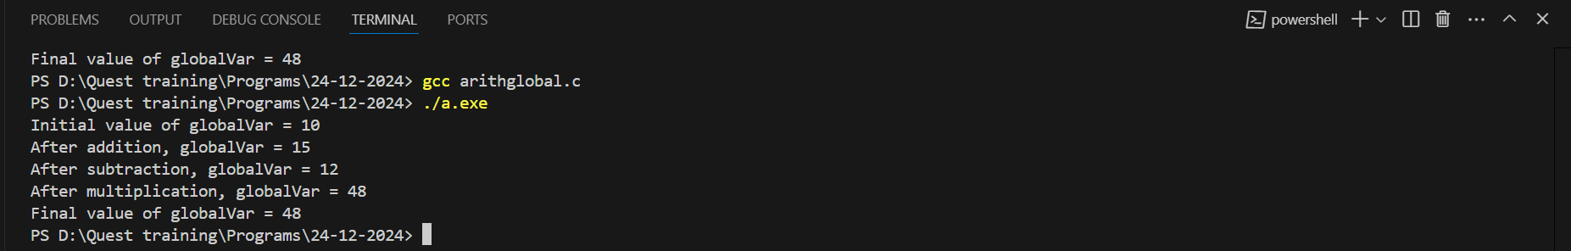

**3. Local Variable Initialization - Problem Statement**: Write a program with a function that declares a local variable and initializes it to a specific value. Call the function multiple times and observe how the local variable behaves with each call.

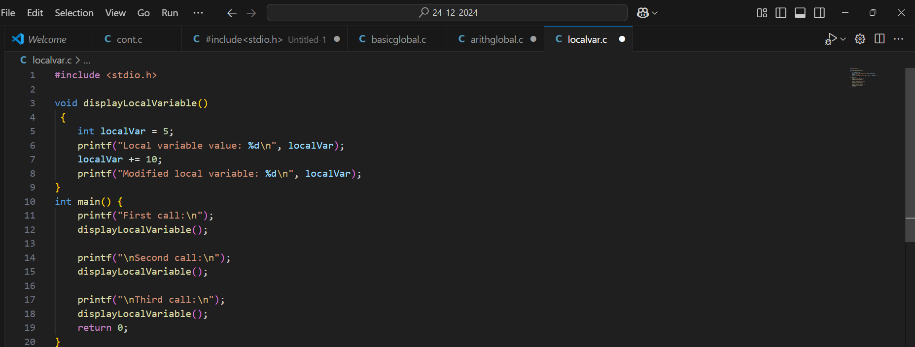

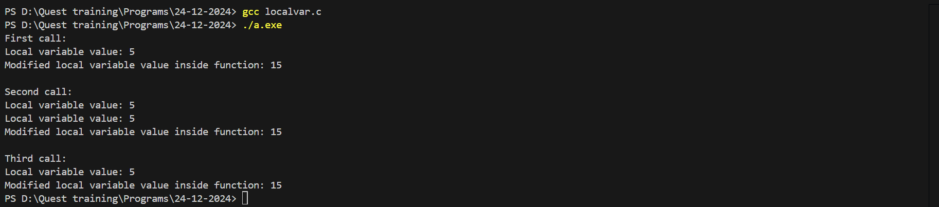

**4. Combining Global and Local Variables - Problem Statement:** Write a program that calculates the sum of a global variable and a local variable inside a function. Print the result and explain the variable scope in comments.

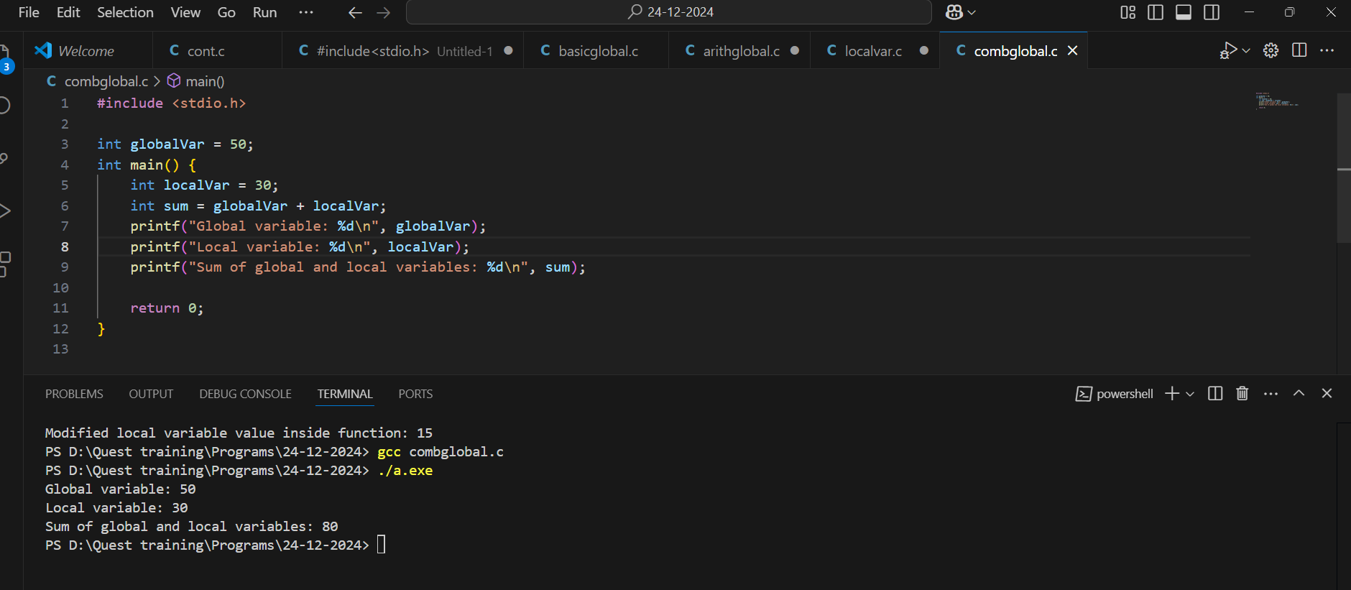

**5.Global Variable for Shared State** - **Problem Statement**: Write a program that uses a global variable as a counter. Multiple functions should increment the counter and print its value. Demonstrate how global variables retain their state across function calls.

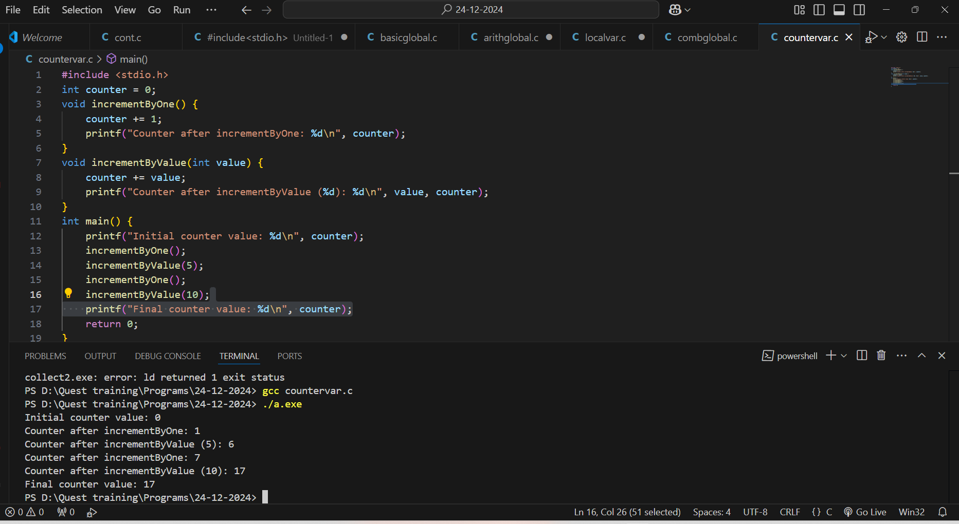

**6.Shadowing Global Variables** - **Problem Statement**: Write a program where a local variable in a function shadows a global variable with the same name. Use the global scope operator to access the global variable and print both values.

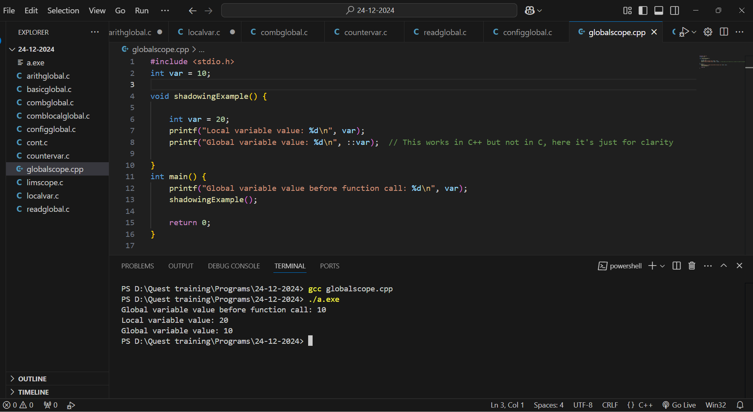

**7.Read-Only Global Variable** - **Problem Statement**: Declare a global constant variable and write a program that uses it across multiple functions without modifying its value. Demonstrate the immutability of the global constant.

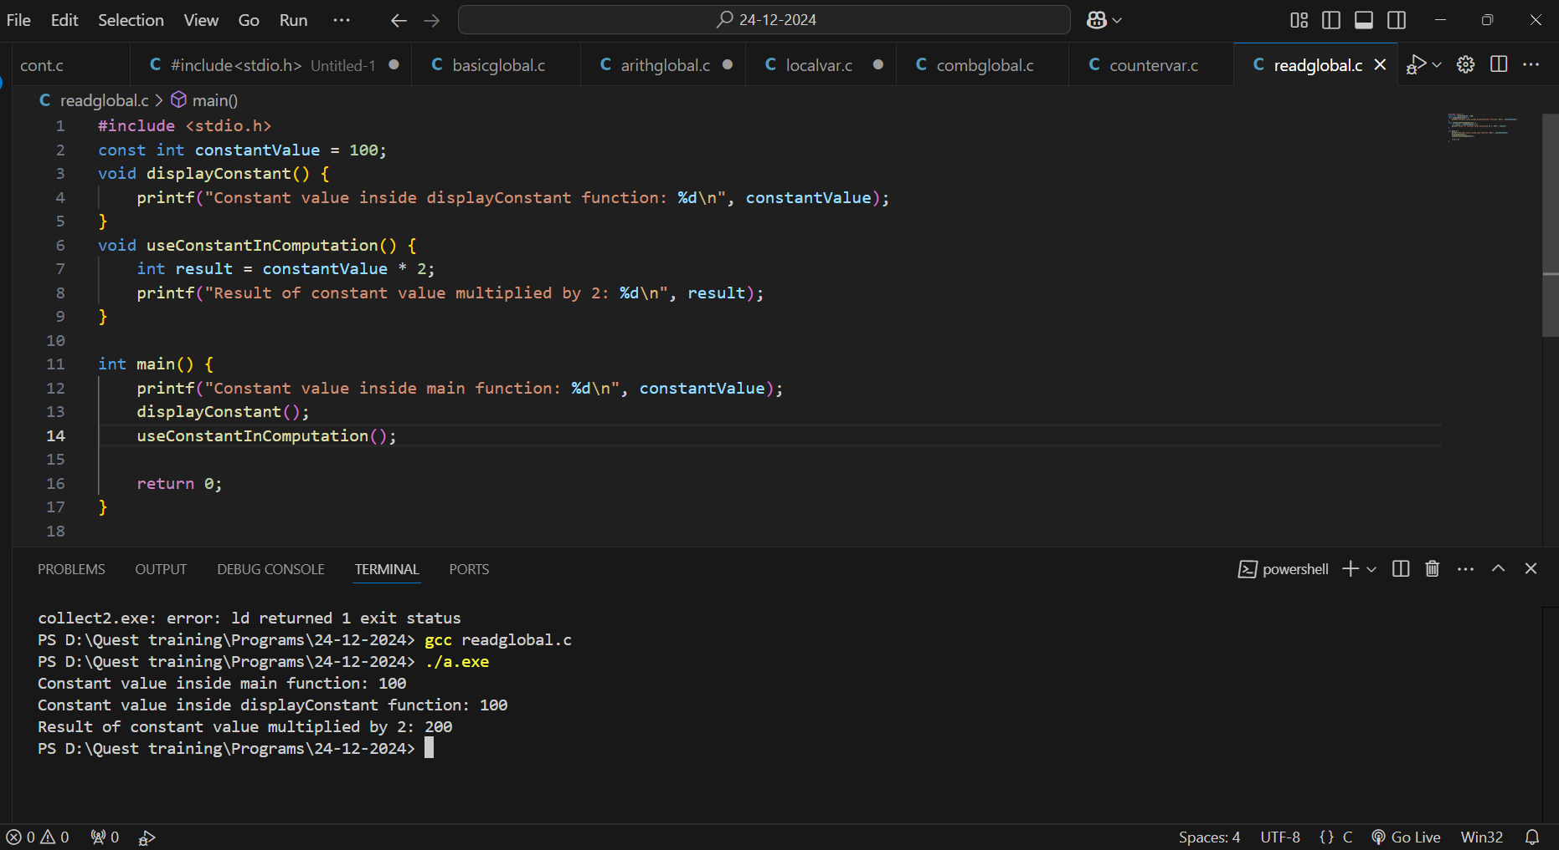

**8. Global Variable for Configuration** - **Problem Statement**: Use a global variable to store configuration settings (e.g., int configValue = 100). Write multiple functions that use this global configuration variable to perform operations.

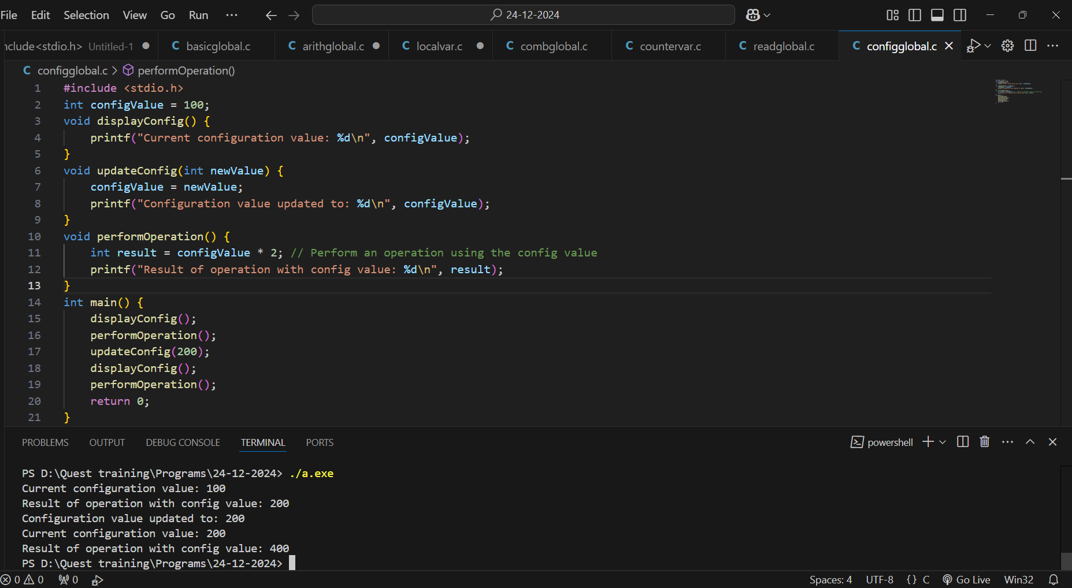

**9.Local Variables with Limited Scope** - **Problem Statement**: Write a program where local variables are declared inside a block (e.g., if or for block). Demonstrate that they are inaccessible outside the block.

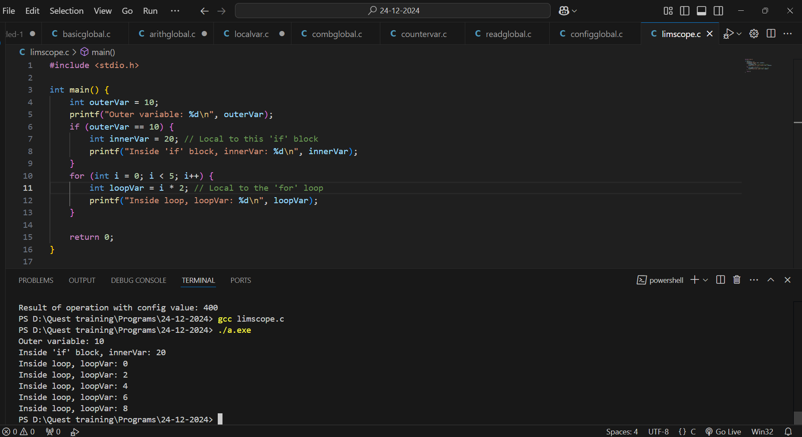

**10. Combining Local and Global Variables in Loops** - **Problem Statement**: Write a program that uses a global variable to track the total sum and a local variable to store the sum of elements in an array. Use a loop to calculate the local sum, then add it to the global total.

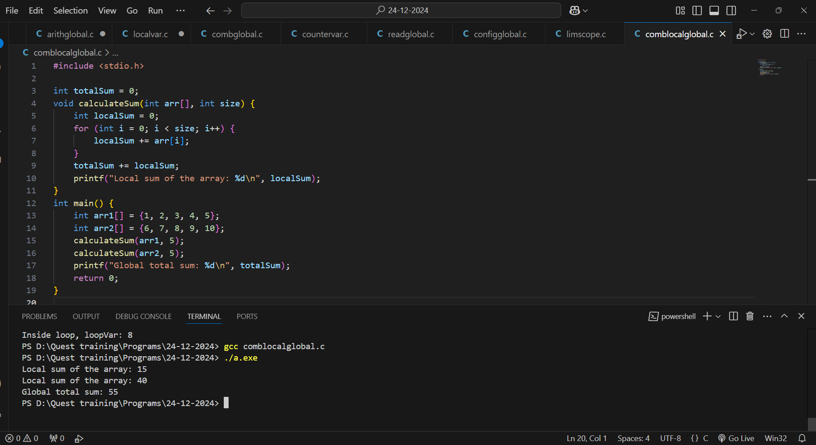

**Static Classes**

**1.Problem statements on Static Storage classes - 1. Static Variable in a Loop Problem Statement: Write a program that uses a static variable inside a loop to keep track of the cumulative sum of numbers from 1 to 10. The loop should run multiple times, and the variable should retain its value between iterations.**

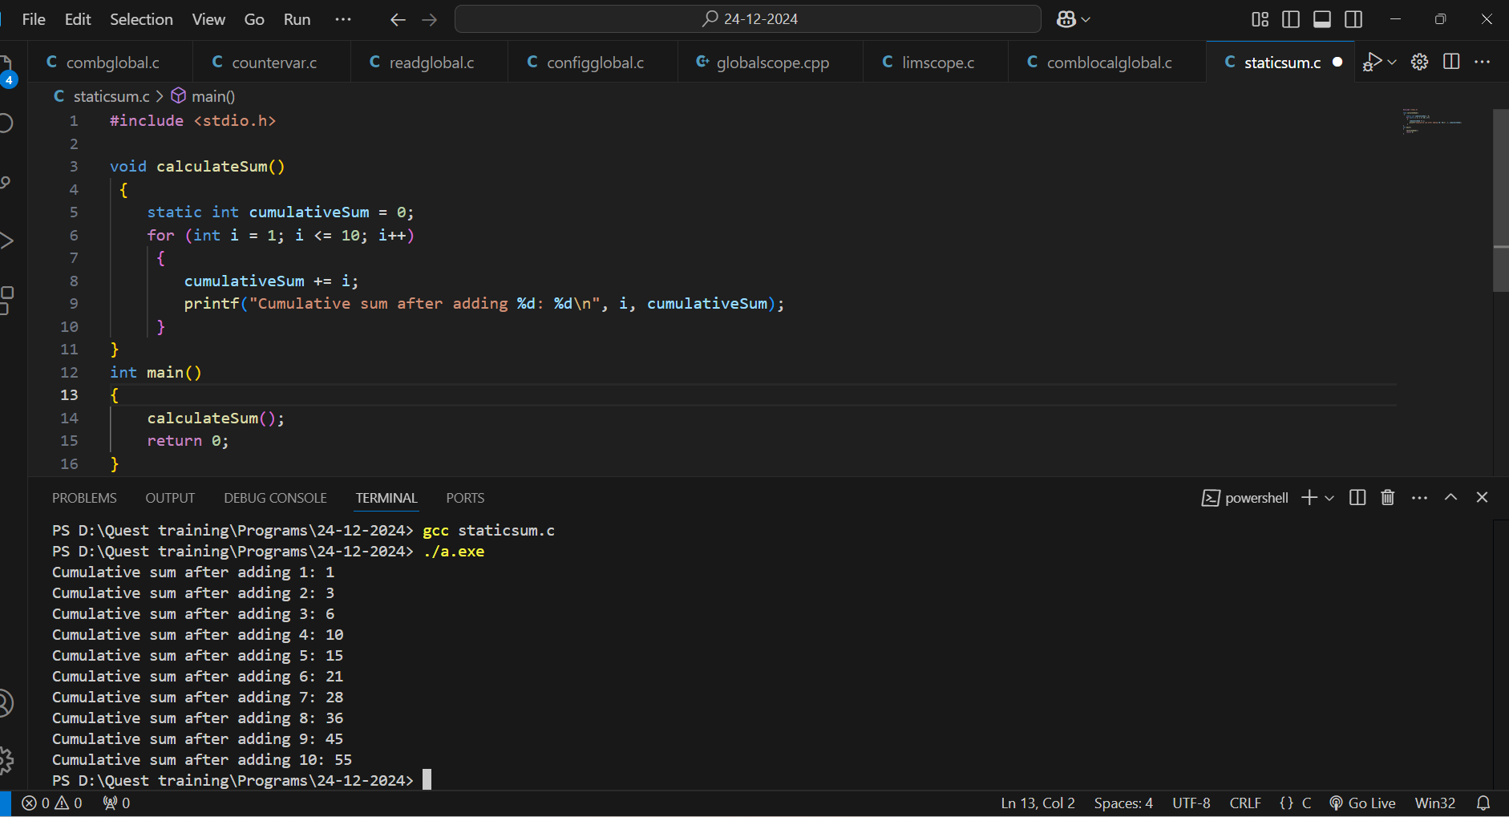

**2.Use a static variable inside a loop to count the total number of iterations executed across multiple runs of the loop. Print the count after each run.**

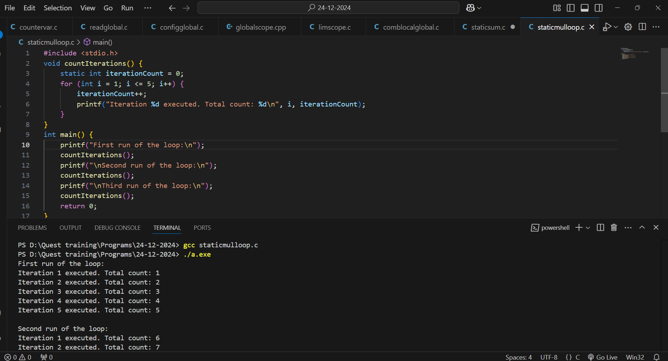

**3.Use a static variable in a nested loop structure to count the total number of times the inner loop has executed across multiple runs of the program.**

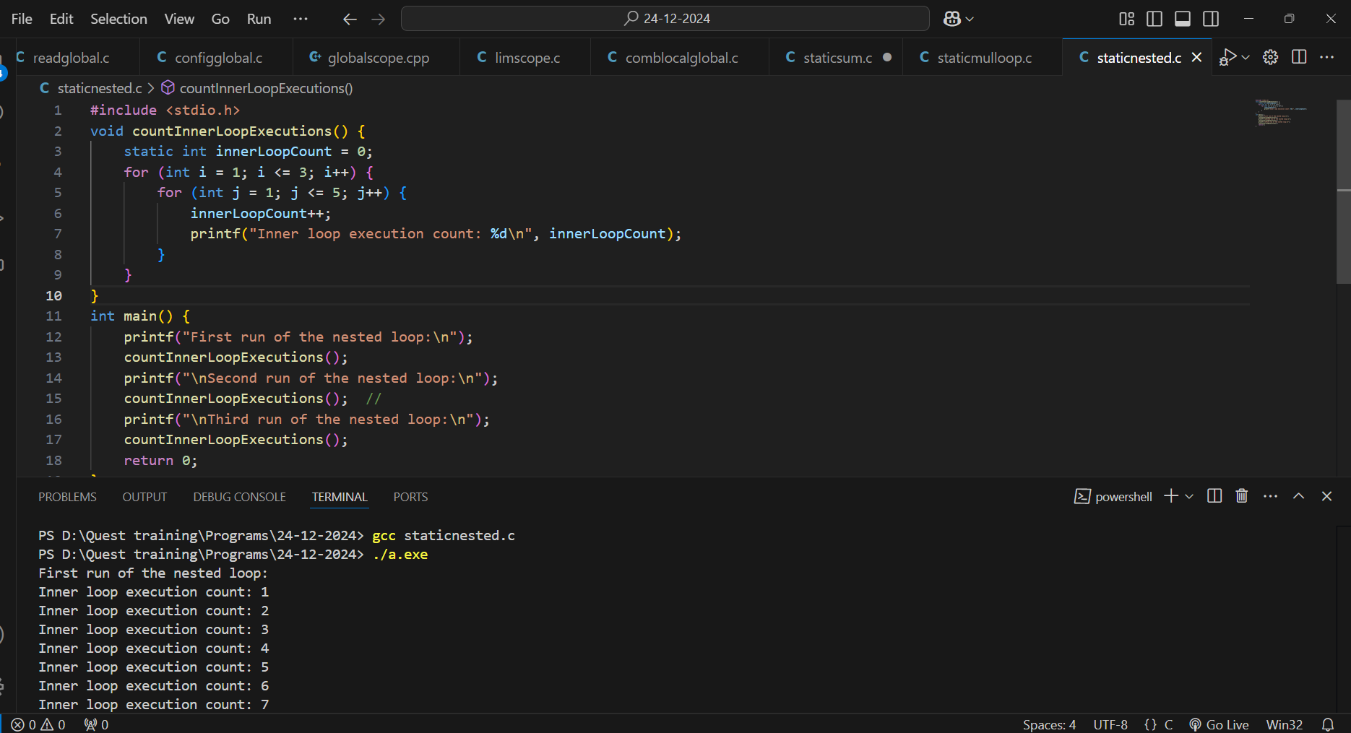

**4.Write a program where a loop executes until a specific condition is met. Use a static variable to track and display the number of times the loop exited due to the condition being true.**

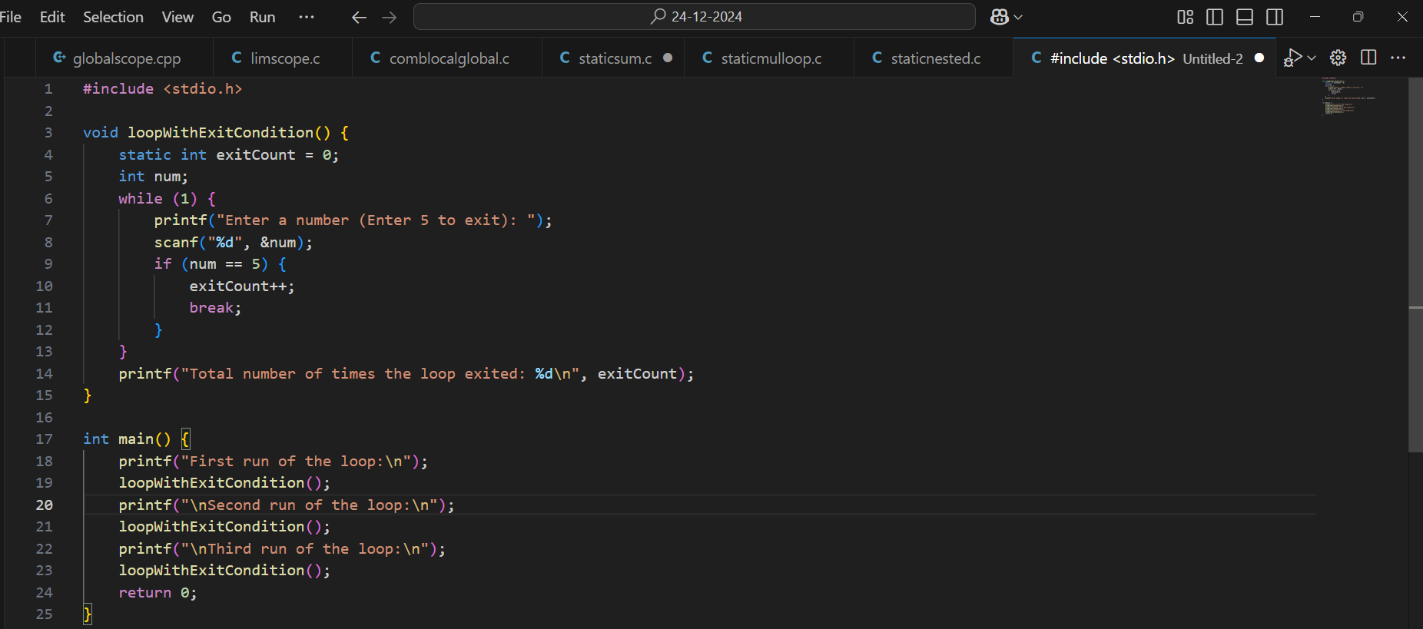

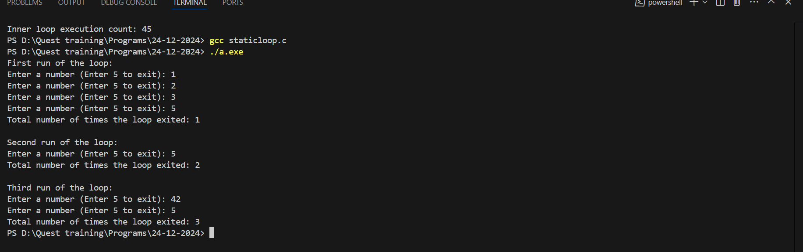

**5.Write a program where a static variable keeps track of how many times the loop is re-entered after being interrupted (e.g., using a break statement).**

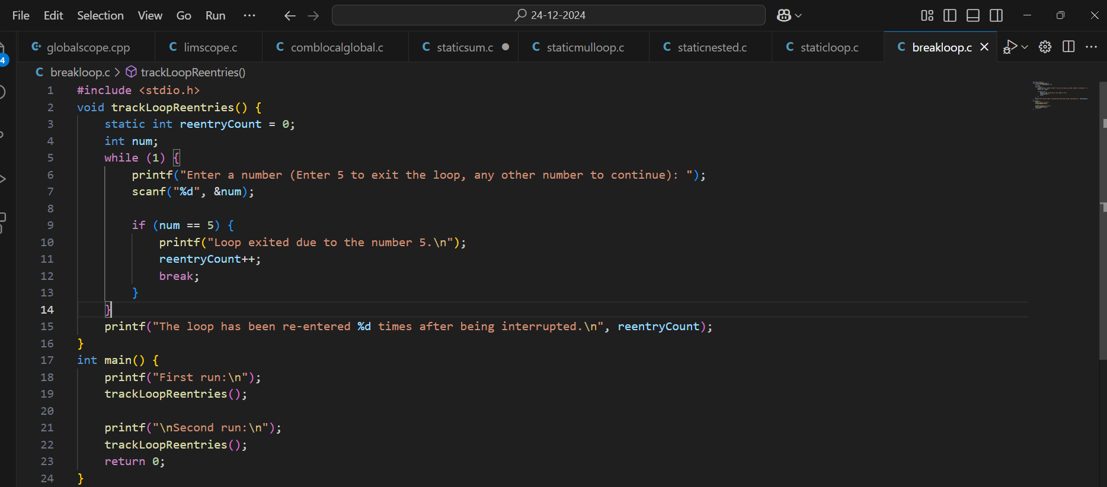

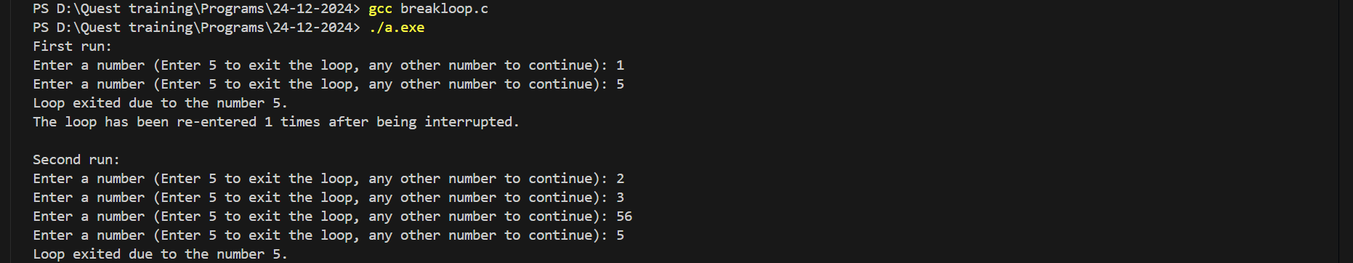

**6.Create a program with a loop that increments by a variable step size. Use a static variable to count and retain the total number of steps taken across multiple runs of the loop.**

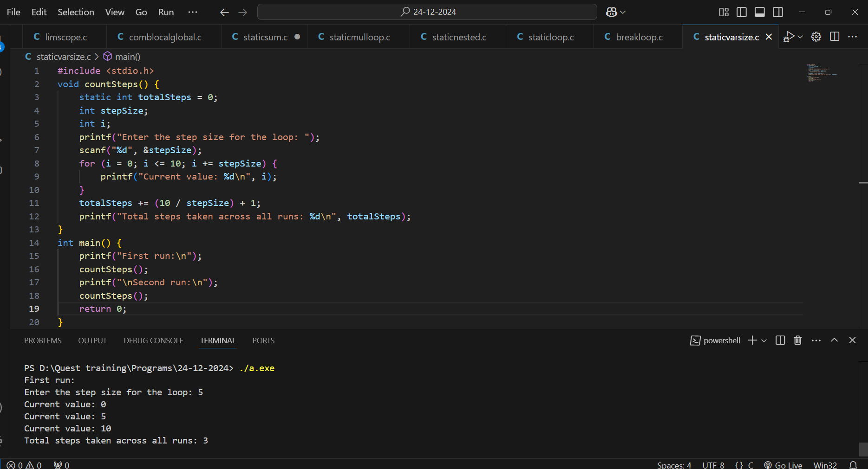

**Problem statement on const Type specifier**

1. **Using const for Read-Only Array Problem Statement: Declare an array of integers as const and use a loop to print each element of the array. Attempt to modify an element inside the loop and explain the result.**

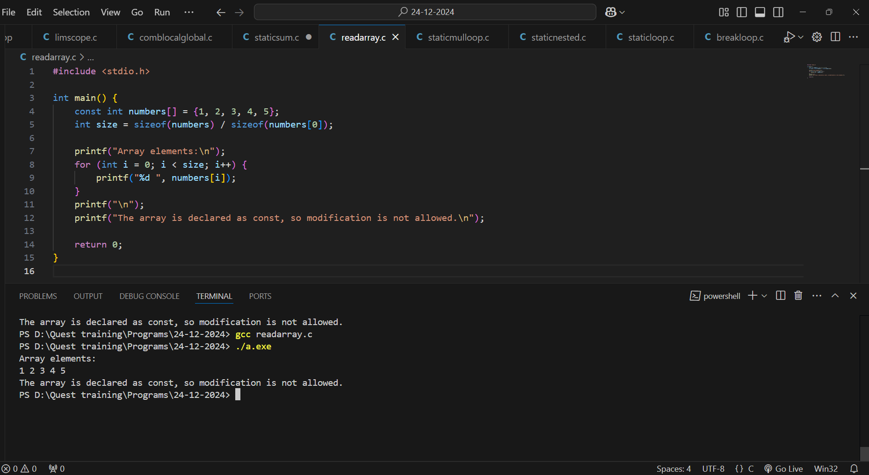

1. **const Variable as a Loop Limit Problem Statement: Declare a const integer variable as the upper limit of a loop. Write a loop that runs from 0 to the value of the const variable and prints the iteration count.**

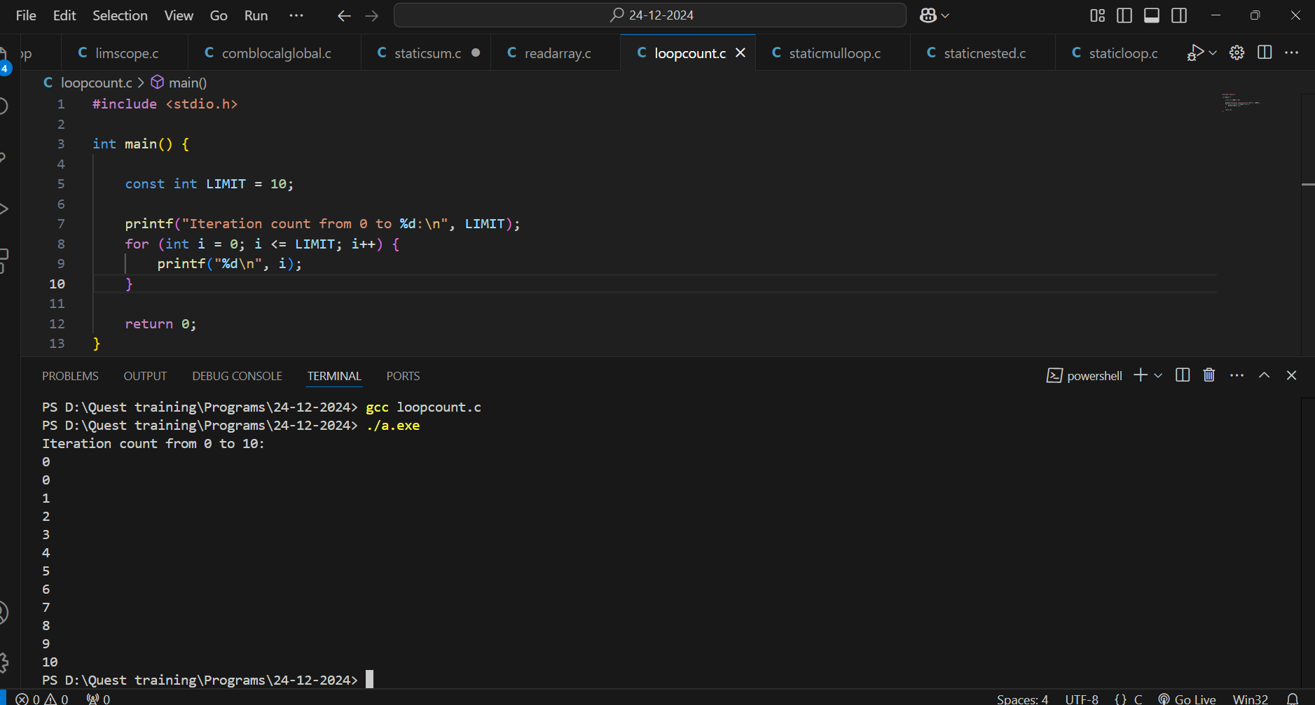

1. **Nested Loops with const Limits Problem Statement: Use two const variables to define the limits of nested loops. Demonstrate how the values of the constants affect the total number of iterations.**

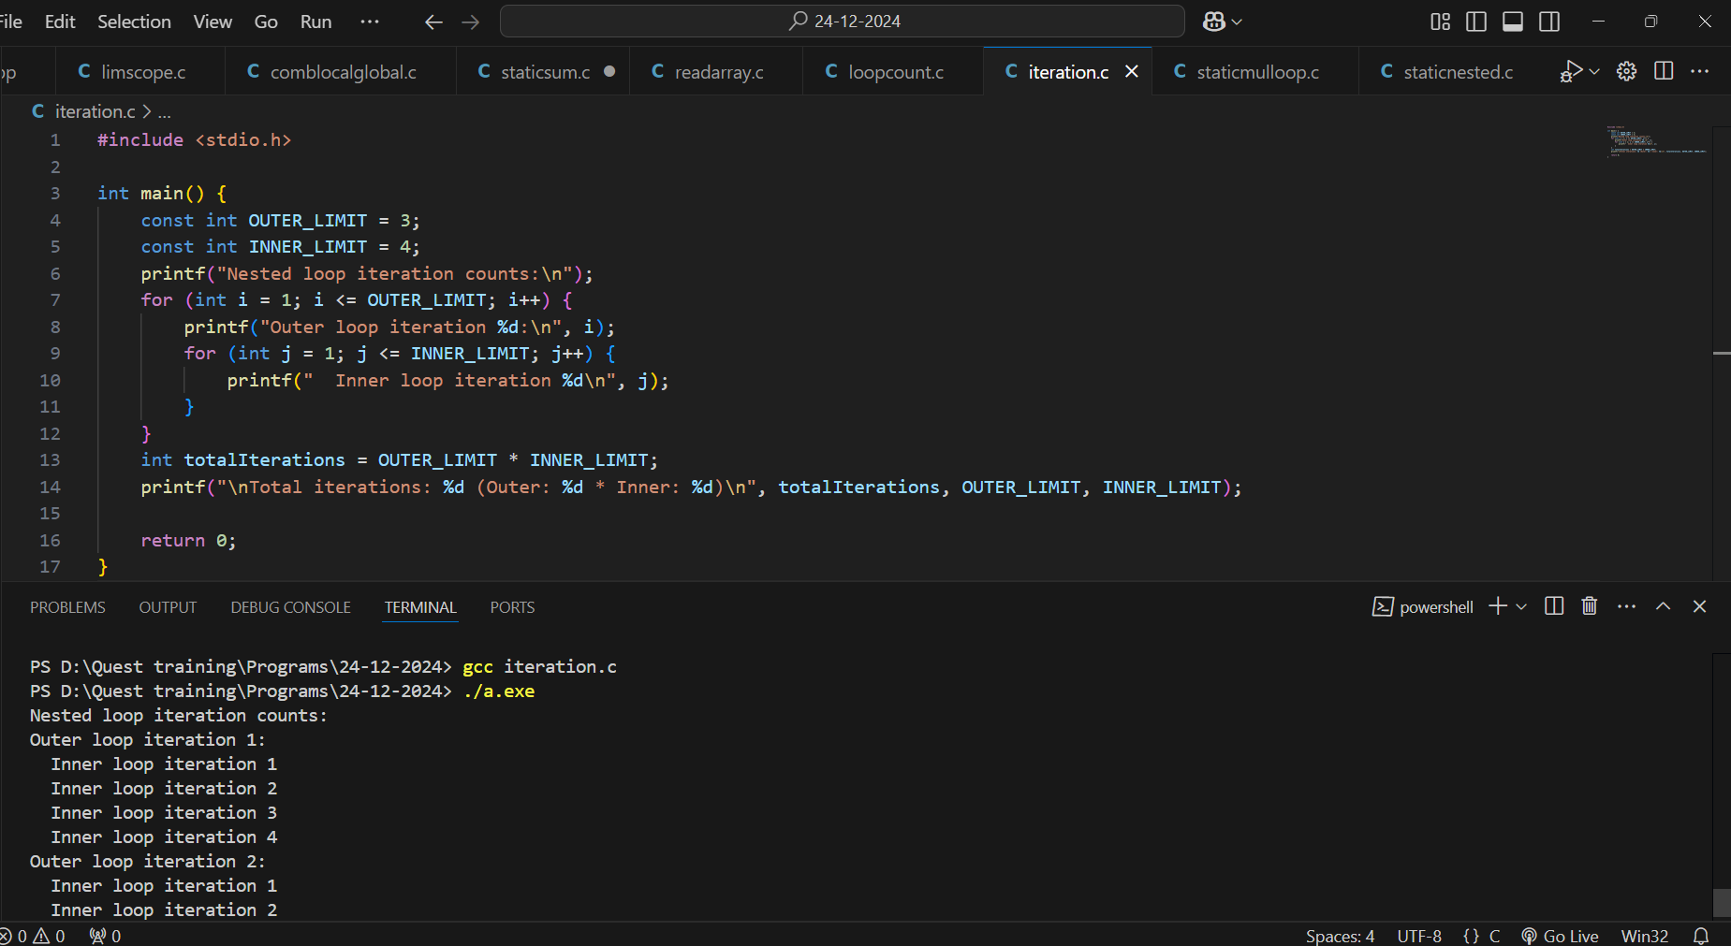

1. **const for Read-Only Pointer in Loops Problem Statement: Declare a const pointer to an integer and use it in a loop to traverse an array. Print each value the pointer points to.**

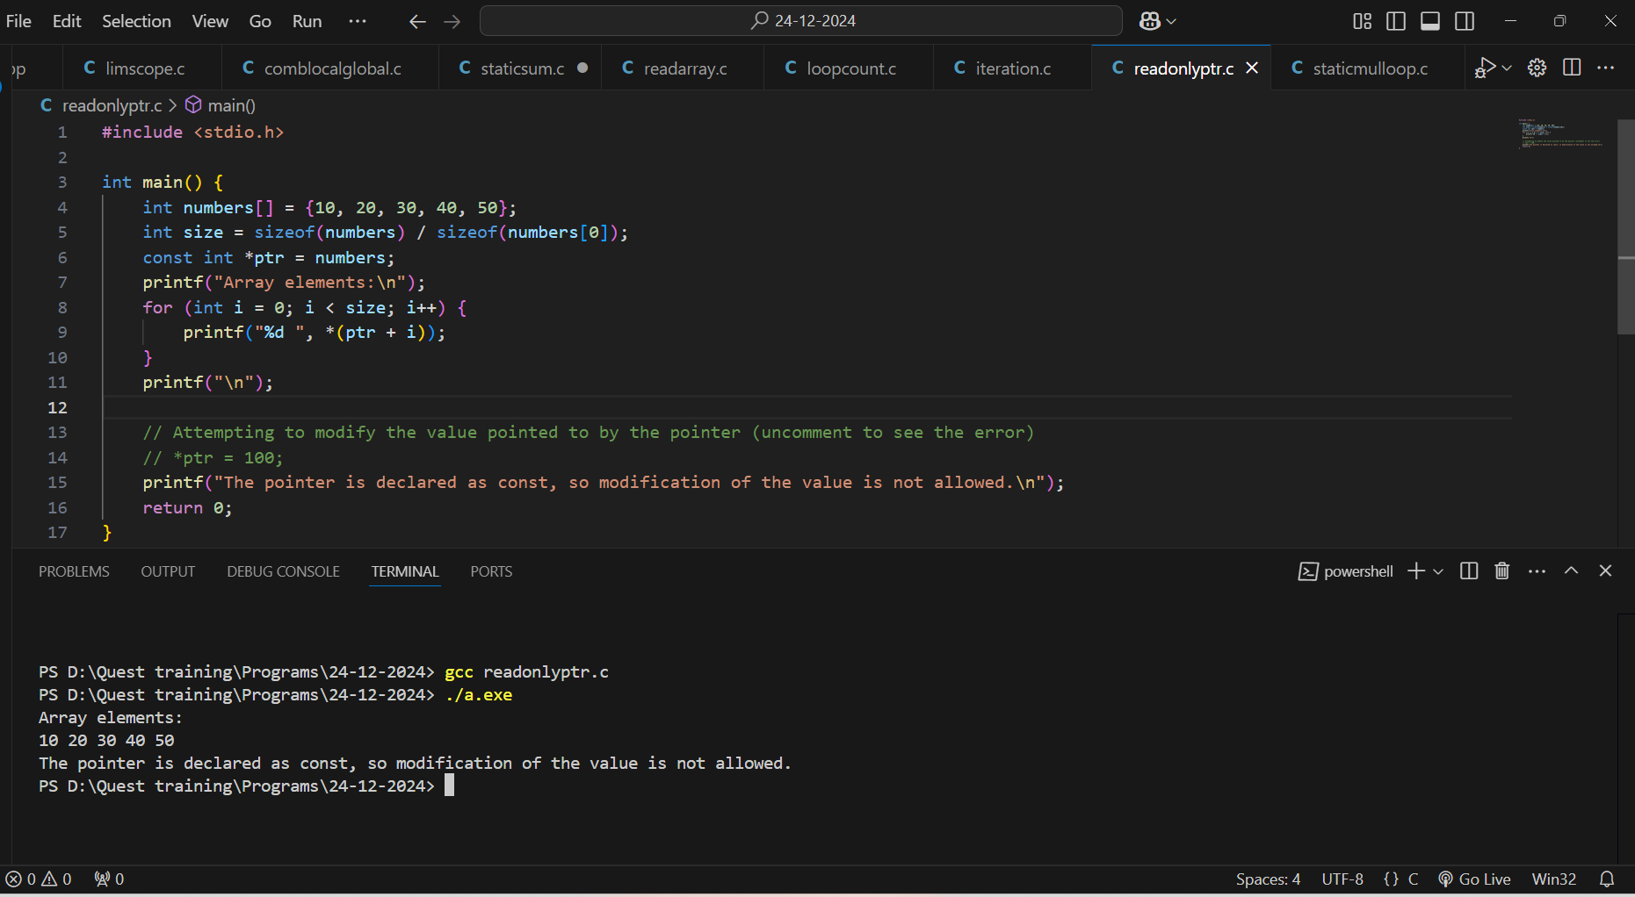

1. **const for Loop-Invariant Variable Problem Statement: Declare a const variable that holds a mathematical constant (e.g., PI = 3.14). Use this constant in a loop to calculate and print the areas of circles for a range of radii.**

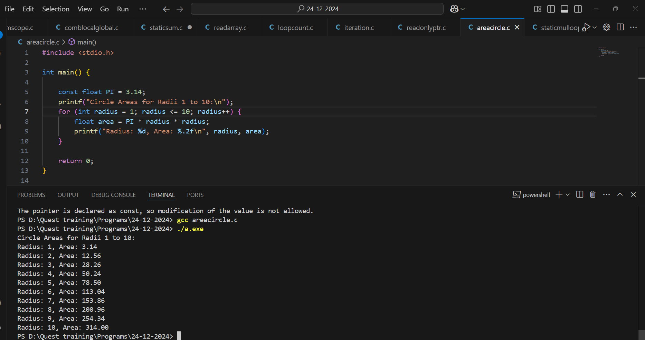

1. **const Variable in Conditional Loops Problem Statement: Use a const variable as a termination condition for a while loop. The loop should terminate when the iteration count reaches the value of the const variable.**

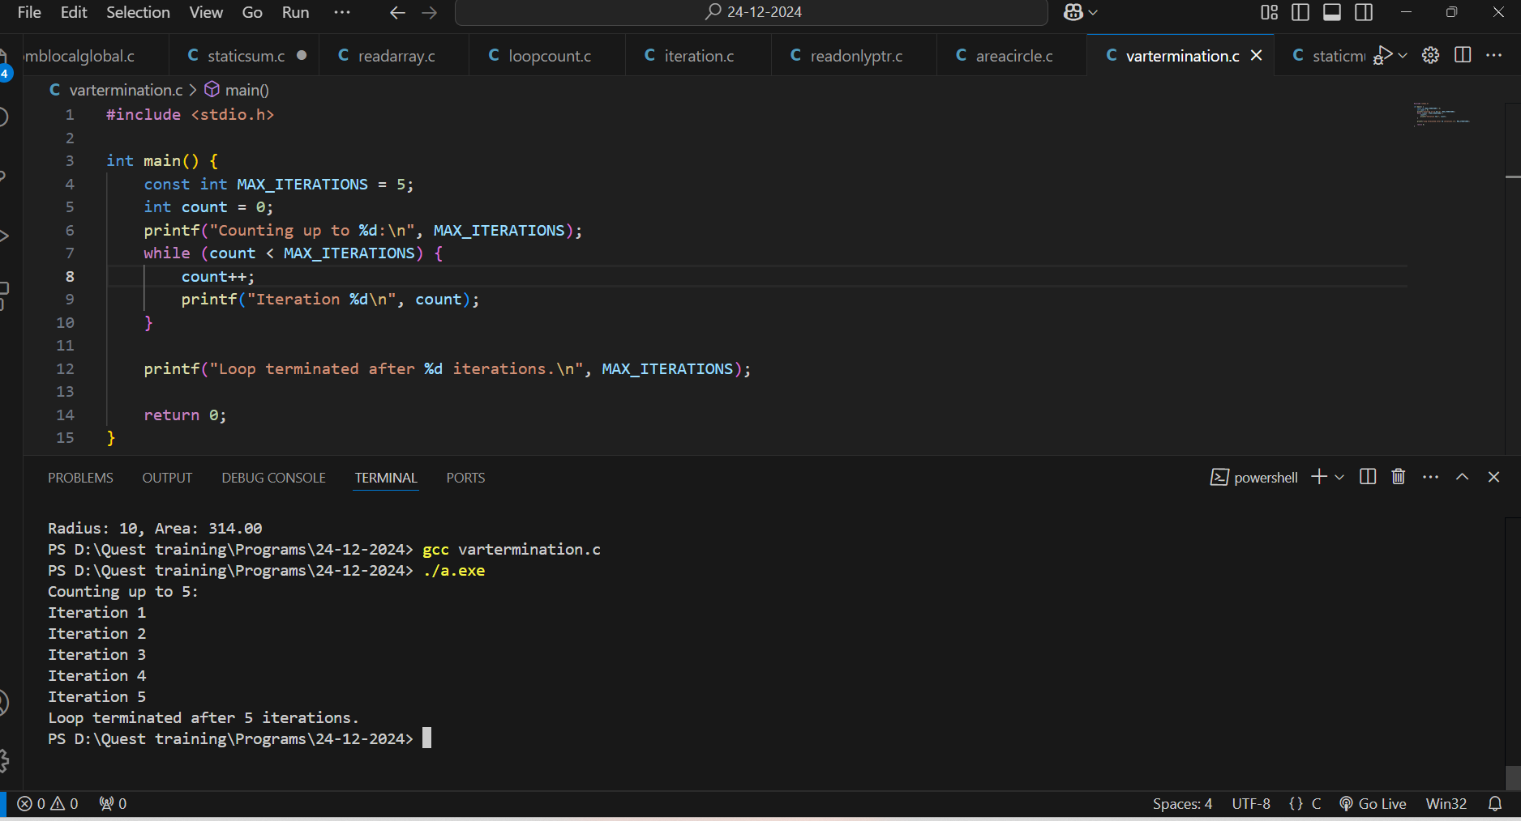

1. **const and Immutable Loop Step Size Problem Statement: Declare a const variable as the step size of a for loop. Use this step size to iterate through a range of numbers and print only every nth number**

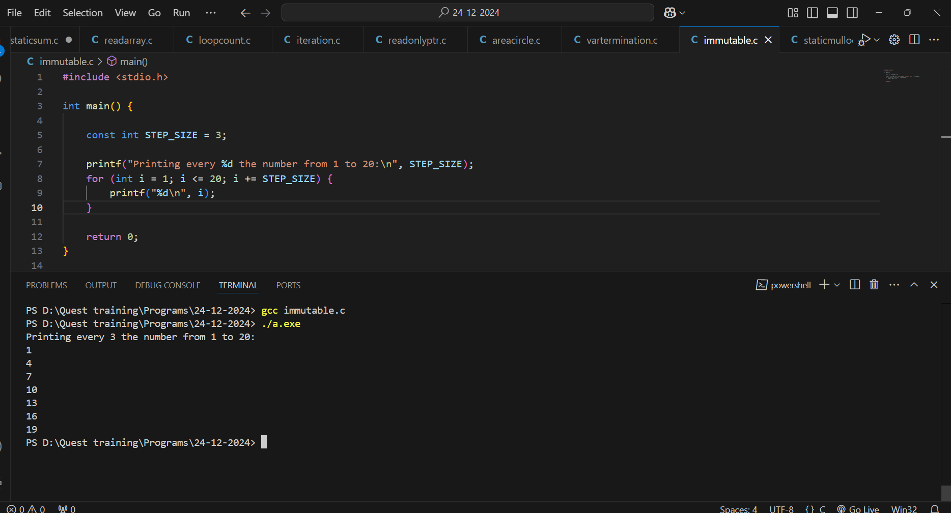

1. **const Variable for Nested Loop Patterns Problem Statement: Use two const variables to define the number of rows and columns for printing a rectangular pattern using nested loops. The dimensions of the rectangle should be based on the const variables.**

