**Assessment – 2 14-01-2025**

**Specifications: Quiz System**

**Variables:** Question, options, correct answer, and score.

**Static & Const:** Static variable for total questions; const for maximum options per question.

**Switch Case:** Menu for taking quiz, viewing results.

**Looping Statements:** Loop through quiz questions.

**Pointers:** Pointer for question and option handling.

**Functions:** Separate functions for quiz execution and result display.

**Arrays:** Store questions and options.

**Structures:** Structure for question details**.**

**Nested Structures:** Nested structures for question-and-answer details.

**Unions:** Union for storing different types of answers.

**Nested Unions:** Nested union for different question formats.

**Output Expectations:** Display quiz results and scores.

**Menu Example:**

1. Start Quiz

2. View Results

3. Exit

**Code:**

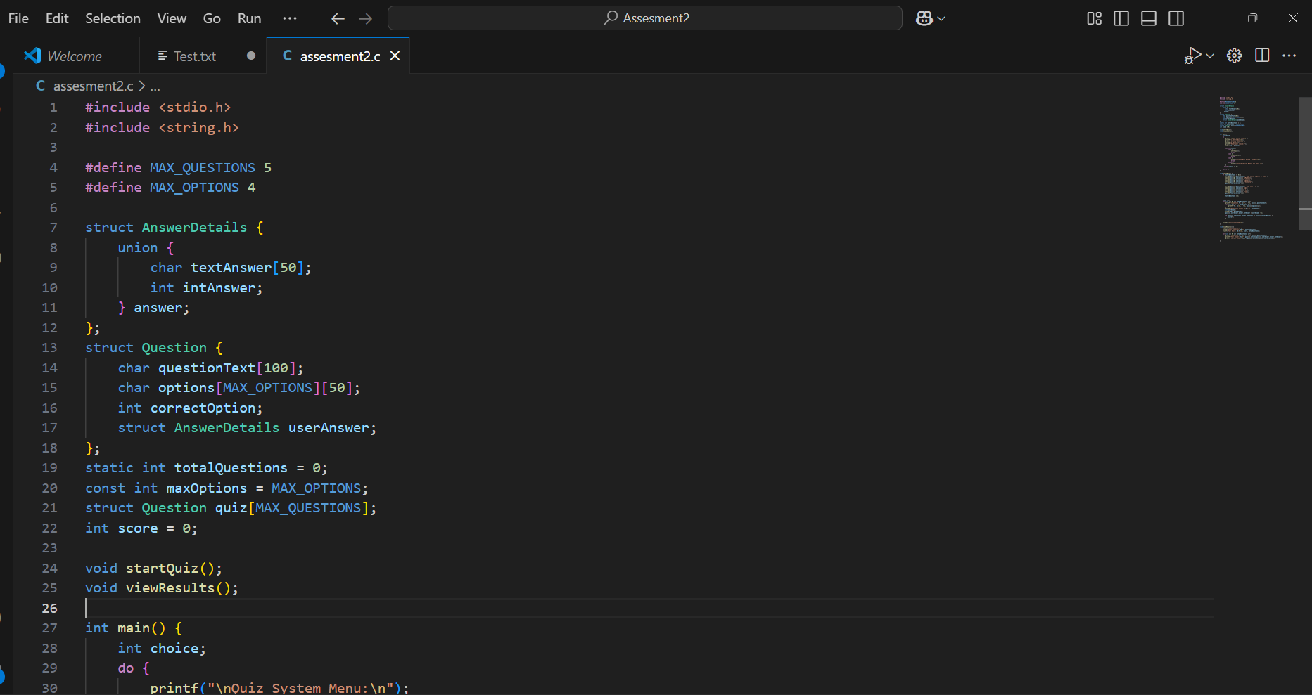

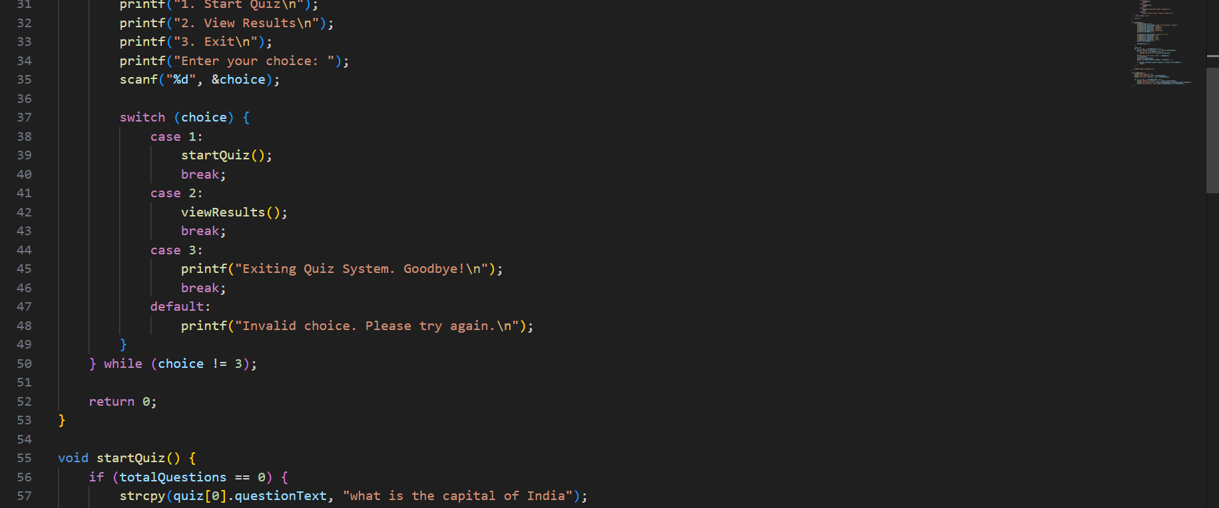

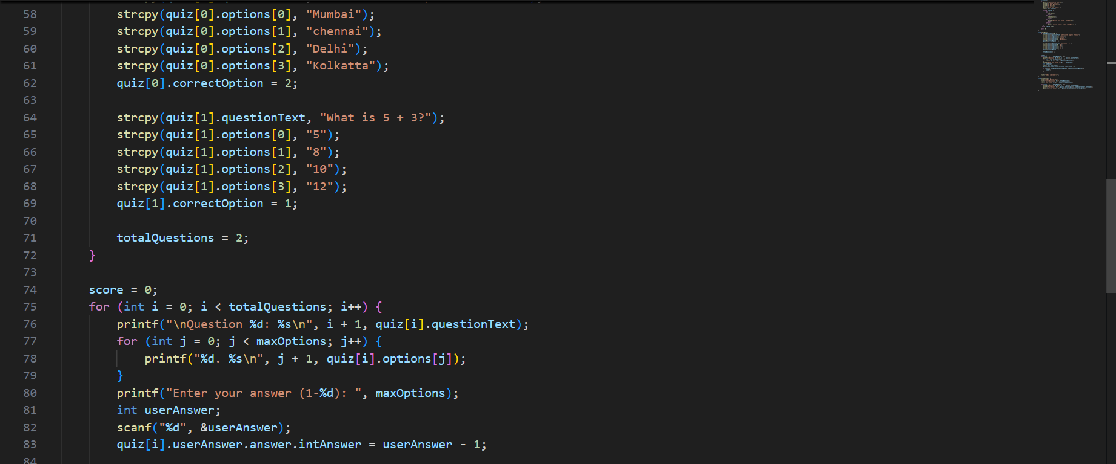

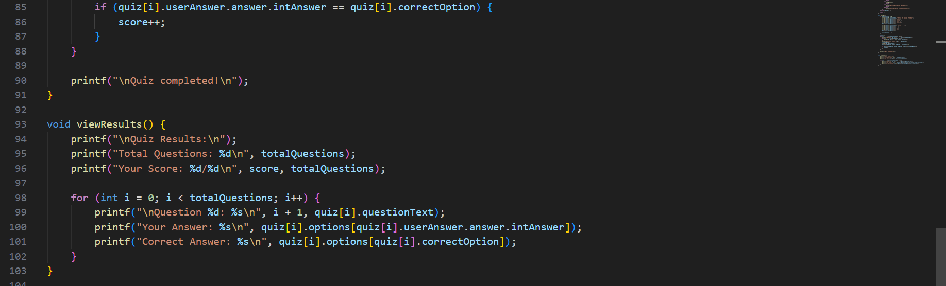

**Output:**

