1. When you run bamazonManager.js, the option displayed are as in the screenshot below

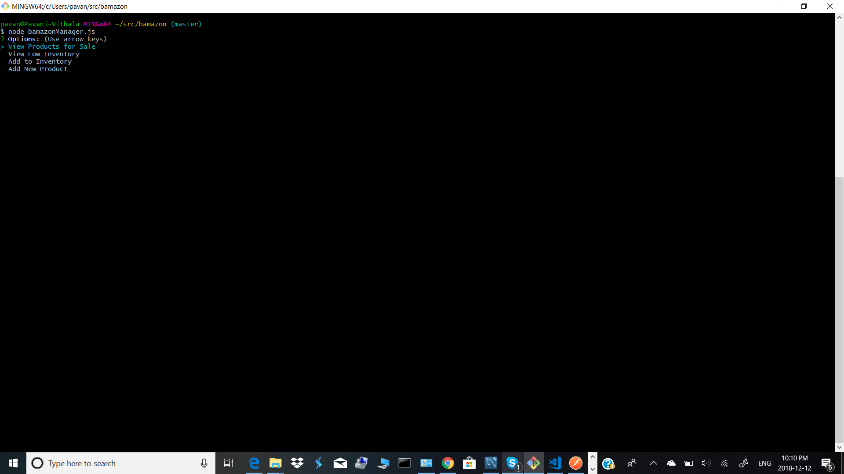

1. When the option “View Products for Sale”, the Products table is displayed.

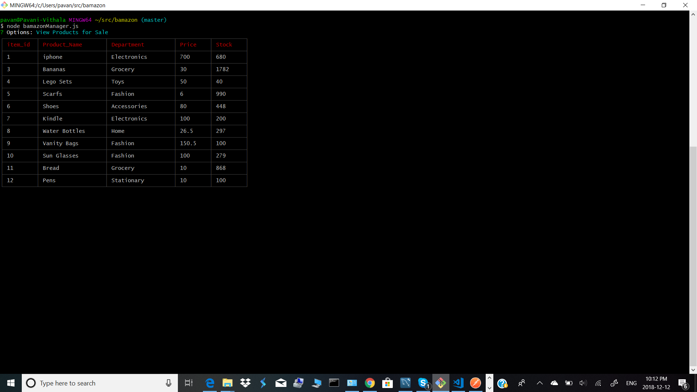

1. When the option View Low inventory is selected, items with less than 5 stock are displayed

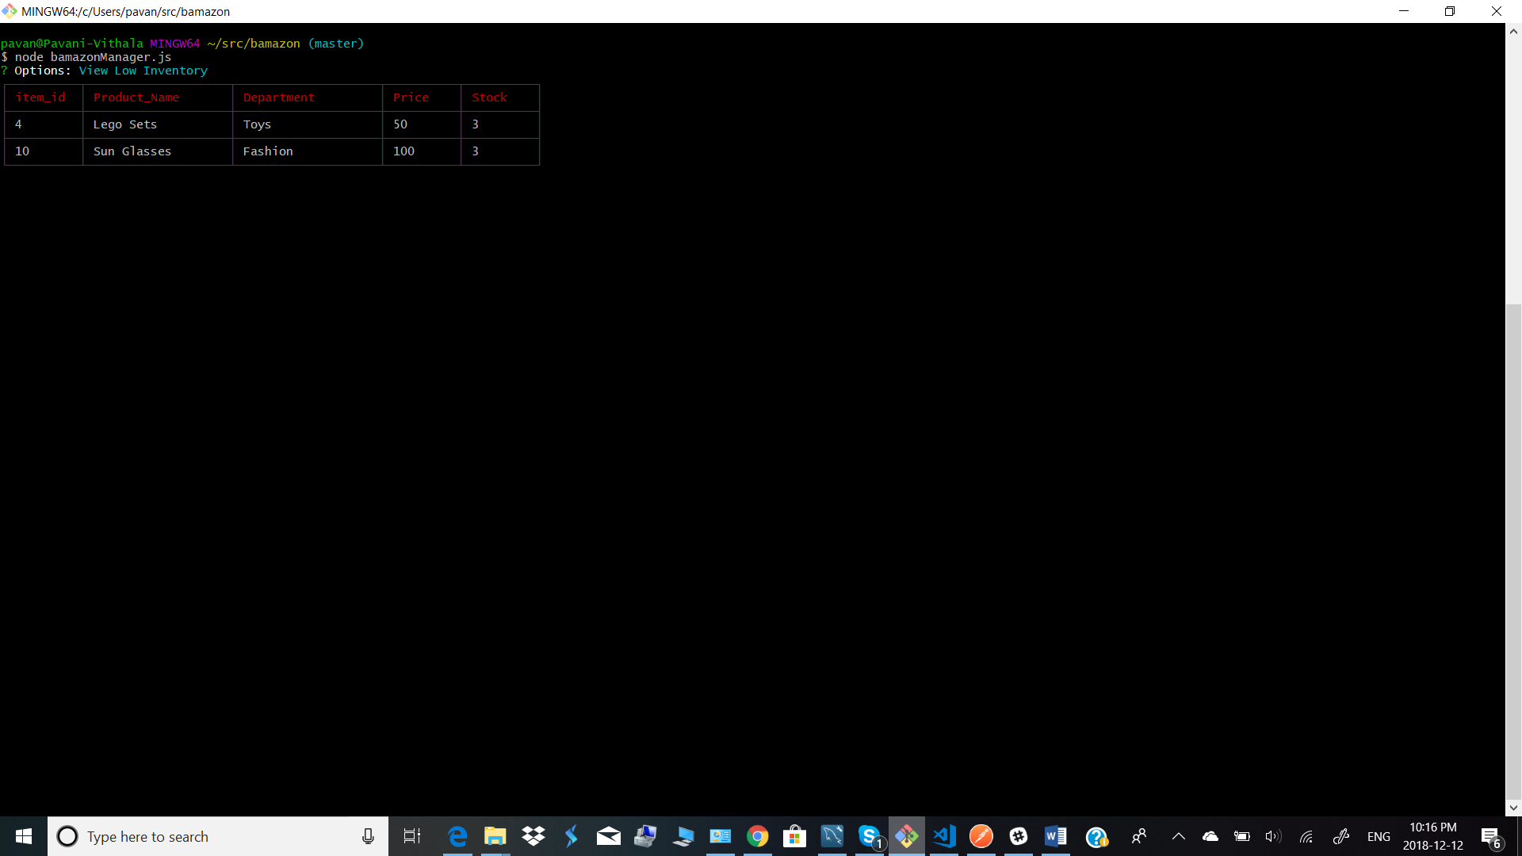

1. When the option “Add to inventory” is selected, options to add inventory is displayed and a message after successfully adding product is displayed as below along with the updated table

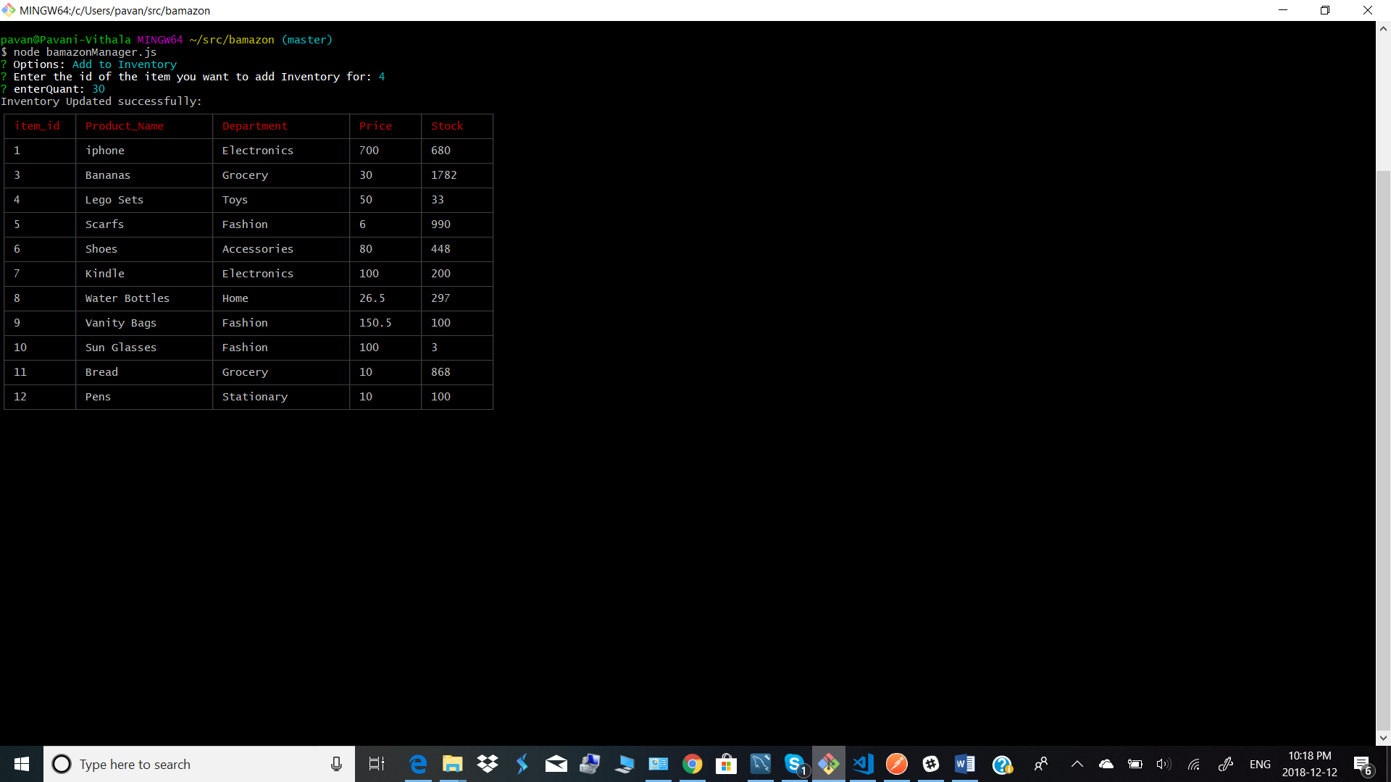

1. When the option “Add New product “ is selected, the below options are displayed and a success message after the product addition along with the updated table as below

