When bamazonSupervisor1.js is run, the below is the flow.

1. The user is presented with the option as below

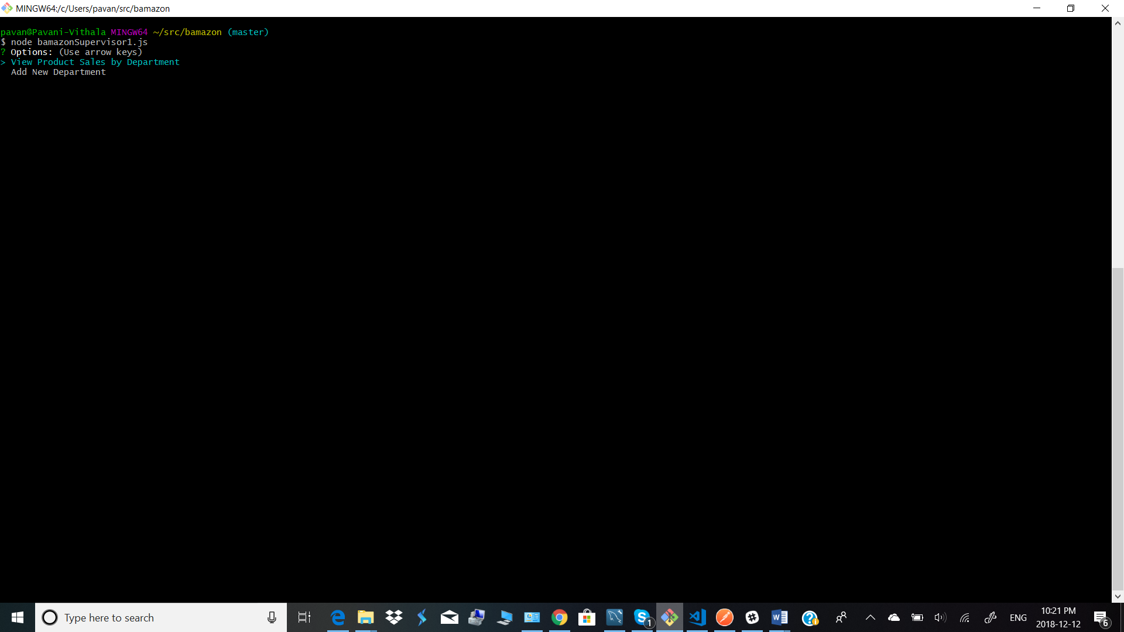

1. When the option View Product Sales by Department is selected, the below is displayed. A summarized display of product sales including total profits department wise.

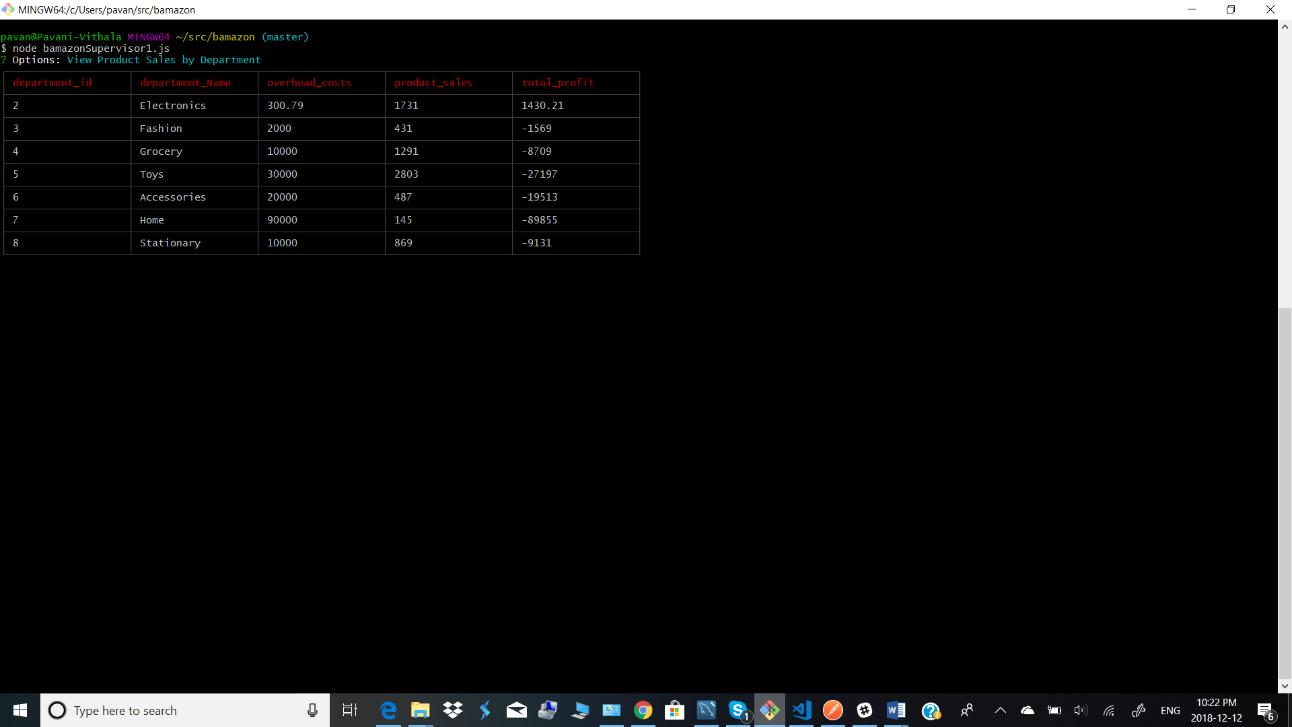

1. When the option “Add Department” is selected, the options to add department are displayed and the department is added to the Departments table.

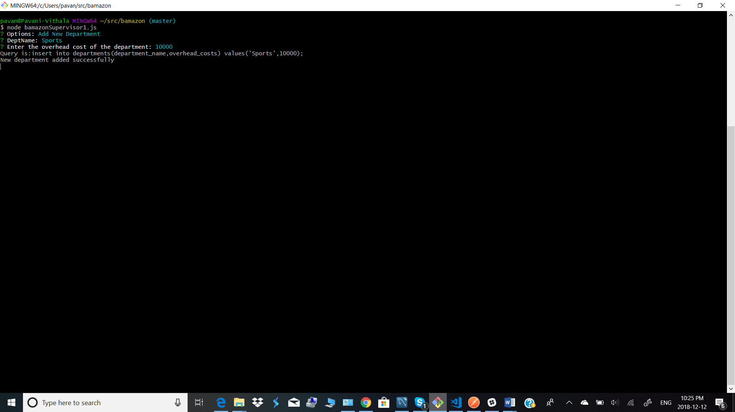

If we see the department table now, we can see the department added as below

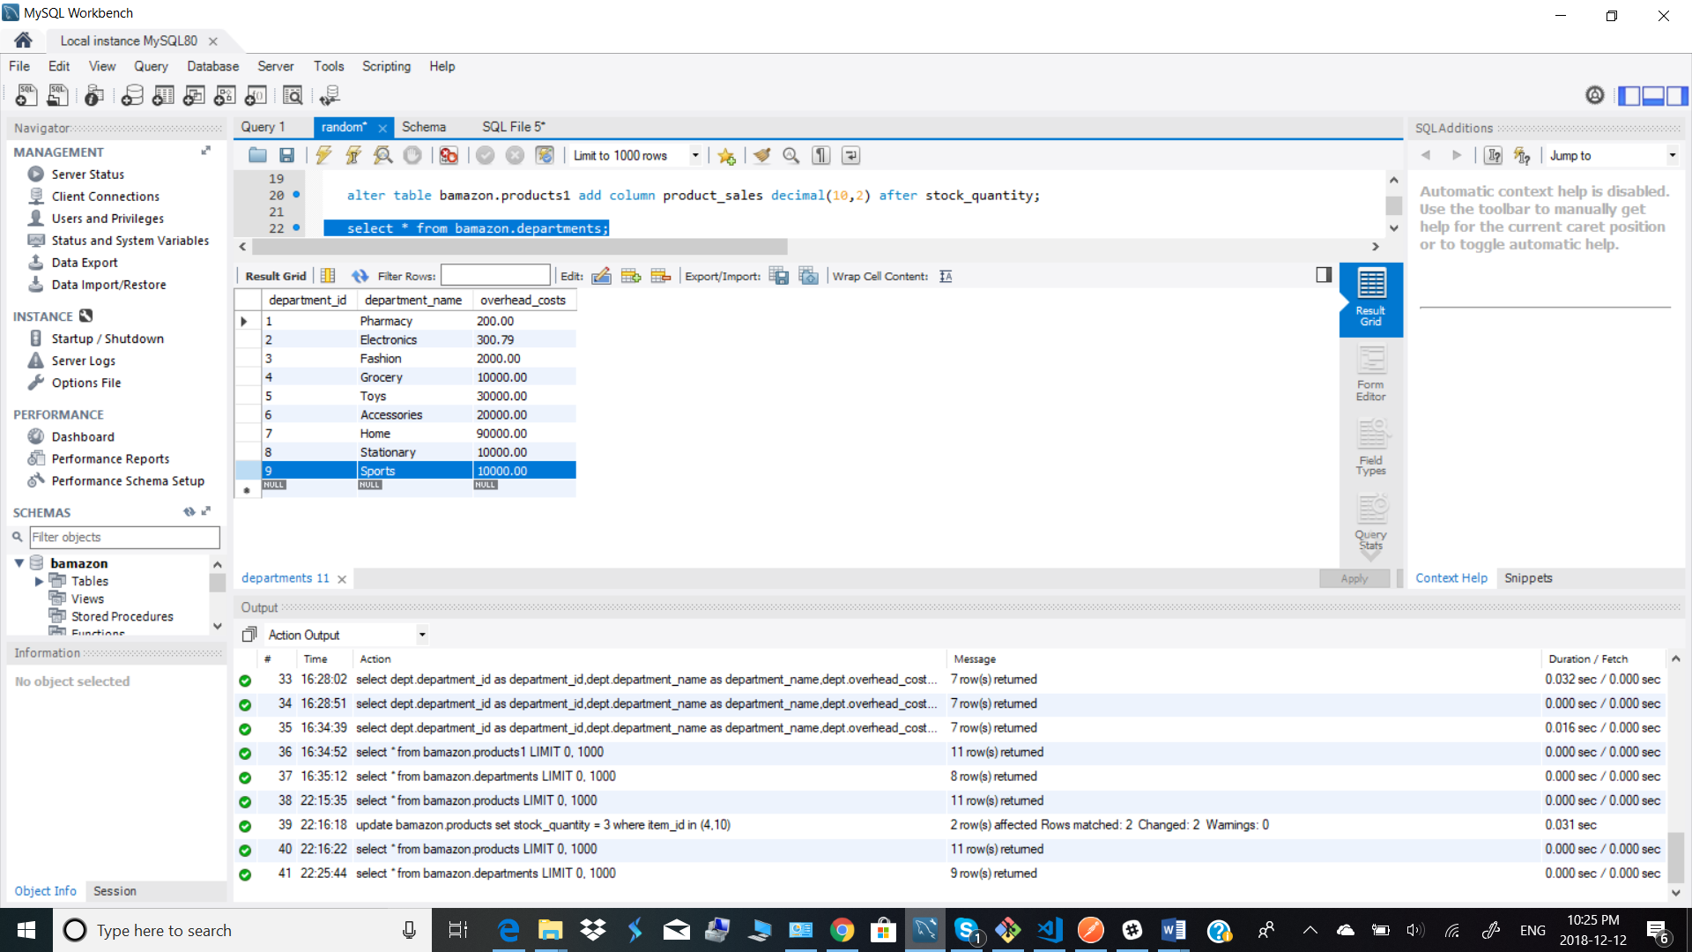

Note: Since there were no products in the Pharmacy department category in products1 table, we don’t get the details of the Pharmacy department in the summarized view.