Exam Invigilation Duty

In this project we are automatically allocating invigilators on exam duty. In propose work admin will add faculty (invigilators) details and then update their leisure times, admin will schedule exams using hall number, date and time and while scheduling admin will get list of available invigilators on selected time and then admin will choose desired invigilator for allotment.

Invigilator can login to system and then can view allotted date, time and hall number for invigilation’s.

We have coded this project using FLASK framework and consists of following modules

1. Admin Login: using this module admin can login to system using username and password as ‘admin’ and ‘admin’.
2. Add Faculty Details: After login admin can add faculty or invigilators and will give login details to invigilators
3. Add Leisure Time: using this module admin can add or update leisure time for the selected invigilator
4. Schedule Exam Time: using this module admin will schedule exam by entering date, time, hall number and then will get list of available invigilators on exam schedule time and then admin will select desired invigilator for that exam invigilation
5. View Schedules: using this module admin can view all scheduled exams and its invigilator and other details
6. Invigilator Login: invigilator can login to system using login details given by admin
7. View Allotted Scheduled: After login invigilator can see allotted invigilation details

SCREEN SHOTS  
to run code copy content from ‘database.txt’ file and then paste in MYSQL database console to create database

Now double click on ‘run.bat’ file to start FLASK server and get below output

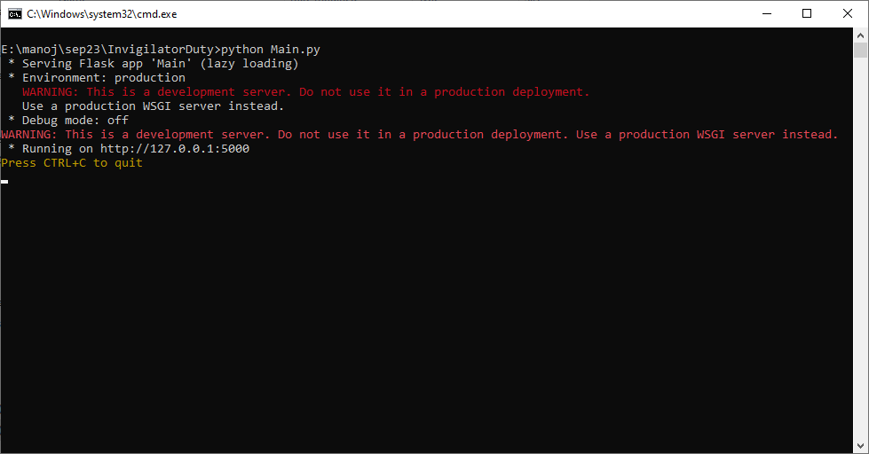

In above screen flask server started and now open browser and enter URL as <http://127.0.0.1:5000/index> and then press enter key to get below page

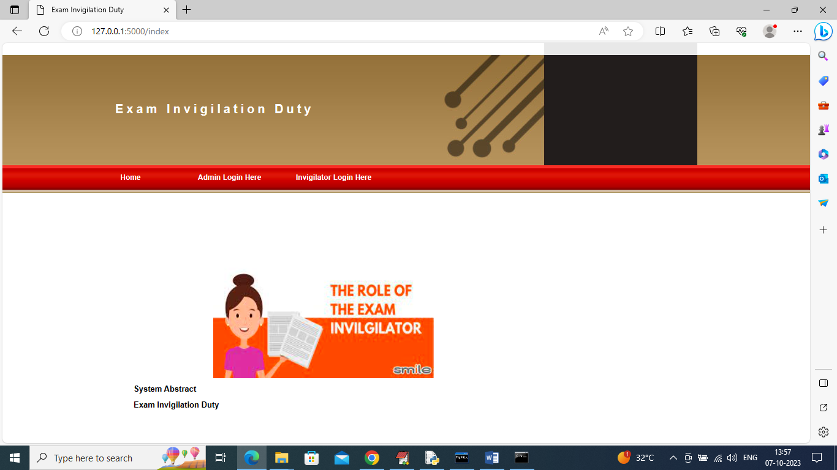

In above screen click on ‘Admin Login Here’ link to get below page

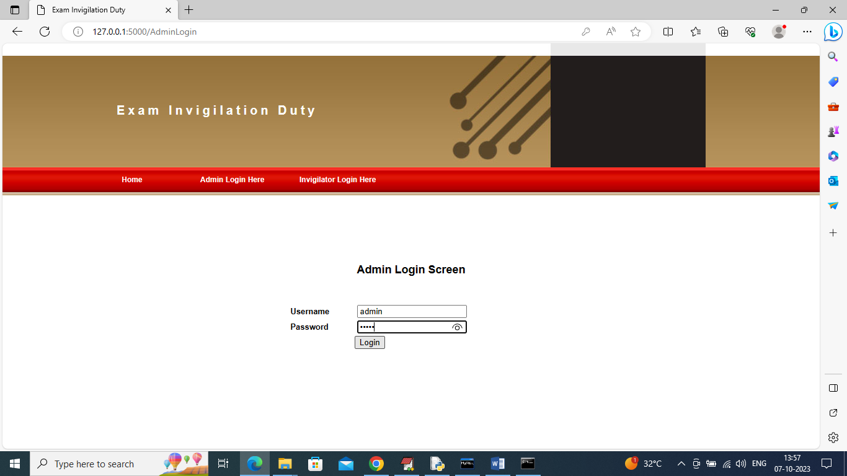

In above screen admin is login and after login will get below page

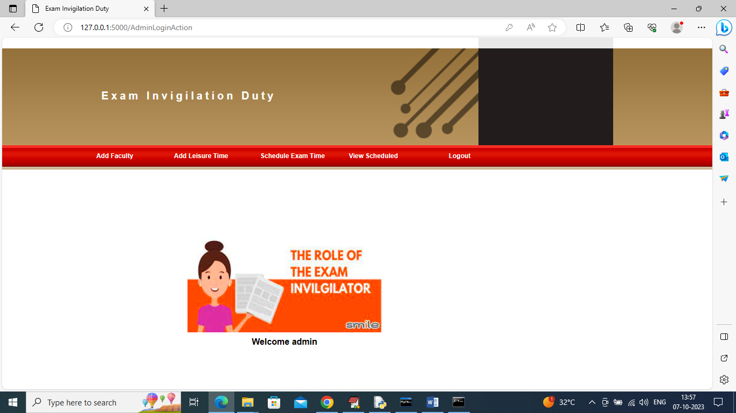

In above screen click on ‘Add Faculty’ link to get below page

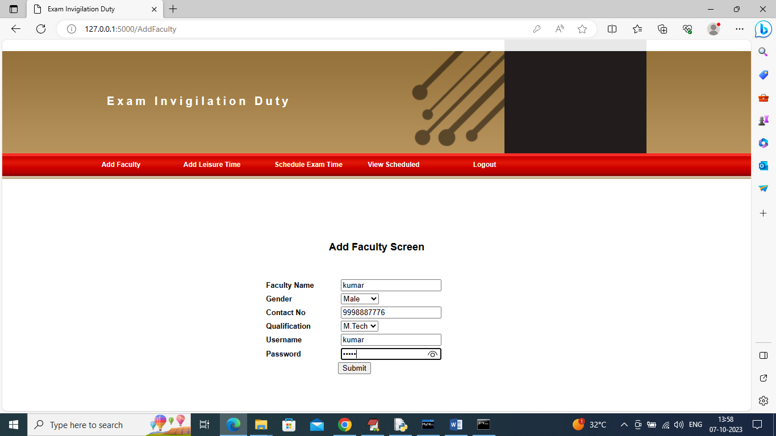

In above screen admin is adding invigilator or faculty details and then press button to get below page

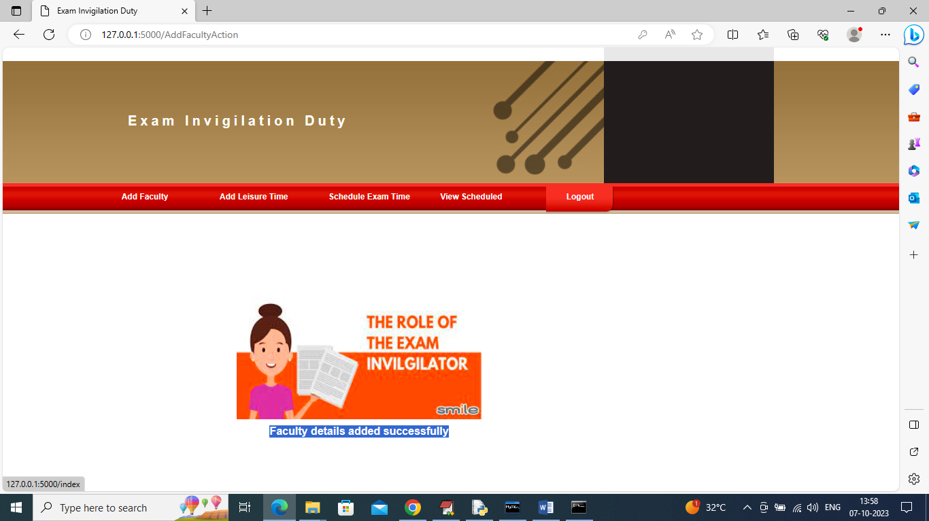

In above screen in blue colour text we can see ‘faculty details added’ and similarly you can add any number of faculty and now click on ‘Add Leisure Time’ link to add leisure time for faculty

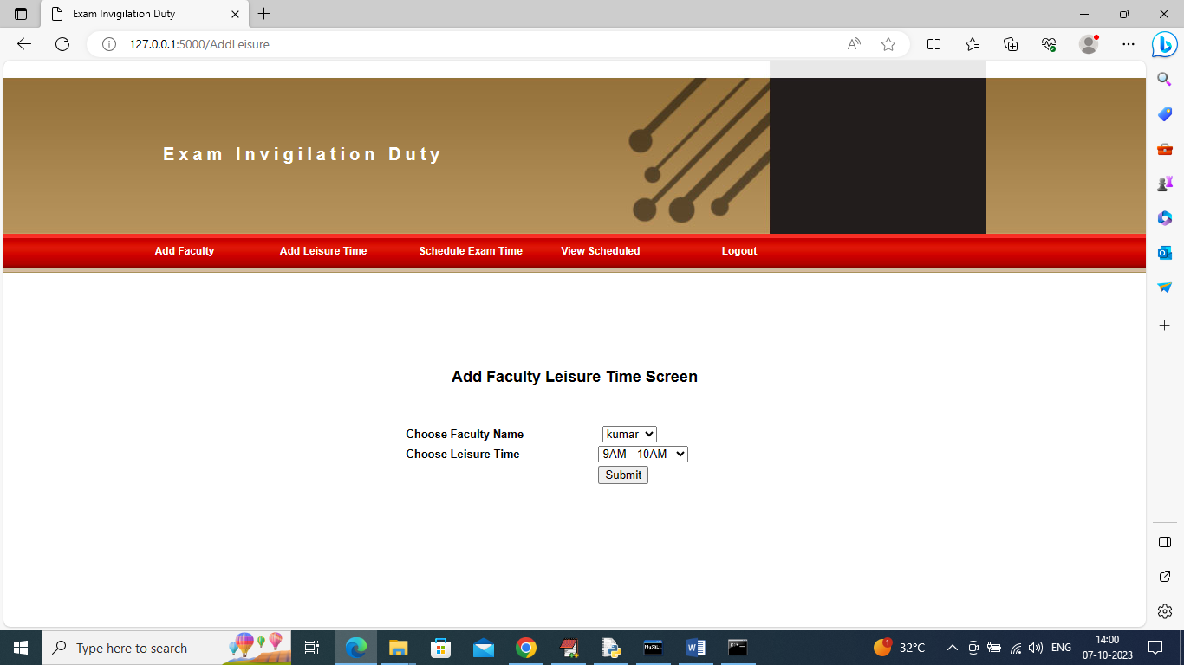

In above screen admin will select invigilator name and then choose his leisure time to add free time details and get below page

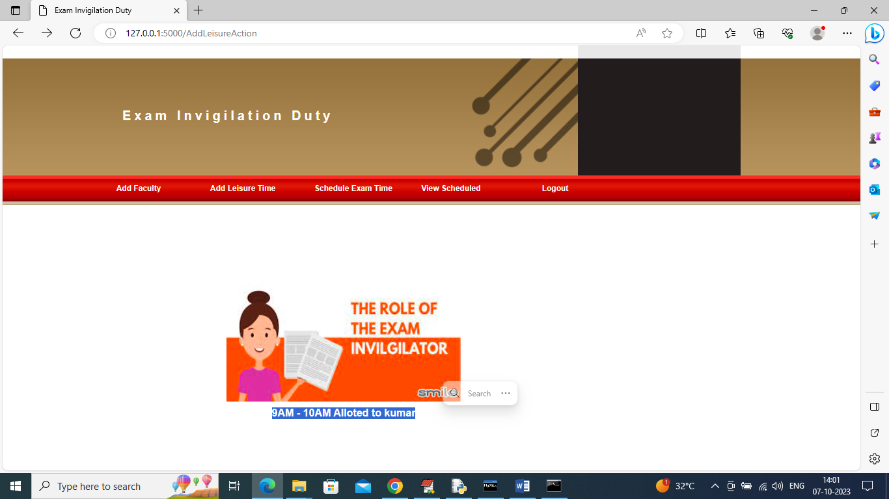

In above screen in blue colour text can see leisure time added to selected faculty kumar and similarly you can assign to many faculties. Now click on ‘Schedule Exam Time’ link to get below page

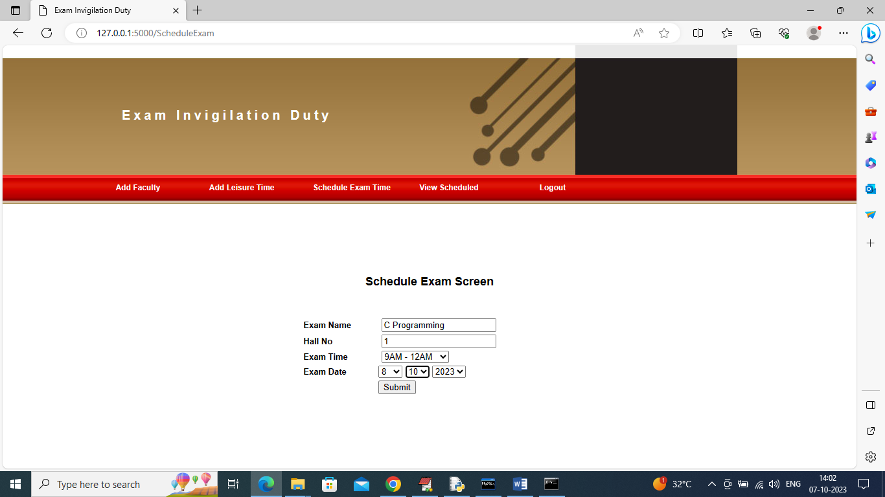

In above screen admin will enter exam details and then select date and time and then press button to get below list of available invigilators on exam time

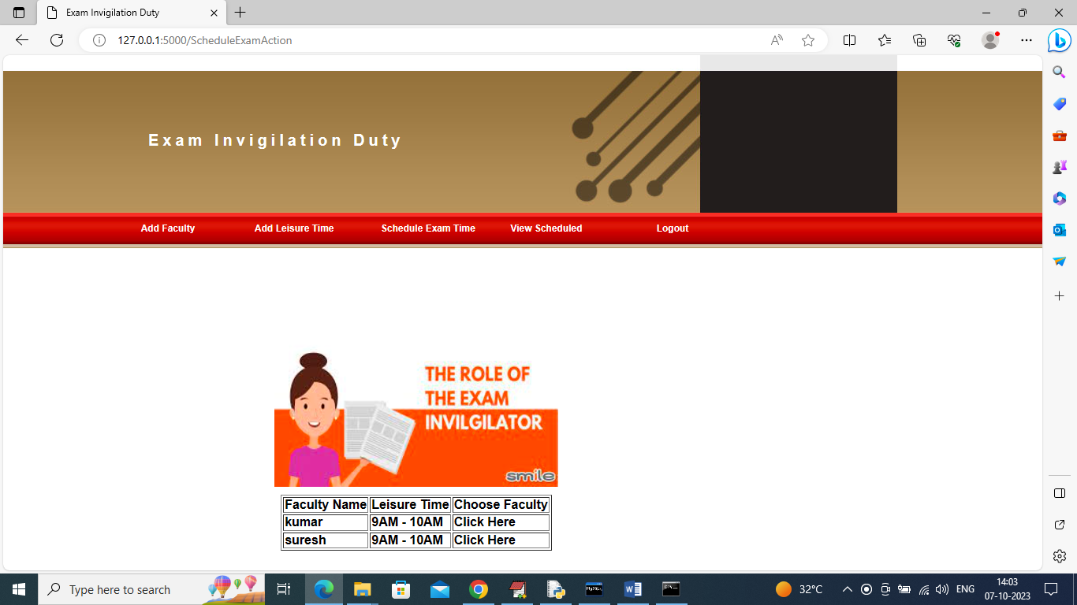

In above screen admin can view list and then click on ‘Click Here’ link to allot that invigilator for selected exam

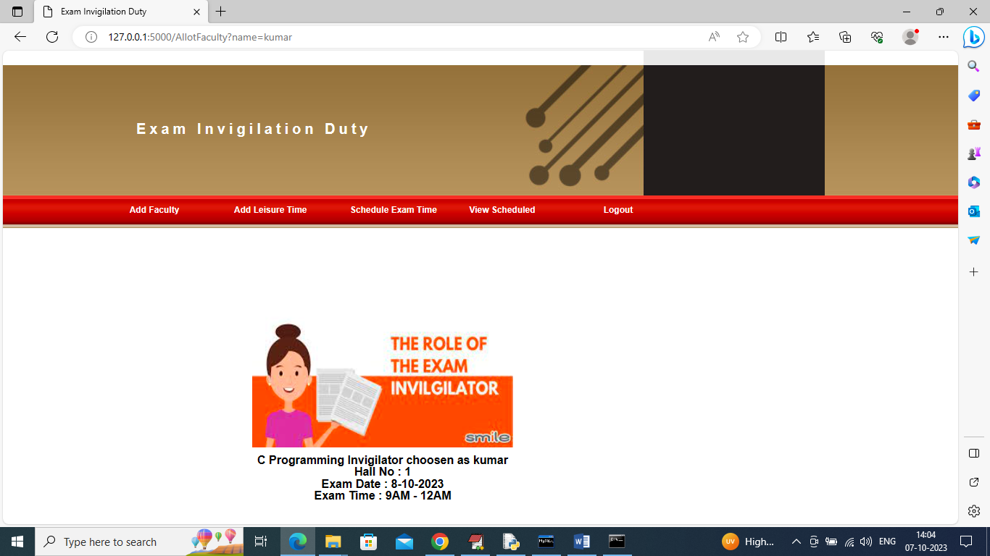

In above screen admin can details of selected invigilator for particular exam with date and time. Once allotted then his name will not show for next allotment on same date. In similar way you can assigned exam to other invigilators and now click on ‘View Schedules’ link to get below page

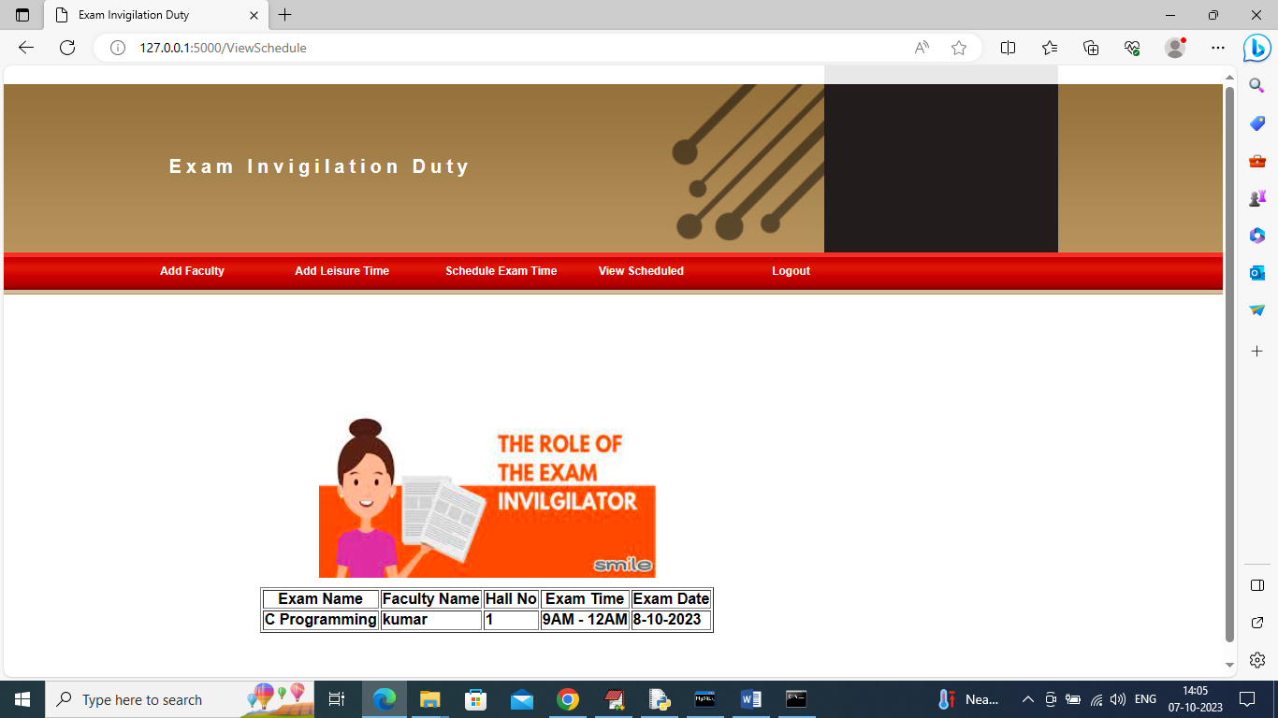

In above screen admin can view list of allotted invigilator for particular exam and now logout and login as ‘Invigilator’ to view his allotted details

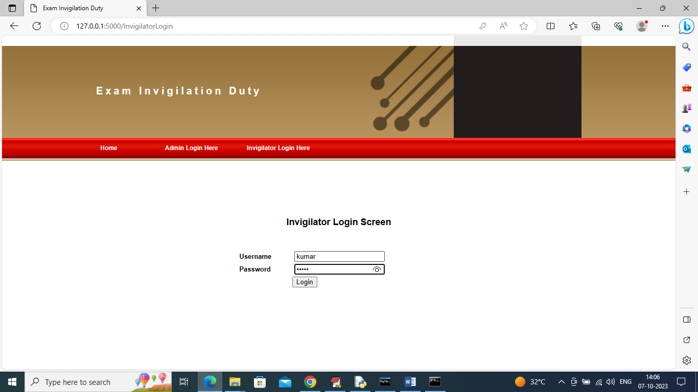

In above screen invigilator is login and after login will get below page

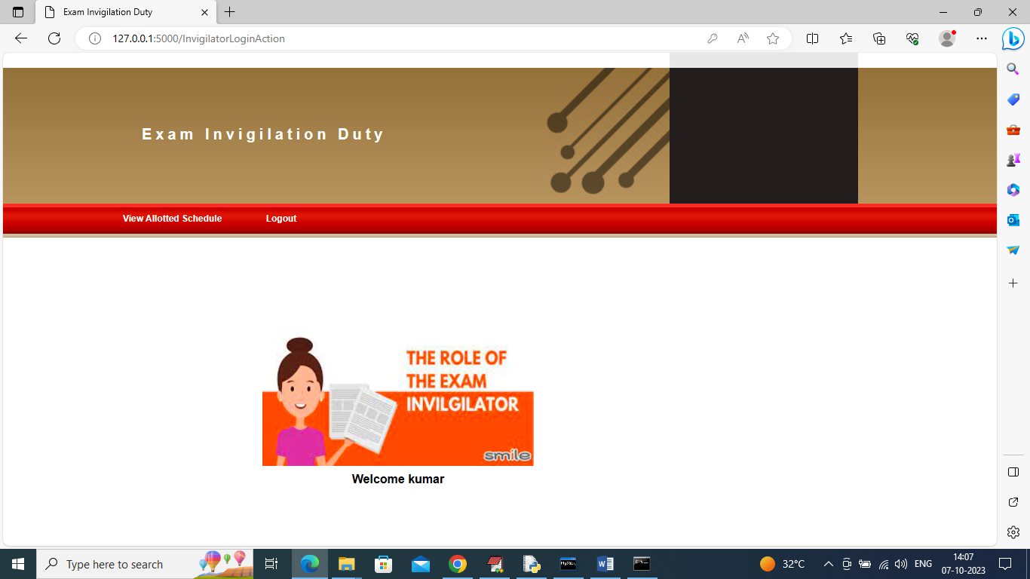

In above screen invigilator can click on ‘View Allotted Schedules’ link to view his allotted exam invigilation like below page

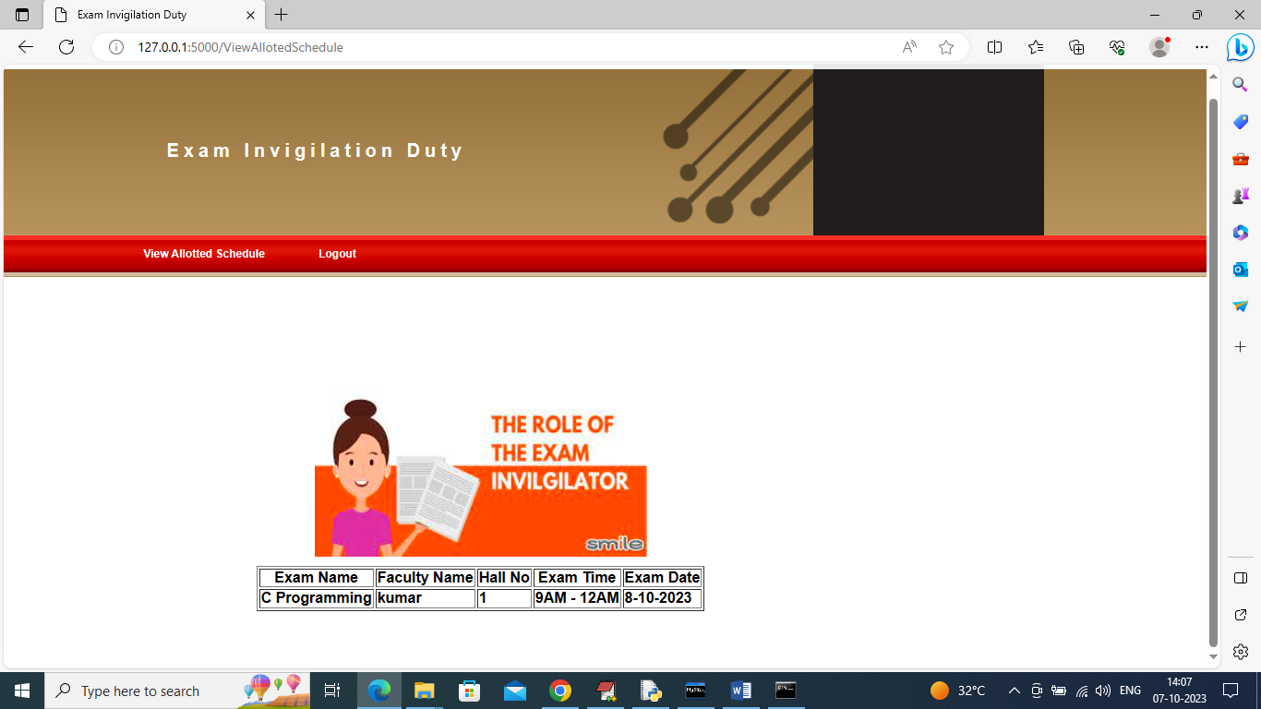

In above page invigilator can view details of exam with hall number, date etc.

In same way by following above screens you can allot invigilation’s to any number of faculties