TRANSFER LEARNING-BASED CLASSIFICATION OF POULTRY SDISEASES FOR ENHANCED HEALTH MANAGEMENT

__________________________________________________________________

Submitted by: Bandi Pavani

Roll No: 228X1A0503

Class: IV Year CSE

Kallam Haranadha Reddy Institue of Technology

Submission Date: July , 2025

1. INTRODUCTION

1.1 Project Overview

This project aims to develop a mobile-friendly, AI-powered poultry disease diagnosis system using transfer learning. It classifies images into four categories: Salmonella, Newcastle Disease, Coccidiosis, and Healthy. This system improves early detection, reduces economic losses, and enhances poultry health management.

1.2 Purpose

To enable farmers and poultry handlers to identify diseases using only fecal images via a simple mobile interface, providing real-time, affordable, and accurate disease classification.

2. IDEATION PHASE

2.1 Problem Statement

Farmers often lack access to timely veterinary services and lab testing. This delay in diagnosis leads to disease spread and financial losses. There is a need for a rapid, low-cost diagnostic tool.

2.2 Empathy Map Canvas

Says: "I need a faster way to identify what's wrong with my poultry."

Thinks: "Lab tests take too long and cost too much."

Feels: Frustrated, anxious about livelihood.

Does: Uses mobile phone for basic tasks; lacks veterinary knowledge.

2.3 Brainstorming

Ideas evaluated:

- Image-based disease recognition

- Symptom-based chatbot

- Smart wearable for chickens (rejected due to impracticality)

Finalized idea: Mobile app using transfer learning to classify fecal images.

3. REQUIREMENT ANALYSIS

3.1 Customer Journey map

|  |  |  |
| --- | --- | --- |
| Step | Action | Experience |
| 1 | Capture image | Easy with mobile |
| 2 | Upload to app | User-friendly UI |
| 3 | Get prediction | Fast, clear result |
| 4 | Take action | Suggested remedies |

3.2 Solution Requirement

Dataset with annotated fecal images

Pre-trained CNN models

Flask backend for inference

Simple frontend with image input

3.3 Data Flow Diagram

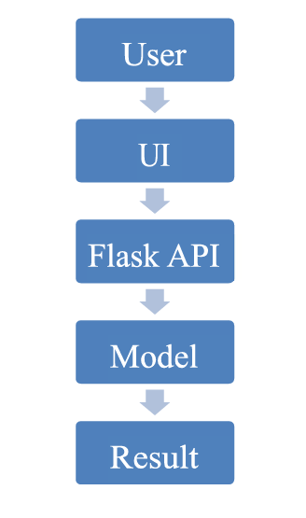

3.4 Technology Stack

Python, Flask

TensorFlow/Keras

HTML/CSS (UI)

Google Colab(Not Used)/VS Code(Used) (training)

4. PROJECT DESIGN

4.1 Problem Solution Fit

The model addresses a major gap in accessible poultry healthcare by giving immediate diagnosis capability to farmers via smartphones.

4.2 Proposed Solution

Transfer learning-based image classifier (MobileNetV2/VGG16) trained on poultry fecal images to predict the disease class.

4.3 Solution Architecture

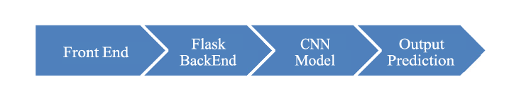

5. PROJECT PLANNING & SCHEDULING

5.1 Project Planning

|  |  |
| --- | --- |
| Date | Task |
| June 9 | Defined problem and tech stack |
| June 10 - 12 | Collected and prepared dataset |
| June 13 - 15 | Image preprocessing and augmentation |
| June 16 - 18 | Implemented VGG16 and MobileNetV2 |
| June 19 - 21 | Model evaluation and hyperparameter tuning |
| June 22 - 23 | Flask integration |
| June 24 - 25 | Frontend HTML page creation |
| June 26 | Testing model with UI |
| June 27 | Final evaluation and screenshots |
| June 28 | Documentation and GitHub upload |

6. FUNCTIONAL AND PERFORMANCE TESTING

6.1 Performance Testing

Accuracy: ~97% (MobileNetV2)

Precision/Recall/F1 evaluated with confusion matrix

Lightweight inference time for real-time prediction

7. RESULTS

7.1 Output Screenshots

Screenshot 1: Home Page

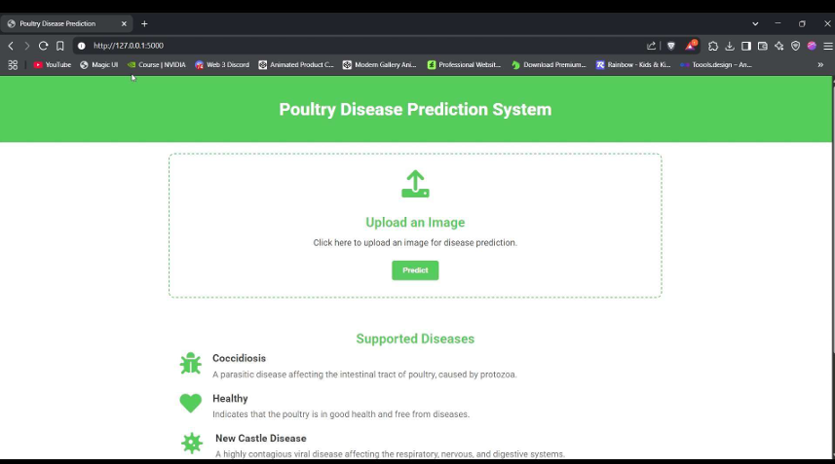

Image Upload

Screenshot 2: Predicted Result Displayed

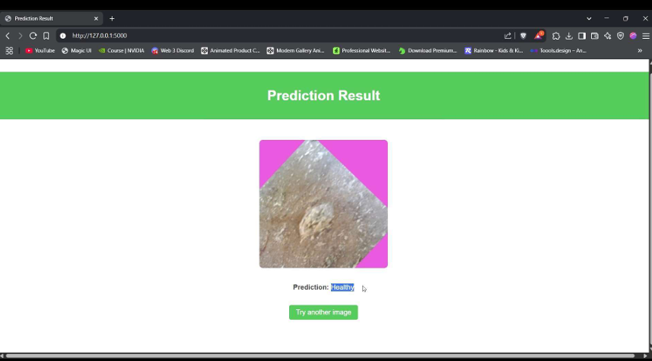

8. ADVANTAGES & DISADVANTAGES

Advantages

- Real-time, accessible, and low-cost

- Lightweight and mobile-compatible

- High accuracy with minimal training data

Disadvantages

- Limited by quality of training data

- May not work with new/unseen environments

- Needs GPU for initial training

9. CONCLUSION

Conclusion

This system demonstrates that transfer learning can effectively classify poultry diseases from fecal images with high accuracy. Its integration into a mobile app provides a practical solution for farmers.

10. FUTURE SCOPE

Future Enhancements

- Add more diseases - Convert to TensorFlow Lite for mobile deployment - Add multilingual support and GPS-based recommendations

11. APPENDIX

Source code https://github.com/susmitha-50/Transfer-learning-based-classification of-poultry-diseases-for-enhanced-health-management-

Demo Link

Google Drive link (public) – https://drive.google.com/file/d/186y9ZKB6nIT2M6kWaFdqzJxcCw4DQNUO/view?usp=sh aring