CH.V.V.S.PAVANI

Analyst

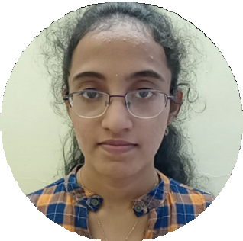

# PROFILE

Training under : I - Transform Base Location : Bangalore Email ID :

chinchinadavvspavani@gmail. com

Mobile Number : 9618573975 Grade : A3

# EDUCATION

BSC (Computer Science) : 2019-2022

# CERTIFICATIONS

Microsoft Azure AZ-900

Microsoft Azure AZ-104

# ADD ON SKILLS

Peer Learning, Team

Management, Communication Skills

Check out my work on

[GitHub](https://github.com/Pavani131)

# STRENGTHS

## FULL STACK DEVELOPER

Full Stack developer with Angular and .Net Hands on experience on C#, ADO.NET,

LINQ, ENTITIY FRAMEWORK, SQL SERVER,

ASP.NET MVC with WEB API and in creating services with .NET FRAMEWORK.

Proficient in creating single web page

applications in angular with Authentication with Routing. Hands on experience in

developing webpages using HTML, CSS, OBJECT ORIENTED, TYPE SCRIPT, ES6,

JSON, XML. Good understanding of DOM and DOM Functions.

Experience in creating Documentation with Swagger and Postman.

# ACHEIVEMENTS

## ONDEMAND CAR WASH SYSTEM

CaseStudy of ONDEMAND CAR WASH

SYSTEM along with API Gateway, Swagger, Responsive UI with HTML, CSS, BootStrap and Angular used as User Interface

# SKILLS C#

Basic, OOPS, Exception Handling, Collections

ang Generics, Arrays, Loops

# . NET

ADO.NET, ASP.NET with MVC, WEB API, Entity

Framework and .NET CORE

# DATABASE

Microsoft SQL Server

# UI TECH

HTML and CSS

# TOOLS

Git, Postman, SSMS, Visual studio, VS Code