Retail Sales Data Processing and Business Insights Generation

Usecase Overview Problem Statement
ABC Retail Solutions, a multinational retail company, operates across multiple cities through both online and offline sales channels. The organization collects transactional retail data from various systems; however, inconsistencies in the dataset such as duplicate transactions, missing values, inconsistent product naming conventions, invalid quantities, and varying date formats have created challenges in generating accurate business insights.
Without a standardized and reliable data pipeline, the company faces difficulties in analyzing revenue trends, identifying bestselling products, monitoring category performance, and making data-driven business decisions.
To improve reporting accuracy and operational efficiency, ABC Retail Solutions aims to build an end-to-end data engineering pipeline that ingests, cleans, transforms, and visualizes retail transaction data for business intelligence and reporting purposes.

Solution Architecture
The solution follows a structured data engineering workflow that transforms raw retail data into business-ready insights.
Architecture Flow
Data Ingestion
Source Files
(Product Details, Retail Data 1, Retail Data 2)
Data Cleaning & Transformation
Data Quality Assessment
Curated Retail Dataset
Power BI Dashboard
KPI Calculations

Dataset Description
The project utilizes three datasets.

Product Details Dataset
This dataset acts as a reference table containing standardized product information.

Column | Description
product_id | Unique product identifier
product_name | Standard product name
category | Product category
price | Standard product price

Retail Transaction Datasets
The retail datasets contain transactional information collected from two independent source systems.

Key attributes include:
- Transaction ID
- Customer ID
- Customer Name
- Product ID
- Product Name
- Category
- Price
- Quantity
- Discount
- City
- Purchase Location
- Transaction Date

- Payment Method
- Payment Status
- Email Address
- Phone Number

Data Quality Assessment
A detailed data profiling exercise was conducted before implementing transformations.

Observations
- Missing values were identified in the Price column.
- Product names contained inconsistent formatting and capitalization.
- Category values were represented using multiple formats.
- Transaction Date was stored as an object datatype.
- Customer email and phone fields contained personally identifiable information (PII).
- Multiple source datasets required consolidation into a single reporting dataset. These issues were addressed through a structured data cleaning strategy.

Data Cleaning and Transformation Strategy

Dataset Consolidation
The two retail transaction datasets were merged into a unified dataset to create a single source of truth for reporting and analytics.

Missing Price Handling
Several transaction records contained missing price values.
To resolve this issue, a product-price lookup was created using the Product Details
reference dataset. Missing prices were populated using the corresponding Product ID.

Reason:
This approach ensured accurate revenue calculations while maintaining consistency with the organization's master product catalog.

Category Standardization
The category column contained multiple representations of the same business category.

Original Value | Standardized Value
ELEC | Electronics
electronics | Electronics
FURN | Furniture
furniture | Furniture
HOME | Home Appliances

Product Name Standardization
Product names were stored using inconsistent capitalization and formatting.

Original Value | Standardized Value
PHONE | Phone
phone | Phone
LAPTOP | Laptop
mixer grinder | Mixer Grinder

Standardization was performed using string cleaning techniques and title-case formatting.

Reason:
Consistent product naming improves product-level analysis and reporting.

Date Standardization
The Transaction Date column was converted from object datatype to datetime datatype.

Reason:
This enables time-based reporting, trend analysis, and date intelligence features in Power BI.

Business KPIs
The transformed dataset was used to generate the following key business metrics.

Total Revenue
The organization generated approximately ₹1.23 Billion in total revenue across all retail transactions.

Revenue by Category
Category-level analysis revealed that:
- Electronics generated the highest revenue contribution.
- Home Appliances and Furniture contributed significantly to overall sales.
- Clothing generated the lowest revenue among the major categories.

Revenue by City
City-level analysis showed:
- Chennai generated the highest revenue.
- Delhi and Hyderabad followed closely.
- Bangalore recorded the lowest revenue among the analyzed cities.
These insights help identify high-performing markets and product segments.

Power BI Dashboard
An interactive Power BI dashboard was developed to provide business users with a consolidated view of retail performance.

Dashboard Components
- Total Revenue KPI Card
- Revenue by Category Analysis
- Revenue by City Analysis
The dashboard enables stakeholders to quickly evaluate business performance and identify key revenue drivers.

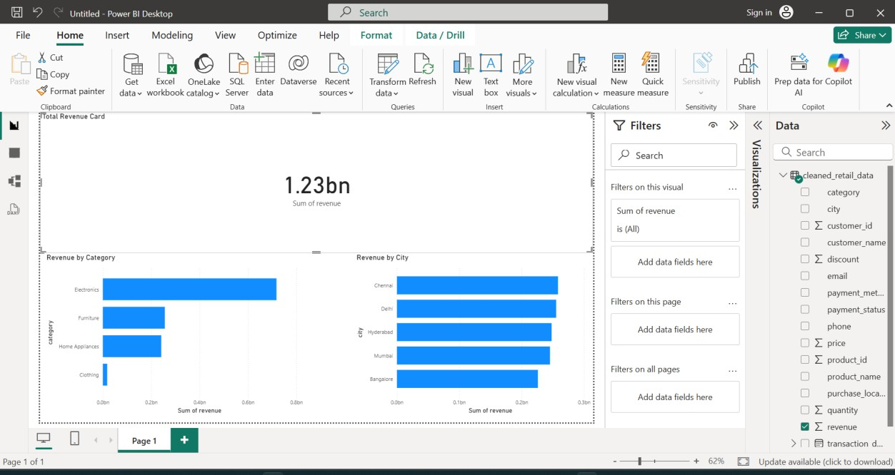

Results and Business Insights

Summary of Key Results
After data cleaning, transformation, and KPI generation, the following business insights were obtained:

KPI | Result
Total Transactions | 8,494
Total Revenue | ₹1.23 Billion
Categories Analyzed | 4
Cities Analyzed | 5
Successful Payments | 8,000
Failed Payments | 494

Revenue Analysis
The total revenue generated across all retail transactions was approximately ₹1.23 Billion. This indicates strong sales performance across multiple product categories and cities.

Category Performance
Category-wise revenue analysis revealed:

Category | Revenue
Electronics | ₹717.58 Million
Home Appliances | ₹241.37 Million
Furniture | ₹256.29 Million
Clothing | ₹18.02 Million

Key Observation
Electronics contributed the highest share of revenue and emerged as the organization's best-performing category. Clothing contributed the least revenue among the analyzed categories.

City Performance
City-wise revenue analysis produced the following results:

City | Revenue
Chennai | ₹258.32 Million
Delhi | ₹255.35 Million
Hyderabad | ₹248.04 Million
Mumbai | ₹245.47 Million
Bangalore | ₹226.09 Million

Key Observation
Chennai generated the highest revenue, indicating strong customer demand and sales activity in that region. Bangalore recorded the lowest revenue among the analyzed cities.

Payment Method Analysis
Revenue contribution by payment method showed that digital payment methods were widely adopted by customers.

Observation
- UPI and Card payments accounted for a significant portion of transactions.
- Cash transactions remained relevant but were comparatively lower than digital payment methods.

Payment Status Analysis

Payment Status | Count
Successful | 8,000
Failed | 494

Overall Business Insights
The analysis highlights the following key findings:
- Electronics is the most profitable product category.
- Chennai is the highest revenue-generating city.
- Digital payment methods dominate customer transactions.
- The retail business demonstrates strong overall revenue performance.
- Data standardization significantly improved reporting accuracy and consistency.

Dashboard Snapshot
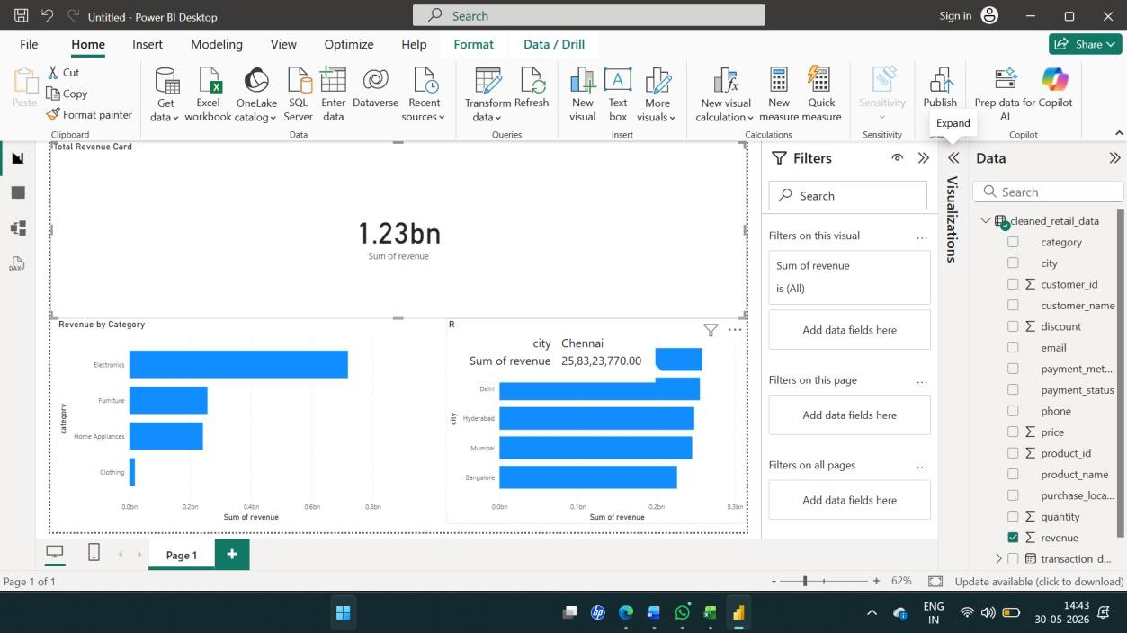

Conclusion
The project successfully implemented a retail data engineering pipeline involving data
ingestion, cleaning, transformation, KPI generation, and Power BI reporting. The solution improved data quality and enabled accurate business insights for decision-making.

