Created new Directory : mkdir git

Initialized that: git init

Copied git readme file to that folder

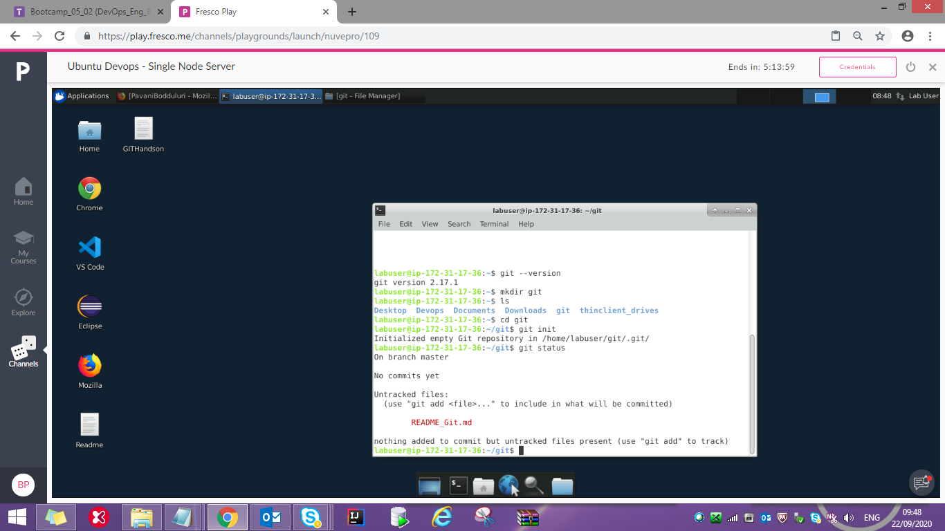

Added and committed newly added file to staging area:

git add .

git commit –m “ReadMe”

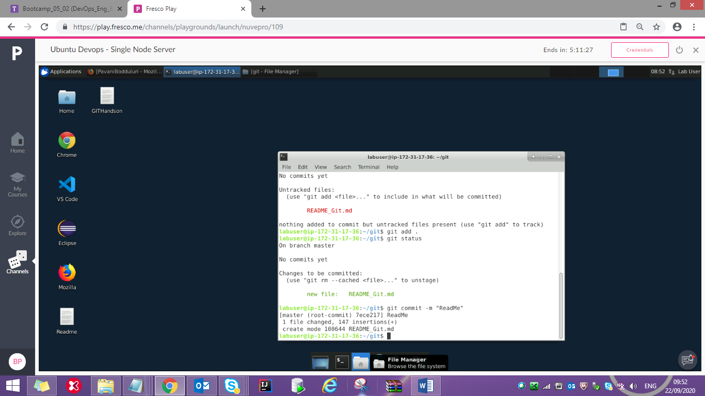

Added newly created repository as our remote repository

git remote add origin <https://github.com/PavaniBodduluri/GitHandsOn.git>

Cloning an existing repository

git clone <https://github.com/PavaniBodduluri/SpringBoot.git> springboot

Creating and deleting branch:

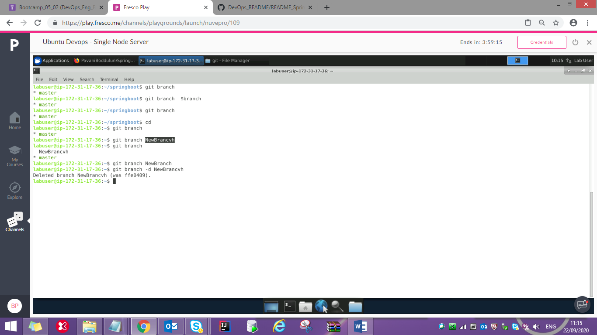

git log

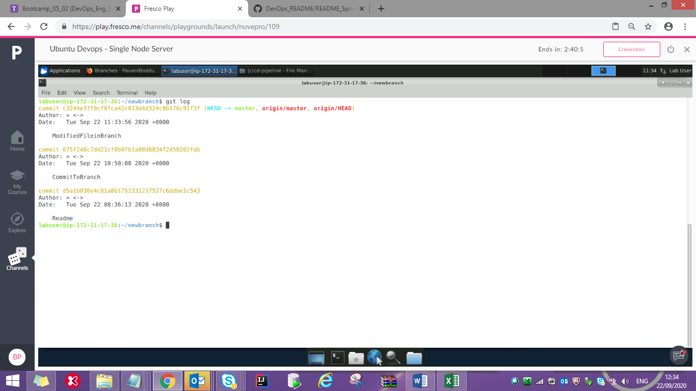

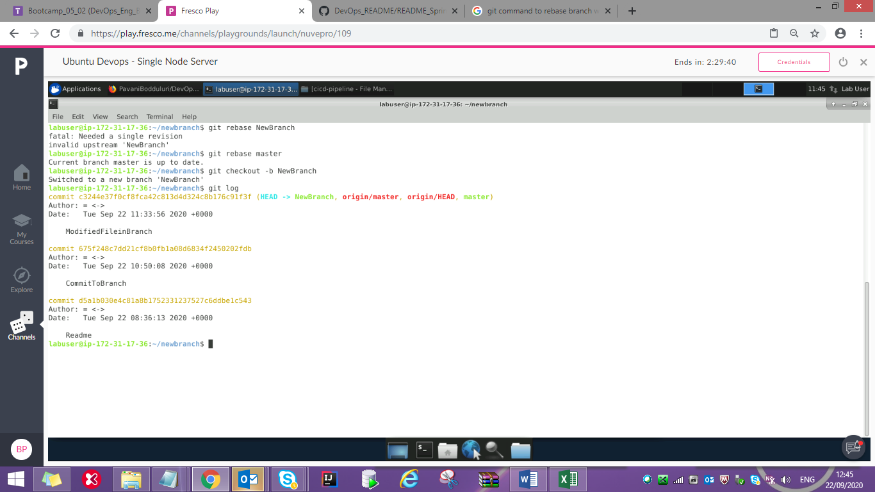

Reverted a commit

