**Assignment 3: Exploring Memory Hierarchy Design in gem5**

Pavani Chavali

Department of Computer Science, University of The Cumberlands

MSCS-531-A01: Computer Architecture and Design

Professor. Vanessa Cooper

Date: 9/13/2025

## 

**Configuration files**

**Cache.py:**

**Used to change the cache values using command line aruguments**

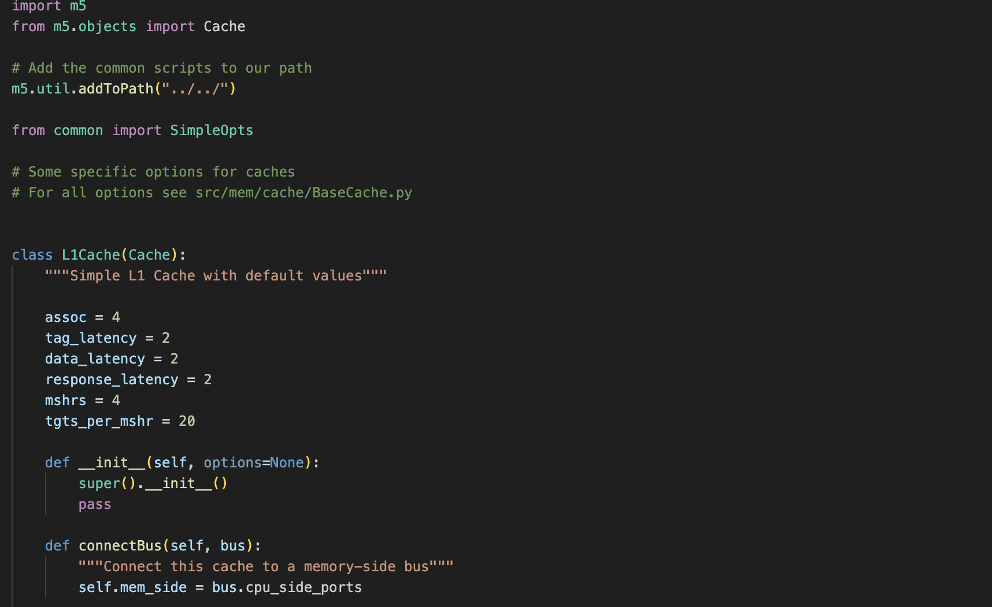

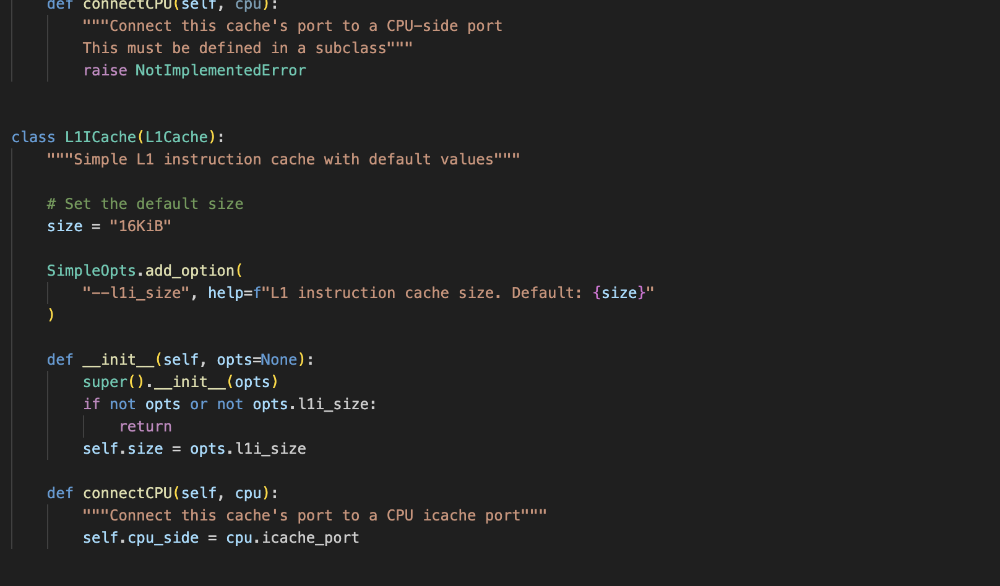

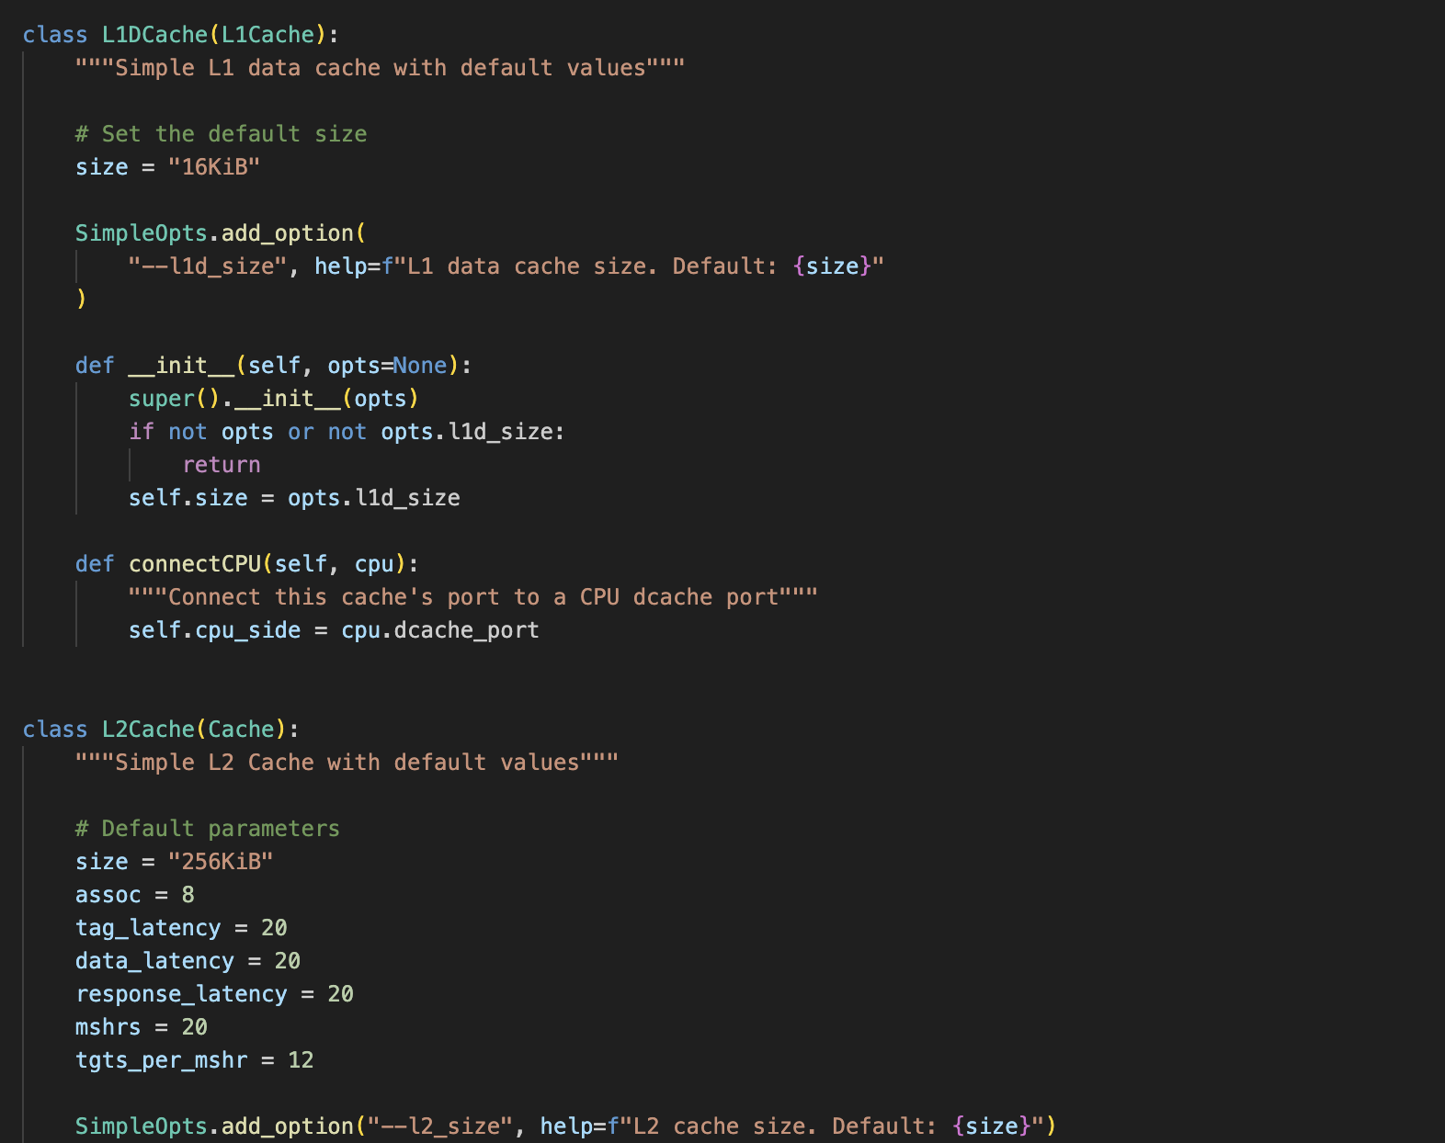

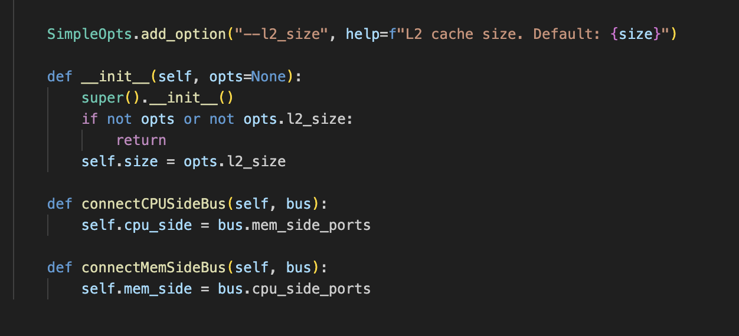

**Se.py**

**Used this file to give input values for cache sizes and associative values**

