**The following are the results of project version 3 implementation.**

**1. Input statement**

**Input:** input x

y <- x+2

display y

**Output:**

**2. block Statement:**

**Input:** block

x <- 2.3 + (4.4*2)

display x

end

**Output:**

**3. If statement:**

**Input:**

input x

if x=0 then

x <- x+1

else

x <- x-1

end

#displaying the result

display x

**Output:**

**4. while statement:**

**Input:** while x < 5

do

block

display x

x <- x+1

end

end

**Output:**

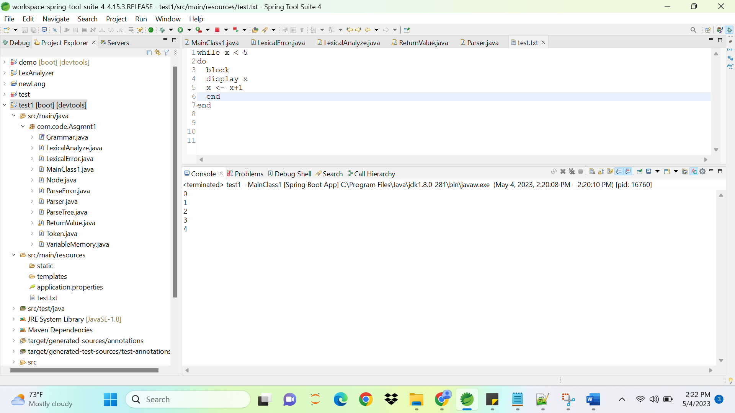

**5. Repeat statement:**

**Input:** repeat

block

display x

x <- x+1

end

until x >= 5

**Output:**

**6. printing Fibonacci series with this toy programming language**

**Input:**

input count

n2 <- 1

n1 <- 0

#printing 0 and 1

display n1

display n2

i <- 2

while i < count # loop to print the rest

do

block

n3 <- n1+n2

display n3

n1 <- n2

n2 <- n3

i <- i+1

end

end

**Output:**

