CS551 Advanced Software Engineering

Assignment 3

Pavani Sree Lakshmi Penumathsa

16149283

**Mobile Web Client Application:** eBay and Walmart Product Comparision.

This application performs both the Lab 3 Assignment Tasks, HTML5 Local Data Storage and Mashup Application which is an extension to my Lab 2 Application – eBay Search.

1. The main screen provides an option to search for same product on eBay and Walmart. Using this App the user can easily compare the prices for a product in these different shops and pick the one with less price.
2. Create account with eBay and Walmart to get access to their Search API’s. Used the API keys provided, in the Search URL to fetch the corresponding product details. This is Mashup Application.
3. Enter the product you want to search in the “ProductName” and click on the “Search” button in the main screen “Search Products:eBay & Walmart”.

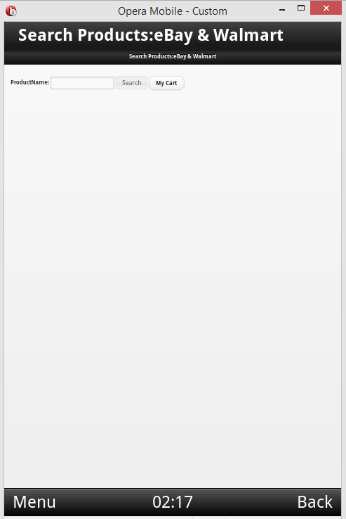

1. This will display the related products both from eBay and Walmart stores with the product names and their respective process in a tabular format as shown in the below screen. E represents eBay and W represents Walmart.

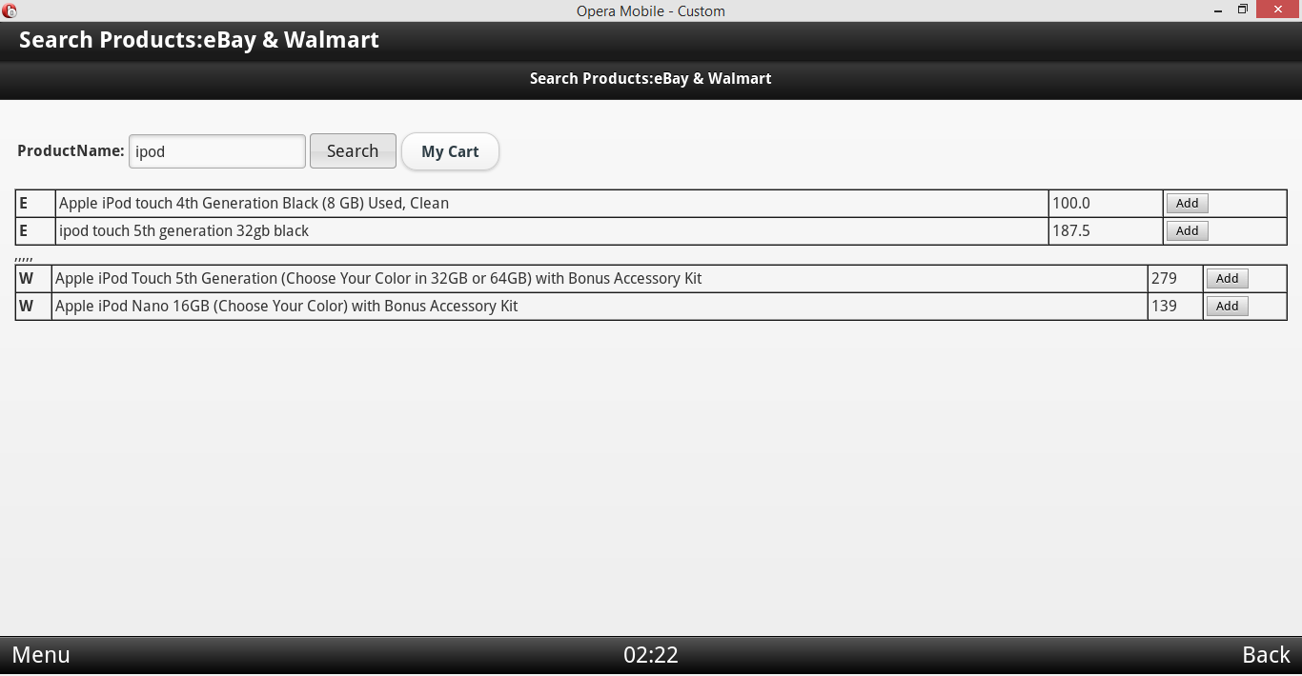

1. There is an “Add” button next to each product using which you can add the respective products to the “My Cart”.
2. Added two products to the “My Cart” and clicked on “My Cart” button in the main screen.

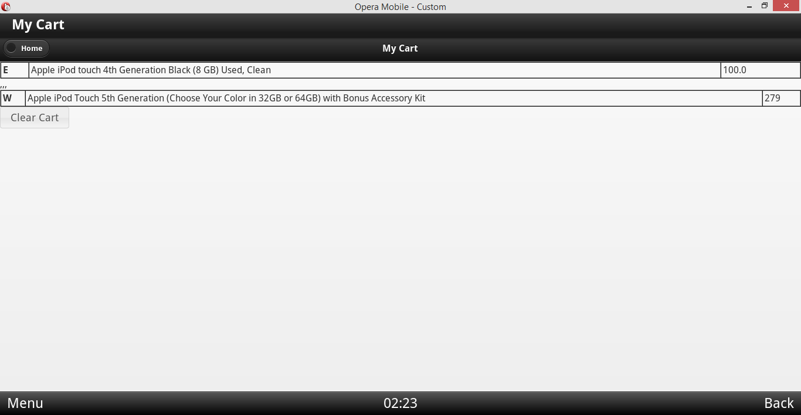

1. This will navigate to the “My Cart” screen where the list of products added to the cart will be displayed as shown in the above screen.
2. Click on the “Home” button to go back to the main screen.

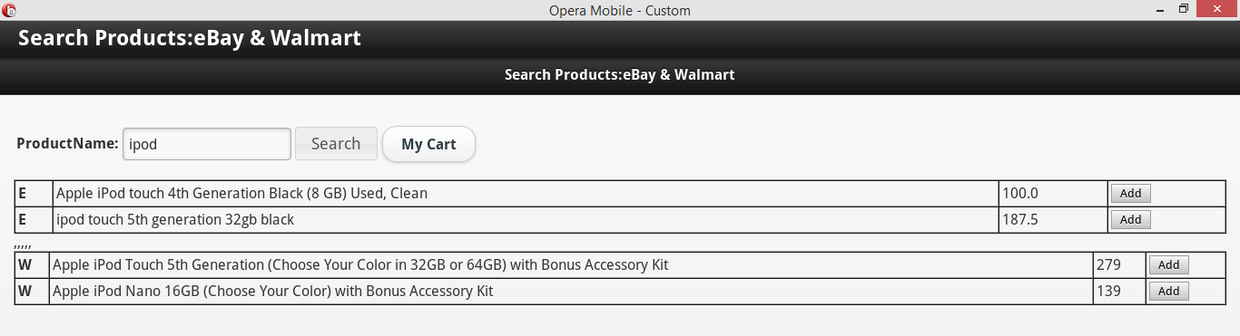

1. Click on the “My Cart” button to view the products in the cart.

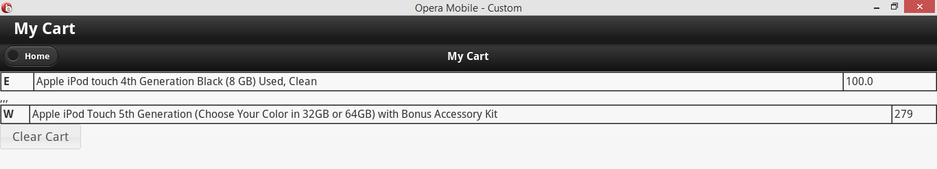

1. By clicking on the “Clear Cart” button in the “My Cart” screen we can remove all the items from the cart.

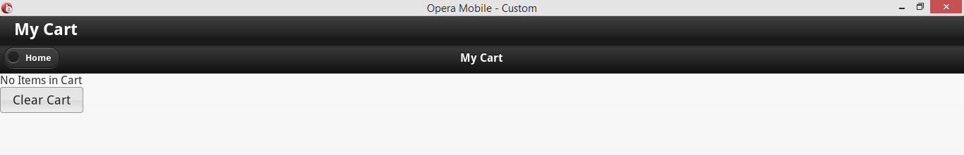

1. Go back to the main screen, the products list based on the search is still available in this screen.

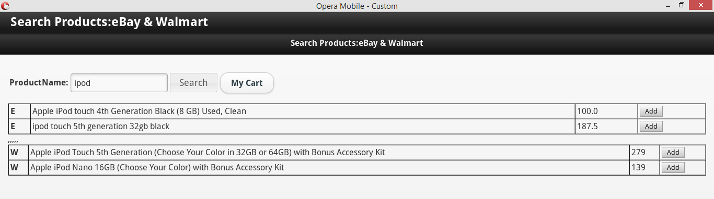

1. Click on the “My Cart” button now, all the products are cleared completely from the “My Cart”. This is HTML5 Local Data Storage implementation.

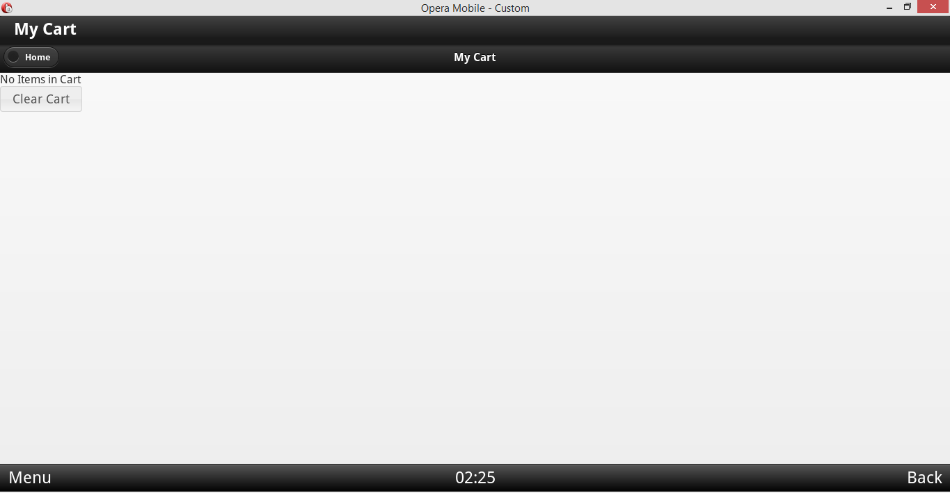

1. eBay and Walmart Product Comparision APP using REST Web Services:

The REST Web Service accessed is developed referring the steps in the ASE Tutorial 5.

Click on the “Sale” button to display the Sale Ad.

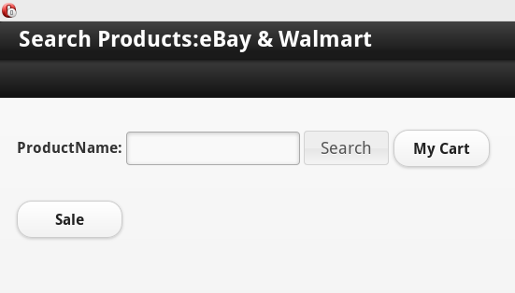

The Web Service is accessed to display the below Sale Ad.



**References:**

ASE Tutorials.

http://developer.ebay.com/DevZone/finding/HowTo/GettingStarted_PHP_NV_XML/GettingStarted_PHP_NV_XML.html