CS551 Advanced Software Engineering

Assignment 1

Pavani Sree Lakshmi Penumathsa

16149283

**Task 1:** Design Class Diagram/Sequence Diagram using Visio for the InClass Exercise.

1. Home Security System : Class Diagram
2. Operator programs the Security System. Operator can Activate/Deactivate the system by entering the security code.
3. Controller: sets the Alarms on/off, threshold levels for the sensors as per Operator.
4. Sensor handles the different type of sensors.
5. Alarm sets on if any of the sensor detects unusual things.
6. Display system displays the sensor that went off and makes calls.

The EntrySensor, SmokeSensor, TempSensor and FloodSensor classes inherits threshold values and Alarm on/off attributes, and setThreshval method from the Sensor class.

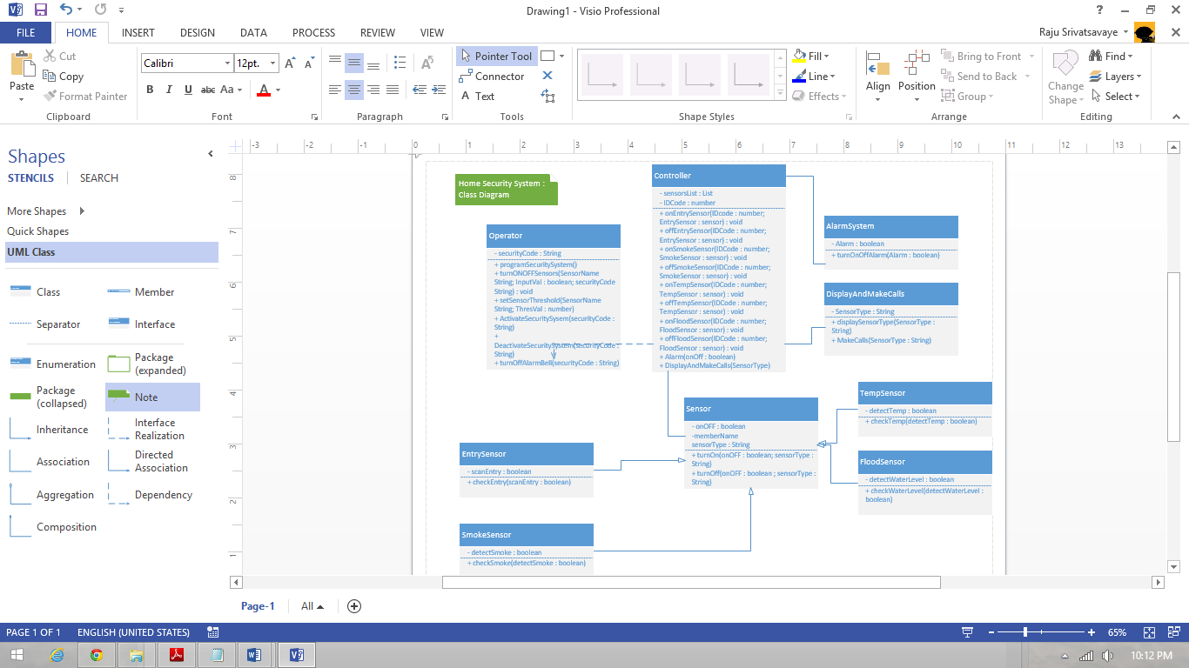

b) Sequence Diagram

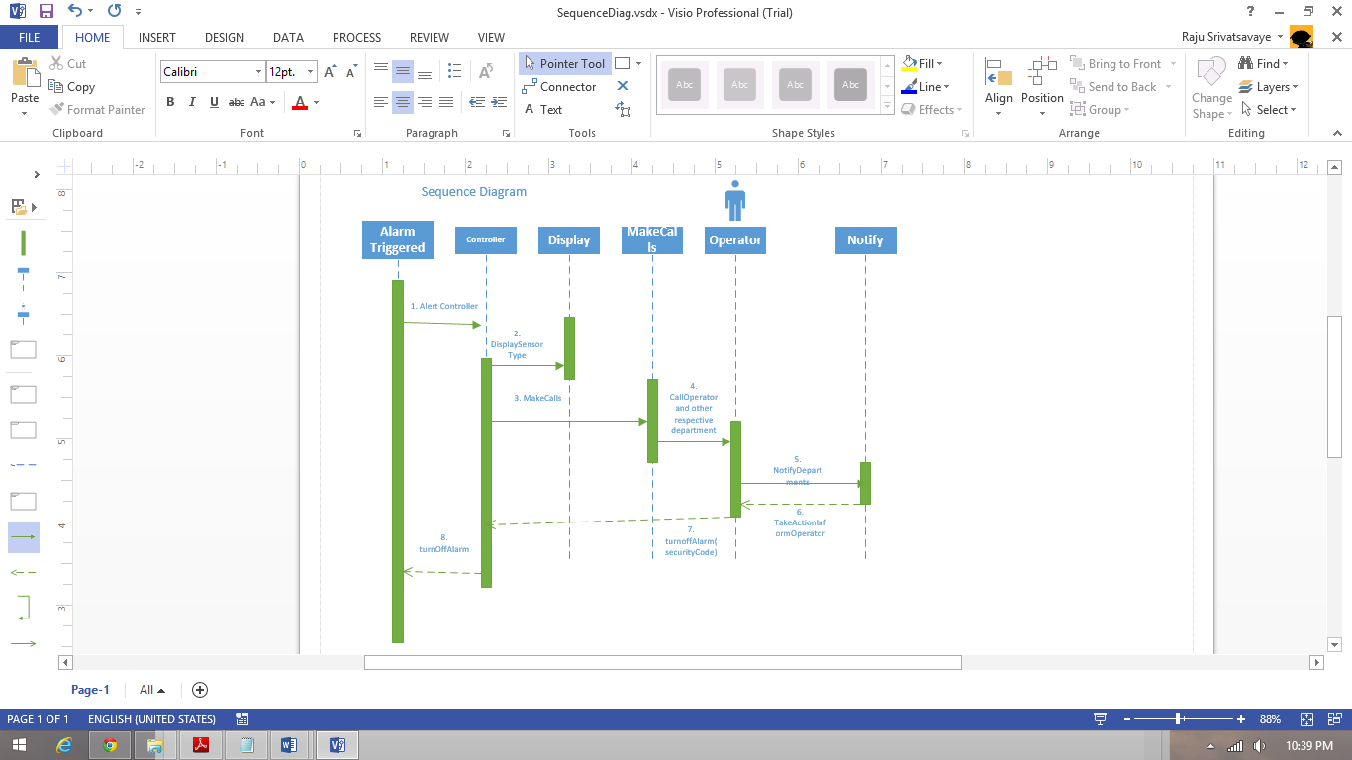

**Task 2:** Create GitHub account

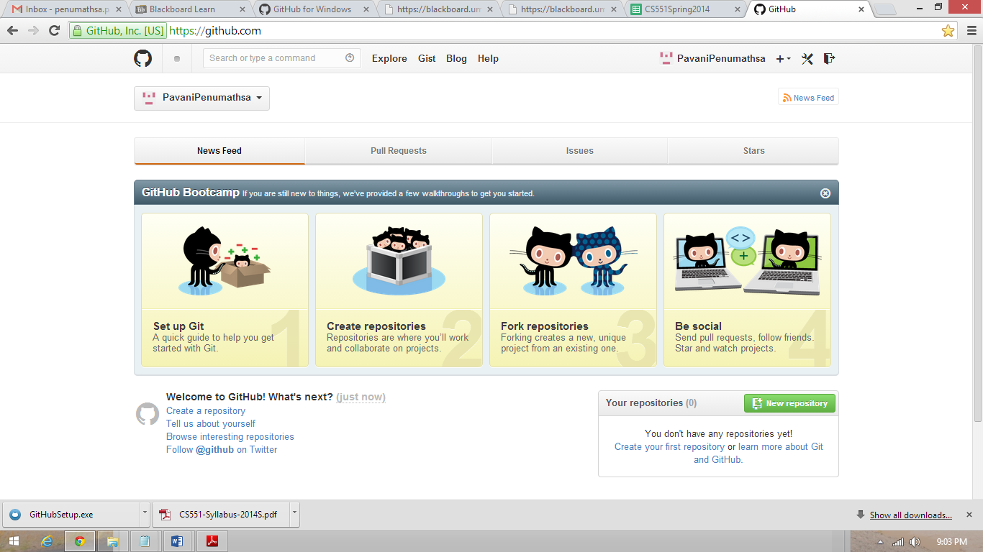

**Task 3:** Create ScrumDo account and define task/plan/delivery for your lab 1 assignment

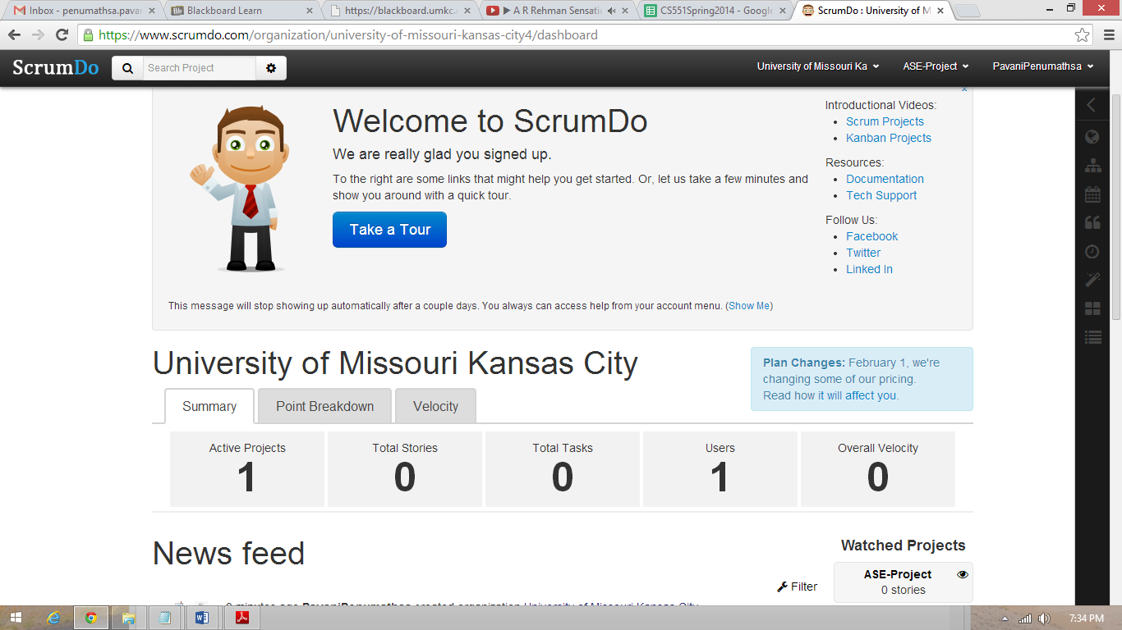

**Create Project:**

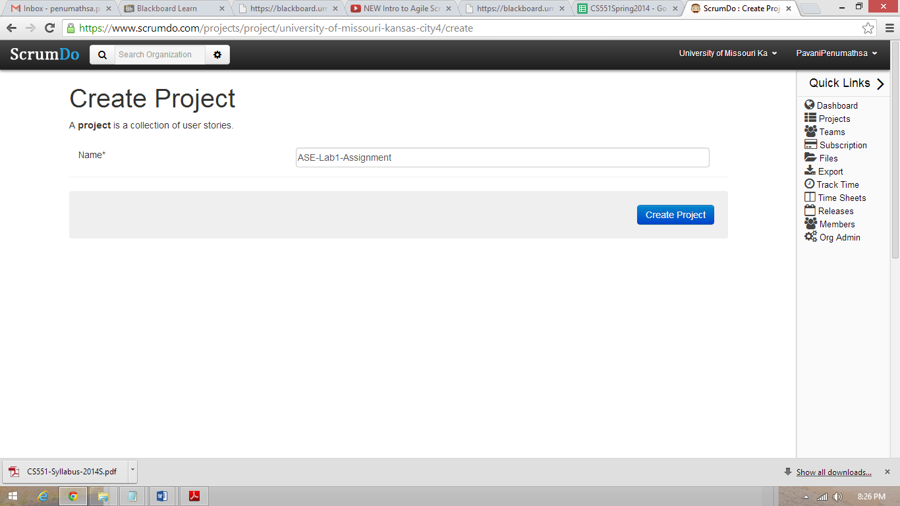

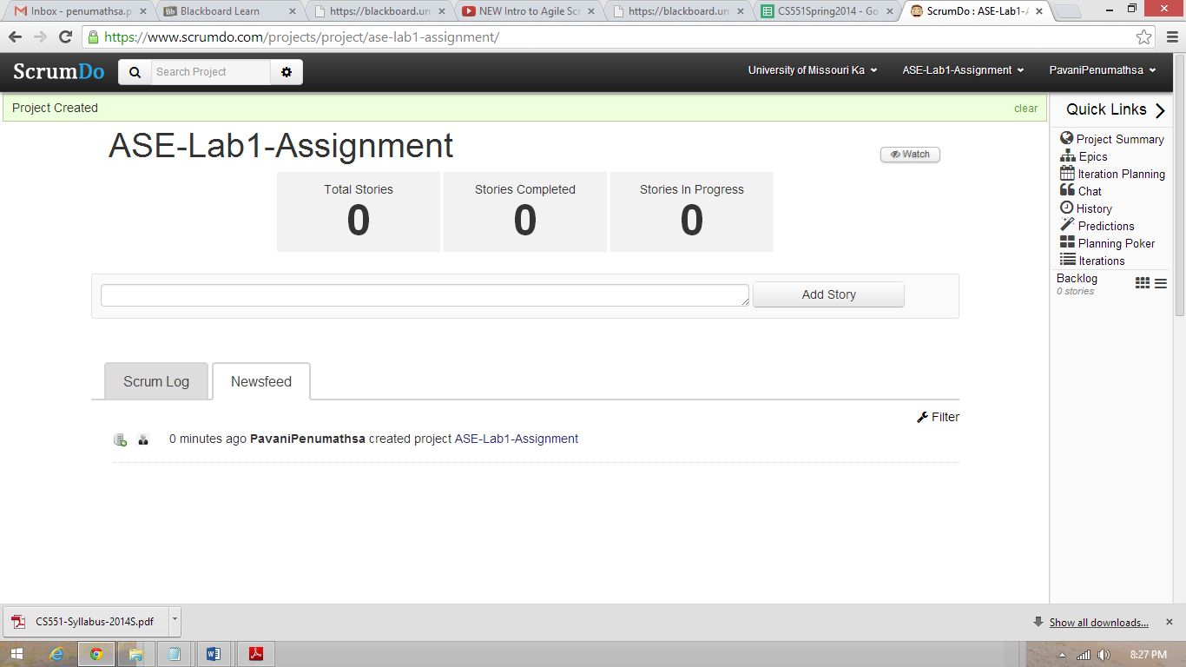

**Create Stories:**

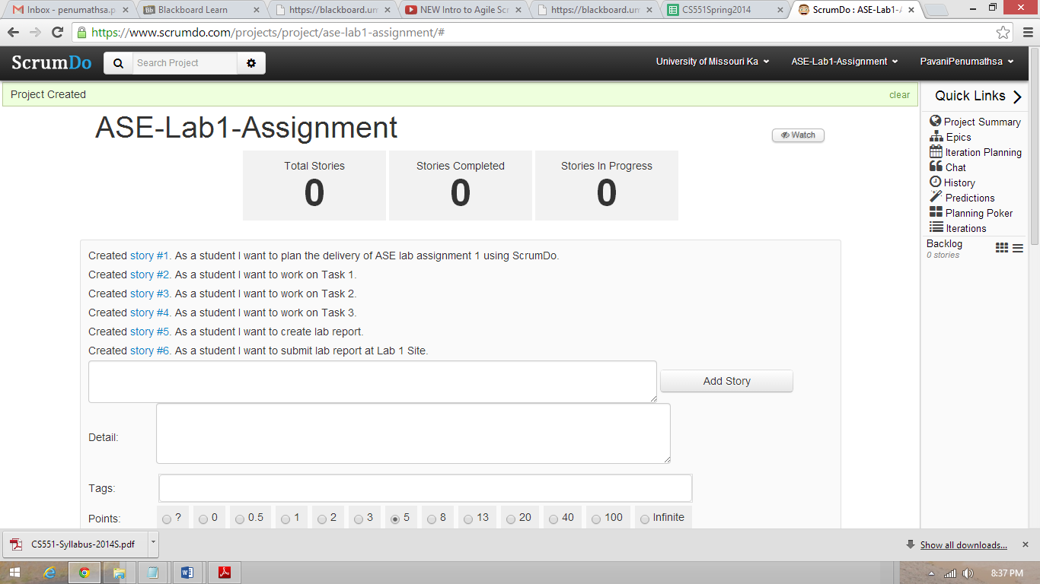

**Create Iteration:**

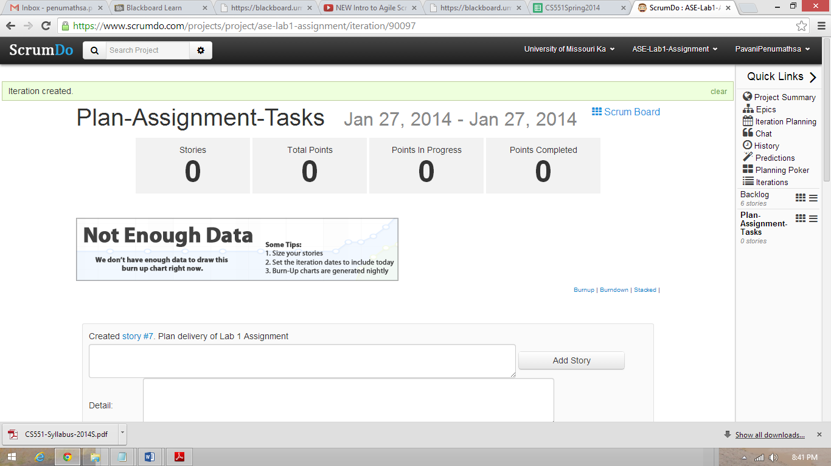

**Backlog:**

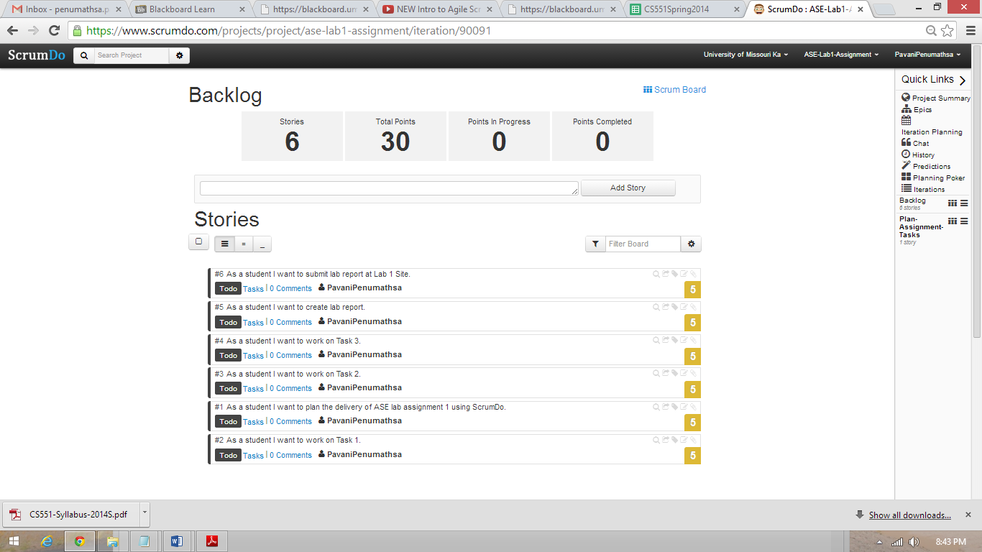

**Scrumboard:**

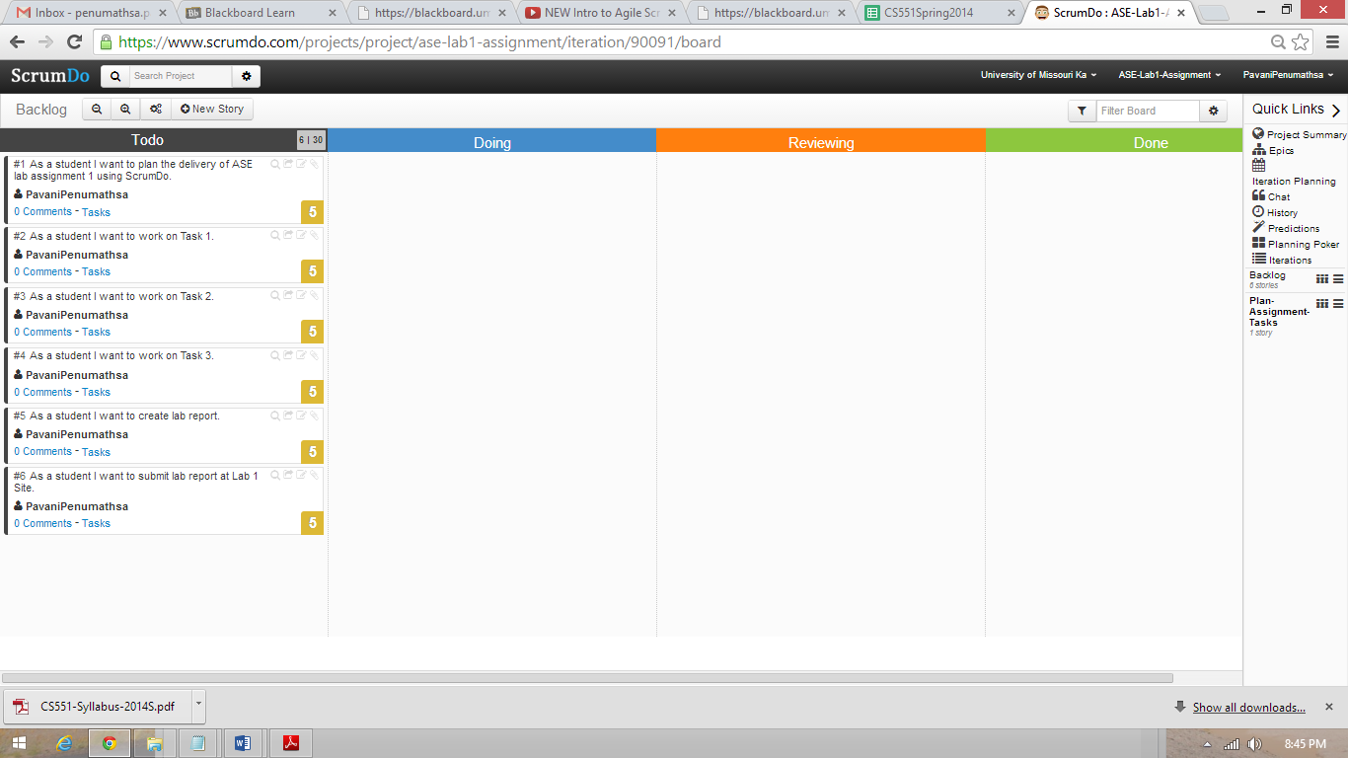

**Scrumboard for Plan-Assignment-Tasks iteration:**

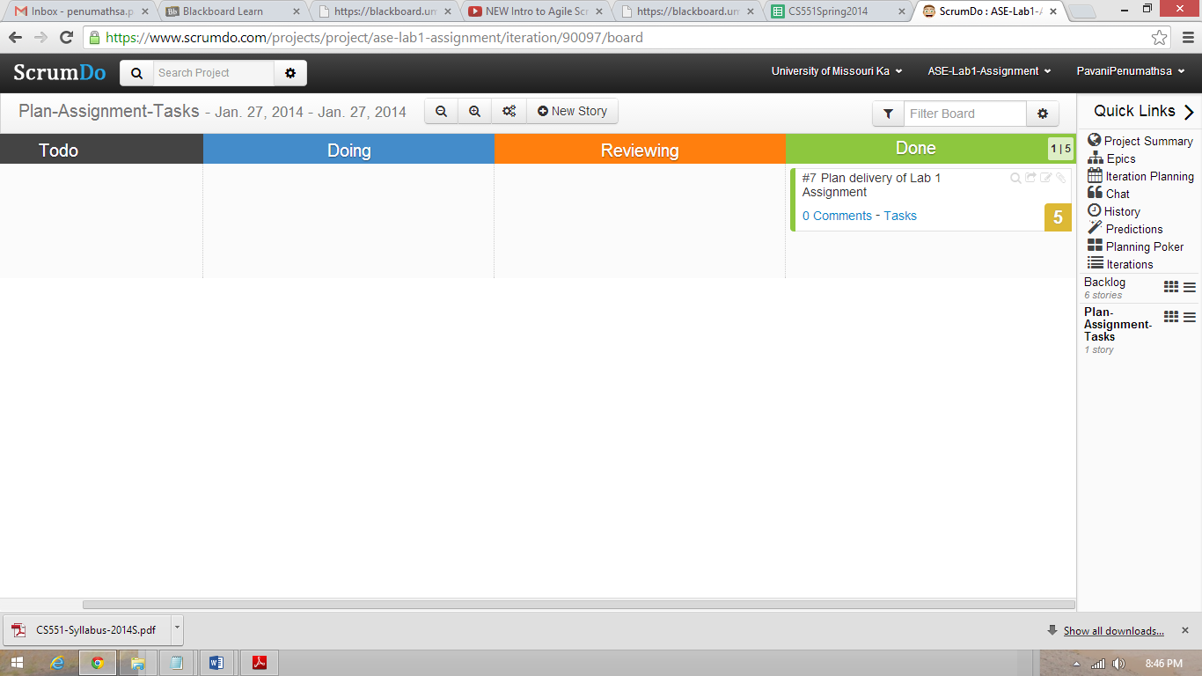

**Scrumboard for complete-Assignment-Tasks iteration:**

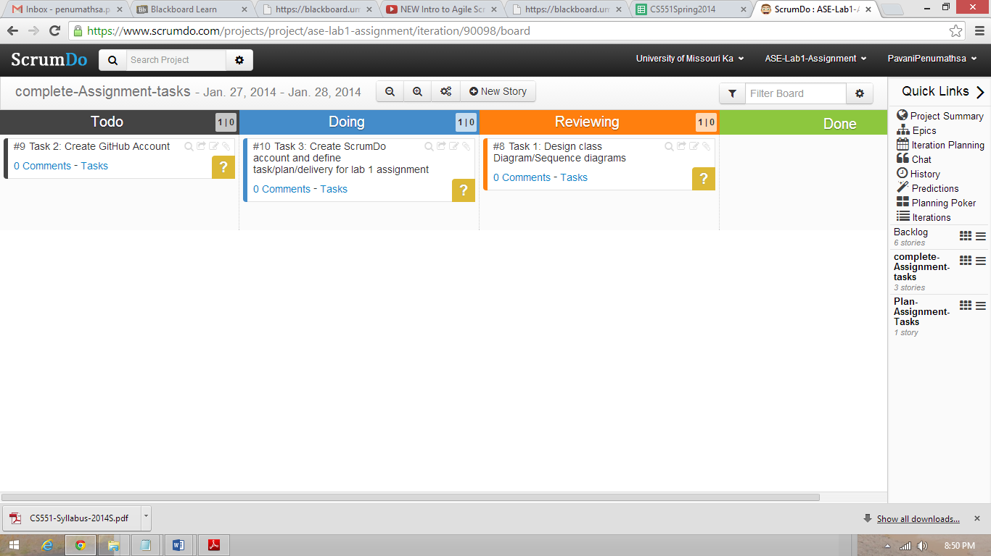

**Scrumboard for submit-lab-report iteration:**

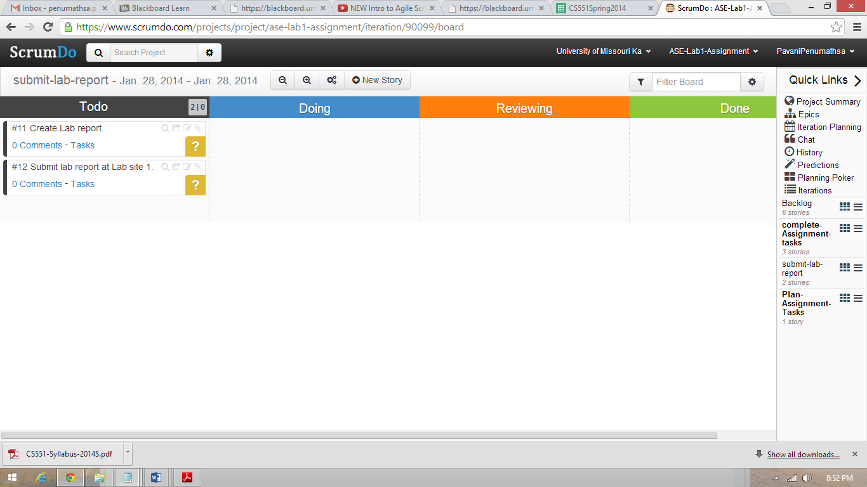

**Project Summary in ScrumDo:**

