CS551 Advanced Software Engineering

Assignment 2

Pavani Sree Lakshmi Penumathsa

16149283

**Mobile Web Client Application:** eBay Search.

1. I implemented “eBay Search” Mobile Web Client Application using JavaScript, HTML5 and CSS3 and jQuery Mobile.
2. This App provides a search screen with the text box to enter Product name we want to search on eBay.

(Geolocation didn’t work on my opera mobile emulator, hence providing the screenshots using chrome).

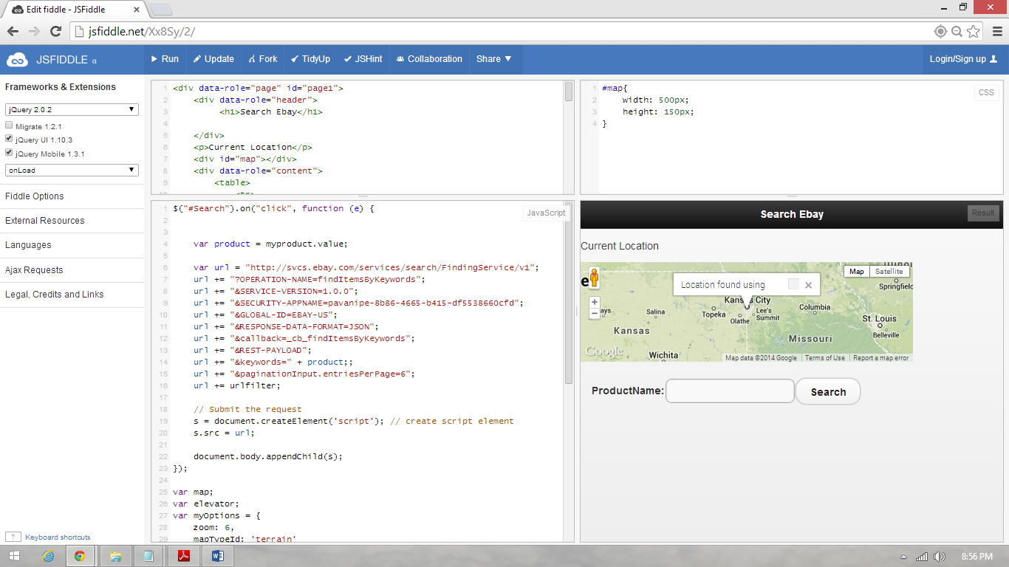

1. After entering the product name and by clicking on Search button, it will display the list of products based on the search.

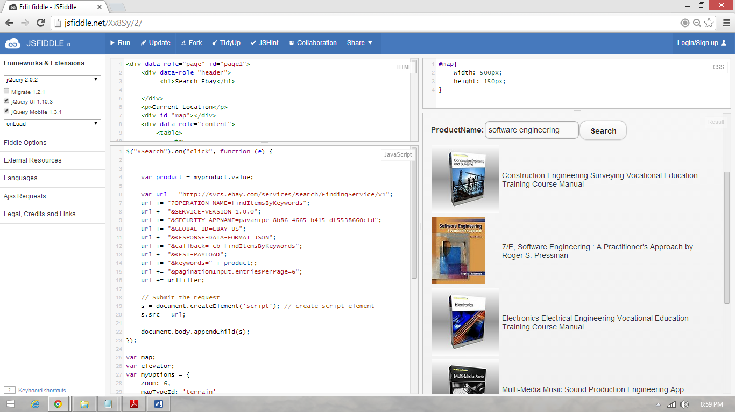

1. The URL will updated dynamically every time you enter the product name.
2. The App also displays your current location.

**References:**

Tutorial 2 and Tutorial 3.

http://developer.ebay.com/DevZone/finding/HowTo/GettingStarted_PHP_NV_XML/GettingStarted_PHP_NV_XML.html