**Linux Commands**

1. The command which is used to know the current working directory is “pwd”.



1. To find the contents “ll” command is used.

1. 1. Mkdir d1
   2. Mkdir d1/d2
   3. cd d1/d2
   4. touch f1.txt
   5. cat f1.txt
   6. ls ../

1. By using the ls command with its options. The directories from the listing can be identified using the “ls -l” command.



1. 1. To list files with single character name we can use the “ls ?” command.



* 1. To list the hidden files “ls -la” command can be used.

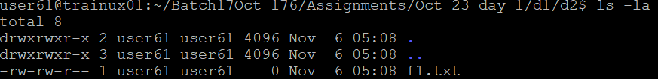

* 1. Suppose there are files tb1.1, tb2.1, tb3.1, ….tb10.1. To list all the files “ls tb*.1” command can be used.

1. To list all files in descending order of their size “ls -lS” command can be used.

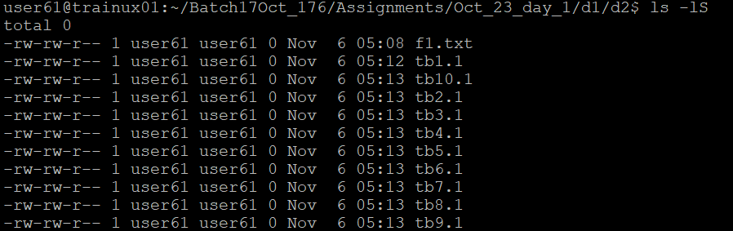

1. Suppose there are files temp1, temp2, temp3. “rm temp*” command is used to remove the files without listing them explicitly.

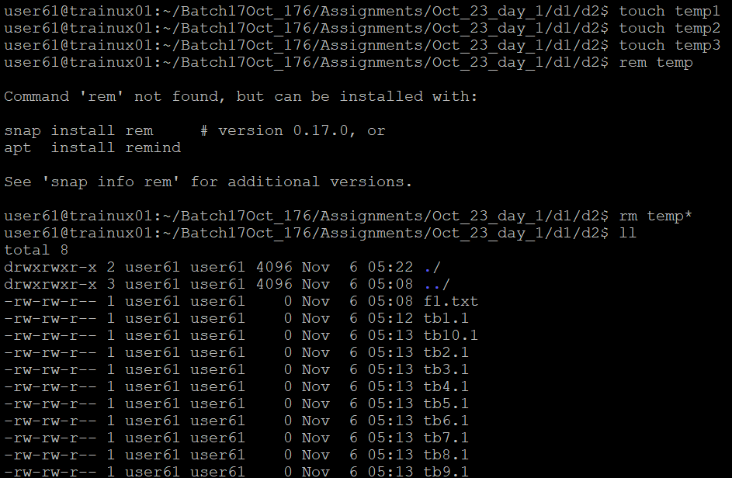

1. “head file_name” command is used to list top few lines in the file.



1. To create a directory “testdir” the command “mkdir testdir” can be used.

1. 1. To copy the file tb1.1 (created above) in the same directory, “cp tb1.1 tb1_copy.1” is used.
   2. To copy all the files i.e. tb1.1, tb2.1, tb3.1,…..tb10.1 in a new directory –“new” ,

the commands:

“mkdir new

cp tb*.1 new/”

* 1. To create a subdirectory in new in named “new1”, “mkdir new/new1” command is used.
  2. To copy only tb2.1, tb6.1, tb7.1 and tb10.1 in the directory new1, the command used is “cp tb2.1 tb6.1 tb7.1 tb10.1 new/new1”.
  3. To copy the entire directory “new” to a directory “newprogs”. The command used is

“mkdir newprogs

cp -R new newprogs/”.

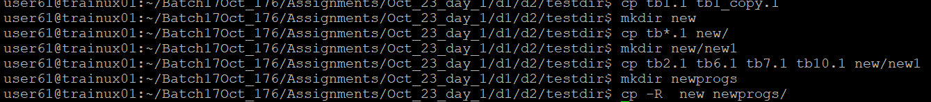



|  |  |
| --- | --- |
| “mv” Command | “cp” Command |
| The “mv” command is used when a file or a directory is supposed to be moved from one location to the another. The original will be removed in this case. | The “cp” command is used when the contents of a file or a directory is supposed to be copied from one location to another location. In this case the original will be remained untouched. |



|  |  |
| --- | --- |
| “rm” Command | “rmdir” Command |
| The “rm” command is used to remove the entire file or directory erasing all the contents inside the file as well. The non-empty directories can be removed as well using the “-r” command attached. | The “rmdir” command is used to remove only the empty directories. When a directory is not empty then rmdir can not remove the certain directory. |



|  |  |
| --- | --- |
| “mkdir” Command | “mkdir -p” |
| The “mkdir” command is used to create a directory. The directory gets created only if there exists a parent directory. | The “mkdir -p” command is used to create a directory even if it does not have a parent as the command creates the parent directory itself. |

1. To remove “testdir” and all its sub directories and files created above, the command used is “rm -r testdir”.

1. The command which is used to get the manual information of a command is “man command_name”.

1. If you are not able to change to a directory it could be likely because
   1. The directory does not exist.
   2. You do not have the necessary permissions to access the directory.
   3. The path provided is incorrect.
2. The difference among the following commands is:
   1. **cd / :** Changes to the root directory.
   2. **cd .. :** Moves up one level to the parent directory.
   3. **cd :** Changes to the user's home directory.
   4. **cd ../.. :** Moves up two levels to the grandparent directory.

**Advanced Optional Questions**

1. To display the inode number of a file, “ls -I file_name” command is used.
2. **Pipe Symbol (|):** The pipe symbol is used to send the output of one command as the input to another command. This command “ls -l | grep "filename" ” lists files and then filters the output for "filename."
3. “ps” command : The ps command displays information about active processes. You can view details using: “man ps”.