**gcov_Assignment_1.0**

1. Login into the Linux server with your login Ids

1. Create a new directory called code_cov in your home directory <home>



1. Go inside the directory you have created in (2) /<home>/code_cov



1. Copy the following files from the path as mentioned by the trainer:

a. sample.c

b. link.c

c. link.h

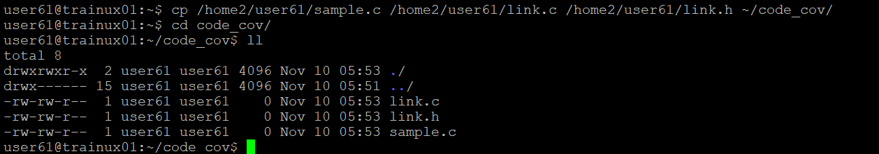

1. Take a look at the example programs sample.c and link.c

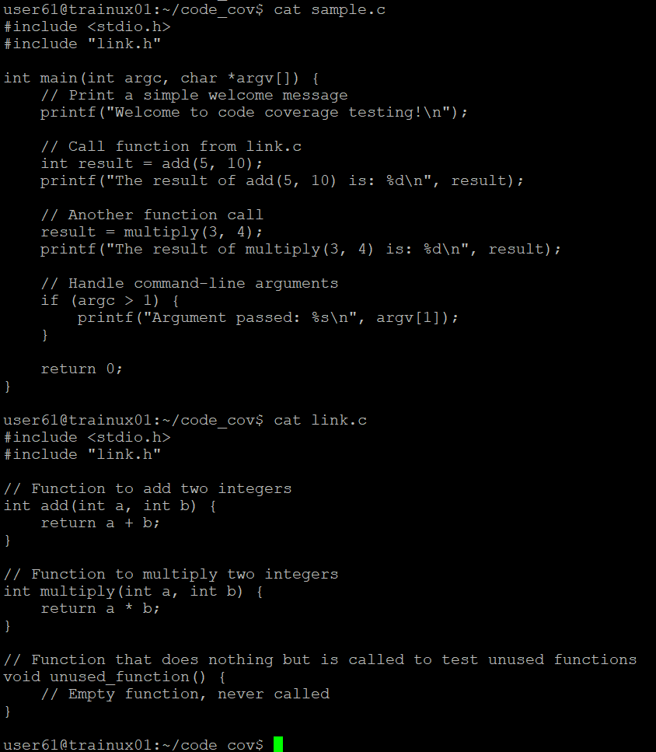

1. Compile the files sample.c and sample1.c and put the output in the executable file called output



1. Execute the file output

1. Now run gcov for each source file one by one

1. Run output again, this time with command line arguments:

>> vi sample.c.gcov

1. Now run gcov for sample.c again

