**Linux Environment Variable Assignment**

1. 1. The command to view current environment variables is “env” or “printenv”.

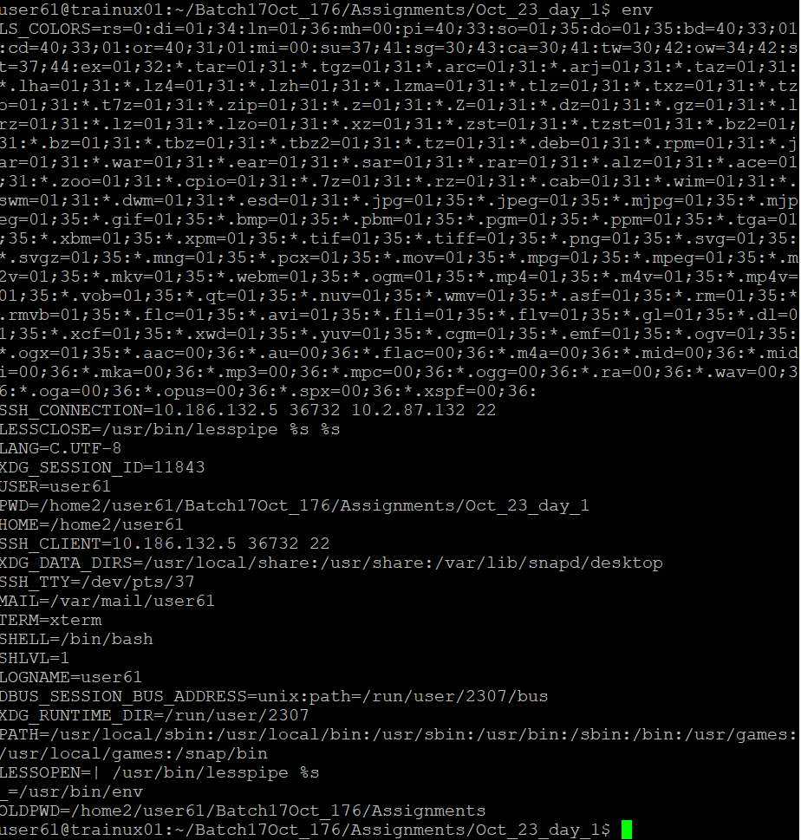

* 1. The command to display the PATH environment variable value is “echo $PATH”.

* 1. The command to update PATH to include the path to your home directory is “export PATH=$PATH:$HOME”.



1. To make the environment changes applicable to all users, the commands used are

>> “sudo nano /etc/profile”

>> “export PATH=$PATH:/home/user/file_name”

>> “source /etc/profile”

The script which is to be modified are “/etc/profile” and “/etc/environment”.

1. To fix the “command myapp not found” error, we need to follow some steps which are:
   * 1. Verify the installation location of **myapp** using which or **whereis**.
     2. If **myapp** is not in a directory that's already in your PATH, add its directory to your PATH in the appropriate configuration file (e.g., /etc/profile or ~/.**bashrc**).
     3. Ensure **myapp** has the correct executable permissions (**chmod +x myapp**).
     4. Optionally, use **hash -r** to clear the shell cache.
     5. Restart the shell session or source the modified configuration files to apply the changes.