**Hash Table assignments**

Mandatory

1. Refer the example code of hashtable in socodery. Implement the additional functions below.

a. Test the program with a sample input file with data below

C Programming

Data Structure and Algorithms

Computer System

C Programming

b. Traverse and display the hash table contents. How many entries are stored in hash table? Is this same as input? Justify the answer with reasons?

c. Which type of collision mechanism is used in code?

d. Modify the hash_function() such that for input string “Computer System” return the index of string “Data Structure and Algorithms”. Let this modification be controlled using a compile time flag below which can be enabled or disabled

#define ENABLE HASHFUNC_STUB

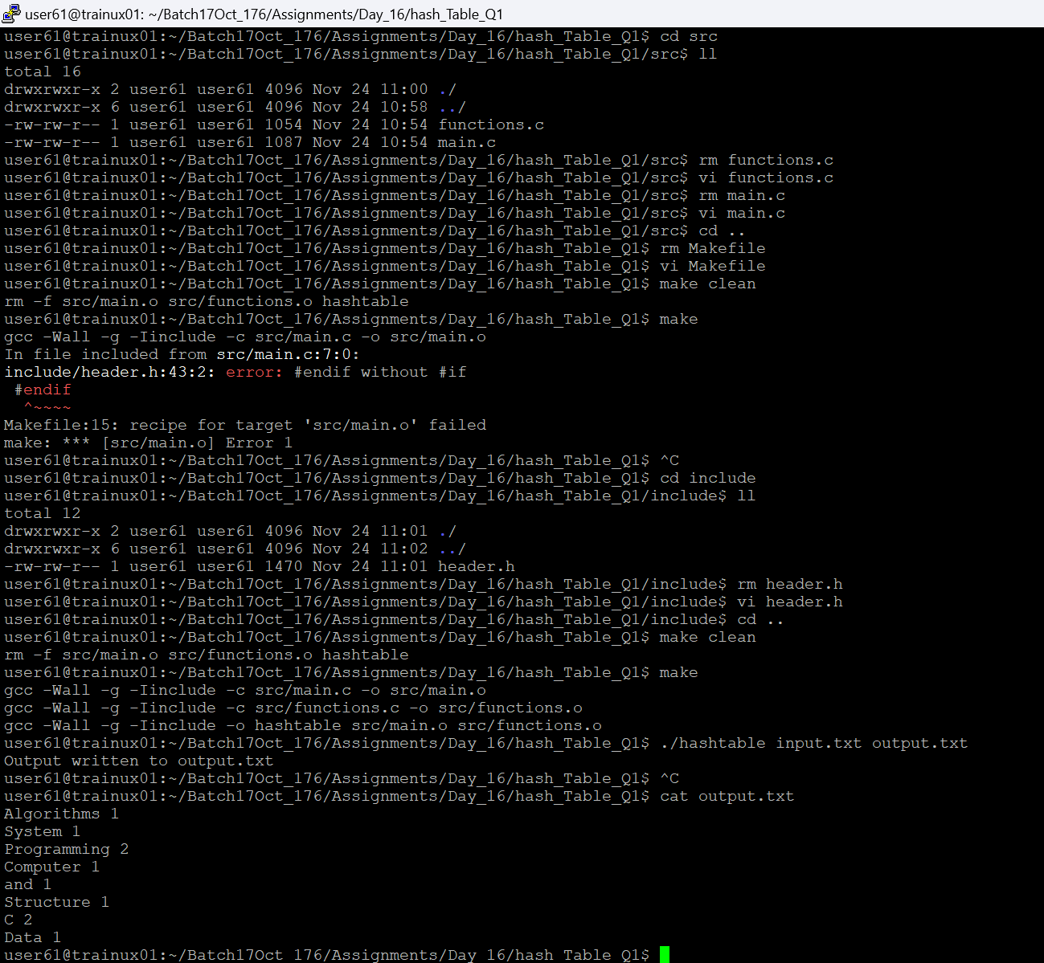

2. Implement a hash table to read a list of strings from the user as command line argument, store each string in hashtable, count their frequency and display them. Use name as hash key and frequency as value. Implement below functions.

int hash(char *str);

int add_to_hash(char *str, int key);

int get_frequency(char *str);

Add anyother required function. Test your solution with input dataset below

“Cprogram,CPPProgram,Cprogram,CPPProgram,Pascal”

