**find Assignment**

1. Search and Display All .c and .h Files in All Subdirectories Starting from Current Directory

To search for all .c and .h files starting from the current directory and including all subdirectories, you can use the find command with the -name

**find . -type f \( -name "*.c" -o -name "*.h" \)**

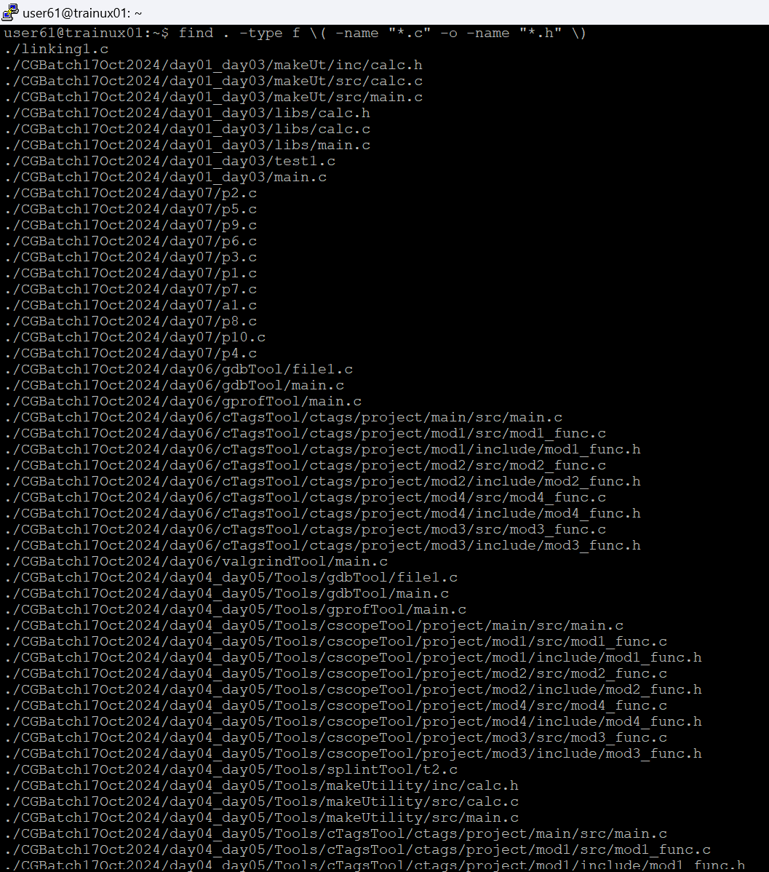

* .: The dot represents the current directory. The search will start from here and explore all subdirectories.
* -type f: Ensures only files (not directories) are found.
* \( -name "*.c" -o -name "*.h" \): This searches for files that end in .c or .h. The -o operator is used to specify an "OR" condition, so it matches either .c or .h files.

1. Search and Display All Directories in All Subdirectories Starting from Current Directory.

To search for all directories (including the current one) in the current directory and all its subdirectories, you can use the find command with the -type d .

**find . - type d**

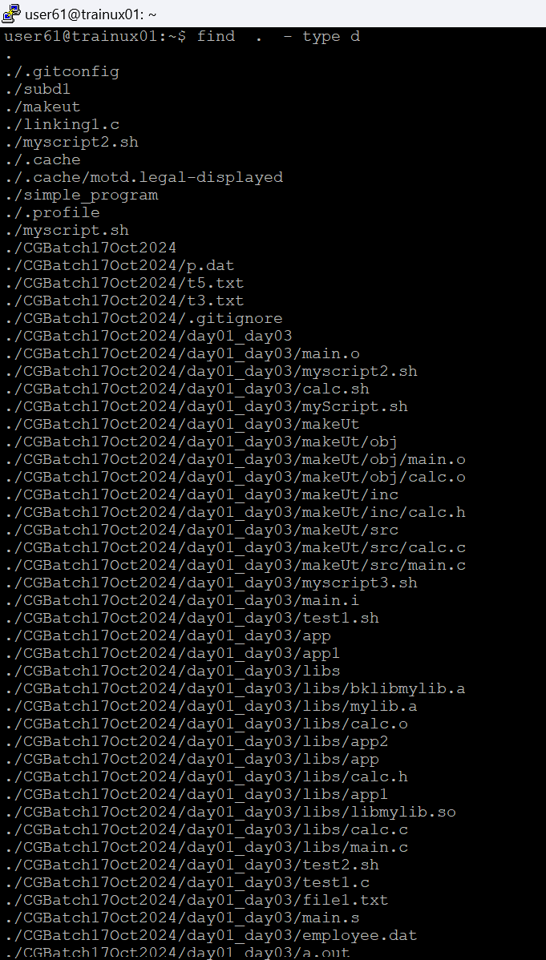

1. Search and Display All Files with Permissions Only rw for User and x for Others.

* In this case, you want to find files that have **read and write permissions for the user**, and **execute permissions for others**. This can be done by using find with the -perm option.
* **$ cd /home/user**
* **$ find . -type f -perm u=rw,o=x**