OUTFIT RENTAL SYSTEM

We create a class named populate to display the contents from the table on to the screen.

For the screen Outfits

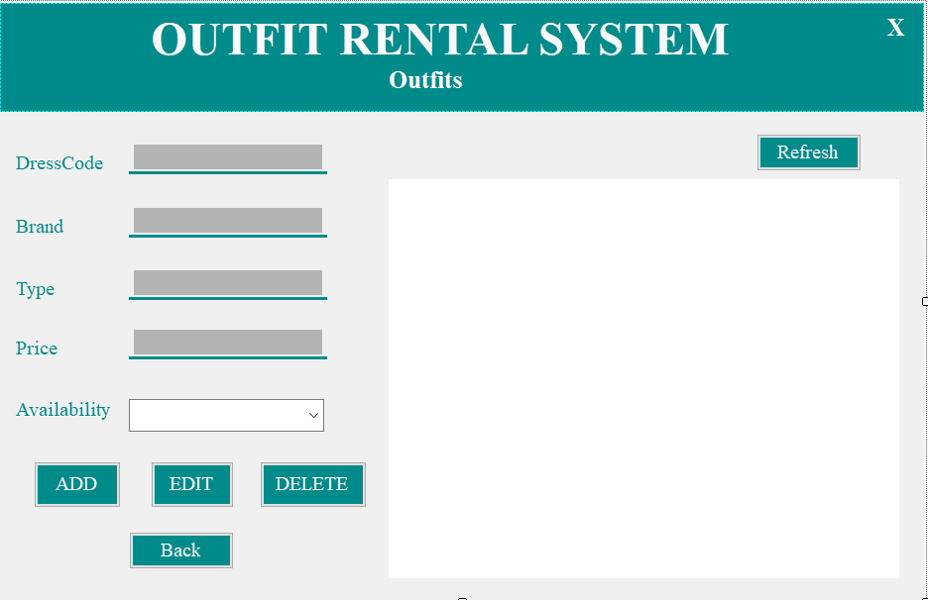

The blank white screen on the right side is the space for displaying the contents of the outfits data that is added. And the code used is,

private void populate()

{

Con.Open();

string query = "select \* from OutfitTbl";

SqlDataAdapter da = new SqlDataAdapter(query, Con);

SqlCommandBuilder builder = new SqlCommandBuilder(da);

var ds = new DataSet();

da.Fill(ds);

OutfitsDGV.DataSource = ds.Tables[0];

Con.Close();

}

Where “OutfitTbl” is the table name and “OutfitsDGV” is the white space datagrid view.

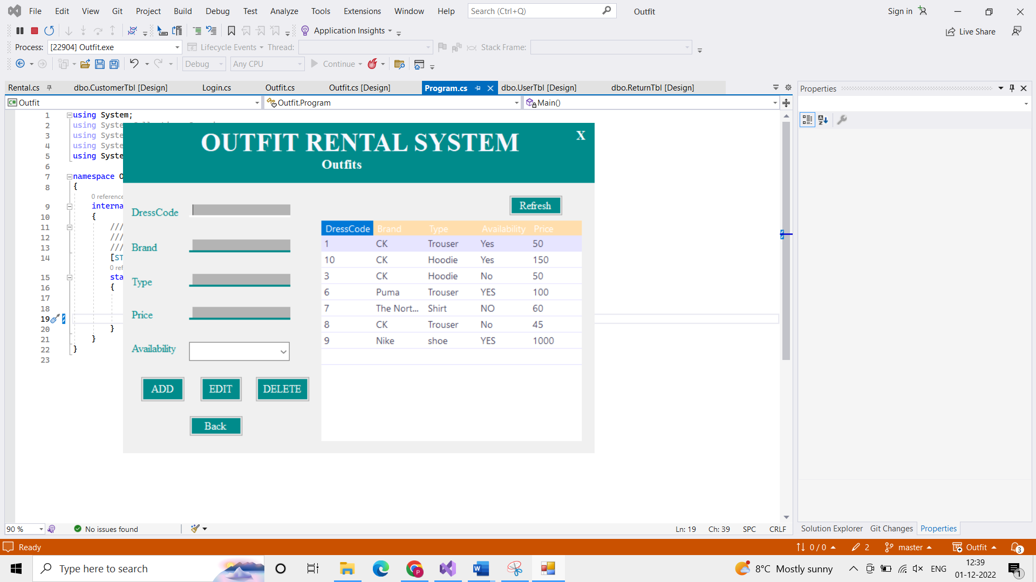

For the screen Customers

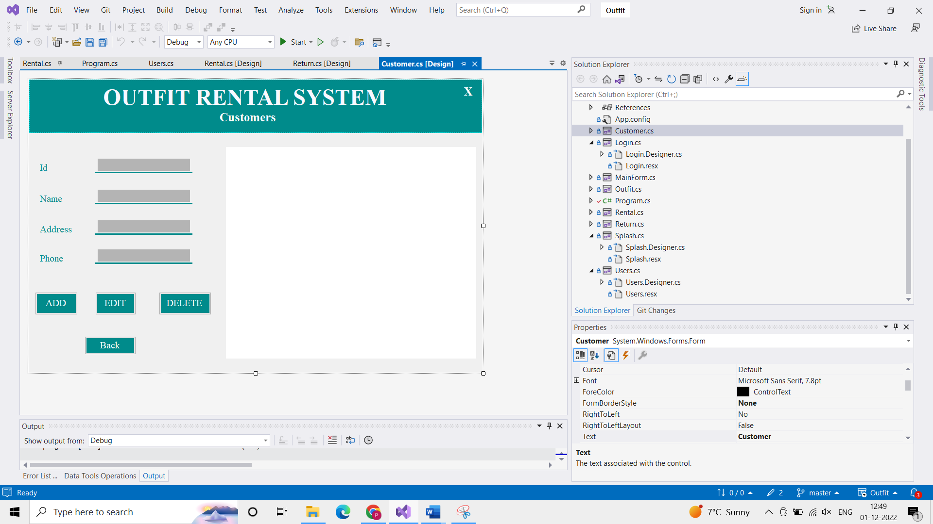

The blank white screen on the right side is the space for displaying the contents of the customers data that is added. And the code used is,

private void populate()

{

Con.Open();

string query = "select \* from CustomerTbl";

SqlDataAdapter da = new SqlDataAdapter(query, Con);

SqlCommandBuilder builder = new SqlCommandBuilder(da);

var ds = new DataSet();

da.Fill(ds);

CustomerDGV.DataSource = ds.Tables[0];

Con.Close();

}

Where “CustomerTbl” is the table name and “CustomerDGV” is the white space datagrid view.

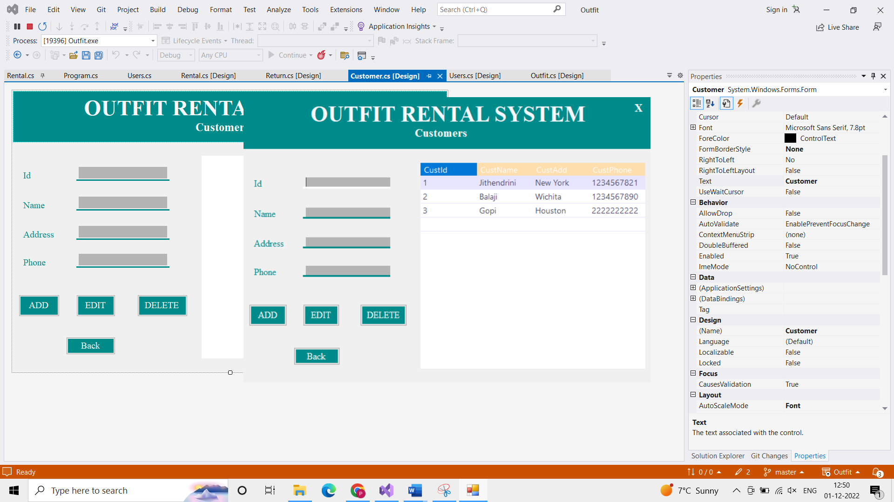

For the screen Rentals

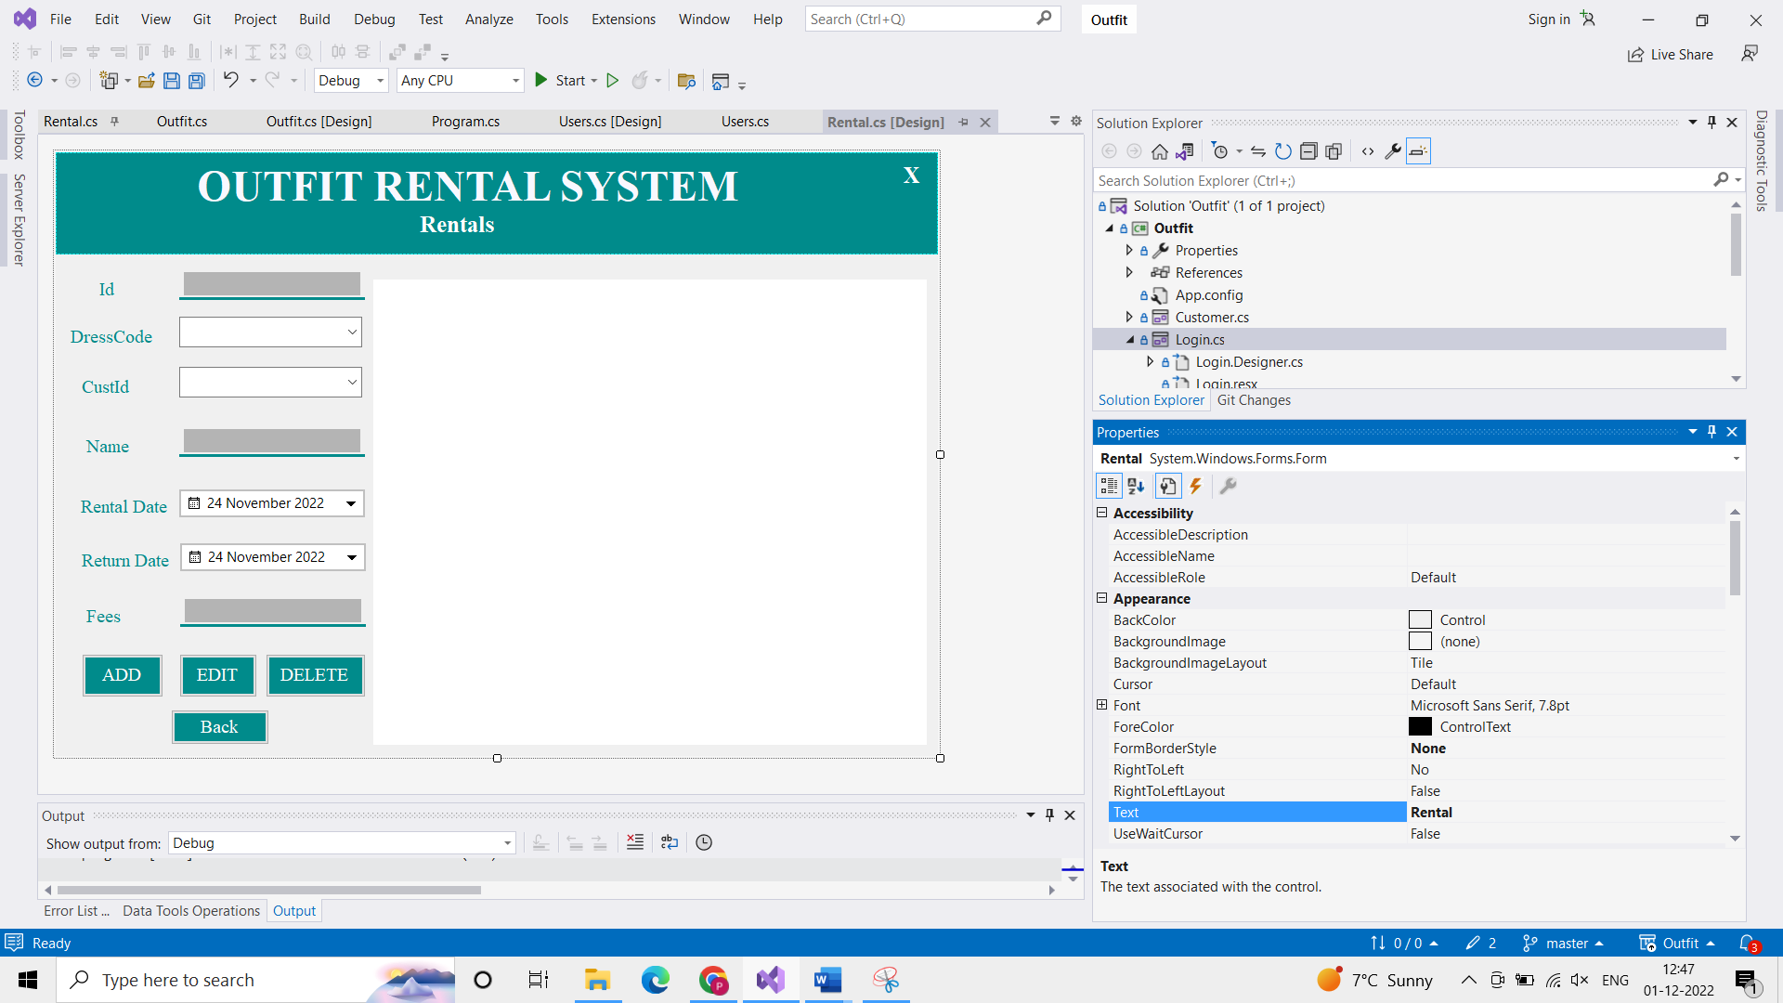

The blank white screen on the right side is the space for displaying the contents of the outfits rental data that is added. And the code used is,

private void populate()

{

Con.Open();

string query = "select \* from RentalTbl";

SqlDataAdapter da = new SqlDataAdapter(query, Con);

SqlCommandBuilder builder = new SqlCommandBuilder(da);

var ds = new DataSet();

da.Fill(ds);

RentDGV.DataSource = ds.Tables[0];

Con.Close();

}

Where “RentalTbl” is the table name and “RentDGV” is the white space datagrid view.

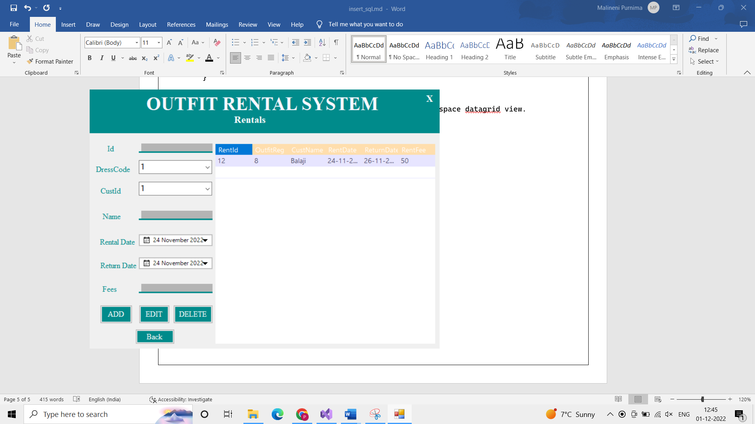

For the screen Returns

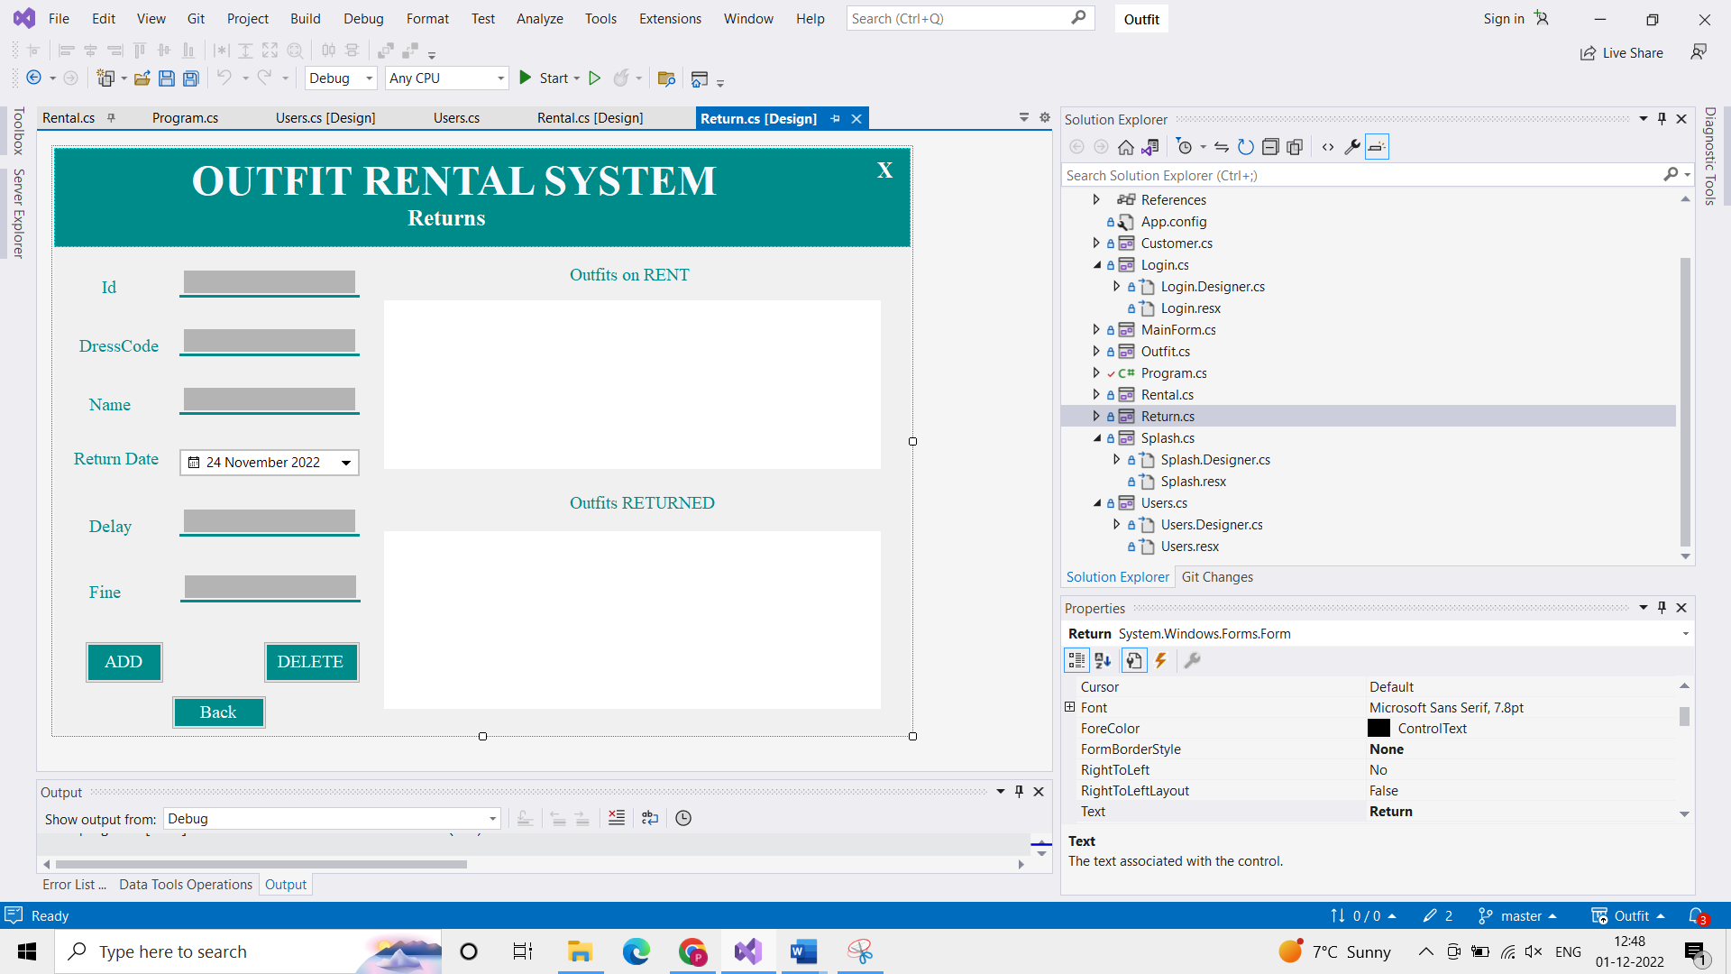

This screen has two blank white screens on the right side is the space for displaying the contents of the outfit rental and return data that is added. And the code used for above screen is same as the rental. For below table, the code is

private void populateRet()

{

Con.Open();

string query = "select \* from ReturnTbl";

SqlDataAdapter da = new SqlDataAdapter(query, Con);

SqlCommandBuilder builder = new SqlCommandBuilder(da);

var ds = new DataSet();

da.Fill(ds);

ReturnDGV.DataSource = ds.Tables[0];

Con.Close();

}

Where “ReturnTbl” is the table name and “ReturnDGV” is the white space datagrid view.

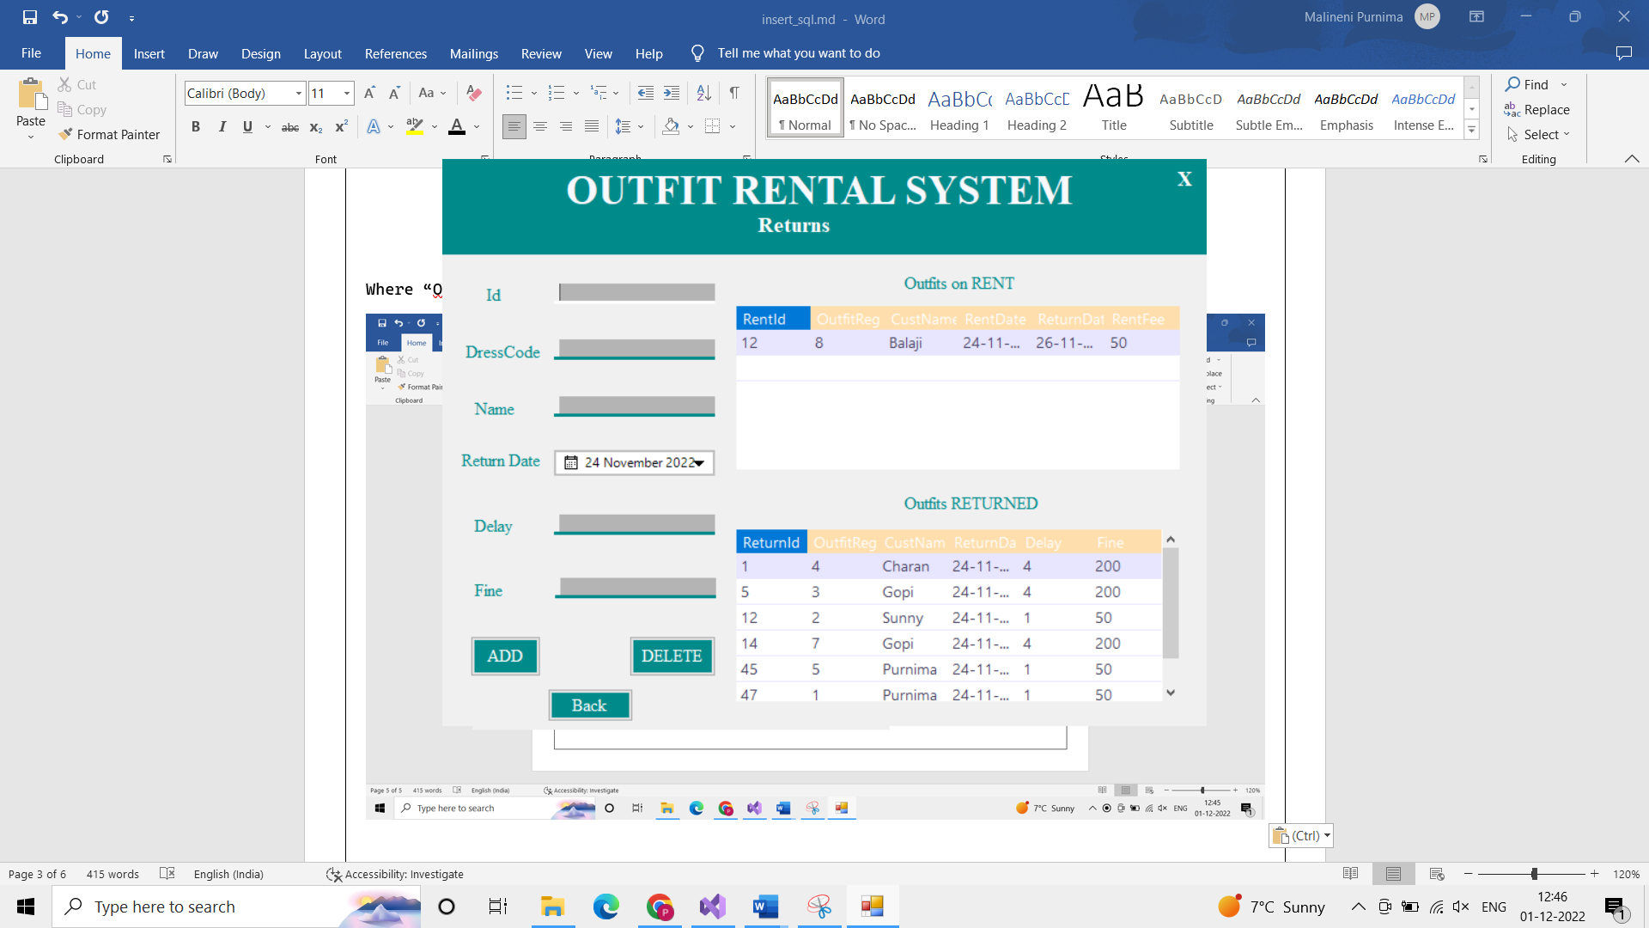

For the screen Users

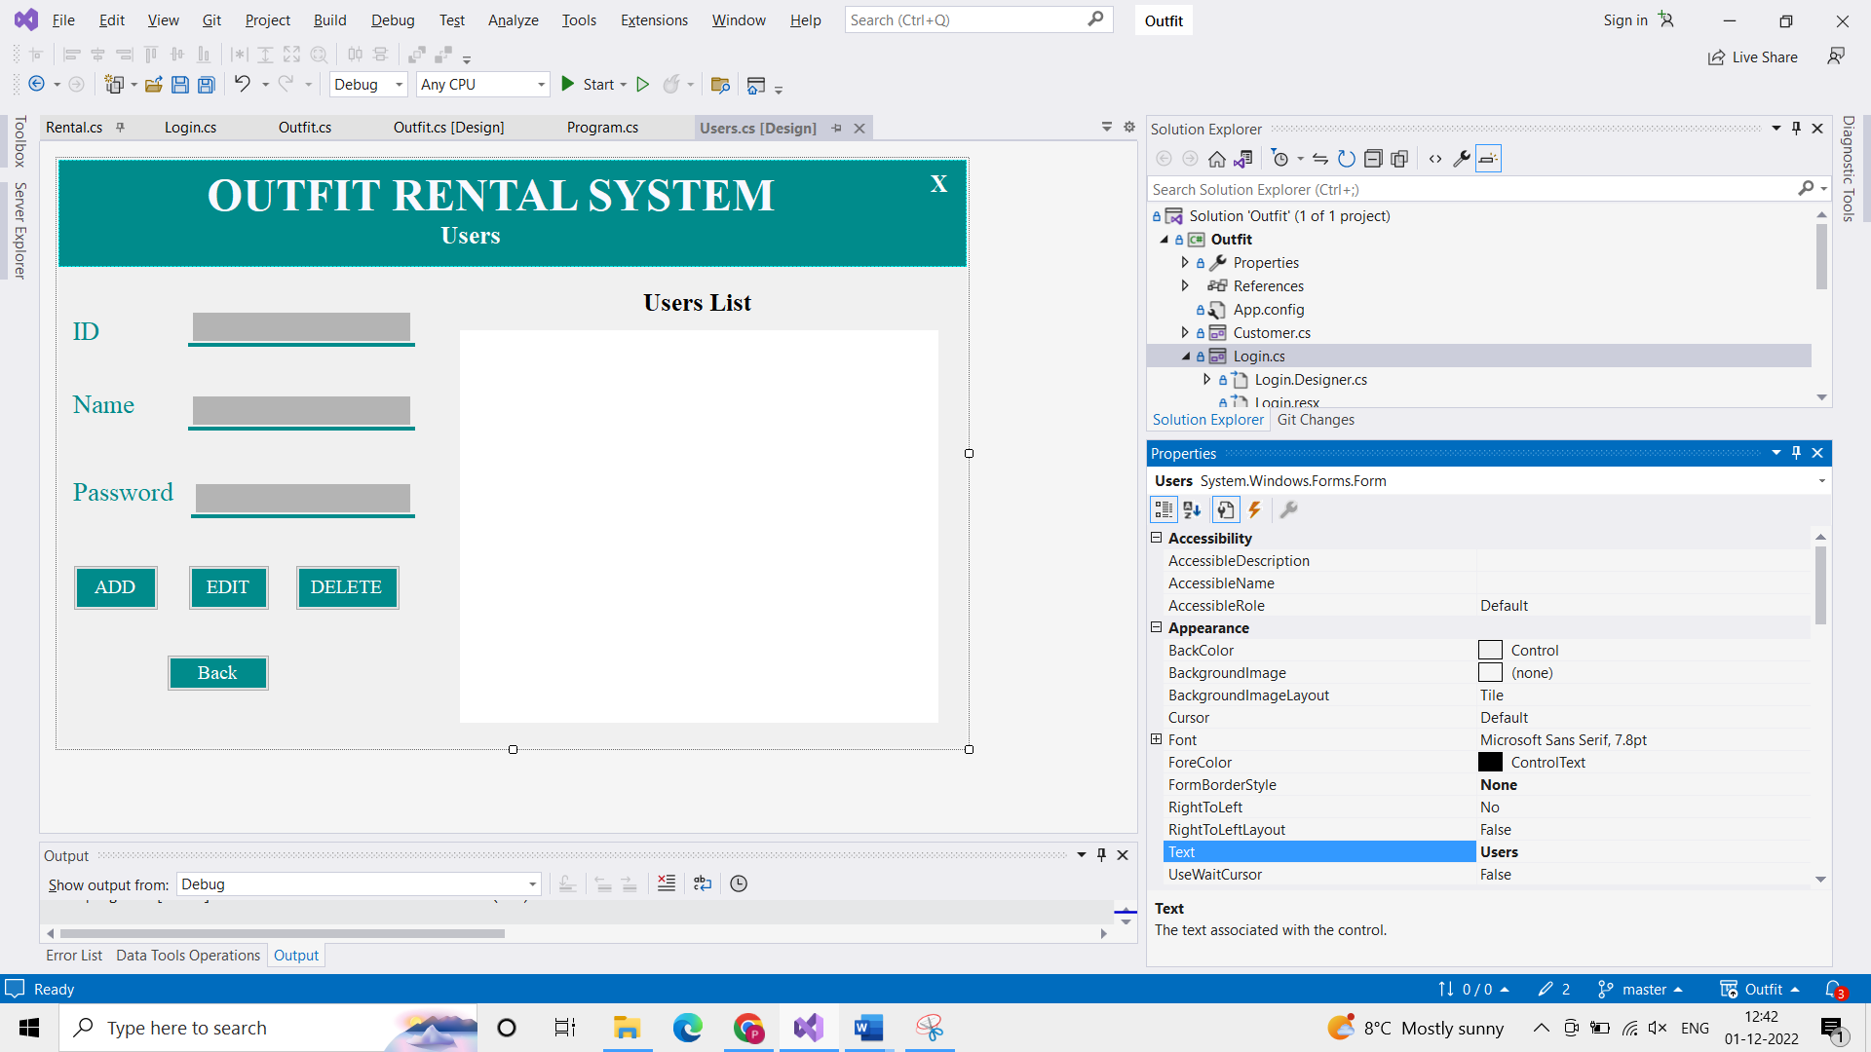

The blank white screen on the right side is the space for displaying the contents of the users data that is added. And the code used is,

private void populate()

{

Con.Open();

string query = "select \* from UserTbl";

SqlDataAdapter da = new SqlDataAdapter(query, Con);

SqlCommandBuilder builder = new SqlCommandBuilder(da);

var ds = new DataSet();

da.Fill(ds);

UsersDGV.DataSource = ds.Tables[0];

Con.Close();

}

Where “UserTbl” is the table name and “UsersDGV” is the white space datagrid view.

