1.Spring Data JPA - Quick Example 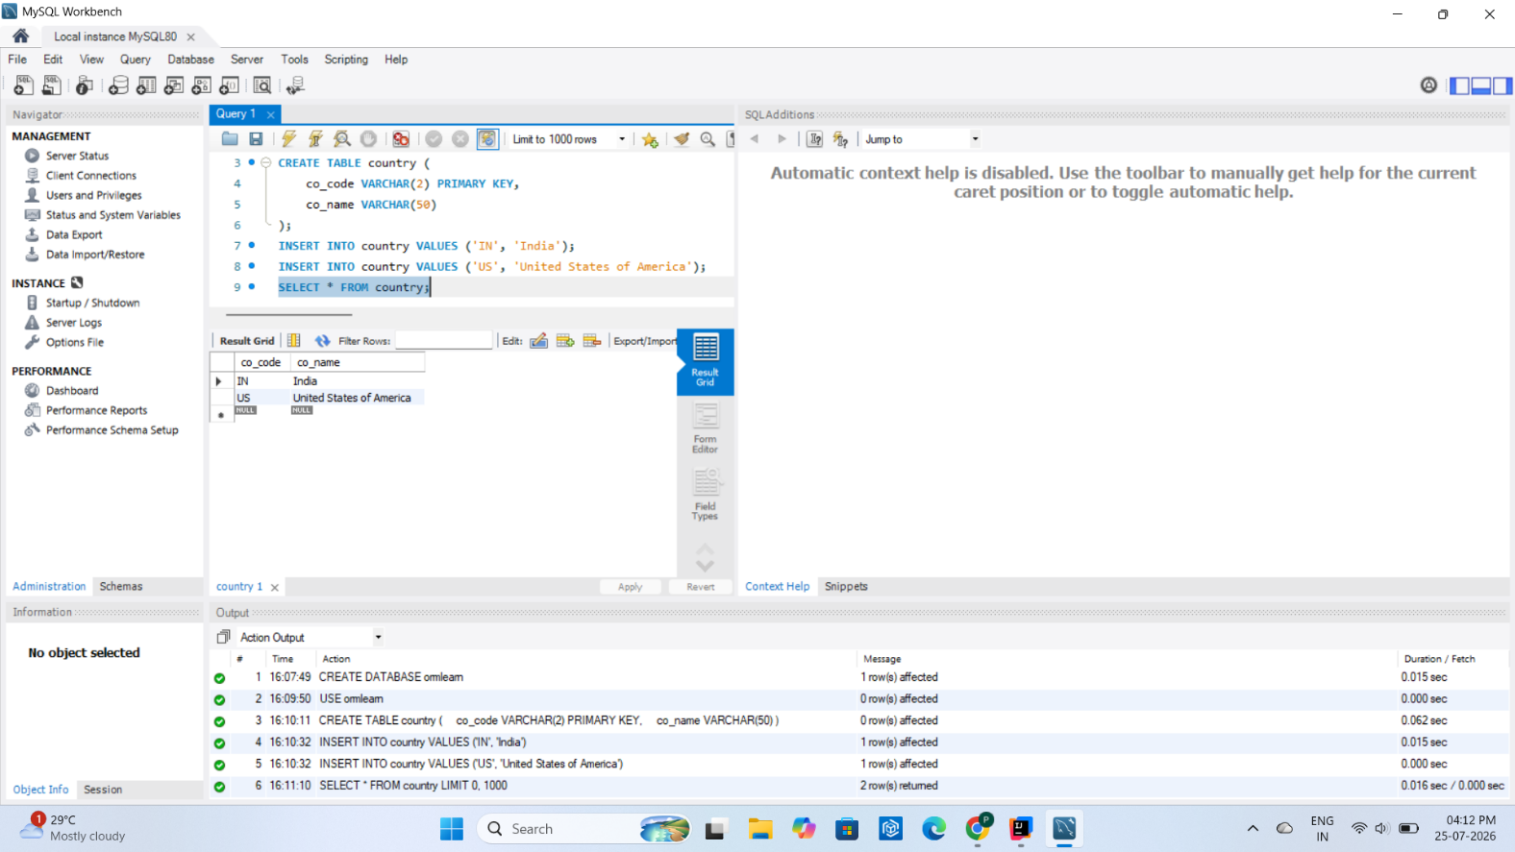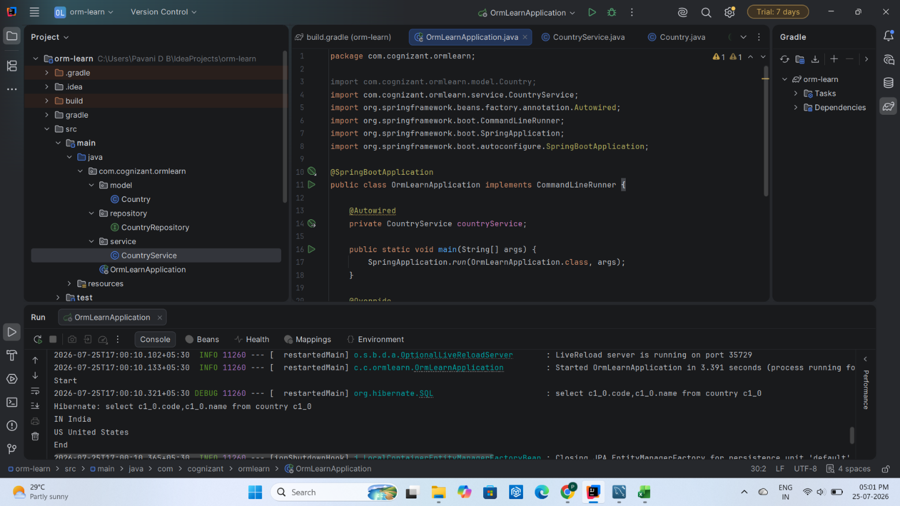

4.Difference between JPA, Hibernate and Spring Data JPA
1. Java Persistence API (JPA)
- JPA stands for Java Persistence API.
- It is a Java specification (JSR 338) for mapping Java objects to database tables.
- JPA defines interfaces and annotations for persistence.
- It does not provide an implementation.
- It requires an implementation such as Hibernate.
2. Hibernate
- Hibernate is an Object Relational Mapping (ORM) framework.
- It is one of the most popular implementations of JPA.
- Hibernate converts Java objects into database records.
- It manages SQL queries, transactions and relationships automatically.
3. Spring Data JPA
- Spring Data JPA is a Spring framework module.
- It uses JPA implementations like Hibernate internally.
- It minimizes boilerplate code.
- CRUD operations can be performed simply by extending JpaRepository.
- Transaction management is handled automatically with @Transactional.
Comparison Table
Feature | JPA | Hibernate | Spring Data JPA
Type | Specification | ORM Framework | Spring Framework Module
Developed By | Oracle/Java Community | Hibernate Team | Spring
Implementation | No | Yes | Uses Hibernate/JPA
Boilerplate Code | More | Moderate | Very Less
Transaction Management | Manual | Manual | Automatic using @Transactional
CRUD Operations | Through EntityManager | Through Session | Through JpaRepository
SQL Generation | No | Yes | Uses Hibernate

Hibernate Example
public Integer addEmployee(Employee employee){

Session session = factory.openSession();
Transaction tx = null;
Integer employeeID = null;
try {
tx = session.beginTransaction();
employeeID = (Integer) session.save(employee);
tx.commit();
} catch (HibernateException e) {

if(tx != null)
tx.rollback();

} finally {

session.close();

}

return employeeID;
}

Spring Data JPA Example
EmployeeRepository.java
import org.springframework.data.jpa.repository.JpaRepository;

public interface EmployeeRepository extends JpaRepository<Employee, Integer> {

}

EmployeeService.java
import org.springframework.beans.factory.annotation.Autowired;
import org.springframework.stereotype.Service;
import org.springframework.transaction.annotation.Transactional;

@Service
public class EmployeeService {

@Autowired
private EmployeeRepository employeeRepository;

@Transactional
public void addEmployee(Employee employee) {
employeeRepository.save(employee);
}
}

Conclusion
- JPA defines the standard for persistence.
- Hibernate is an implementation of JPA that performs ORM operations.
- Spring Data JPA sits on top of JPA and Hibernate, reducing code by providing repositories and automatic transaction management.

