Exercise 1: Control Structures
- Scenario 1: Apply 1% Interest Discount for Customers Above 60
- Scenario 2: Promote Customers to VIP
- Scenario 3: Loan Due Reminder
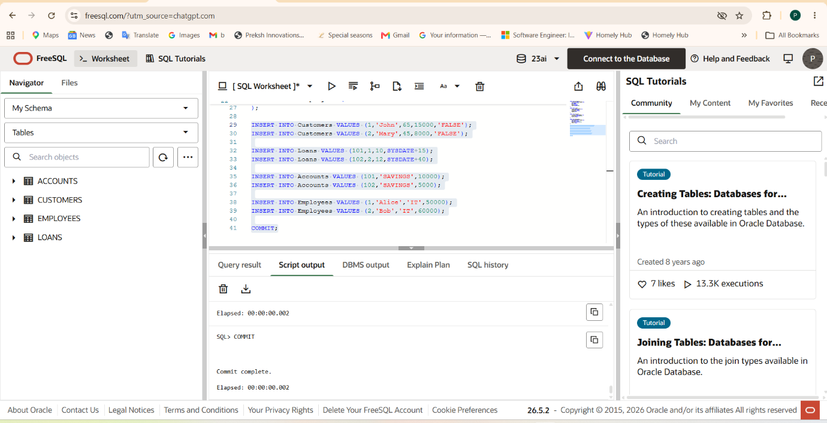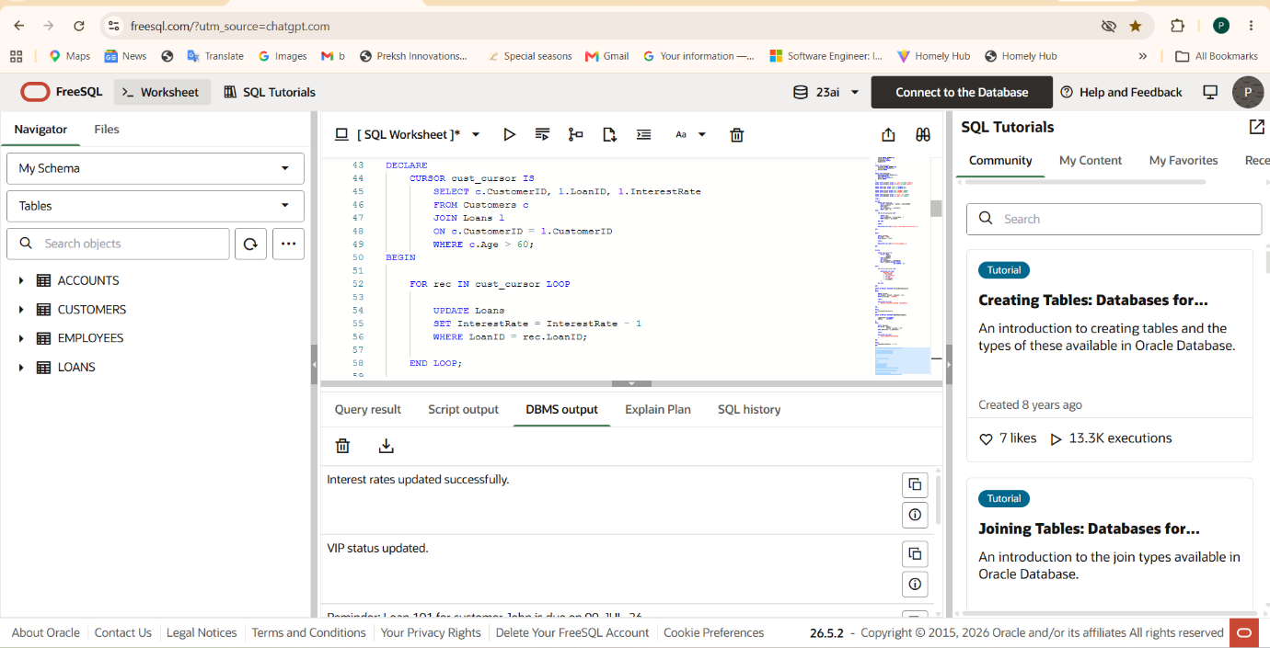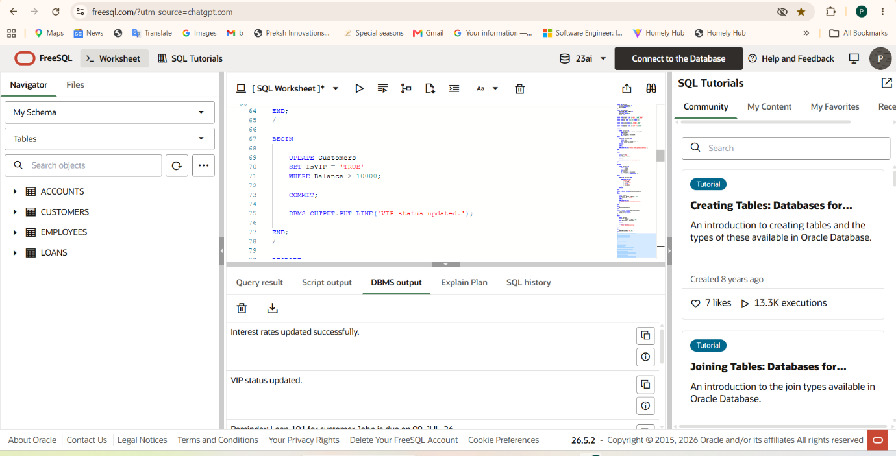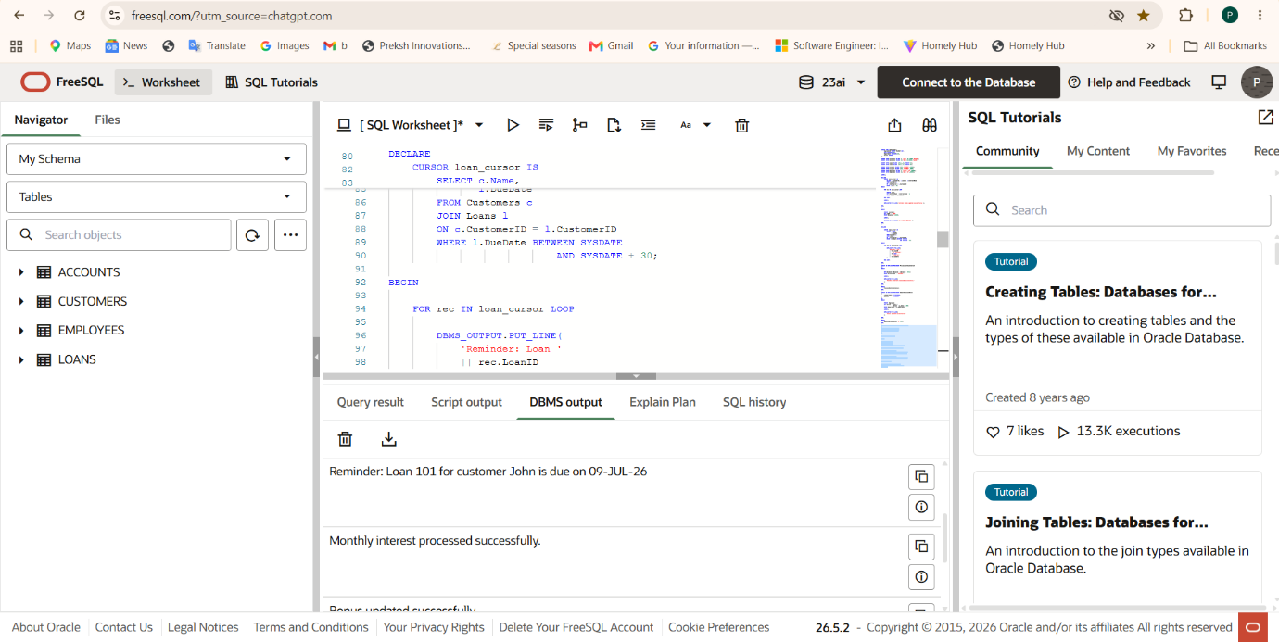

Exercise 3: Stored Procedures
- Scenario 1: Process Monthly Interest
- Scenario 2: Employee Bonus Procedure
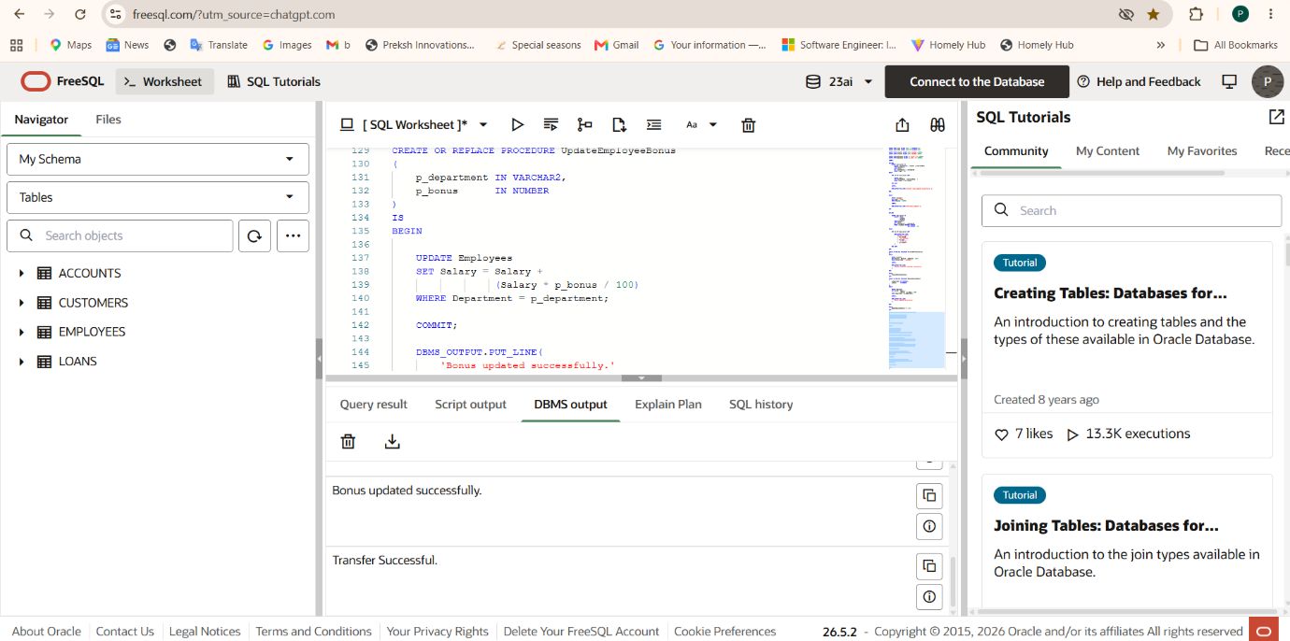
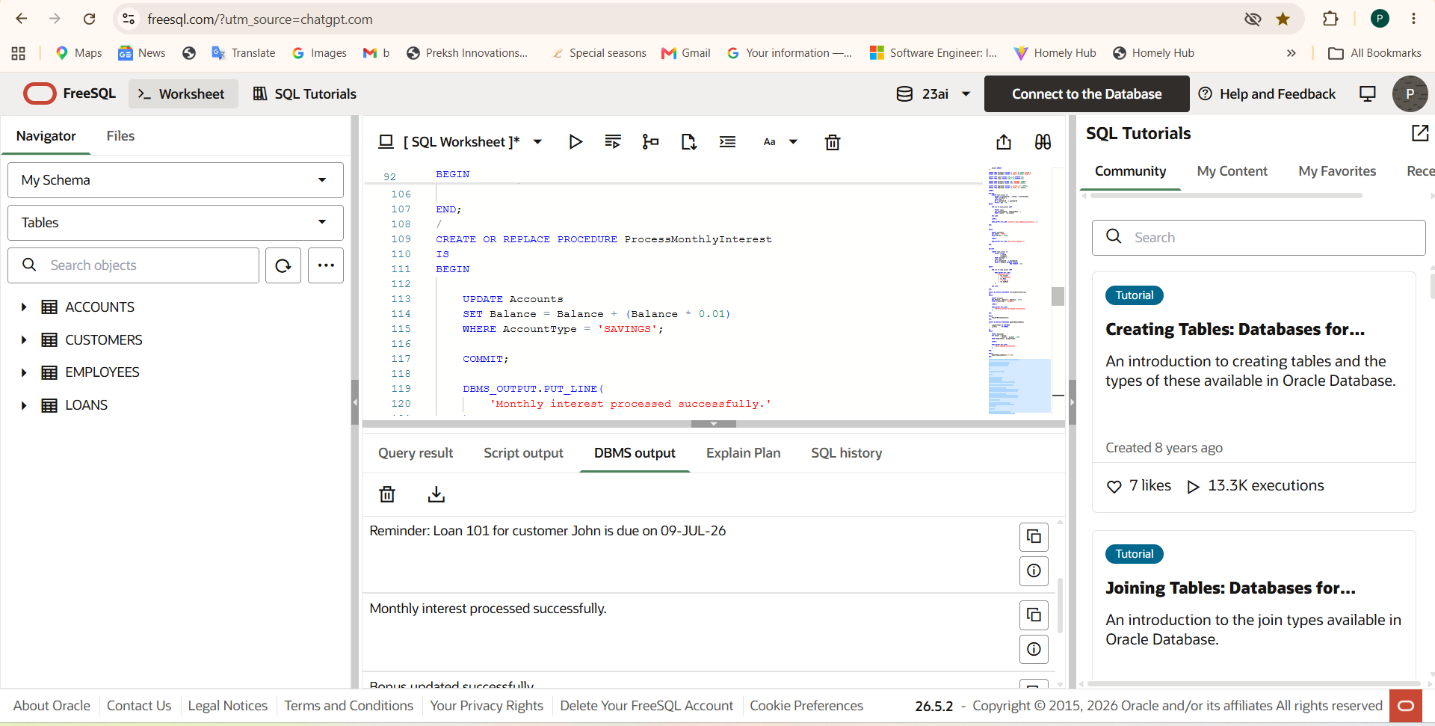
- Scenario 3: Transfer Funds Between Accounts
