CLOUD_ASSESSMENT
Task 1 – Create Your First EC2 Instance
Objective: Launch a t2.micro EC2 instance with Amazon Linux 2.
Steps:
- AWS Console → EC2 → Instances → Launch instances.
- Name: MyFirstInstance.
- AMI: Amazon Linux 2 (Free Tier).
- Instance Type: t2.micro.
- Key Pair: Select or create new, download .pem.
- Security Group: Allow SSH (port 22) from your IP.
- Launch instance and wait until running.
Screenshot:
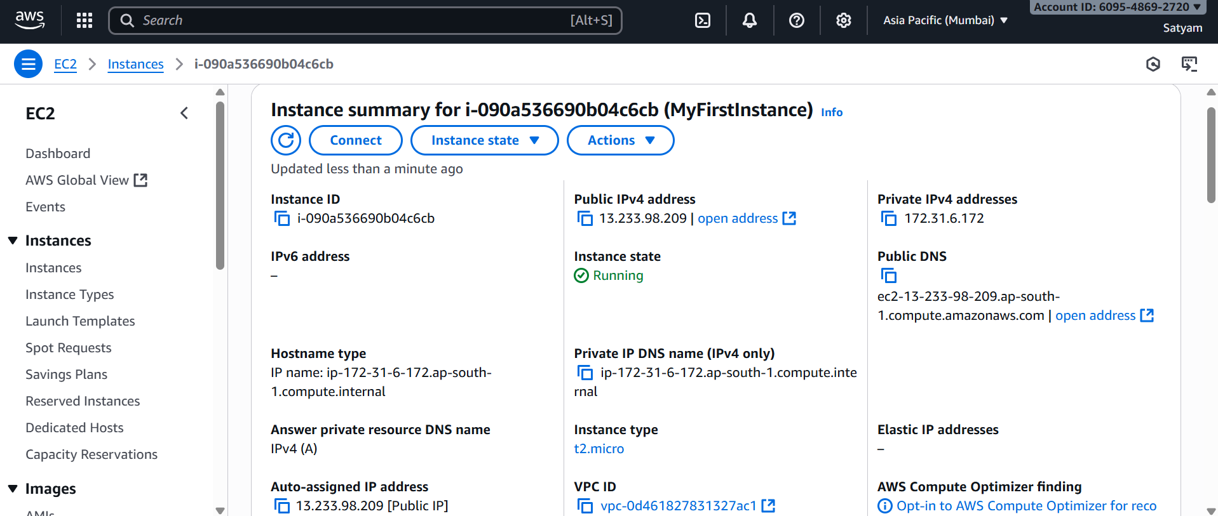
Task 2: Connect to EC2 via SSH
Steps:
- Linux/Mac: chmod 400 mykey.pem
ssh -i mykey.pem ec2-user@<Public-IP>
- Windows (PuTTY): Convert .pem → .ppk → connect via PuTTY.

Screenshot:
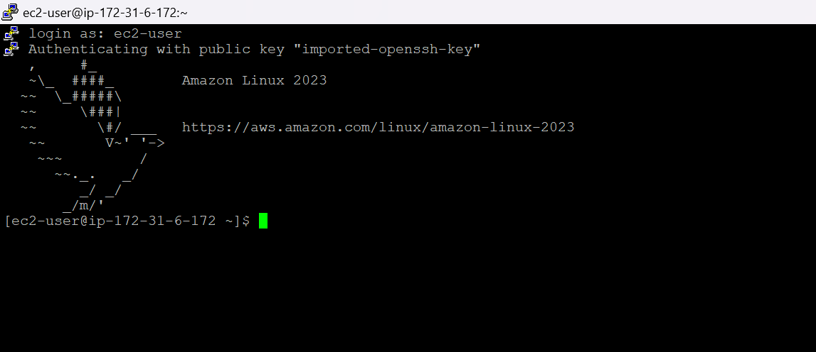
Task 3 – Host a Simple Web Page
Objective: Install Apache and display “Hello AWS”.
Steps:
sudo yum install httpd -y
sudo systemctl start httpd
sudo systemctl enable httpd
echo "Hello AWS" | sudo tee /var/www/html/index.html
- Open browser: http://<Public-IP>
Screenshot:
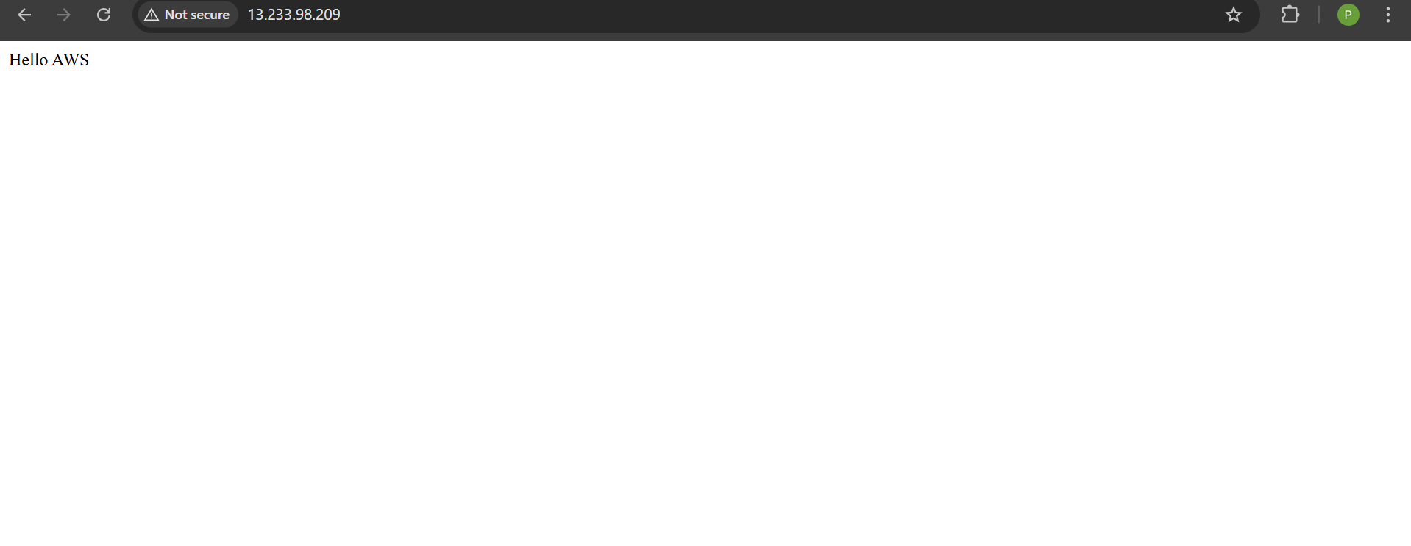
Task 4 – Create an S3 Bucket
Objective: Create a versioned S3 bucket.
Steps:
- S3 → Create bucket → Name (e.g., mybucket123) → Region.
- Enable Versioning → Create.
Screenshot:
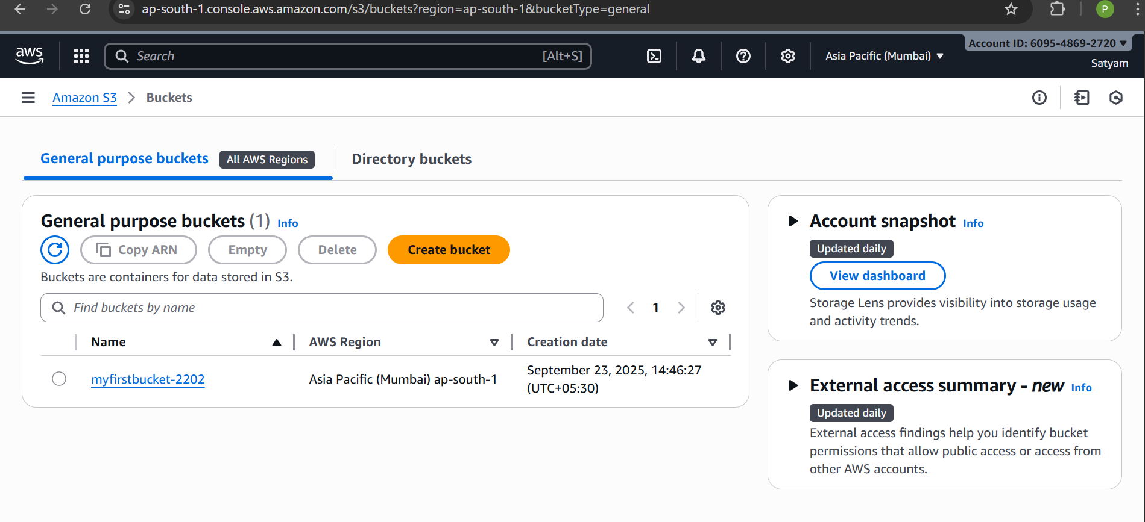
Task 5 – Upload & Share Files in S3
Objective: Upload a file and make it accessible.
Steps:
- Open bucket → Upload → Add file (e.g., logo.jpg).
- Set permissions as needed (private or public).
- Copy URL → open in browser.
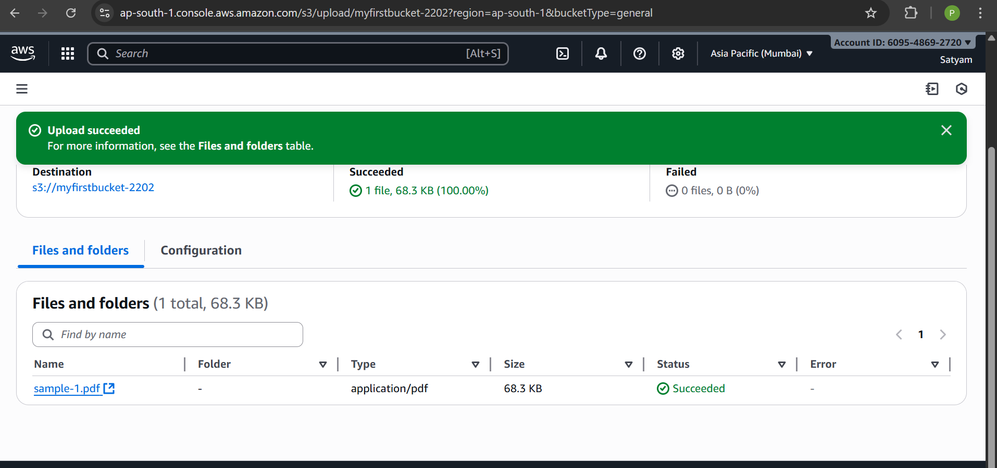
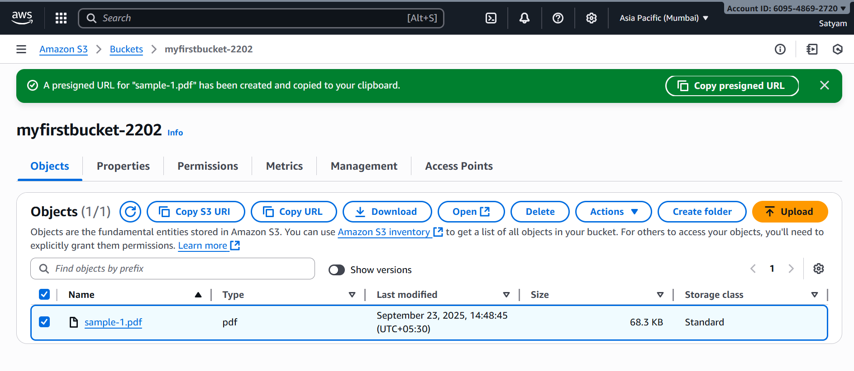
created presigned URL and paste it in chrome (screenshot of file opened in browser)
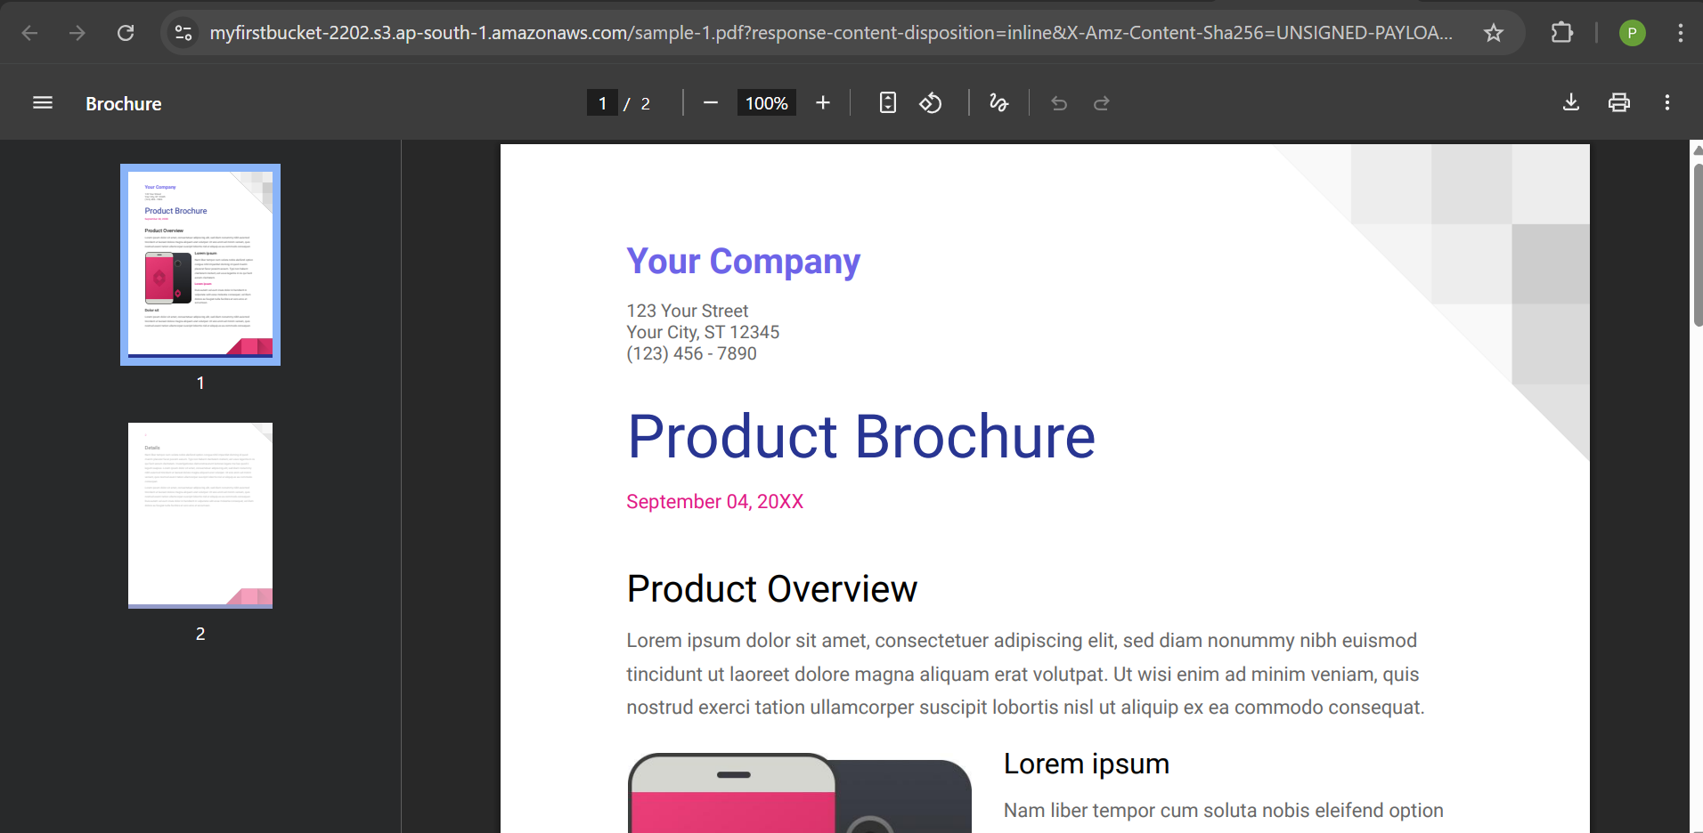

Task 6 – Configure IAM User & Policy
Objective: Create IAM user with S3 ReadOnly access.
Steps:
- IAM → Users → Add user (e.g., S3ReadUser).
- Access type: Console or Programmatic.
- Attach policy: AmazonS3ReadOnlyAccess → Finish.
- Login as new user.

Screenshot:
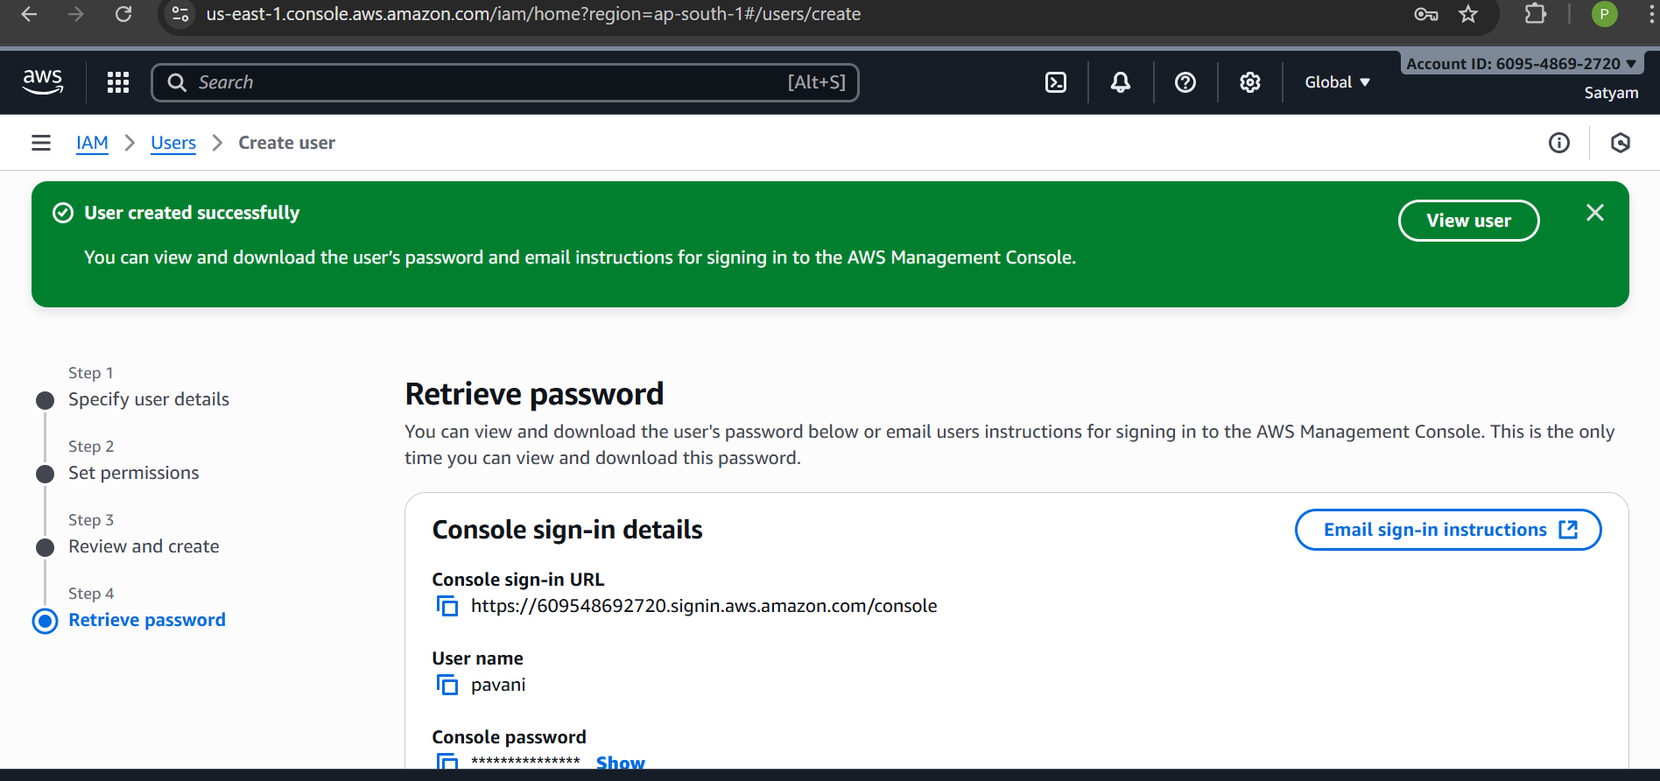

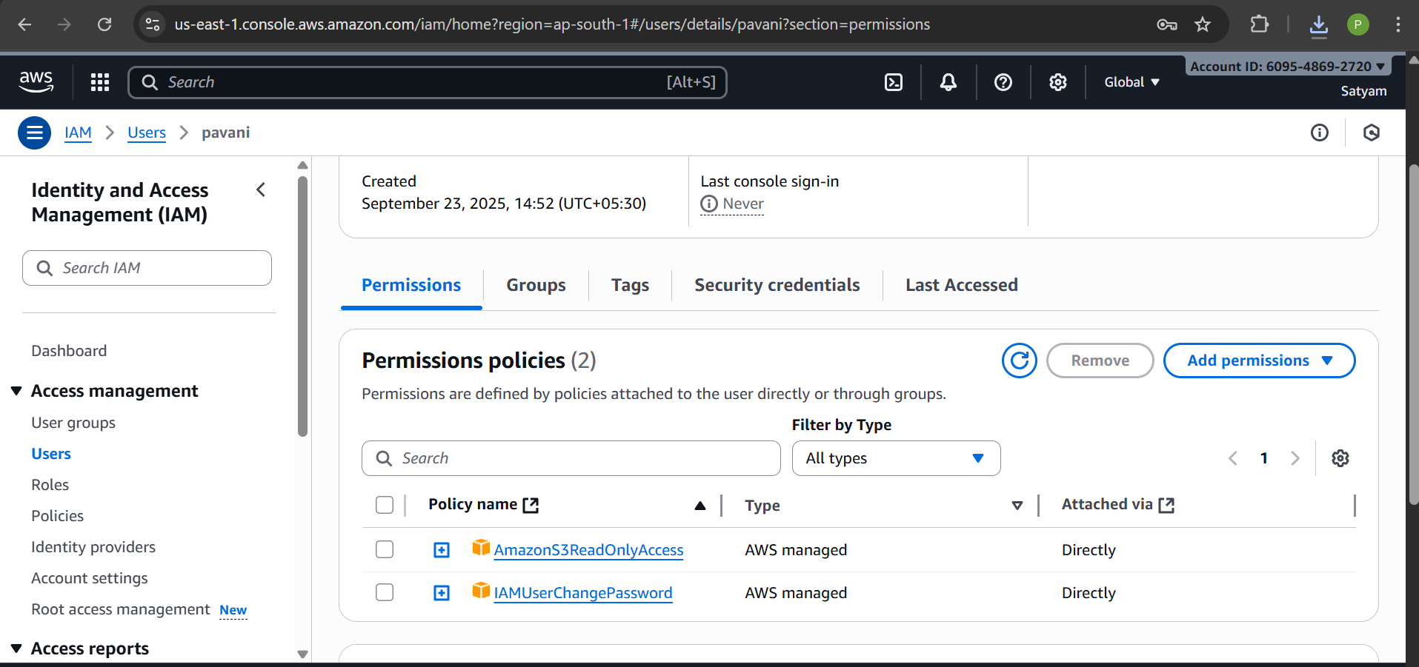
Now login to new IAM user with the name: Pavani
Take credentials from Download.csv file
Now logged into IAM User: pavani
Task 7 – Create a Custom IAM Policy
Objective: Allow only EC2 DescribeInstances.
Steps:
- IAM → Policies → Create policy → JSON:
{
"Version": "2012-10-17",
"Statement": [
{
"Effect": "Allow",
"Action": "ec2:DescribeInstances",
"Resource": "*"
}
]
}
- Name: EC2DescribeOnly → Create.
- Attach policy to a user.
Screenshot:
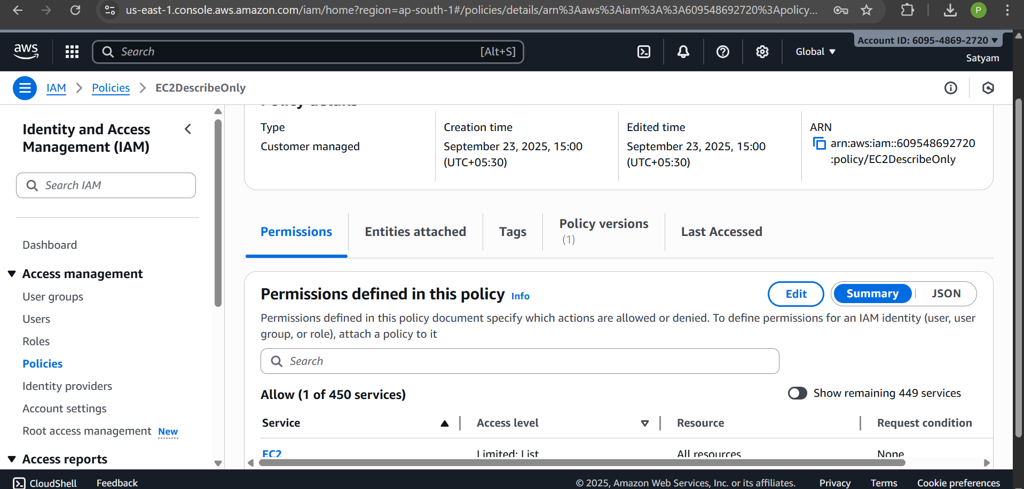
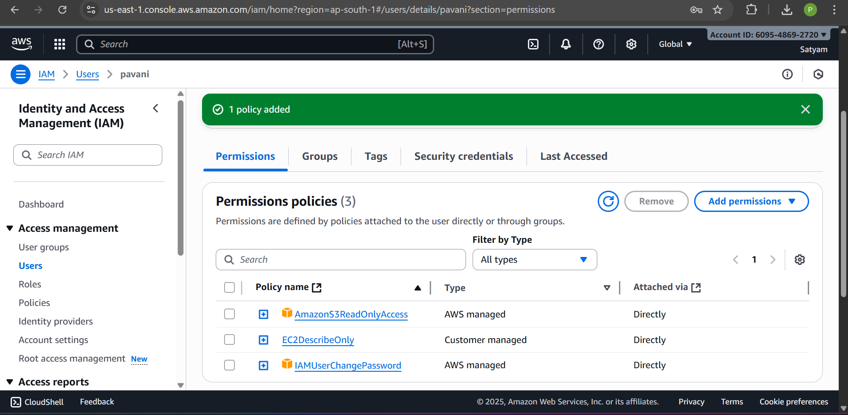

Task 8 – Secure Access with IAM Roles
Objective: Assign EC2 a role to access S3.
Steps:
- IAM → Roles → Create Role → EC2 → Attach AmazonS3ReadOnlyAccess → Name: EC2S3Role.
- EC2 → Instances → Select instance → Actions → Security → Modify IAM Role → attach EC2S3Role.
- SSH → verify: aws s3 ls
Screenshot:
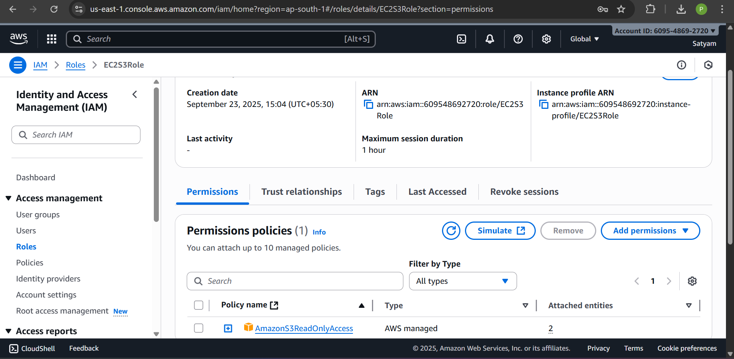
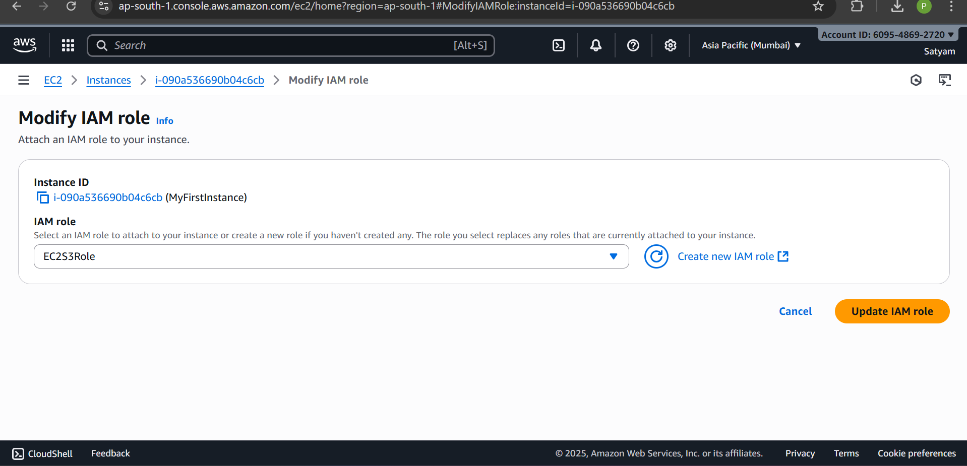
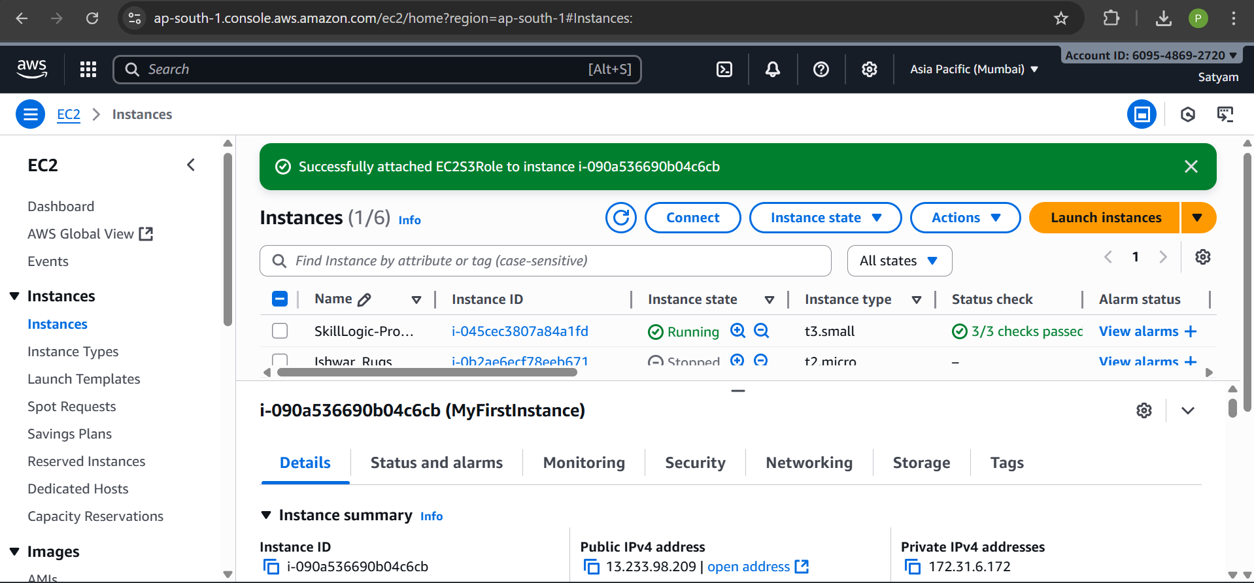
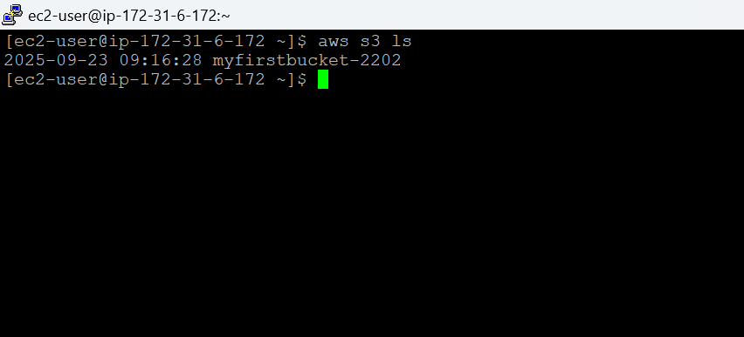
Task 9 – Automate with User Data Script
Objective: Launch EC2 that automatically installs Apache and displays “Hello from User Data”.
Steps:
- EC2 Launch → Advanced Details → User Data → paste:
#!/bin/bash
yum update -y
yum install -y httpd
systemctl start httpd
systemctl enable httpd
echo "Hello from User Data" > /var/www/html/index.html
- Open browser: http://<Public-IP>.

Screenshot:
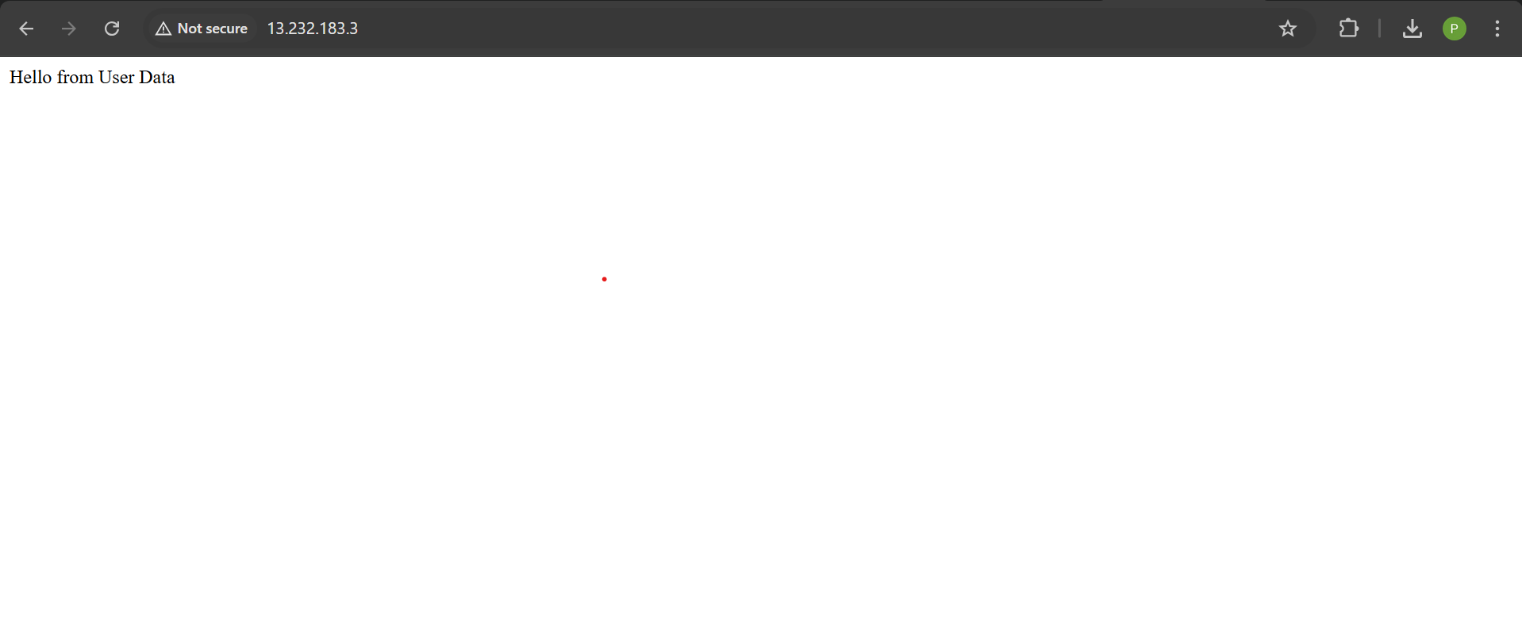

Task 10 – Mini Project: Secure Web App Hosting
Objective:
Create a secure web application by combining EC2, Apache, S3, and IAM Roles. The EC2 instance will serve a web page that includes an image stored in S3, accessed securely using an IAM role.
Step 1: Launch an EC2 Instance
- Sign in to the AWS Management Console → EC2 → Instances → Launch instances.
- Name: SecureWebAppEC2.
- Amazon Machine Image (AMI): Select Amazon Linux 2 (Free Tier).
- Instance Type: t2.micro.
- Key Pair: Select an existing key pair or create a new one. Download .pem file if new.
- Network & Security:
  - Add a Security Group with rules:
    - SSH (Port 22) → Source: Your IP
    - HTTP (Port 80) → Source: 0.0.0.0/0
- Click Launch and wait until the instance shows running and 2/2 Status Checks Passed.
Screenshot: EC2 dashboard showing running instance.
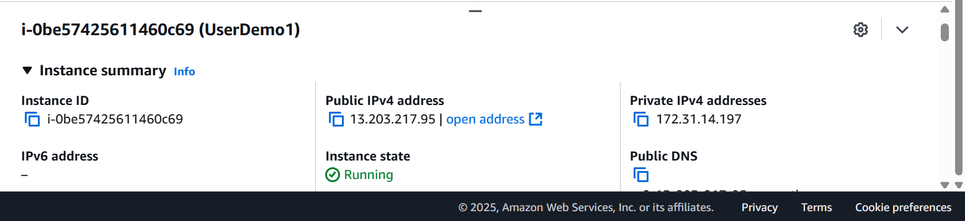
Step 2: Install Apache Web Server
- SSH into your EC2 instance:
chmod 400 mykey.pem
ssh -i mykey.pem ec2-user@<Public-IP>
- Update the system and install Apache:
sudo yum update -y
sudo yum install -y httpd
- Start and enable Apache so it runs at boot:
sudo systemctl start httpd
sudo systemctl enable httpd
- Test locally:
curl http://localhost
- You should see the Apache default page content.
Screenshot: Terminal showing Apache running.

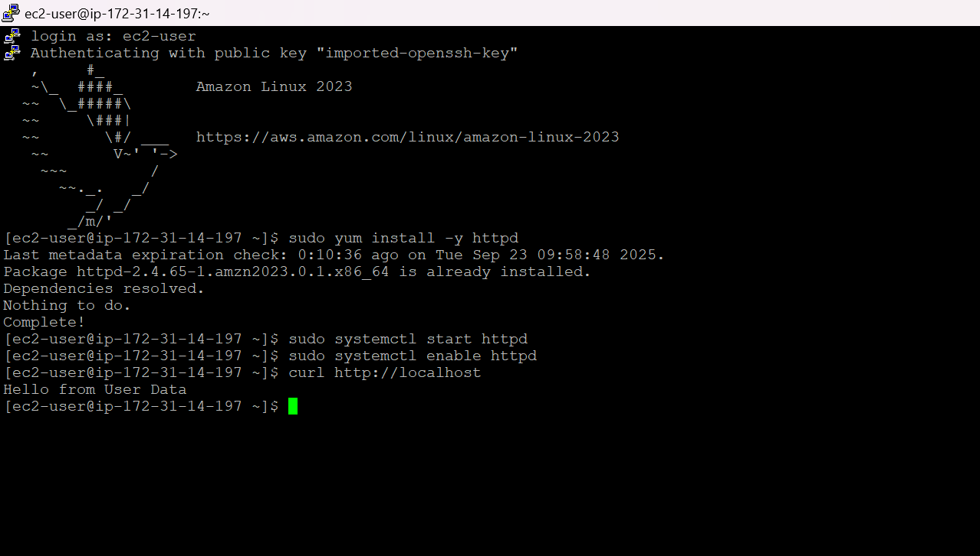
Step 3: Create an S3 Bucket and Upload an Image
- Go to S3 → Create bucket.
  - Name: my-secure-webapp-bucket-<yourname>
  - Region: Same as EC2
  - Block all public access: Enabled (keep bucket private)
- Click Create bucket.
- Inside the bucket → Upload → Select file (e.g., logo.jpg).
- Upload the file. Keep bucket private; don’t make it public.
Screenshot: S3 bucket with uploaded image.
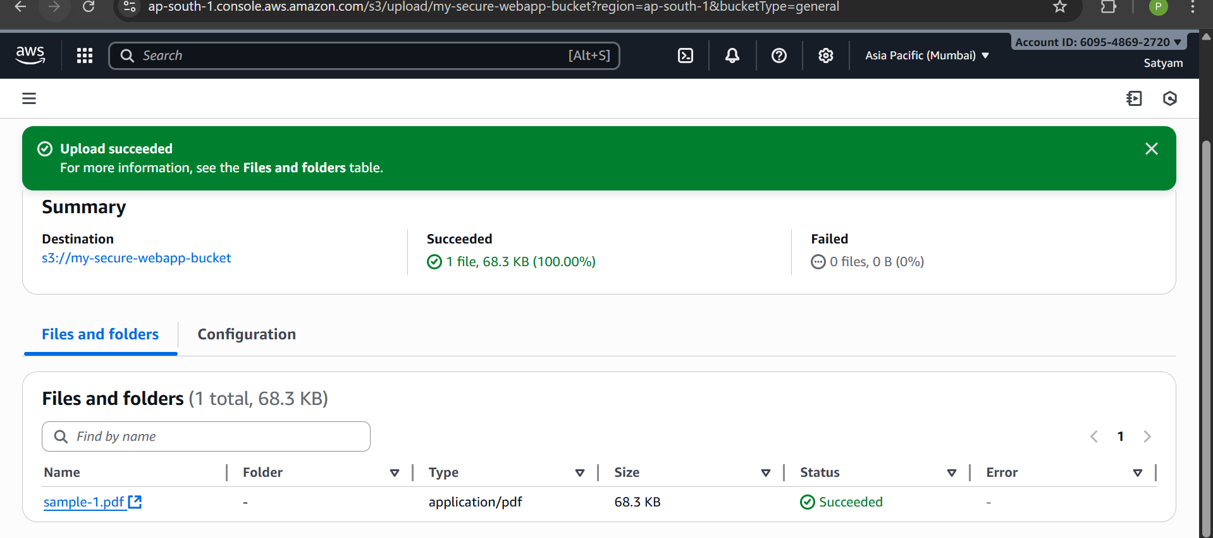
Step 4: Create an IAM Role for EC2 to Access S3
- Go to IAM → Roles → Create Role.
- Select trusted entity: AWS service → EC2.
- Permissions: Attach AmazonS3ReadOnlyAccess.
- Name: EC2S3ReadRole.
- Assign role to EC2 instance:
  - EC2 → Instances → Select instance → Actions → Security → Modify IAM Role → select EC2S3ReadRole.
Screenshot: EC2 instance with IAM role attached.

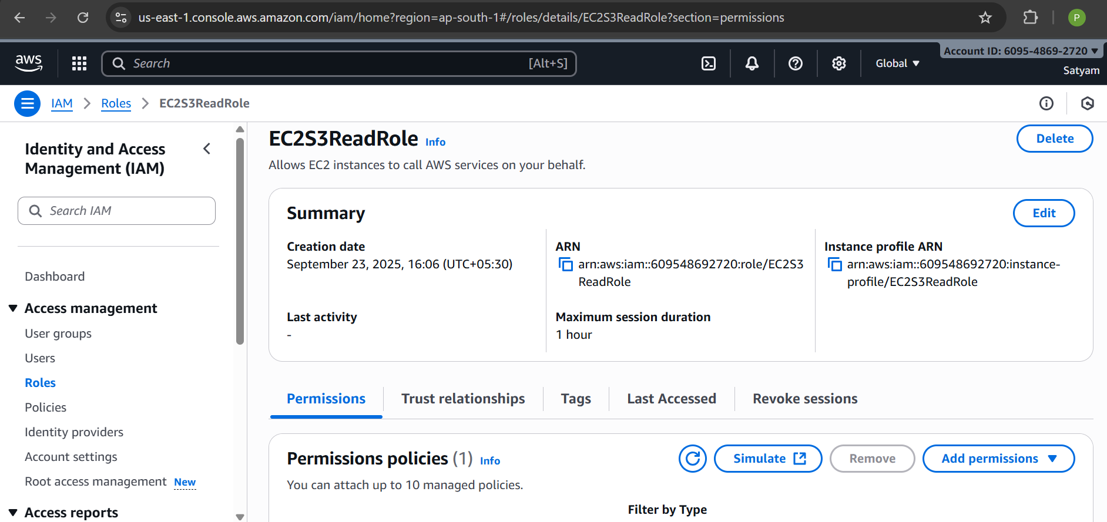
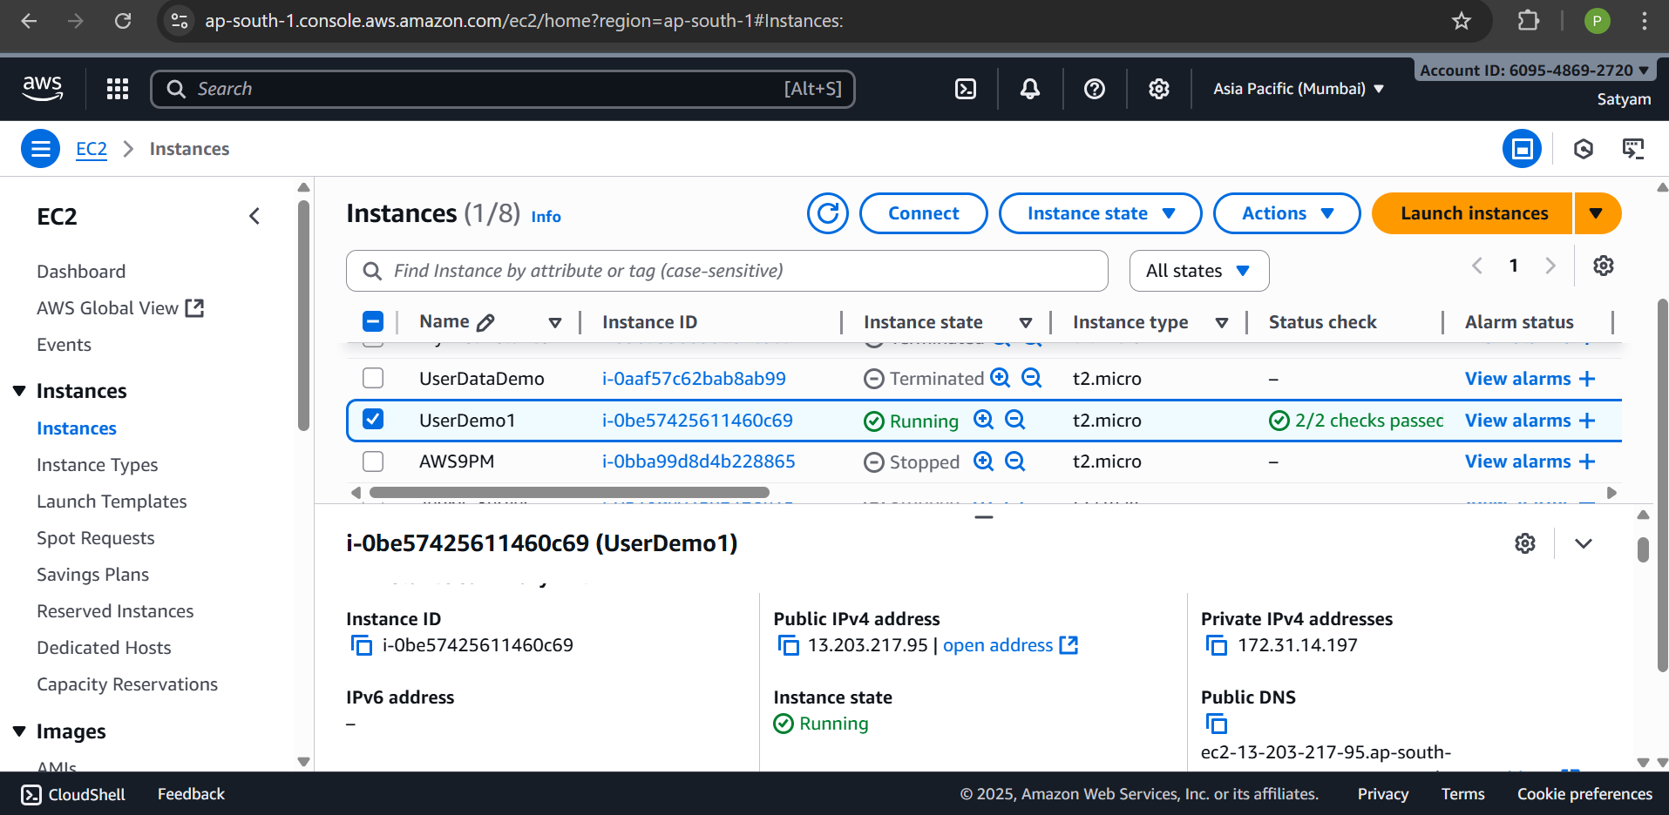
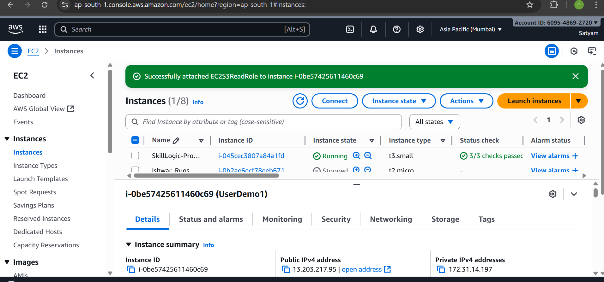

Step 5: Generate a Pre-Signed URL for the S3 Image
- Ensure AWS CLI is installed on EC2:
sudo yum install -y awscli
- Generate a pre-signed URL (valid for 24 hours) to access the private image:
aws s3 presign s3://my-secure-webapp-bucket-<yourname>/logo.jpg --expires-in 86400
- Copy the URL returned. This URL allows your web page to access the image securely without making the bucket public.
Screenshot: Terminal showing pre-signed URL.
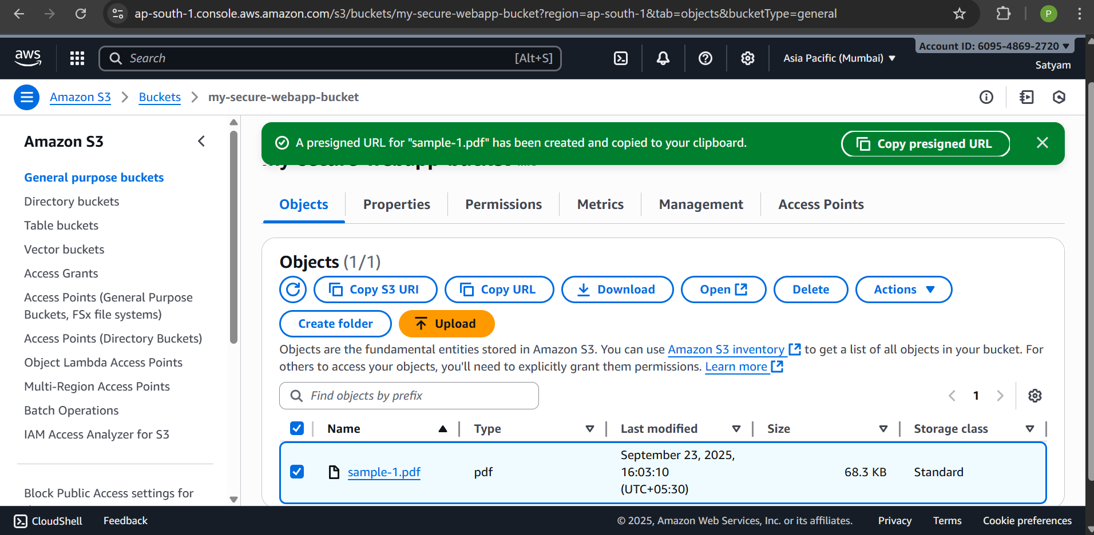
Step 6: Configure the Web Page to Load the Image from S3
- On your EC2 instance, create/edit the index.html:
sudo tee /var/www/html/index.html <<EOF
<html>
<h1>Secure Web App</h1>
<p>Image loaded securely from S3:</p>
<img src="<PASTE-PRESIGNED-URL-HERE>" alt="S3 Image">
</html>
EOF
- Restart Apache to apply changes:
sudo systemctl restart httpd

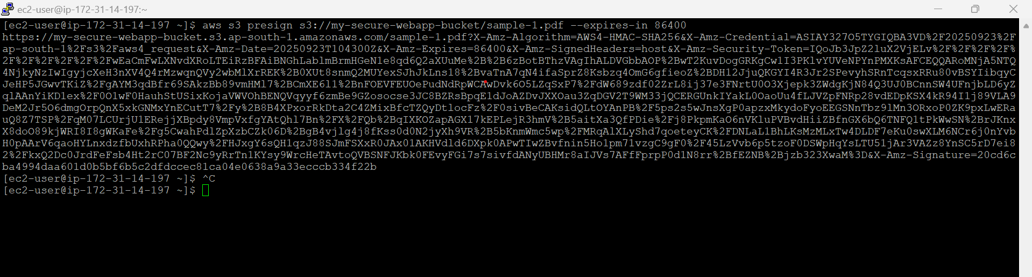
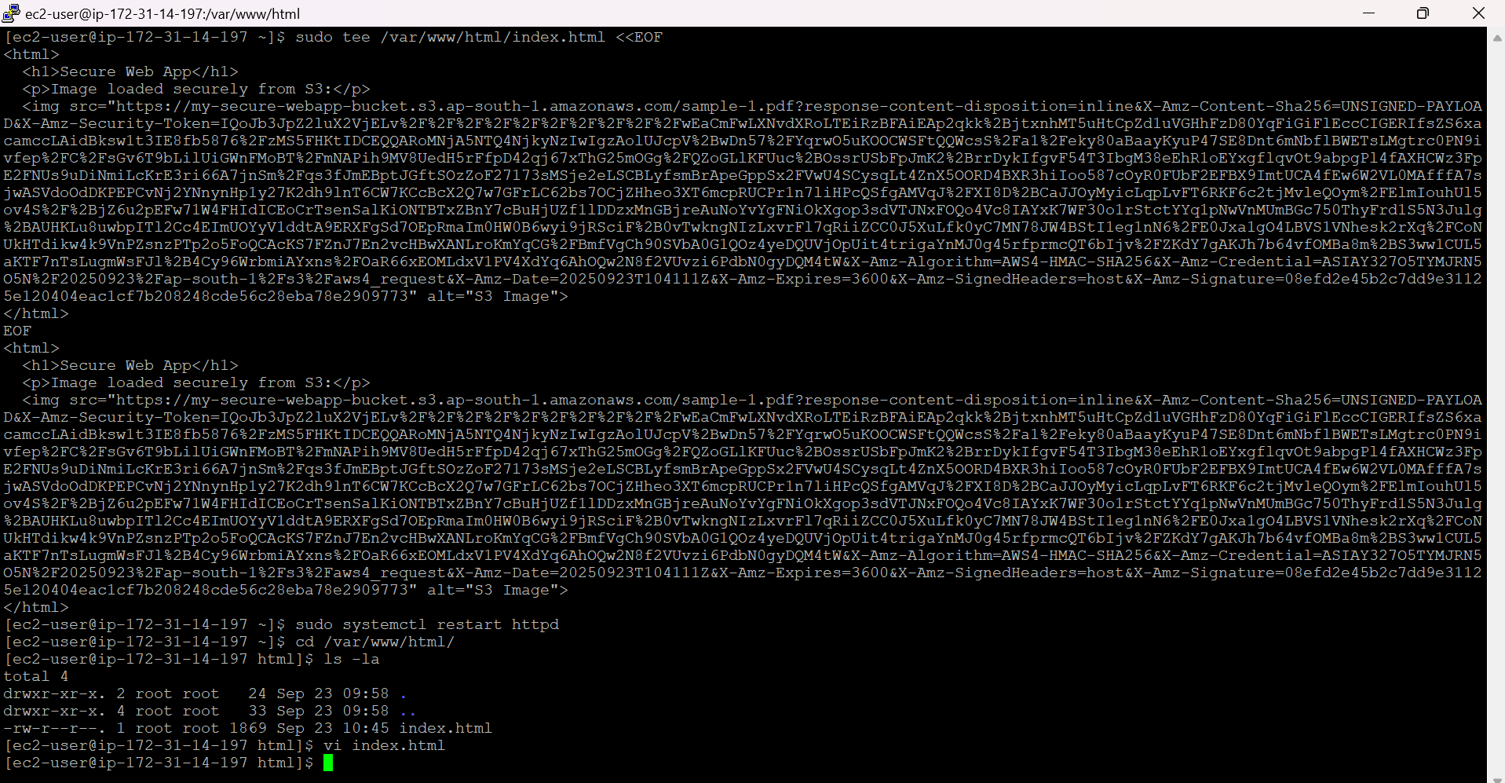
Step 7: Access the Web Page in a Browser
- Open your browser.
- Enter your EC2 Public IPv4 address:
http://<Public-IP>
- You should see:
  - Heading: Secure Web App
  - Image loaded from S3 via the pre-signed URL
Screenshot: Browser showing web page with heading + image from S3.
