**Neural Networks & Deep Learning: ICP3**

**Name: Pavani Medavarthi**

**Student ID: 700741643**

**GitHub Link: <https://github.com/Pavanimedavarthi/NN-DL_Summer-2>**

**Video Link: <https://drive.google.com/file/d/14nBpHMEv0U1HJpq-nSeQJ3XTyE-T1d_R/view?usp=drive_link>**

1. **Follow the instruction below and then report how the performance changed.(apply all at once)**

• Convolutional input layer, 32 feature maps with a size of 3×3 and a rectifier activation function.

• Dropout layer at 20%.

• Convolutional layer, 32 feature maps with a size of 3×3 and a rectifier activation function.

• Max Pool layer with size 2×2.

• Convolutional layer, 64 feature maps with a size of 3×3 and a rectifier activation function.

• Dropout layer at 20%.

• Convolutional layer, 64 feature maps with a size of 3×3 and a rectifier activation function.

• Max Pool layer with size 2×2.

• Convolutional layer, 128 feature maps with a size of 3×3 and a rectifier activation function.

• Dropout layer at 20%.

• Convolutional layer,128 feature maps with a size of 3×3 and a rectifier activation function.

• Max Pool layer with size 2×2.

• Flatten layer.

• Dropout layer at 20%.

• Fully connected layer with 1024 units and a rectifier activation function.

• Dropout layer at 20%.

• Fully connected layer with 512 units and a rectifier activation function.

• Dropout layer at 20%.

• Fully connected output layer with 10 units and a Softmax activation function

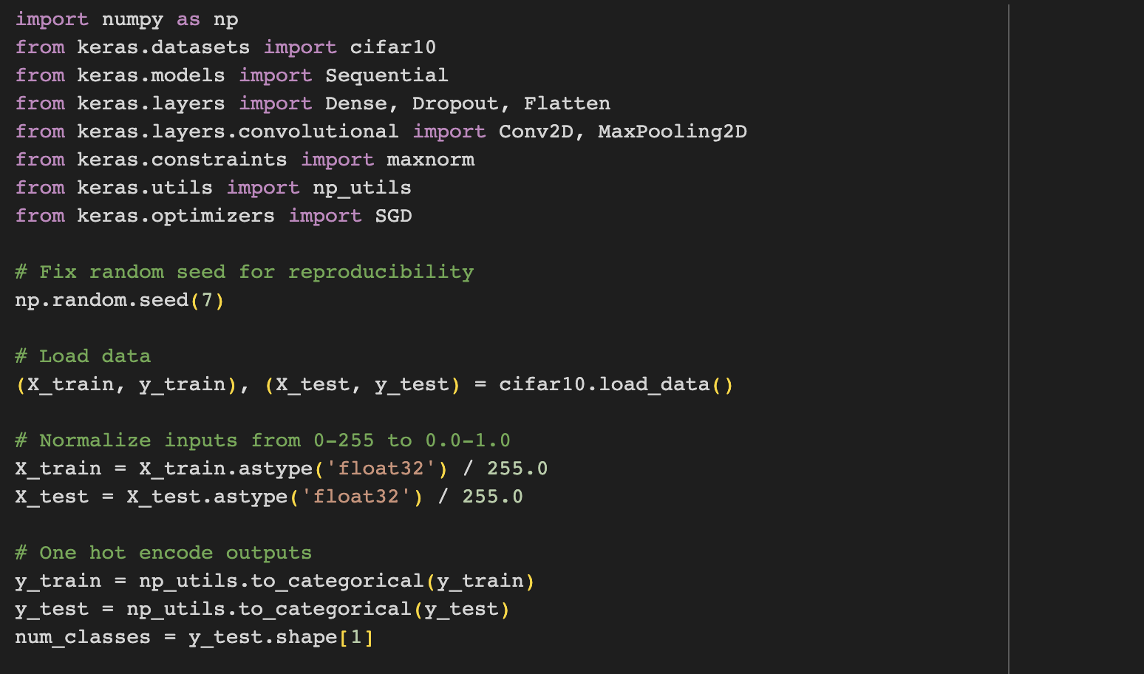

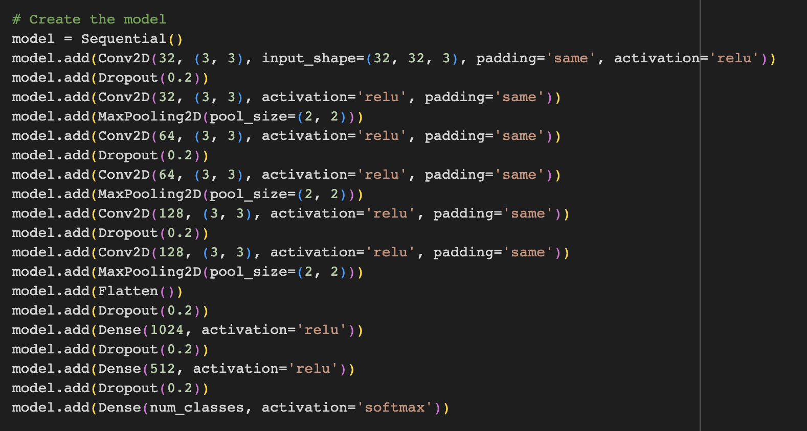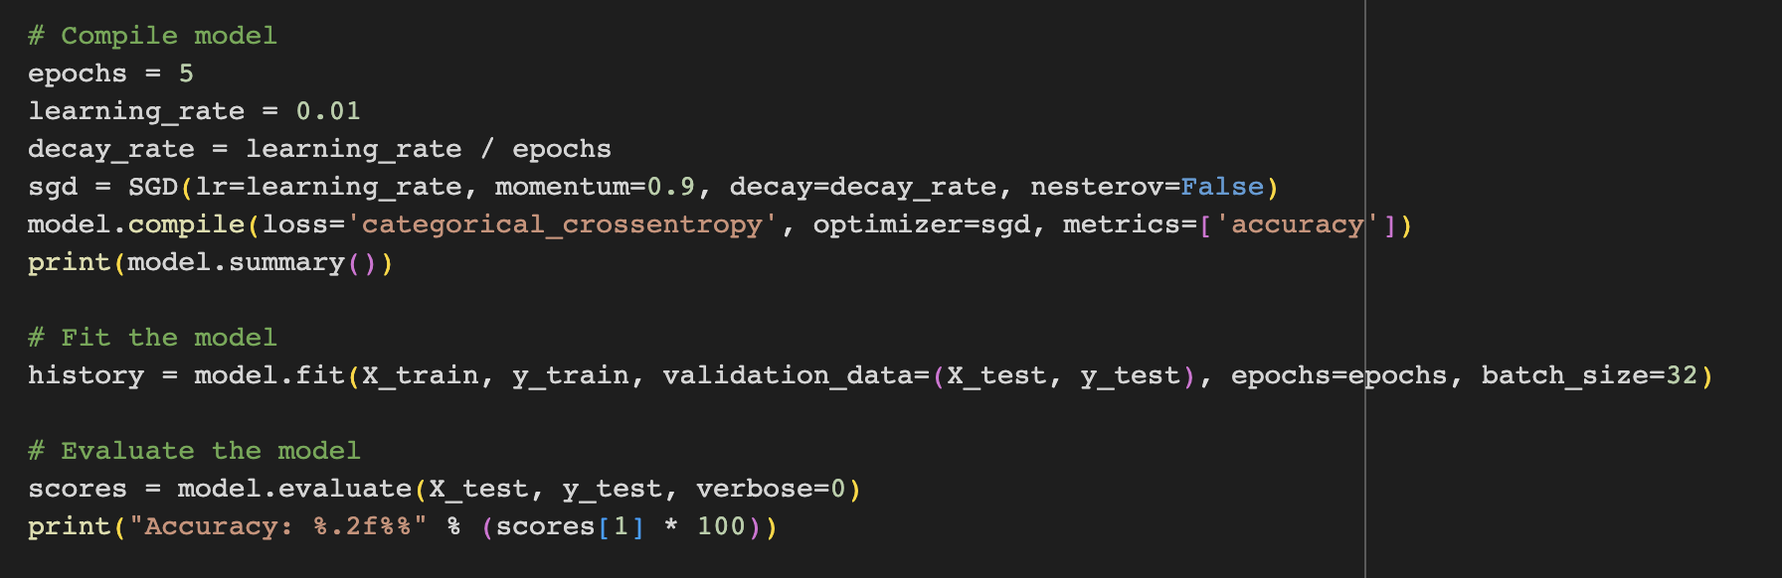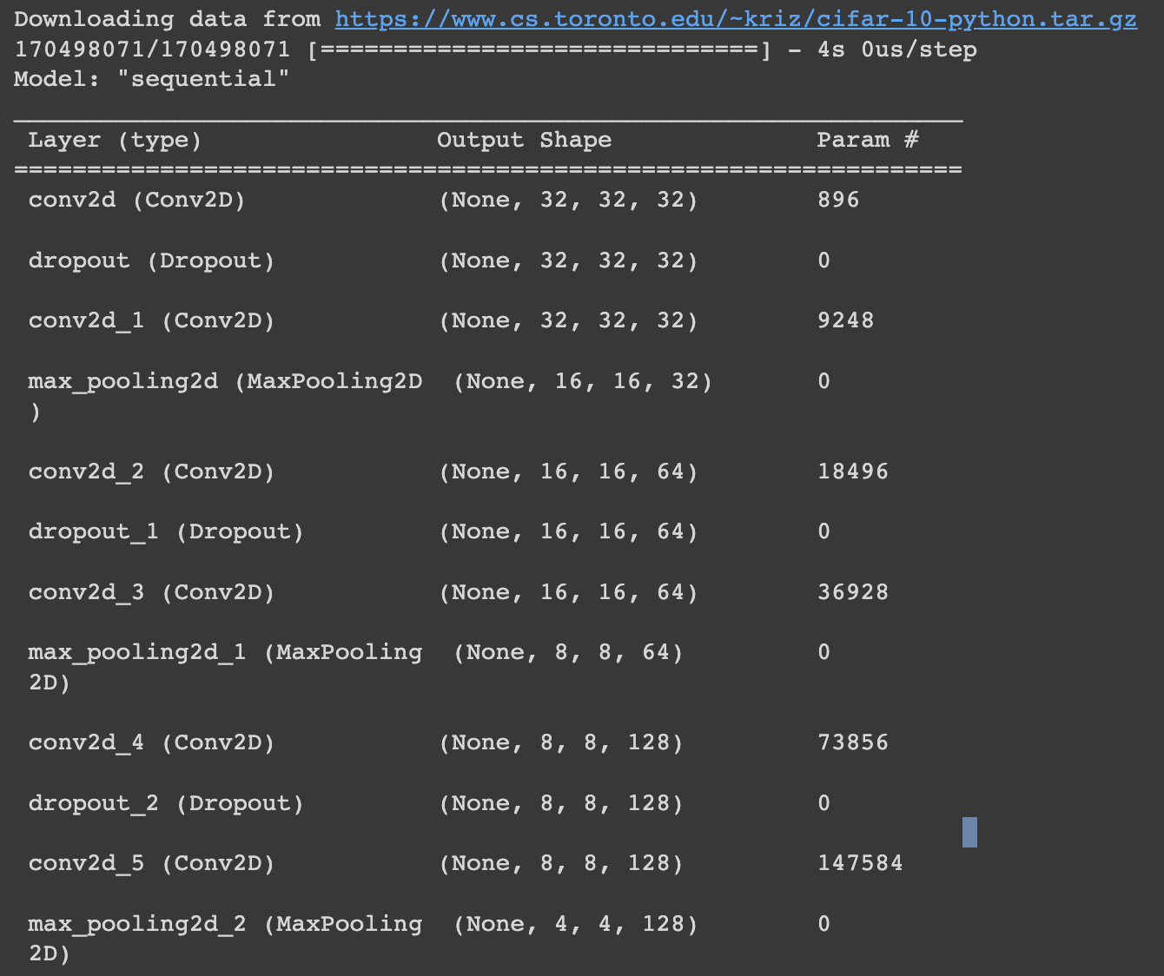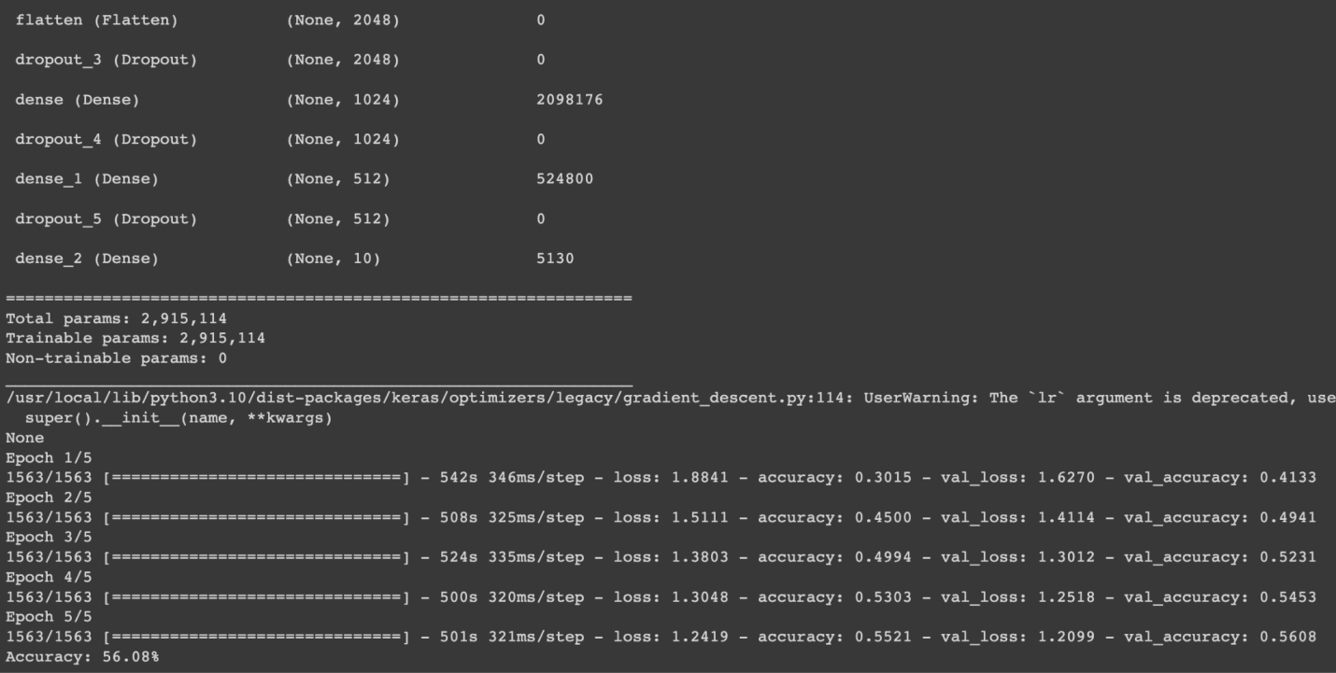

Did the performance change?

The model's performance is expected to improve by incorporating additional layers and a higher number of feature maps, resulting in enhanced accuracy. Nonetheless, this improvement is accompanied by the downside of increased model complexity and longer training durations, as mentioned in the instructions.

**2. Predict the first 4 images of the test data using the above model. Then, compare with the actual label for those 4**

**images to check whether or not the model has predicted correctly.**

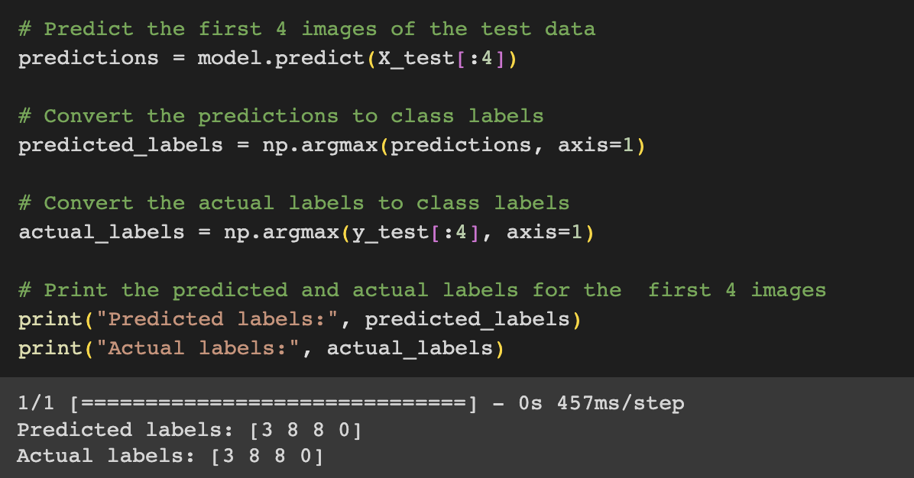

**3. Visualize Loss and Accuracy using the history object**

