NAME – PEDDAPUDI PAVANI

ROLL No - 216Q1A4605

BRANCH – CYBER SECURITY

**TASK-1**

TOPIC : **Git Commands**

**1.git init**

**2.git add .**

**3. git commit**

**4.git branch**

**5.git remote**

**6.git push**

COMMANDS🡪

1.**git init** -The git init command creates a new Git repository. It can be used to convert an existing, unversioned project to a Git repository or initialize a new, empty repository.



2.**git add .** - The git add command adds a change in the working directory to the staging area**.**



3.**git commit -** The commit command performs a commit, and the -m "message" adds a message**.**

A new message or a new file will be added.

Command – git commit – m “message”



4.**git branch -** In Git, a branch is a new/separate version of the main repository.

Command : git commit -M “message”



5.**git remote add origin-** The `git remote add origin` command is used to add a remote repository to your local Git repository. This allows you to push and pull changes between your local and remote repositories. The term “origin” is an alias that refers to the remote repository URL**.**

**Command:**git remote add origin url



**6.git push –** The git push command is used to upload local repository content to a remote repository. Pushing is how you transfer commits from your local repository to a remote repo. It’s the counterpart to git fetch, but whereas fetching imports commits to local branches, pushing exports commits to remote branches**.**

**Command :** git push -u origin main

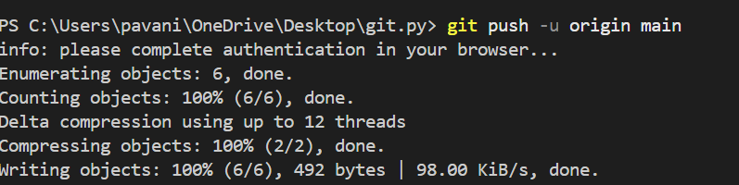

**PROCEDURE**

1. **Creating folder**

Create a new folder so that the files will be stored in the folder. That folder will connect with git

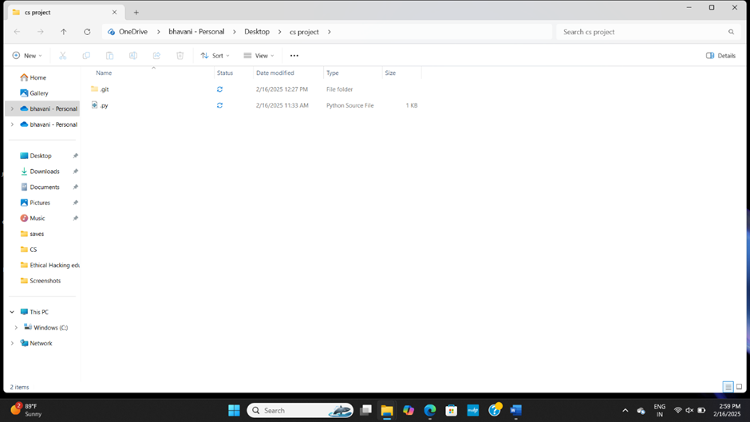

1. **Creating file**

Create the file in that folder as above shown picture python is created with extension of python

1. **Opening terminal**

Install VS code which is nothing but code editor . in vs code open terminal in that terminal initialize git by using the command **git init** by doing so git will be initialized on your vs code.

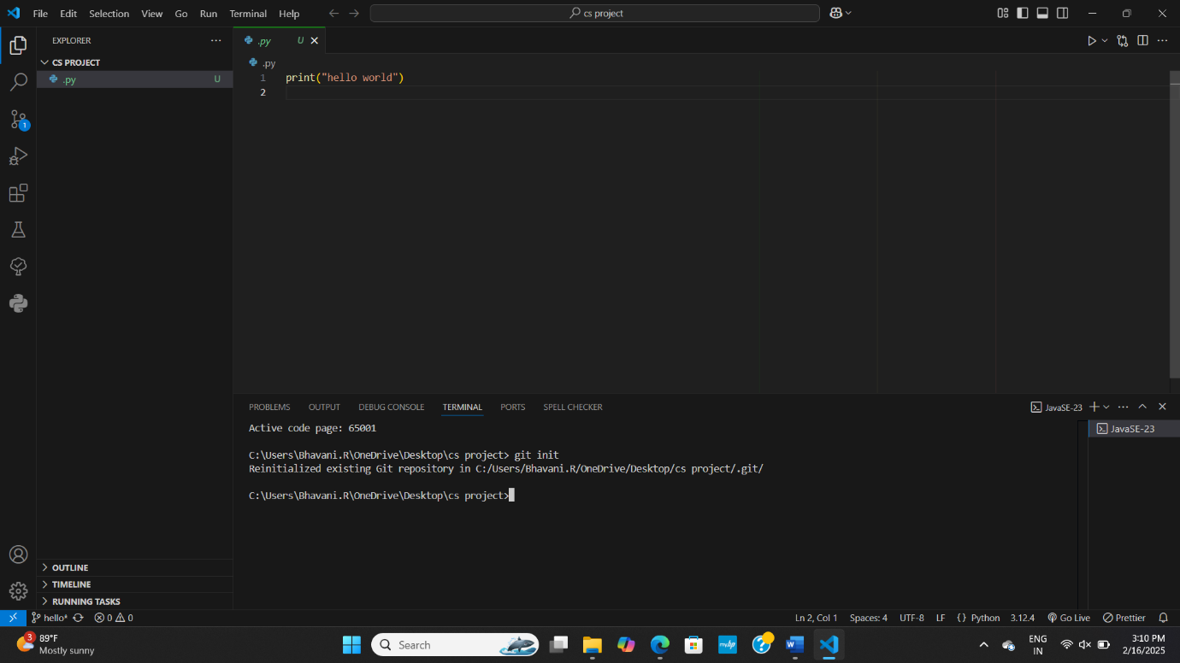

1. **Git initialization**

AS above shown by using the command **git init** I initialized git in terminal

1. **Adding file to git**

For adding file in git we should use command **git add .** this command is used to add a file in the folder

1. **Adding new line to file**

For adding new line we should use command **git commit -m “hello world line”**  by using this command it says that we are adding new line to the file

1. **Create a branch**

Branch is a new/separate version of the main repository for doing this we use command git commit -M “python”

1. **Maintain a connection between git &git repository**

To establish connection between git and github repository and to push the code into github. Command **git remote add origin “url”**

**1.create a new branch to the repository**

**2. git branch -M Branch name**

**new branch will be created**

**3. git checkout Branch name**

**it is used to shift from one branch to onther branch**

**4. git clone “link”**

**another person’s repository fills and the folders will be loaded in your system**

**5. git fetch “link”**

**Details of the other person’s repository will be loaded.**