# REQUIREMENT SPECIFICATION

|  |  |
| --- | --- |
| **Project Code:** | OMRP-01 |
| **Project Name:** | Online Mobile Recharge Portal |
| **Account:** |  |
| **Vertical:** |  |
| **Location:** | ABC Development Center |
| **Customer Name:** |  |
| **Technical Manager/ Email ID:** |  |
| **Project Manager / Email ID:** |  |
| **Quality Co - Ordinator / Email ID:** |  |
| **Customer Contact Information:** |  |
|  |
|  |
|  |

**Affected Groups**

|  |
| --- |
| Development Engineering |
| Quality Assurance |
| XYZ Solutions |
|  |

# List of Reference Documents

|  |  |
| --- | --- |
| **Name** | **Version No.** |
| 1. Request For Proposal | 1.2 |
| 2. |  |
| 3. |  |
| 4. |  |

**Prepared by/Date Reviewed by/Date Approved by/Date**

# Table of Contents

1. INTRODUCTION 3
2. FUNCTIONAL REQUIREMENTS 3
   1. AUTHENTICATION & AUTHORIZATION 3
   2. EXIT HANDLERS 3
   3. ADMIN 4
3. INTERFACE REQUIREMENTS 4
4. NON-FUNCTIONAL REQUIREMENTS 4
5. ASSUMPTIONS/DEPENDENCIES/LIMITATIONS 5
6. ACCEPTANCE CRITERIA 5
7. REQUIREMENTS PRIORITY TABLE 5
8. ACRONYMS AND GLOSSARY 5

# 1 Introduction

## Online Mobile Recharge is a web-based application developed to recharge mobile phones. The project focuses at providing an easy and reliable platform to recharge mobile of any telecommunication company through online without buying recharge card. The registered users of the system can recharge their prepaid mobile phones or can pay their postpaid mobile bills from anywhere at any time. The proposed project for recharging mobiles developed to automate the mobile recharging process. It roots out the manual card system of recharge and introduces a new and genuine online recharge process. The online mobile recharge system is beneficial to both the admin and users. Using the online application, the admin can add new operators, tariff plans, offers and update or modify the existing tariff plans. It helps the users in creating their account, and then recharging the mobiles phones at any time.

## Scope and Overview:

The scope of the Online Mobile Recharge Portal (OMRP) will be to provide the functionality as described below. The system will be developed on a Windows operating system using Java/J2EE.

# Functional Requirements

* Secure user login and registration with field validation and session management.
* Able to add new mobile operator and company name.
* Able to add new recharge plan with price and plan details on existing operator.
* Able to register mobile number with operator.
* Able to recharge on mobile number that is associated with operator.
* Recharge can be made with existing plan or custom price entered by user.
* User can update its account details when logged into system.
* User can change login credentials (password) when logged into system.
* User can delete there account permanently when logged into system.

### Authentication & Authorization

All users must be able to perform login and change password.

|  |  |  |
| --- | --- | --- |
| Requirement ID | Description | Priority |
| AA-001 | All users (Admin, User) logging into the OMRP application should  be authenticated using a unique login-id and password (operations to be supported based on type of user) | P1 |
| AA-002 | All users should be able to change their password | P2 |

### Exit handlers

All users must be able to successfully exit from the application.

|  |  |  |
| --- | --- | --- |
| Requirement ID | Description | Priority |
| EX-001 | The application should handle logout (close all open database connections, invalidate sessions, etc) | P1 |

### Admin

Admin must be able to perform the below mentioned functionalities.

|  |  |  |
| --- | --- | --- |
| Requirement ID | Description | Priority |
| AD-001 | Secure user login and registration with field validation and session management. | P1 |
| AD-002 | Able to add new mobile operator and company name. | P1 |
| AD-003 | Able to add new recharge plan with price and plan details on existing operator. | P1 |
| AD-004 | Able to register mobile number with operator. Recharge can be made with existing plan or custom price entered by user. | P1 |
| AD-005 | User can update its account details when logged into system. | P2 |
| AD-006 | User can change login credentials (password) when logged into system. | P1 |
| AD-007 | User can delete there account permanently when logged into system. | P2 |

# 3 Interface Requirements

The Online Mobile Recharge Portal should be developed as a Web Application using HTML/JSP screens with spring framework.

# Non-functional Requirements

**User Interface-**

* **Login Form-**

A login requires that the user having the User ID and the password.

* **Complaint Form-**

User complaints are directly addressed to a company or public service provider, and most consumers manage to resolve problems with products and services in this way, but it sometimes requires persistence.

* **Update Form-**

User can update their Id and Password.

* **Feed Back-**

User gives the feedback and that helps in generating the performance reports to improve the overall service.

## Target Environment:

* + Windows Operating System
  + Server – Apache Tomcat 9 or higher
  + Database – MYSQL
  + JRE 1.8 or higher
  + Eclipse IDE

# 5 Assumptions/Dependencies/Limitations

* Takes lot of time
* In current system maintaining security is very difficult.
* There are calculation errors.
* In today’s world most of the people don’t have time to go to retail shops and do the recharge.
* Every time your talk time runs out, you have to rush to the vendor for buying recharge.
* Sometime while having an important talk/discussion with your friends/family/client, the talk time get over.

# Acceptance Criteria

The acceptance criteria will be defined in Acceptance Test Plan.

## List of expected deliverables:

* Use Cases definitions document
* Test Case documents (with test results)
* Tested source code
* Tested Data and Report
* Design Specification.
* Database Schema
* System Architecture System
* Development Environment Setup
* Security Documentation
* Performance Metrics and Reports
* Deployment Plan
* Billing and Invoicing System

# Requirements Priority Table

Explains the importance of Priority

|  |  |
| --- | --- |
| **Abbreviation** | **Remark** |
| P1 | First Priority (Priorities have been specified along with the requirements) |
| P2 | Second Priority (Priorities have been specified along with the requirements) |

# Acronyms and Glossary

Acronym and glossary for this document mentioned in the below table.

|  |  |
| --- | --- |
| **Abbreviation** | **Remark** |
| OMRP | Online Mobile Recharge Portal |
| GUI | Graphical User Interface |

**DETAILED DESIGN**

|  |  |
| --- | --- |
| **Project Code:** | MRP |
| **Project Name:** | Mobile Recharge Portal |

**Prepared by/Date Reviewed by/Date Approved by/Date**

# Table of Contents

TABLE OF CONTENTS 2

1. INTRODUCTION 3
   1. Background 3
   2. Purpose 3
   3. Scope 3
2. GLOBAL DATA STRUCTURES AND SHARED DATA FUNCTIONS 3
3. HIGH LEVEL DESIGN 4
   1. Use Case Diagrams 4
      1. Use Case Diagram for Admin 5
      2. Use Case Diagram for User 5
   2. Use case Definition 6
   3. Class Diagram 8
   4. Sequence Diagram 9

3.4.1viewing results 10

* 1. Packages / Classes / Interface 11
  2. UI Templates 16

1. CRITICAL FUNCTIONS AND FOCUS FOR TESTING 20
2. LIMITATIONS 20
3. APPENDIX 20
4. Table: MRP_TBL_User_Details 20
5. Table: MRP_TBL_ Operator_Details 20
6. Table: MRP_TBL_ MobileNo_Details 21
7. Table: MRP_TBL_ Mobile_Recharge 22
8. Table: MRP_TBL_ Recharge_Plan_Details 22
9. Table: MRP_TBL_ Card_Details 23

# Introduction

## Background

A background mobile recharge portal refers to the technical infrastructure that supports the user interface, handling tasks like authentication, transaction processing, and database management for mobile recharges.

## Purpose

The purpose of a mobile recharge portal is to provide a convenient platform for users to recharge their mobile phones with prepaid plans and services, offering options, accessibility, and convenience.

## Scope

The scope of a mobile recharge portal includes providing a platform for users to recharge their mobile phones with various prepaid plans, supporting multiple operators, offering secure payment options, maintaining transaction history, sending notifications, providing customer support, ensuring security measures, and adhering to legal compliance.

# Global Data Structures and Shared Data Functions

This section describes the structure of 9 tables to be used for the implementation of requirements as stated in the specification.

# High Level Design

The section describes all the high level designs of the project which includes class diagrams, use case diagrams and sequence diagrams which describes the visual representation and purpose of the project.

* 1. **Use Case Diagrams**

The requirements of a system can be represented using a use case model in the Use Case Diagram. The use case diagram for the actors of this case study is given as below.

## Use Case Diagram for Admin

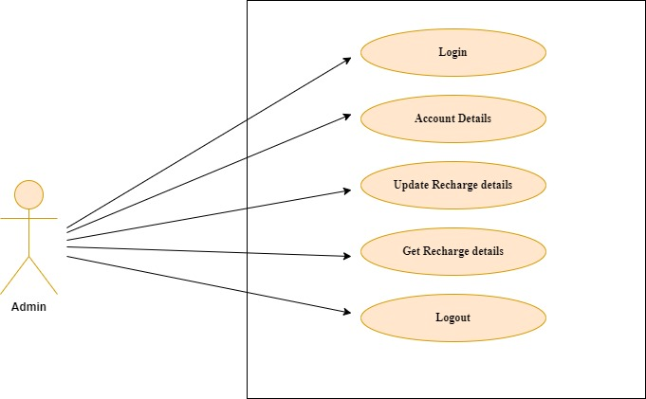

## Use Case Diagram for User

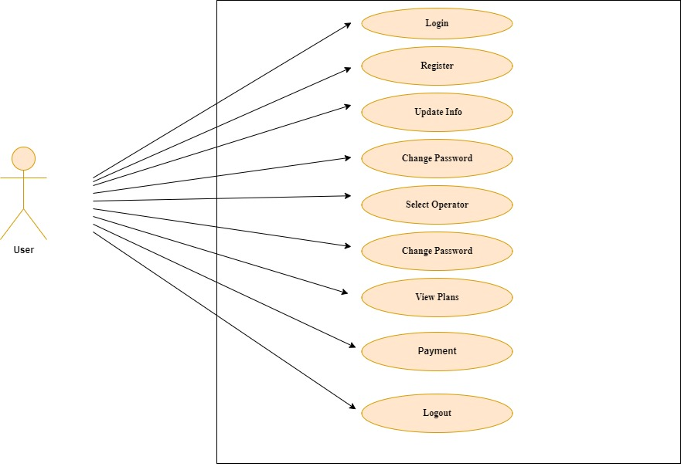

## Use case Definition

Generally, in a design document, Use case definitions should be written for all the *Requirements* of the system.

Note: Participants are expected to document use case definitions for all requirements. However, for few requirements documented below for reference.

Below table explains ‘Use Case’ definition for requirement “AA-001” - Login operation for all users.

* + 1. **Login**

|  |  |
| --- | --- |
| **USE CASE #** | AA-001 *Login* |
| **Goal** | *All users logging into the system should be authenticated using a unique login-id and password (operations to be supported based on type of user)* |
| **Preconditions** | If the user type is ‘Admin’, credential details should exist. |
| **Success End Condition** | If the user type is ‘Admin’, then redirect to the Admin page.  If the user type is ‘New’, then redirect to the Registration page. If the user type is existing Customer as an ‘ Account’, then redirect to My Account page. |
| **Failed End Condition** | *The end user is redirected to an Error Page, and/or is asked to re- enter login credentials.* |
| **Primary, Secondary Actors** | Admin, New, Account. |

|  |  |  |
| --- | --- | --- |
| **Trigger** | *Login button* | |
| **DESCRIPTION** | **Step** | **Action** |
| **1** | *Enter Login credentials (id & password)* |
| **2** | *Click on Login button* |
| **3** | *If id & password is Success, then identify user type Display appropriate(Admin/New User/Customer) home page* |
| **Step** | **Branching Action** |
| **1** | *If 'id' is not existing then return with requesting for Registration* |
| **2** | *If password is not matching return with suitable error message say 'Re-enter id & password'* |
| **Assumptions** | Admin/New User/Customer login credentials are available in the Database and others are already registered with their credentials | |

Below table explains ‘Use Case’ definition for requirement “AD-001” – ADD Customer Details operation for Admin user only.

* + 1. **ADD Candidate Details**

|  |  |  |
| --- | --- | --- |
| **USE CASE #** | AD-001 *Add Customer details* | |
| **Goal** | *To enable Administrator to create and add new Customer* | |
| **Preconditions** | Administrator must be logged in to be able to create a new Customer. | |
| **Success End Condition** | *“Redirect to Admin home page”* | |
| **Failed End Condition** | *"Redirect to Error Page"* | |
| **Primary, Secondary Actors** | *Administrator* | |
| **Trigger** | *'Add Customer button* | |
| **DESCRIPTION** | **Step** | **Action** |
| **1** | *Provide appropriate Customer details* |

|  |  |  |
| --- | --- | --- |
|  | **2** | *Click on Add Customer button* |
| **Step** | **Branching Action** |
| **1** | *If failed to add Customer details* |
| **2** | *Display appropriate message to the admin* |
| **Assumptions** | Admin login credentials are available in the Database | |

## Class Diagram

Class diagrams are the blueprints of the project. It includes all the attributes and methods. They represent the relationship between classes and interfaces.

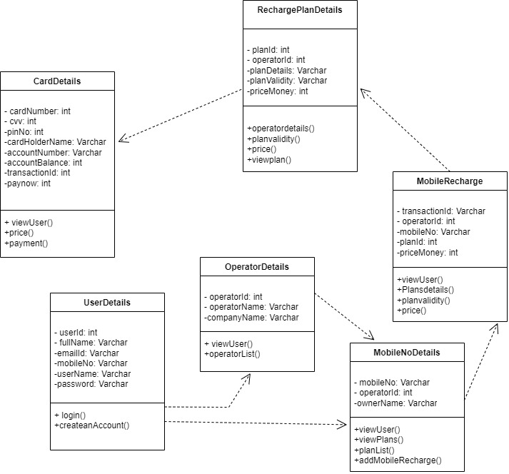

## Sequence Diagram

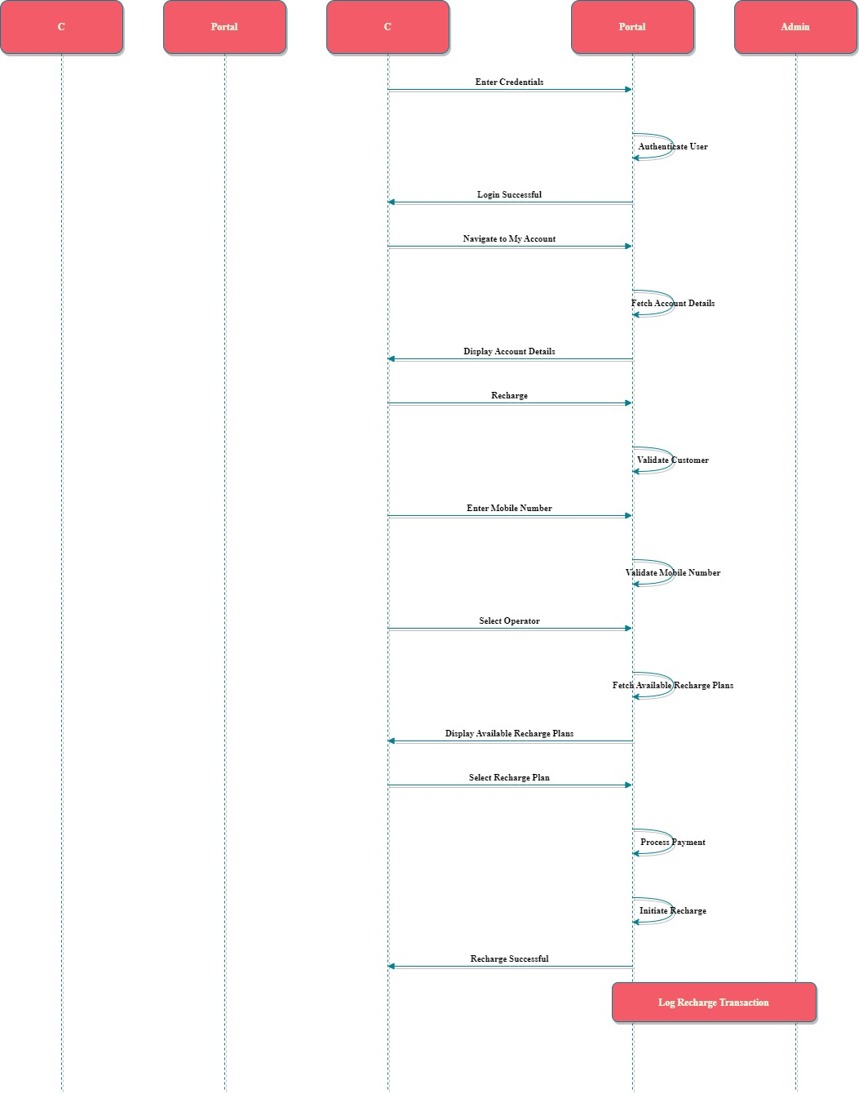

* + 1. **View results:**

Admin viewing User details and user viewing his account.

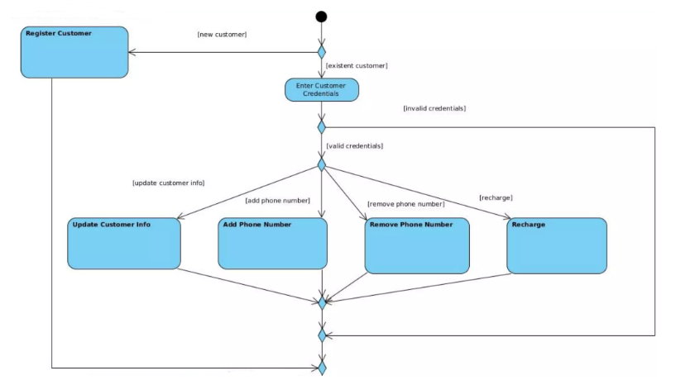

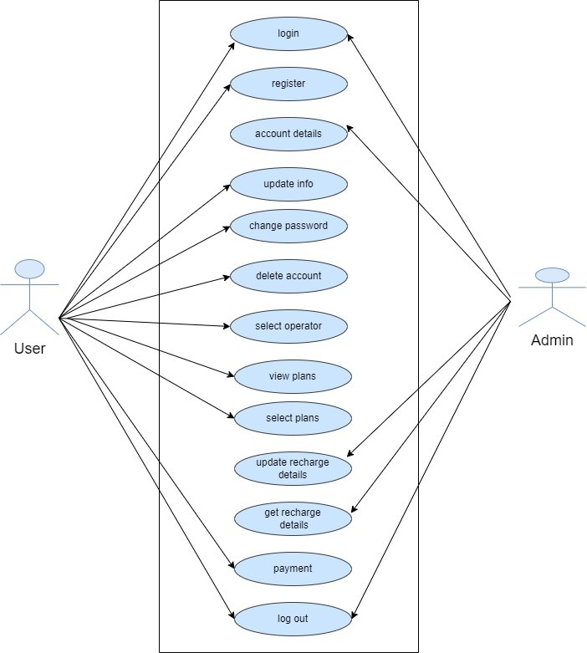

## Packages / Classes / Interface

This section provides a brief outlook on the packaging hierarchy along with the respective classes to be used for the implementation.

The 2 packages mentioned below are for both GUI and Web Application.

|  |  |
| --- | --- |
|  | **Packages** |
| **Package** | **Description** |
| **com.project.user.entity** This package contains all the bean classes  **com.project.user.dao** This package contains all the DAO functionality classes  **com.project.user.service** This package contains all the Service classes | |

**Package com.project.its.entity**

|  |  |  |
| --- | --- | --- |
| **Class Name** | **Attributes** | **Data Type** |
| **UserDetails** | userId | int |
| fullName | String |
| emailId | String |
| mobileNo | int |
| userName | String |
| password | String |

|  |  |  |
| --- | --- | --- |
| **OperatorDetails** | operatorID | int |
| operatorName | String |
| companyName | String |

|  |  |  |
| --- | --- | --- |
| **MobileNoDetails** | mobileNo | int |
| operatorId | int |
| ownerName | String |

|  |  |  |
| --- | --- | --- |
| **MobileRecharge** | transactionId | String |
| operatorId | int |
| mobileNo | int |
| planId | int |
| priceMoney | int |

|  |  |  |
| --- | --- | --- |
| **RchargePlanDetails** | planId | int |
| operatorId | int |
| planDetails | String |
| planValidity | int |
| priceMoney | int |

|  |  |  |
| --- | --- | --- |
| **CardDetails** | cardNumber | int |
| cvv | int |
| pinNo | int |
| cardHolderName | string |
| accountNumber | int |
| accountBalance | int |
| transactionId | int |
| payNow | int |

**Package com.project.user.service**

|  |  |
| --- | --- |
| **Interface Summary** | |
| **Interface** | **Description** |
| **Administrator** | Entity interface for Administrator dealing with the admin process functionalities |
| **Method Summary** |
| String mobile_recharge(User user) |
| String check_plan_exist(User user) |
| String check_plan_exist(User user) |

**Package com.project.its.dao**

Find below the suggestive approach for CRUD operations [method naming & signature] for the DAO Interface/classes. Create the necessary DAO classes.

|  |  |
| --- | --- |
| **Interface Name**  **UserDetailsDAO** | **Description** |
| DAO interface/class to deal with operations related to the specific table. |
| **Method Summary** |
| String validateLoginDetails(User user) |
| String registerUser(User user) |
| String updateInfo(User user) |
| Void deleteUser(User user) |
| Void deleteUser(User user) |
| String insert_mobileno(User user) |
| List<Operator> operator_list() |
| List<Plan>plan_list() |
| String changePassword(User user) |
| List<User> view_plans() |

## UI Templates

**3.6.1 UI Principle**

The UI [Presentation Layer] should be designed with the below mentioned principles which helps easy interaction by the user to the application.

* + 1. **UI controls and Usage Principle**

|  |  |  |
| --- | --- | --- |
| **UI Type** | **Controls** | **Description** |
| Direct Entry | Text Box, Text Area | Any input that cannot be predicted and needs the user to key in. e.g Name, emailId, mobile no etc. |
| Static Selection | Drop Down | If number of items is more, drop down is preferred. e.g.  Select operator. |
| Decision Control | Button | Operations like submit, save, Login, register, account should be executed only upon clicking respective buttons. |

* + 1. **UI Template**

|  |  |  |
| --- | --- | --- |
|  | | **Mobile Recharge Portal** |
| < Logged in Name > | | Home Logout |
|  |  | |
| <Navigation Links> |
| <Navigation Links> |
| <Navigation Links> |
| <Navigation Links> |

|  |  |  |
| --- | --- | --- |
|  | | **Mobile Recharge Portal** |
| < Logged in Name > | | Home Logout |
|  |  | |
| <Navigation Links> |
| <Navigation Links> |
| <Navigation Links> |
| <Navigation Links> |

|  |  |  |
| --- | --- | --- |
|  | | **Mobile Recharge Portal** |
| < Logged in Name > | | Home Logout |
|  |  | |
| <Navigation Links> |
| <Navigation Links> |
| <Navigation Links> |
| <Navigation Links> |

|  |  |  |
| --- | --- | --- |
|  | | **Mobile Recharge Portal** |
| < Logged in Name > | | Home Logout |
|  |  | |
| <Navigation Links> |
| <Navigation Links> |
| <Navigation Links> |
| <Navigation Links> |

|  |  |  |
| --- | --- | --- |
|  | | **Mobile Recharge Portal** |
| < Logged in Name > | | Home Logout |
|  |  | |
| <Navigation Links> |
| <Navigation Links> |
| <Navigation Links> |
| <Navigation Links> |

# Critical Functions and Focus for Testing

login(),

# Limitations

 Adding Candidate details will be performed by admin, but not customer. 

Customer doesn't have login or to view any kind of information.

# APPENDIX

## Table: ITS_TBL_User_Details

This table contains Authentication Information for Administrator.

|  |  |  |
| --- | --- | --- |
| **Field Name** | **Data Type** | **Description** |
| userId | INT | Primary Key |
| fullName | VARCHAR(30) | Not Null |
| emailId | VARCHAR(35) | Unique Key |
| mobileNo | VARCHAR(10) | Unique Key |
| userName | VARCHAR(20) | Unique Key |
| password | VARCHAR(15) | Not Null |

## Table: ITS_TBL_Operator_Details

This table contains Operator details.

|  |  |  |
| --- | --- | --- |
| **Field Name** | **Data Type** | **Description** |
| operatorId | INT | Primary Key |
| operatorName | VARCHAR(20) | Unique Key |
| companyName | VARCHAR(20) |  |

## Table: ITS_TBL_MobileNo_Details

This table contains Customer details.

|  |  |  |
| --- | --- | --- |
| **Field Name** | **Data Type** | **Description** |
| mobileNo | VARCHAR(10) | Primary Key |
| operatorId | INT | Not Null |
| ownerName | VARCHAR(20) | Not Null |

## Table: ITS_TBL_Mobile_Recharge

This table contains Recharge information.

|  |  |  |
| --- | --- | --- |
| **Field Name** | **Data Type** | **Description** |
| transactionId | INT | Exact 10 digit only |
| operatorId | INT | Not Null |
| mobileNo | VARCHAR(10) | Not Null |
| planId | INT |  |
| priceMoney | INT | Not Null |

## Table: ITS_TBL_Recharge_Plan_Details

This table contains Recharge Plan details.

|  |  |  |
| --- | --- | --- |
| **Field Name** | **Data Type** | **Description** |
| planId | INT | Primary Key |
| operatorId | INT | Not Null |
| planDetails | VARCHAR(80) | Not Null |
| planValidity | VARCHAR(30) | Not Null |
| priceMoney | INT | Unique Key |

## Table: ITS_TBL_Card_Details

This table contains Payment details.

|  |  |  |
| --- | --- | --- |
| **Field Name** | **Data Type** | **Description** |
| cardNumber | VARCHAR(16) | Primary Key |
| cvv | INT | Not Null |
| pinNo | INT | Unique Key |
| cardHolderName | VARCHAR(50) | Not Null |
| accountNumber | VARCHAR(20) | Not Null |
| accountBalance | INT | Not Null |
| transactionId | INT |  |
| payNow | INT |  |