2,3 Partition Testing

Login and Menu Services Active, Order, Payment and Review Services are down

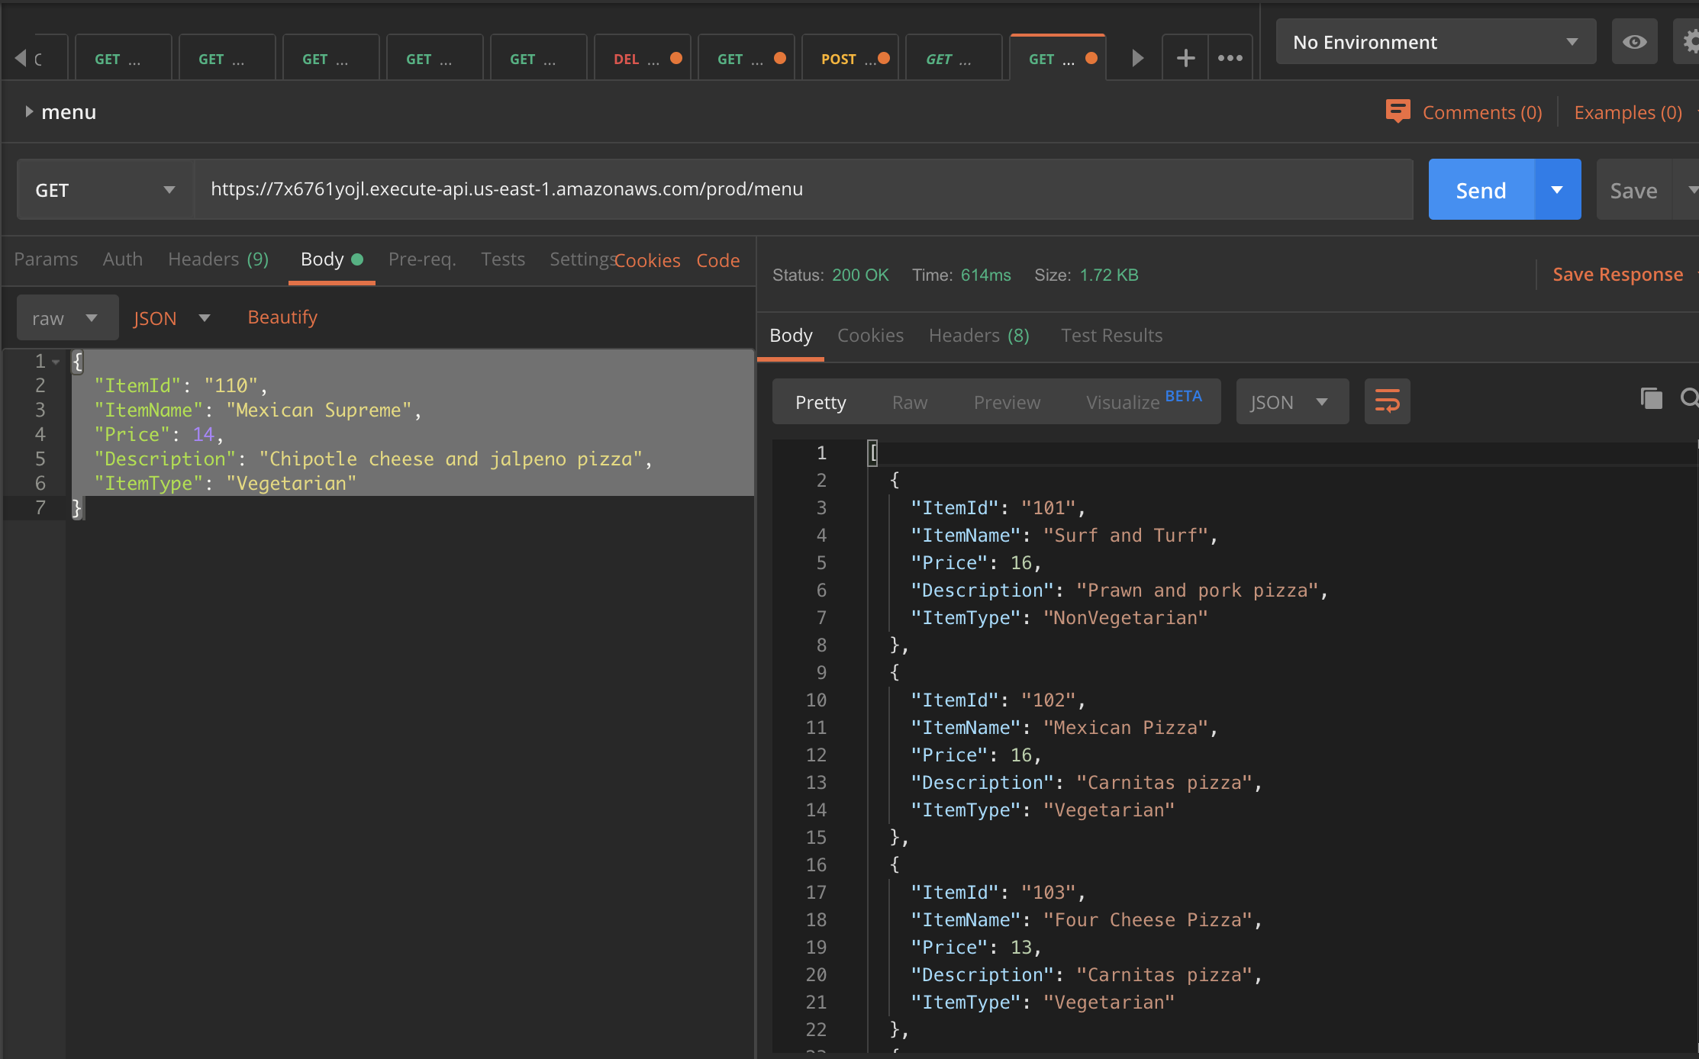MENU – GET ALL ITEMS

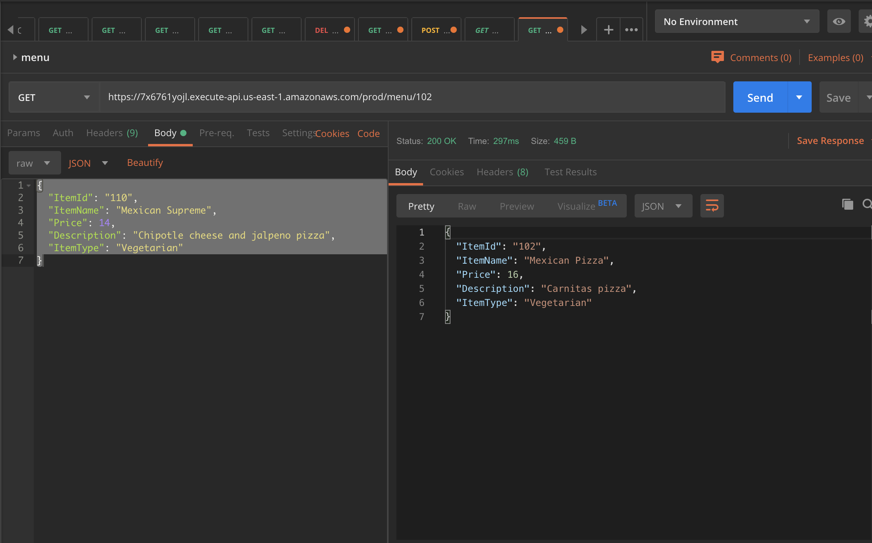MENU GET ITEM BY ID :