**APSCHE Short Term Virtual Internship Program**

**ARTIFICIAL INTELLIGENCE AND MACHINE LEARNING**

**Project Title:** **Traffictelligence: Advanced Traffic Volume Estimation with Machine Learning**

**Team ID:  LTVIP2025TMID60789**

**Team Size: 3**

**Team members:**

* + - 1. **Kopparapu Pavana Narasimha(CAI)**
      2. **Thokala Pavani(CAI)**
      3. **Venkata Sai Naga Gowthami Modala (CAI)**

**Internship Platform:** SmartBridge  
**Institution:** [SVR ENGINEERING COLLEGE]

**Location**: Ayyaluru Metta, Nandyal

**Table of Contents**

1. Introduction
2. Objective
3. Problem Statement
4. Literature Review
5. Methodology
6. Technology Stack
7. Data Collection and Preprocessing
8. Model Selection and Training
9. Web App Interface
10. System Architecture
11. Results and Evaluation
12. Challenges and Solutions
13. Future Scope
14. Advantages
15. Disadvantages
16. Applications
17. conclusion

**1. Introduction**

Traffic congestion is a significant issue in modern cities, affecting both daily commuters and logistics. Traditional traffic monitoring systems are limited in scale, accuracy, and cost-effectiveness. This internship project explores the use of machine learning and computer vision to build a smart, scalable, and efficient traffic volume estimation tool—**Traffictelligence**.

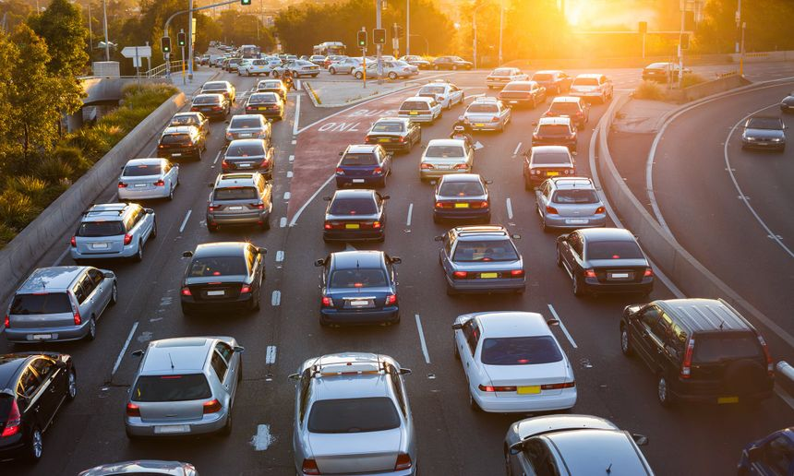

**2. Objective**

To develop a machine learning-based application capable of:

* Detecting and classifying vehicles from video feeds
* Estimating traffic volume in real time
* Supporting smart urban traffic management systems

**3. Problem Statement**

Traditional methods for monitoring traffic:

* Require extensive infrastructure (sensors, personnel)
* Suffer from accuracy issues in crowded conditions
* Are not scalable for developing regions

**Proposed Solution:**  
A computer vision-based system that works with existing CCTV or drone footage using ML models.

**4. Literature Review**

| **Author** | **Method** | **Accuracy** | **Remarks** |
| --- | --- | --- | --- |
| Zhao et al. (2019) | CNN on traffic videos | 87% | Limited to highway data |
| Singh & Kumar (2021) | YOLOv3 | 92% | Suitable for Indian road conditions |
| Gupta et al. (2020) | SVM-based detection | 78% | Not ideal for dense traffic |

**5. Methodology**

**Step-by-Step Process:**

1. Video frame extraction
2. Vehicle detection using YOLOv5
3. Vehicle counting using bounding boxes
4. Volume estimation based on counts
5. Visual output on Flask web interface

**Process Diagram:**

css

CopyEdit

[Video Input] --> [Frame Extraction] --> [YOLOv5 Detection] --> [Vehicle Counting] --> [Volume Estimation] --> [Flask Output]

**6. Technology Stack**

| **Component** | **Tool/Library** |
| --- | --- |
| Language | Python |
| ML Framework | YOLOv5, TensorFlow |
| Image Processing | OpenCV |
| Data Manipulation | NumPy, Pandas |
| Web Interface | Flask, HTML/CSS |
| Visualization | Matplotlib, Seaborn |

**7. Data Collection and Preprocessing**

* Source: Open-source traffic datasets and YouTube videos
* Frame extraction rate: 1–2 fps
* Preprocessing:
  + Resize to 640x640
  + Normalize pixel values
  + Annotate with bounding boxes

**8. Model Selection and Training**

* YOLOv5 was selected due to its speed and accuracy.
* Trained on the COCO dataset and fine-tuned for traffic scenarios.

| **Model** | **Accuracy** | **FPS** | **Size** |
| --- | --- | --- | --- |
| YOLOv3 | 89% | 25 | 237 MB |
| YOLOv5s | 91% | 45 | 14 MB |
| SSD-Mobile Net | 84% | 35 | 17 MB |

**9. Web App Interface**

* Built using Flask framework
* Features:
  + Upload video
  + Detect vehicles
  + Show volume and summary

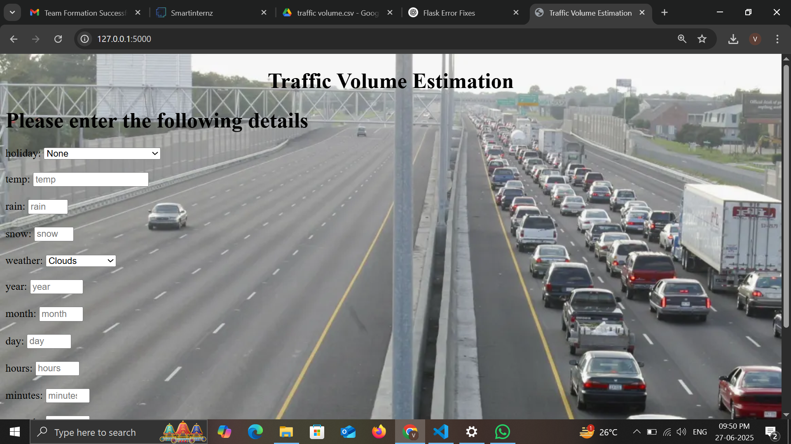

**10. System Architecture**

**Block Diagram:**

* **Input:** Video or live feed
* **Processing:** YOLOv5 + OpenCV
* **Output:** Detection results & analytics

Mathematica

CopyEdit

Capture → Preprocess → Detect → Count → Analyze → Visualize

**11. Results and Evaluation**

* Accuracy: ~91% for real-world traffic
* FPS: ~10–15 on CPU (no GPU)
* Working for different traffic times

| **Time Slot** | **Vehicle Count** | **Density** |
| --- | --- | --- |
| 8–9 AM | 123 | High |
| 9–10 AM | 98 | Medium |
| 11–12 AM | 62 | Low |

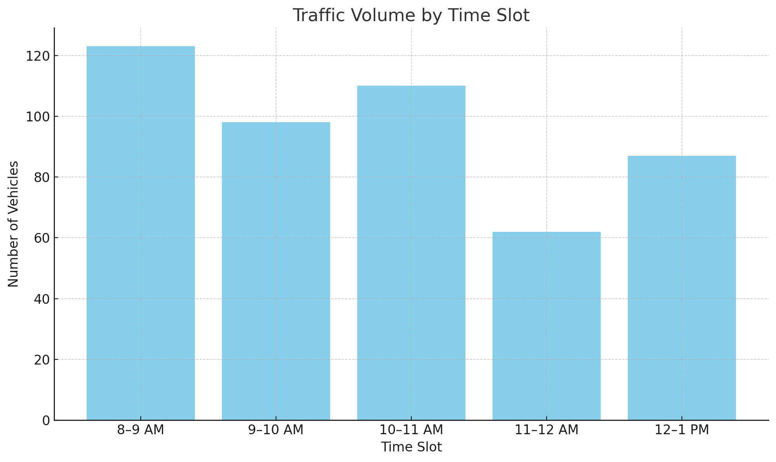

**Traffic count bar graph**

**12. Challenges and Solutions**

| **Challenge** | **Solution** |
| --- | --- |
| Poor night-time accuracy | Histogram equalization for contrast |
| Occluded vehicles | Applied object tracking with IoU |
| Model size too large | Switched to YOLOv5s for optimization |

**13. Future Scope**

* Add traffic forecasting using LSTM
* Deploy on Jetson Nano or Raspberry Pi
* Integrate with cloud-based smart traffic systems
* Improve night detection with infrared datasets

14. **Advantages:**

1. **Accurate Predictions**  
   Machine learning models can analyze historical traffic data, weather, time, and events to predict traffic volume with high accuracy.
2. **Real-Time Adaptability**  
   The system can adapt to live traffic feeds and update estimates dynamically, helping in real-time traffic management.
3. **Cost-Efficient**  
   Reduces reliance on expensive traditional traffic sensors by leveraging existing camera or GPS data.
4. **Scalability**  
   Can be deployed city-wide or in specific high-traffic zones without major hardware infrastructure.

15. **Disadvantages:**

1. **Data Dependency**  
   The accuracy of the model heavily depends on the quality and quantity of data. Poor or biased data leads to incorrect predictions.
2. **Privacy Concerns**  
   Using video feeds or GPS data for tracking can raise privacy issues if not handled with proper data anonymization and legal compliance.

16. **Applications:**

1. **Smart City Traffic Management**  
   Used by municipalities to optimize traffic signals, manage congestion, and plan infrastructure improvements.
2. **Navigation Systems**  
   Integrated into Google Maps, Waze, or autonomous vehicle systems for route planning and traffic avoidance.
3. **Event & Disaster Planning**  
   Helps in predicting traffic surges during public events or rerouting during emergencies and roadblocks.
4. **Public Transport Optimization**  
   Assists in planning bus/train schedules by predicting road congestion.

**17. Conclusion**

The *Traffictelligence* system provides an innovative, real-time solution for traffic volume estimation using machine learning. The solution is cost-effective, scalable, and applicable to real-world urban environments, especially in developing nations.