# Project:

# Build multiple Vnet connection in different 3 regions and connect each vm with another vm.

Vnet (Virtual network):

* In Azure, VNet stands for "Virtual Network."
* It is a fundamental building block of the Azure network infrastructure and provides a way to logically isolate and segment your Azure resources, such as virtual machines (VMs), web apps, and databases, within your own defined network boundary.

Virtual Machines(vm’s):

* A virtual machine, commonly shortened to just VM, is no different than any other physical computer like a laptop, smart phone, or server.
* It has a CPU, memory, disks to store your files, and can connect to the internet if needed. While the parts that make up your computer (called hardware) are physical and tangible, VMs are often thought of as virtual computers or software-defined computers within physical servers, existing only as code.

Peering:

* **Virtual network peering**: Connecting virtual networks within the same Azure region.
* Virtual network peering enables you to seamlessly connect two or more Virtual Networks in Azure.

Why we use peering concept?

* Virtual Network (VNet) peering is a concept used in Azure to connect two or more Azure VNets together.
* It allows these VNets to communicate with each other as if they are on the same network, even if they are in different Azure regions or subscriptions.

Step by step process:

Step 1:

* open and sing in to azure portal.
* Then search vnet (virtual network) in search bar.
* After that create a vnet with a different region.
* In these process we have to create three different vnet’s with three different regions.

Create a vnet (virtual network) as shown below.

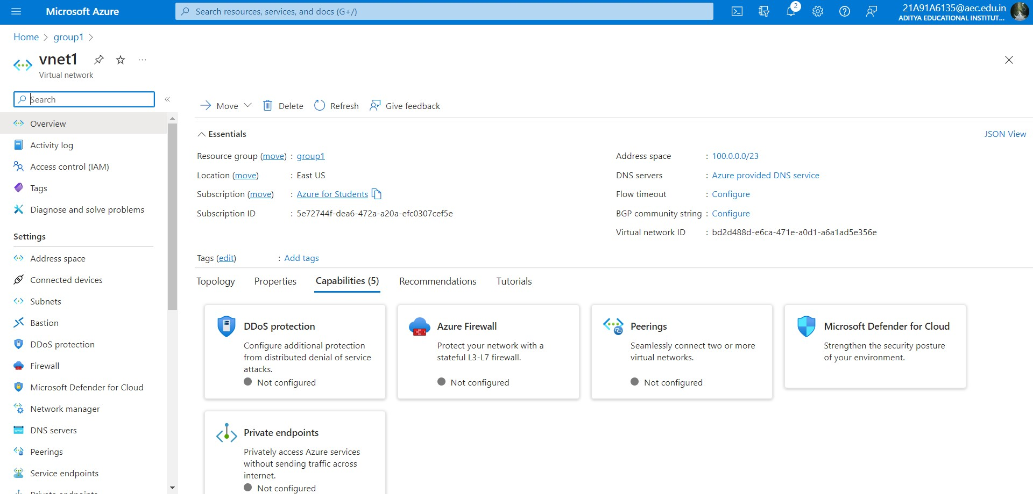

Step 2:

* after creating three different vnets.
* Go to the home page of azure portal search virtual machines.
* Now create three different virtual machines.

Create a virtual machine as shown below:

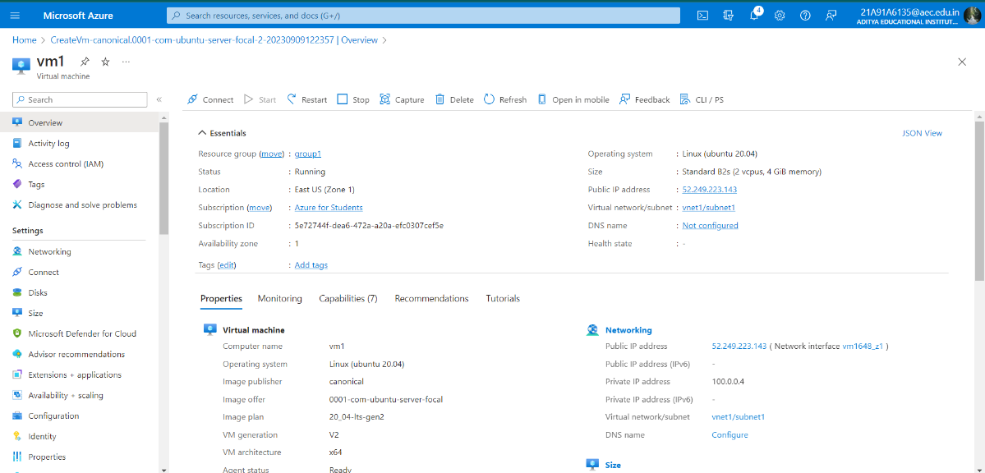

Vnet2 with different region.

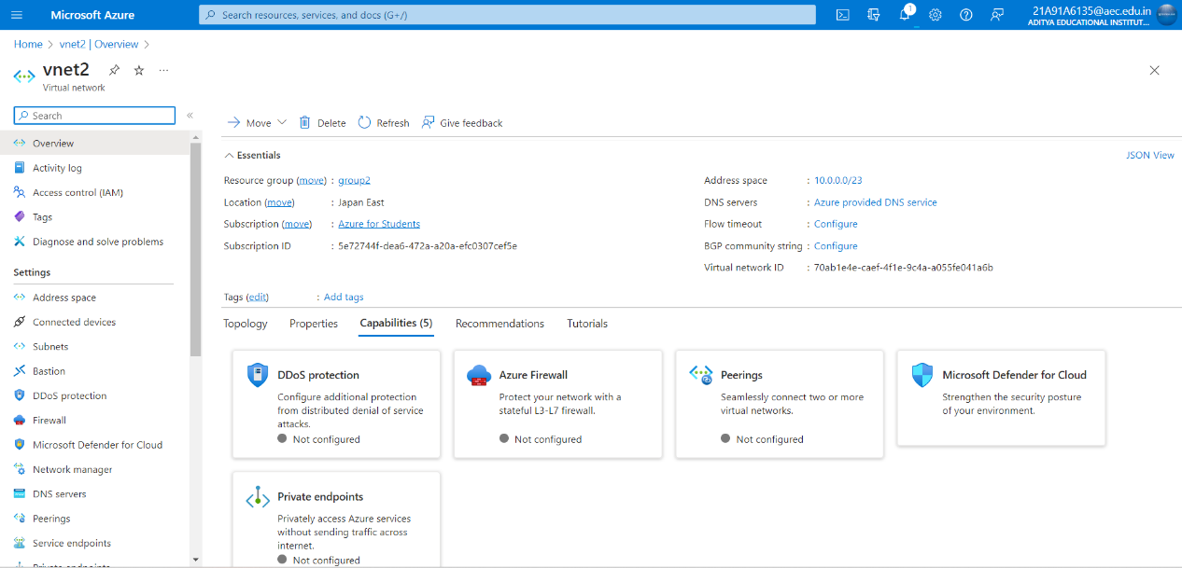

Virtual machine for vnet2.

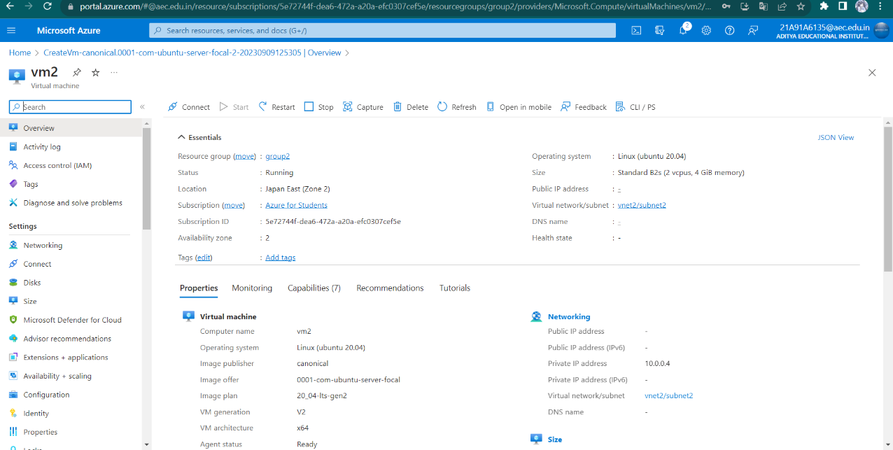

Vnet3 with different region.

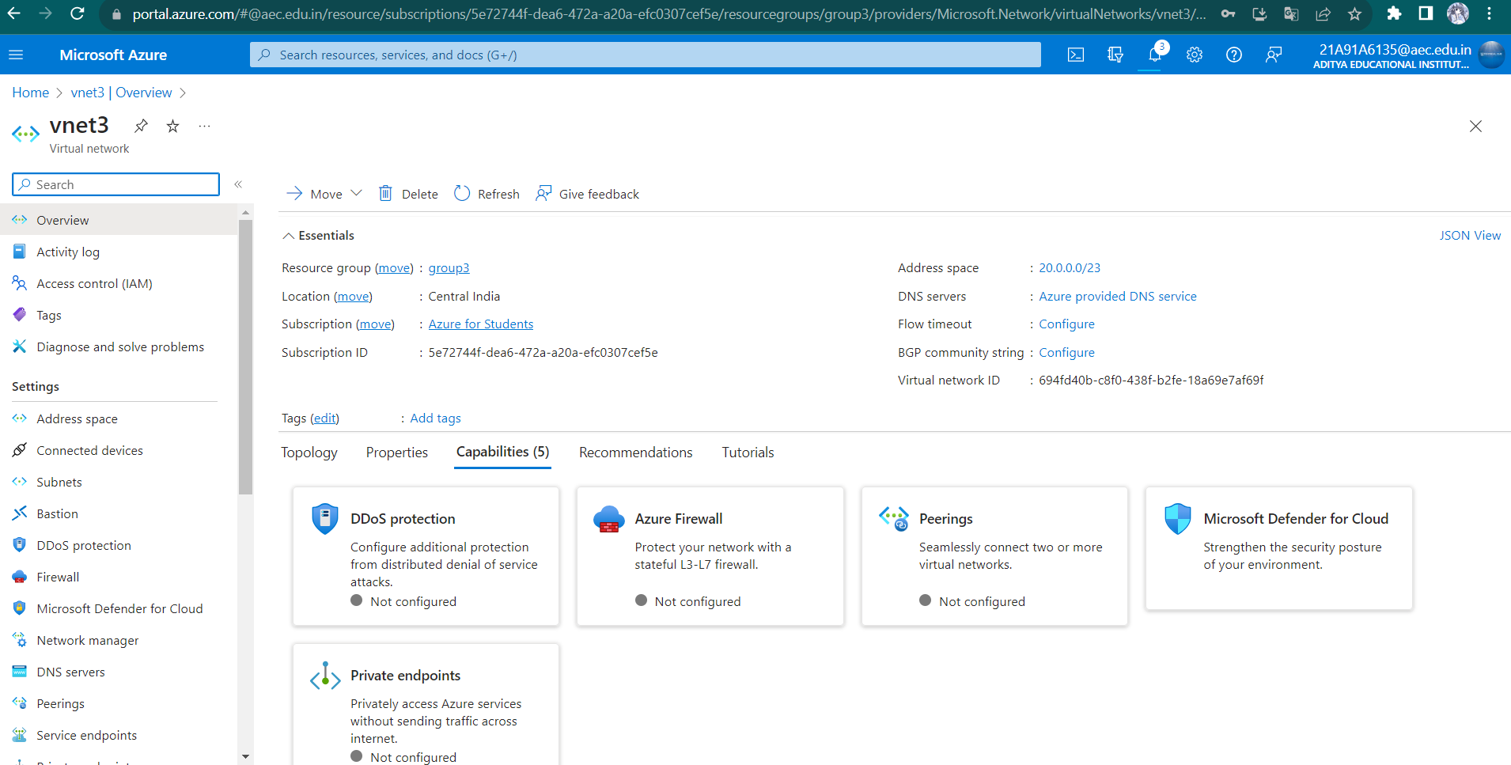

Virtual machine for vnet3.

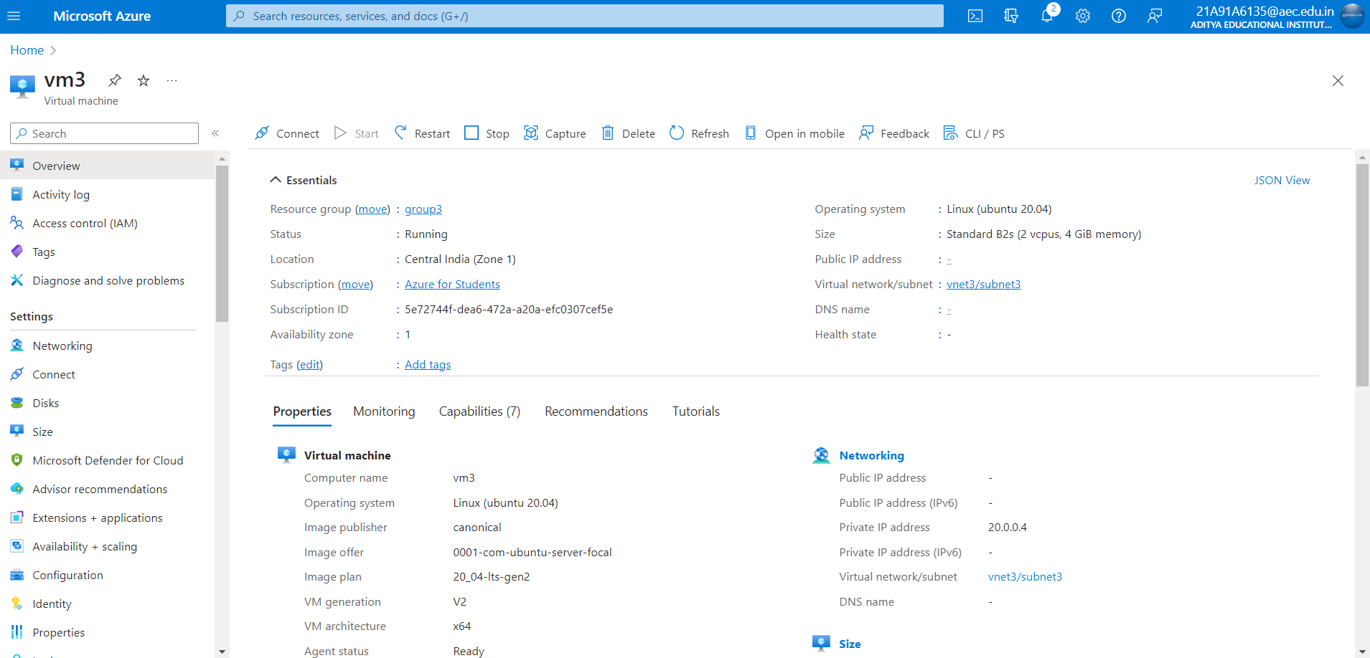

So these are the three different vnets with three different regions.

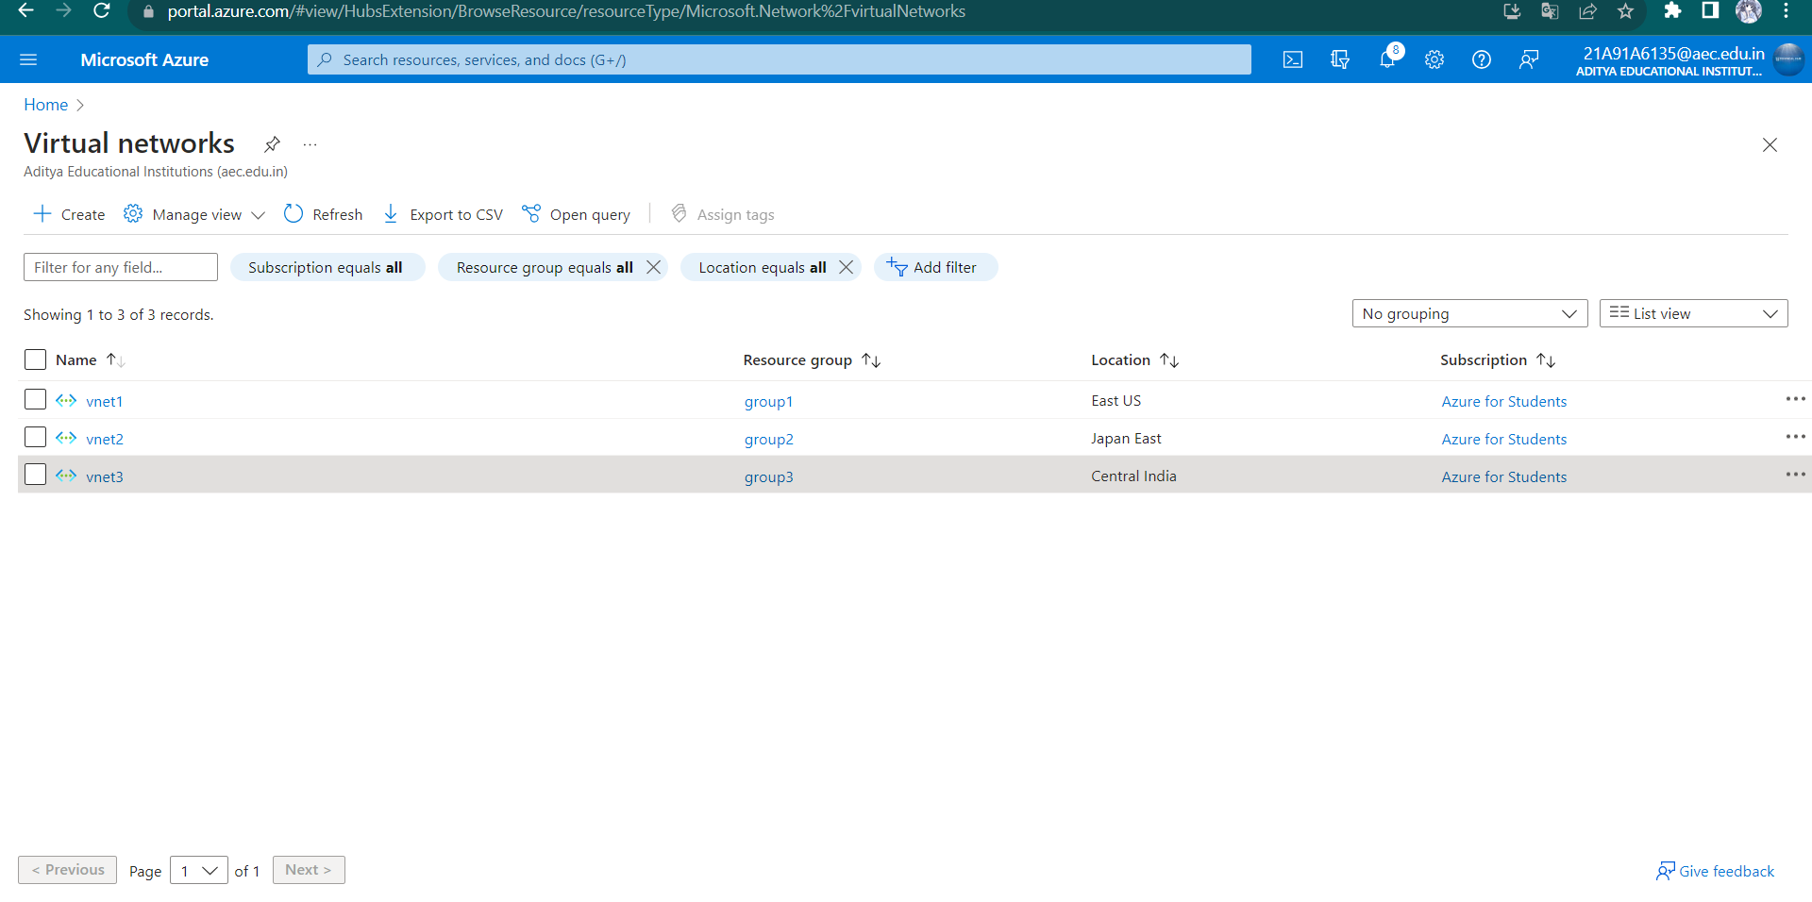

Step 3: peering for vnet1 to vnet2

* Open the vnet1 you have created.
* Then go to settings click on peerings.
* Click on add and create peering for vnet1 to vnet2.

Create peering connection for vnet1 to vnet2 as shown below.

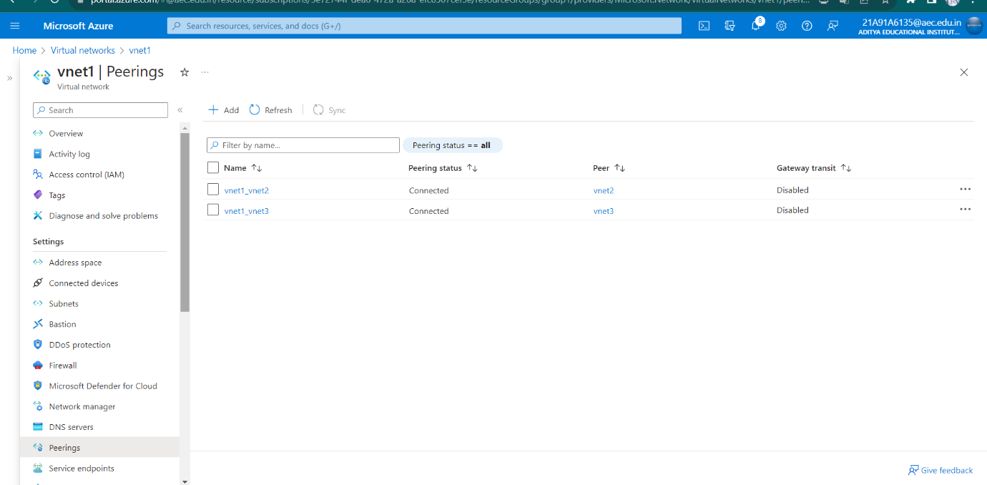

Step 4: open virtual network🡪vnet2🡪settings🡪peerings🡪add.

Create peering connection for vnet2 to vnet3.

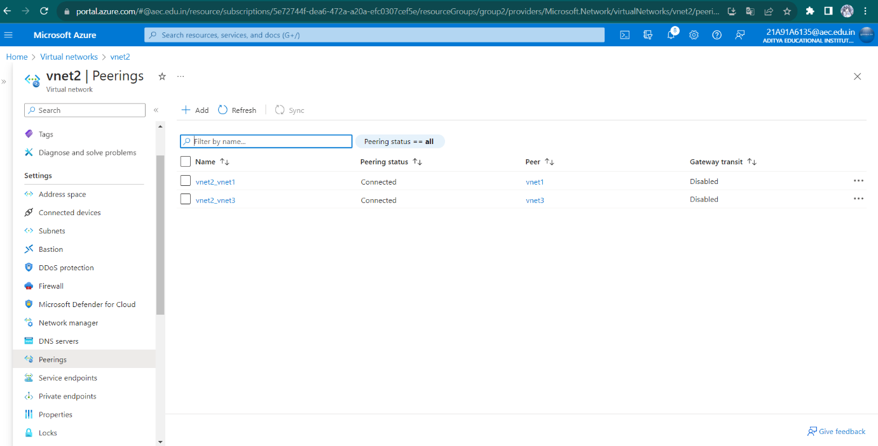

Step 5: open virtual network🡪vnet3🡪settings🡪peerings🡪add.

Create peering connection for vnet3 to vnet1.

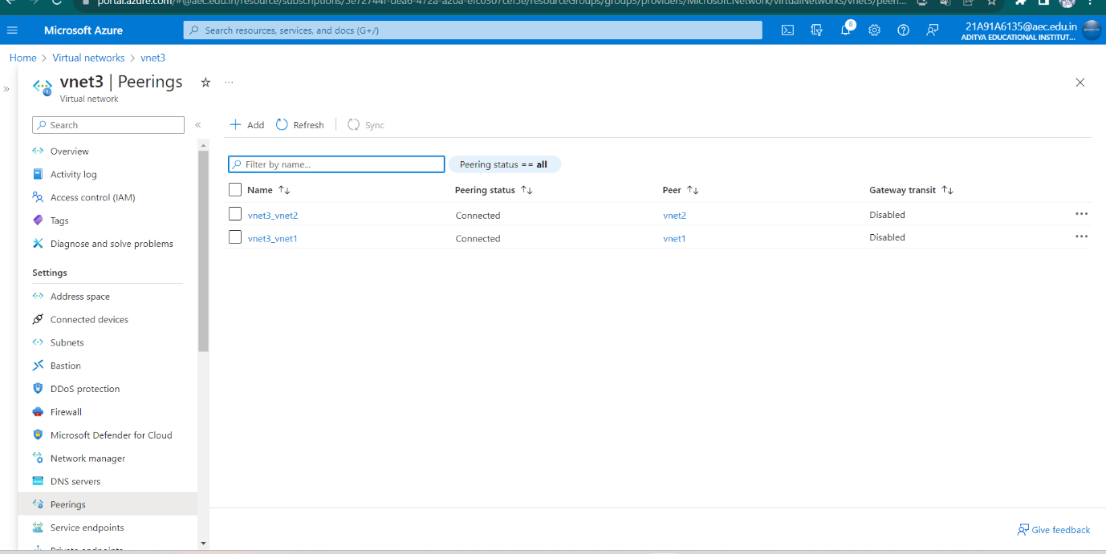

Step 6: after peering connection. To get connection from one virtual machine to another virtual machine .

* Open mobaXterm.
* Open session then click on ssh in ssh give your virtual machines ip address and user name then click on ok.
* Then it asks your password then it shown as below the picture.

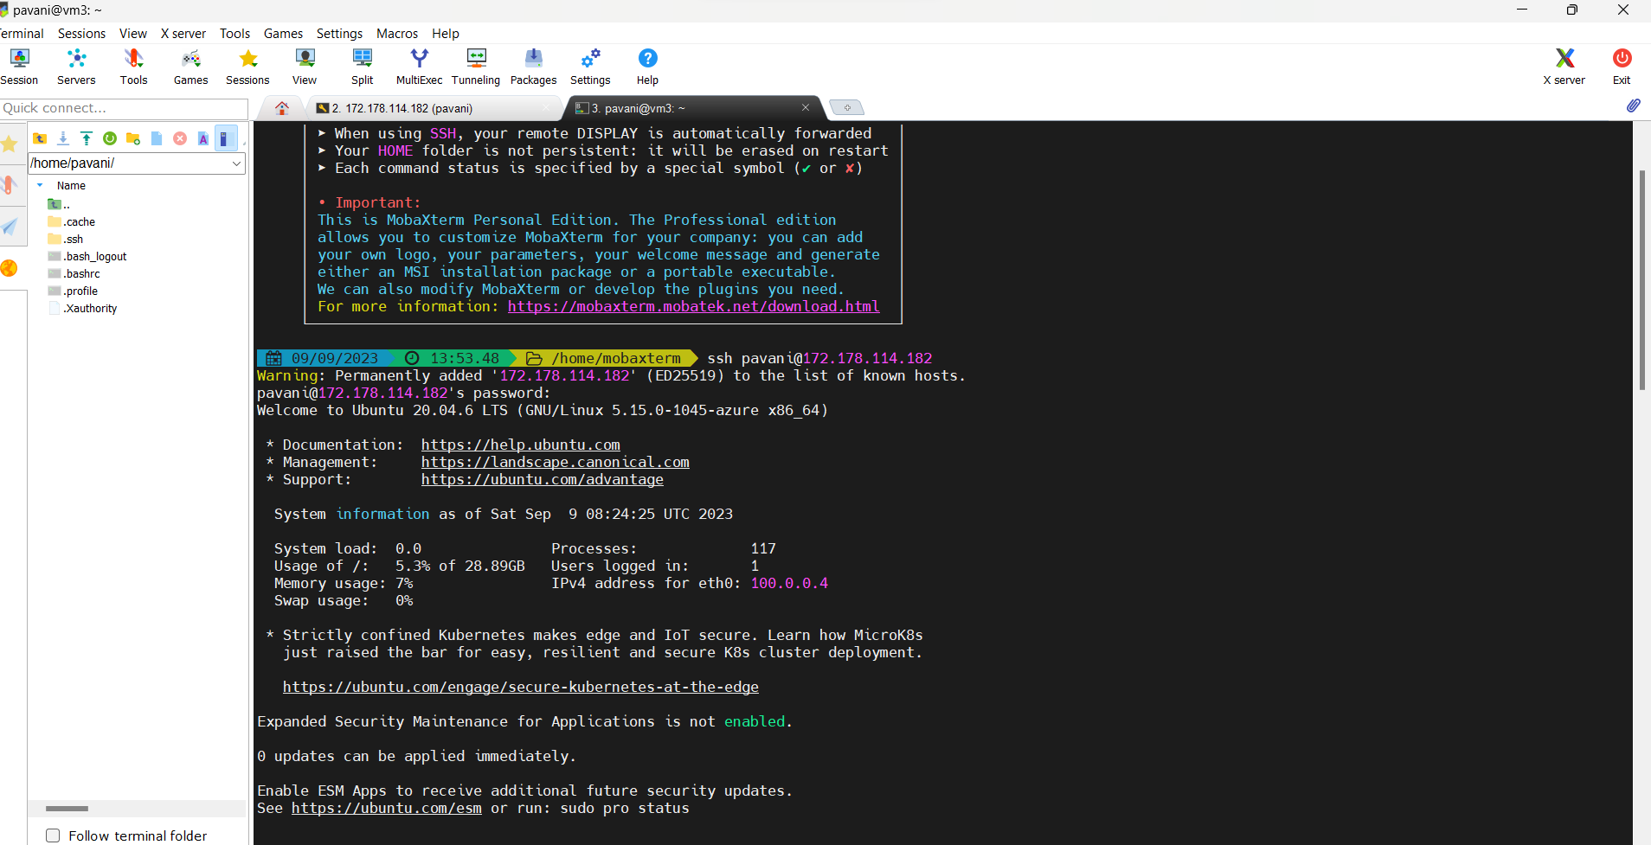

Connect vm1 to vm2

To get connect with vm1 to vm2 the command is “ssh username password”

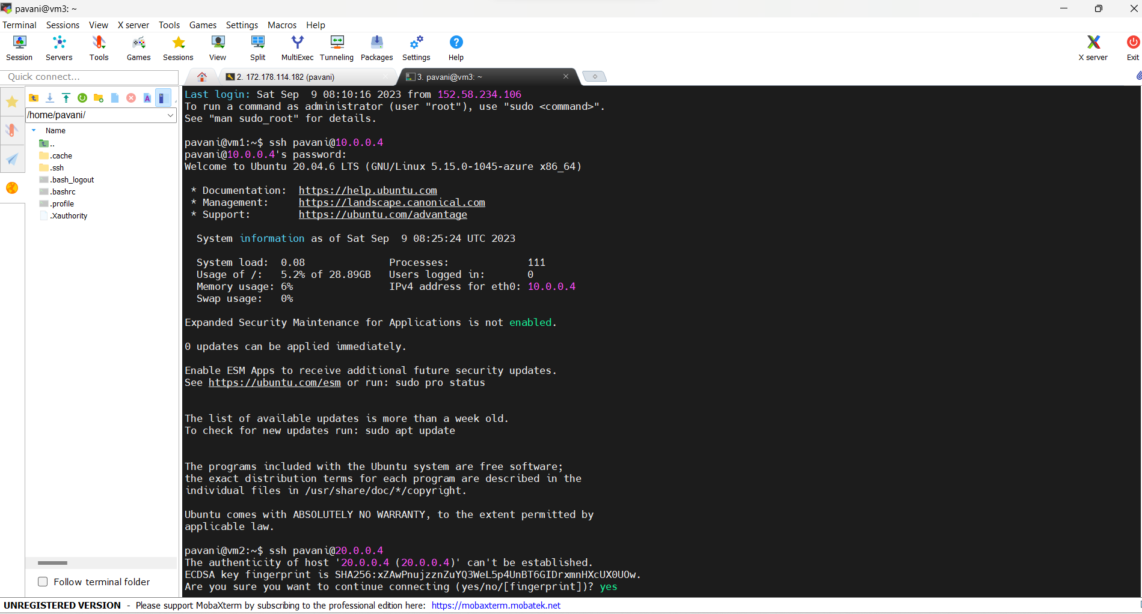

Connect vm2 to vm3.

