**HTML**

HTML stands for Hyper Text Markup Language.

For reference, please follow the MDN site and w3 schools

This document contains the important topics only in HTML, not the detailed description.

* Tags: html, head, h1, h2 .. h6, etc..
* Elements: It contains both tags and also the information within this
* Html tag: it is the root element
* Head element: it contains meta data, SEO data, title information, can include style sheets
* Body element: it contains all the content of the website.
* To comment the HTML code; short cut: ctrl + /
* There are three main types of tags they are:
* **Semantics tags:**

1. <h1> to <h6>
2. <p>
3. <a>
4. <ul>
5. <table> <tr> <td>
6. <img>
7. <form>
8. <input>

* **Structure tags:**

1. Html
2. Head
3. Body
4. Header
5. Main
6. Aside
7. Footer
8. Article
9. Section
10. nav

* **Formatting Tags:**

1. <b>
2. <i>
3. <u>
4. <strong>
5. <sup> - ex: 2^5
6. <sub> - ex: O2
7. <pre>
8. <em> - emphasize
9. <s> - strike

**Difference bw div, section, para and article tags?**

**Div**: It is like a single container which contains multiple blocks within the div element. It will be not useful by SEO.

**Section**: It can be used where particular information is related to one thing. Such as we can create contact us, about sections separately and it will be used by seos in the browser.

**Article**: It is independent self-contained element where as it is not dependent on other, context. It can contain links, images etc.,

Main components of a web page:

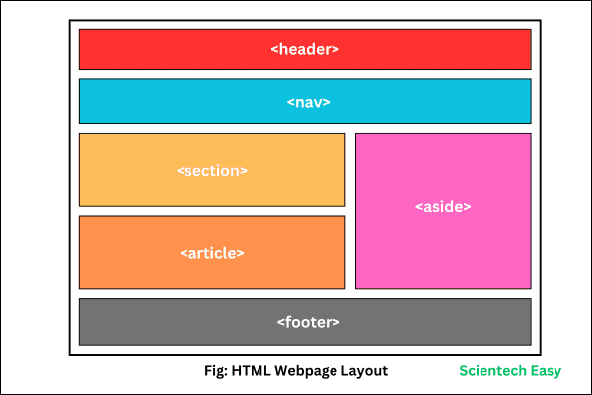

**Emmet shortcuts to write html syntax:**

Use + to bring two tags separately one by one.

Ex: p+h1

Use {} to put the content inside the tag

Ex: P{Hello}

Use > to create the multiple tags inside one tag.

Ex: div>P*t 🡺 it give 5 para tags inside a div tag.

Use P.para1 to create a para tag with id para1

Use P#para1 to create a para tag with class para1

**Class and Id attributes:**

**Id** is an attribute which identifies an element uniquely. It is identified by dot(.)

**Class** is a parent level entity whereas for example if we take Car, it is one class and there are many different brands available. It is identified by #.

We can create multiple classes also for one element.

If there are 10 paras and 5 headings in a webpage we can give a class and apply the changes for all at a time.

**Div tag: Division Tag:**

**It is a used as a container or wrapper of multiple tags in the page and it is block level element.**

**Block elements and Inline elements:**

**Block elements** will come to next line and it takes place from left to right. Eg: div, para tags

To convert the block element into the inline element use the display-inline attribute.

**Inline elements** will not come to next line and it the place whatever the content is. Eg: span tag

**Create a bookmark in a webpage:**

Create an element and assign an id to that.

Assign that id to an anchor tag element.

**Tables in HTML**

**Below are the tags used while working with tables:**

**Table**: to define the table.

**Thead**: to define the table header section

**Tbody**: to define the table body section

**Tfooter**: to define the table footer section

**Tr**: to create the table row

**Td**: to insert the data in the table

**Th**: to create the table header in the table.

**Rowspan**: to extend the rows

**Columnspan**: to extend the columns

**FORMS**

Forms in html are used to collect the data from the user.

**Form tag:** to create a form

**Input tag:** to take the data from the user

**Label**: to give the info about the input tag on what info is needed. Input tag id need to same as label value, then only it works.

**Value** attribute can be used to display what test is needed.

**Placeholder** for having keeping the data.

**Select** option for creating the dropdown

**Textarea**: for creating the multiline text box

**Fieldset: grouping of elements in the form such as male, female etc..**

**Legend: to give any caption for fieldset we use legend.**

**Input types:**

* Text
* Password
* Date
* Radio button – gives same names to select only name.
* Check box
* Submit button
* File
* Image
* Search

To display as frequently asked questions or question and answer types elements in the web page. We can use Details and summary tags.

**Details** tag and within that we should have **summary** tag.

**Each detail element will have one summary tag.**

**Media Tags in HTML:**

* **Image**
* **Audio**
* **Video**
* **Iframe by using we can display the other html pages, videos and youtube videos etc..**

**To display youtube videos then use the embed keyword in place watch keyword in the url of the youtube.**

**Lazy loading** attribute in HTML:

Lazy loading" in HTML refers to the technique of delaying the loading of certain elements on a webpage, like images or videos, until they are actually needed by the user, typically when they scroll near the visible area of the page, thus improving the initial page load speed and optimizing website performance by only loading necessary resources when required.

**HEAD TAG**

The content or the elements which are written in head element will not be visible in the browser. This is more related to the SEO purpose, Search Engine Optimization.

Head section contains meta, title, to insert favicon or logo of the website.

**To add favicon to the site use below syntax in the head tag.**

  <link rel="icon" href="codeimg.jpg">

To link the styling elements, we use below syntax.

<link rel="stylesheet" href="style.css">

**To make the website more search engine optimization we use meta tags for describe, add multiple keywords.**