**EMOTION BASED MUSIC RECOMMENDATION SYSTEM**

In this paper author is describing concept to recommend music to user by detecting moods of user. Existing technique were using collaboration technique which will use previous user data to recommend music to user, if there is no input from previous user then this technique will not useful. This existing technique requires lots of manual work to arrange different music to different categories such as happy, sad or angry etc.

To overcome from above issue author is using web camera to capture user image and then detect user mood to recommend music.

In this application I am uploading image and then using python OPENCV i am pre processing image to extract features and then this features is applied on Deep Learning Neural Network Training Model to predict moods of user and based on user mood all songs will be detected and shown in drop down box and user can select any song and play.

All sample images are in images folder and all songs are in songs folder and u too can include new songs to that folder and given name as happy1.mp3, happy2, happy3 or sad1, sad2 etc. Like this for all categories you can add songs. Currently i am using same song for all moods.

To run project install below package

Pip install playsound

Screen shots

Double click on ‘run.bat’ file to get below screen

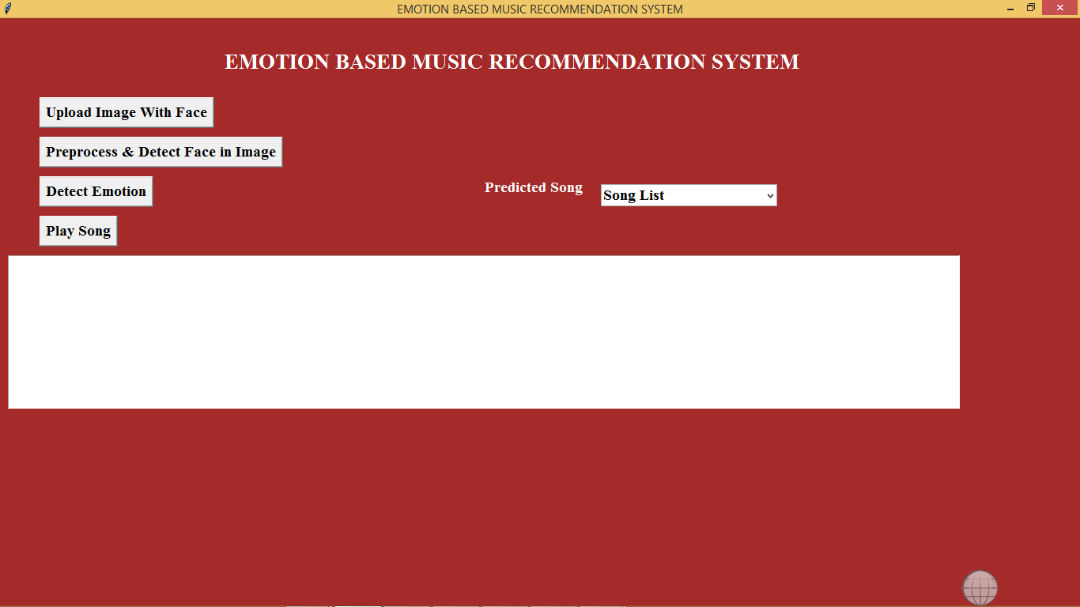

In above screen click on ‘Upload Image With Face’ button to upload image

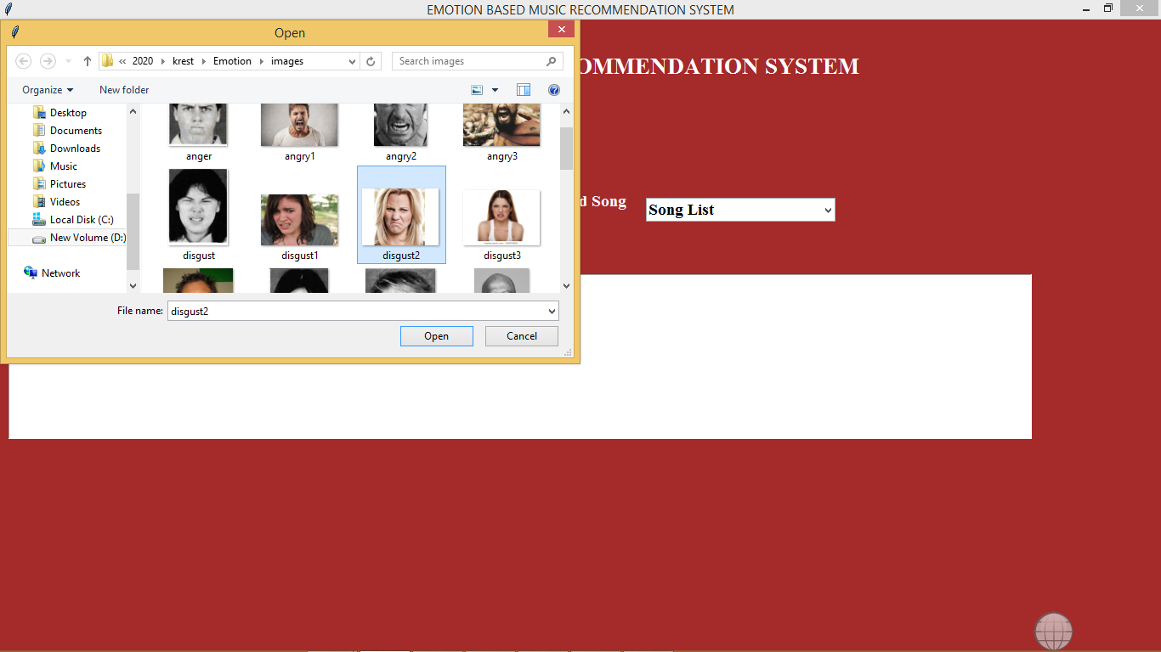

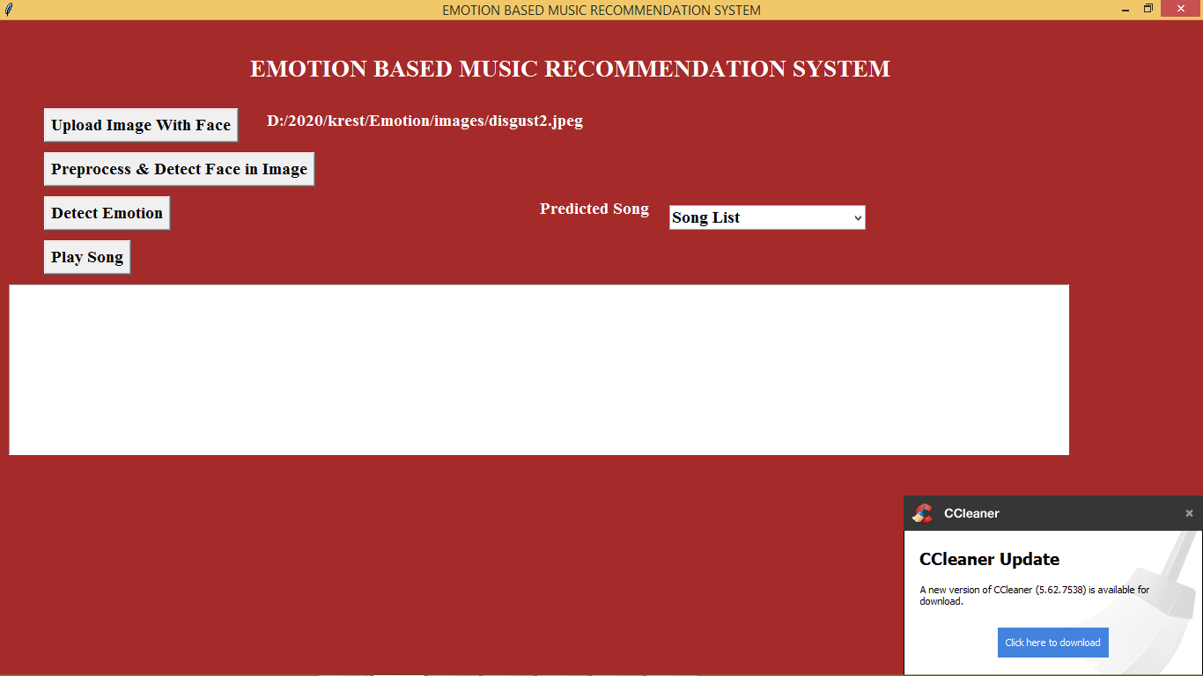

In above screen i am selecting one ‘disgust’ image. Now click on ‘Pre-process & Detect Face In Image’ button to perform pre-processing and to extract face from images

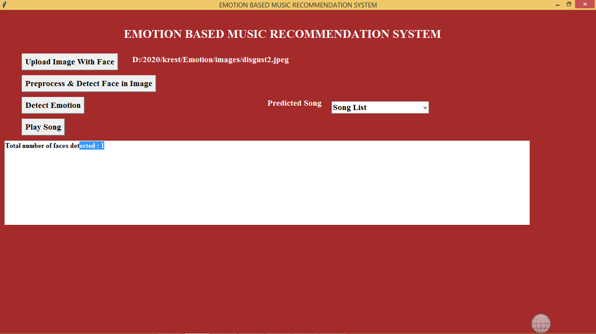

In above screen we can see in uploaded image one face is detected. Now click on Detect Emotion button to detect emotion

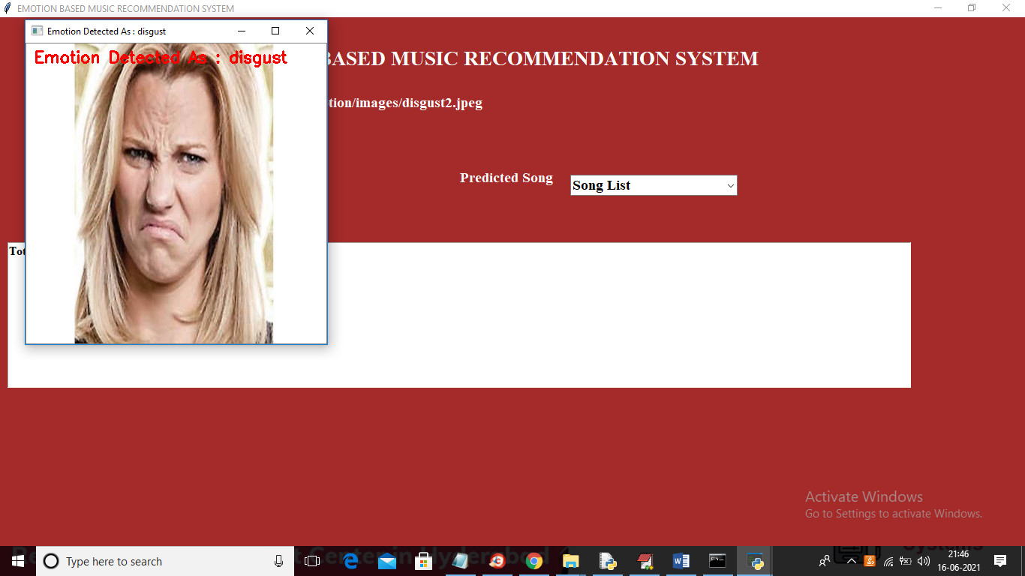

In above screen we can see emotion disgust is detected and now close above image and click on drop down arrow link to get all disgust songs list

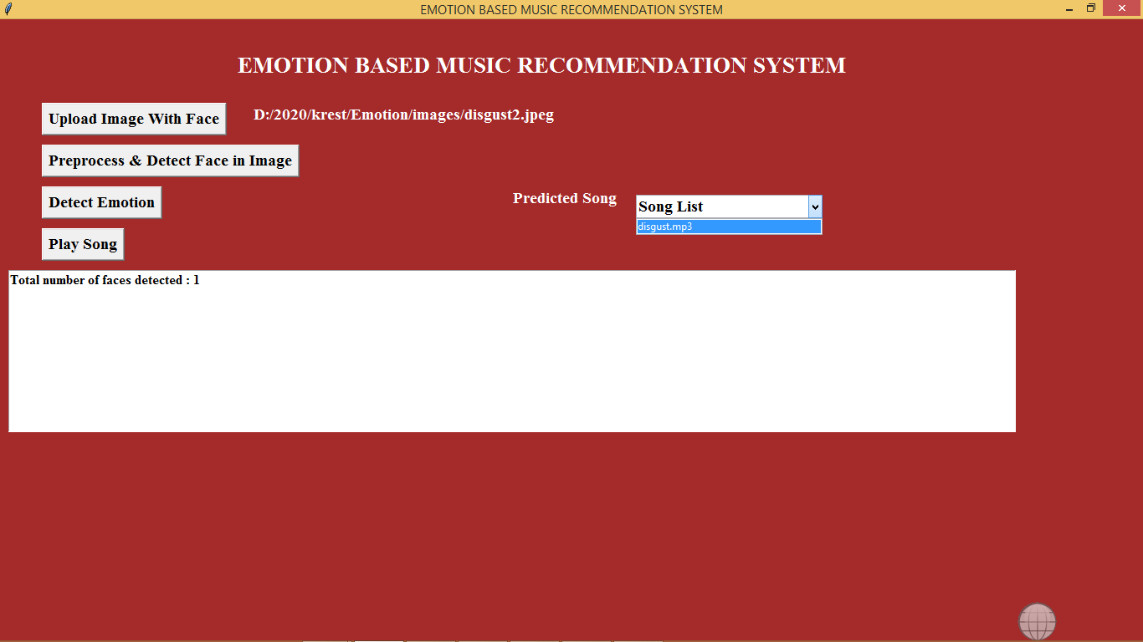

In drop down box we can see ‘disgust.mp3’ songs is showing, select that song and click on ‘Play Song’ button to play song

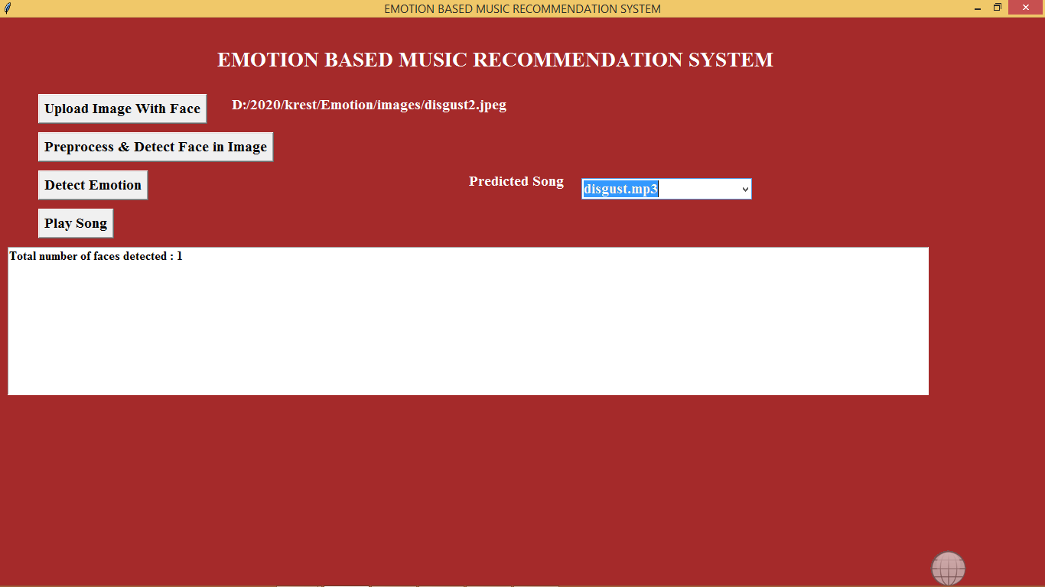

If your system has audio driver then u can hear song. Similarly you can upload remaining images and test and you replace some songs also as for same songs I gave different names.

Note: no technologies can detect 100% emotion from images but this project can detect upto 90%