
RESEARCH REPORT · VERSION 1.0 · PILOT STUDY
Pavan Krovvidi
FingerWave Neural Network
A biologically inspired, boundary-seeded neural PDE that recovers orientation fields and their topology the way fingerprints are formed in the womb.
“Every life has a unique print. So does every prediction.”
Pavan Kumar Krovvidi
Independent Researcher · AI Engineer October 2026
Vizianagaram / Hyderabad, India Apache License 2.0
pavank9848@gmail.com github.com/Pavankrovvidi
ORCID 0009-0001-3286-7173

ABSTRACT
Standard neural networks process every pixel with equal trust. When part of a signal is hidden or noisy, they can produce structures that violate the underlying physics or topology. Human fingerprints offer a different strategy: ridges are initiated at a few reliable sites on the fingertip and travel inward as waves, and the points where those waves collide become the cores and deltas that define each pattern.
In this report I present the Pavan Krovvidi FingerWave Neural Network, which I designed to turn that developmental process into a neural architecture. A small encoder estimates a seed field and a confidence map. A learned, stable reaction–diffusion PDE then propagates information from confident regions into uncertain ones, and a differentiable topological loss discourages spurious singularities.
On a benchmark of 500 synthetic, degraded fingerprints with exact ground truth, FingerWave reduced the Topological Error Rate from 5.8% to 4.0% (≈31% relative) compared with a U-Net of the same size, and achieved the lowest orientation error inside occluded regions (7.36° vs 7.66°), averaged over three random seeds. Ablations show that the bio-inspired boundary seeding is the decisive component, while learned anisotropy gave no additional benefit in this setting. These are pilot-scale results, and validation on real fingerprint databases is the next step.

−31%  topological errors vs same-size U-Net (TER 4.0% vs 5.8%) | 96.0%  pattern-class accuracy (arch / loop / whorl) from recovered topology | 3 / 3  random seeds where FingerWave beat every U-Net run on TER | 0 → 0.44  gradient norm of the topological loss after the redesign

Contents
1 Biological inspiration | 5 Benchmark design | 9 Applications and future work
2 The FingerWave method | 6 Results | 10 Reproducibility
3 The research journey | 7 Ablation findings | 11 Related work and references
4 Verification of the building blocks | 8 Scope and next steps | 12 Contributions, citation, Telugu summary

1 Biological inspiration
Fingerprints are set down between roughly the 10th and 17th weeks of gestation on transient swellings of the fingertip called volar pads. Recent developmental work by Glover et al. (2023) showed that ridges are laid down by a Turing-type reaction–diffusion system: WNT and EDAR signalling act as activators, while BMP signalling acts as an inhibitor. Ridge formation does not start everywhere at once. It begins at a small number of initiation sites (at the fingertip apex, near the nail and at the distal crease) and spreads across the pad as travelling waves.
Where these wavefronts meet, their orientations must be reconciled. The compromise produces the familiar singular points: cores, where ridges turn back on themselves (topological index +½), and deltas, where three ridge systems meet (index −½). The geometry of the pad and the timing of each wave decide whether the result is an arch, a loop or a whorl. Because of that, even identical twins differ in fine detail.
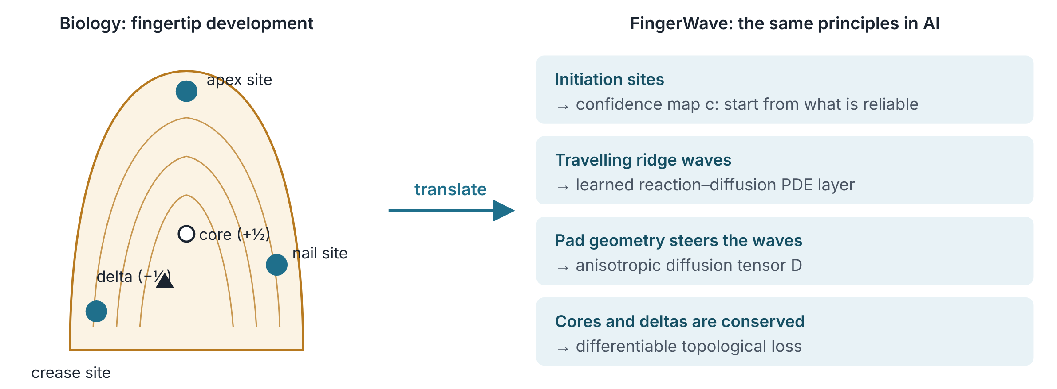
Figure 1. The developmental principles behind fingerprints (left, schematic) and the component of FingerWave that each one inspired (right).
The guiding idea behind my work is simple. An AI model that fills in missing structure should behave like a developing fingertip. It should start from the places it trusts, let information travel along the structure instead of across it, and respect the conservation laws that govern how singular points are created and destroyed.

2 The FingerWave method
FingerWave operates on a director field: at every location it stores a ridge orientation θ, which has no head or tail (θ and θ+π describe the same ridge). I represent the field with the doubled-angle complex number Ψ = A·e^{i2θ}, stored as two real channels. This representation makes the field continuous across the θ ≡ θ+π identification and turns fingerprint cores and deltas (index ±½) into ordinary ±1 vortices of Ψ.
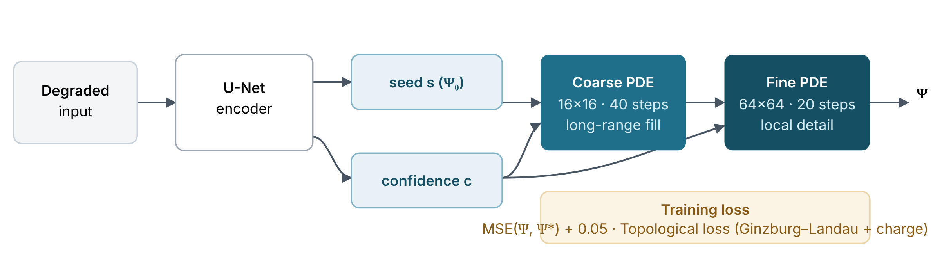
Figure 2. FingerWave pipeline. An encoder predicts a seed field and a confidence map. Two PDE stages (coarse, then fine) propagate information from confident to uncertain regions. Training combines a data term with the differentiable topological loss.

2.1 Boundary seeding (the initiation sites)
The encoder outputs a seed field s and a per-pixel confidence c ∈ (0,1). During every PDE step, confident pixels are pulled towards their seed through a forcing term, while low-confidence pixels are filled in by the dynamics alone:
∂Ψ/∂t = 𝒫(Ψ) + λ · c · (s − Ψ) (1)
The strength λ is learned and bounded (λ·Δt ≤ 0.8) so that the forcing step stays stable.

2.2 The wavefront PDE (the travelling waves)
The propagation operator 𝒫 combines anisotropic diffusion with a complex Ginzburg–Landau reaction, the standard model for travelling waves and spiral patterns in physics and chemistry:
𝒫(Ψ) = ∇·(D∇Ψ) + (α + iβ)Ψ − (1 + iγ)|Ψ|²Ψ (2)
The diffusion tensor D = d⊥I + (d∥ − d⊥)·c·t tᵀ, with t = (cos θ, sin θ), lets information move faster along ridges than across them. It is computed directly from Ψ, without any arctangent, so that gradients stay finite where Ψ = 0. Diffusion is discretised in conservative flux form, and the cubic reaction is treated semi-implicitly. The coefficients d∥, d⊥ are bounded by d_{max} through a sigmoid, and the time step Δt = 0.2/d_{max} keeps the explicit scheme inside its stability limit.

2.3 Differentiable topological loss (conservation of cores and deltas)
The loss combines a Ginzburg–Landau energy, which assigns a smooth, differentiable cost to every defect, with a soft topological charge computed from the Jacobian of Ψ:
ℒ_{topo} = ⟨|∇Ψ|²⟩ + ⟨(1 − |Ψ|²)²⟩ / 2ε² + w_{q} (Σρ/2 − q∗)², ρ = (∂ₓu ∂ᵧv − ∂ᵧu ∂ₓv)/π (3)
The target net index is q∗ = 0, which holds for arches, loops and whorls alike. A hard, integer-valued winding counter is kept only as an evaluation metric.

3 The research journey
This section describes how my research actually progressed, including the mistakes. I drove every stage with a test that either confirmed or contradicted an assumption, and I changed the design whenever the evidence required it.
STAGE 1 · HYPOTHESIS
Fingerprint development as an AI architecture
I formulated the concept: a boundary-seeded wavefront network with a manifold prior and a topology-preserving loss, along with initial code and proposed applications (vision, forecasting, drug discovery).
STAGE 2 · CRITICAL REVIEW
Seven technical issues identified
With AI assistance, I critically reviewed my original design and identified that (i) the original topological loss had zero gradient, (ii) its Poincaré–Hopf target (χ = 1) contradicted the biology (net index 0), (iii) the code treated the unoriented ridge field as an oriented vector field, (iv) the "anisotropic" diffusion was isotropic, (v) the complex wave Ψ was not implemented, (vi) explicit Euler had no stability bound, and (vii) some application mappings had sign errors.
STAGE 3 · FIX 1
Topological loss rebuilt
I redesigned the loss around the doubled-angle director field, Ginzburg–Landau energy and a soft Jacobian charge. A gradient test confirmed the diagnosis: old loss ‖∇‖ = 0.00, new loss ‖∇‖ = 0.44.
STAGE 4 · FIX 2
Wavefront PDE layer rebuilt
I rebuilt the layer with a complex Ψ, a true flux-form ∇·(D∇Ψ), a Ginzburg–Landau reaction and a stability bound. It passed four physics tests (Section 4).
BUG FOUND
Cubic reaction exploded; arctangent produced NaN
The |Ψ|²Ψ term diverged for large inputs, so I now integrate it semi-implicitly. At Ψ = 0, atan2 produced NaN gradients, so I now compute the diffusion tensor from Ψ directly.
BUG FOUND
Hard seeding blocked learning (gradient ≈ 10⁻²⁵)
Blending the field with the seed at every step meant that almost nothing from the PDE survived, so its parameters received gradients of order 10⁻²⁵. I reformulated seeding as the forcing term of Eq. (1), after which the PDE parameters trained normally.
STAGE 5 · BENCHMARK
15 training runs on 2,500 benchmark fingerprints
I compared six methods with three seeds each, about 1.5 hours on a 2-core CPU. I report all results and ablations in Sections 6 and 7, including the ones that did not favour my original hypothesis.

WHY INCLUDE THE FAILURES?
The bugs are part of the evidence. A method whose weaknesses I actively searched for and fixed is more trustworthy than one that has only been shown to work.

4 Verification of the building blocks
Before any benchmark, I tested each component against problems with known answers.

4.1 Topological loss
Test | Expected | Result
Defect counter on reference loop, whorl, arch fields | correct ±½ counts, net index 0 | all three exact | PASS
Gradient of old vs new loss | old = 0, new > 0 | 0.00 vs 0.44 | PASS
Denoise a noisy loop (37 core/delta pairs, 36 of them spurious) | remove spurious, keep true | 37 → 1 pair, true sites within 1 px; old loss: 37 → 37 | PASS
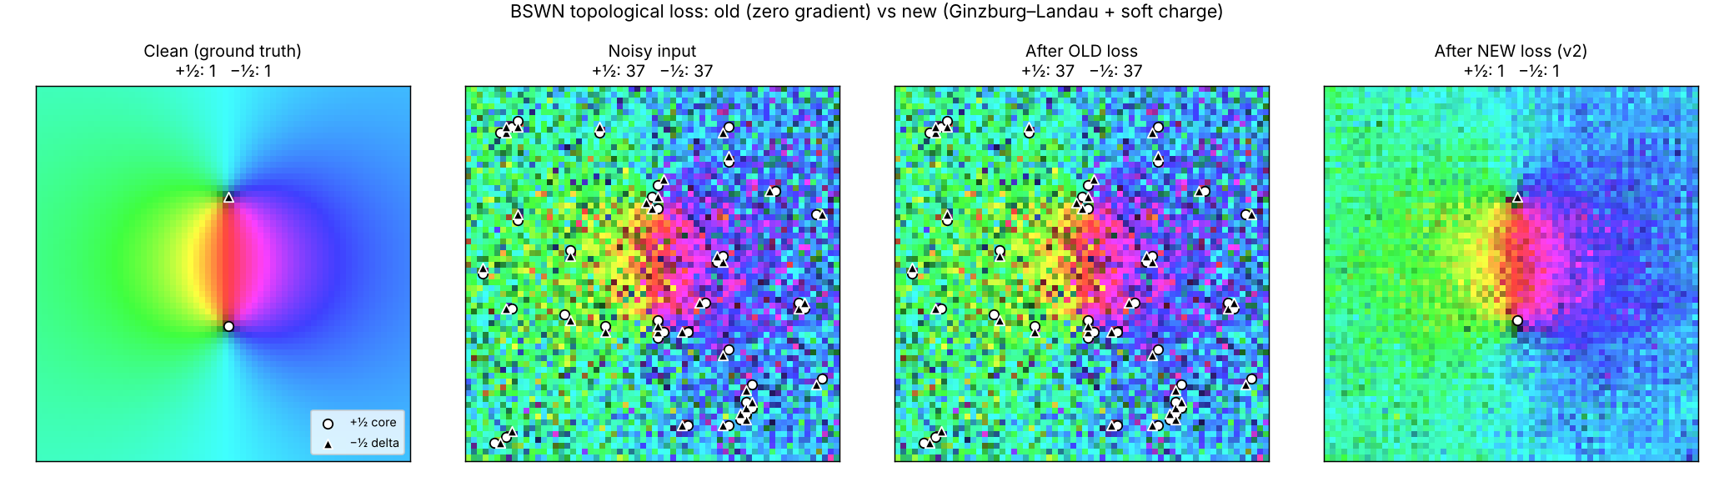
Figure 3. Colour encodes ridge direction; ○ core, △ delta. The old loss leaves all 36 spurious pairs untouched because its gradient is zero. The new loss removes them and keeps the true core and delta.

4.2 Wavefront PDE layer
Test | Expected | Result
Isotropic diffusion of a point source | variance = 2Dt = 20.00 | 20.00 (error 0.01%) | PASS
Anisotropic, d∥=1, d⊥=0.1, θ=30° | ratio 10, axis 30° | 10.00, 30.0° | PASS
Stability with very large D | bounded | old scheme → 10⁴⁰ then NaN; new ≈ 1.0 | PASS
Mass conservation, 500 steps, random θ | ΔΣψ ≈ 0 | relative change 1.2×10⁻⁸ | PASS
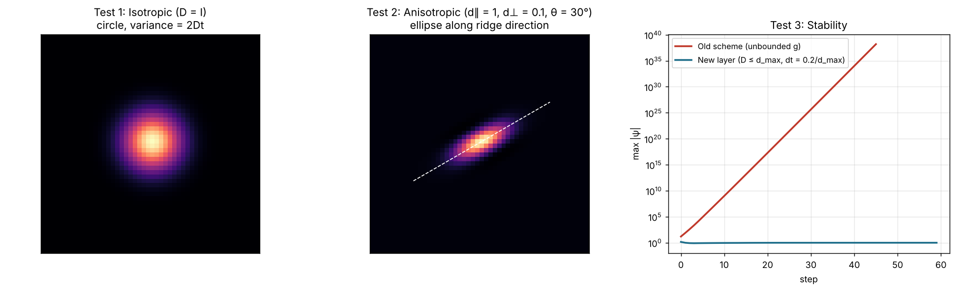
Figure 4. Left: isotropic spread. Centre: anisotropic spread along the ridge direction. Right: the original scheme diverges, while the new layer stays bounded.

5 Benchmark design
Real fingerprint databases do not provide exact ground-truth orientation fields or singular-point locations. I therefore built a synthetic generator in the spirit of SFinGe, so that every quantity can be measured exactly.

5.1 Synthetic fingerprints
- Orientation fields: Sherlock–Monro zero-pole model with randomly placed cores and deltas for five classes (arch, tented arch, left loop, right loop, whorl), plus random rotation (±15°) and a smooth perturbation that does not change topology.
- Ridges: rendered at 128×128 by iterative orientation-adaptive Gabor filtering (16 orientation bins, ridge period 7 px).
- Degradations: contrast loss, blur, strong Gaussian noise, one to three elliptical smudges, and a 50% chance of a partial print (a missing band at one edge). On average 14.9% of each image is occluded.
- Input to every model: the structure-tensor orientation estimate of the degraded image, its coherence, and the image itself, on a 64×64 grid.
- Split: 2,000 training and 500 test images (test classes: 100 / 95 / 100 / 103 / 102).
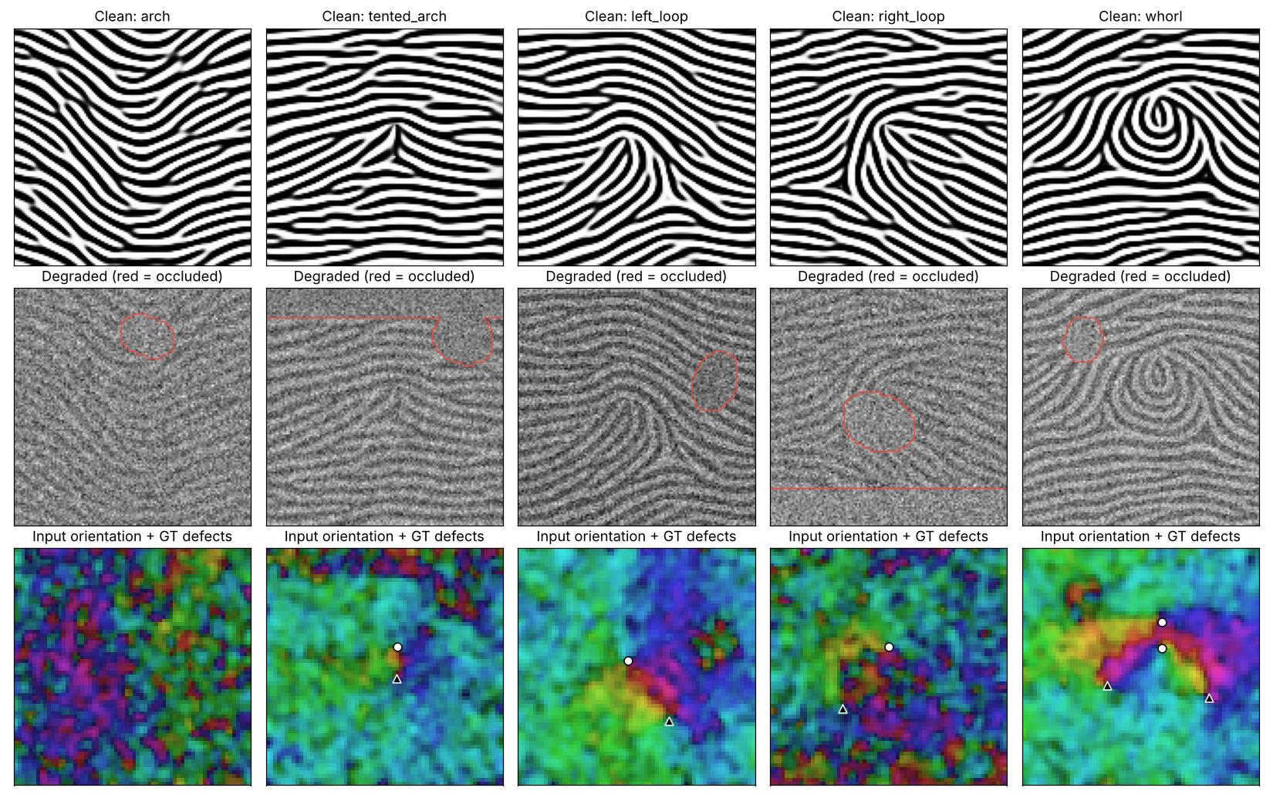
Figure 5. One sample per class. Top: clean ridges. Middle: degraded input, with occluded areas outlined in red. Bottom: the noisy orientation estimate that models receive, with ground-truth cores (○) and deltas (△).

5.2 Methods compared
Method | Description | Parameters
Classic | Gaussian smoothing of the orientation field (σ tuned on training data) | 0
U-Net | Standard encoder–decoder baseline | 118,434
U-Net + topo | U-Net trained with the same topological loss | 118,434
FingerWave | Same U-Net as encoder + seeding + two-stage PDE + topological loss | 118,463
FingerWave − seeding | Ablation: PDE runs without confidence forcing | 118,463
FingerWave − anisotropy | Ablation: d⊥ = d∥ (isotropic diffusion) | 118,463

5.3 Metrics
Angle error: mean absolute ridge-orientation error in degrees, over all pixels and over occluded pixels. Core/delta precision and recall: a detection counts as correct within 8 image pixels and with the right sign. Topological Error Rate (TER): the fraction of test images whose number of cores or deltas is wrong. Class accuracy: arch / loop-family / whorl inferred from the recovered defect counts.

6 Results
I trained all learned methods for 10 epochs with identical settings and evaluated them on the same 500 test images. Values are mean ± standard deviation over three random seeds.
Method | Angle err (°) | Occluded (°) | Precision | Recall | TER ↓ | Class acc ↑
Input (no processing) | 18.15 | 41.12 | 0.022 | 0.954 | 100% | 0.0%
Classic smoothing | 8.32 | 16.98 | 0.463 | 0.400 | 44.4% | 55.6%
U-Net | 4.79 ± 0.02 | 7.66 ± 0.08 | 0.930 | 0.887 | 5.8 ± 1.1% | 94.2%
U-Net + topo | 4.75 ± 0.02 | 7.62 ± 0.03 | 0.935 | 0.896 | 5.3 ± 0.5% | 94.7%
FingerWave | 4.69 ± 0.03 | 7.36 ± 0.06 | 0.938 | 0.913 | 4.0 ± 0.2% | 96.0%
FingerWave − seeding | 10.07 ± 7.36 | 12.58 ± 5.69 | 0.528 | 0.458 | 37.7 ± 39% | 62.3%
FingerWave − anisotropy | 4.70 ± 0.05 | 7.32 ± 0.01 | 0.945 | 0.913 | 3.9 ± 0.5% | 96.1%
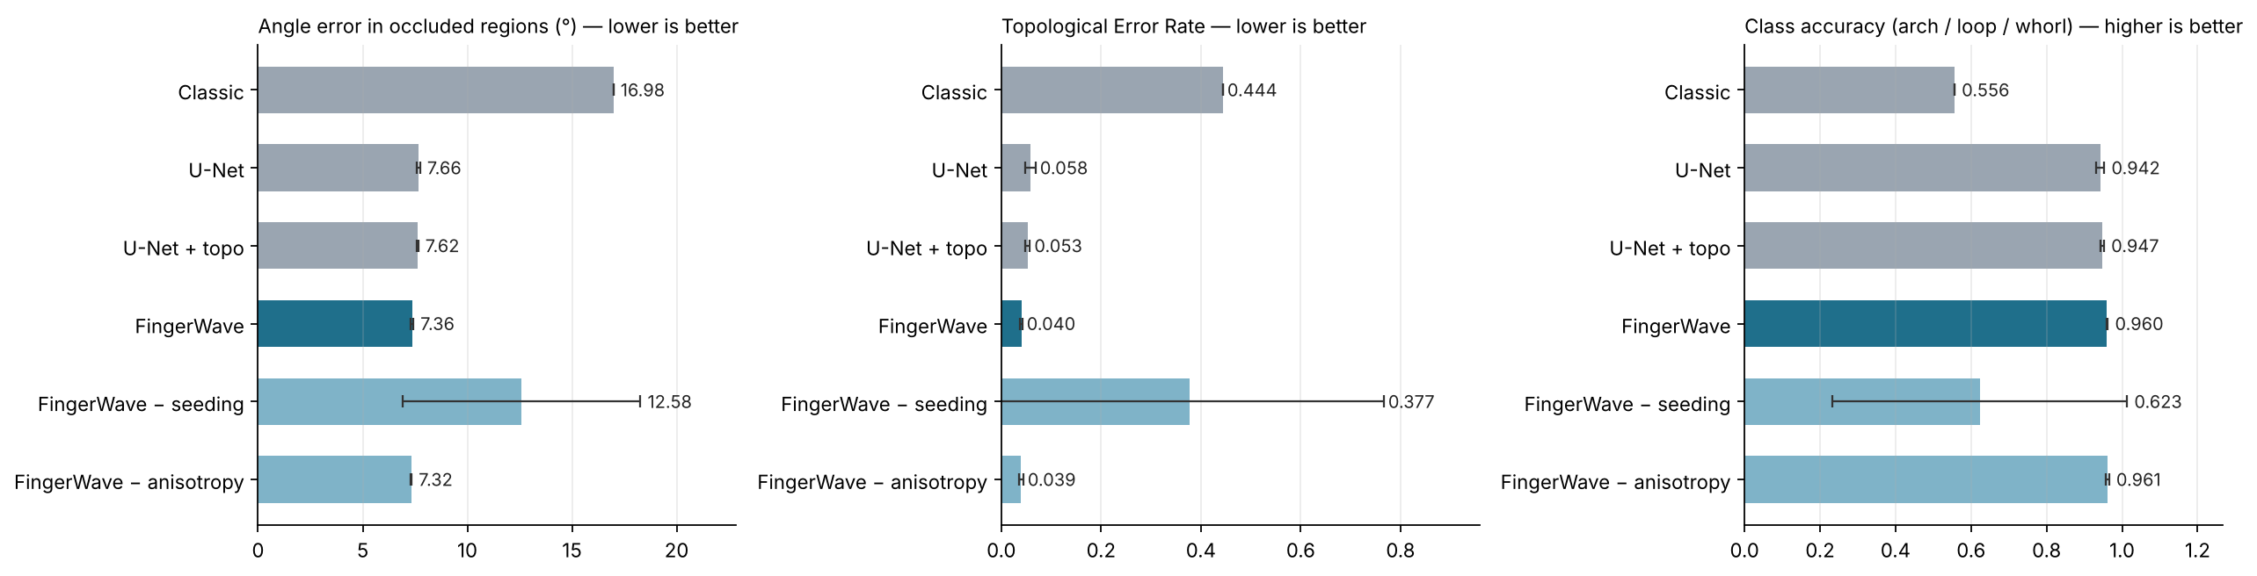
Figure 6. Occluded-region angle error, Topological Error Rate and class accuracy (mean ± s.d., 3 seeds). Dark teal: FingerWave. Light teal: ablations. Grey: baselines.
Key observations. FingerWave had the lowest TER of all non-ablated methods, and all three of its runs (3.8%, 4.0%, 4.2%) beat all three U-Net runs (5.4%, 5.0%, 7.0%). It was also roughly five times more consistent across seeds. Improvements in orientation error were smaller (about 2% overall and 4% in occluded regions). The main benefit is therefore topological correctness, getting the right number of cores and deltas, rather than raw pixel accuracy.
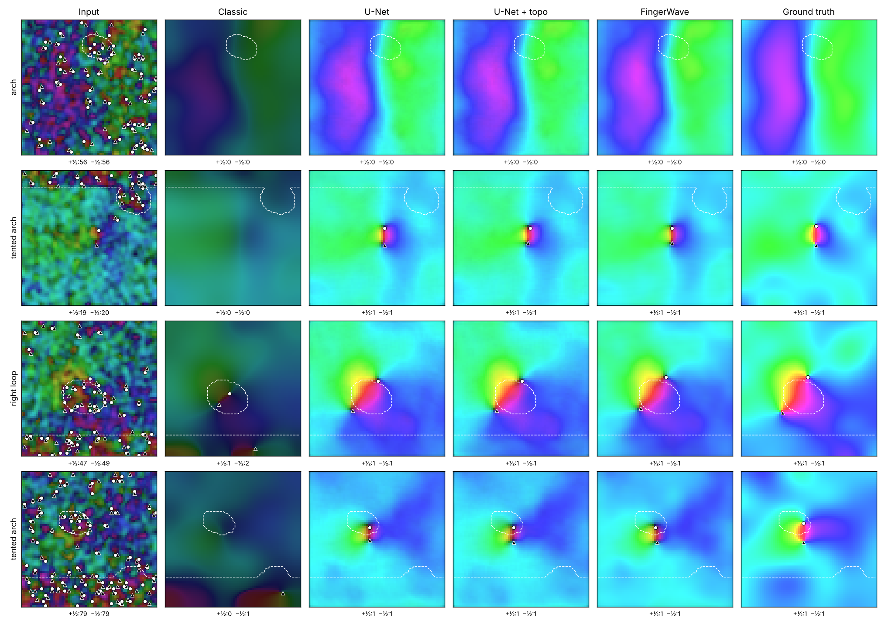
Figure 7. Four test fingerprints (first four of the test set, not selected). Columns: noisy input, classic smoothing, U-Net, U-Net + topo, FingerWave, ground truth. Dashed outlines mark occluded regions; counts below each panel are detected cores (+½) and deltas (−½). The classic method loses the singular points; all learned methods recover them on these examples, and differences appear mainly in the aggregate statistics.

7 Ablation findings
Component | Evidence | Verdict
Boundary seeding (initiation sites) | Removing it raised TER from 4.0% to 9.8%, 82.2% and 21.0% across the three seeds. One run collapsed entirely. | Essential
Anisotropic diffusion (pad geometry) | The isotropic version matched the full model (TER 3.9 ± 0.5% vs 4.0 ± 0.2%; angle 4.70° vs 4.69°). | No measurable benefit here
Topological loss (on U-Net) | TER 5.8% → 5.3%; angle 4.79° → 4.75°. | Small benefit
Topological loss (noisy field, Section 4.1) | Removed all 36 spurious defect pairs and kept the true one; the old loss removed none. | Strong in isolation
Interpretation. The central biological insight, start from what is reliable and propagate inward, is supported by the data. The anisotropy hypothesis was not confirmed in this setting. A plausible explanation is that the encoder already learns direction-aware features, so the PDE mainly needs to transport information rather than steer it. Anisotropy may matter more on larger occlusions, on real prints, or on data where direction is the dominant signal (for example diffusion MRI), and this should be tested rather than assumed.

8 Scope and next steps
WHERE FINGERWAVE GOES NEXT
- Real fingerprint databases. Quantitative validation on public databases such as FVC and NIST, starting with the pretrained model released with this report.
- Scale-up. Move from the current pilot setting (64×64 grids, ~118k parameters, 10 epochs, 2-core CPU) to larger models and GPU training.
- More seeds. Extend the comparison beyond three seeds per method to tighten the confidence intervals.
- Efficiency. Reduce the PDE cost. Training currently takes about 3.6× longer than the U-Net (449 s vs 125 s) and inference 4.1 ms vs 2.6 ms per image.
- Stronger classic baseline. Widen the σ search for the smoothing baseline (the best value, 6.0, lay at the edge of the range).
- New domains. Test the applications listed in Section 9, beginning with drug-discovery electrostatics.

9 Applications and future work
FingerWave is designed for data that (1) form a spatial field, (2) carry a meaningful direction, and (3) are partly missing or unreliable. Candidate domains, roughly in order of how directly the method applies:
Domain | Why it fits | Next experiment
Drug discovery: electrostatics | The Poisson–Boltzmann equation ∇·(ε∇φ) = −ρ has the same form as FingerWave's diffusion term | Fast learned surrogate vs a physics solver (e.g. APBS)
Cryo-EM density maps | Local-resolution maps act as a natural confidence map; helices and strands give direction | Map completion vs DeepEMhancer / EMReady
Diffusion MRI (DTI) | Nerve-fibre orientation is a director field with a diffusion tensor | Fibre-orientation inpainting
Real fingerprints / forensics | Partial and smudged latent prints | FVC benchmark against state-of-the-art enhancers
Liquid crystals, satellite gap-filling | Physical ±½ defects; cloud-occluded ocean fields | Exploratory
Planned next steps: (1) validation on real fingerprint data; (2) a Poisson–Boltzmann electrostatics surrogate for drug discovery; (3) larger occlusions and GPU-scale training to re-test the anisotropy hypothesis; (4) a Laplace–Beltrami extension to curved surfaces such as protein surfaces.

10 Reproducibility
Item | Setting
Software | Python 3, PyTorch (CPU), NumPy, Matplotlib
Hardware | 2-core CPU, no GPU; full benchmark ≈ 1.5 h
Data | Generator seed 0 (train, 2,000) and seed 1 (test, 500); 128×128 images → 64×64 fields
Training | Adam, lr 2×10⁻³ with cosine decay, batch 16, 10 epochs, gradient clipping 1.0; seeds 0, 1, 2
Loss | MSE + 0.05 · ℒ_{topo} (ε = 1.5, w_{q} = 0.1, q∗ = 0)
PDE | Coarse 16×16, 40 steps; fine 64×64, 20 steps; d_{max} = 1, Δt = 0.2; init d∥ 0.9, d⊥ 0.2, α 1
Learned values (seed 0) | coarse d∥ 0.78, d⊥ 0.32; fine d∥ 0.93, d⊥ 0.33; λ = 2.12 / 1.80
Code | pavan_krovvidi_fingerwave (Apache 2.0): topological loss, PDE layer, data generator and benchmark scripts, with all tests

11 Related work and references
FingerWave belongs to the family of physics-informed and PDE-based neural networks. Neural PDE layers (PDE-Net), graph diffusion and reaction–diffusion networks (BLEND, GREAD), Neural Cellular Automata and topology-aware losses already exist. My contribution is the specific combination of these ingredients, motivated by fingerprint development: confidence-seeded propagation, a stable complex Ginzburg–Landau wavefront layer acting on a director field, and a differentiable defect-conserving loss, together with an exact-ground-truth benchmark and ablations.
- Glover J.D. et al. (2023). The developmental basis of fingerprint pattern formation and variation. Cell 186(5), 940–956.
- Kücken M., Newell A.C. (2005). Fingerprint formation. Journal of Theoretical Biology 235(1), 71–83.
- Turing A.M. (1952). The chemical basis of morphogenesis. Phil. Trans. R. Soc. B 237, 37–72.
- Sherlock B.G., Monro D.M. (1993). A model for interpreting fingerprint topology. Pattern Recognition 26(7), 1047–1055.
- Cappelli R., Maio D., Maltoni D. (2002). Synthetic fingerprint-database generation. Proc. ICPR.
- Kass M., Witkin A. (1987). Analyzing oriented patterns. Computer Vision, Graphics, and Image Processing 37(3), 362–385.
- Weickert J. (1998). Anisotropic Diffusion in Image Processing. Teubner.
- Bethuel F., Brezis H., Hélein F. (1994). Ginzburg–Landau Vortices. Birkhäuser.
- Aranson I.S., Kramer L. (2002). The world of the complex Ginzburg–Landau equation. Rev. Mod. Phys. 74, 99.
- Long Z., Lu Y., Ma X., Dong B. (2018). PDE-Net: Learning PDEs from data. ICML.
- Chamberlain B.P. et al. (2021). Beltrami flow and neural diffusion on graphs. NeurIPS.
- Choi J., Hong S., Park N., Cho S.-B. (2023). GREAD: Graph neural reaction-diffusion networks. ICML.
- Mordvintsev A., Randazzo E., Niklasson E., Levin M. (2020). Growing neural cellular automata. Distill.
- Hu X., Li F., Samaras D., Chen C. (2019). Topology-preserving deep image segmentation. NeurIPS.
- Ronneberger O., Fischer P., Brox T. (2015). U-Net: Convolutional networks for biomedical image segmentation. MICCAI.
- Raissi M., Perdikaris P., Karniadakis G.E. (2019). Physics-informed neural networks. J. Comput. Phys. 378, 686–707.

12 Author contributions, AI assistance and citation

Author contributions
I, Pavan Kumar Krovvidi, conceived the FingerWave idea and its biological framing, set the research direction, decided which issues to fix and which experiments to run, chose the benchmark and ablations, and own the method, name and code.

AI assistance
I used AI assistance (Claude, Anthropic) during this work, for coding, testing, reviewing my design and writing this report. The ideas, decisions and research direction are my own. All results come from executed code and can be reproduced with the released scripts.

How to cite
Krovvidi, P. K. (2026). Pavan Krovvidi FingerWave Neural Network: A Biologically
Inspired, Boundary-Seeded Neural PDE. Research Report v1.0.

@misc{krovvidi2026fingerwave,
author = {Krovvidi, Pavan Kumar},
orcid = {0009-0001-3286-7173},
title = {Pavan Krovvidi FingerWave Neural Network: A Biologically
Inspired, Boundary-Seeded Neural PDE},
year = {2026},
note = {Research Report v1.0}
}

License
Code: Apache License 2.0. Redistributions must keep the copyright notice and the NOTICE file crediting Pavan Kumar Krovvidi.

Contact
ORCID: orcid.org/0009-0001-3286-7173
pavank9848@gmail.com · github.com/Pavankrovvidi · linkedin.com/in/pavan-kumar-krovvidi-927290250

తెలుగు సారాంశం
నా ఆలోచన: గర్భంలో శిశువు వేలిముద్రలు కొన్ని నమ్మకమైన స్థానాల (అంచుల) నుండి మొదలై, అలలలాగా లోపలికి వ్యాపిస్తాయి. ఆ అలలు కలిసే చోట cores మరియు deltas ఏర్పడతాయి. Pavan Krovvidi FingerWave Neural Network ఇదే సూత్రాన్ని AI లోకి తీసుకువస్తుంది: ముందు నమ్మదగిన భాగాల నుండి మొదలుపెట్టి, అక్కడి నుండి సమాచారాన్ని physics నియమాల ప్రకారం తెలియని భాగాల్లోకి ప్రవహింపజేస్తుంది.
మూడు భాగాలు: (1) Boundary seeding: ఏ pixel నమ్మదగినదో చెప్పే confidence map. (2) Wavefront PDE: stable గా ఉండే reaction–diffusion layer. (3) Topological loss: నకిలీ cores/deltas రాకుండా చూసే, gradient ఉండే loss.
పరిశోధన ప్రయాణం: మొదటి version లో 7 సాంకేతిక లోపాలు దొరికాయి. ముఖ్యంగా topological loss కి gradient సున్నాగా ఉంది, అంటే అది ఏమీ నేర్పడం లేదు. ప్రతి లోపాన్ని test తో నిర్ధారించి సరిచేశాను. దారిలో ఇంకా 3 bugs దొరికాయి, వాటిని కూడా సరిచేశాను. ఈ report లో విజయాలతో పాటు ఆ తప్పులను కూడా నిజాయితీగా చూపించాను.
ఫలితాలు: ఖచ్చితమైన ground truth ఉన్న 500 benchmark fingerprints పై, అదే పరిమాణం ఉన్న U-Net తో పోలిస్తే FingerWave topology errors ను 5.8% నుండి 4.0% కి (~31% తక్కువ) తగ్గించింది. Class accuracy 96.0% వచ్చింది, మరియు దాచిన భాగాల్లో దిశ error కూడా అత్యంత తక్కువగా వచ్చింది. మూడు seeds లోనూ ఫలితం స్థిరంగా ఉంది.
Ablation నేర్పిన పాఠం: "అంచుల నుండి మొదలుపెట్టడం" (seeding) అనే biological ఆలోచనే అసలైన శక్తి. అది తీసేస్తే algorithm కూలిపోయింది. Direction ప్రకారం ప్రవాహం (anisotropy) ఈ test లో అదనపు లాభం ఇవ్వలేదు. ఈ విషయాన్ని కూడా నిజాయితీగా నమోదు చేశాను.
నా పాత్ర: ఈ పరిశోధనలోని అన్ని ఆలోచనలు, నిర్ణయాలు, మరియు research దిశ నావే.
తదుపరి దశలు: FVC, NIST వంటి నిజమైన fingerprint databases పై validation, GPU తో పెద్ద scale training, మరియు drug discovery (electrostatics) లో ఉపయోగం.
“ప్రతి జీవితానికి ఒక ప్రత్యేకమైన ముద్ర ఉంటుంది. ప్రతి prediction కి కూడా.”
— పవన్ కుమార్ క్రొవ్విడి

