# A CRM Application To Manage The Services Offered By Institution

*By*

Pavan kumar vandanapu

**Pavankumar_v@srmap.edu.in**

# Project Abstract

EduConsultPro Institute, a renowned educational institution offering diverse courses and programs, faces increasing challenges in managing its growing admission inquiries, student engagement, and consulting services. With the influx of prospective students each year, the need for a more efficient and streamlined process has become paramount. To address these challenges, EduConsultPro Institute adopts Salesforce CRM as a comprehensive solution to enhance the admission process and overall student experience.

This project focuses on utilizing Salesforce CRM to optimize the management of student inquiries, streamline the admission process, and improve expert consulting services. By leveraging the platform’s capabilities, the institute aims to offer a seamless, transparent, and efficient experience for both students and staff. The solution provides a unified interface to track and process admissions, handle student inquiries, and manage cases, ensuring better communication and more informed decision-making. Ultimately, the system enhances the productivity of the admissions team while delivering a superior experience for prospective students.

**INDEX page**

|  |  |  |
| --- | --- | --- |
| **Topic**  **No.** | **Topic Name** | **Page No.** |
| **1.** | **Requirements:**  1.1 Admission Application Management  1.2 Approval Process for Consulting Requests  1.3 Consulting Services Management  1.4 Immigration Case Management | 5 |
| **2.** | **Creating Objects from Spreadsheets:**  2.1 Course Object  2.2 Create Remaining Objects  2.3 Create Relationship Among The Objects  2.4 Configure the Case Object  2.5 Create a Lightning App | 6-10 |
| **3.** | **Create a Screen Flow For Student Admission Application**  **Process:**  3.1 Student Info Screen  3.2 Create Student Record  3.3 Course Selection Screen  3.4 Decision and Get Rec Elements  3.5 Creating Registration Records  3.6 Send Confirmation Emails | 11-13 |
| **4.** | **Creating Users and Configuring User Settings:**  4.1 User Creation  4.2 Approval Settings | 14 |

|  |  |  |
| --- | --- | --- |
| **5.** | **Approval Process For Appointment Object:**  5.1 Email Template  5.2 Approval Process Configuration | 15-16 |
| **6.** | **Create a Record-Trigger Flow For Approvals:**  6.1 Flow Configuration  6.2 Action Element | 17 |
| **7.** | **ScreenFlow For Existing Students To Book An**  **Appointments:**  7.1 Get Student Info Screen  7.2 Get Record Elements  7.3 Add Decision Elements  7.4 Appointment Booking Screen  7.5 Confirmation Screen  7.6 Add Screen element  7.7 SubFlow Elements | 18-19 |
| **8.** | **Combining All Flow into a Single Flow:**  8.1 Welcome Screen  8.2 Existing or New Student Confirmation Screen  8.3 Decision Elements  8.4 SubFlow Elements | 20-21 |
| **9.** | **Creating a Lightning App Page** | 22 |
| **10.** | **Outputs** | 23-29 |

# 1. Requirements

**1.1 Admission Application Management**

Prospective students can fill out and submit their admission applications on the institute’s website. Once submitted, their details are stored in Salesforce CRM. Students will receive an automatic email confirming their application, and Admissions staff can use Salesforce to generate reports and dashboards to analyse metrics like application volume, acceptance rates, and enrolment trends.

**1.2 Approval Process for Consulting Requests**

In Salesforce, create an approval process to review and approve consulting requests. Set up email alerts to notify students of their request’s approval or rejection. Ensure that each consulting request is automatically submitted as soon as it is created.

**1.3 Consulting Services Management**

-

Students can request consulting services through the institute’s website. The request form collects their details, preferences, and needed expertise. Submitted requests are recorded in Salesforce CRM, and consultants receive automatic notifications. Consultants can view, accept, and manage these requests in Salesforce, including scheduling and tracking appointments.

**1.4 Immigration Case Management**

Students can start immigration cases via phone, email, or online. The details are captured in a form and stored in Salesforce CRM. Automated emails notify immigration agents of new cases. Agents can view, process, and track cases in Salesforce, with statuses updated as the case progresses. Document management tools are also integrated for efficient case processing and communication.

# 2.Creating Objects from Spreadsheets

Objects in Salesforce are database tables that allow you to store data specific to your organization. Each object comprises records (rows) and fields (columns) that help organize and structure your data efficiently. We use objects to manage and relate various types of information, enabling seamless data tracking, reporting, and analysis within the Salesforce platform.

To create objects from spreadsheets in Salesforce, follow these steps:

* **Prepare Your Spreadsheet** : Organize your spreadsheet data so that each column corresponds to a field in Salesforce, and each row represents a record. Ensure the data is clean and well-structured.
* **Save the Spreadsheet** : Save the file in a compatible format, typically as a CSV (Comma Separated Values).
* **Log in to Salesforce** : Access your Salesforce account and navigate to the Setup menu.
* **Use the Data Import Wizard** : In the Setup menu, locate and open the Data Import Wizard. Choose the standard or custom object you want to create records for.
* **Upload Your Spreadsheet** : Follow the wizard’s instructions to upload your CSV file, mapping the spreadsheet columns to the appropriate Salesforce fields.
* **Start the Import** : Review the mappings, then begin the import process. Salesforce will create records based on the data in your spreadsheet, enabling you to manage and analyse the information within the platform.

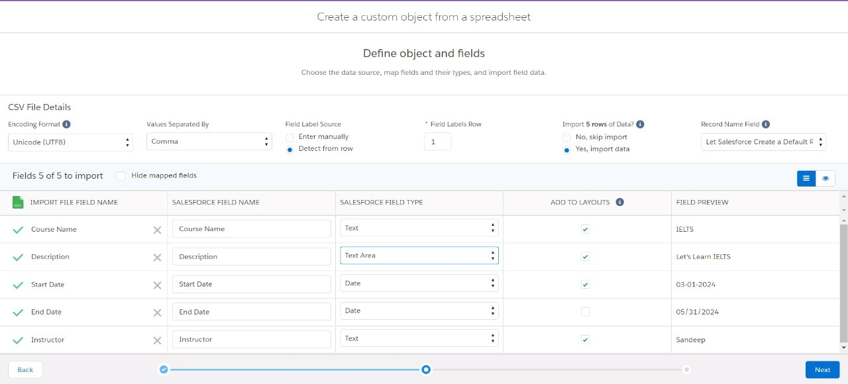

**2.1-Create Course Object :**

**Course Object :** It Stores detailed information about each course, such as its description, duration, and associated instructors, enabling efficient tracking and management of educational services.

**1.Navigate to Object Manager**

■ Log in to your Salesforce instance.

■ Go to the Object Manager tab in Salesforce setup.

**2.Create Object from Spreadsheet**

■ Click on "Create Object from Spreadsheet."

■ Download the Course spreadsheet via the provided link.

■ Upload the downloaded file to Salesforce.

**3.Map Fields**

■ Map the fields from the spreadsheet to the Salesforce object fields.

■ Review and finalise the field mapping.

■ Upload the data to create the Course object.

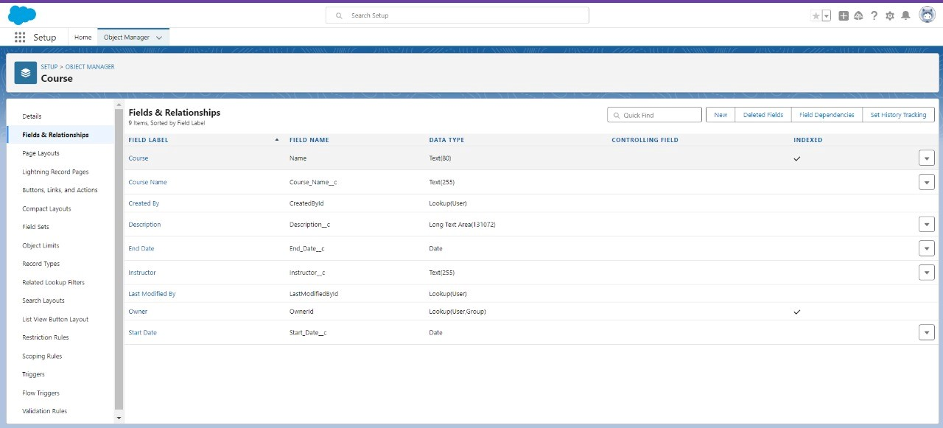

**2.2-Create Remaining Objects :**

**Consultant Object** : It Stores details about consultants, including their expertise, availability, and assigned courses, to manage and allocate resources effectivly.

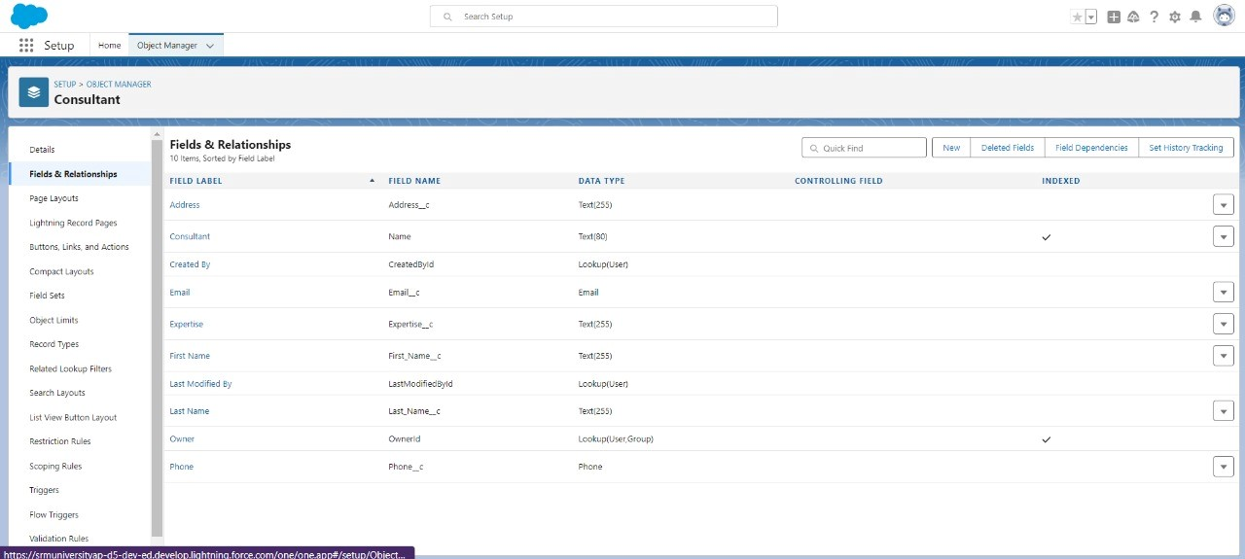

**Student Object :** It Contains detailed student information, including enrollment records, contact details, and course registrations, enabling efficient tracking and personalized communication.

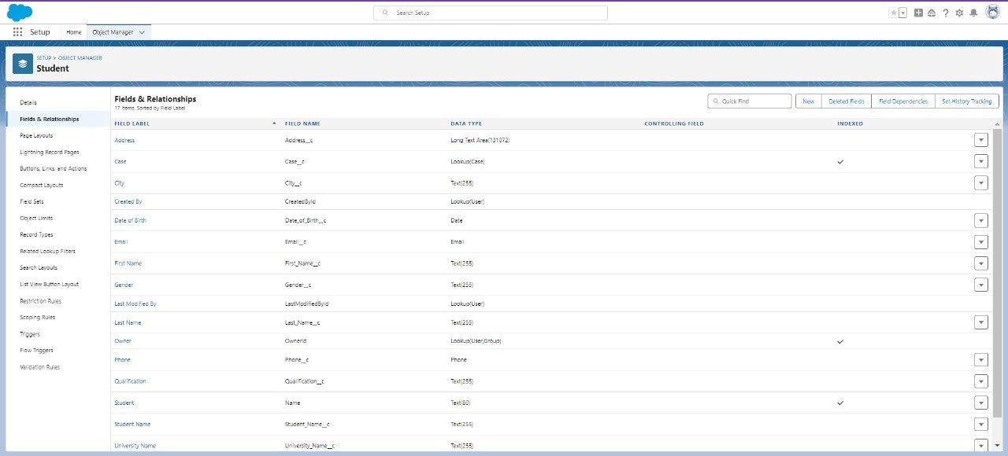

**Appointment Object** : Oversees scheduled meetings or sessions by tracking key details such as date, time, participants, and purpose, ensuring smooth and efficient coordination between students and consultants.

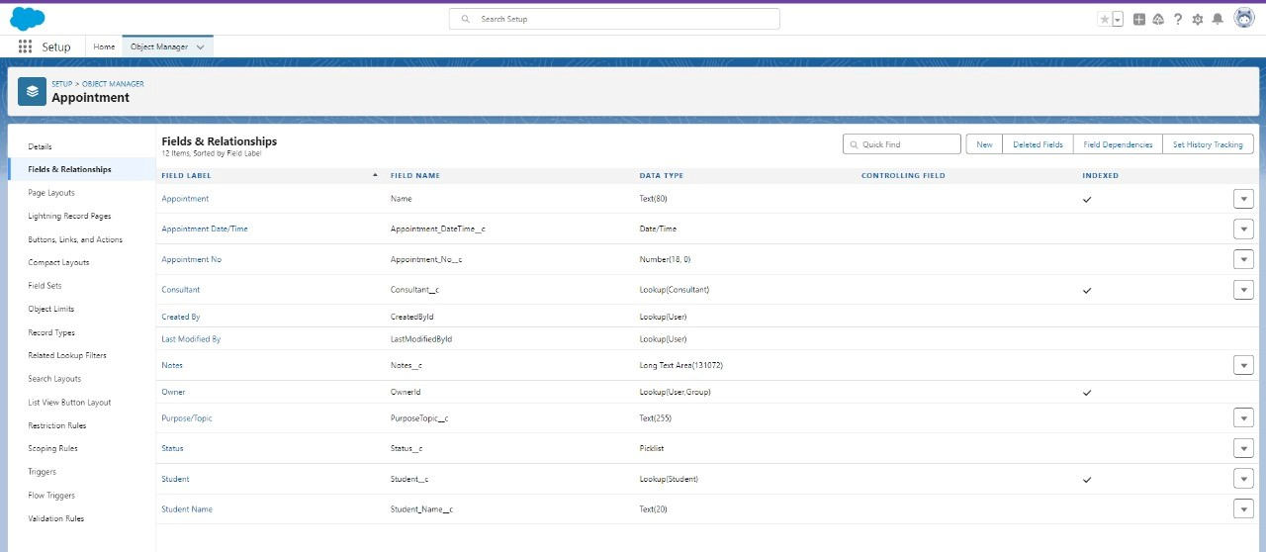

1. **3-Create Relationship Among the Objects :**It refers to establishing connections between different objects in a Salesforce database. These relationships define how the data in one object relates to data in another, enabling you to link records across objects for better organization, data integrity, and reporting.

In this Includes :

**1.Lookup Relationships**: Link each appointment to a specific student and also link each appointment to a specific consultant.

**2.Create a Registration Object**: Stores details about students and their course enrolments.

1. **Create a Lookup**: Link Student and Case to store the student queries for immigration or visa application.

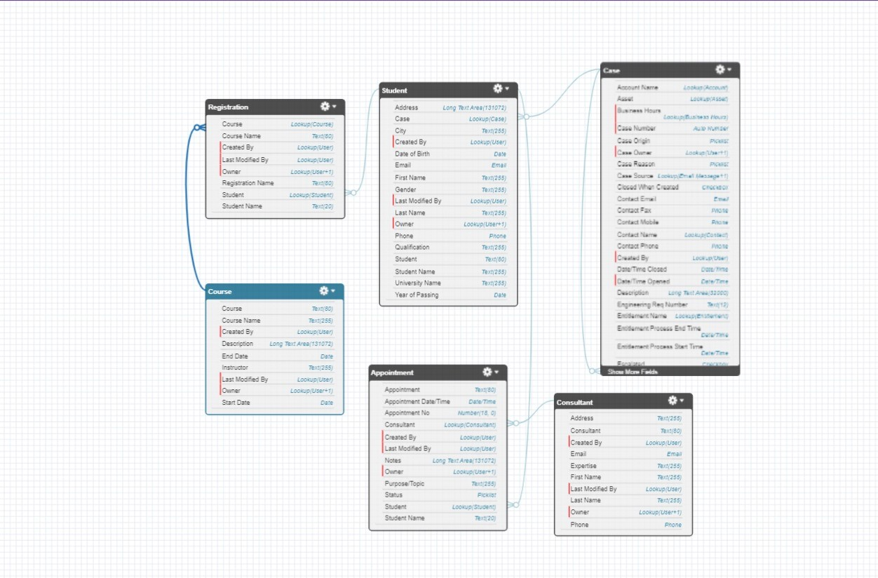

**2.4-Configure the Case Object :**

It involves customising the Case object in Salesforce to fit your organization’s needs.

This typically includes:

1. Go to the object manager and edit the case object.

2.Select the “Type” field and add the values in it.

a)Immigration b) Visa Application

3.Now Select the “Status” field and add the values in it.

a)Open b)In-progress

**2.5 - Create a Lightning App :**

A Lightning App in Salesforce is a custom application built using the Lightning Experience interface. It allows users to group related features, objects, and components into a cohesive, personalized workspace. 1. Go to Setup, search for "App Manager" in Quick Find.

1. Click on "New Lightning App.
2. Enter the app name as “EduConsultPro,” then click Next, Next, Next.
3. Add Home, Students, Courses, Consultants, Appointments, Registrations, and

Cases from Available Items to Selected Items.

1. Add the “System Administrator” profile from Available Profiles to Selected Profiles, then click Save & Finish.

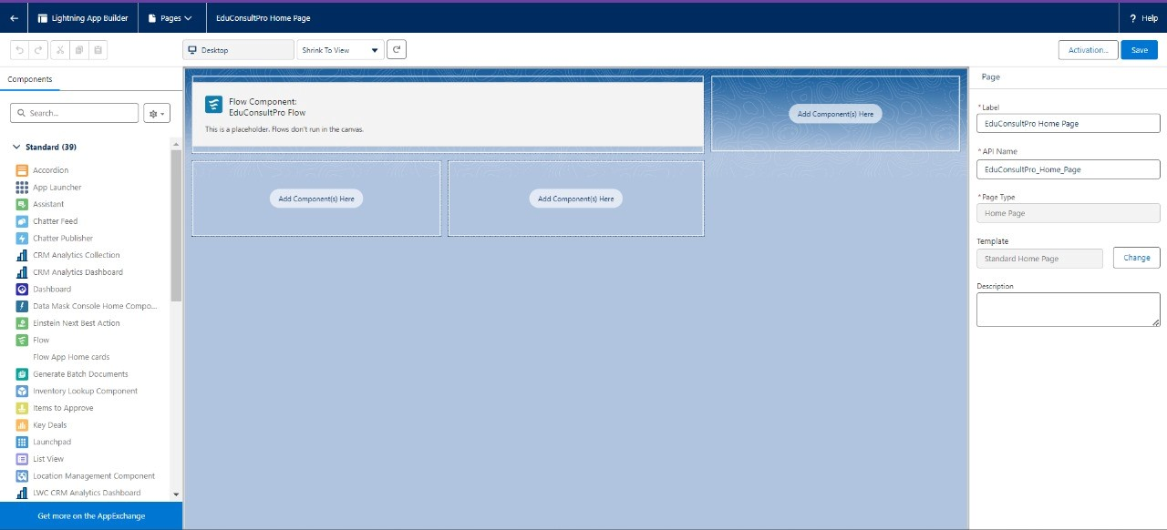

**3. Create a Screen Flow For Student Admission Application Process:**

The ScreenFlow for the Student Admission Application Process is a powerful tool in your CRM application designed to manage the services offered by an institution. It streamlines the entire admission process by automating data collection, course selection, and record creation. This automation reduces manual data entry errors, saves time, and ensures a consistent process for all applicants. It also allows for immediate feedback and communication with prospective students, improving their overall experience. By centralizing and organizing data, the institution can more efficiently manage student information, track admissions, and provide tailored educational services. This leads to enhanced operational efficiency and better service delivery.

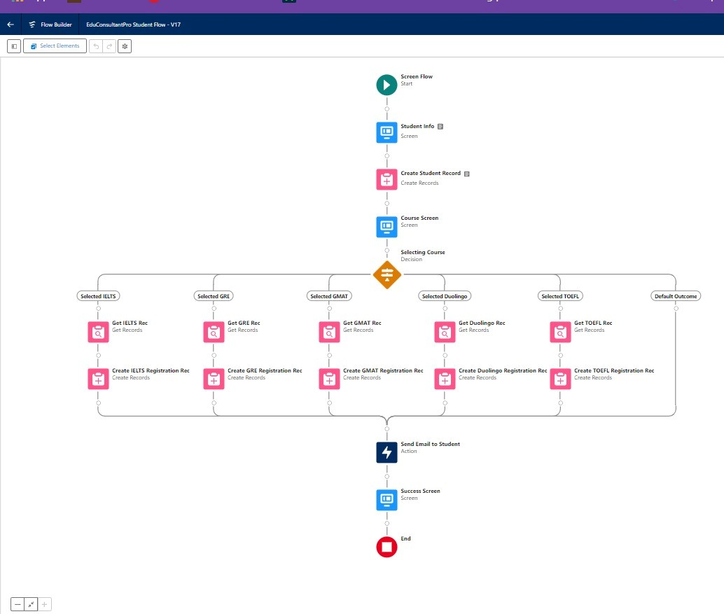

**3.1-Student Info Screen:**

* Open Flow Builder and start a new Screen Flow.
* Add a Screen element labeled “Student Info.”
* Create a record variable named "StudentRecordRes" to capture all fields from the Student object.Drag required fields (like name, email, etc.) from the

Student object to the screen to collect student information.

1. **2-Create Student Record :** 
   * After the "Student Info" screen element, drag and drop a "Create Records" element onto the canvas and name it "Create Student Record."
   * Select "One" for the number of records to create.
   * Choose "Use all values from a record" for setting the record fields.
   * Choose the "StudentRecordRes" record variable created in the previous screen to create the new Student record.Save the configured element.

**3.3- Course Selection Screen :**

* + After the "Create Student Record" element, drag and drop a "Screen" element onto the canvas and label it as “Course Screen.”
  + From the left side panel, drag a picklist component onto the screen and label it as “Select Course.”
  + Under choices, type “IELTS” and press enter to create a variable named IELTS. Repeat the process for “GRE,” “GMAT,” “Duo lingo,” and “TOEFL.”
  + Save your changes.

**3.4-Decision and Get Rec Elements :**

* Drag and drop a "Decision" element onto the canvas after the "Course Screen" element.
* Label this element as "Selecting Course."
* Under "Outcomes," create the first outcome and label it “Selected IELTS.”
* Configure the condition as:
  1. **Resource**: Select_Course (the picklist component from the "Course Screen" element)
  2. **Operator**: Equals
  3. **Value**: IELTS (the choice variable from the "Course Screen" element) ● Click the “+” icon to add more outcomes.
* Repeat the configuration from Step 2 for each of the following options:
  1. GRE
  2. GMAT
  3. DuoLingo
  4. TOEFL
* Once all outcomes are configured, click "Done" to complete the setup of the

"Selecting Course" Decision element,and Save your changes.

* After the "Selecting Course" Decision element, under the IELTS path, drag and

drop a "GET Record" element.

* Label this element “Get IELTS Rec.”
* **Object**: Select "Course."
* **Condition Requirements**: Set to "All Conditions are Met (AND)."
* **Configure Field**: Set "Course Name" as the field, "Equals" as the operator, and the value to {!Select_Course}.For each of the other paths (GRE, GMAT, DuoLingo, TOEFL), repeat the steps to configure GET Record elements:
* Adjust the label to correspond to the course (e.g., “Get GRE Rec,” “Get GMAT Rec,” etc.).
* Use the same "Course" object and set the "Course Name" field condition accordingly.
* Save the configured elements to ensure all paths and conditions are correctly set up.

1. **5-Creating Registration Records :**

● After the "Get IELTS Rec" element, add a "Create Records" element labeled “Create IELTS Registration Rec.” ● **Configuration**:

* + 1. **Records to Create**: Select “One.”
    2. **Field Setting**: Choose “Use separate resources and literal values.”
    3. **Object**: Set to "Registration."
    4. **Fields**:**Course_Name__c**: {!Get_IELTS_Rec.Id},**Student_Name__c**: {!StudentRecordRes.Id}

Repeat the above steps for GRE, GMAT, TOEFL, and DuoLingo paths, adjusting labels accordingly (e.g., “Create GRE Registration Rec”).

**3.6 Send Confirmation Emails :**

* + After all Decision paths, add an Action element labeled “Send Email to Student.”
  + **Configuration**:
    1. **Body**: {!StuRegistrationEmailTextTempBody}
    2. **Recipient Address List**: {!StudentRecordRes.Email__c}
    3. **Subject**: {!StuRegistrationEmailTextTempSub}
  + After the email Action, add a Screen element labeled “Success Screen.”
  + Drag a "Display Text" component, label it “SuccessMessage,” and add the

Success text in the Resource picker box.

Click “Done” and save the flow as “EduConsultPro Student Flow.”

1. **Creating Users and Configuring User Settings:**

**Creating Users:**Setting up individual accounts in Salesforce, including details like name, email, and profile, to grant access and define permissions.

**Configuring User Settings:**Customizing user access, roles, and personal settings in Salesforce to ensure appropriate data visibility and functionality based on their job requirements.

1. **1-User Creation**

**Create a New User :**

■ Navigate to **Setup** → **Administration** → **Users** → **New User**. ■ Enter the following details:

○ **Last Name**: Consultant

○ **License**: Salesforce Platform

○ **Profile**: Standard Platform User

■ Fill in all mandatory fields.

■ Click **Save**.

**4.2 -Approval Settings**

**Configure User Settings** :

* + Go to **Setup** → **Administration** → **Users**.
  + Click **Edit** next to your name.
  + Scroll down to the bottom and, under **Approver Settings**, select “Consultant” in the **Manager** field.
  + Click **Save**.

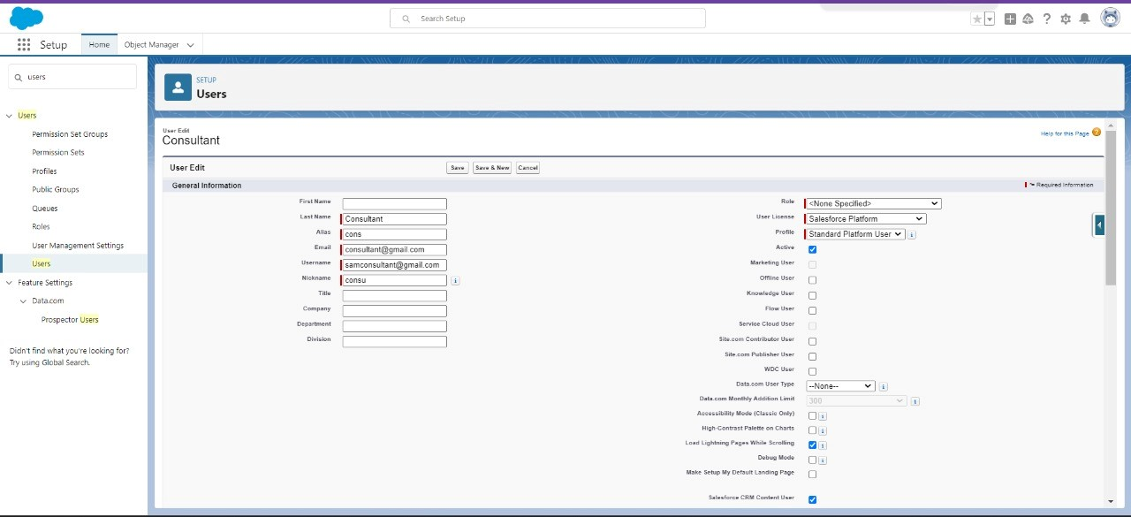

**5.Approval Process For Appointment Object :**

**5.1 Email Template**

**Enable Lightning Email Templates**:Now,we implemented a structured approach to managing email templates in Salesforce:

**Enable and Create Lightning Email Templates:**

* + Go to Setup,Enter "Templates" in the Quick Find box and select Lightning

Email Templates and clickToggle the feature on.

* + Open the App Launcher and search for "Email Templates",Click Create New Folder, name the folder, and click Save.
  + Click New Email Template,Choose the folder created earlier,Name the template "**Submission Template**".Enter the content in the HTML Value field and Click Save.
  + Repeat the process to create two more templates:

○ One for **Approval**,One for **Rejection**,enter content for each template accordingly.Save each template

**1)Submission Template** :



**2)Approval Template :**

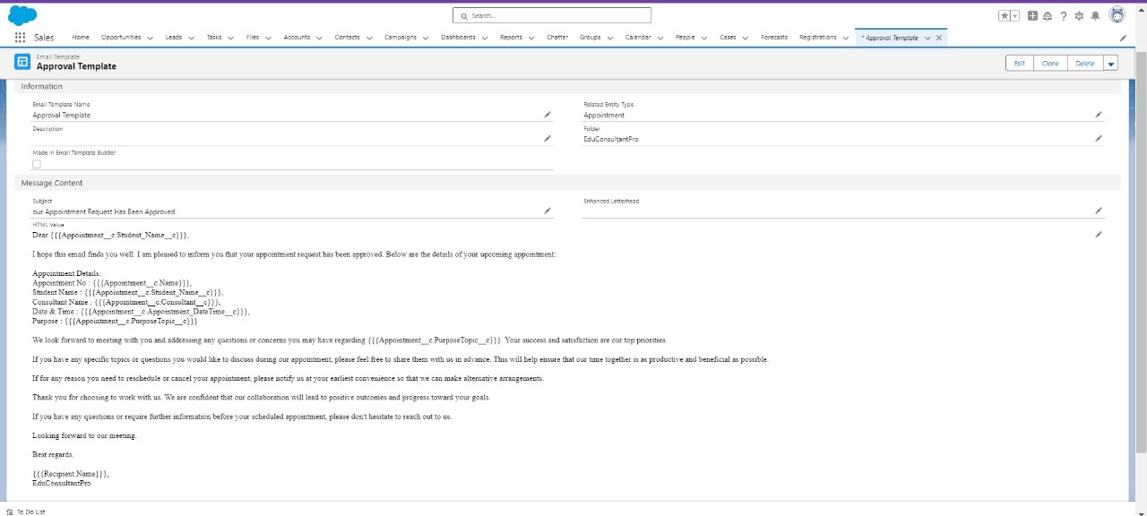

**3)Rejection Template :**

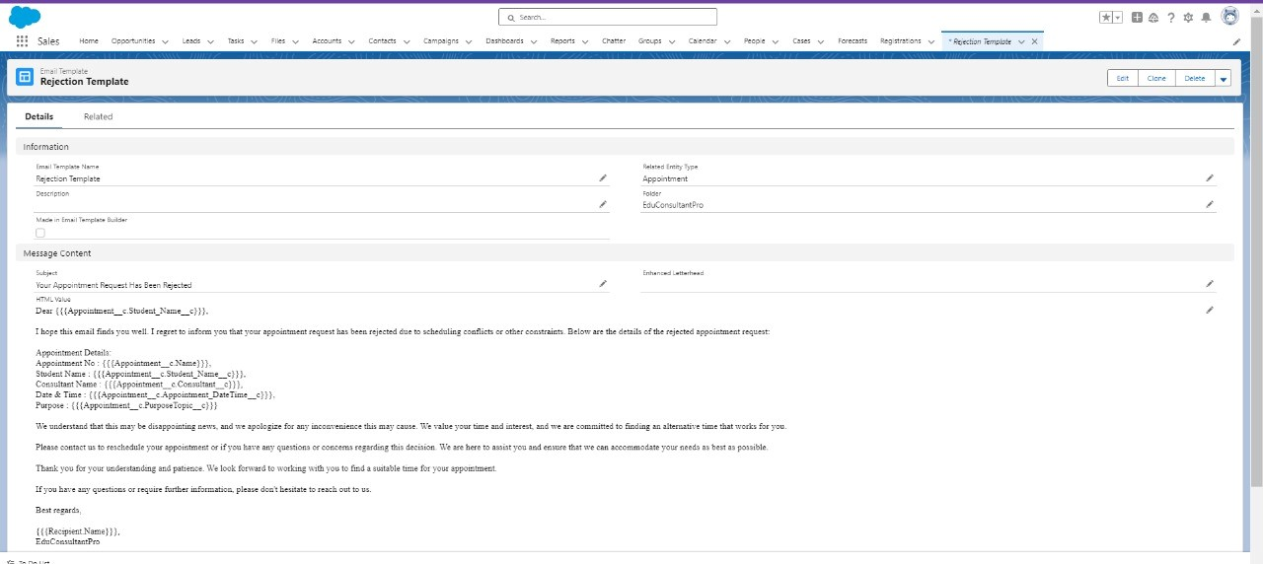

**5.2 Approval Process Configuration:**

To create a new approval process in Salesforce.Firstly,Go to Setup and Enter "approval" in the Quick Find box and select Approval Processes.

* + Set the Process Name to “**Appointment Approval**.”
  + Configure Approvers Under Select Approver, choose Manager for the option:

“Automatically Assign an Approver Using a Standard or Custom Hierarchy

Field.”

* + Record Auditability Properties, choose Administrators or the Currently Assigned Approver Can Edit Records During the Approval Process.
  + Save the Approval Proces

**Configure Initial Submission Actions**:Click View Approval Process Detail Page,Under

Initial Submission Actions, Click Add New:Choose Field Update And Configure It With The Necessary Values and also Click Add New Again And Select Email Alert:

○ Description: Enter “submission Email Alert.”

○ Unique Name: This Will Auto-populate.

○ Email Template: Choose “submission Template.”

○ Recipient Type: Select Your Name.Click Save.

**Configure Final Actions** : Repeat the same process for Final Rejection Actions, Add

Appropriate Field Updates And Email Alerts For Each Action.Use Suitable

Descriptions, Email Templates, And Recipient Types.

## 6. Create A Record Triggered Flow

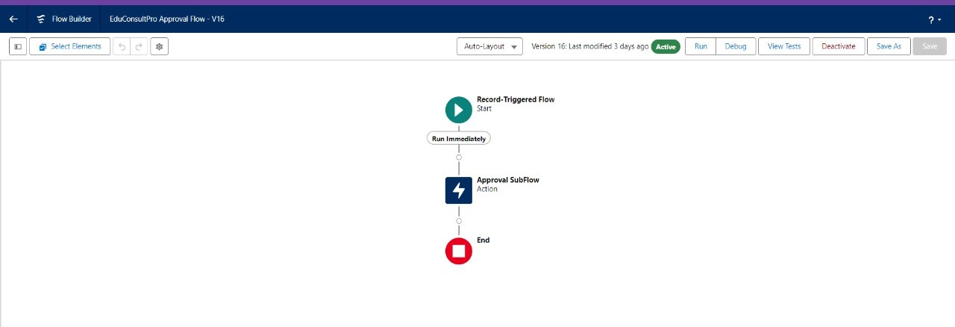

**6.1 Configure The Start Element:**

* Click on the gear icon in the top-right corner of Salesforce and select "Setup." In the Quick Find box on the left side of the Setup page, type “flows.”Click on“Flows” under the "Process Automation" section.
* On the Flows page, click the “New Flow” button.Select “Record-Triggered Flow” from the list of flow types.Click the “Create” button to start building your flow.You will be prompted to configure the Start element of your flow.For the

“Object” field, choose “Appointment” from the dropdown menu.

* This specifies that the flow will trigger on changes to Appointment records.Select “A Record Is Created” to specify that the flow should run whenever a new Appointment record is created.

1. **2-Add An Action Element :**

Drag and drop an Action element onto the flow canvas after the Start element.Select "Submit for Approval" action and label it as “Approval Subflow.”Set the Record ID field to “{!$record.Id}.”Save the flow with the label "educonsultpro Approval Flow" and click Activate.

**7.Create a ScreenFlow for Existing Student to Book an Appointment**

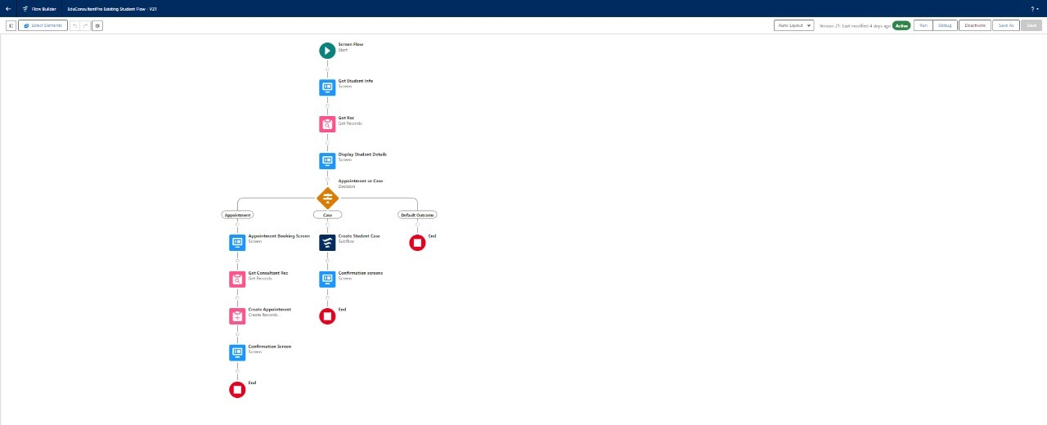

To create a Screen Flow for existing students to book an appointment in Salesforce :

1. **1-Get Student Info Screen :** 
   * From Setup, enter “Flow Builder” in the Quick Find box,Select “New Flow” and choose “Screen Flow",Click "+" Add Element and Select “Screen” from the list of elements.
   * In the Screen Properties pane, set the Label to “Get Student Info",Drag and drop two “Text” components from the left side panel onto the screen,Label the first Text component as “Enter Student Name",Label the second Text component as “Enter Student Email.”Click “Done” to save the screen configuration.

**7.2-Get Record Elements :**

* After the Decision element, under the IELTS path, click “+ Add Element.” Select “Get Records” and label it as “Get Rec".
* Configure the GET Record Element for Object: Select “Student.” and Condition

Requirement : Choose “All Conditions are Met (AND).”

* Set Conditions for Field: Student Name,Operator: Equals and Value: {!Enter_Student_Name}

Field: Email__c,Operator : Equals,Value: {!Enter_Student_Email}

**7.3-Add Decision Element :**

* Add a Decision Element after Select Display Student Details Element, label it as “Appointment or Case”.
* Under outcome, label it as “Appointment” and write the condition such as below-**Resource** : {!How_may_I_Help_you},**Operator** : Equals

**Value** : {!Book_an_Appointment},Click on the “+” icon and Repeat for case.

**7.4**-**Add Screen Element :**

* Add a Screen element after the Decision Element, on the Appointment path, and label it as “**Appointment Booking Screen**".
* Click on Fields, click on the record variable input and create a new Resource

(AppointmentRecordRes) to display all the fields which are in the Appointment object.

* Drag all the fields which are needed to add on the screen in order to collect the student information.

**7.5-Create Appointment Record using Create Records Element**

Add a Create element after the Get Consultant Rec element and label it as

“**Create Appointment**”.Select “one” under How many records to Create, and select

“Use separate resources and literal values” under How to Set the record fields. Select Object : Appointment

1. **Field** : Appointment_DateTime__c

**Value** : {!AppointmentRecordRes.Appointment_DateTime__c}

1. **Field** : Consultant__c

**Value** : {!Get_Consultant_Rec.Id}

1. **Field** : Notes__c

**Value** : {!AppointmentRecordRes.Notes__c}

1. **Field** : PurposeTopic__c

**Value** : {!AppointmentRecordRes.PurposeTopic__c}

1. **Field** : Student_Name__c **Value** : {!Get_Rec.Id}

**7.6-Add Screen Element :**

* After the “Send Email to Student” Action element, click the “+ Add Element” button,Select “Screen” from the list of elements,Label the Screen element as “Confirmation Screen".From the Left Side Panel Search for the “Display Text” component and drag it onto the main panel of the Screen element.Label the Display Text Component Enter “Appointment_Confirmation” as the label. ● Set Up the Display Text :

Consultant Name: {!Get_Consultant_Rec.Name}

Date & Time:{!AppointmentRecordRes.Appointment_DateTime__c} Notes: {!AppointmentRecordRes.Notes__c}

* Click “Done” to save the configuration of the Screen element.

1. **7-Add an SubFlow Element:** 
   1. Add a sub flow element after the Decision Element, on the Case path, and search and Select for “Create a Case”, label it as “**Create Student Case**”.
   2. Save the flow and label it as “**EduConsultantPro Existing Student Flow**”, you can use the below image for reference.

1. **Create a ScreenFlow to Combine all the flows at one place**

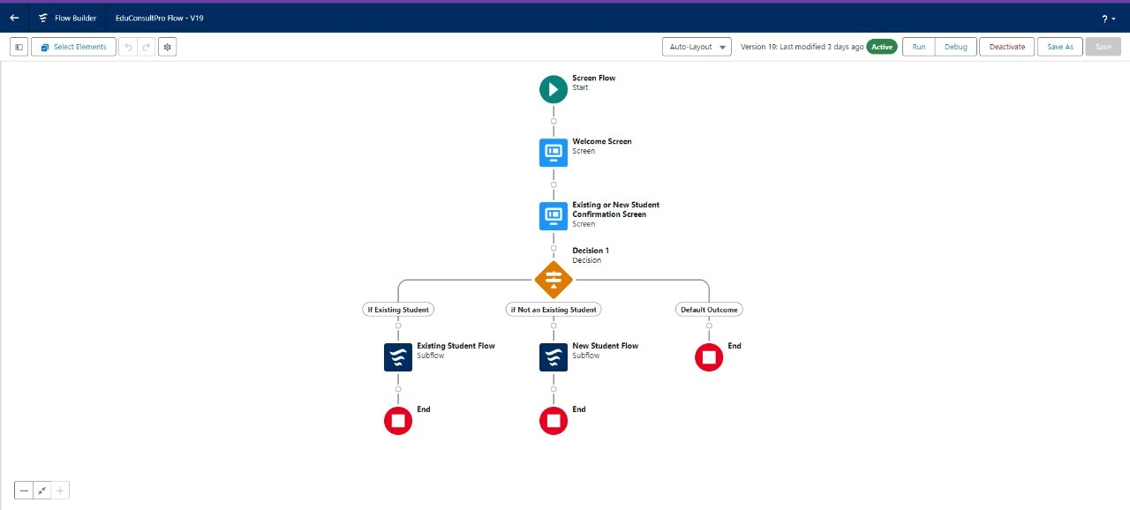

**8.1-Add Screen Element :**

* Go to the Flow Builder where you’re working on your Salesforce FlowIn the left side panel, find the "Elements" section,Drag and drop the "Screen" element into the main panel,Click on the newly added Screen element,In the properties pane on the right, set the "Label" to "Welcome Screen".
* Inside the "Welcome Screen" configuration, locate the "Display Text" component in the left side panel under "Components".
* Drag and drop the "Display Text" component onto the main panel of the Screen element.Click on the Display Text component you just added.In the properties pane on the right, set the "Label" to "SuccessMessage".Enter the text you want to display in the "Text" field ,Save your changes to the Flow.Make sure to connect this Screen element appropriately with other elements in your Flow as needed.

**8.2-Add Screen Element**

* Go to the Flow Builder where you’re working on your Salesforce Flow.In the left side panel, find the "Elements" section.Drag and drop the "Screen" element onto the main panel, placing it after the existing "Welcome Screen" element.
* Click on the newly added Screen element,In the properties pane on the right, set the "Label" to "Existing or New Student Confirmation Screen".
* Inside the "Existing or New Student Confirmation Screen" configuration, locate the "Radio Buttons" component in the left side panel under

"Components".Drag and drop the "Radio Buttons" component onto the main panel of the Screen element.

* Click on the Radio Buttons component you just added.In the properties pane on the right, set the "Label" to "Are you an Existing Student".Click on "Add Choice" to create a new choice.In the input field that appears, type "Yes".Click "Create Yes choice" to add this choice to the radio buttons.Repeat step 6 to add another choice with the label "No".
* Click "Create No choice" to add this choice to the radio buttons.Click "Done" to finalise the configuration of the Screen element.
* Save your changes to the Flow.

Ensure you connect this Screen element appropriately with other elements in your Flow as needed.

**8.3-Add Decision Element :**

* After the “Existing or New Student Confirmation” Screen Element, click the “+” icon.

Select “Decision” from the menu,Label this Decision element as “Decision 1.”

* In the Outcomes section, click “Add Outcome.”Label the Outcome: Enter “If

Existing Student.”Set Condition :Resource:

{!Are_you_a_Existing_Student},Operator: Equals,Value: {!Yes},Click the “+” icon to add another outcome

* Enter “If Not Existing Student.” and Set Condition:

■ **Resource**: {!Are_you_a_Existing_Student}

■ **Operator**: Equals

■ **Value**: {!No}

* Double-check the outcomes and conditions to ensure they are correctly configured. Click “Done” to save the Decision element configuration.

1. **4**-**Add an SubFlow** 
   * Go to the Flow Builder where you’re working on your Salesforce Flow. Find the "Elements" section in the left side panel.
   * Drag and drop the "Sub flow" element onto the main panel, placing it after the "Decision 1" element on the "Existing Student" path.Click on the Subflow element you just added.
   * In the properties pane on the right, click on the "Sub flow" dropdown to search and select the "EduConsultantPro Existing Student Flow".

Set the "Label" to "**Existing Student Flow**".Save your changes to the Flow, Label the Flow as "**EduConsultantPro Existing Student Flow**"

* + Click "Done" to finalise the configuration of the Sub flow element.
  + Ensure the Sub flow element is connected appropriately with other elements in your Flow as needed.

1. **Creating a Lightning App Page** 
   * From Setup, type App Builder in the Quick Find box and select Lightning App Builder. Click NewChoose Home Page and click Next.
   * Name the page “EduConsultPro Home Page”, select the Standard Home Page template, and click Done.Drag the Flow component to the top-right region of the page layout.Search for “**EduConsultantPro Flow**” in the component list.
   * Click Save and Activate.Choose App and Profile, then click Assign to Apps and Profiles.
   * Select the Sales app and click Next,Scroll through the profiles and select

System Administrator, then click Next,Review the assignment and click Save.



1. **OUTPUT :**

**EduConsultantPro** is a platform for expert guidance in education and immigration, offering personalized support to help you achieve your academic and professional aspirations abroad. Our dedicated team ensures a seamless and rewarding journey, from selecting institutions to navigating visa processes.

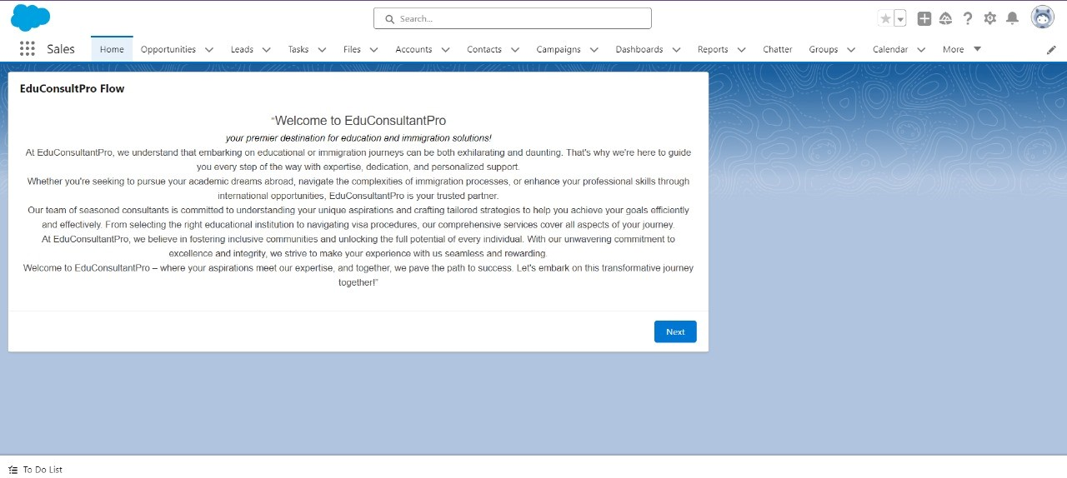

**Are u existing student YES?**

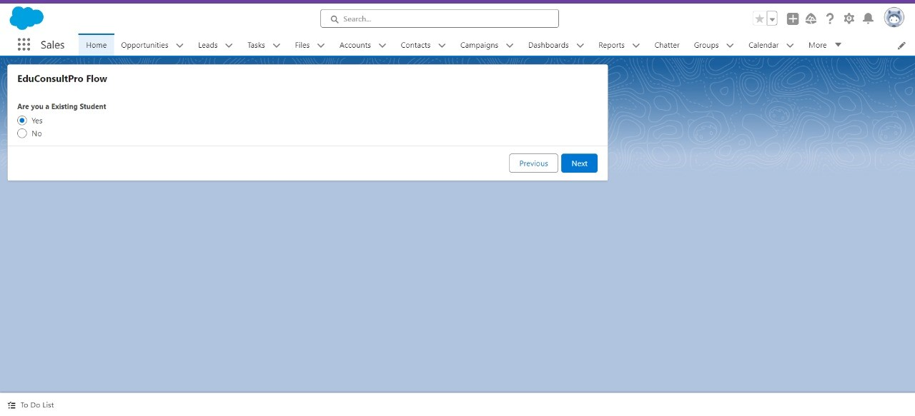

It has two input fields labeled:

* 1. **Enter Student Name** - A text field for inputting the student’s name.
  2. **Enter Student Email** - A text field for entering the student’s email address.

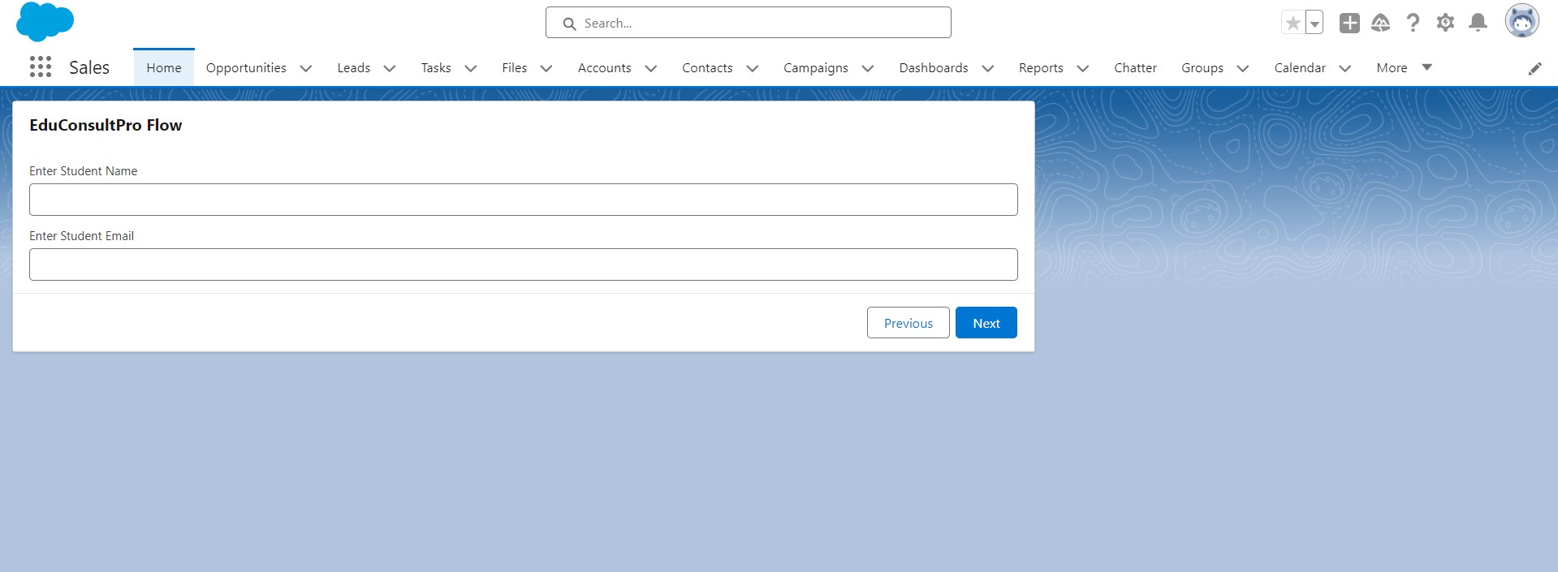

The EduConsultantPro Flow allows users to either **Book an appointment** or initiate an **immigration case**, streamlining the process for personalized support.

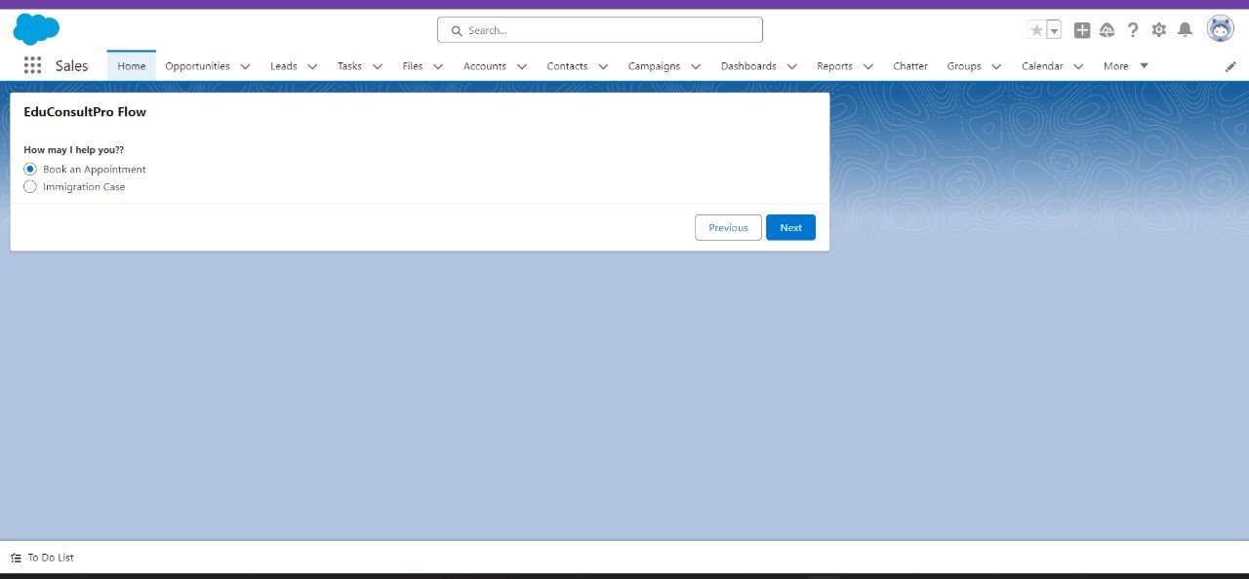

**Book an appointment :**

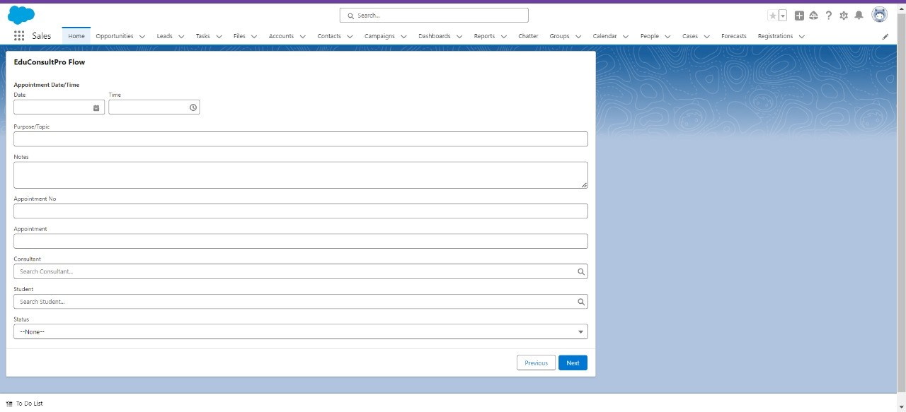

The **EduConsultantPro** Flow includes a form for adding **new consultant** details, enabling efficient management of consultant information.

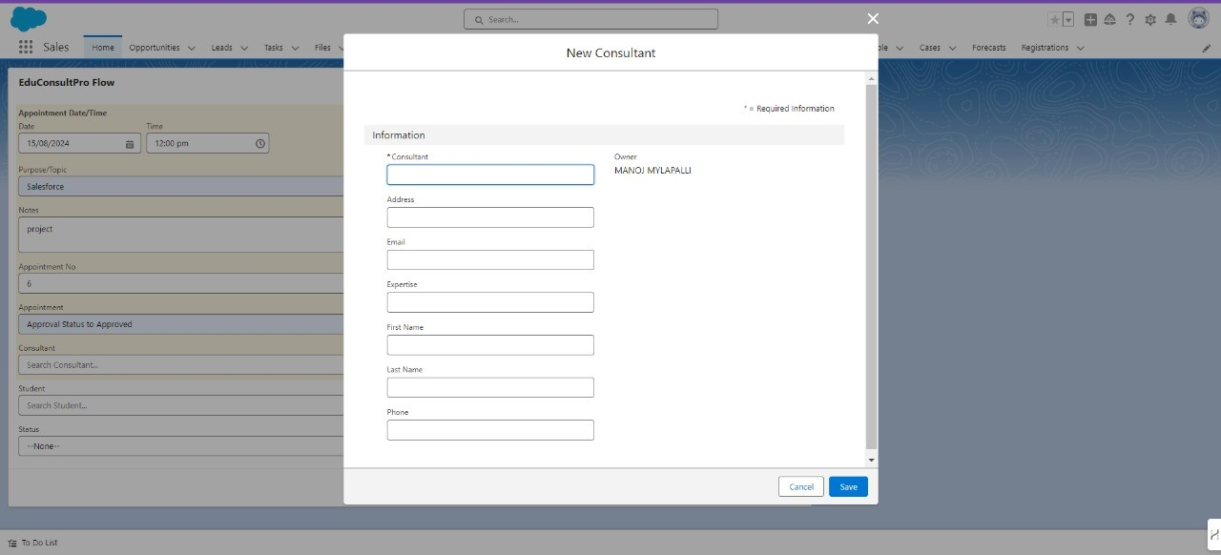

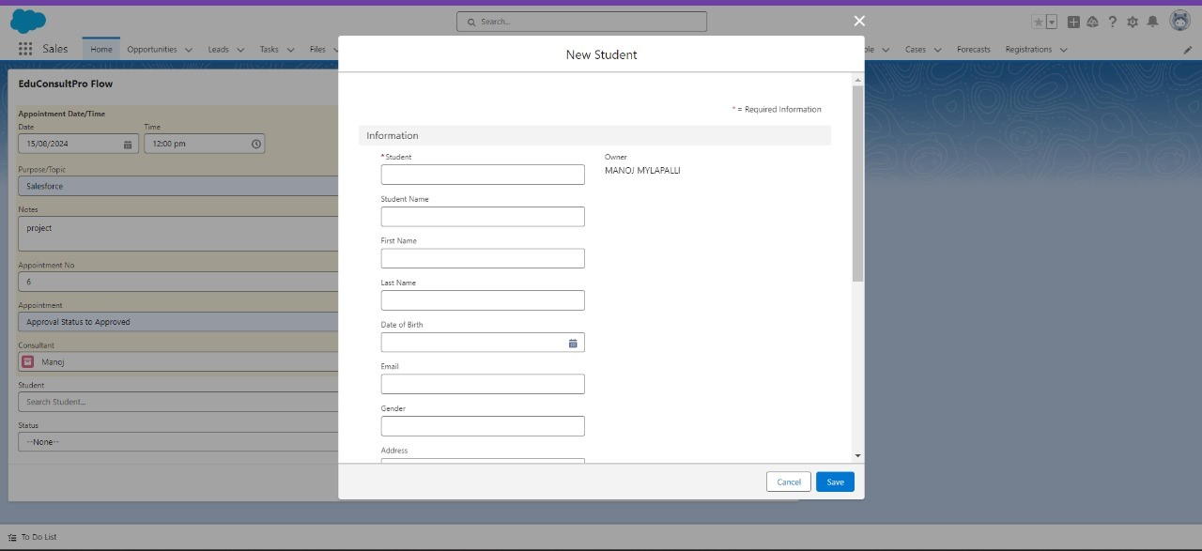

The **EduConsultantPro** Flow includes a form for adding **New Student** detail.

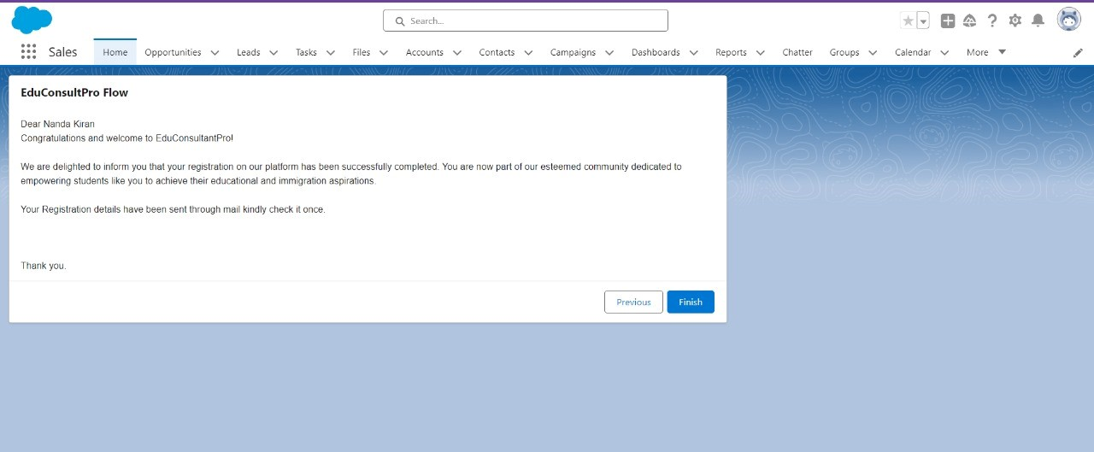

**Immigration case :**

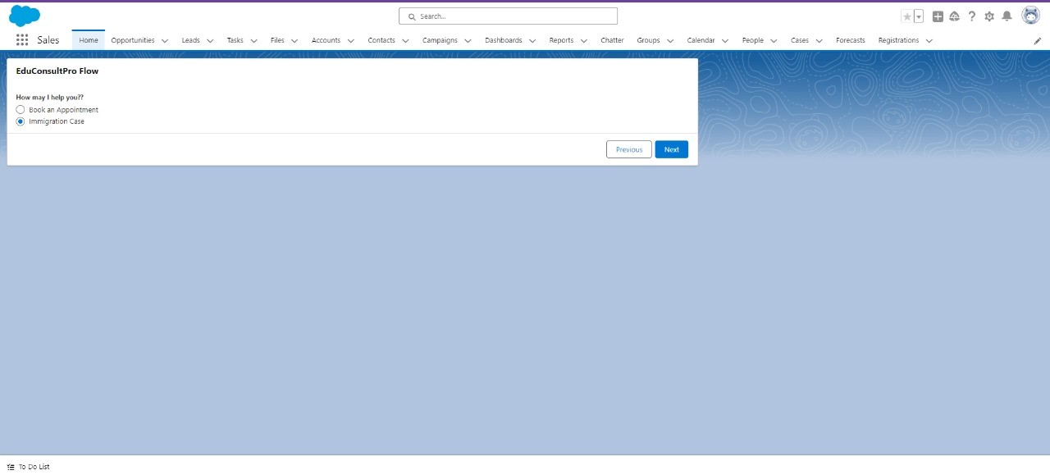

This screen is part of the **EduConsultPro Flow** within Salesforce. It is designed to **confirm customer Information.**

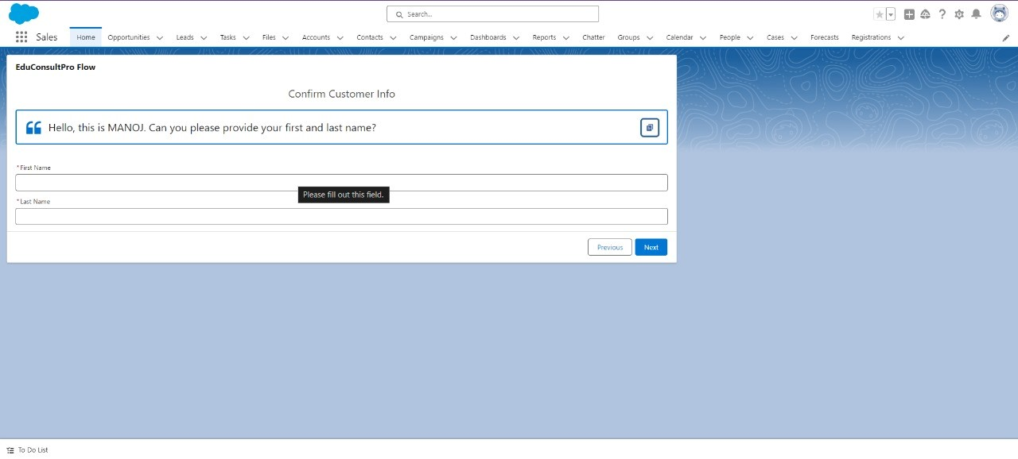

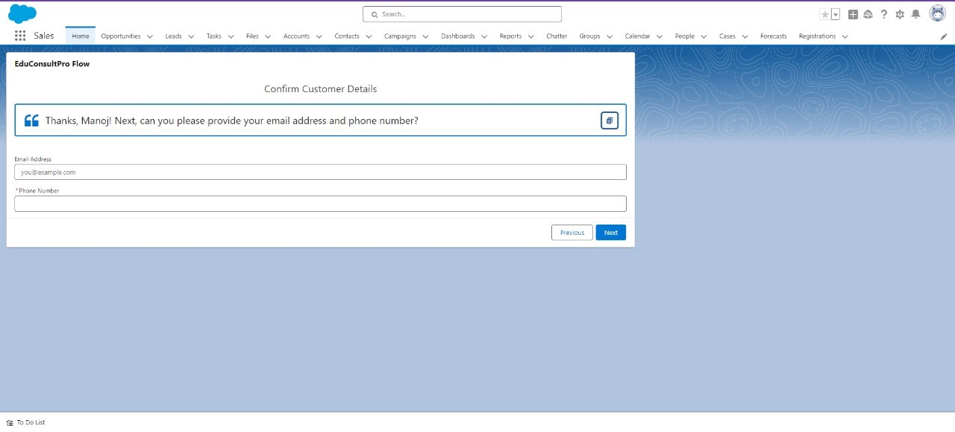

**"EduConsultPro Flow,**" where users are prompted to input case details, including case type, case origin, case subject, and case details, before proceeding to the next step.

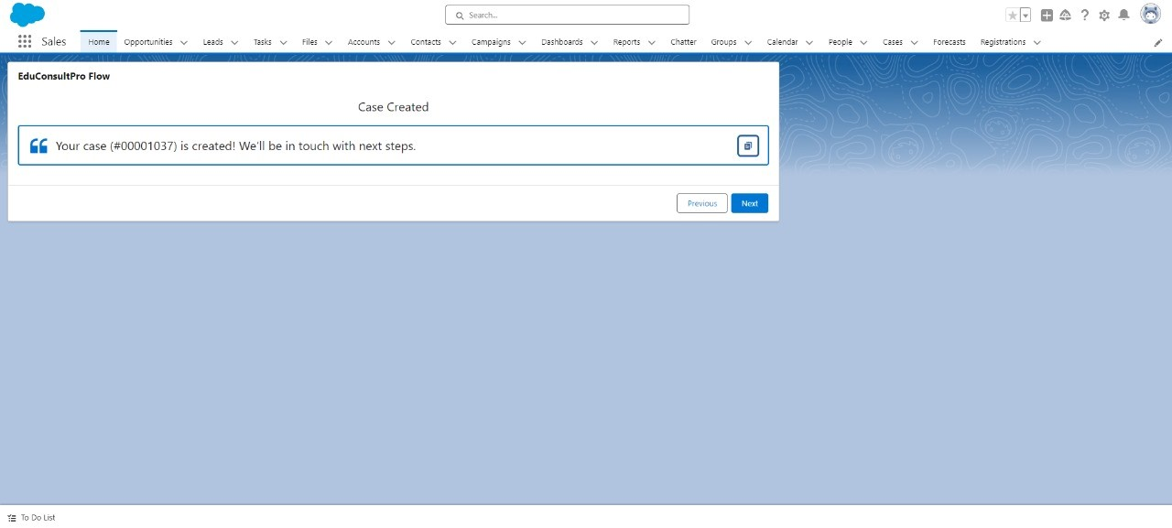

The final step of the **"EduConsultPro Flow"** in Salesforce, where a message informs the student that their immigration case has been successfully processed. The student is advised to check their email for further details and next steps.

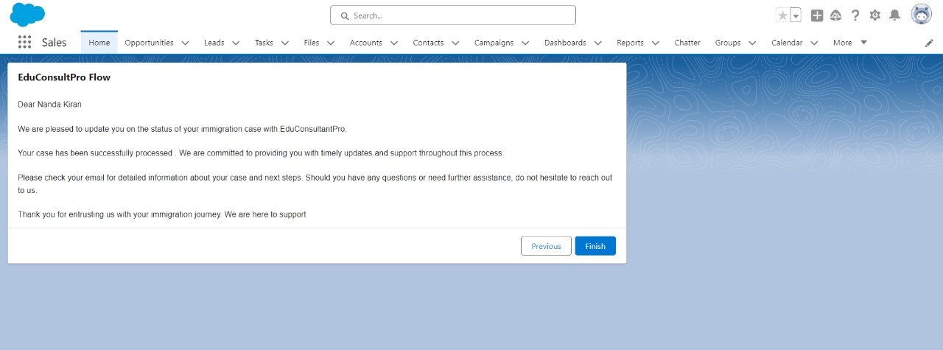

**Are u existing student NO?**

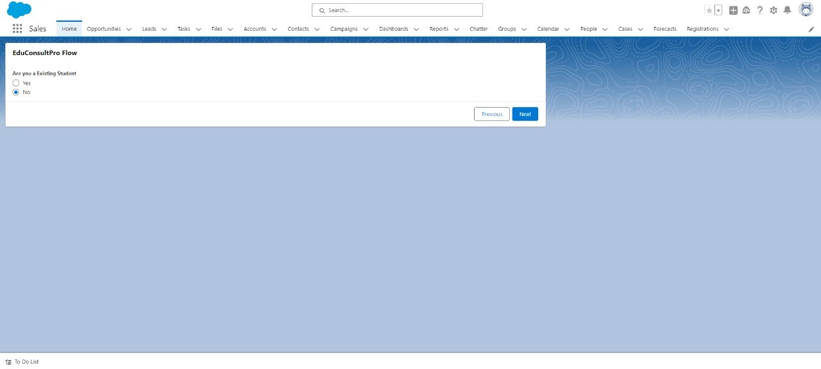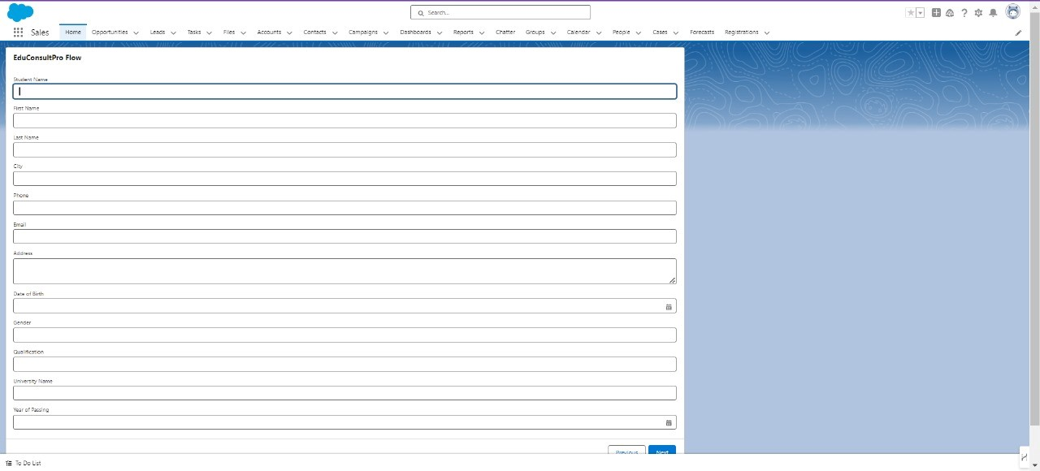

This screen is the final step of the **EduConsultPro Flow** in Salesforce. It displays a confirmation message indicating that the registration process is complete.

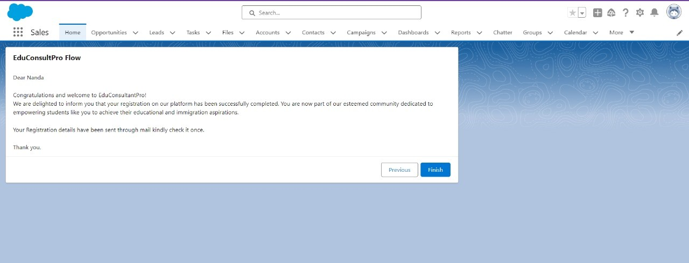

"Search for **EduConsultPro** in the App Launcher, and you will be directed to the corresponding page."

