Netflix Content Portfolio & Business Analytics
Auspify Technologies — Business Analytics Internship
Dataset: Dataset.csv | Tools: Python, Pandas, Matplotlib

1. Project Overview
This project analyzes a Netflix titles dataset across four tasks: content mix, country representation, content ratings, and trends by release year and catalogue-addition year. The internship task list requires any four of six tasks; this report covers Tasks 1–4.

2. Dataset Overview
The dataset contains 8,790 rows and 10 columns: show_id, type, title, director, country, date_added, release_year, rating, duration, and listed_in. The initial missing-value check reported zero missing values across all columns. Country values were split for country-level counting, and date_added was converted to a date for catalogue-addition trends.

3. Task 1 — Netflix Content Portfolio Analysis
Content Type | Titles | Share
Movie | 6,126 | 69.69%
TV Show | 2,664 | 30.31%
Total | 8,790 | 100%
Finding: Movies represent 69.69% of the dataset, compared with 30.31% for TV Shows. Recommendation: evaluate viewing engagement, audience demand, and production/licensing costs before changing the content mix.

4. Task 2 — Global Market Performance Analysis
The United States has 3,240 country-associated titles, India 1,057, the United Kingdom 638, Pakistan 421, and “Not Given” 287. Counts overlap when titles list multiple countries. “Not Given” is a data-quality category, not a country.
Recommendation: assess audience engagement, licensing availability, and local demand before proposing regional expansion. Title counts alone do not measure revenue or viewership.

5. Task 3 — Audience Segmentation Analysis
The rating comparison chart indicates that TV-MA is the most common rating for both Movies and TV Shows. Movies have higher counts across most displayed categories, while TV-Y and TV-Y7 show relatively greater TV Show counts in the chart. Ratings are content classifications and do not directly identify actual viewer demographics.
Recommendation: combine rating distributions with viewing hours, completion rates, and audience research.

6. Task 4 — Content Growth & Trend Analysis
The release-year chart rises sharply in recent years and peaks around 2018 in the displayed data. Catalogue additions peak at 2,016 titles in 2019, followed by 1,879 in 2020 and 1,498 in 2021. Release year and catalogue-addition year measure different things and should be interpreted separately.
Recommendation: track these trends separately and combine them with licensing, viewing, and engagement metrics. Recent-year declines may reflect dataset coverage or timing and do not prove a business decline.

7. Limitations
- This is descriptive analysis of the supplied dataset, not a complete measure of Netflix’s current catalogue.
- Country counts overlap when a title is associated with multiple countries.
- The dataset does not include viewing hours, revenue, production costs, or customer demographics.
- Trend patterns should be interpreted in light of the dataset’s coverage and collection date.

8. Conclusion
Movies form the larger share of the supplied catalogue, the United States has the highest country-associated title count, TV-MA is the most common rating in the comparison chart, and catalogue additions peaked in 2019. These findings provide a starting point; stronger investment decisions require audience engagement and financial data.

Appendix — Analysis Visuals
Task 1: Movies and TV Shows percentage share
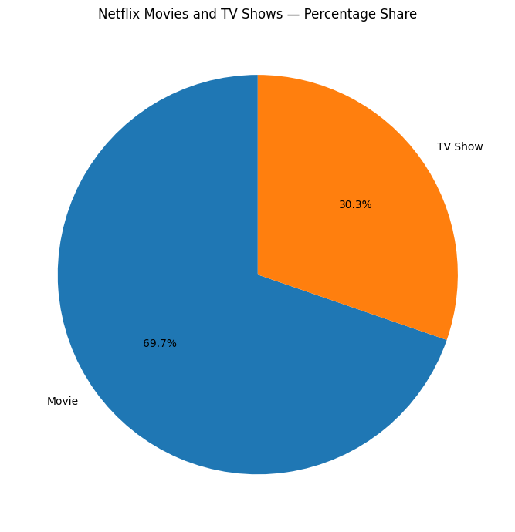
Task 2: Top 10 countries by Netflix content count
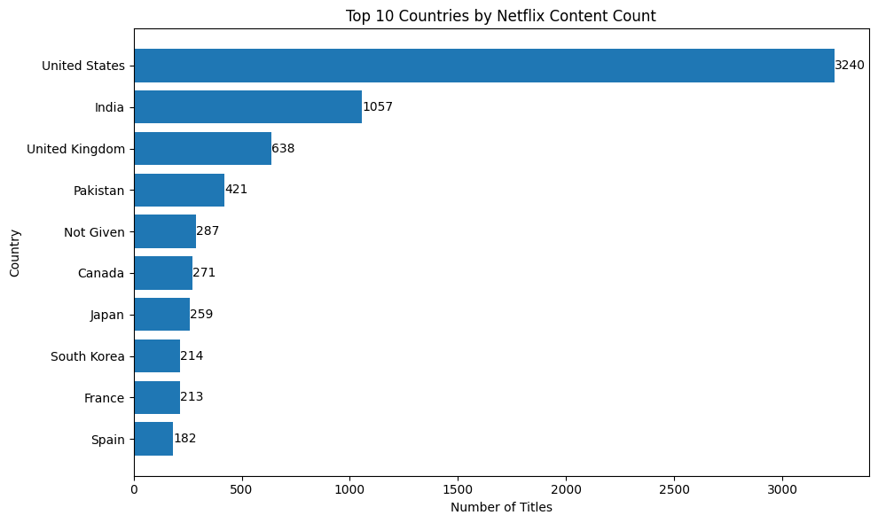
Task 3: Content ratings comparison
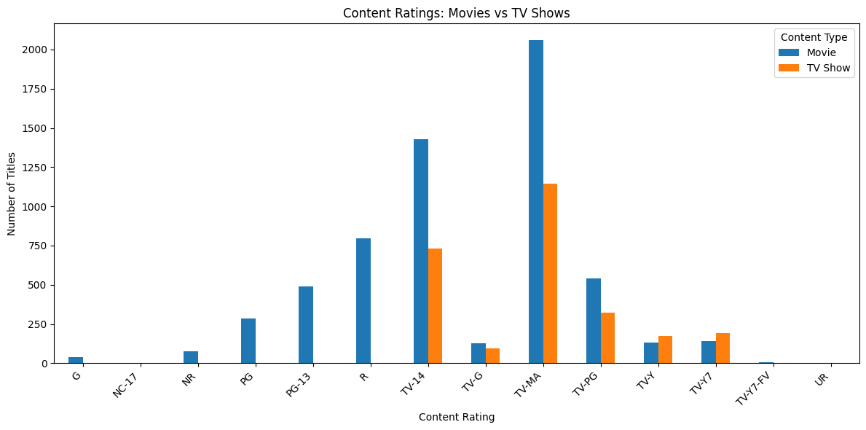
Task 4: Content distribution by release year
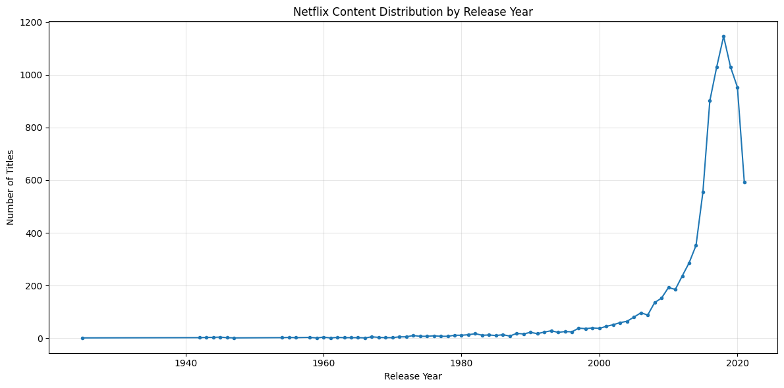
Task 4: Catalogue additions by year
