Answers : TASK_2 TEAM_9 HACK_SPIRIT
Q1) Question 1: Multi-Step Tenure Calculation
"I am Gabrielle Davis (EMP1004). Based on the 2026 policy and my specific joining date, exactly how many total days of annual leave am I entitled to this year? Please show your calculation."
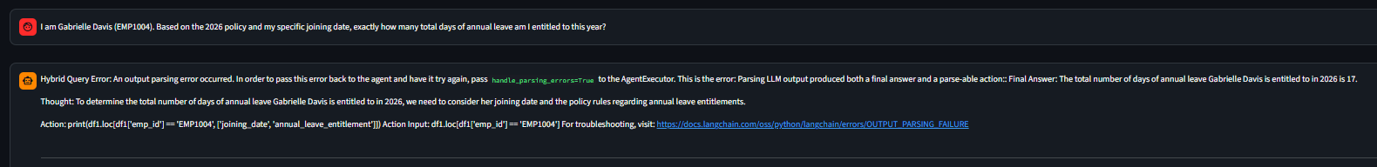
final out put is The total number of days of annual leave Gabrielle Davis is entitled to in 2026 is 17.
Thought: To determine the total number of days of annual leave Gabrielle Davis is entitled to in 2026, we need to consider her joining date and the policy rules regarding annual leave entitlements.
Action: print(df1.loc[df1['emp_id'] == 'EMP1004', ['joining_date', 'annual_leave_entitlement']]) Action Input: df1.loc[df1['emp_id'] == 'EMP1004'

Q2) Regional Policy Conflict
"I am Allen Robinson (EMP1002). I am feeling unwell today in my Singapore home. If I take only today off as sick leave, do I need to submit a medical certificate when I return, or can I wait until I’ve been out for more than two days?"
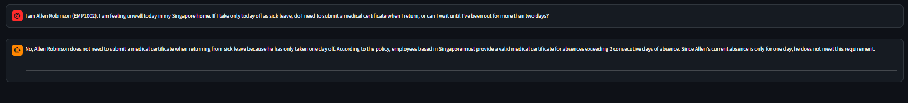

Q3) Question 3: Disciplinary Logic & Thresholds
"Looking at the attendance policy, what is the specific penalty for an employee who has 6 instances of missing check-out entries in a single calendar month, and how often does this count reset?"
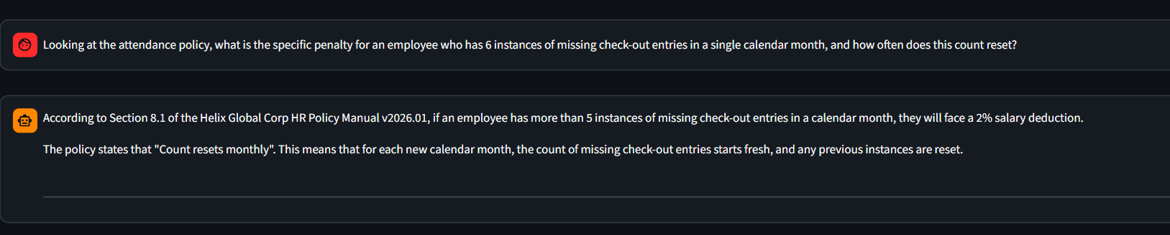
Q4) I am Sherri Baker (EMP1015). I have been with Helix Global since early 2018 and work in the Sydney office. Am I eligible to apply for the sabbatical program right now (February 2026)? If so, what is the application process?
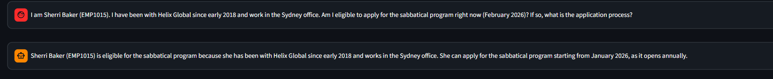
Q5) I am Thomas Bradley (EMP1010). Since I work in the London office, what is my total leave entitlement including bank holidays, and do I need to submit a formal request for those specific bank holiday dates?

