|  |  |
| --- | --- |
|  | **Agenda** |
|  | CSS |
|  | Understand the need CSS |
|  | Apply CSS |
|  | Different ways to implement CSS  Inline CSS  Internal CSS  External CSS |
|  | Examples |

|  |  |
| --- | --- |
|  | **Understand CSS** |
|  | **CSS (**Cascade Style Sheet) is a **style language** (**not a programming language**) used to apply styles to the tags in Html Pages.  Style refer to color, size, alignment, positioning, visibility etc.,  CSS is a language that describes the style of an HTML Document.  CSS describes how HTML elements should be displayed.  CSS play an important role in **Webpage Designing** (**not for WebPage Development**) for applying styles.  CSS is used to provide consistent look in the Web Application  **CSS provided 3 ways to apply styles:**   |  |  |  | | --- | --- | --- | |  | **Types of CSS** | **Advantages** | | 1 | Inline style sheet | Used to specify style in the same line of Html tag | | 2 | Internal style sheet | Used to specify style to be provided **Entire Page** for specified tags | | 3 | External style sheet | Used to specify style in separate file (.css) and import into pages need the same style |   **Note**: **CSS no way related to functionality** (only effect styles)  CSS saves a lot of work. It can control the layout of multiple web pages all at once |

|  |  |
| --- | --- |
|  | **Inline css** |
|  | Inline CSS is used provide styles which to applied only for the specified tag.  Using style attribute we have to apply CSS style, The CSS styles will be provide using **JSON** format  **Syntax:**  style ="property:value"  **json value:** color:red  **json object:** { color:green; text-alignment:center; }   |  |  |  | | --- | --- | --- | |  | **Example** | **Advantage** | |  | <body style="color:green"> | This statement is used to change the font color to green for elements under body tag | |  | <body  style="background-color:GREEN;  color:CYAN"> | This statement is used to change the body background color to green and all elements foregroud color to cyan | |  | <h1 style="color:red"> My First Web Application </h1> | Used to change the h1 color to red | |  | <h1 style="text-align:center; color:RED;  background-color:GREEN">  My Company Name </h1> | Used to set center alignment with back color green and fore color red |   **Note**: It is preferred to apply styles in every tag individually |

|  |  |
| --- | --- |
|  | **Inline css example1:** |
|  | <body style="color:red">  <h1 style="color:blue;text-align:center;">Web Page styles demo</h1>  First message <br />  second line <br />  end of message  </body> |

|  |  |
| --- | --- |
|  | **Understand Internal css** |
|  | The styles provided using internal CSS will be effected for all respective elements in the current page.  Internal CSS refers to provide the styles in the <style> </style> in head section  JSON Object syntax is used in internal CSS  **Example:**  <style>  h1{  text-align:center;  font-size : 30px;  }  p{  color:red;  font-family:"Times New Roman";  }  </style>  <h1> Formatting using css </h1>  <p> First paragraph </p>  <p> Second paragraph </p>  <p> Third paragraph </p> |

|  |  |  |
| --- | --- | --- |
|  | **Internal or external CSS Styles can be provided as:** | |
|  | **Element selector** | Theelement selector selects elements based on the element name  p {  text-align: center; color: red;  } |
|  | **Id selector** | id selector uses the id attribute of an HTML element to select a specific element.  #para1 {  text-align: center; color: red;  } |
|  | **Grouping selector** | The styles will beapplied to group of tags  h1, h2, p {  text-align: center; color: red;  } |
|  | **Class selector** | The class selector selects elements with a specific class attribute.  .center {  text-align: center; color: red;  } |
|  | **All selector** | Used to apply styles to all the elements  **\*{**  **}** |

|  |  |
| --- | --- |
|  | **Example2** |
|  | <style>  h1 {  text-align:center;  text-transform:capitalize;  }  p{  color:blue;  }  div{  border:5px solid red;  }  span{  border:5px solid green;  }  </style>  <body>  <h1>This is heading 1</h1>  <p>This is paragraph1</p>  <div >This is division1</div>  <span>This span1</span>  <pre>This is the pre tag1</pre>  <h1 >This is heading 2</h1>  <p>This is paragraph2</p>  <div>This is division2</div>  <span>This span2</span>  <pre>This is the pre tag2</pre>  <h1>This is heading 3</h1>  <p>This is paragraph3</p>  <div>This is division3</div>  <span>This span3</span>  <pre>This is the pre tag3</pre>  </body> |

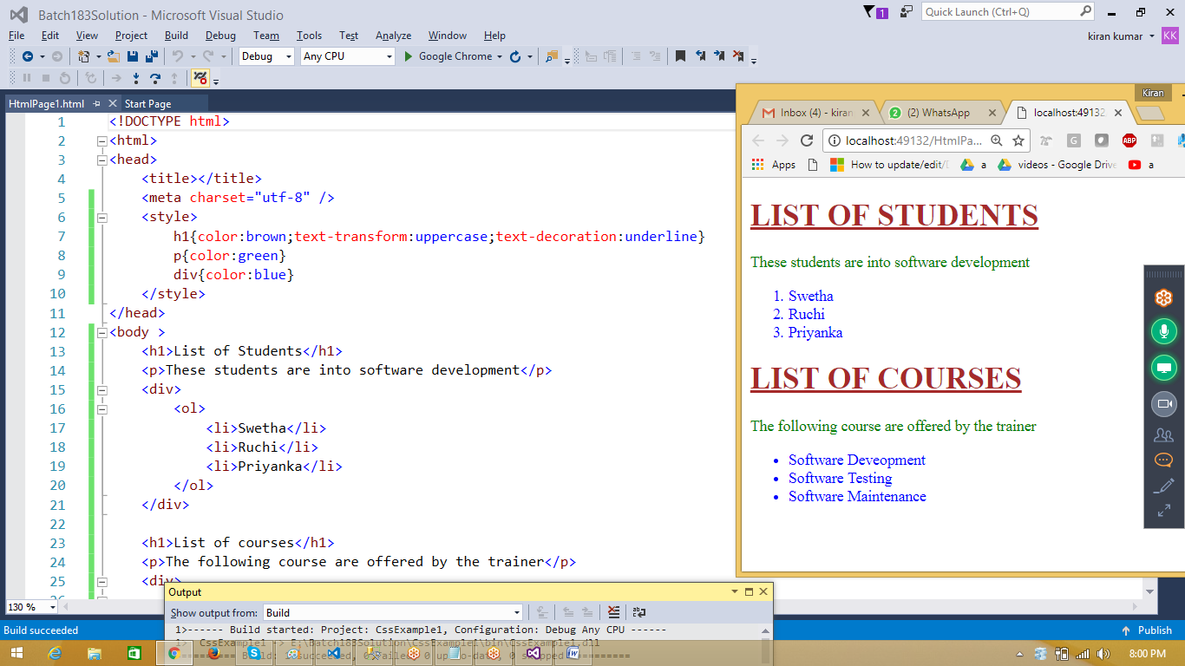

|  |  |  |
| --- | --- | --- |
|  | **CSS Background properties** | |
|  | **Property** | **Functionality** |
|  | background-color | Used to effect background color of specified tag  { background-color:red }  { background-color:blue } |
|  | background-image | To set image for background  background-image: url("paper.gif"); |
|  | background-repeat |  |
|  | background-attachment |  |
|  | background-position |  |

|  |  |  |
| --- | --- | --- |
|  | **CSS Font properties** | |
|  | **Property** | **Functionality** |
|  | Font-family | font-family: "Times New Roman"; |
|  | Font-size | font-size: 250%; |
|  | Font-style | font-style: italic;  font-style: oblique; |
|  | Font-weight | font-weight: normal;  font-weight: bold; |
|  | Font-variant | font-variant: small-caps;  font-variant: normal; |

|  |  |  |
| --- | --- | --- |
|  | **CSS border properties** | |
|  | **Property** | **Functionality** |
|  | Border-color | To change border color |
|  | Border-style | To change border style |

|  |  |  |
| --- | --- | --- |
|  | **CSS Text properties** | |
|  | **Property** | **Functionality** |
|  | color | Refers to text(foregroud) color |
|  | direction |  |
|  | text-decoration | Underline |
|  | text-indent |  |
|  | text-align | center  left |
|  | letter-spacing |  |
|  | word-spacing |  |
|  | text-transform | Uppercase  Lowercase  Titlecase |
|  | white-space |  |

|  |  |  |
| --- | --- | --- |
|  | **Property** | **Functionality** |
|  | background-color | Used to effect background color of specified tag  { background-color:red }  { background-color:blue } |
|  | Color | Used to change foreground color  { color:red } { color:green } |
|  | font-family | Used to change the font  {font-family: "Times New Roman";} |
|  | font-size | { font-size: 20px;} {font-size:smaller;} |
|  | border | { border: 5px solid red;} |

|  |  |  |
| --- | --- | --- |
|  | **Text styles** | |
|  | Text-align | Used to set the alignment of text  {text-align:right} {text-align:left}  {text-align:center} {text-align:justify} |
|  |  |  |
|  | Text-decoration | Used to provide underline or overline or strike  {text-decoration:none;} {text-decoration:overline;}  {text-decoration:line-through;} {text-decoration:underline;} |
|  | Text-transform | Used to change the case {text-transform: uppercase;}  {text-transform: lowercase;} {text-transform: capitalize;} |

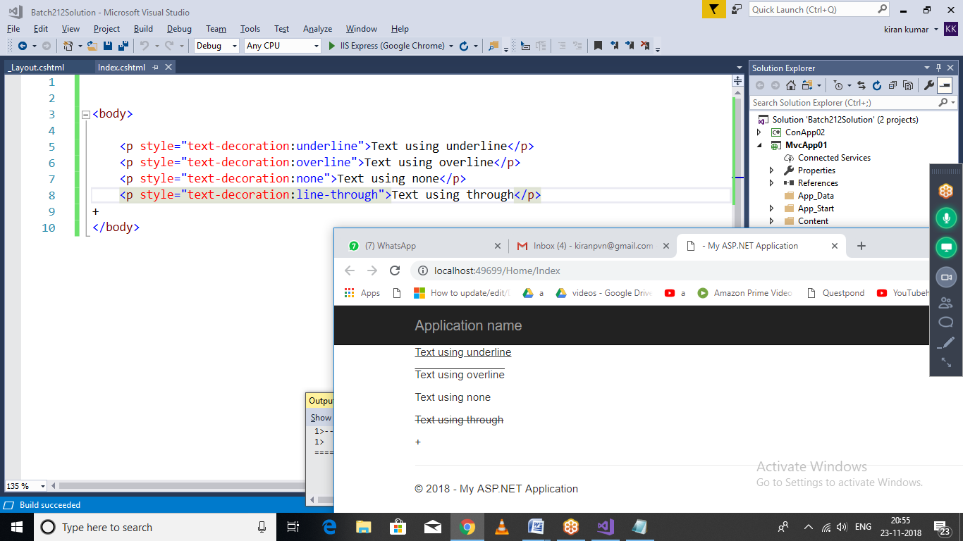

|  |  |  |
| --- | --- | --- |
|  |  |  |
|  | Css visibility | Visibility:visible|hidden  Will occupy space even in hidden state |
|  | Css display | Display: none|inline|block  Will not occupy space at hidden state  <div> Division1 </div>  <div style= "visibility:hidden"> Division2 </div>  <div> Division3 </div>  <div style="display:none"> Division4 </div>  <div> Division5 </div> |

|  |  |  |
| --- | --- | --- |
|  | **Block vs inline** | |
|  | Block elements | Block elements contains before and after line separation  **Example**: <h1>, <li>, <div>, <p>  **Note:** not required to <br> |
|  | Inline elements | These are the elements are provided in same line, by adding <br> we can move to next line  Example: <span> <a> <input> <img/> |
|  |  | Display attribute is used to make block elements to inline and inline elements to block  Example:  li{  display:inline  }  span{  display:block  } |

|  |  |
| --- | --- |
|  | **How to make span like div** |
|  | <span style="display:block">  Span text like div block  </span>  Span default display is inline (in the same line) |

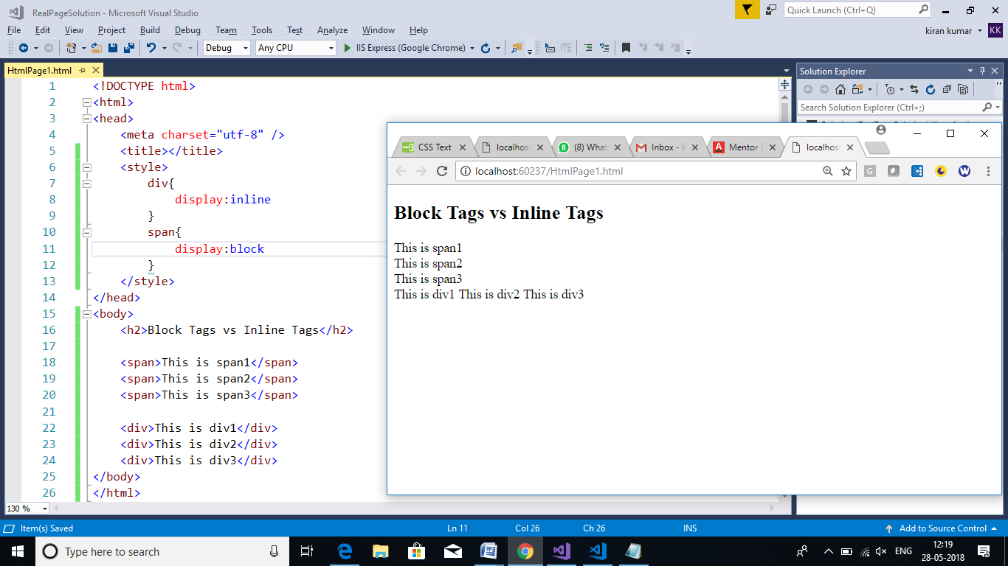

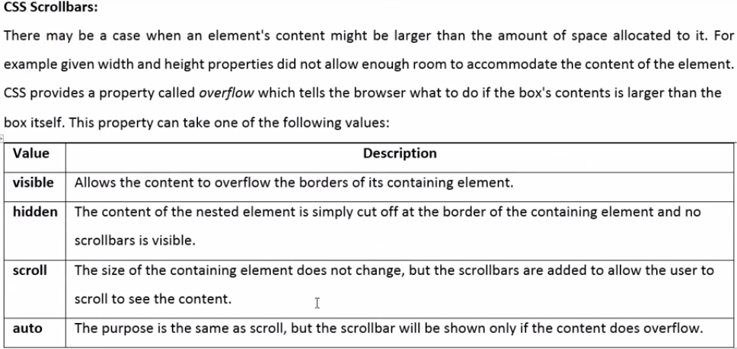

|  |  |
| --- | --- |
|  | **CSS class** |
|  | CSS Classes are used to provide group of styles to a tag using class property  With class feature multiple styles can be provided to one tag.  To provide CSS class, we have to prefix class name with .  Example:  <style>  .classname  {  Property:value;  }  </style>  To consume class  <tag class="classname"> </tag> |



|  |  |  |  |  |
| --- | --- | --- | --- | --- |
|  | **W3C stand colors are 16 colors** | |  |  |
|  | Black | Gray | Silver | White |
|  | Yellow | Lime | Auqa | Fuchsia |
|  | Red | Green | Blue | Purple |
|  | Maroon | Olive | Navy | teal |

|  |  |  |
| --- | --- | --- |
|  | **Hexa Decimal Color Code System** | |
|  | Hexa | (A-F) / (a-f) |
|  | Decimal | 0 to 9 |
|  | Primary colours | RED => 0 to 255  GREEN => 0 to 255  BLUE => 0 to 255  RGB = 256 * 256 * 256 = 16 million colour shades |
|  | Every color represent using  2 letters | **Example:** RED => RR  GREEN = GG  BLUE = BB |
|  | **Color code start with # symbol** |  |
|  | RED colour | #FF0000 |
|  | Green colour | #00FF00 |
|  | BLUE colour | #0000FF |
|  | Black colour | #000000  00 represent least colour i.e. black |
|  | White colour | #FFFFFF  FF represent highest colour i.e. white |

|  |  |
| --- | --- |
|  | **Color, example-1** |
|  | <h2>Color Names Examples</h2>  <h2 style="background-color:red"> Red background-color </h2>  <h2 style="background-color:green"> Green background-color </h2>  <h2 style="background-color:blue;color:white"> Blue background-color and white text color </h2>  <h2 style="background-color:orange"> Orange background-color </h2>  <h2 style="background-color:yellow"> Yellow background-color </h2>  <h2 style="background-color:cyan"> Cyan background-color </h2>  <h2 style="background-color:black;color:white"> Black background-color and white text color </h2> |

|  |  |
| --- | --- |
|  | **Css class example1:** |
|  | <style>  p.uppercase {  text-transform: uppercase;  }  p.lowercase {  text-transform: lowercase;  }  p.capitalize {  text-transform: capitalize;  }  </style>  </head>  <body>  <p class="uppercase">This is some text.</p>  <p class="lowercase">This is some text.</p>  <p class="capitalize">This is some text.</p>  </body>  </html> |
|  | http://www.w3schools.com/css/tryit.asp?filename=trycss_text-transform |

|  |  |
| --- | --- |
|  | **css class** |
|  | A class in css is used to provide group of styles with a name  The set of styles can be applied to any tag by providing class attribute  Class name should be prefixed with fullstopwhile creation under style attribute  Example:  <style>  .red  {  Color:red;  }  </style>  <h1 class="red"> Heading 1</h1> |

<input type="button" style="color:white;background-color:black" value="Click" />

|  |  |
| --- | --- |
|  | **Css class** |
|  | Css classes are used to provide multiple style as group.  These styles can be applied to any tag with class attribute  While creation of css tyles in class we have prefix with fullstop  Example:  <style>  .red  {  color:red;  }  </style>  <h1 class="red">Heading1 </h1>  **Example2:**  <style>  .heading  {  text-align:center;  text-transform:uppercase;  color:brown;  background-color:cyan  }  </style>  <body >  <h1 class="heading">About CSS</h1>  <h1>About HTML</h1>  <h1 class="heading">About Javascript</h1>  </body> |

|  |  |
| --- | --- |
|  | Css class Example1: |
|  | <style>  .red  {  color:red  }  .center  {  text-align:center  }  </style>  <h1 class="red center">Red Heading</h1>  **Note: More than one class setting can be provided in the class attribute** |

|  |  |
| --- | --- |
|  | **External CSS** |
|  | Used to provide css styles in separate .css file and this file can be imported in the pages need those styles  Most of the web application will maintain same style and they can change at any time by modify code in .css file  It is strongly recommended to provide all .css files under Styles folder  To import css file we need to drag and drop in the page need those style  **Example to import:**  <link href="MyStyles.css" rel="stylesheet" /> |

|  |  |  |
| --- | --- | --- |
|  | **Css measurements** | |
|  | px | Pixels |
|  | in | Inches |
|  | cm | Centimeters |
|  | pt | Points |
|  |  |  |

|  |  |
| --- | --- |
|  | **Understand Div tag** |
|  | This tag is used to create division.  The div tag can have all elements like Paragraphs, Heading, UI, etc.,  In real time div tag is used to present huge amount of content which can be controlled   |  |  | | --- | --- | |  | **Applying styles to div tag** | |  | Width | |  | Text-align | |  | Border | |  | Padding | |  | Color | |  | Background-color | |  | Overflow | |  | Etc., |   **Note:** Div tag can have UI controls, regular tags like <p>, <span>, etc., |

|  |  |
| --- | --- |
|  | **Div example** |
|  | <div style="width:400px;text-align:justify;border:solid;padding:5px">  Cascading Style Sheets (CSS) is a style sheet language used for describing the presentation of a document written in a markup language.[1] Although most often used to set the visual style of web pages and user interfaces written in HTML and XHTML, the language can be applied to any XML document, including plain XML, SVG and XUL, and is applicable to rendering in speech, or on other media. Along with HTML and JavaScript, CSS is a cornerstone technology used by most websites to create visually engaging webpages, user interfaces for web applications, and user interfaces for many mobile applications.[2]  CSS is designed primarily to enable the separation of document content from document presentation, including aspects such as the layout, colors, and fonts.[3] This separation can improve content accessibility, provide more flexibility and control in the specification of presentation characteristics, enable multiple HTML pages to share formatting by specifying the relevant CSS in a separate .css file, and reduce complexity and repetition in the structural content.  This separation of formatting and content makes it possible to present the same markup page in different styles for different rendering methods, such as on-screen, in print, by voice (when read out by a speech-based browser or screen reader) and on Braille-based, tactile devices. It can also be used to display the web page differently depending on the screen size or device on which it is being viewed. Readers can also specify a different style sheet, such as a CSS file stored on their own computer, to overri  de the one the author has specified.  </div> |

|  |  |
| --- | --- |
|  | **Div with scroll** |
|  | <div style="width:400px;height:300;text-align:justify;border:solid;padding:5px;overflow:scroll">  Cascading Style Sheets (CSS) is a style sheet language used for describing the presentation of a document  written in a markup language.[1] Although most often used to set the visual style of web pages and user interfaces  written in HTML and XHTML, the language can be applied to any XML document, including plain XML, SVG  and XUL, and is applicable to rendering in speech, or on other media. Along with HTML and JavaScript, CSS is  a cornerstone technology used by most websites to create visually engaging webpages, user interfaces for web  applications, and user interfaces for many mobile applications.[2]  CSS is designed primarily to enable the separation of document content from document presentation, including  aspects such as the layout, colors, and fonts.[3] This separation can improve content accessibility, provide more  flexibility and control in the specification of presentation characteristics, enable multiple HTML pages to share  formatting by specifying the relevant CSS in a separate .css file, and reduce complexity and repetition in the  structural content.  This separation of formatting and content makes it possible to present the same markup page in different styles  for different rendering methods, such as on-screen, in print, by voice (when read out by a speech-based browser  or screen reader) and on Braille-based, tactile devices. It can also be used to display the web page differently  depending on the screen size or device on which it is being viewed. Readers can also specify a different style sheet,  such as a CSS file stored on their own computer, to override the one the author has specified.  </div> |

|  |  |  |
| --- | --- | --- |
|  |  | **Draw square using <div>** |
|  | Inline | <div style="height:200px;width:200px;background-color:green"></div> |
|  | Internal | <style>  .square{  height:200px;  width:200px;  background-color:green;  }  </style>  <div class="square"></div> |

|  |  |  |
| --- | --- | --- |
|  |  |  |
|  | Output |  |
|  | Inline | <div style="width:200px;height:200px;  background-color:red;  border-top:60px solid blue;  border-right:60px solid green;  border-left:60px solid yellow;  border-bottom:60px solid grey">  </div> |

|  |  |  |
| --- | --- | --- |
|  | **Four triangles in a square** | |
|  | Output |  |
|  | Inline | <div style="width:0px;height: 0px;  border-top:60px solid blue;  border-right:60px solid green;  border-left:60px solid yellow;  border-bottom:60px solid grey">  </div> |

|  |  |  |
| --- | --- | --- |
|  | **Display triangle using div element** | |
|  | Output |  |
|  | Internal | <style>  .triangle{  height:0px;  width:0px;    border-bottom:60px solid red;  border-right:60px solid transparent;  border-left:60px solid transparent;  }  </style>  </head>  <body>  <div class="triangle"></div> |

|  |  |  |
| --- | --- | --- |
|  | **Display triangle using div element** | |
|  | Output |  |
|  | Inline | <div style="height:0px;  width:0px;  border-top:60px solid blue;  border-right:60px solid transparent;  border-left:60px solid transparent;"></div> |

|  |  |  |
| --- | --- | --- |
|  | **Display circle using div element** | |
|  | Output |  |
|  | Internal | <style>  .circle{  background-color:red;  height:50px;  width:50px;  border-radius:50px;  }  </style>  <div class="circle"></div> |

|  |  |  |
| --- | --- | --- |
|  | **Border Template** | |
|  | Output |  |
|  | Code | <table border="1">  <tr style="height:100px">  <td colspan="2" style="width:800px">  <h1 style="text-align:center">Kiran Technologies</h1>  </td>  </tr>  <tr style="height:400px">  <td style="width:200px"></td>  <td></td>  </tr>  <tr style="height:20px">  <td colspan="2" style="width:800px">  <h3>Copy Rights &copy; 2016 Reserved</h3>  </td>  </tr>  </table> |

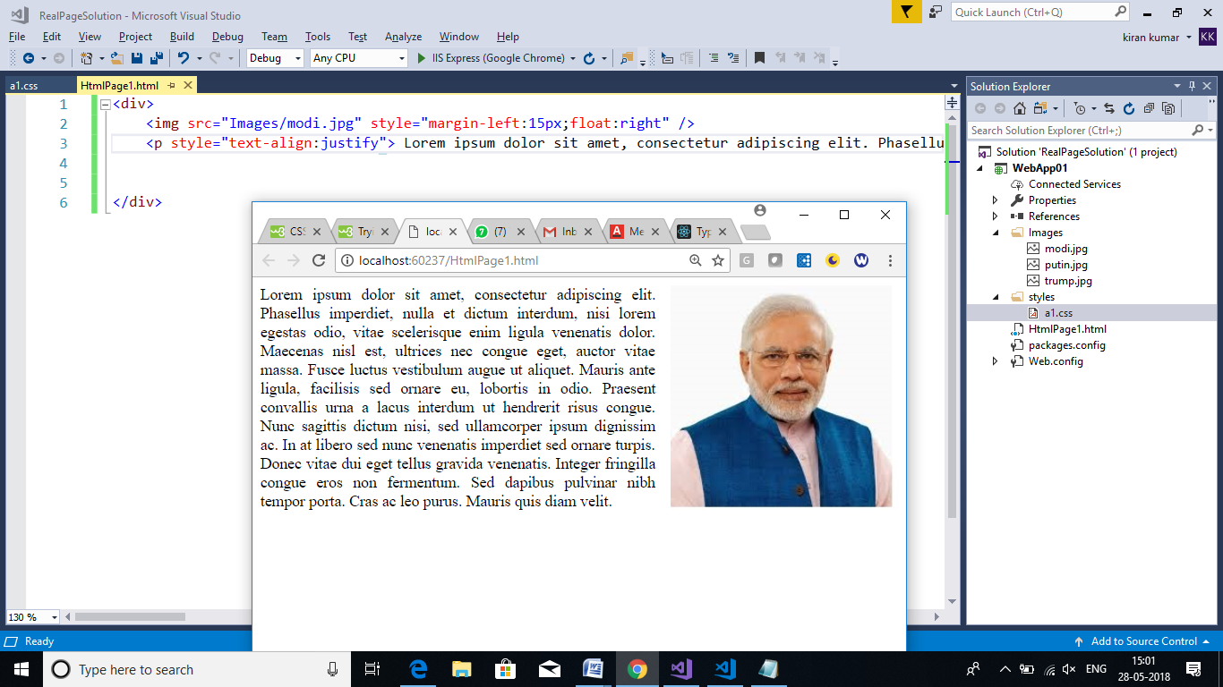

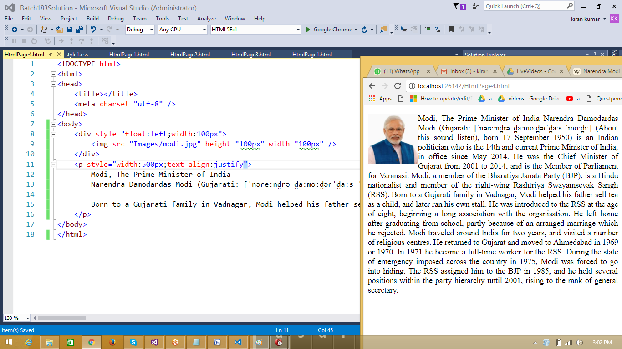

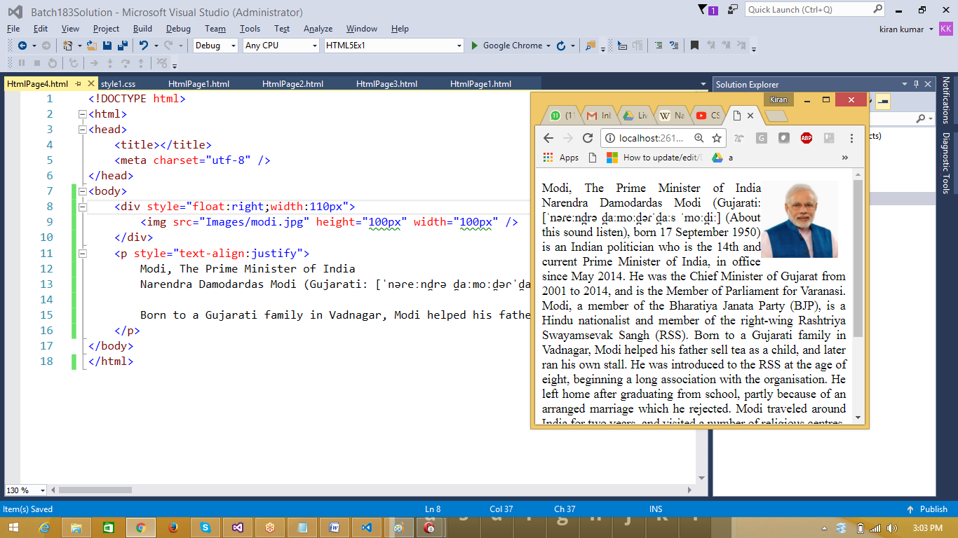

|  |  |
| --- | --- |
|  | **Css3 advanced style sheets** |
|  | Font-face |
|  | Opacity |
|  | RGBA (Red Green Blue Alpha or Amber) |
|  | Border-radius |
|  | Box-shadow |
|  | Text-shadow |
|  | Gradient |
|  | Multiple background images |
|  | Transform |
|  | Transition |
|  | Multi column layout |
|  | Styling forms with attribute selector |
|  | Wrapping up |
|  | Box-sizing and box-model |
|  | CSS3 selector |

|  |  |
| --- | --- |
|  | **CSS3 colors** |
|  | <h2>RGB Color Examples</h2>  <h2 style="background-color:rgb(255, 0, 0)"> Background-color set by using rgb(255, 0, 0) </h2>  <h2 style="background-color:rgb(0, 255, 0)"> Background-color set by using rgb(0, 255, 0) </h2>  <h2 style="background-color:rgb(0, 0, 255)">Background-color set by using rgb(0, 0, 255) </h2>  <h2 style="background-color:rgb(255, 165, 0)"> Background-color set by using rgb(255, 165, 0) </h2>  <h2 style="background-color:rgb(255, 255, 0)"> Background-color set by using rgb(255, 255, 0) </h2>  <h2 style="background-color:rgb(0, 255, 255)"> Background-color set by using rgb(0, 255, 255) </h2> |

|  |  |
| --- | --- |
|  | **Text shadow** |
|  |  |

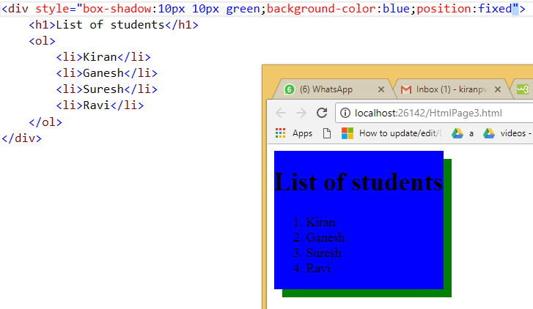

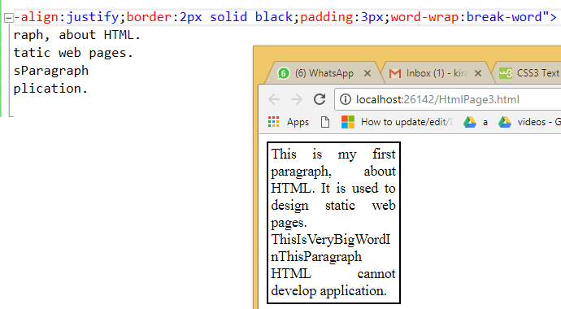

|  |  |
| --- | --- |
|  | **CSS transforms** |
|  | This is a powerful property introduced in CSS3 to move, scale, turn, spin and stretch element. it supports the list of properties.  Transform, Transform-origin and Transform-style  Transform support following 5 methods  Translate(), rotate(), scale(), skew() and matrix() |

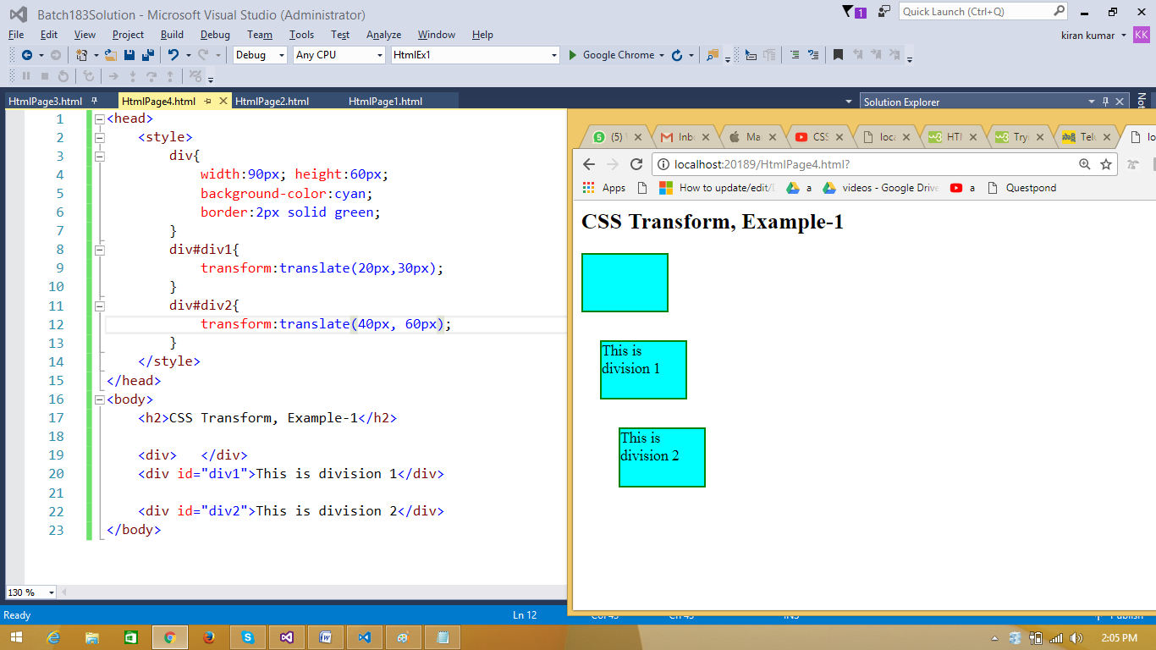

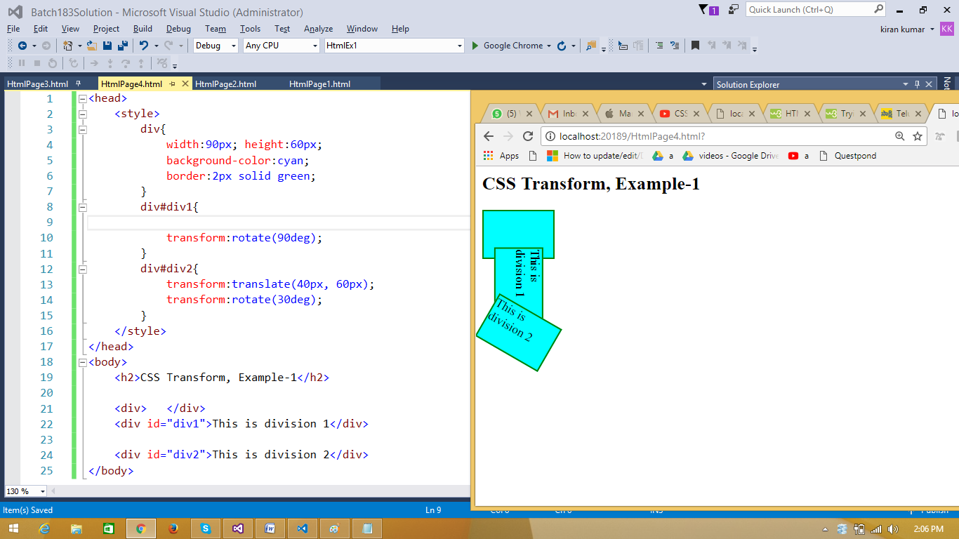

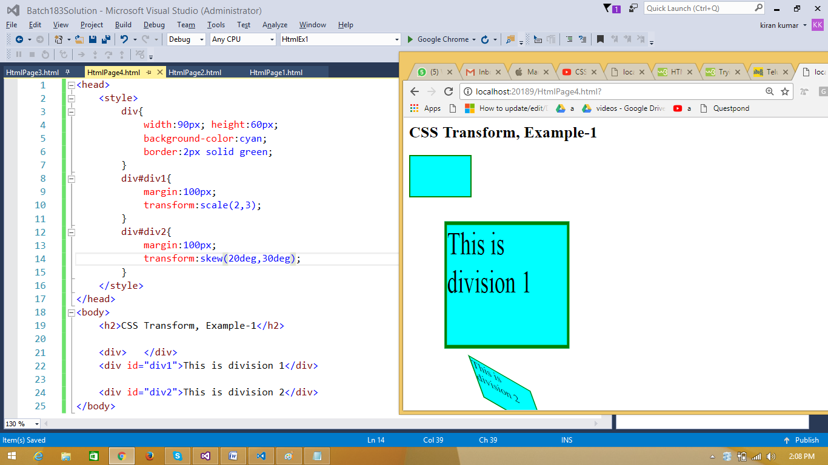

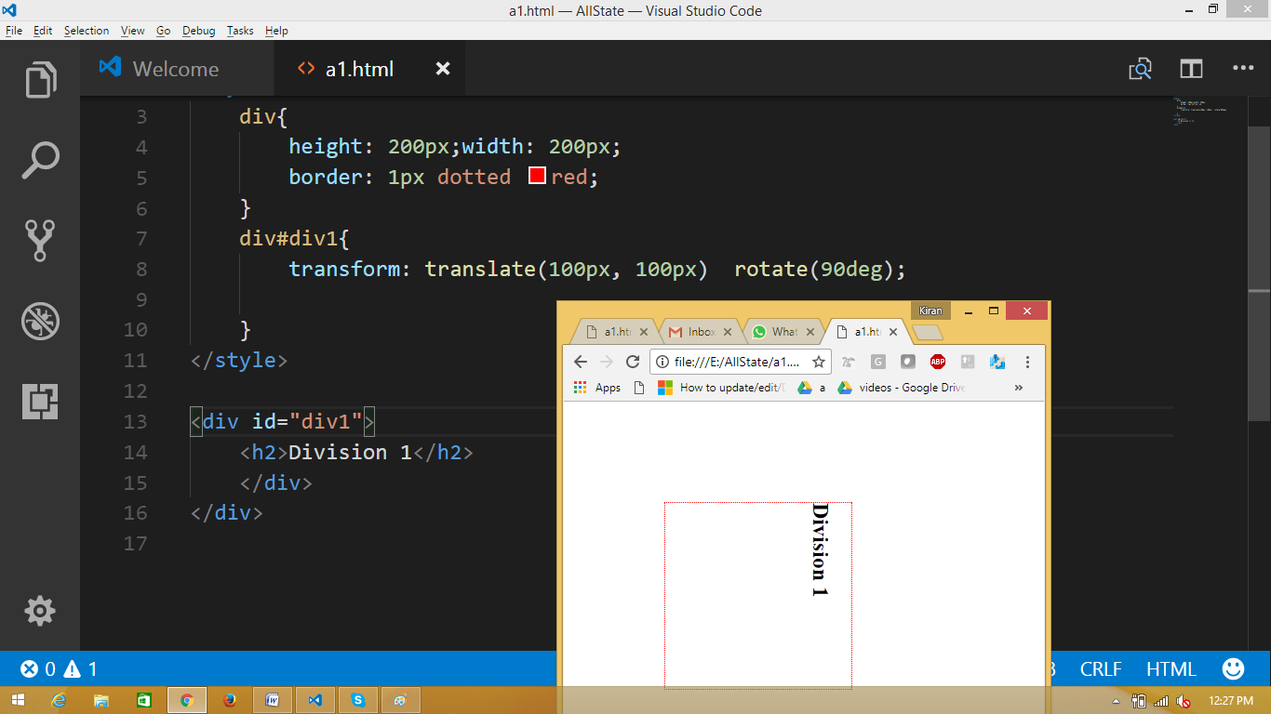

|  |  |
| --- | --- |
|  | Hover |
|  | <html>  <style>  #b1{  background-color:blue;  }  #b1:hover{  background-color: green;  }  </style>  <body>  <button id="b1">Click Me</button>  </body>  </html> |

|  |  |
| --- | --- |
|  | **CSS Box Model** |
|  | This feature is available from CSS3 Version onwards (Advanced browsers support this feature)  Explanation of the different parts:  Content - The content of the box, where text and images appear  Padding - Clears an area around the content. The padding is transparent  Border - A border that goes around the padding and content  Margin - Clears an area outside the border. The margin is transparent |

|  |  |
| --- | --- |
|  | **CSS Outline styles** |
|  | <!DOCTYPE html>  <html>  <head>  <style>  p {  border: 1px solid black;  outline-color:red;  }  p.dotted {outline-style: dotted;}  p.dashed {outline-style: dashed;}  p.solid {outline-style: solid;}  p.double {outline-style: double;}  p.groove {outline-style: groove;}  p.ridge {outline-style: ridge;}  p.inset {outline-style: inset;}  p.outset {outline-style: outset;}  </style>  </head>  <body>  <h2>The outline-style Property</h2>  <p class="dotted">A dotted outline</p>  <p class="dashed">A dashed outline</p>  <p class="solid">A solid outline</p>  <p class="double">A double outline</p>  <p class="groove">A groove outline</p>  <p class="ridge">A ridge outline</p>  <p class="inset">An inset outline</p>  <p class="outset">An outset outline</p>  <b>Note:</b> IE8 supports the outline properties only if a !DOCTYPE is specified.  </body>  </html> |

|  |  |
| --- | --- |
|  | **Media queries, example-1** |
|  | <style>  body {  background-color: cyan;  }  @media only screen and (max-width: 800px) {  body {  background-color: red;  }  }  @media only screen and (max-width: 600px) {  body {  background-color: green;  }  }  @media only screen and (max-width: 400px) {  body {  background-color: blue;  }  }  </style>  <body>  <p>Resize the browser window. When the width of this document is less than 500 pixels, the background-color is "lightblue", otherwise it is "lightgreen".</p>  </body>  </html> |

|  |  |
| --- | --- |
|  | **Different images for different sizes** |
|  | /* For width smaller than 400px: */ body {     background-image: url('modi.jpg');  }  /* For width 400px and larger: */ @media only screen and (min-width: 400px) {     body {          background-image: url('putin.jpg');      } } |

|  |  |
| --- | --- |
|  | **Responsive image size** |
|  | img {     width: 100%;     height: auto; } |
|  | <img src="flowers.jpg" width="460" height="345"> |

CSS 3 New selectors

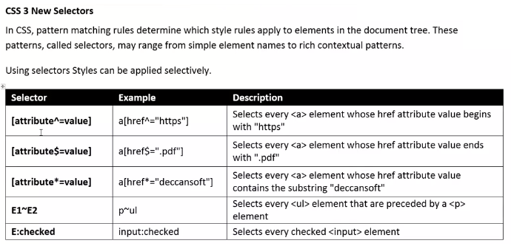

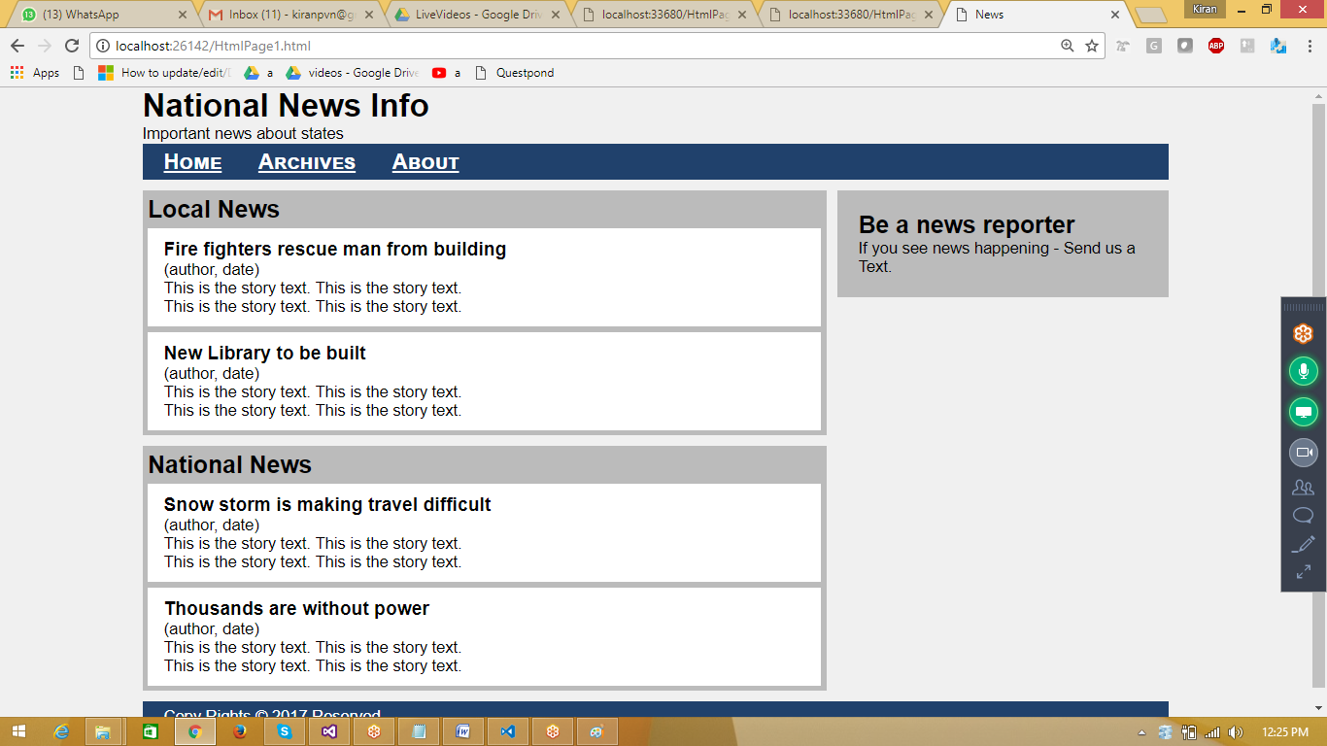

|  |  |
| --- | --- |
|  | **Semantic tags, example** |
|  | <!DOCTYPE html>  <html lang="en">  <head>  <meta charset="UTF-8">  <title>News</title>  </head>  <body>  <header>  <h1>National News Info</h1>  <p>Important news about states </p>  </header>  <nav>  <ul>  <li><a href="index.html">Home</a></li>  <li><a href="archive.html">Archives</a></li>  <li><a href="about.html">About</a></li>  </ul>  </nav>  <main>  <section>  <h2>Local News</h2>  <article>  <header>  <h3>Fire fighters rescue man from building</h3>  <p>(author, date)</p>  </header>  <p>This is the story text. This is the story text.</p>  <p>This is the story text. This is the story text.</p>  </article>  <article>  <header>  <h3>New Library to be built</h3>  <p>(author, date)</p>  </header>  <p>This is the story text. This is the story text.</p>  <p>This is the story text. This is the story text.</p>  </article>  </section>  <section>  <h2>National News</h2>  <article>  <header>  <h3>Snow storm is making travel difficult</h3>  <p>(author, date)</p>  </header>  <p>This is the story text. This is the story text.</p>  <p>This is the story text. This is the story text.</p>  </article>  <article>  <header>  <h3>Thousands are without power</h3>  <p>(author, date)</p>  </header>  <p>This is the story text. This is the story text.</p>  <p>This is the story text. This is the story text.</p>  </article>  </section>  </main>  <aside>  <h2>Be a news reporter</h2>  <p>If you see news happening - Send us a Text.</p>  </aside>  <footer>  <p>Copy Rights &copy; 2017 Reserved</p>  </footer>  </body>  </html> |
|  | @charset "UTF-8";  article, aside, footer, header, main, nav, section {  display: block;  }  html, body, h1, h2, h3, ul, li, a, p,  article, aside, footer, header, main, nav, section {  padding: 0;  margin: 0;  }  .banner {  background-color: #11233b;  color: white;  padding: 10px 20px;  }  body {  width: 960px;  margin-left: auto;  margin-right: auto;  background-color: #f0f0f0;  font-family: Helvetica, Arial, sans-serif;  font-size: 15px;  }  nav {  background-color: #20416c;  padding: 5px;  margin-top: 1px;  }  li a {  color: white;  }  li {  display: inline;  margin-left: 15px;  margin-right: 15px;  font-size: 20px;  font-variant: small-caps;  font-weight: bold;  }  section {  background-color: #bbbbbb;  margin-top: 10px;  padding: 5px;  }  article {  background-color: white;  margin-top: 5px;  padding: 10px 15px;  }  main {  width: 640px;  float: left;  margin-bottom: 10px;  }  aside {  background-color: #bbbbbb;  width: 270px;  float: right;  padding: 20px;  margin-top: 10px;  }  footer {  clear: both;  background-color: #20416c;  color: white;  padding: 5px 20px;  } |
|  |  |

In CSS & CSS3 please mention concepts like Box model, Flex Boxes, Selectors, Transformations, Positions, media queries etc.,

Advanced Selectors ( conditional selectors )

^= refers to all class names begin with the string

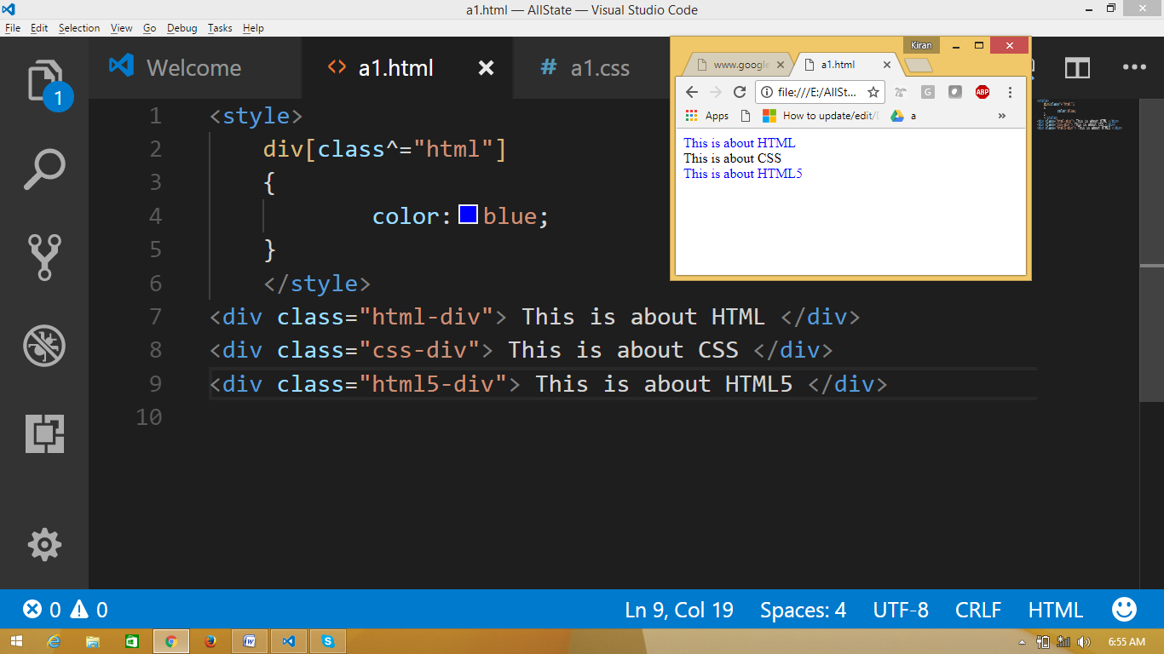

$= refers to all class names end with the string

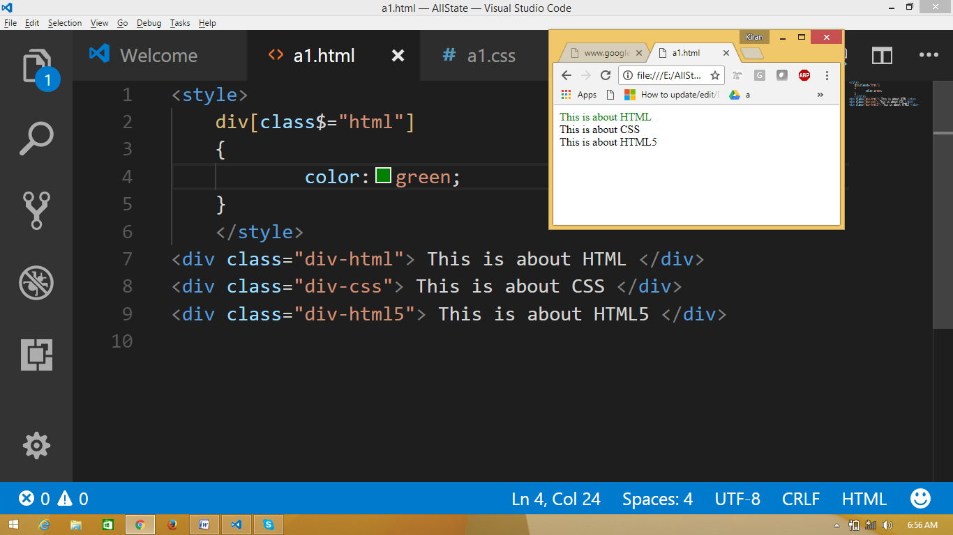

*=refers to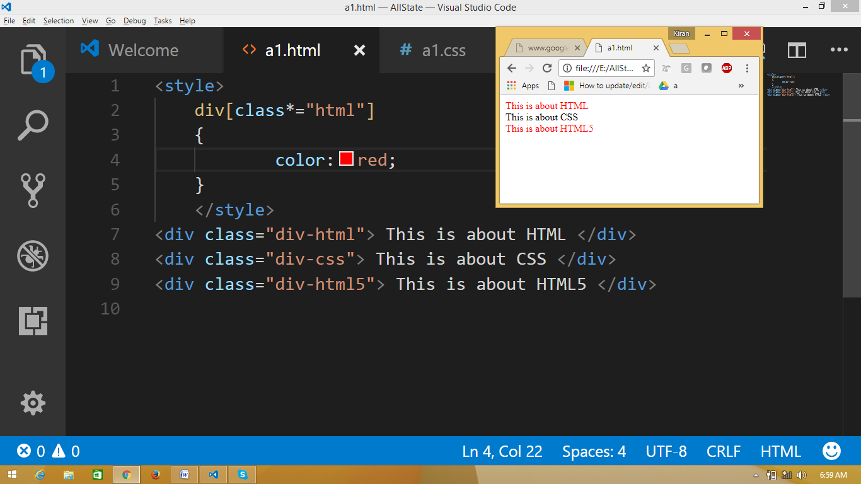

First-of-type

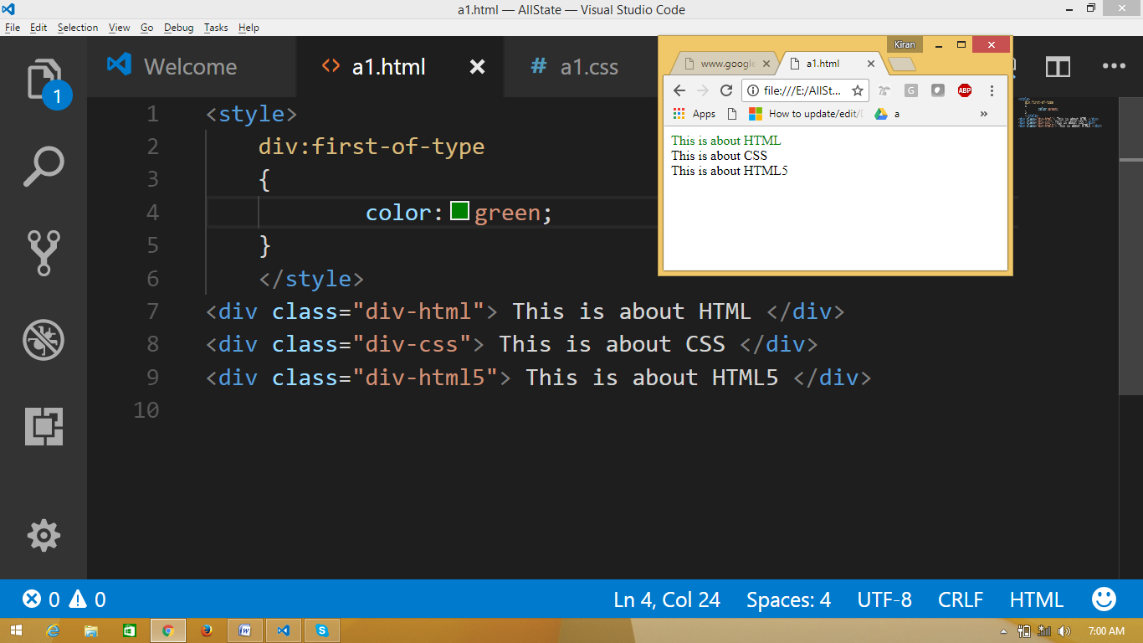

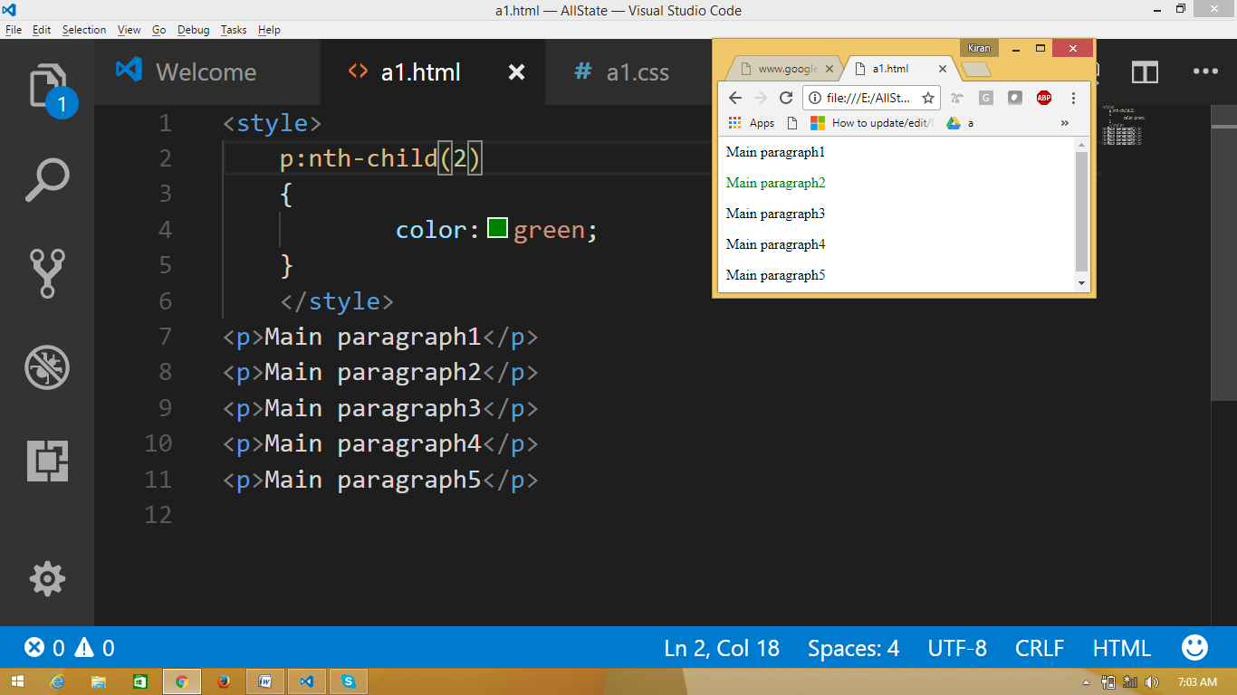

CSS3 User interface

resize

