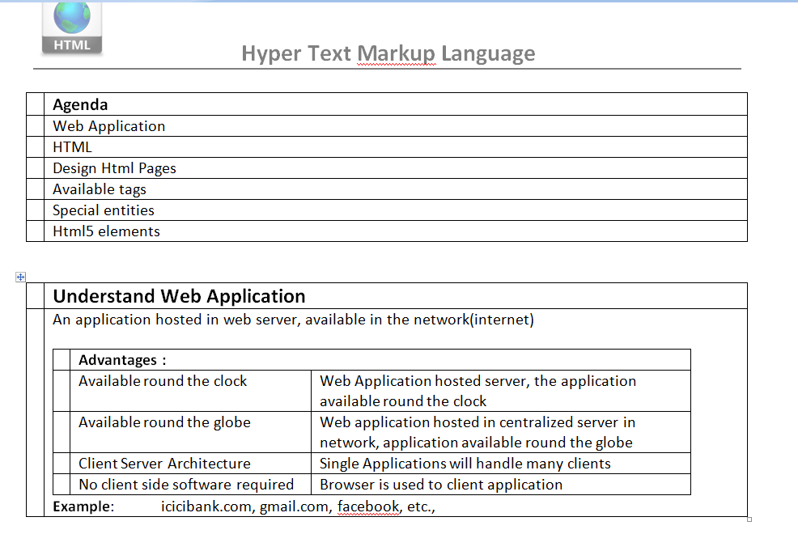

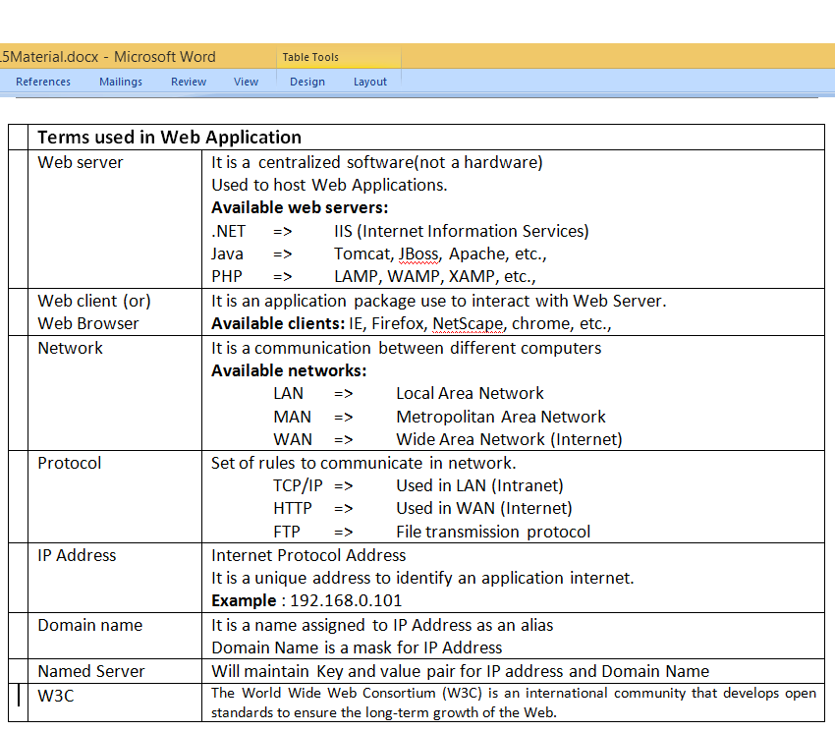

|  |  |
| --- | --- |
|  | **To Develop Web Application at Server** |
|  | Every technology provided a Web Specification ( Server Side scripting ) to develop web applications.  **Example:** Java => JSP  .NET => ASP.NET  PHP => PHP  NodeJs, etc., |

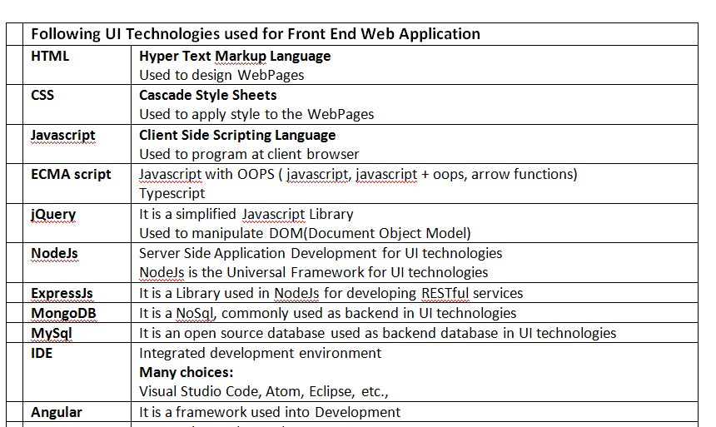

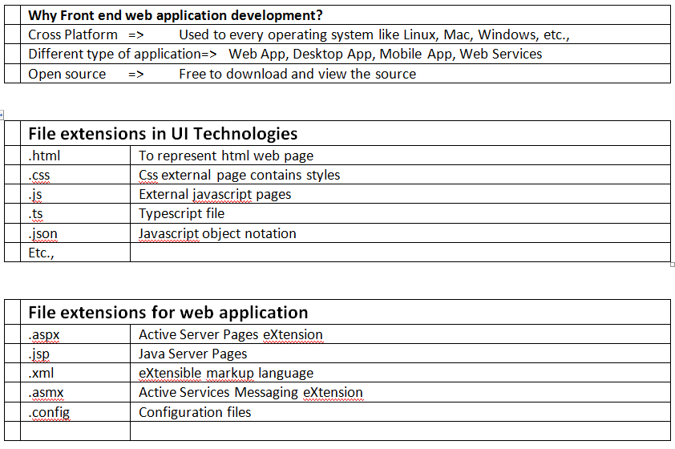

|  |  |
| --- | --- |
|  | **Understand HTML** |
|  | **HTML (Hyper Text Markup Language)**, used to design WebPages like HomePage, AboutUsPage, etc.,.  For every Web Application, the UI(User Interface) will be done using HTML  http://news.mit.edu/sites/mit.edu.newsoffice/files/images/2013/20130318105145-1_0.jpgTim Berners-Lee created html in 1990 (Father of Web Environment)  **Why do we need HTML?**  HTML is the standard understandable code for every Web Browser for UI Designing.  Every Web Application (developed using ASP.NET, JSP, PHP, NodeJs etc.,) render the output into client browser Html Tags.  **Points to Note:**  HTML is not a programming language  No variables, no declaration  No programming constructs (only Tags & special entities are available)  No Error, No termination. Any unidentified tags found will be ignored  We cannot develop software application. We can design static web pages |

|  |  |
| --- | --- |
|  | **IDEs for Html and UI Technologies** |
|  | In order to work with simple Html other UI technologies, no software required.  We can use any text editor like Notepad also for HTML  In order to avail intelligense, autoformatting, and with inbuilt terminals there are many IDEs available in the market, like Eclipse, Visual Studio Code, Visual Studio, Sublime, Atom) etc.,  **To run html:**  Open any browser like chrome and select the html file  UI Technologies uses Visual Studio code for HTML, CSS, Javascript, Angular, etc.,  Link: https://www.visualstudio.com/downloads/ |

|  |  |  |
| --- | --- | --- |
|  | **HTML Sections** | |
|  | Version information | DTD |
|  | **Head Section** | Contains tags like  <head> </head> represents body heading  <meta/> refers to information about page, simplify in SEO  <script></script> refers to import any JavaScript library  <title> </title> refers to title to be printed in browser title bar  <style> </style> refers to CSS style to be application in entire document |
|  | **Body Section** | <body></body> Used to design body part with or without UI of the document |

|  |  |
| --- | --- |
|  | **HTML Comments** |
|  | **Comments are used to ignore statements/tags (non executable statements)**  **Single line comment**  <!—Single line Comment -->  **Multi line comment**  <!--  Multiple line  Comments --> |

|  |  |
| --- | --- |
|  | **Source page ( Ctrl+U)** |
|  | Display the page source of current web page , this page contains html text code  <html lang="en-IN" >  UTF => Unicode Transformation Format  Refers to multilingual (Not only english support all the languages like greece, japaneese, hebrew, etc.,)  8 - octa decimal  To define character encoding of the web page, tells the browser and validators what set of character we are using  <meta charset="UTF-8">  <meta name="author" name="Kiran" /> |

|  |  |
| --- | --- |
|  | **To design Web Page** |
|  | By writing **Html Tags** orusing **Special Entities** we can design the WebPage.  Paired tag contains opening and closure, will represent block, Special entities to provide symbol   |  |  |  |  | | --- | --- | --- | --- | |  | **Paired Tag** | **Unpaired Tag** | **Special Entities** | |  | <html> </html>  <head> </head>  <title> </title>  <script> </script>  <style> </style>  <body> </body>  <table> </table> | <br />  <hr />  <img />  <input /> | &copy;  &dollar;  &gt;  &lt;  &trade;  &pound;  &euro; |   Unpaired tag will not contain closure, will not have any section |

|  |  |  |  |  |  |  |  |  |  |  |  |  |  |  |  |  |  |  |
| --- | --- | --- | --- | --- | --- | --- | --- | --- | --- | --- | --- | --- | --- | --- | --- | --- | --- | --- |
|  | **Different types of tags** | | | | | | | | | | | | | | | | | |
|  | **Heading tags** | <h1></h1> | <h2></h2> | | | | | <h3></h3> | | | <h4></h4> | | | <h5></h5> | | | | <h6></h6> |
|  | **Formatting tags** | <b></b> (or) <strong></strong> | | | | | | <i> </i> | | | | | | <u> </u> | | | | |
|  | **Paragraph tags** | <p> </p> | | | | <div> </div> | | | | <span> </span> | | | | | <pre> </pre> | | | |
|  | **Table tags** | <table> </table> | | <thead> </thead> | | | <tbody>  </tbody> | | | <tr></tr> | | | <th> </th> | | | | <td> </td> | |
|  | **UI tags** | <Input /> | | | <textarea>  </textarea> | | | | <select> </select> | | | <output> </output> | | | |  | | |

|  |  |  |
| --- | --- | --- |
|  | **Formatting tags** | |
| 1 | <b> </b>  <strong> </strong> | Bold the text |
| 2 | <i> </i> | Italic (*slanting text*) |
| 3 | <u> </u> | Underline |
| 4 | <del> </del>  <strike></strike> | Strikeout text |
| 5 | <center> </center> | To align the content into center |
| 6 | <sup> </sup> | Superscript tag  To place to the power of |
| 7 | <sub> </sub> | Subscript tag  To make text in subscript |
| 8 | <font></font> | Used to set the font like color, size, type, etc., |
|  | Etc., |  |

|  |  |
| --- | --- |
|  | **Example1:** |
|  | <h1>Formatting Text</h1>  <b> The text in bold </b> <br>  <strong> The text in strong </strong> <br>  <i> This text in italic</i> <br>  <u> The text in under line</u> <br>  <del> The text is deleted </del> <br>  <strike> The text is striked</strike> <br>  <center> The content in center alignment </center><br>  a<sup> 2</sup><br>  H<sub>2</sub><br> |

|  |  |
| --- | --- |
|  | **Common Properties used in HTML tags** |
|  | Properties are used to pass arguments to the html tags   |  |  |  | | --- | --- | --- | |  | **Attribute** | **Purpose** | |  | Name | Provide identity | |  | Id | Provide unique identity | |  | Title | Used to provide tool tip | |  | Width | Size attribute | |  | Height | Size attribute | |  | Disabled | To make the input element disable | |  | Style | Used to apply inline css style | |  | Alt | Specify the alternative text in case image not found |   Using property a functionality can be added in current tag |

|  |  |
| --- | --- |
|  | **<hr> horizontal ruler** |
|  | This is an un-paired tag, this tag is used to print a horizontal line in the web page  <hr>  <hr color="RED" />  <hr color="GREEN" />  <hr color="BLUE" />  <hr color="RED" width="50%" />  <hr color="GREEN" width="40%" /> |

|  |  |
| --- | --- |
|  | **Display images** |
|  | **<img >** This is an unpaired tag is used to display the image in the web page like .jpg, .gif, .png, etc.,   |  |  |  | | --- | --- | --- | |  | **Property** | **Functionality** | |  | src | This property is used to provide the path of the image | |  | alt | This property is used to display alternative message | |  | Title | This property is used to display title message when the mouse over on the image | |  | Height | Used to provide height | |  | Width | Used to provide weight |   **Example:**  <img src="c:\pictures\choclate.jpg" alt="Image not found">  <img src="modi.jpg" /><br />  <img src="Images/obama.jpg" alt="obama image not found" />  <img src="Images/modi.jpg" title="Modi Image" /> |

|  |  |
| --- | --- |
|  | **Scrolling content** |
|  | **<marquee> </marquee>** This tag is paired tag, used to scroll the content like text, image, etc.,   |  |  |  | | --- | --- | --- | |  | **Properties** | **Usage** | |  | Scrollamount | Used to increase/decrease the scroll speed  Default scrollamount is 5 | |  | Beahvior= alternate | We can provide bounce effect | |  | Direction=right|left|up|down | Used to change the direction side  Default direction is left |  |  |  | | --- | --- | |  | **Example3:** | |  | <marquee>My Company Name </marquee>  <marquee scrollamount=20>My Sister Company </marquee>  <marquee direction=right>Your Company </marquee>  <marquee scrollamount=30 behavior=alternate>Bouncing content</marquee> |   Common requirement: Bus moving right to left |

|  |  |  |
| --- | --- | --- |
|  | Hyper link using anchor tag | |
|  | **<a> </a>** |  |
|  | Relative Path | Which contains file name with drivername |
|  | <A href="home.html">Home Page</a> | Redirect to home.html in current folder |
|  | <A href="demo/index.html">Demo</a> | Redirect to index.html page in demo folder |
|  | <A href="../index.html">Back</a> | Redirect to above folder index.html page |
|  | Actual Path | It contains complete path |
|  | <A href="C:\myfile.htm">Local File</a> | Redirect to c drive myfile.html |
|  | <A href="http://yahoo.com">Yahoo!</a> | Redirect to yahoo web site |
|  | <a href="http://www.gmail.com">GMAIL</a> | Redirect to gmail page |
|  | <a href="http://www.onlinesbi.com" target="_blank">SBI Bank</a> | Display the web page in new tag |
|  | Book mark |  |
|  | How to provide book mark | <a name="bookmarkname"></a> |
|  | Navigate to book mark | <a href="#bookmarks"></a> |

|  |  |
| --- | --- |
|  | **Example4:** |
|  | <html xmlns="http://www.w3.org/1999/xhtml">  <head>  <title></title>  </head>  <body>  <h1>Anchor Tag Example</h1>  <a href="http://www.gmail.com">Gmail</a> <br />  <a href="http://www.yahoo.com">Yahoo</a>  </body>  </html> |

|  |  |
| --- | --- |
|  | Example5: |
|  | <a href="http://www.gmail.com">Gmail</a> <br>  <a href="http://www.yahoo.com" target="_blank">yahoo</a> |

|  |  |
| --- | --- |
|  | **Open text file in new window** |
|  | <a href=""  onclick="window.open('test.txt','','height=200,width=200')">one text file</a> |

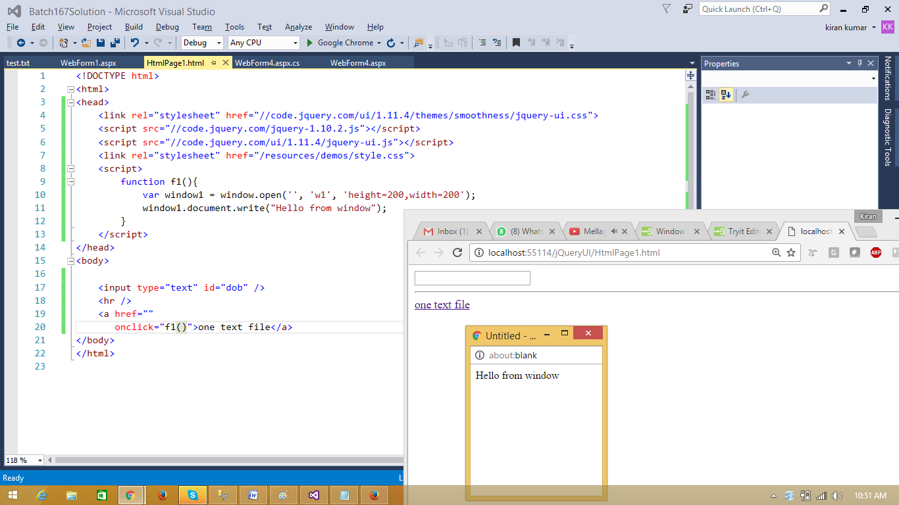

|  |  |
| --- | --- |
|  | **Open web site in new window** |
|  | <a href=""  onclick='window.open("https://www.w3schools.com", "_blank", "toolbar=yes,scrollbars=yes,resizable=yes,top=500,left=500,width=400,height=400");' >  w3schools  </a> |

|  |  |
| --- | --- |
|  | **Replace the current window with a new window** |
|  | var myWindow = window.open("", "_self");  myWindow.document.write("<p>I replaced the current window.</p>"); |

|  |  |
| --- | --- |
|  | **Listing tags** |
|  | Used to provide list of items  Html provided 2 types of listing  1) ordered list => Will provide listing with numbers, roman numbers or alphabets  2) unordered list => will provide bullet listing (circle, round, square)  <ol> </ol> refers to order list  <ul> </ul> refers to un-order list  <li> </li> refers to list item |

|  |  |
| --- | --- |
|  | **Un-ordered list:** Used to display list of items in bulleted list |
|  |  |
|  | <ul type="circle">  <ul type="square">  Ul stands for unordered list  Li stands for list item |

|  |  |
| --- | --- |
|  | Example5: |
|  | <ul type="square">  <li> Software </li>  <li> IT </li>  <li> Hardware </li>  <li> Networking </li>  </ul> |

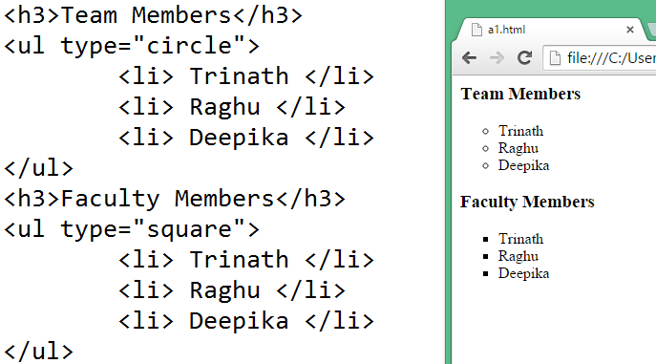

|  |  |
| --- | --- |
|  | **Ordered list** |
|  | Used to display list of items with numbers/roman numbers/alphabets |

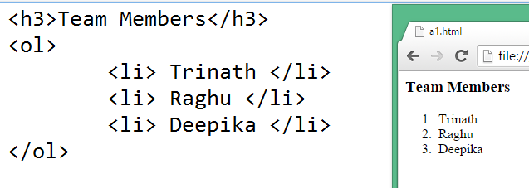

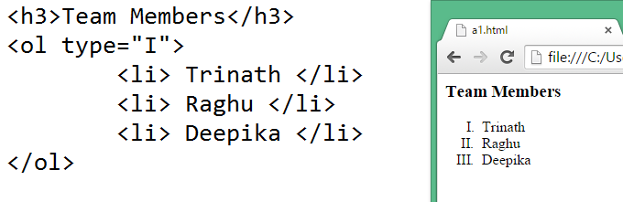

|  |  |
| --- | --- |
|  | **Example5:** |
|  | <ol>  <li> Santosh </li>  <li> Rajesh </li>  <li> Srikanth </li>  </ol> |
|  | Roman number <ol type="I"> |

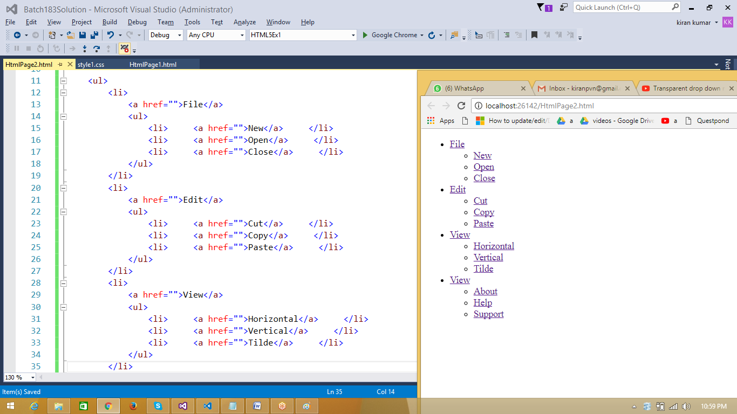

|  |  |
| --- | --- |
|  | **Table tags** |
|  | These tags are used to place table in the web page  The following are table tags   |  |  |  | | --- | --- | --- | |  | **Tags** | **functionality** | | 1 | <table> </table> | Table | | 2 | <th> </th> | Table heading | | 3 | <tr> </tr> | Table row | | 4 | <td> </td> | Table data (column value) |  |  |  |  | | --- | --- | --- | |  | **Properties** | **functionality** | | 1 | border property | Used to specify border thickness  Default 0 thickness | | 2 | Colspan property | Is used to merge columns | | 3 | Rowspan property | Used to merge rows | | 4 | Height | Used to specify the height | | 5 | Width | Used to specify the width | |

|  |  |
| --- | --- |
|  | **Exampl1:** |
|  |  |

|  |  |
| --- | --- |
|  | Table tags |
|  | <center><h1>Table Demo</h1></center>  <table border="1">  <tr>  <td colspan="3">  <center>Student List</center>  </td>  </tr>  <tr>  <th> Sno </th>  <th> Sname </th>  <th> Course </th>  </tr>  <tr>  <td> 1001 </td>  <td> Rajesh </td>  <td> .NET </td>  </tr>  <tr>  <td> 1002 </td>  <td> Santosh </td>  <td> Sql Server </td>  </tr>  </table> |

|  |  |
| --- | --- |
|  | **UI Designing** |
|  | In order to design GUI element, HTML provided many tags called UI Tags.  Example:  <form>, <input>, <select>, <textarea>, etc.,  It is recommended to place UI tags under form, so the elements will be under one group. |

|  |  |
| --- | --- |
|  | **Form tag** |
|  | Form is a tag in html used to group UI tools in HTML Page.  A form used to refer a UI location in web page.  Form is used to provide an individual location to have separate collection of ui elements.  <form name="form1" method="post" action="HtmlPage1.html" runat="server">  </form>   |  |  |  | | --- | --- | --- | |  | **Property** | **Functionality** | |  | Name | Used to provide an identity | |  | Action | Used to specify the target page  And also used to specify the url of the page to which we have to send the data. | |  | Method | Used to specify type of request to be processed  Get|Post | |  | runat="server" | Specify the run location to server |   **Points to note:** When we have more than one form, a form array gets created. |

|  |  |
| --- | --- |
|  | **Understand HTTP** |
|  | HTTP (Hyper Text Transfer Protocol)  This is a transfer protocol design to enable communication between client and server   |  |  |  | | --- | --- | --- | |  | **http support get and post request** | | |  | Get | This method commonly used to first interaction with web page.  This method mostly used while carrying raw data and it is not secured.  This method is the default  <form method="get">  </form>  Points to note:  1) Get request can be cached  2) get request maintain browser history  3) get request can be bookmarked.  4) get request has length restriction  5) get request not suggested while dealing with sensitve data. | |  | Post | This method is used to pass data in secured way, we can send bulk data to the server pages. it uses encrypted format from client to server | |

|  |  |
| --- | --- |
|  | **Form elements:** Used to design UI in html |
|  | <form>  </form> |
|  | <input type="button"> |
|  | <input type="text"> |

|  |  |
| --- | --- |
|  | **Buttons** |
|  | **Html support 3 types of buttons**  **Button, Submit and Reset**   |  |  |  | | --- | --- | --- | |  | **Type** | **Functionality** | | 1 | Button | Used to place a command button  <input type=button value="click"> | | 2 | Submit | Used to place submit button,  When the submit button press, page redirected to the action  <input type=submit> | | 3 | Reset | Used to clear all input elements in the current form  <input type=reset> |   **Html Buttons: Button is used to initiate an action.** |

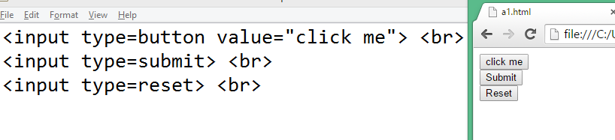

|  |  |  |
| --- | --- | --- |
|  | **Page1: ex1.html** | **Page2: ex2.html** |
|  |  |  |
|  | <h1>We are in Page1</h1>  <form action="ex2.html">  <input type=submit value="Goto Page2">  </form> | <h1>We are in page2</h1>  <form action="ex1.html">  <input type="submit" value="Goto Page1">  </form> |

|  |  |
| --- | --- |
|  | **Text (input boxes)** |
|  | **Text: This is used to read input from user or to display output**     |  |  |  | | --- | --- | --- | |  | **Property** | **Functionality** | | 1 | Name | Used to provide identification to a textbox  More the one textbox can have same name, array gets created with that name | | 2 | Id | Used to provide a unique identification to a textbox | | 3 | Maxlength | Used to provide maximum size for a textbox | | 4 | Size | Used to provide visible size of a textbox | | 5 | Placeholder | Used to place a watermark text | | 6 | Value | Used to provide a value to a textbox | | 7 | Readonly | To make textbox for readonly outputs |   **HTML support 4 types of TextBoxes** |

|  |  |
| --- | --- |
|  | **RadioButton** |
|  | **Used to place multiple options to choose one in the group.**  **<input type=radio> is used to place a radio button.**   |  |  |  | | --- | --- | --- | |  | **Properties** | **Functionality** | |  | Name | Used to provide a common name to radio buttons | |  | ID | Used to provide a unique id | |  | Checked | Used to provide default selection |   **Points to note:**  **In HTML every radio button under one group by default.**  **By placing a common name, you can group the radio buttons into one category.** |
|  |  |

|  |  |
| --- | --- |
|  | **CheckBox** |
|  | Used to place checkbox in the screen.  Used in the scenarios like on or off feature, discount availability, door delivery, etc., |
|  |  |

|  |  |
| --- | --- |
|  | **Html5 Date, Time and Week Elements** |
|  |  |

|  |  |
| --- | --- |
|  | **Html5 tags** |
|  | <input type=date> <br>  <input type=month> <br>  <input type=time> <br>  <input type=week> <br>  <input type=range> <br>  <input type=number> <br>  <input type="number" size="2" min="1" max="10" />  <input type="number" step="1" min="1" max="10" />  <input type=color> <br> |

|  |  |
| --- | --- |
|  | **Label tag** |
|  | This tag is used to provide a programmable text in the web page  <label> Your Name </label>  Using label, we can associate a text to a control  Provide an id the control and assign that id to for in a label property |

|  |  |
| --- | --- |
|  | **Association of control to a label** |
|  | In order to select a control with its label, we have to associate by providing control id at label for  Example:  <label for="t1">Enter Name</label> <input type=text id="t1" > |

|  |  |
| --- | --- |
|  | **Association of control to a label** |
| Output |  |
| Html source | <label for="txt1">Enter your name : </label> <input type=text id="txt1">  </br>  Gender <br>  <input type=radio name="gen" id="male"> <label for="male">Male</label>  <input type=radio name="gen" id="female"> <label for="female">Female</label>  <br>  <input type=checkbox id="cb1"> <label for="cb1"> Door Delivary </label> |

|  |  |
| --- | --- |
|  | **<select> tag** |
|  | This tag is used to provide dropdownlist or listbox in the web page   |  |  |  | | --- | --- | --- | |  | Property | Functionality | |  | Name | Used to provide a name | |  | Id | Used to provide a unqiue id | |  | Multiple | To display multiple options at a time  Will have 4 items bydefault | |  | Size | Used to display list box for with size number of items | |

|  |  |  |
| --- | --- | --- |
|  | **Working with Dropdown list** | |
|  |  | **It is used to provide combobox in the web page.**  **<select>**  **<option> First option </option>**  **<option> Second option </option>**  **<option> Third option </option>**  **<option> Fourth option </option>**  **</select>** |
|  | Output |  |
|  | Html source | Directions :<br>  <select>  <option> North </option>  <option> East </option>  <option> West </option>  <option> South </option>  </select> |

|  |  |
| --- | --- |
|  | **File Upload Control** |
|  | Attach A File: <br>  <input type=file> |

|  |  |  |
| --- | --- | --- |
|  | **listBox: Used to place multiple options in a list, allows to see and select multiple.** | |
|  | Output |  |
|  | Html source | Team Members:<br>  <select multiple>  <option> Santosh </option>  <option> Rajesh </option>  <option> Pradeep </option>  <option> Venkat </option>  <option> Srikant </option>  </select> |

|  |  |  |
| --- | --- | --- |
|  | **Div tag** | **Span tag** |
|  | Block level tag/element | Inline tag/element |
|  | Provide section before and after the tag | Will not provide section before and after the tag |
|  | Div, divide and create block | Span will not create a block |



|  |  |  |  |  |
| --- | --- | --- | --- | --- |
|  | **W3C stand colors are 16 colors** | |  |  |
|  | Black | Gray | Silver | White |
|  | Yellow | Lime | Auqa | Fuchsia |
|  | Reg | Green | Blue | Purple |
|  | Maroon | Olive | Navy | teal |

|  |  |  |
| --- | --- | --- |
|  | **Hexa Decimal Color Code System** | |
|  | Hexa | (A-F) / (a-f) |
|  | Decimal | 0 to 9 |
|  | Primary colors | RED => 0 to 255  GREEN => 0 to 255  BLUE => 0 to 255  RGB = 256 * 256 * 256 = 16 million color shades |
|  | Every color represent using 2 letters | **Example:**  RED => RR  GREEN = GG  BLUE = BB |
|  | Color code start with # symbol |  |
|  | RED color | #FF0000 |
|  | Green color | #00FF00 |
|  | BLUE color | #0000FF |
|  | Black color | #000000  00 represent least color i.e. black |
|  | White color | #FFFFFF  FF represent highest coor i.e. white |
|  |  |  |

|  |  |
| --- | --- |
|  | **Html 5 features** |
|  | About HTML5 |
|  | DTD (Document Type Definition) |
|  | Advanced Forms (Forms 2.0) |
|  | Html5 Multi Media  Audio, Video tags |
|  | Symantic elements |
|  | HTML5 element attributes  PlaceHolder, Autocomplete, autofocus, form, required, formnovalidate,  Formtarget="_blank", etc., |
|  | <output> element |
|  | Html5 graphics SVG |
|  | Inline elements |
|  | Etc., |

|  |  |
| --- | --- |
|  | **Html 5 features (With Javascript)** |
|  | Html5 canvas |
|  | Html5 geolocation |
|  | Html5 webstorage |
|  |  |
|  | Etc., |

|  |  |
| --- | --- |
|  | **About HTML5** |
|  | HTML5 was published in October 2014 by W3C ( World Wide Web Consortium )to improve the language with support for the latest multimedia, while keeping it both easily readable by humans and consistently understood by computers and devices such as web browsers, parsers, etc. HTML5 is intended to subsume not only HTML 4, but also XHTML 1 and DOM Level 2 HTML. |

|  |  |
| --- | --- |
|  | **Understand DTD** |
|  | **DTD (Document Type Definition)**  DTD is used to provide information about the document   |  |  |  | | --- | --- | --- | |  |  |  | |  | Version | <!DOCTYPE html>  Html5 Version can be provided to browser using <!DOCTYPE html>  The <!DOCTYPE> declaration is not an HTML tag; it is an instruction to the web browser about what version of HTML the page is written in.  <!DOCTYPE> tells the browser and validator's that which type of version we are using  console.log ( document.firstChild ); | |  | Lang | Lang is used to provide what kind of language used in the browser  This lang attribute to be provide at html element  <html lang=en-uk>  Represent we used html code using UK(United Kingdon) English  <html lang=en-US> (or) <html lang=en > (Default american english)  Represent we used html code using United States English  <html lang=en-nz>  Represent we used html code using newzland English  <html lang=en-in>  Represent we used html code using indian English ( Example: => colour) | |  | Charset | UTF => Unicode Transformation Format  <meta charset="utf-8" /> |   DTD includes Version, Language, charset, etc., |
|  | HTML4 declaration  <!DOCTYPE HTML PUBLIC "-//W3C//DTD HTML 4.01//EN" "http://www.w3.org/TR/html4/strict.dtd"> |

|  |  |
| --- | --- |
|  | **Html 5 Advanced Forms (Forms 2.0)** |
|  | For UI designing HTML5 provided latest input types in Web2.0  Existing UI elements(HTML4) remain the importance as it is  **DataTime Pickers:**  <input type=time >  <input type=date >  <input type=week >  <input type=month >  <input type=datetime local>  **General Form Controls:**  <input type=email >  <input type=url >  <input type=color >  <input type=range >  <input type=number >  <input type=search >  <input type=tel >  **Note:** All the advanced browsers support above elements, if not behave like regular text field |

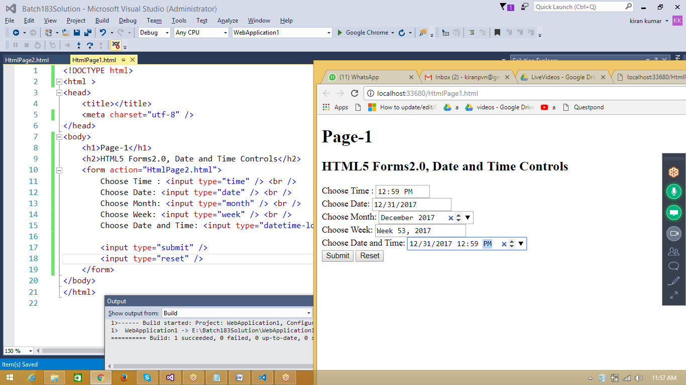

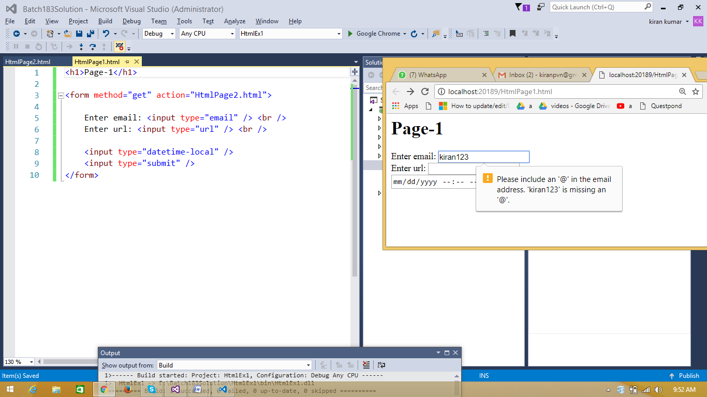

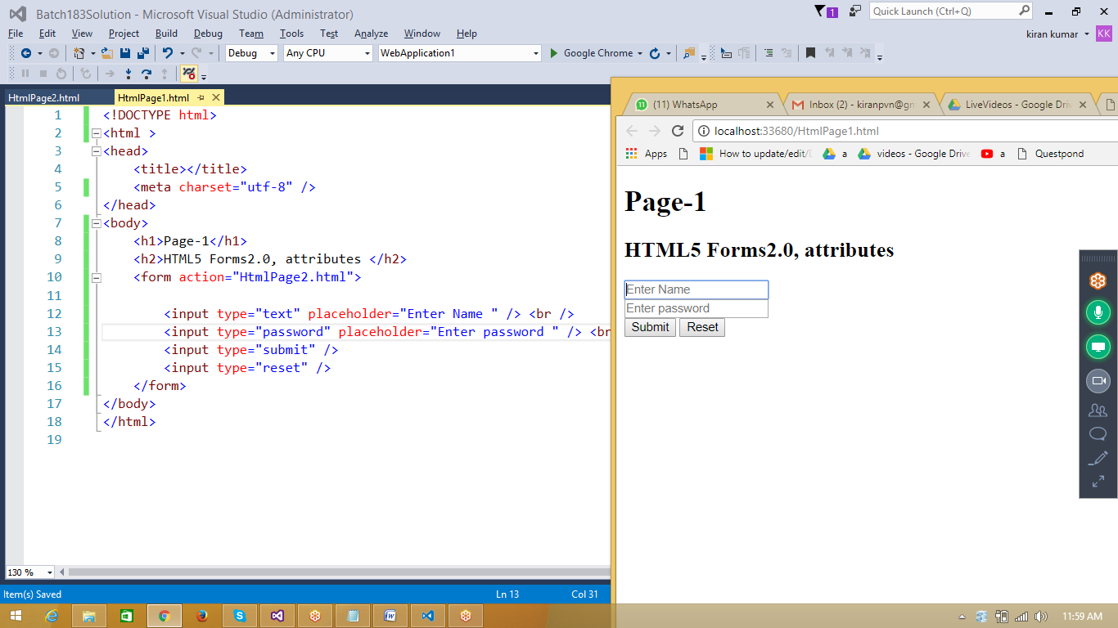

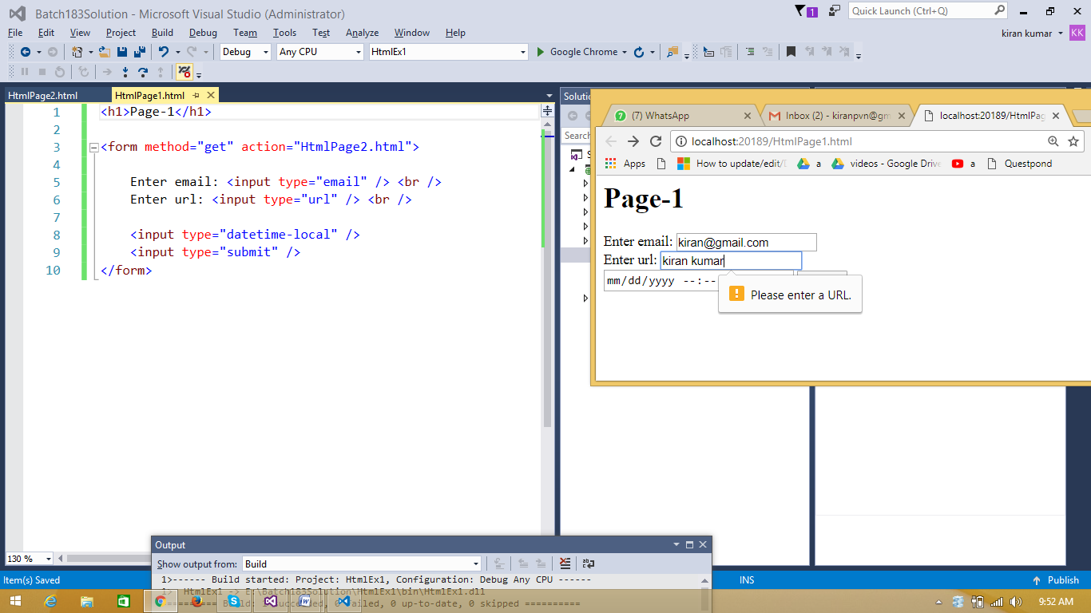

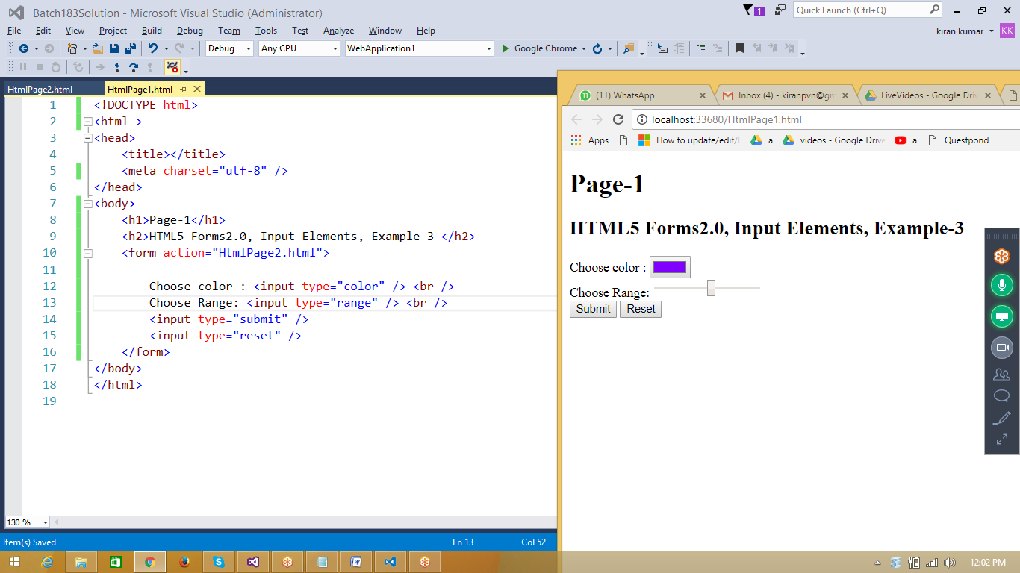

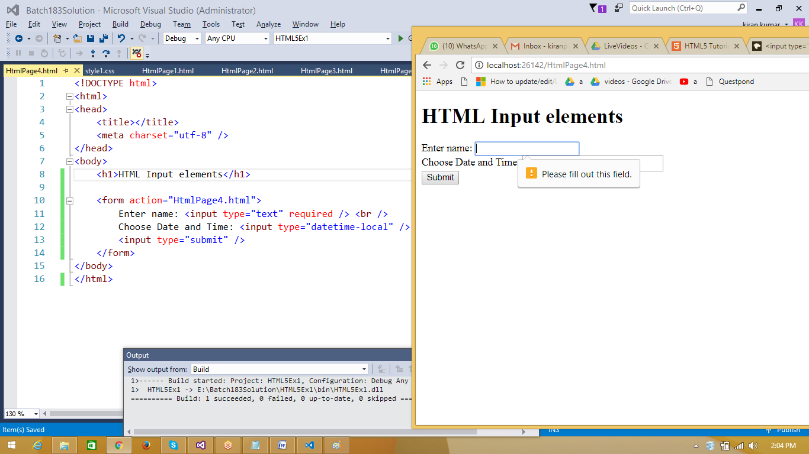

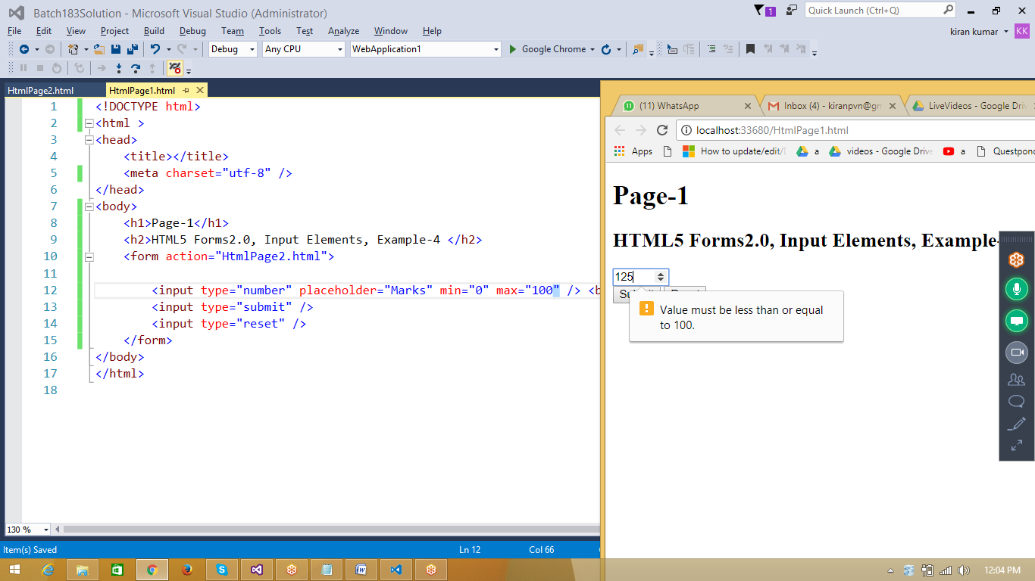

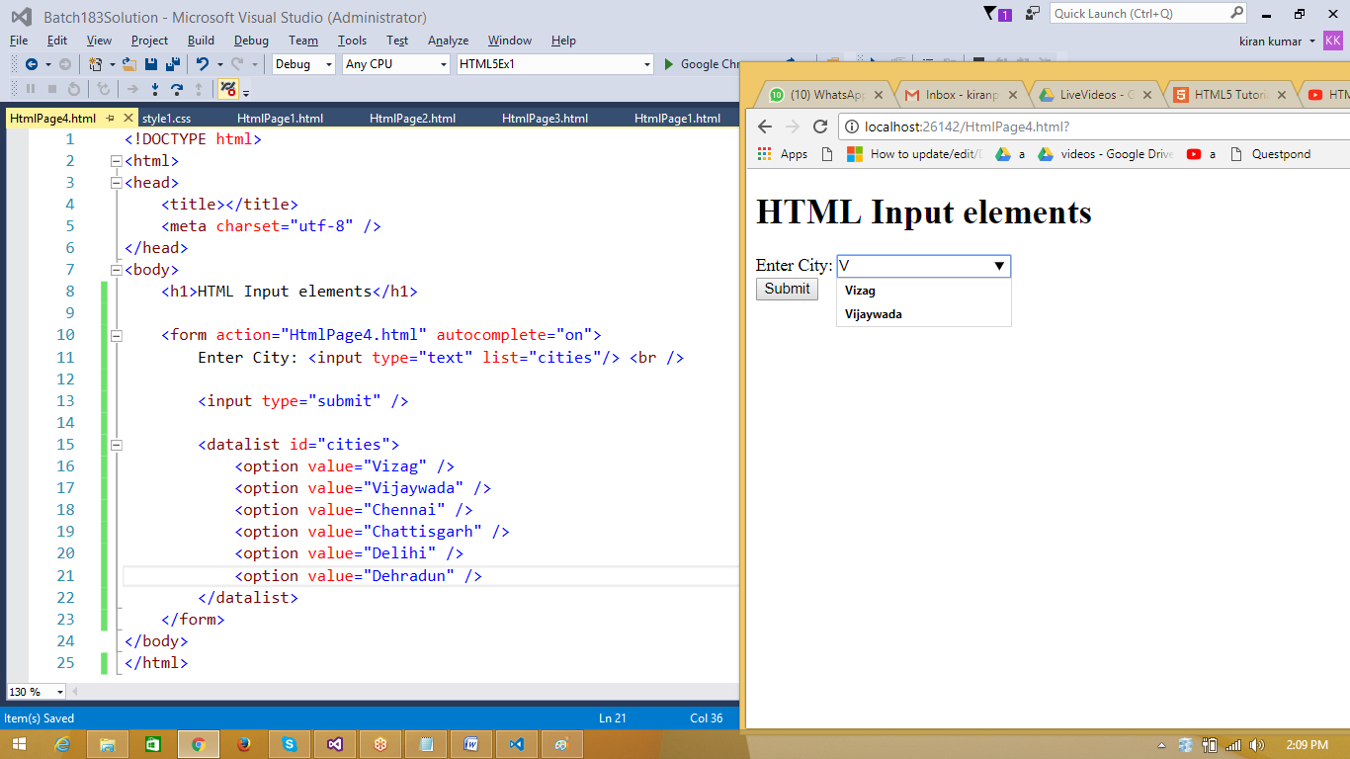

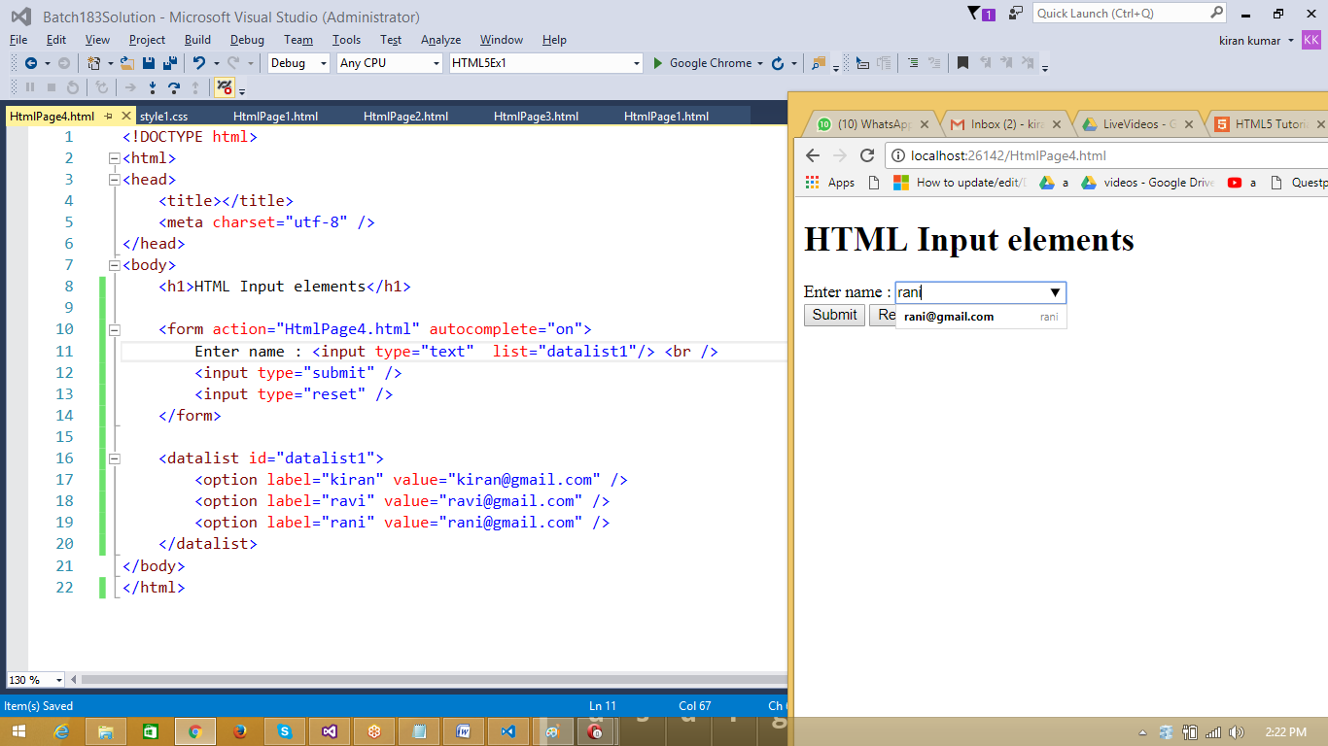

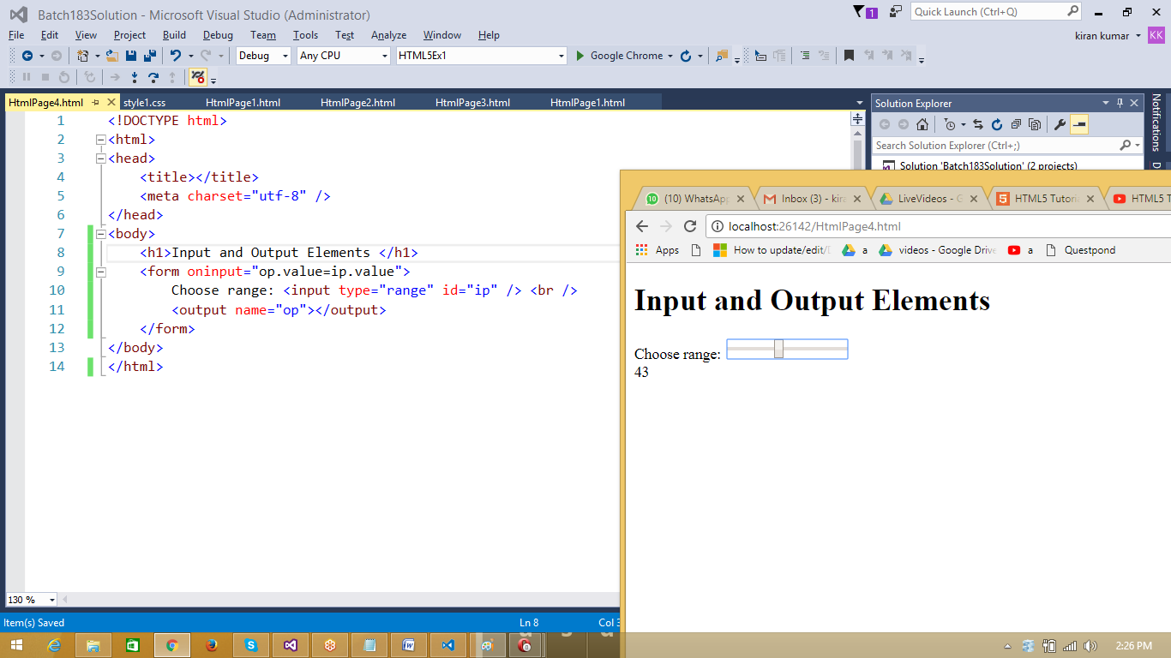

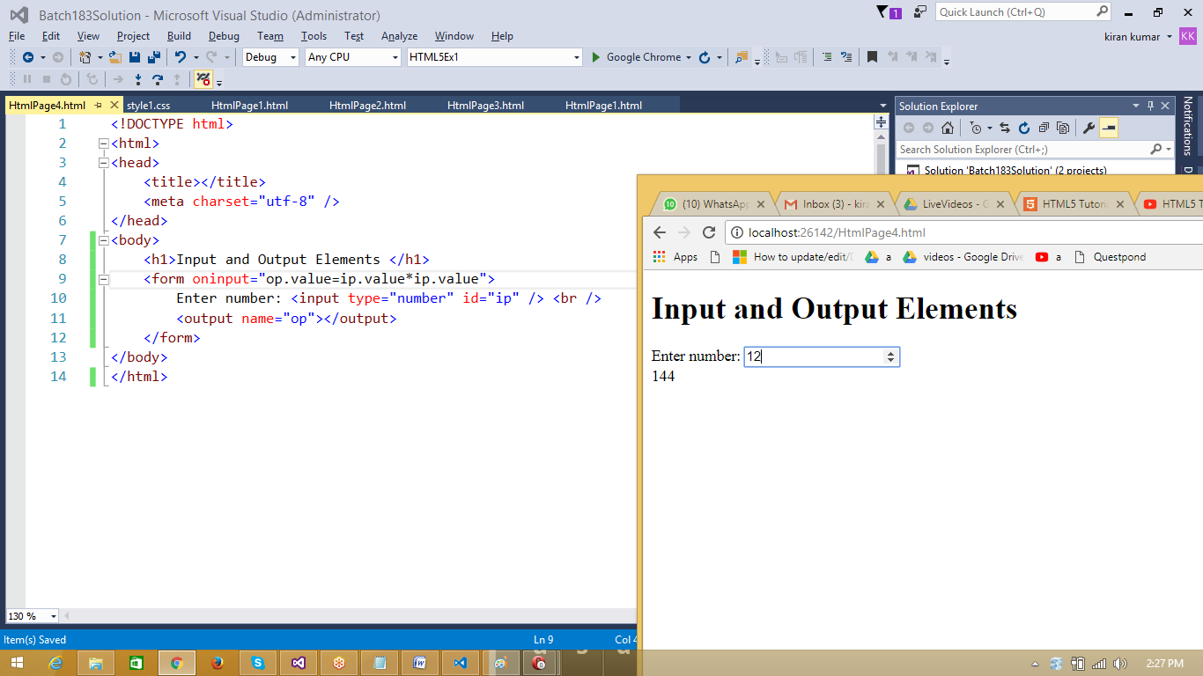

HTML page with 2 submit buttons

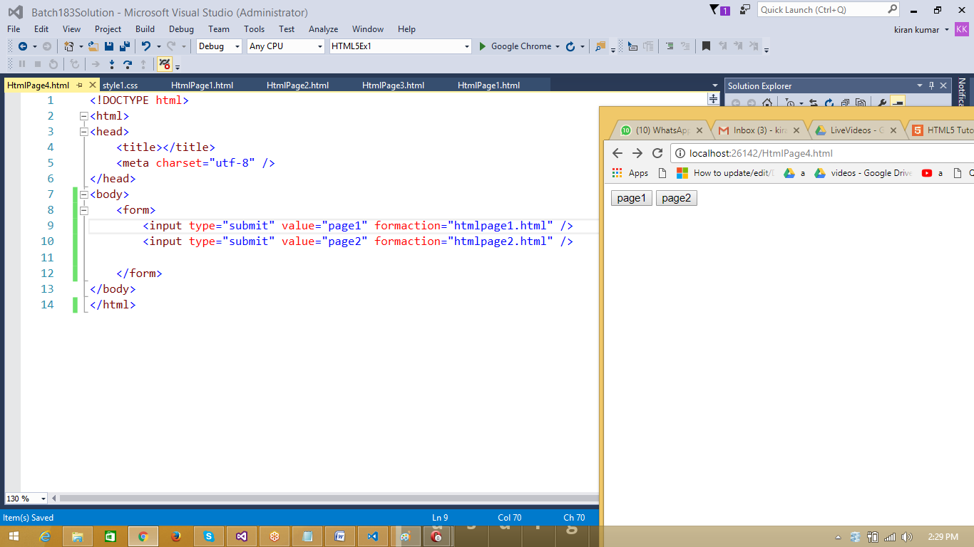

<input type="submit" value="page2" formaction="htmlpage2.html" formnovalidate />

input element outside form tag

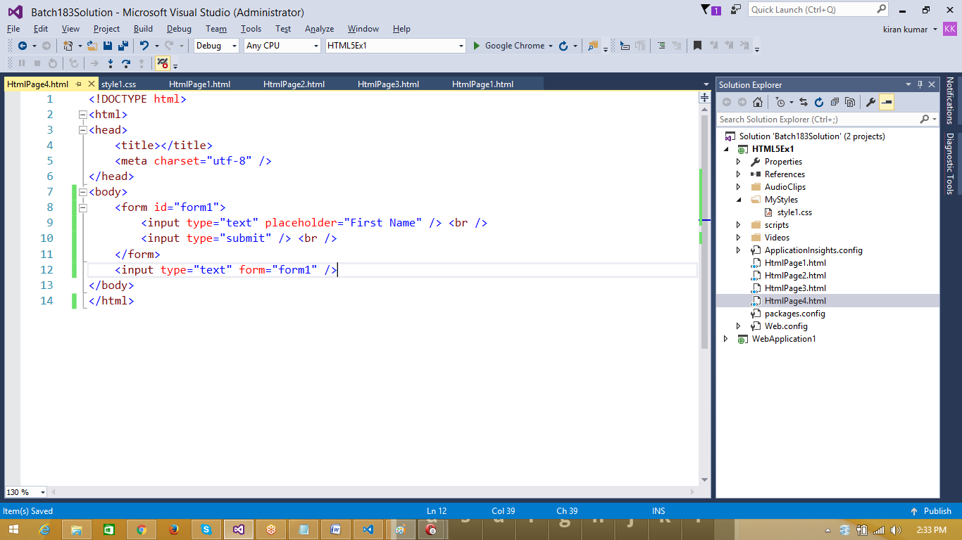

autofocus

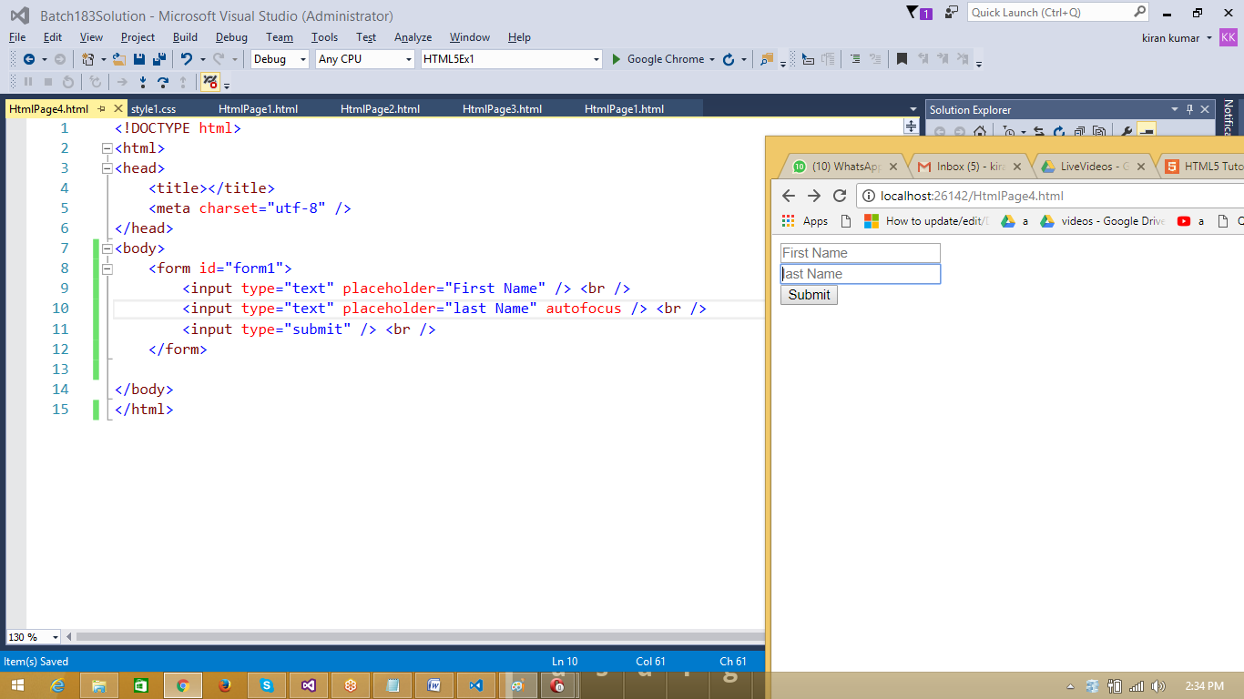

<form id="form1" action="HtmlPage1.html">

<input type="submit" value="Page1" /> <br />

<input type="submit" formtarget="_blank" />

</form>

===

<input type="image">

image button behave like a submit

====

Submitting multiple files

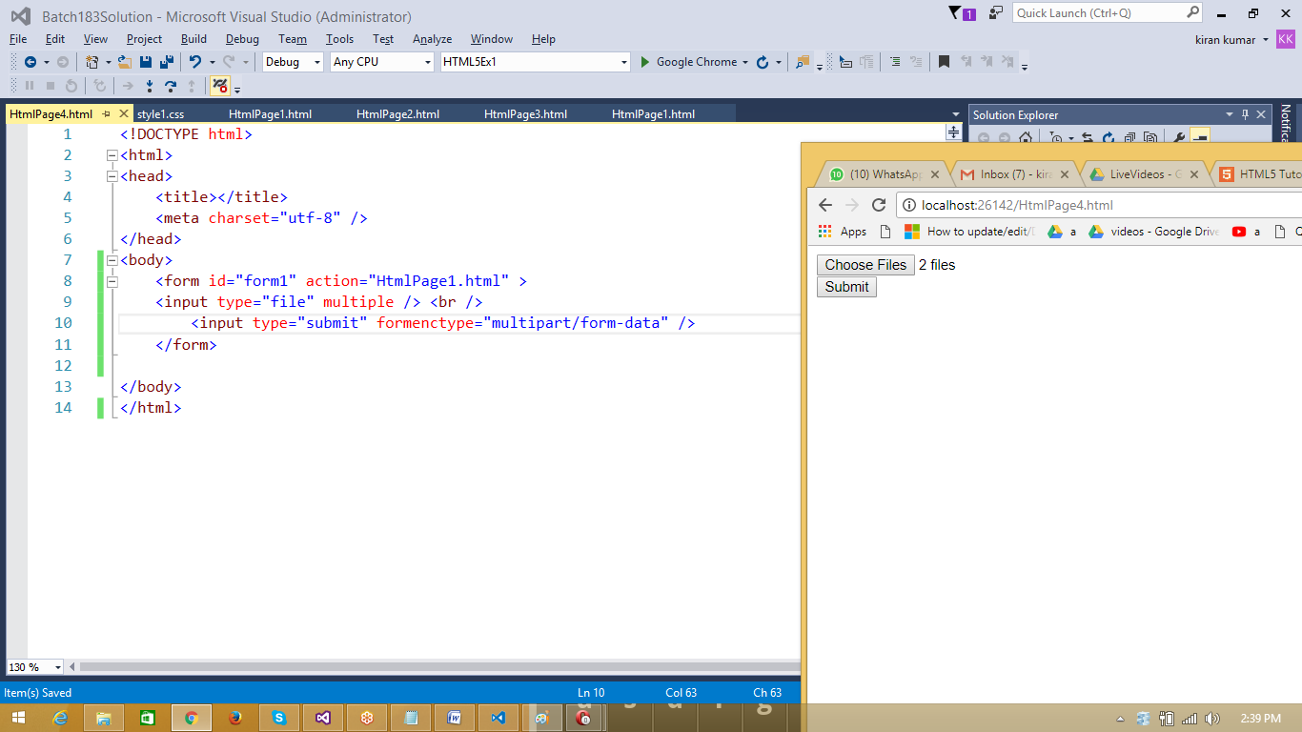

|  |  |
| --- | --- |
|  | **HTML5 Multimedia** |
|  | HTML5 provided in build Audio and Video tags for multimedia  Using this feature we can play audio file and video files in the browser  Common attributes for audio and video tags  Src used to provide the source of the file  Controls to specify control to be displayed  Autoplay used to play the video/audio when the page is loaded  Loop is used to make the video to start automatically once it is completed play |

|  |  |
| --- | --- |
|  | **HTML5 Audio element** |
|  | <audio src="JanaGanaMana.mp3" controls /> |
|  | <audio controls autoplay loop>  <source src="JanaGanaMana.mp3" type="audio/mp3" />  </audio> |
|  | Autoplay will play the audio whenever the browser is refreshed |
|  | Loop will play the audio continously |

|  |  |
| --- | --- |
|  | **HTML5 Video element** |
|  | <video controls src="https://www.w3schools.com/html/mov_bbb.mp4"></video> |

|  |  |  |
| --- | --- | --- |
|  | **Passing data from one page to another** | |
|  | **HtmlPage1.html** | <h1>Page-1</h1>  <form method="get" action="HtmlPage2.html">  Enter your name : <input type="text" name="ename" /> <br />    <input type="submit" />  </form> |
|  | **HtmlPage2.html** | <!DOCTYPE html>  <html>  <head>  <title></title>  <meta charset="utf-8" />  </head>  <body>  <h2>Page-2</h2>  </body>  <script>  function f1() {  var parameters = location.search.substring(1).split("&");  var temp = parameters[0].split("=");  var ename = unescape(temp[1]);  document.write(ename + "<br>");  }  f1();  </script>  </html> |

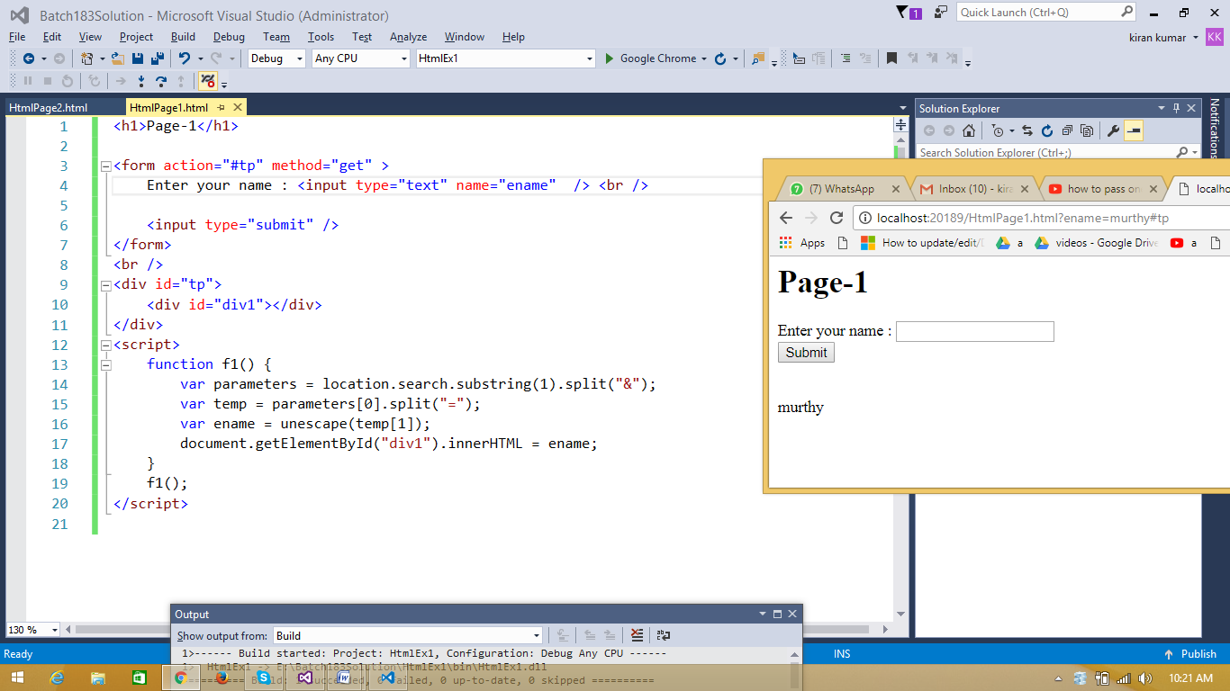

|  |  |
| --- | --- |
|  | Display data in same page |
|  | <h1>Page-1</h1>  <form action="#tp" method="get" >  Enter your name : <input type="text" name="ename" /> <br />    <input type="submit" />  </form>  <br />  <div id="tp">  <div id="div1"></div>  </div>  <script>  function f1() {  var parameters = location.search.substring(1).split("&");  var temp = parameters[0].split("=");  var ename = unescape(temp[1]);  document.getElementById("div1").innerHTML = ename;  }  f1();  </script> |