|  |  |
| --- | --- |
|  | **Agenda** |
|  | What is Database?  Why do we need? |
|  | Available databases |
|  | Understand MySql |
|  | Understand NoSql |
|  | Available NoSql databases |

|  |  |
| --- | --- |
|  | **Understand Database** |
|  | Database is backend software used to store data huge amount of data in the form of tables (contains structured rows).  The data inside the database is available till it is modified  **Available databases:** Oracle, SqlServer, MySql, etc.,  **NoSql DB** => It is a database, used to store data in the form of collections (with json format).  Available NoSql DB: MongoDB, DocumentDB, etc.,  **Following databases are commonly used in UI technologies:**  MongoDB, MySql, DocumentDB, etc., |

|  |  |
| --- | --- |
|  | **Understand MySql** |
|  | It is the Open Source RDBMS, commonly used in PHP, NodeJs, Angular4, etc.,  MySql is the best backend for PHP and other UI frameworks  MySql is free to download  **MySql for Windows OS:**  Software download link: <https://dev.mysql.com/downloads/windows/installer/5.7.html>  <https://dev.mysql.com/downloads/file/?id=474496>  Recommended to have password as : manager  Software installation path: C:\Program Files\MySQL\MySQL Server 5.7\bin |

|  |  |
| --- | --- |
|  | **Installation steps** |
|  | Double click on .msi file and keep pressing next button  Admin user name will be : root  Password to be provided: manager  To connect to my sql we need to change loc to mysql bin folder |

|  |  |
| --- | --- |
|  | **My sql available in** |
|  | **Command line interface:**  This is available to operate database using commands.  UI: User Interface:  It is a UI, to operate database using desiner |

Connect to mysql

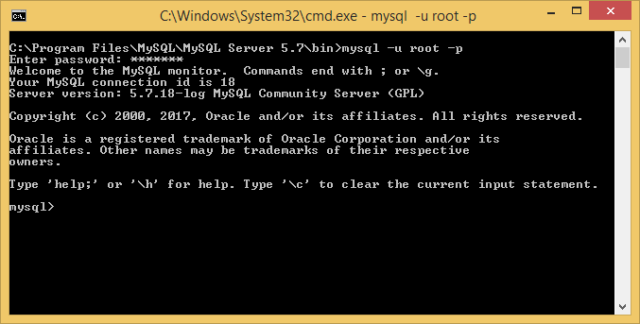

Download mysql

Extract all and copy the folder to c:\

Open command prompt and type

Mysql –u root -p

|  |  |
| --- | --- |
|  | **SQL (Structured Query Language)** |
|  | It is a standard database language  Sql is used to create or operate relational database  **Following are categories in Sql**  **DDL (Data definition language):** Commands in category are used to work with database objects  Example: CREATE, ALTER, DROP, TRUNCATE  **DML(Data Manipulation Language):** Commands in this category are used to access data within tables  Example: SELECT, INSERT, DELETE, UPDATE  **TCL(Transaction Control Language):** Commands in this category are used to transact  Example: Commit, Rollback  **DCL(Data Control Language):** Command in this category are used to provide permission  Example: Grant, revoke |

|  |  |
| --- | --- |
|  | **Database objects** |
|  | Database object are entities inside the database  Available database objects:  Table, View, Index, Sequence  Procedure, Function, Trigger, etc., |

|  |  |
| --- | --- |
|  | **Understand Database** |
|  | Database is a set of inter-related databases.  The tables inside the database can maintain relationship  **Example:**  CollegeDB  tblCourses  tblStudents  tblExams  EmployeeDB  tblDepartments  tblEmployees   |  |  |  | | --- | --- | --- | |  | **Commands for database** | | |  |  |  | |  | To create | **Syntax:**  Create database name;  **Example:**  Create database EmployeeDB;  Create database CollegeDB; | |  | To display all databases | Show databases; | |  |  |  | |  | To switch to database | Use EmployeeDB;  Use CollegeDB; |   **Note:** Database is a object in RDBMS |

|  |  |
| --- | --- |
|  | **Understand database table** |
|  | A table is two dimensional storage area inside database  Table definition contains columnname followed by datatype and sizes  A database can have multiple tables which can be inter-related  Relationship is provided using foreign key   |  |  |  | | --- | --- | --- | |  | **To display all tables** | **Show tables;** | |  | Syntax to create table | Create table tableName  (  Colname database size constraint,  Colname database size constraint,  …  ); | |  | To create a table | create table tblEmployees  (  id int primary Key,  ename varchar(20),  job varchar(20),  salary int  ); | |  |  | Create table tblProduct  (  Id int primary key,  Pname varchar(20),  Model varchar(20),  Make varchar(20),  Price int  ); |   Note: Table is a database object |

|  |  |
| --- | --- |
|  | **Data Manipulations(CRUD Operations)** |
|  | The manipulation of data in existing table called as data manipulations or CRUD operations  C => CREATE Row => Add record using INSERT INTO command  R => Retrieve Row => Retrieve record using SELECT command  U => Update Row => Edit row using UPDATE command  D => Delete Row=> Delete row using DELETE command   |  |  |  | | --- | --- | --- | |  | **Manipulation** | **Command** | |  | Add rows | insert into tblEmployees values ( 1,'Kiran','Trainer',8000);  insert into tblEmployees values ( 2,'Ashok','Develoer',7000);  insert into tblEmployees values ( 3,'Raiv','Programmer',6500); | |  | To display all rows | Select * from tblEmployees; | |  | To display particular row | Select * from tblEmployees where id=2; | |  | To edit row | Update tblEmployees set name='Pavan' where id=3; | |  | To edit all rows | Update tblEmployees set salary=salary+200; | |  | To delete a row | Delete from tblEmployees where id=3; | |  | To delete all rows | Delete from tblEmployees; |   In order to perform CRUD operations on existing database table, every database provide DML commands called INSERT, SELECT, UPDATE and DELETE |

|  |  |  |
| --- | --- | --- |
|  |  | |
|  |  |  |
|  |  |  |
|  |  |  |
|  |  |  |

Insert into tblProduct values ( 1, 'Iphone 6', 'Apple','Apple',45000);

Insert into tblProduct values ( 2, 'S 6', 'Samsung','Galaxy’,56000);