|  |  |
| --- | --- |
|  | **Agenda** |
|  | Understand Database Concepts |
|  | Introduction to SQL Server |
|  | Understand Backend and Frontend |
|  | Components of SQL Server |
|  | SSMS |

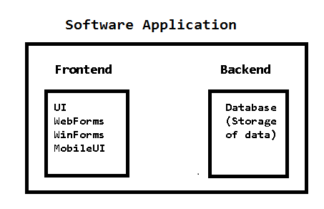

|  |  |
| --- | --- |
|  | **Understand SQL Server** |
|  | It is RDBMS (Backend) Software from Microsoft.  Sql Server is used to store huge amount of data permanently in the form of tables.  The data inside sql server database is secured and transact-able.  **Why do we need SQL Server?**  It is a powerful **Backend** from Microsoft Technologies.  It is native database for Microsoft. |

|  |  |
| --- | --- |
|  | **History of SQL Server** |
|  | Originally it is an RDBMS from SYBASE  Microsoft purchased this Sybase and changed the name to **SQL Server** and released as SQL Server 2000    Later Microsoft redesigned from the scratch of the architecture of Sybase and released  SQL server 2005  Sql server 2008  Sql server 2012  Sql server 2014 |

|  |  |
| --- | --- |
|  | **SQL Server is the best backend for .NET Technologies** |
|  | Most of the banks are rely on SQL server  More companies are using SQL server as their backend.  **Example:**  Banks like Axisbank, Hdfcbank, iciciprulife, etc.,  Reliance shares, many finance company sites, share market sites, they maintain their data in SQL Server. |

|  |  |
| --- | --- |
|  | **Software link to download sql server 2012 Express Edition** |
|  | <https://www.microsoft.com/en-in/download/details.aspx?id=29062>  Select first option (Sql Server Database Software)  Select last option ( Sql Server Management Studio)  **Installation steps link:**  http://www.sherweb.com/blog/how-to-install-sql-server-2012-express-edition |

|  |  |
| --- | --- |
|  | **Components of SQL Server** |
|  | When we install sql server the following components gets installed in windows o/s   1. Database file : Used to store data in the form of tables  |  |  | | --- | --- | |  | **In SQL data will be stored in database files** | | .mdf | Master data file  It is a primary data file, which store data permanently.  This is mandatory file. | | .ndf | Next data file  It is a secondary file, it is used to additional data.  It is optional file. | | .ldf | Log data file  This file contains the queries log |  1. Database Server is Sql Server: It is centralized software, where data can be distributed. 2. Database Service is MSSqlServer: Used to handle client request 3. Client Connecting Tool is SSMS: It is an environment used to interact with database |

|  |  |
| --- | --- |
|  | **SQL Server** |
|  | It is a centralized software program; it is a place where sql Server software is installed.  **Why do we need server?**  To access data base in client computers (through network)  SQL server is pure RDBMS support client server architecture.  **Points to note:**  SQL server is an fully RBDMS  It is Server and Client based RDBMS  SSMS allows to interact with RDBMS in two ways   1. Using Designer 2. Using queries or Stored Procedures. |

|  |  |
| --- | --- |
|  | **SQL Server Service** |
|  | It is a software program (back-end program) it is thread runs in parallel, which process client requests.  It is a program which handle clients requests.  Start=>run=>services.msc (list of services which are running in parallel) |

|  |  |
| --- | --- |
|  | **Client connecting tool (SSMS)** |
|  | SSM Stands for Sql Server Management Studio  It is an environment used to operate database exist in sql server.  This is an IDE to operate rdbms using designer and queries/stored procedures. |

|  |  |
| --- | --- |
|  | **SQL Server Versions** |
|  | SQL Server 2014  SQL Server 2012  Sql Server 2008  Sql Server 2005  SQL Server 2000 ( Sybase with sql server name) |