**CSEE 5542 Big Data Analytics and Appn**

Pavankumar Manchala

Class Id: 16

Team - 5

**Objectives:**

Image Caption Generator:

1.Generate captions for your own dataset using the Show and Tell model.

2.Generate 4 captions for each image. (Beam Search k=4)

3.Report your accuracy in BLEU, CIDER, METEOR and ROGUE measures.

**Platform used:**

PyCharm IDE

**Packages installed:**

1. nltk
2. numpy
3. matplotlib
4. opencv-python
5. Tensorflow
6. PyRouge
7. BLEU score
8. Show and Tell model
9. PIL

**Extraction of Images from the URLs:**

We used the SBU dataset and extracted the images from the URLs. The screenshot is as follows: 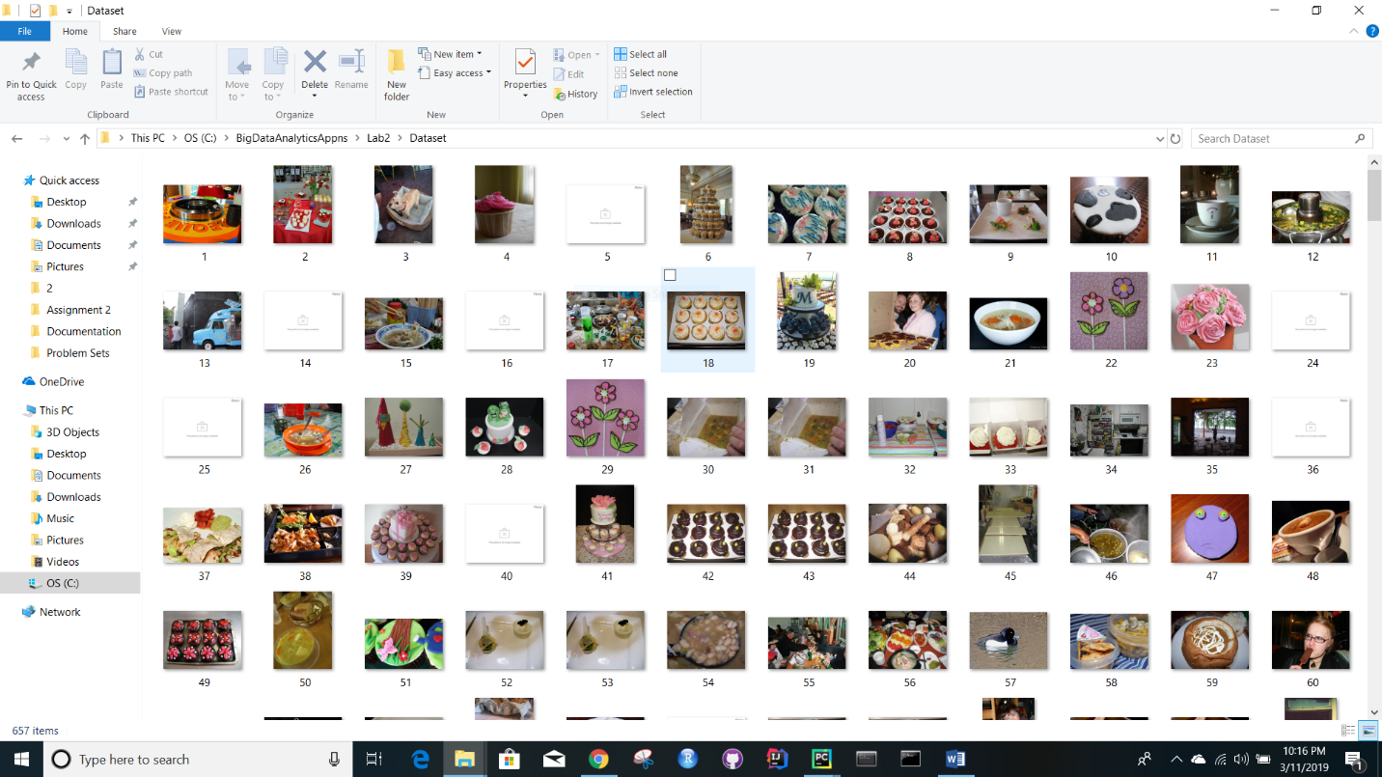

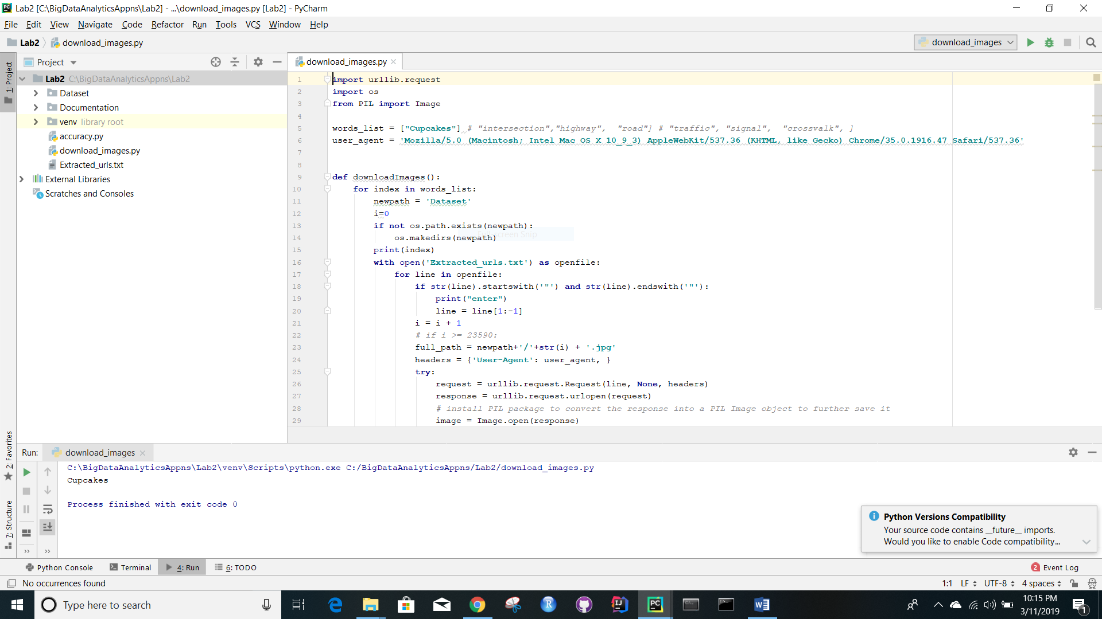

**Task 1:**

Generated the captions for the extracted images using show and tell model.

For every image four captions are generated by changing the beam size value to 4.

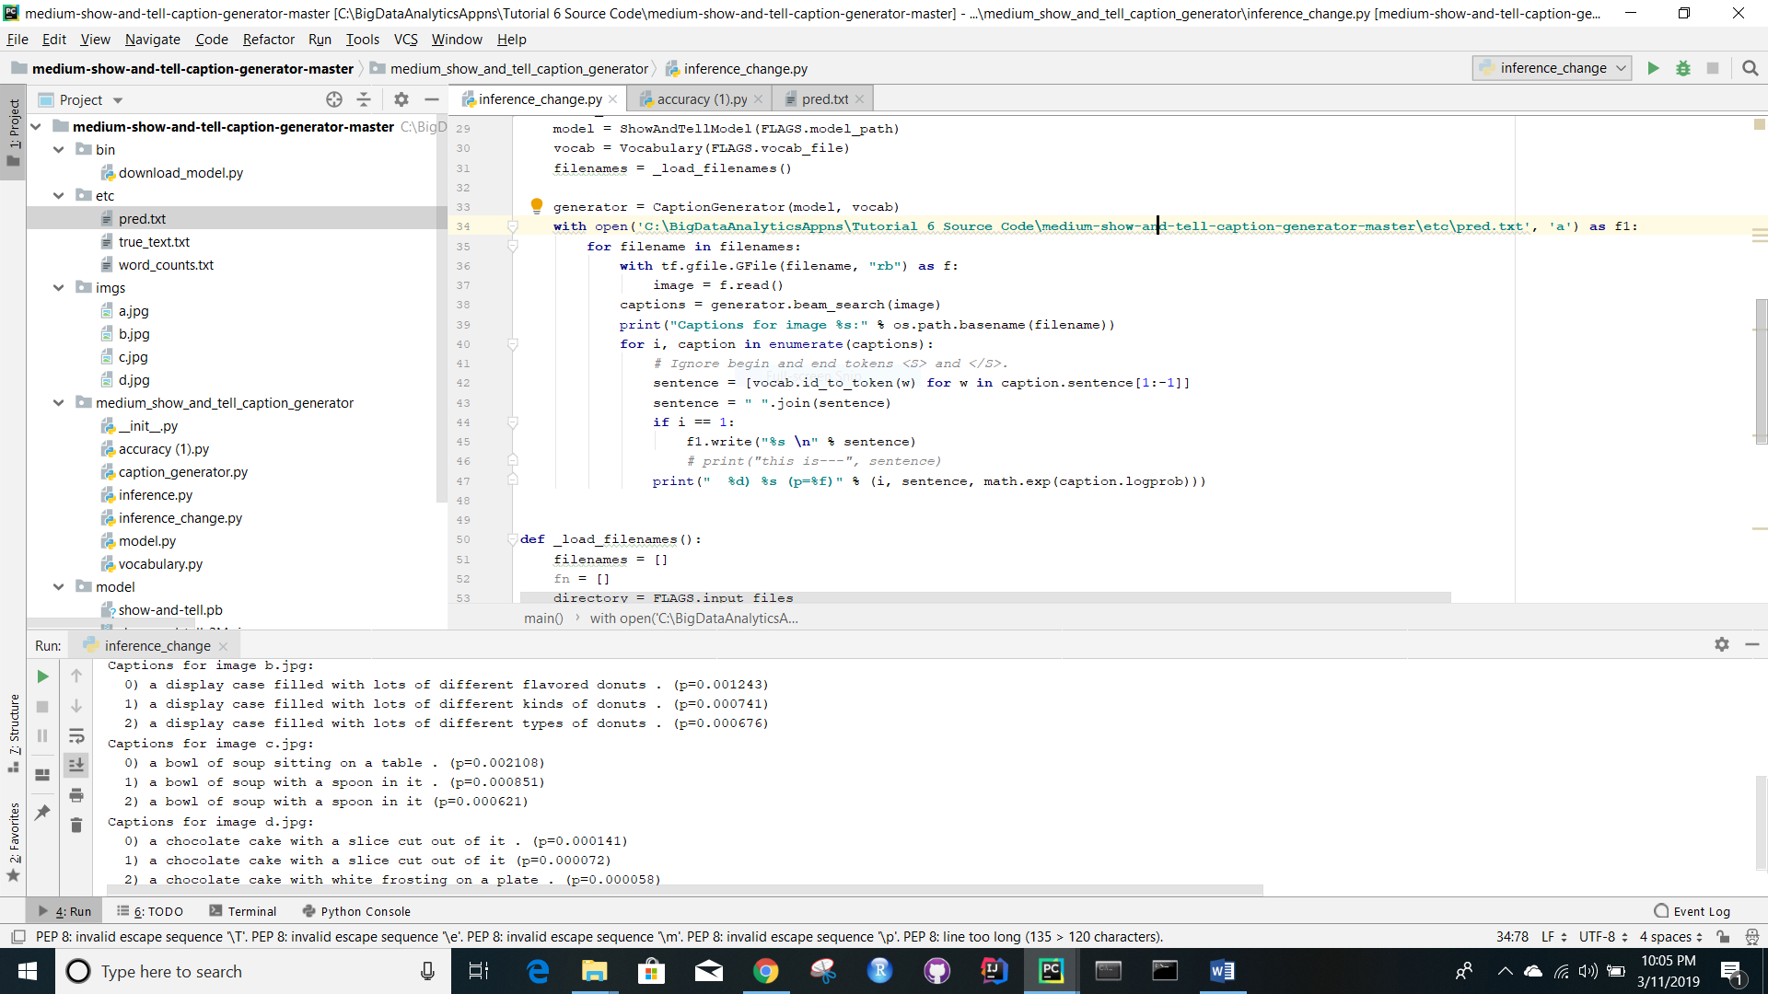

**Task 2:**

Calculation of BLEU Score and ROGUE measures.

