Age Detection
In this project we have experiment with DenseNet & InceptionV3 to predict Age and to train this model we have used WIKI-images dataset and below screen showing dataset images
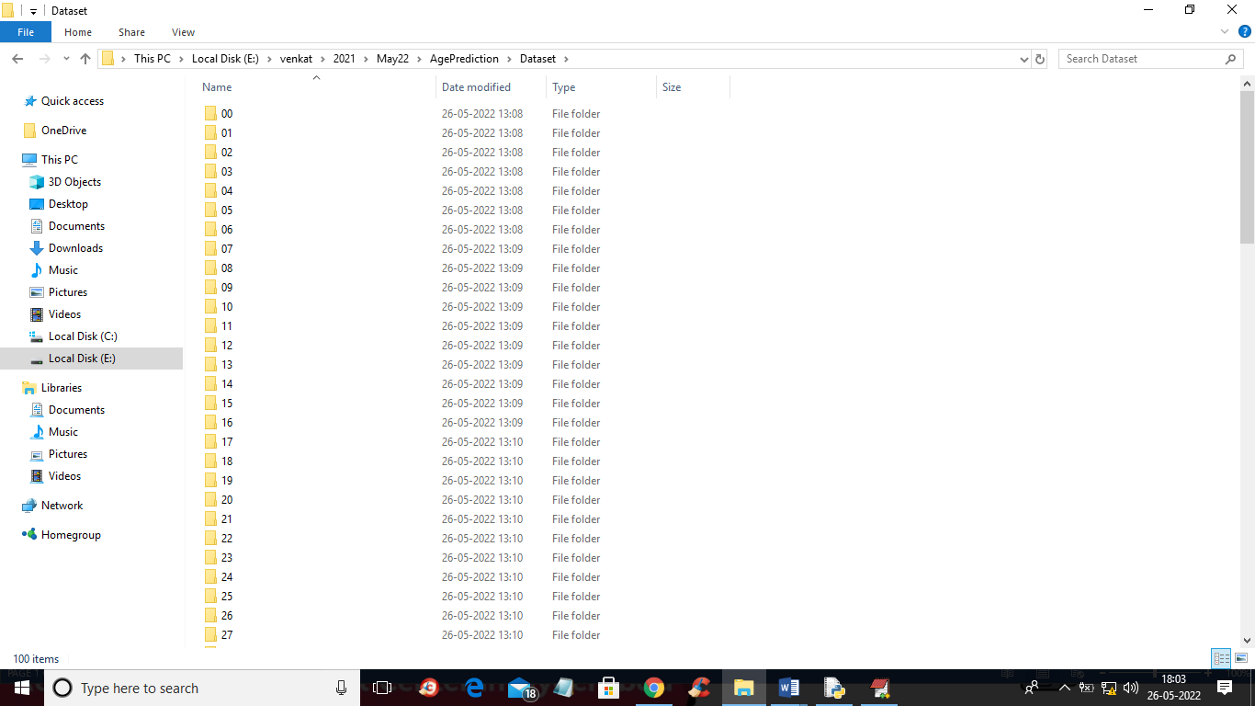
In above screen we have 0 to 100 folders and just go inside any folder to view people’s image with date of birth
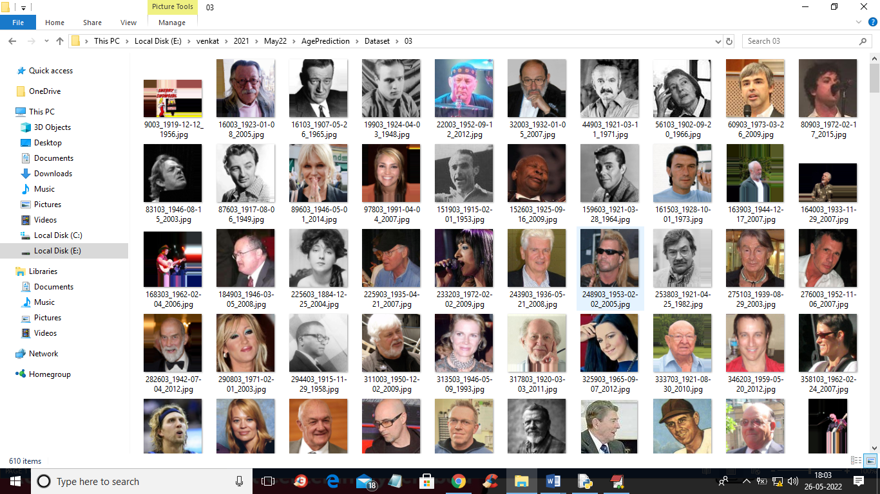
In above screen we can see each image is associated with date of birth so we will use images as features and date of birth as labels to train both DenseNet and InceptionV3 algorithms.
After training algorithms we can apply test images to predict AGE.
To implement this project we have designed following modules
- Upload WIKI-Faces Dataset: using this module we will upload dataset to application
- Preprocess Dataset: using this module we will read all images and then normalize and resize pixel values to equal sizes and then split dataset into train and test where application used 80% dataset for training and 20% for testing
- Train DenseNet Model: using this module we will define DenseNet object and then apply CNN filters to apply features reduction and then trained age prediction model. This model will be applied on test data to calculate correct prediction accuracy
- Train InceptionV3 Model: using this module we will define InceptionV3 object and then apply CNN filters to apply features reduction and then trained age prediction model.
- Accuracy Graph: using this module we will plot DenseNet and InceptionV3 training accuracy and loss graph
- Detect Age from Test Image: using this module we will upload test image and then application will predict age from that image
SCREEN SHOTS
To run project double click on ‘run.bat’ file to get below screen
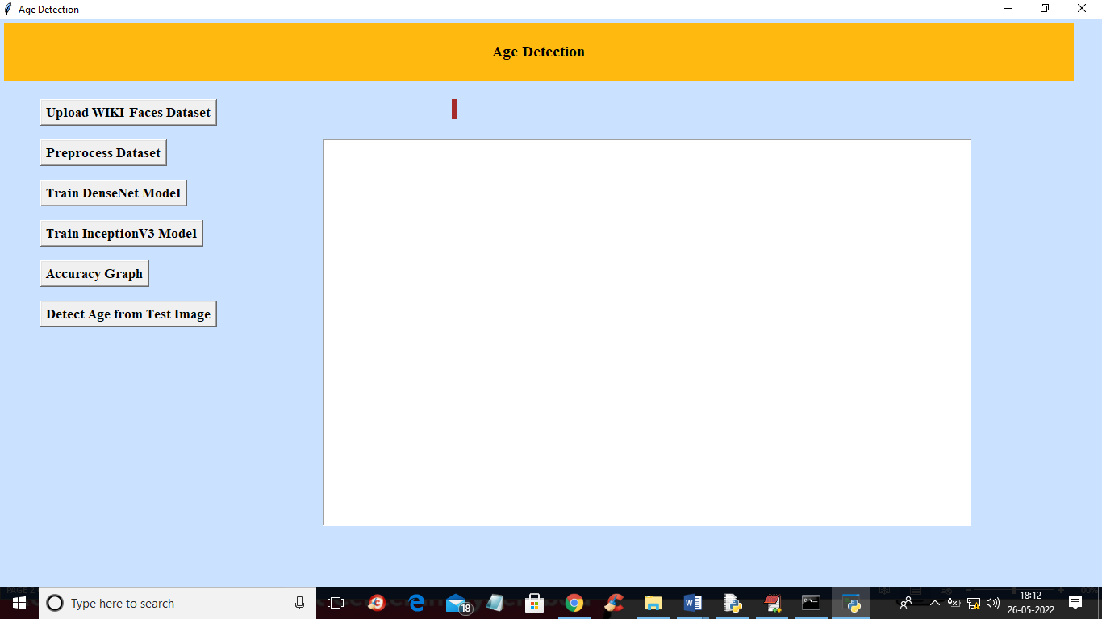
In above screen click on ‘Upload WIKI-Faces Dataset’ button to upload dataset and get below output
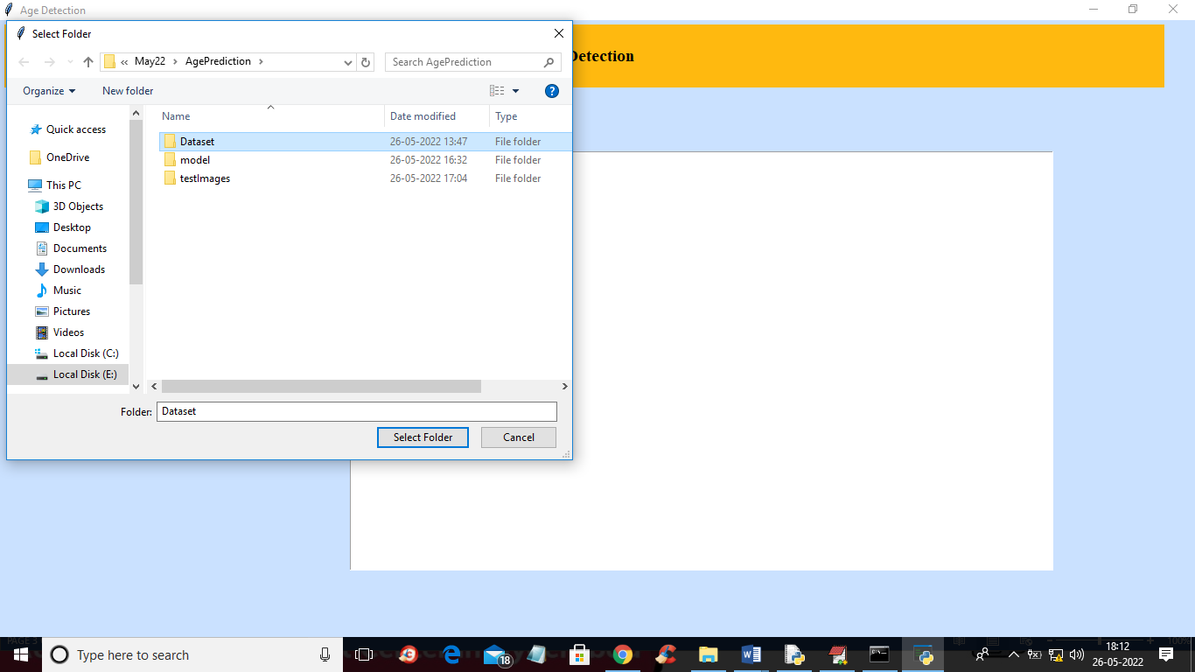
In above screen selecting and uploading dataset folder and then click on ‘Select Folder’ button to load dataset and get below output
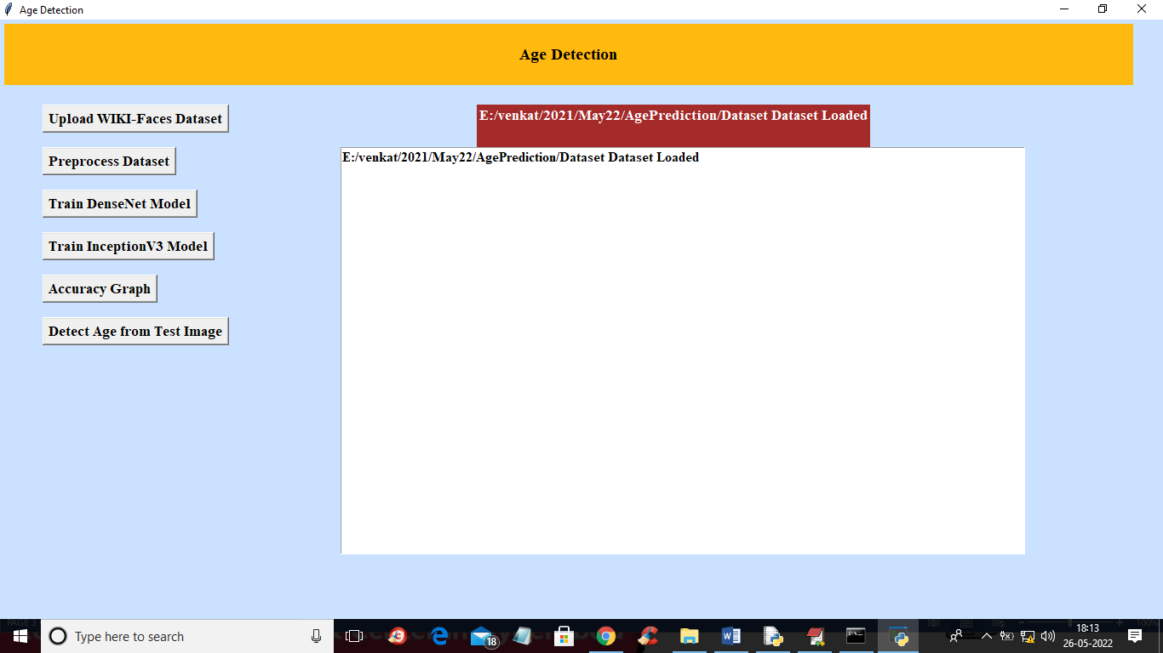
In above screen dataset loaded and now click on ‘Preprocess Dataset’ button to process images like resizing and normalization and then split dataset into train and test
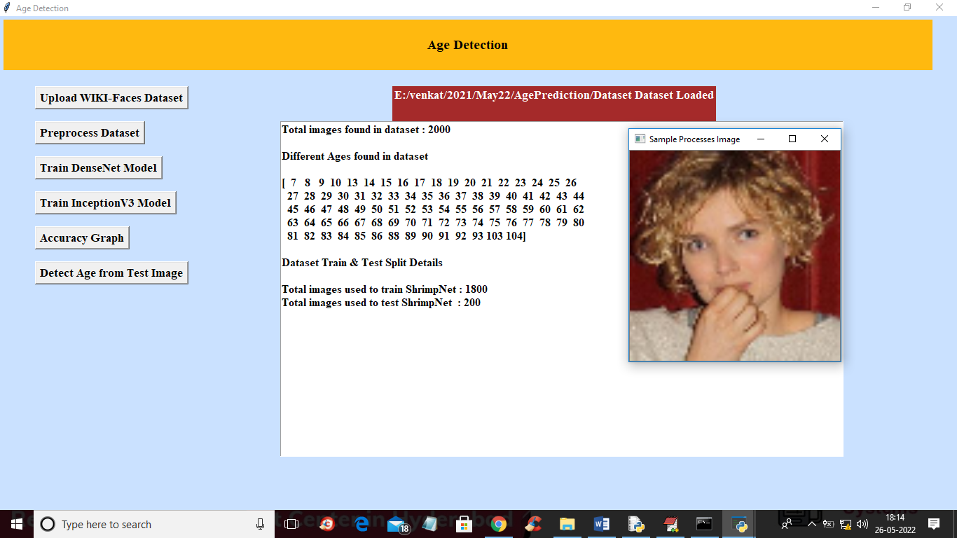
In above screen we can see dataset contains 2000 image and application using 1800 images for training and 200 for testing and we can see different ages peoples found in dataset and then displaying one normalized image to check all images are processed properly and now close above image and then click on ‘Train DenseNet Model’ button to train dense net with above image and get below accuracy
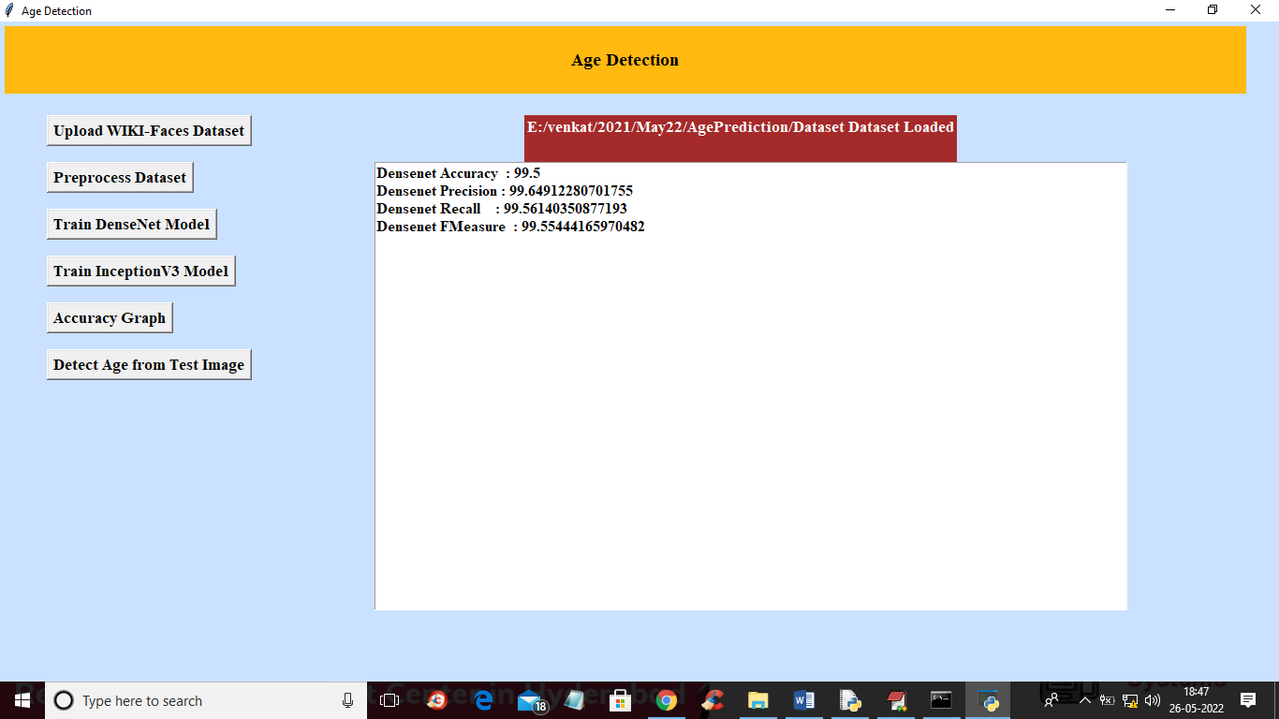
In above screen with DenseNet we got 99% accuracy on test image and now click on ‘Train InceptionV3 Model’ to train inception and get below output
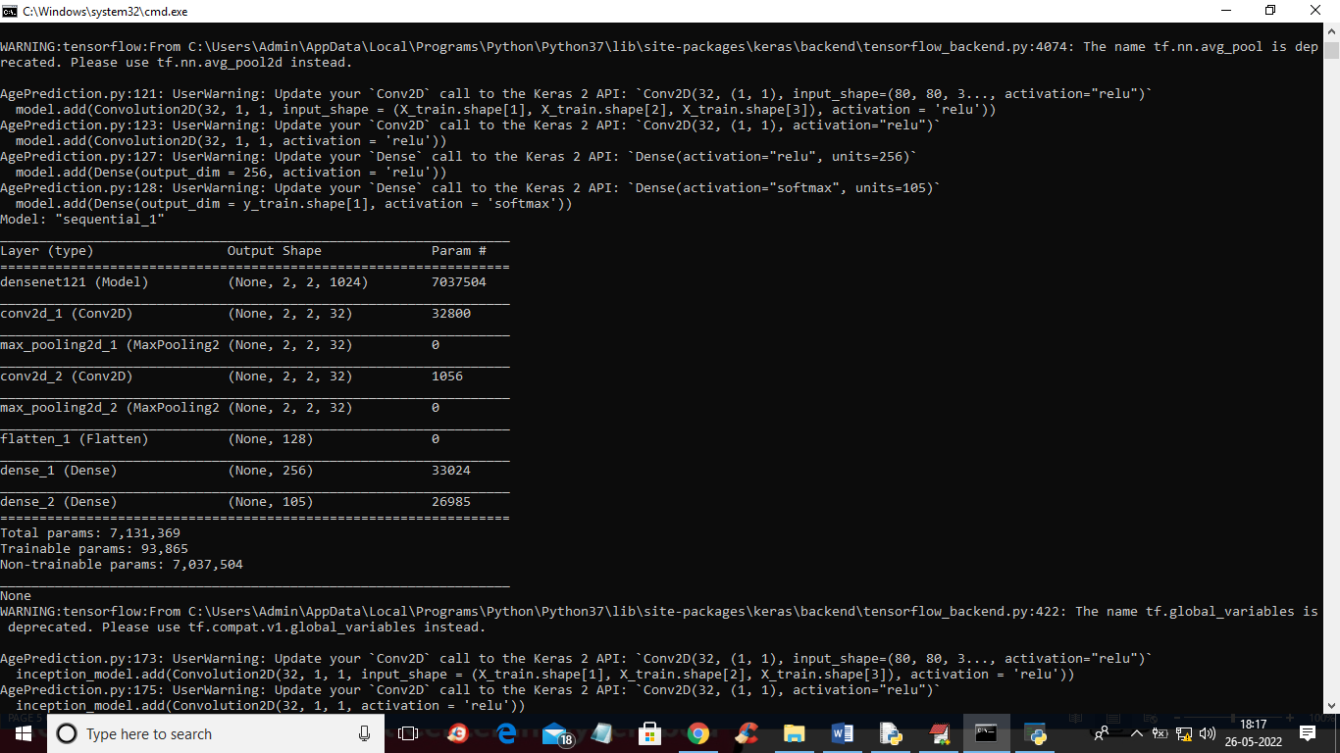
In above screen we can see DenseNet architecture and in below screen we can see InceptionV3 architecture
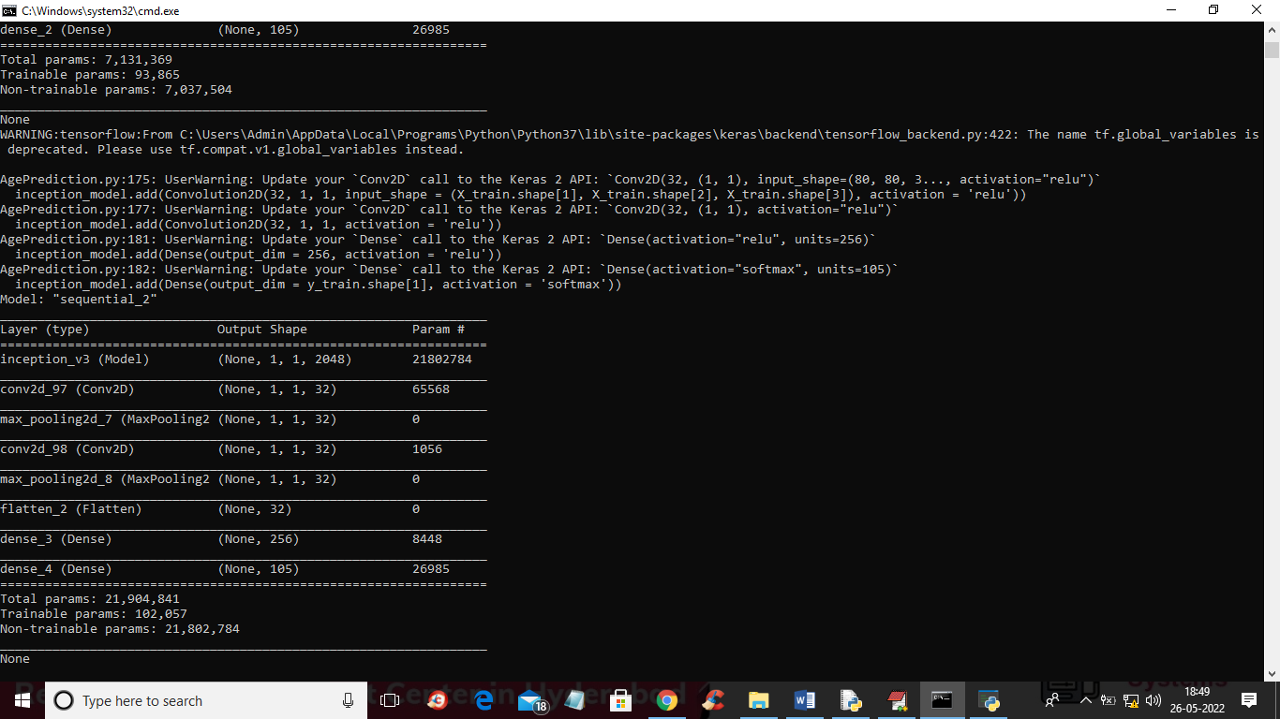
In below screen we can see InceptionV3 accuracy
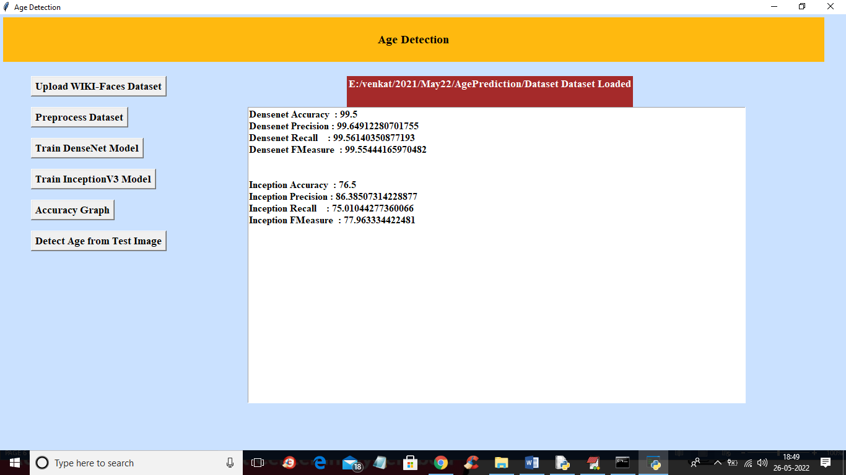
In above screen with InceptionV3 we got 76% accuracy and now click on ‘Accuracy Graph’ button to get DenseNet and InceptionV3 training accuracy and loss graph
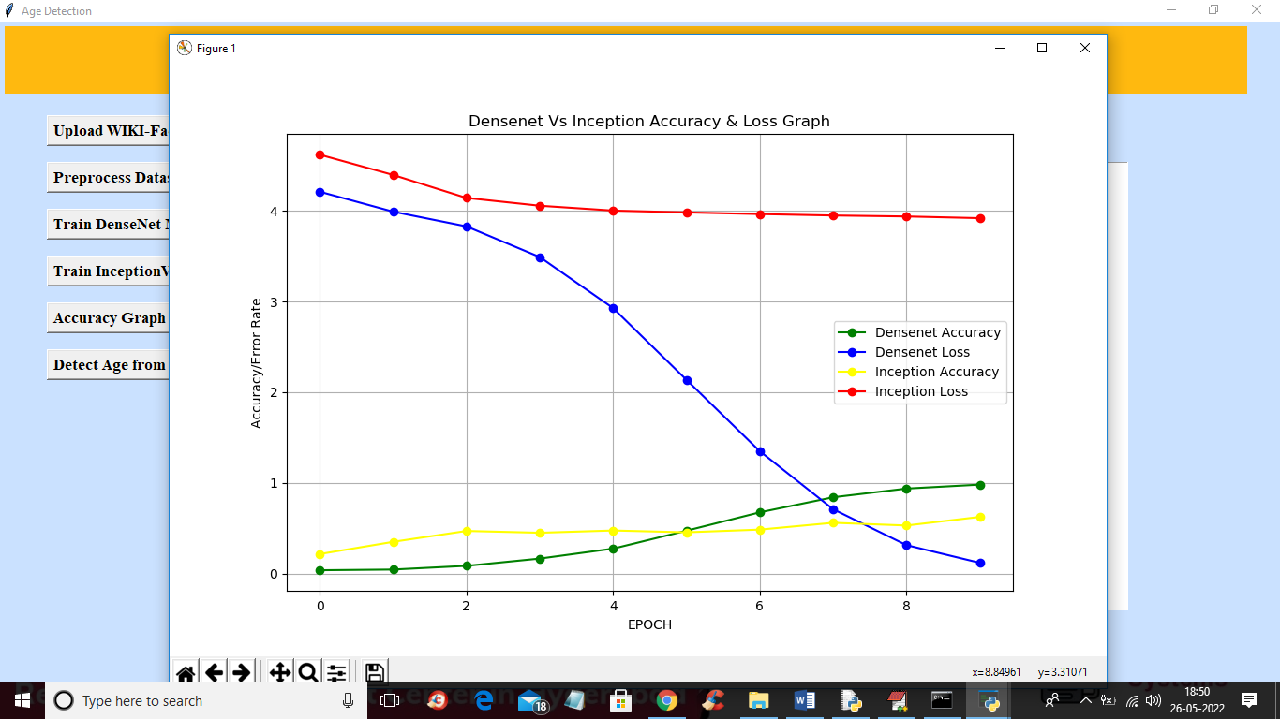
In above graph x-axis represents training epochs and y-axis represents ACCURACY and LOSS values and in above graph green line represents DenseNet accuracy and blue line represents DenseNet Loss and yellow line represents InceptionV3 accuracy and red line represents InceptionV3 LOSS and in above graph we can see with each increasing epoch accuracy got increases and loss got decrease. Now close above graph and then click on ‘Detect Age from Test Image’ button to upload test image and get AGE as prediction
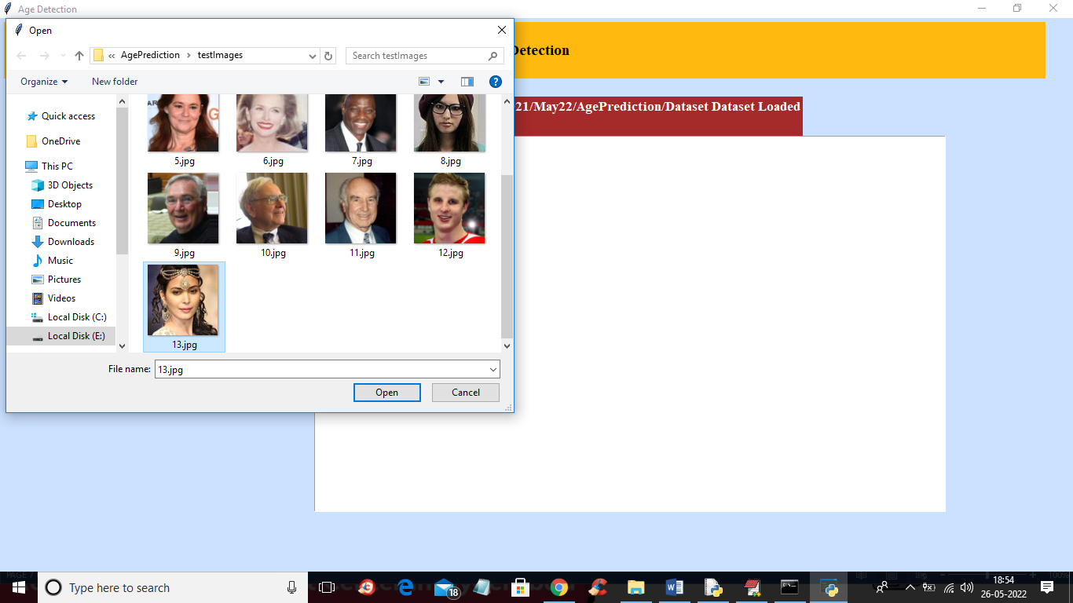
In above screen selecting and uploading 13.jpg image and then click on ‘Open’ button to get below output
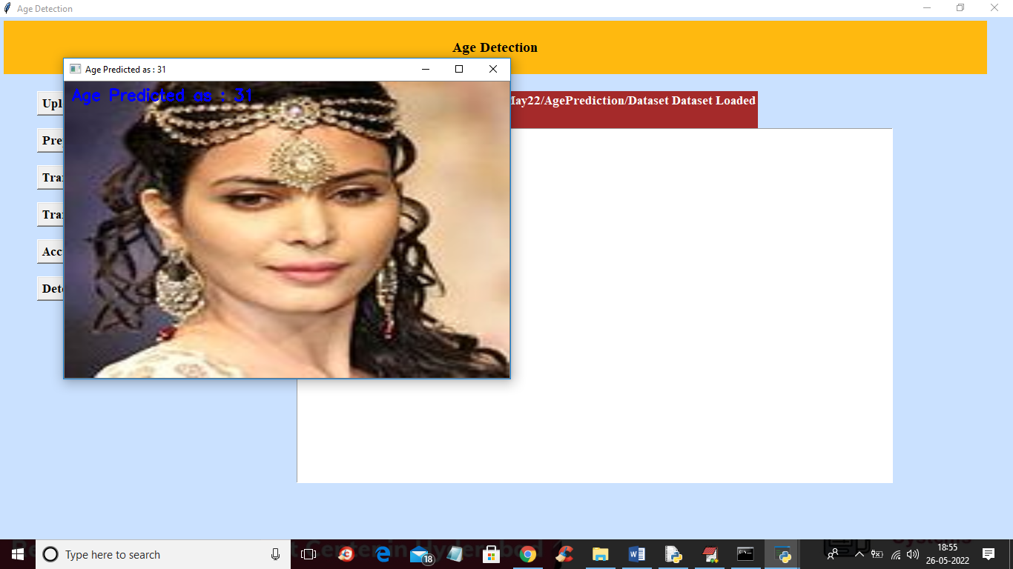
In above screen in blue colour text we can see Age predicted as 31 and similarly you can upload other images and test
