Operating Systems–2: Spring 2024
Programming Assignment 3: Dynamic Matrix Squaring
-Pavankumar shinde
-co22btech11008

low level design:

* all four algorithms, Takes N,K and rowInc and Matrix A as input. Then K threads will created using pthread_create.

* Now every ith thread in out of these K threads will calculated a set of rows of anser values.

* Let N=2048.
K=16
rowInc=16
then every thread will calculate 16 rows of ans matrix.
And last thread will calculated all remaining rows.

* Now which thread will do which set of rows work . Depends on Counter(C).
if at time of Any threads enter in critical section. And now it have Counter=x, then this thread will do work for rows from x to x+rowInc . ( critical section will give value of start and end to each thread.)

* For Four algorithms Critical section is same but their implementaion is different. Different ways of achieving mutual exclusion.

* Once Matrix multiplication done. We can see time required to do it. In std output on terminal.

* Timings are calculated for different experiments. To compare efficiency of these algrithms.

Experiment 1:
Time vs. Size, N:
The y-axis will show the time taken to compute the square matrix in this graph. The x-axis will be the values of N (size on input matrix) varying from 256 to 8192 (size of the matrix will vary as 256*256, 512*512, 1024*1024, ....) .
And we have rowInc=16 and K = 16 for all these experiments.

Time for all algothms for defferent calues of N , computed and written below.

N | TAS | CAS | Bounded CAS | Atomic
256 | 0.0103323 | 0.0137768 | 0.0116005 | 0.00993897
512 | 0.177277 | 0.153623 | 0.1574 | 0.153828
1024 | 1.69275 | 1.5724 | 1.92589 | 1.93376
2048 | 13.8229 | 16.907 | 14.6666 | 16.6361
4096 | 160.173 | 162.569 | 180.58069 | 173.738
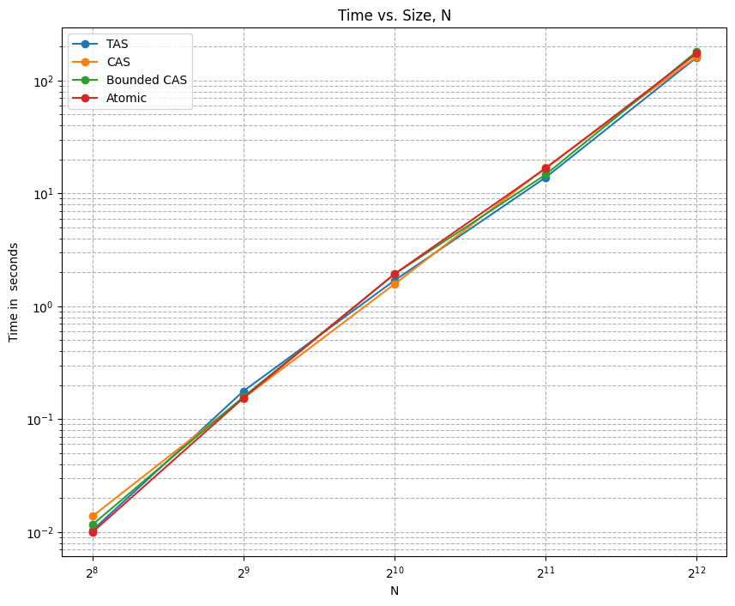

Observations:
1) here for all algorithms time is increaing with increaseing value of N. This is obsvious as . More calculations will required to compute square of larger matrix.

2)Comparing algorithms (From Table above ) ,We can say time is for highest for Bounded CAS and least for Atomic for perticular value of N.

3) This , we can explain as ,due to one extra while loop in bounded CAS as waiting[i]. And Atomic is least as it is simplest as Only two commands.

4)mostly Overall order is:
Atomic timing < TAS < CAS< bounded CAS.

Experiment 2:
Time vs. RowInc
row Increment: Like the previous graph, the y-axis will show the time to compute the square matrix. The x-axis will be the rowInc varying from 1 to 32 (in powers of 2, i.e., 1,2,4,8,16,32).here N = 2048 and K = 16 for all these experiments.

rowInc | T AS | CAS | Bounded CAS | Atomic
1 | 24.6262 | 25.1531 | 23.5888 | 23.9795
2 | 23.3577 | 24.5554 | 23.0393 | 22.0932
4 | 23.1552 | 24.647 | 24.652 | 23.9922
8 | 22.2127 | 23.4124 | 21.8215 | 20.4695
16 | 21.5294 | 22.6335 | 21.0456 | 19.1853
32 | 22.2257 | 20.7523 | 18.62642 | 17.4534

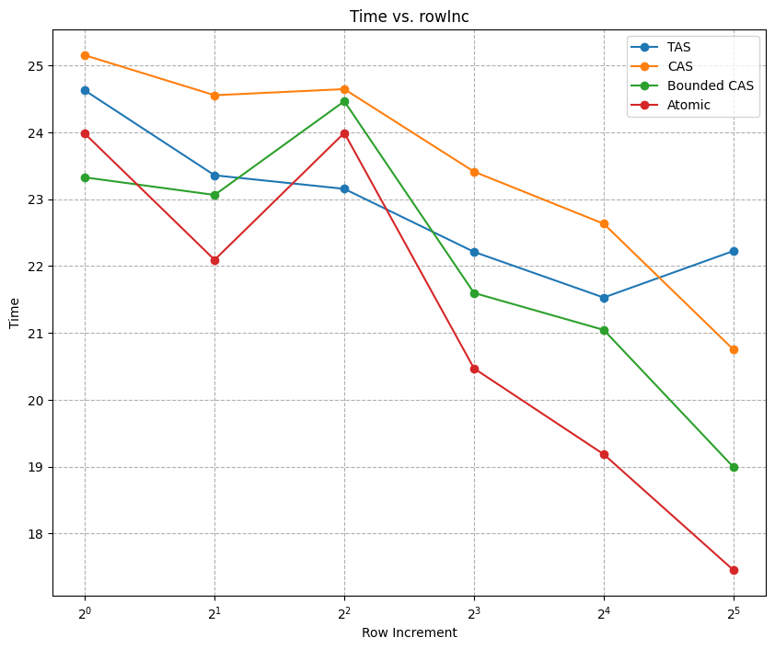

Observations:

1)For all algorithms time is mostly decreasing with increasing row_increment. And it is expected. We can explain as: If rowInc is low then last thread have to compute m ore rows, Result in increase in time.

2) when row_Inc is high all threads will have almost equal work . So total time will be less.

3) Comparing all algrithms for perticular value of row_inc , we can say Atomic time is lowest. And Cas and Bounded CAS timings are high.

`

Experiment 3:
Time vs. Number of threads
Again, like the previous graphs, the y-axis will show the time taken to do the matrix squaring, and the x-axis will be the values of K, the number of threads varying from 2 to 32 (in powers of 2, i.e., 2,4,8,16,32). N=2048 and rowInc =16 for all these experiments.

K | TAS | CAS | Bounded CAS | Atomic
2 | 28.2632 | 22.5071 | 29.5575 | 25.0026
4 | 25.8624 | 22.4825 | 27.864 | 24.2282
8 | 25.1074 | 21.7397 | 27.6184 | 24.3049
16 | 27.26 | 20.1591 | 26.2034 | 21.7255
32 | 19.8821 | 19.0076 | 21.9971 | 19.1006
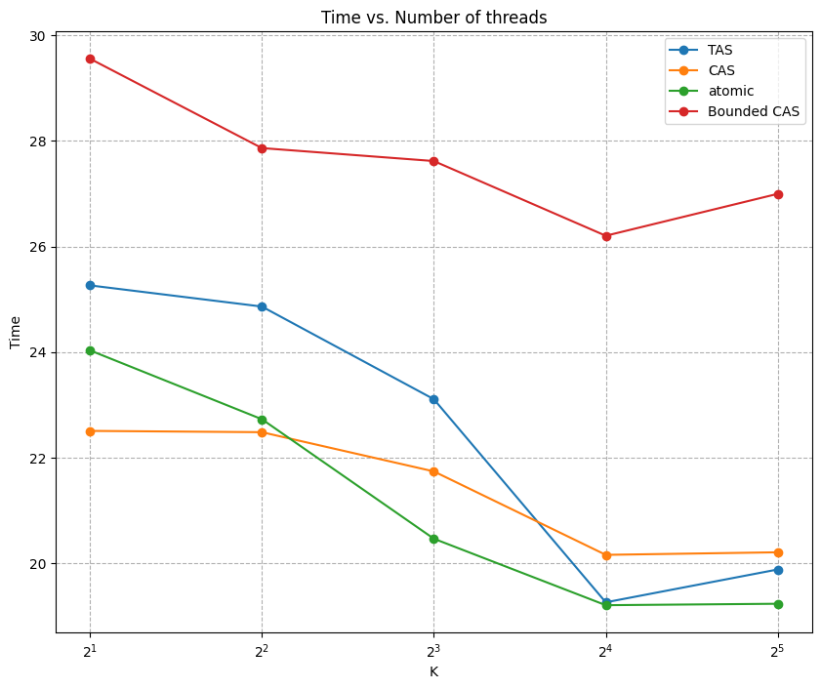

Observations:

1) with increase in number of threads , time is decreaing. As No. Of threads increasing, we have more worker to do same work .

2) We can see across all algorithms , after 16 threads , time is constant or increasing. As my os have handle 16 threads at max. So after 16 time will constant. Or increase to due context swicths. (this is overload)

3) Comparing all algrithms for perticular value of K , we can say Atomic time is lowest. Bounded CAS timings is highest . So Bounnded CAS is heavier than all.

Experiment4:
Time vs. Algorithms
Again, like the previous graphs, the y-axis will show the time taken to do the matrix squaring, and the x-axis will be different algorithms -
a) Static rowInc b) Static mixed
c) Dynamic with TAS d) Dynamic with CAS
e) Dynamic with Bounded CAS f) Dynamic with Atomic.

Static rowInc | static mixed | dynamic Tas | dynamic with Cas | dynamic with Bounded Cas | dynamic with atomic
20.5878 | 23.53152 | 20.4412 | 20.8839 | 20.8301 | 20.4012

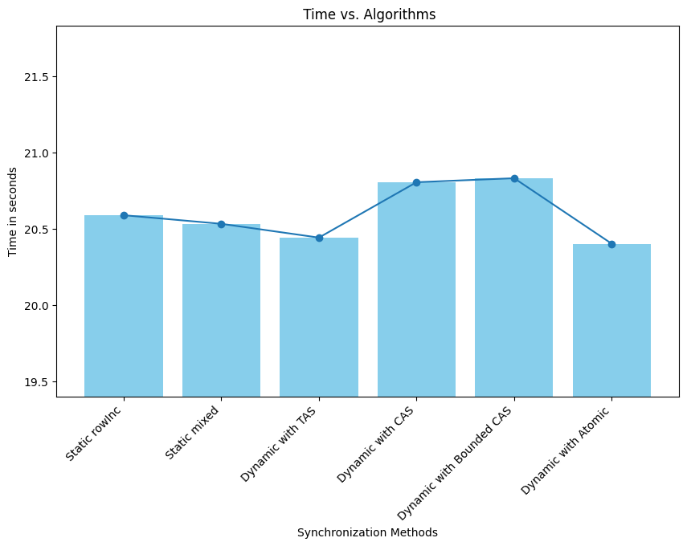

Observations:

1)timings are nearly equal across all six algorithms. But we can have some conclusions like:

2)Atomic takes lowest time as compared to others.whereas Bounded CAS and CAS take highest time among all.

3) comparing static and dynamic. Dont give any conclusion. No specific trend.

Approx. Overall order:
Atomic < TAS<static rowInc<=mixed rowInc <CAS<Bounded CAS.

Conclusion:
dynamic Atmoic mutual exclusion is most efficient and Bounded CAS is least efficient.

THANK YOU....

