->Blog-Scalable Appliaction using Angualar and Asp.Net Core

-> Angular CLI

-> Bootstrap CSS for reponsive front ends

->Angular Components

-> Angular Services - to make https calls an learn CORS

->RxJs - Observables, subjects, subscriptions

->CRUD by creating angular forms in the app

->upload images-> Reusable image selector component

Backend

-> Rest web Api

-> Domain driven design

-> Create End points, Action methods &CRUD on our domain model

-> Enitiy frmework core to creste database

-> EF realtionships

->Repository Pattern and Async Progr in API

-> Authe And Autho in API and UI

->use ASP.NET identity to create Identity tokens from our API so that our Angular APP can use jsw token to make Auth calls.

->interceptos and Auth guad..

Tools

Dotnet sdk, runtime

Asp.net dev, .net desktop dev, data storage & proce, node js

Extensions fro Vs code: path intesllisense, intellisnense for css, angular language service . eslint, angular snippt, css formatter,

Concepts:

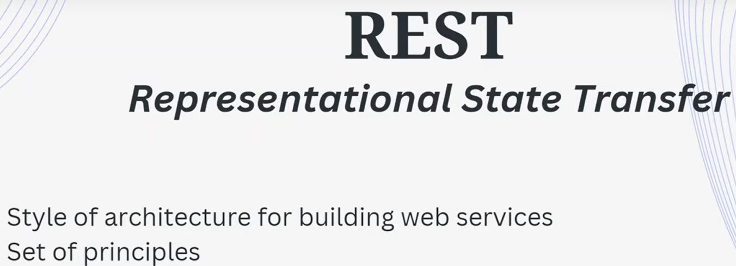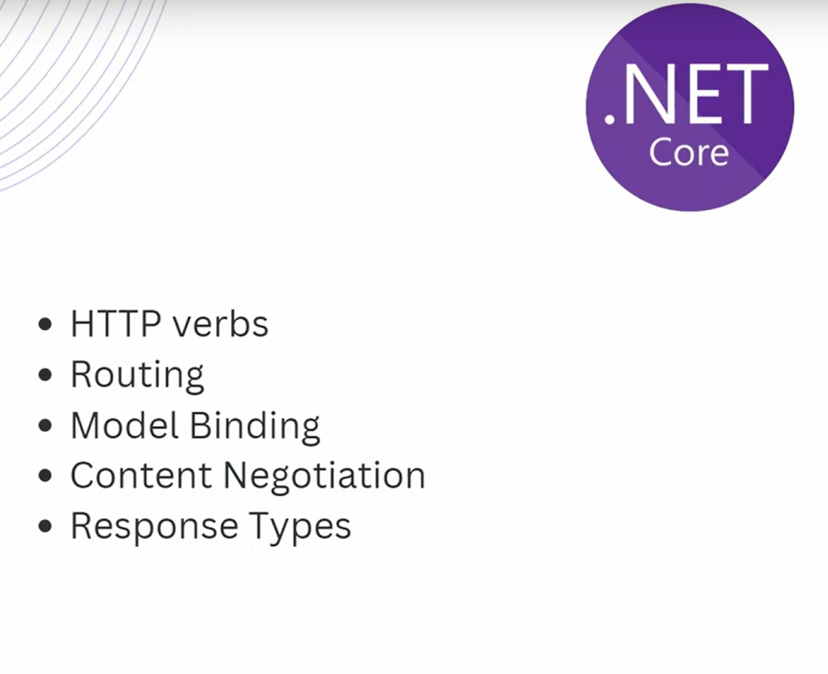

1.HTTP verbs: get, post, pull. Delete, Patch and options.

2. Routing in ASP.NET CORE

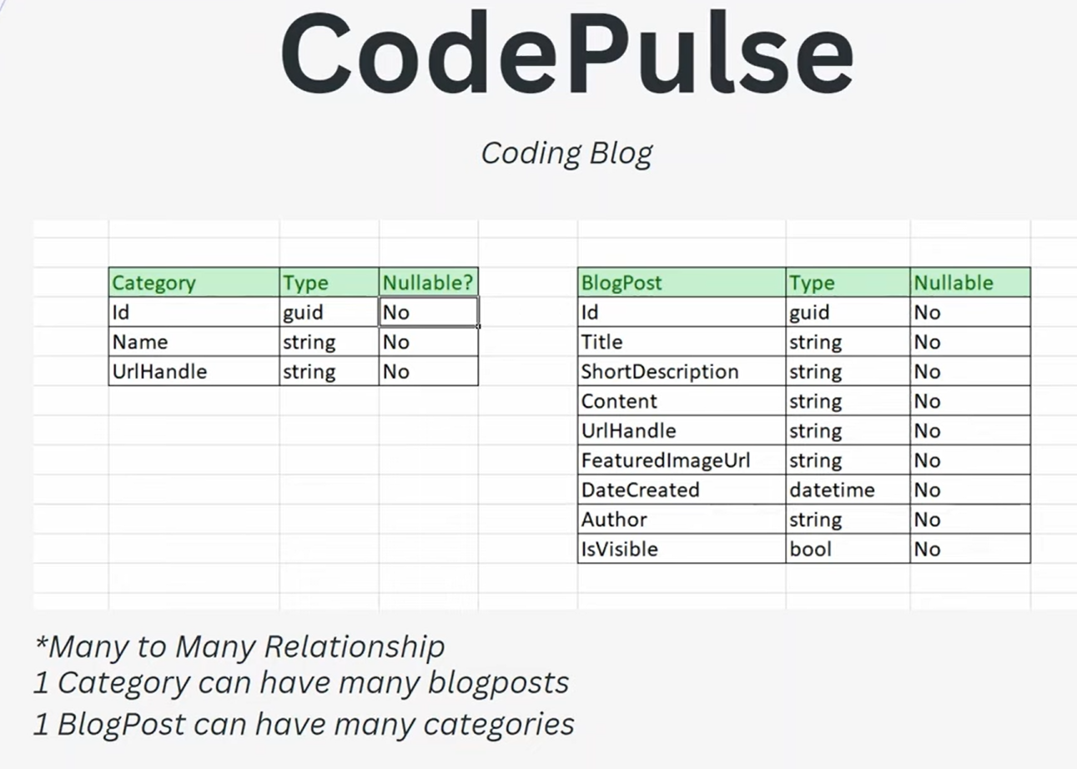

DbContext Class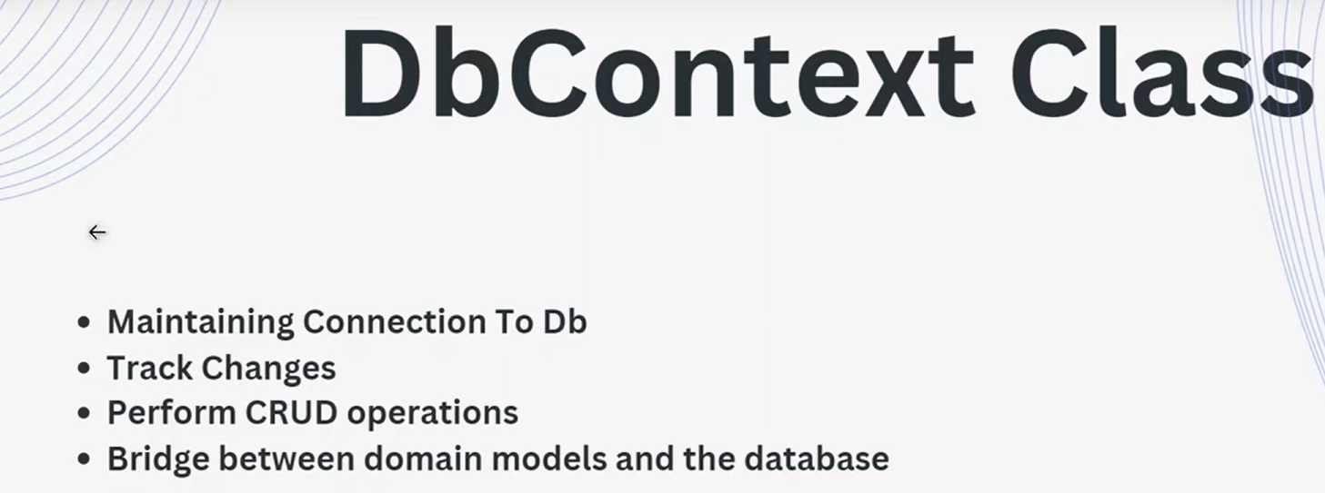

Add conection String-

"AllowedHosts": "*",

 "ConnectionStrings": {

   "CodePulseConnnectionString": "Server=PAVANKUMAR;Database=CodePulseDb;TrustServerCertificate=True;Trusted_Connection=True"

 }

Dependency Injection->

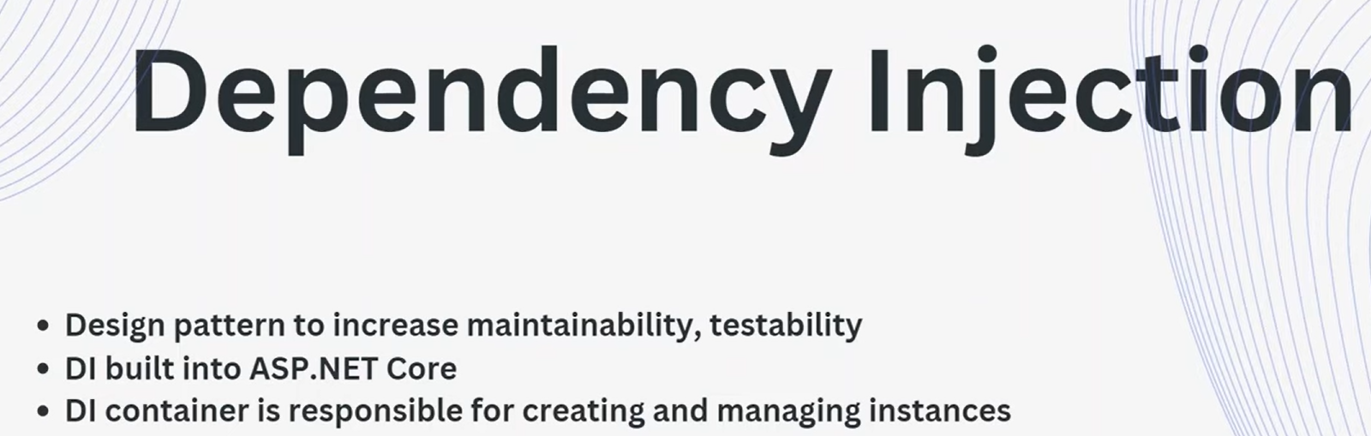

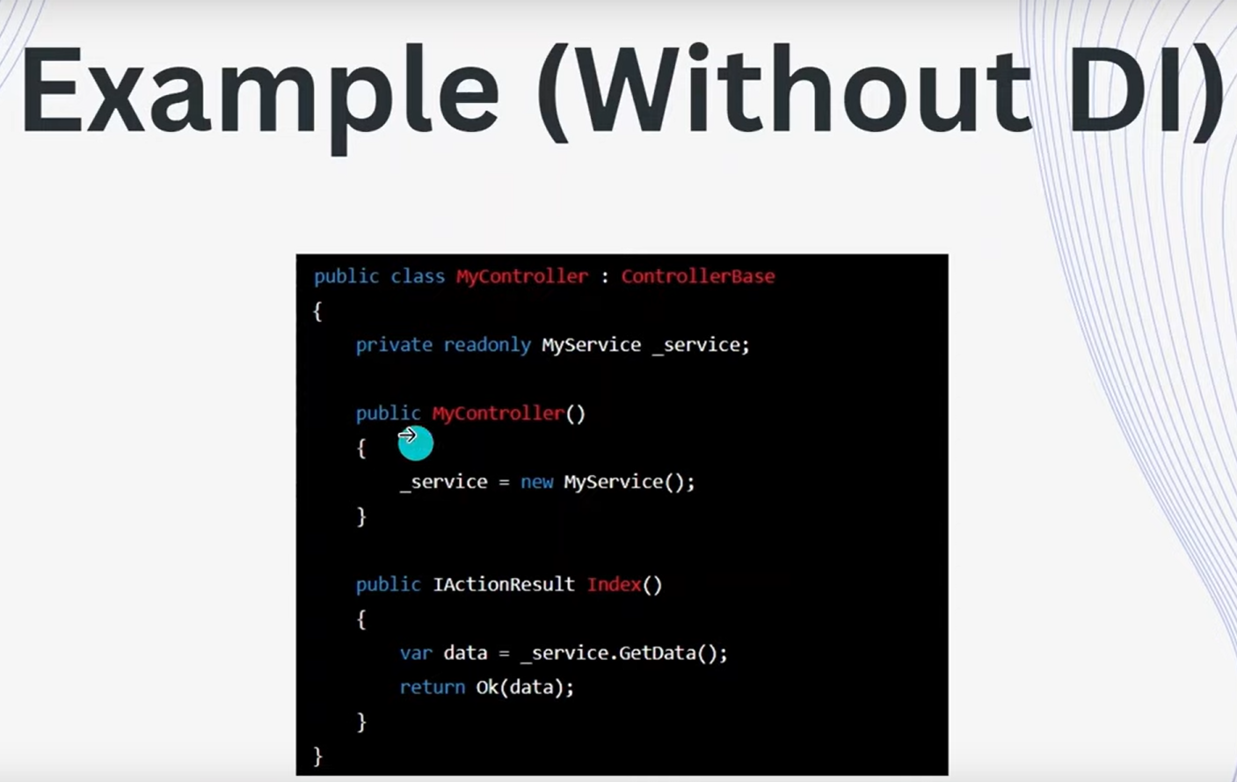

Running Ef core Migrations

commands

1. Add migration “Initial Migration”
2. Update-database

Crate controller and Actions - get, post, update and delete

* Dto s and domaim models
* 

