Game Design Document

Fill up the Following document

1. Write the title of your project.

The Hero

1. What is the goal of the game?

To save a baby falling from building

1. Write a brief story of your game?

First a person will be walking he stops to have a cup of tea.

While drinking tea he sees a baby crawling from top floor then

He identified that she/he was in danger so he soon reacts and uses

Physics to save the baby.

1. Which are the playing characters of this game?

* Playing characters are the ones which respond to the user based on the input from the user
* Cars, monkeys, dinos, wizards etc, are the playing characters in the game.

|  |  |  |
| --- | --- | --- |
| Number | Character Name | What can this character do? |
| 1 | The Man | He Runs and catches the baby |
| 2 |  |  |
| 3 |  |  |
| 4 |  |  |
| 5 |  |  |
| 6 |  |  |
| 7 |  |  |
| 8 |  |  |

1. Which are the Non Playing Characters of this game?

* Non Playing characters are the ones which don't have an action or a behaviour when the user interacts with the game.
* Hurdles, stones, bananas, coins, etc are non playing characters in the game.

|  |  |  |
| --- | --- | --- |
| Number | Character Name | What can this character do? |
| 1 | baby | She will be crawling and slips from edge. |
| 2 |  |  |
| 3 |  |  |
| 4 |  |  |
| 5 |  |  |
| 6 |  |  |
| 7 |  |  |
| 8 |  |  |

Draw your imagination of this game. What does this game look like?

* Draw the game either on your computer or on paper,
* Add images of scenes of the game to show each of the playing and non-playing characters at least once.

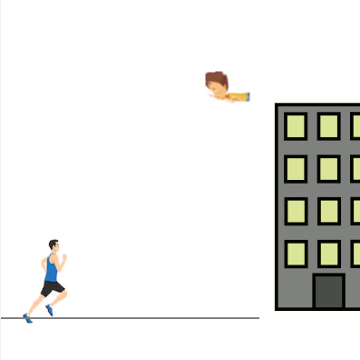

How do you plan to make your game engaging?

While playing there are adaptive music, people will try to save the baby in

different type of scenarios .