1) a) What is Virtualization?
- Virtualization is the process of abstracting physical resources into a pool of virtual resources.
- These virtual resources can then be allocated to Virtual Machines (VMs).
The different resources that can be virtualized include: Memory, Processors, Storage, Network, Data, and Application.
b) List out the benefits of virtualization?
- Better resource utilization
- Increases ROI
- Dynamic data center
- Supports green IT
- Eases administration
- Improves disaster recovery
c) What are the different approaches to Virtualization?
Approaches to Virtualization
- Protection rings are used to isolate the OS from untrusted user applications.
- In protection ring architecture, the rings are arranged in hierarchical order from Ring 0 to Ring 3.
- Ring 0 → contains the most privileged programs.
- Ring 3 → contains the least privileged programs.
- Highly trusted OS instructions run in Ring 0 and have unrestricted access to physical resources.
- Ring 3 contains untrusted user applications and has restricted access to resources.
- Ring 1 and Ring 2 are allotted for device drivers.
- Protection ring architecture restricts misuse of resources and malicious behavior of user programs.
- Depending on the type of virtualization, the hypervisor and guest OS will run at different privilege levels.
- Normally, the hypervisor runs at Ring 0 (most privileged).
- The guest OS runs at a lower privilege than the hypervisor.
The three types of approaches are:
- Full virtualization
- Para virtualization
- Hardware-assisted virtualization

Full Virtualization
- The guest OS is fully abstracted from the real hardware.
- The virtual machine manager (VMM) or hypervisor separates the guest OS from the infrastructure.
- The guest OS does not know it is virtualized – it thinks it runs on real hardware.
- Hypervisor (VMM) runs at Ring 0 (highest privilege).
- Guest OS runs at Ring 1 (lower privilege than hypervisor).
- User applications run at Ring 3 (least privilege).
- The OS cannot talk directly to physical hardware – it must go through the hypervisor.
Uses two techniques:
  - Binary translation → translates guest OS instructions into safe instructions for virtual hardware.
  - Direct execution → allows user applications to directly use resources without changes.
Pros
- This approach provides the best isolation and security for the VMs.
- Different OSs can run simultaneously.
- The virtual guest OS can be easily migrated to work in native
hardware.
- It is easy to install and use and does not require any change in the guest OS.

Cons
- Binary translation is an additional, overhead, and it reduces the
- overall system performance.
- There is a need for correct combination of hardware and software
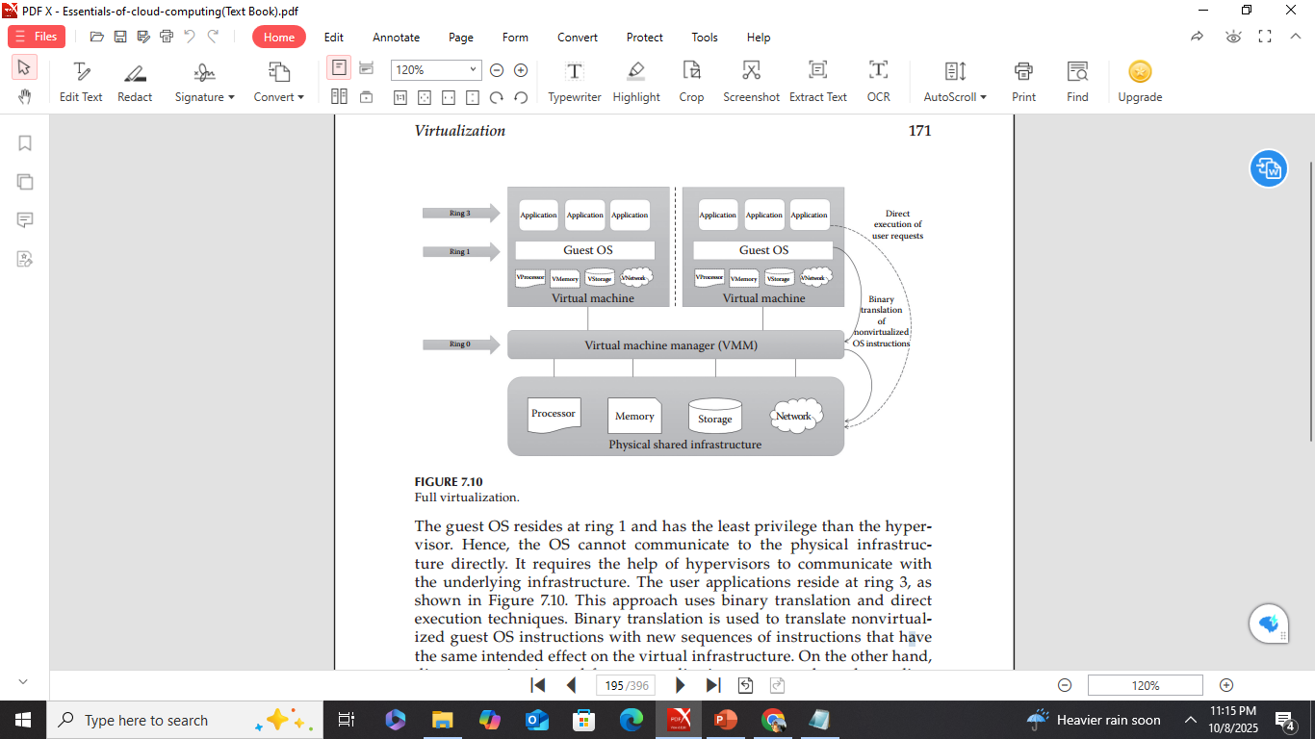

Paravirtualization
- Also called partial virtualization or OS-assisted virtualization.
- Provides partial simulation of the underlying infrastructure.
- Main difference from full virtualization:
  - In full virtualization, the guest OS does not know it is virtualized.
  - In paravirtualization, the guest OS knows it is in a virtualized environment.
- Instead of binary translation, hypercalls are used.
  - Hypercalls = like system calls, allow direct communication between guest OS and hypervisor.
- This direct communication improves performance and efficiency.
- In full virtualization → guest OS runs unmodified.
- In paravirtualization → guest OS must be modified to replace certain instructions with hypercalls.
Architecture:
  - Modified guest OS runs at Ring 0.
  - User applications run at Ring 3.
- Guest OS at Ring 0 can communicate directly with the hypervisor via hypercalls.
- Like full virtualization, user applications can access hardware directly.
Pros
- It eliminates the additional overhead of binary translation and hence improves the overall system efficiency and performance.
- It is easier to implement than full virtualization as there is no need
for special hardware.
Cons
- There is an overhead of guest OS kernel modification.
- The modified guest OS cannot be migrated to run on physical hardware.
- VMs suffer from lack of backward compatibility and are difficult to migrate to other hosts.
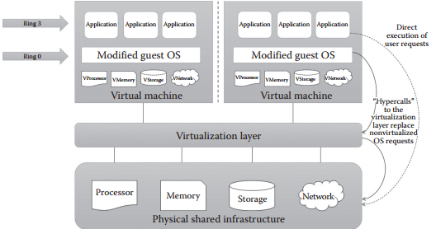

Hardware-Assisted Virtualization
- In full and paravirtualization, there is overhead due to binary translation or modifying the guest OS.
- In this approach, hardware vendors (Intel, AMD) provide built-in support for virtualization → reduces overhead.
- Examples: Intel VT-x, AMD-V
- VT-x uses virtual machine control structures.
- AMD-V uses virtual machine control blocks.
- VMM (hypervisor) has the highest privilege (root privilege) even below Ring 0.
- OS runs at Ring 0, and user applications at Ring 3.
- In this method, guest OS and applications share the same non-root privilege level.
- Removes the need for binary translation or OS modification.
- OS requests go directly to the hypervisor (trapped without translation).
- User requests are executed directly, just like in other virtualization approaches.
Pros
- It reduces the additional overhead of binary translation in full
virtualization.
- It eliminates the guest OS modification in paravirtualization.
Cons
- Only new-generation processors have these capabilities. All
x86/x86_64 processors do not support hardware-assisted
virtualization features.
- More number of VM traps result in high CPU overhead, limited scalability, and less efficiency in server consolidation.

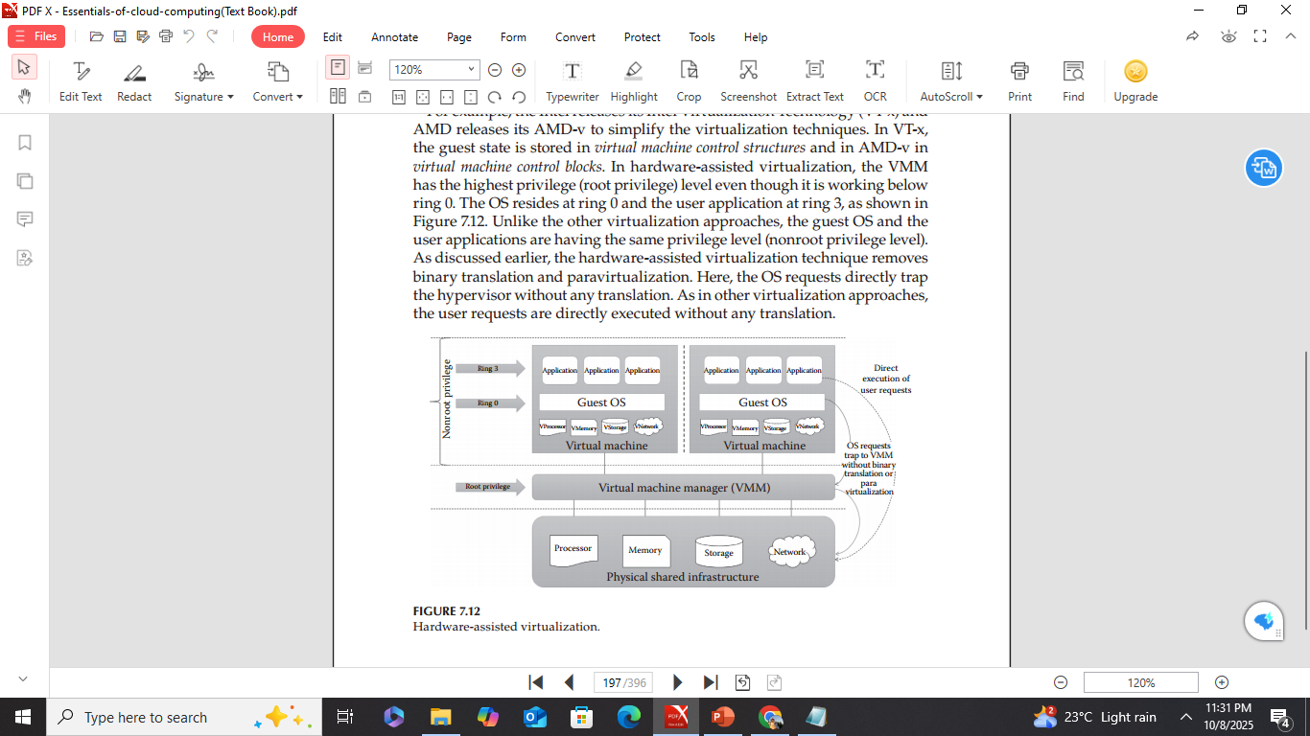
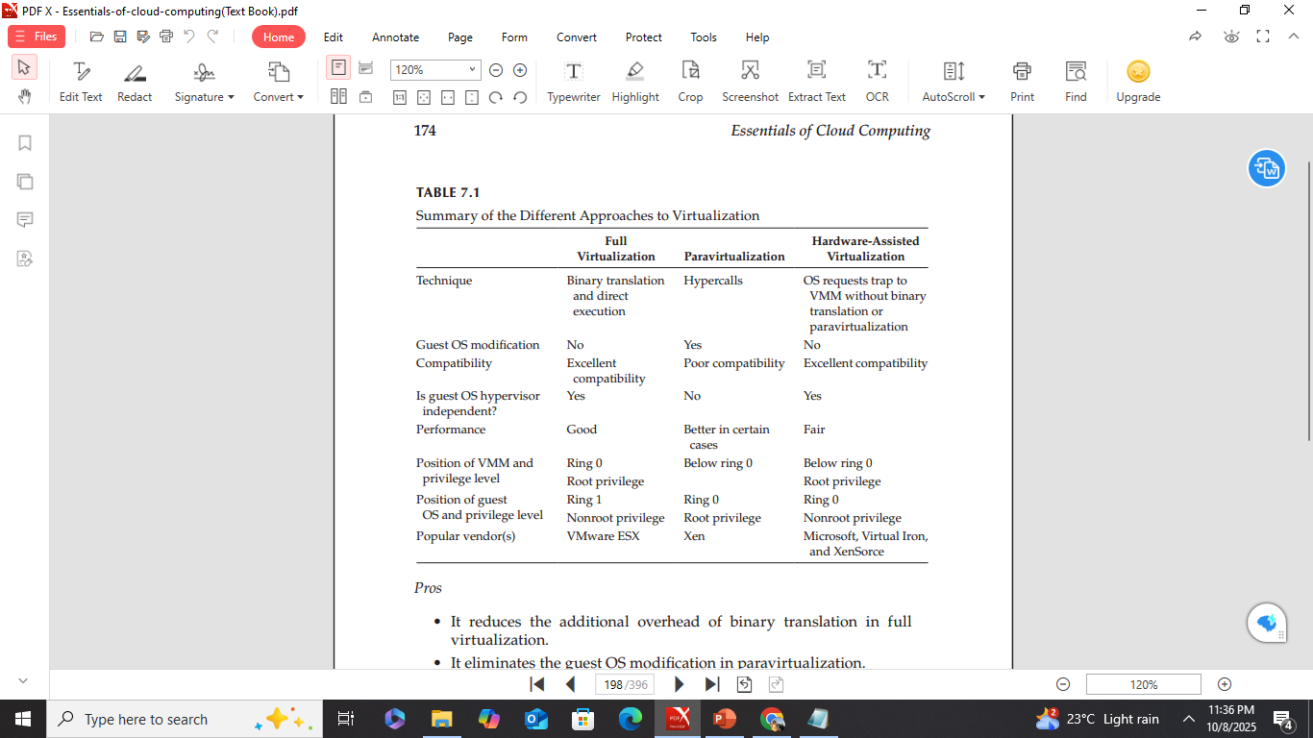
2)a) What are the drawbacks of Virtualization?
- Single point of failure
- Demands high-end and powerful infrastructure
- May lead to lower performance
- Requires specialized skill set
b) Define Hypervisor?
Hypervisors are the software tool that sits in between VMs and physical infrastructure and provides the required virtual infrastructure for VMs.
c) Explain in detail about any 3 virtualization opportunities?
Virtualization Opportunities
- Virtualization is the process of abstracting physical resources into a pool of virtual resources.
- These virtual resources can then be allocated to Virtual Machines (VMs).
The different resources that can be virtualized include: Memory, Processors, Storage, Network, Data, and Application.
Processor Virtualization
- Processor virtualization lets VMs share virtual processors.
- These virtual processors are abstracted from physical processors.
- The virtualization layer (hypervisor) creates the pool of virtual processors.
- Processor virtualization can be done using a single hardware or distributed servers.

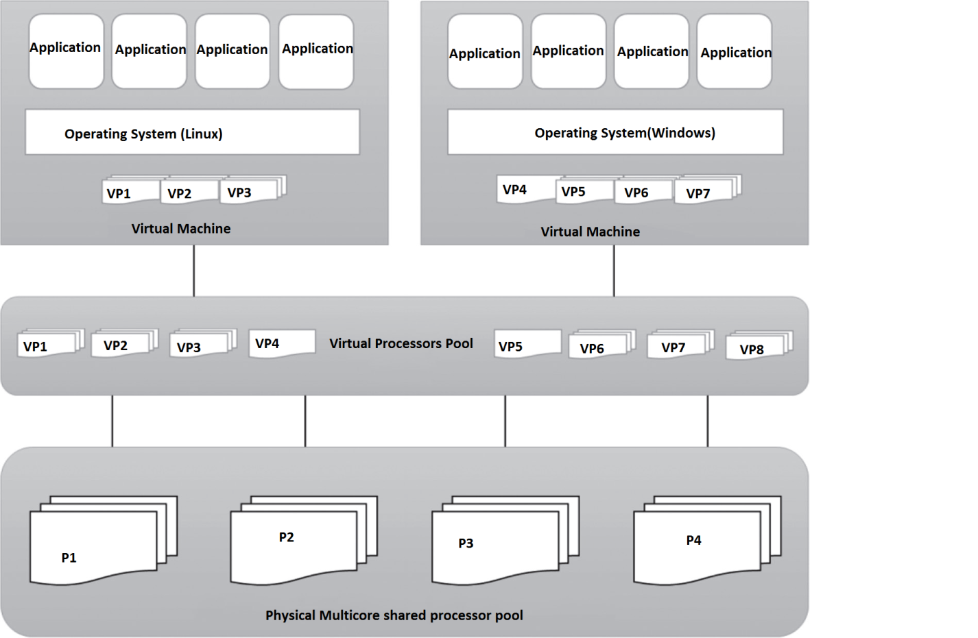
Memory Virtualization
- A resource virtualization technique that gives virtual main memory to VMs.
- Physical main memory is mapped to virtual memory, like in OS virtual memory.
- Main idea: map virtual page numbers to physical page numbers.
- All modern x86 processors support memory virtualization.
- Can also be done using hypervisor software.
- In virtualized data centers, unused memory from servers is combined into a virtual memory pool for VMs.
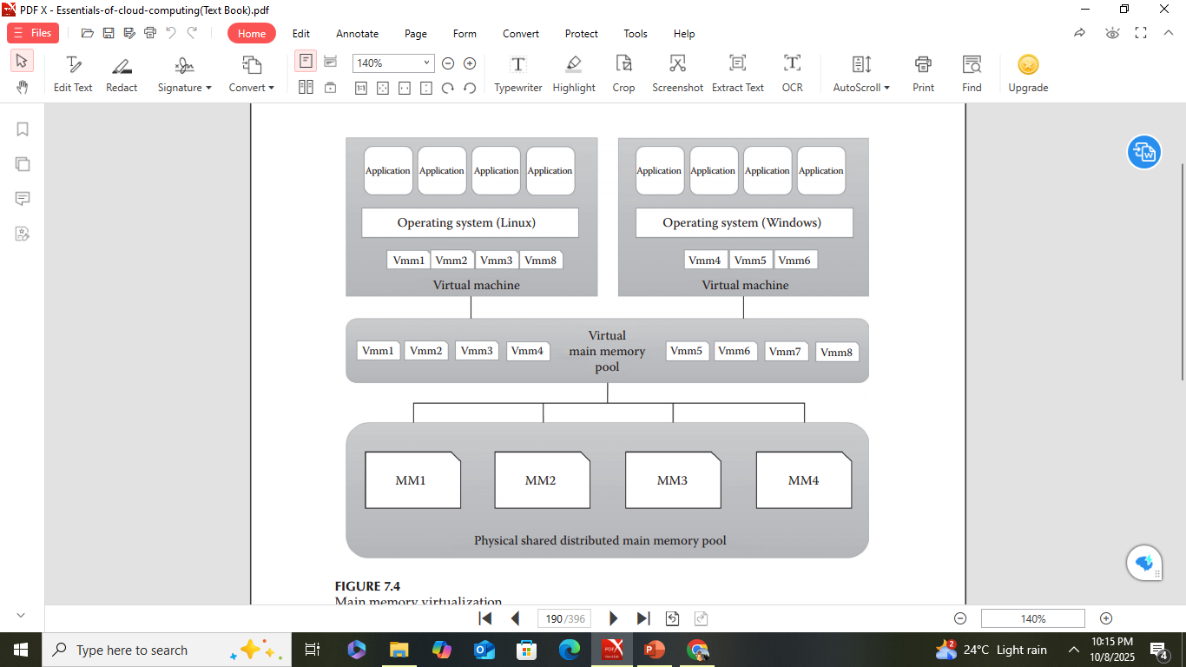

Storage Virtualization
- A type of resource virtualization where many physical disks are combined into a pool of virtual storage for VMs.
- This virtualized storage is called logical storage.
- Mainly used for backup or replica of data stored on VMs.
- Supports high availability of data.
- Can be achieved through hypervisors.
- Makes efficient use of physical storage.
- Advanced techniques: Storage Area Networks (SAN) and Network-Attached Storage (NAS).

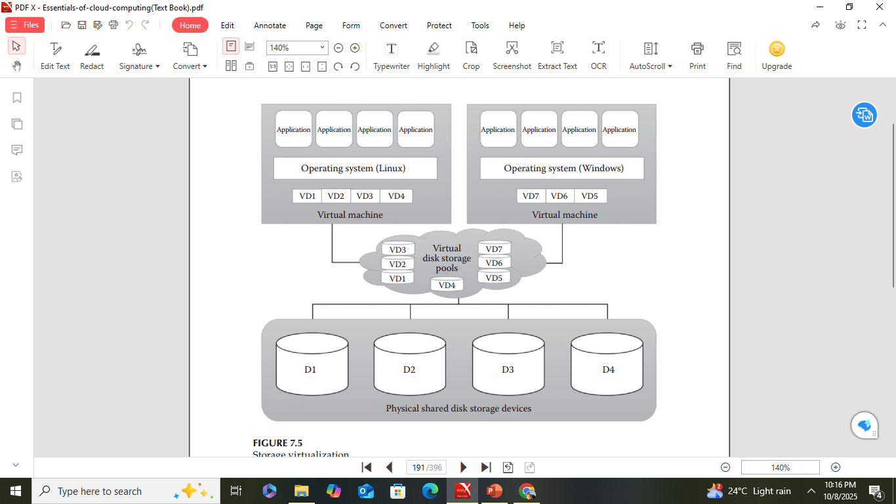

3)a) List out the types of Hypervisors?
Hypervisors are generally classified into two categories:
- Type 1 or bare metal hypervisors
- Type 2 or hosted hypervisors
b) What are the two possibilities of attacking the hypervisor?
The two possibilities of attacking the hypervisor
1. Through the host OS
2. Through the guest OS
c) List the best practices to keep the Hypervisor secured?
Most of the attacks on the hypervisor are through the host OS or the guest OS. So, the OS should be protected from the malicious attacker or the hypervisors should be protected from the compromised OSs. There are several best practices to keep the hypervisor secured:

- Update the hypervisor software and the host OS regularly.
- Disconnect the unused physical resources from the host system or hypervisor.
- Enable least privilege to the hypervisor and guest OS to avoid the attacks through unauthorized access.
- Deploy the monitoring tools in the hypervisor to detect/prevent malicious activities.
- Strong guest isolation.
- Employ mandatory access control policies.

d)How can we prove that Virtualization and Cloud computing are different?
Many users of current IT solutions consider the technologies virtualization and cloud computing as the same. But both technologies are actually different, or in other words, we can say virtualization is not cloud computing. We can prove this claim with the following parameters:
1. Type of service: Generally, virtualization offers more infrastructure services rather than platform and application services. But cloud computing offers all infrastructure (IaaS), platform (PaaS), and software (SaaS) services.
2. Service delivery: The service delivery in cloud computing is on-demand and allows the end users to use the cloud services as per the need. But virtualization is not made for on-demand services.
3. Service provisioning: In cloud computing, automated and self-service provisioning is possible for the end users, whereas in virtualization, it is not possible and a lot of manual work is required from the providers or system administrator to provide services to the end users.
4. Service orchestration: Cloud computing allows the service orchestration and service composition to meet end user requirements. Some providers are also providing automated service orchestration to the end users. But in virtualization, orchestrating different service to get composite services is not possible.
5. Elasticity: One of the important characteristics that differentiate cloud computing from virtualization is elasticity. In cloud computing, we can add or remove the infrastructure dynamically according to the need, and adding or removing the infrastructure is automatic. But virtualization fails to provide elasticity as stopping and starting a VM is manual and is also difficult.
6. Targeted audience: The targeted audience of these two technologies is also different. Cloud computing targets the service providers for high resource utilization and improved ROI. At the same time, it also facilitates the end users to save money by using on-demand services. In the case of virtualization, the targeted audience is only the service providers or IT owners, not the end users.

4) a)List some examples for Type 1 Hypervisors?
Examples of type 1 hypervisors include Microsoft Hyper-V, Citrix XenServer, VMWare ESXi, and Oracle VM Server for SPARC.
b) Which formula depicts the exact operation for Map Function?
A map function works on a single document. The following formula depicts the exact operation:
Map (Key1, Val1) ->List (Key2, Val2)
The list of key/value pair obtained is subsequently sent to the reduce function.
c) Explain in detail about Cloud Haskell?
Cloud Haskell: Functional Programming
- Cloud Haskell is built on the Haskell functional programming language.
- Functional programming works like mathematical functions — the output depends only on the input.
- It uses immutable components, meaning their state cannot be changed after creation.
- These immutable components are the foundation of Cloud Haskell.
- Cloud Haskell is a domain-specific language (designed for a specific purpose).
Programming Model
- The programming model is based on a message-passing interface.
- It is suitable for reliable and real-time applications.
- It follows a concurrent programming style — many processes run at the same time.
- The cloud has many users and applications, so concurrency helps handle many requests efficiently.
- Each application is independent, and data are isolated — one cannot access another’s data.
- Communication happens only through message passing.
- A cost model is used to measure data movement between processes.
Main Features and Advantages
- Uses Erlang’s fault tolerance concept.
- Pure functional language — all data are immutable by default.
- Functions are idempotent, meaning they can restart automatically if stopped due to an error, without needing outside help.
Fault Tolerance
- Failures can happen often in cloud systems as the number of users and nodes increases.
- Normally, systems restart completely after failure — this is inefficient for large clouds.
- Cloud Haskell uses Erlang’s method, allowing individual functions to restart separately without affecting others.
- Components are immutable and called pure functions.
Cost Model and Serialization
- Cloud Haskell introduces a new cost model (not present in Haskell).
- It calculates communication cost between processes.
- The model does not use shared memory.
- Each process is isolated, so if one fails, others continue (ensuring fault tolerance).
- Adds new features like serialization, allowing distributed code to run on remote systems automatically.
- This process is fully abstract — the programmer doesn’t have to handle it manually.
Key features
- Fault tolerant
- Domain-specific language
- Uses concurrent programming paradigm
- No shared memory
- Idempotent
- Purely functional
d) Write short notes on Map Reduce?
MapReduce is a parallel programming model developed by Google.
- It has a specific impact on the area of parallel computing and cloud computing.
- It uses a parallel programming paradigm for the computation of a large amount of data.
- The data are partitioned or segregated into several pieces.
- These pieces are processed in parallel.
- The results are then combined to generate a single result.
- These processes are called map and reduce, respectively.
- The PaaS called Aneka also uses MapReduce with the .NET platform .
- The first step involves segregation of large data and sending it to the map function.
- The map function performs the map operation on data.
- Then, the data are sent for the reduce operation, where the actual results are obtained.
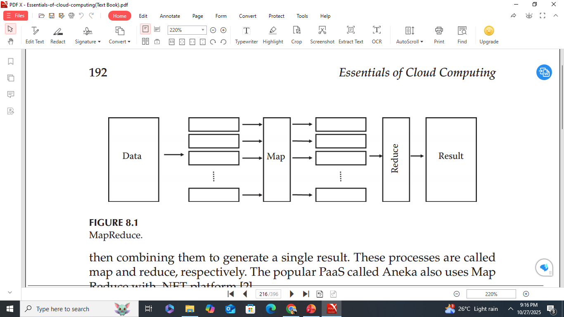
Map Function
- The large data are traced and segregated as key/value pairs.
- The map function accepts the key/value pair and returns an intermediate key/value pair.
- Usually, a map function works on a single document.
Formula for operation:
Map(Key₁, Value₁) → List(Key₂, Value₂)
- The list of key/value pairs obtained is subsequently sent to the reduce function.
Reduce Function
- After the map function, a sort and merge operation is applied on the key/value pairs.
- Usually, the reduce function works on a single word.
- The input consists of distinct key/value pairs, and it returns a group with the same key/value pair.
Formula for operation:
Reduce(Key₂, List(Value₂)) → List(Value₃)
- The resultant values give the final set of results.
- Key Features of MapReduce-
Supports parallel programming,
Fast,
Can handle a large amount of data
Example
- The most popular example is counting the words in a file.
- In the first step, words (keys) are assigned values (counts).
- The word represents the key, and the count represents the value.
- Whenever a word is encountered, a key/value pair is generated.
- This set of <word, count> pairs from the map function is sent to the reduce function.
- The result is sorted, and the reduce function combines all words with the same key.
- The count (value) is added for each pair obtained.
- The final result gives each word with its count.
5)a) What is the role of middleware in cloud computing?
Middleware acts as a bridge between applications and cloud infrastructure, managing communication and resources.
b) List out the key features of Cloud Haskell?
Key features
- Fault tolerant
- Domain-specific language
- Uses concurrent programming paradigm
- No shared memory
- Idempotent
- Purely functional
c) Explain in detail about the suitability of Saas?
Suitability of SaaS
SaaS is cost-effective and widely used by individuals and organizations, including large enterprises. However, it is not suitable for all types of applications.
SaaS May Not Be Suitable
- For real-time applications that need very fast data processing.
- When an organization has highly confidential data and doesn’t want to store it outside their system.
- When existing on-premise software already meets the organization’s needs.
SaaS Is the Best Option
- When users need on-demand software instead of buying full licenses.
- For start-ups that cannot afford expensive licensed software.
- For applications that must be accessible on mobile devices or thin clients.
- For applications with unpredictable or changing workloads.

d)List some of the benefits of Saas?
Benefits of SaaS
SaaS gives customers a low-cost, on-demand, and easy way to use software without needing to buy or install it.
It is also simple to adopt and connect with other software.
1. Pay per Use
- Users pay only for what they use.
- SaaS works on a subscription basis — customers can start or stop anytime.
- In traditional software, users pay the full price even if they use it rarely.
2. Zero Infrastructure
- No need to buy hardware, operating systems, or updates.
- SaaS reduces capital costs, as everything runs on the provider’s infrastructure.
3. Ease of Access
- Needs only a web browser and internet connection.
- The responsive interface adjusts automatically to any device (PC, tablet, phone).
4. Automated Updates
- Service provider handles all updates automatically.
- Users always get the latest version without manual installation.
5. Composite Services
- SaaS can integrate with other software or cloud services using APIs.
- This helps create combined or extended services easily.
6. Dynamic Scaling
- SaaS can handle changing or unpredictable user loads.
- Uses dynamic load balancing to manage extra demand without slowing down.
7. Green IT Solutions
- SaaS supports eco-friendly computing.
- Because resources are shared (multi-tenant), it uses less energy and hardware.
- High resource use means less waste and lower power consumption.
6.a) Mention two examples of PaaS providers?
1)Heroku
2)Microsoft Azure App Service.

b) Give one example of a Type 2 hypervisor?
Oracle Virtual Box - a widely used hosted hypervisor that runs as an application on a host operating system rather than directly on the hardware.
c) Discuss the challenges that make the SaaS development difficult?
The challenges that make SaaS development difficult are:
1. Multitenancy
- Multitenancy means one application serves many customers (tenants) using a shared instance.
- It improves resource utilization.
- Can be implemented at infrastructure, platform, database, or application levels.
- In databases, it can be:
  - Separate databases per tenant
  - Shared database with separate schemas
  - Shared database and shared schema
- Developers must choose the right level based on customer needs.
- Using PaaS can reduce the complexity of building multitenant systems.
2. Security
- Data security is a big challenge because tenants share the same environment.
- There is a risk of data breaches between tenants.
- Enterprises are often hesitant to adopt SaaS for this reason.
- Developers must isolate tenant data and use:
  - Encryption
  - Authentication & Authorization
  - Access control
  - Auditing
  - Intrusion detection/prevention systems (IDS/IPS)
3. Scalability
- SaaS applications must handle extra or unpredictable loads smoothly.
- Developers should design scalable architectures using:
  - Vertical scaling (add more power to existing servers)
  - Horizontal scaling (add more servers)
  - Load balancing
- IaaS and PaaS help improve scalability.

4. Availability
- SaaS must ensure 99.99% uptime for users.
- Use backup, replication, and disaster recovery mechanisms.
- Distributed NoSQL databases support automatic replication and failover, improving reliability.
5. Usability
- SaaS must support multiple devices (laptops, mobiles, tablets).
- Developers should design a responsive web interface (UI) that adapts to all screens.
- Each tenant’s customization settings must be saved properly for each device.
6. Self-Service Sign-Up
- SaaS must allow users to sign up instantly — no admin approval needed.
- Users should also be able to unsubscribe anytime.
- The application should become available immediately after registration.
7. Automated Billing
- SaaS must include automatic billing and usage tracking.
- Should prevent overcharging after users disconnect.
- Users should see total usage and per-service billing details.
8. Nondisruptive Updates
- Updates should not interrupt users or cause downtime.
- Must avoid SLA (Service Level Agreement) violations.
- Updates should be scheduled and smooth without affecting normal use.
9. Service Integration
- SaaS should easily integrate with third-party services using APIs.
- Use Service-Oriented Architecture (SOA) for better integration.
- Integration helps automate some tasks and improve functionality.
10. Vendor Lock-In
- Vendor lock-in happens when it’s hard to move from one cloud provider to another.
- Caused by different standards used by providers.
- Developers should choose IaaS and PaaS that are interoperable with other platforms to avoid lock-in.

